NAME:DUGGASANI NAGA SUREKHA

Session-3

Project: Write a program to read, write and append to a file

Project Obejective: As a developer ,Write a java code to read, write and append to a file.

Background of the problem statement

As a developer ,Write a java code to read, write and append to a file.

Sourcecode:

**package** com.simplilearn.demo6;

**import** java.io.FileReader;

**import** java.io.FileWriter;

**import** java.util.Scanner;

**import** java.io.IOException;

**import** java.io.PrintWriter;

**public** **class** Filehandling {

**public** **static** **void** main(String[] args) {

**char** ch;

**try** {

Scanner sc=**new** Scanner(System.***in***);

System.***out***.println("enter a word to write w to read r and to append a");

ch=sc.next().charAt(0);

**switch**(ch) {

**case** 'w':

{

System.***out***.println("enter a text to be written to a file");

sc.nextLine();

String text=sc.nextLine();

FileWriter fwriter=**new** FileWriter("C:\\Demo\\Handlingdemo1");

fwriter.write(text);

fwriter.close();

System.***out***.println("File with data given has been written successfully");

**break**;

}

**case** 'r':

{

FileReader fr=**new** FileReader("C:\\Dem\\Handlingdemo1");

**int** i;

**while**((i=fr.read())!=-1)

System.***out***.println((**char**)i);

fr.close();

**break**;

}

**case** 'a':

{

PrintWriter pw=**new** PrintWriter("C:\\Demo\\Handlingdemo1");

pw.append('s');

System.***out***.println("File after append");

pw.flush();

**break**;

}

**default**:

System.***out***.println("Invalid character");

**break**;

}

}

**catch**(Exception e) {

System.***out***.println(e.getMessage());

}

}

}

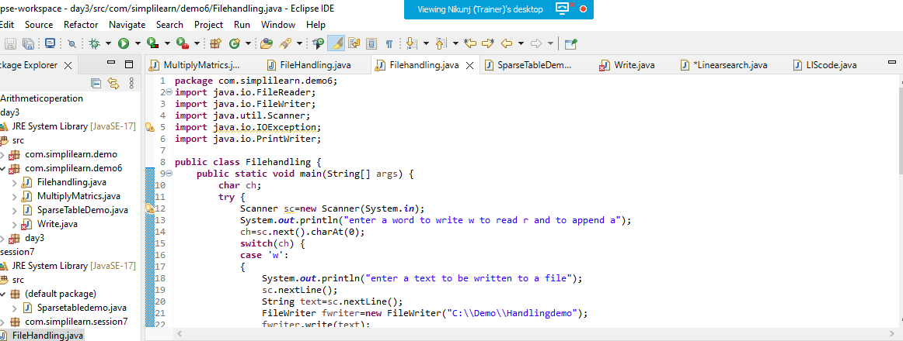 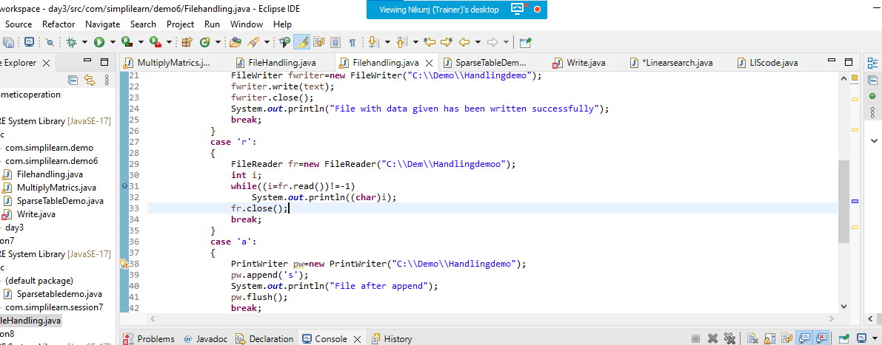 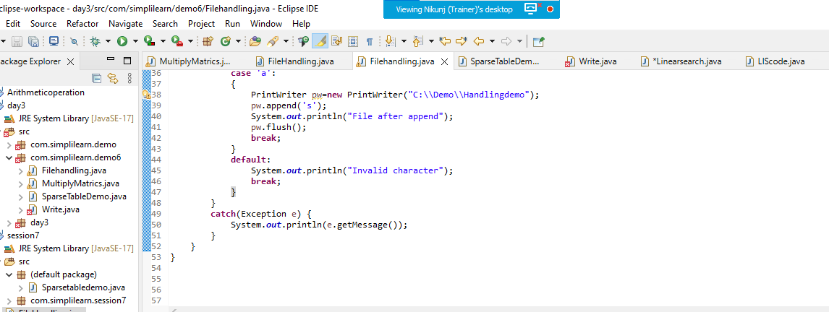

Output:

