**Indian Institute of Information Technology, Allahabad Course: Software Engineering**



**Software Requirement Specifications**

**“Anusandhan” - University Project Bank**

*Surendra Tholiya - IIT2021097*

*Dasari Vamshi Krishna - IIT2021008*

*Aadesh Agte - IIT2021007*

*Tanmay Sreejith - IIT2021004*

*Sparsh Gupta - IIT2021002*

**1. Introduction:**

“Anusandhan” is an online University Project Bank which allows students to search and view existing projects and submit new projects. The platform also allows the university to create a database of all existing projects and that will allow students to be informed regarding the ongoing research works.

This software makes use of ‘Tokens’ to map project approval requests to students which is used in multiple functionalities such as checking the status of projects and allowing admin to have a list of all the projects done by the students to accept / reject the projects appropriately.

**1.1 Purpose:**

The main objective of this project is to provide the university administration with a software that allows them to store and provide the students with curated projects and maintain a record of all the previously completed student projects. The students are also provided with a platform to upload their existing projects which can later be added by the admin to the database after thorough checking.

**1.2 Scope:**

*In Scope:*

a) A well-maintained project database.

b) Student search bar, project approval request, approval status checking.

c) Admin has absolute control over the database, he can accept / reject relevant projects which would be then stored in the database if accepted.

*Out of Scope:*

a) Third party plagiarism checker that can be used by the admin.

b) Search Engine Optimization for better results.

**1.3 Overview:**

The software’s briefly explained description is given in Section 2. The user’s required input and software usability is detailed, key features are highlighted and software dependencies & constraints are noted.

**2. Overall Description:**

**2.1 Product Perspective:**

“Anusandhan” is designed as an alternative to the various project management softwares available to users in the current market. It enables an enhanced level of user interactivity between the students and administration and helps in providing better learning experience with curated projects from the admin for the students.

**2.2 Product Functions:**

“Anusandhan” supports the following use cases:

|  |  |
| --- | --- |
| **Use Cases** | **Description of Use Cases** |
| Student Login | The student enters their credentials to be directed to the ‘Student Home Page’. |
| Admin Login | The admin of the Project bank enters their credentials to be directed to the ‘Admin Home Page’. |
| Student Home Page | This homepage has three features - a search bar for searching up previous projects, a ‘check status’ button to view the status of all of the student’s projects and a ‘project request’ button for new submissions. |
| Admin Home Page | This is the page that the admin has access to and can use several features like the search bar, checking the pending project approvals and updating the project database. |
| Search | The admin / student can search for projects based on keywords of the project. |
| Search Results | Relevant search results are displayed based on the keywords entered. |
| View Project Page | The project page displays a list of existing projects, and is reached by clicking on a particular project from the search results. |
| Project Submission Request | The student uses this feature to request to add a new project into the database. The request is later checked and verified by the admin. |
| Enter Details Page | This is the next step in the project request process where the student is expected to enter the details pertaining to the project like the title, keywords, abstract, and the entire documentation of the project. |
| Submit Request /  Token Generation | This is the ‘submit’ button that the student clicks after filling the aforementioned information, and has a token generated specific to their uploaded request. |
| Check Status Button | Students may view the list of all the projects that they are involved in along with its status by pressing this button in the Student Home Page. |
| Display Project List | This feature allows the student to check the status of their project approval. There can be three cases - Rejected, Accepted and Pending. It also displays all the other projects that a student has submitted in the past. |
| Check Tokens | This is the button used by the admin to view all pending tokens, for the admin’s perusal. |
| Token List | This list is used by the admin and comprises all the pending tokens which need to be verified by the admin. |
| Display Project Details | For each token submitted, information and specifics such as the project document, abstract and author details will be mentioned which the admin makes use of in case the project request is accepted. |
| Accept Project | If favorable, the admin accepts the project request and the project get uploaded to the project bank directly with no further steps. |
| Reject Project | If the admin does not want to add the project onto the database, they can reject the project which will be discarded. |
| Add Project | This feature is explicitly used by the admin to add external projects that the admin feels is relevant to the database. |
| Upload | The admin uploads the project documentation which reflects the changes in the database. |
| Update Status List | The status list is updated depending on the action taken by the admin (accepted/rejected) which can later be referenced by the student to know the status of their project approval. |

**2.3 User Characteristics:**

The admin and student both should be well aware of the searching process and good utilization of keywords which will result in better results.

Entering relevant information regarding the project to be uploaded is also a crucial part of this software as it enhances readability and optimizes search.

**2.4 Principal Actors:**

There are two actors considered in the working of this software - one is the ‘Student’ who checks for projects or requests to upload their own, and the other is the ‘Admin’, the authority figure behind the Project Bank who approves the project requests or adds their own.

**2.5 Assumptions and Dependencies:**

a) The user is aware of the working of tokens (used to check for approval) and project submission procedure.

**APPENDIX:**

**USE CASE DIAGRAM**

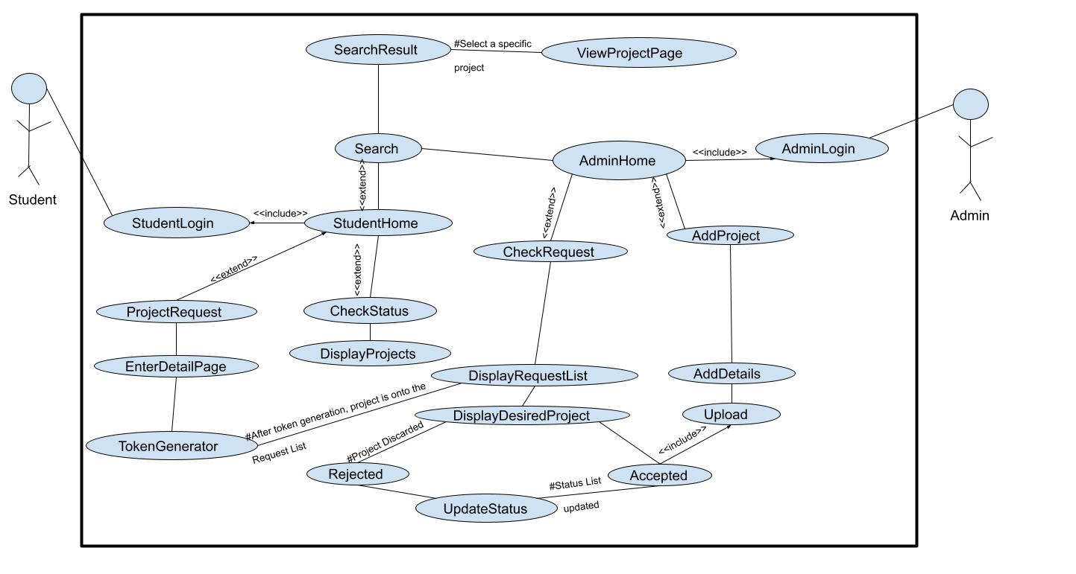

**3. Specific Requirements:**

**From a Student Point of View :**

* Relevant projects for students are tough to get, since vast search results on the internet, But our software provides them only relevant projects as desired by the administration.
* Database is managed only by the Admin and others cannot commit changes in the database.
* General searching is tedious with inefficient results, but our software gives brief abstracts and introduction of the project which helps the student get an insight.
* Publishing paper online is time consuming and more intensive, since multiple forms as well as validation protocols have to be followed.
* Here, we have simplified the uploading and verification process as only validated students can try to upload their projects because the student login is required.
* Checking status of projects in online/general platforms often leads to errors in communication because of spam mails/ missed mails and unreceived mails.
* Token generation simplifies the status checking procedure.

**From the Admin point of view :**

* To get the project details , the admin needs to communicate with the students with multiple back and forth mails which is hectic.
* In our software, all the information is filled by the student while requesting approval and the admin can find that all at one place.
* Even though plagiarism checking in a project is out of scope, the admin can utilize a third party application and compare the token id’s to identify the student who is responsible for the plagiarism.
* Admin does not need to write individual mail to each student about the status of their project submission at regular periods of time.
* For the status of the student's project, Admin updates the status in the token table which can later be referenced by the student as per their own convenience. This reduces the hassle of ensuring prompt communication by other platforms.

**Use Case 1:**

**Name:** Student Login

**Summary:** Student opens the website in student login. Enter username and password. If credentials are valid, then the student goes to the Student Home Page.

**Pre-Conditions:**

* Student device has a working browser.

**Main Success Scenario:**

* The user desires to use the Application in the device environment.
* Student clicks login button.
* App checks for authorisation.

**Post-Condition:**

* Successful Login will then redirect students to the Student Home Page.

**Use Case 2:**

**Name:** Admin Login

**Summary:** Admin opens the website in Admin Login and enters the required credentials. Admin is redirected to the Amin home page if the credentials are valid.

**Pre-Conditions:**

* Admin device has logged into the system.

**Main Success Scenario:**

* Admin clicks login button
* System checks if credentials are correct or not.

**Post-Condition:**

* Successful login redirects to the admin home page.

**Use Case 3:**

**Name:** Student Home Page

**Summary:** Student Home page allows the student to search for projects in the search bar using appropriate keywords, and has a few buttons to choose from which facilitates the options to submit project requests and can check the status of all the pending, accepted and rejected applications.

**Pre-Conditions:**

* Student device has logged into the system.

**Main Success Scenario:**

* Student selects an option.

**Post-Condition:**

* Page is redirected to the required page depending on the service chosen.

**Use Case 4:**

**Name:** Admin Home Page

**Summary:** Admin Home page allows the admin to choose options to add new projects, accept student projects and search for existing projects.

**Pre-Conditions:**

* Admin device has logged into the system.

**Main Success Scenario:**

* Admin selects an option.

**Post-Condition:**

* Page is redirected to the required page depending on the service chosen.

**Use Case 5:**

**Name:** Search

**Summary:** Student can search using appropriate keywords in the search bar and search algorithm will generate results based on keywords searched.

**Pre-Conditions:**

* Student device has logged into the system.
* Student has entered appropriate keywords in the search bar.

**Main Success Scenario:**

* Student clicks the search button and search result displays.

**Post-Condition:**

* Student can view the results of their search.

**Use Case 6:**

**Name:** Search Result Page

**Summary:** A student can search for keywords in the search bar and the search algorithm is then expected to generate results based on the appropriate keywords searched. All the relevant projects would then be displayed in the order of most recently published projects.

**Pre-Conditions:**

* Student device has logged into the system.
* Student has entered appropriate keywords in the search bar.

**Main Success Scenario:**

* Student can scroll through all the results and can select the project to view.

**Post-Condition:**

* Student can view the project page.

**Use Case 7:**

**Name:** View Project Page

**Summary:** Every project has a project page with a brief abstract of the project, names of author(s), contact details and links related to the project (as submitted by the author(s)).

**Pre-Conditions:**

* Student has searched for keywords
* The search results have been displayed and have at least one relevant search result.

**Main Success Scenario:**

* Static window opens for students to get details of the project.

**Post-Condition:**

* Student can download resources or go back to results.

**Use Case 8:**

**Name:** Project Approval Request.

**Summary:** Students can upload their project details and wait for approval from the Admin.

**Pre-Conditions:**

* Student has logged in and in Student Home Page.

**Main Success Scenario:**

* Student clicks Project Request Button.

**Post-Condition:**

* Details page opens.

**Use Case 9:**

**Name:** Details Page

**Summary:** Student who wants to apply will add the required details, such as author name(s), keywords, abstract, links and other relevant information.

**Pre-Conditions:**

* Student has logged in and clicked Project Request Button

**Main Success Scenario:**

* Student fills the form with all required fields and clicks the submit button.

**Post-Condition:**

* Token Submitted page opens.

**Use Case 10:**

**Name:** Submit Token

**Summary:** Student will get a unique Token Number for every project submission request.

**Pre-Conditions:**

* Student has filled all the required fields in the details page.

**Main Success Scenario:**

* Student can view the token number and can go back to the home page if required.

**Post-Condition:**

* Student goes to the Home Page.

**Use Case 11:**

**Name:** Check Status

**Summary:** A check status button is made available in the Student Home Page that the students may use to view the list of their submitted projects along with its status of submission.

**Pre-Conditions:**

* Student has logged in, and is in Student Home Page.

**Main Success Scenario:**

* ‘Student’ click the Check Status button to view a list of all their projects.

**Post-Condition:**

* The set of all projects that the student has been involved with is displayed, along with the date and status of its publishing in the Project Bank.

**Use Case 12:**

**Name:** Display Project List

**Summary:** Students are given the functionality to view the list of all their projects, along with the status of each, which may be either of - ‘Accepted’ , ‘Rejected’, ‘Pending’.

**Pre-Conditions:**

* Student has logged in, and is in Student Home Page.

**Main Success Scenario:**

* Student has clicked the Check Status button.

**Post-Condition:**

* Students are informed of the status of their projects.

**Use Case 13:**

**Name:** Check Tokens

**Summary:** The Admin makes use of this button to view all pending project requests.

**Pre-Conditions:**

* Admin has logged in to their Home Page.

**Main Success Scenario:**

* Admin wishes to view pending requests and clicks on the ‘Check Tokens’ button.

**Post-Condition:**

* The set of all project requests that students have made for submission is made visible for the Admin, and the Admin may click on one token to view detailed information on the project.

**Use Case 14:**

**Name:** Token List

**Summary:** Admin can view all the pending tokens for project requests, and may click on one for further detailed information.

**Pre-Conditions:**

* Admin has logged in to their Home Page and has clicked on the ‘Check Tokens’ button.

**Main Success Scenario:**

* Admin can view the pending project requests and can select a particular project.

**Post-Condition:**

* Admin is able to view pending project requests, and may choose to view the Project Information of a particular one for further action.

**Use Case 15:**

**Name:** Display Project Details

**Summary:** On clicking on a particular token, Admin has the entire project information displayed to them for further perusal.

**Pre-Conditions:**

* Admin has logged in and viewed the pending tokens’ list.

**Main Success Scenario:**

* Admin clicks on a particular token in the token list, and on doing so the entire project information - including author details, project abstract and document PDF - is visible to the Admin.

**Post-Condition:**

* The Admin takes a decision on the project’s upload status based on the project information displayed prior.

**Use Case 16:**

**Name:** Accept Project

**Summary:** Admin clicks the ‘Accept’ button if the project is deemed satisfactory, and the project is then successfully uploaded directly with no further human input to the University Project Bank.

**Pre-Conditions:**

* Admin has logged in, has viewed the pending tokens list and has gone through the details of a particular project.

**Main Success Scenario:**

* Admin clicks on the ‘Accept’ button after perusing the project request details.

**Post-Condition:**

* The particular project is uploaded to the University Project Bank.

**Use Case 17:**

**Name:** Upload Button

**Summary:** Admin uploads the project onto Database and receives confirmation.

**Pre-Conditions:**

* Admin has filled all required fields in the details page.

**Main Success Scenario:**

* Admin clicks the submit button on the details page.

**Post-Condition:**

* Admin can see confirmation of successful entry.

**Use Case 18:**

**Name:** Reject Project.

**Summary:**  The projects that the admin deems not worthy of being added onto the database are rejected and discarded.

**Pre-Conditions:**

* The admin has to go through the entire project and verify it.

**Main Success Scenario:**

* Admin clicks the Reject Project button on the screen.

**Post-Condition:**

* The project is then discarded and the project status list which can be accessed by the student is updated to show the same.

**Use Case 19:**

**Name:** Update Status List

**Summary:** Admin can select the action to be taken on the project, i.e, accept / reject and the same is updated in the status list which can be accessed by the student.

**Pre-Conditions:**

* Admin has to either ACCEPT or REJECT the project.

**Main Success Scenario:**

* The action taken by the Admin is correctly displayed in the status list.

**Post-Condition:**

* Students can verify the status of their project approval request using the status list and know whether the project is accepted, rejected or if it is still pending for approval.