VALUE-DRIVEN AI FOR PETROCHEMICAL OPERATIONS: COMMON GAPS FROM PROOF OF CONCEPT TO PLANTWIDE DEPLOYMENT

XXXX XXXXXXX, Ingenero Inc., Houston, TX, USA

Biography
[Chandra Pulleti: Has 30 years of experience in Chemical Engineering space, highly accomplished professional, known for driving innovation and delivering outstanding results in Project Engineering Delivery, Value Enhancement, Manufacturing Intelligence Digitalization. Has the distinction of working on Mega projects from concept to commissioning. Had the rare opportunity to hone my process design, optimization, project execution skill over various technologies, which helped me to establish as a leader in engineering excellence, continuous operational improvements and Sustainability practices.]

Prepared for presentation at the 2027 AIChE Spring Meeting, Oklahoma City, OK, March 21-25,2027
AIChE shall not be responsible for statements or opinions contained in papers or printed in its publications

Abstract
In petrochemical operations, developing an artificial intelligence / machine learning (AI/ML) model that performs well on historical data, or that demonstrates value in a controlled proof of concept (POC), is often only the beginning. The greater challenge is converting that technical capability into sustained operational and economic value in the plant environment.
A successful AI solution has to fit into several interconnected layers. It is a multidisciplinary transformation that connects AI/ML with plant economics, process engineering, IT/OT infrastructure, operational workflows, human decision making, and continuous performance improvement. AI/ML enhances each of these layers, and at the same time the layers come together into one AI-enhanced solution. Each layer can be technically competent on its own, but without cross-domain plant (“tribal”) knowledge the pieces do not come together into a well-tuned orchestra.
Much of today’s AI development follows a general-purpose, “can do everything” approach, which is one of the reasons behind inflated expectations and failed use cases. Petrochemical operations need purpose-built industrial AI. The goal is not to build a machine that can do everything; it is to build an AI solution that does one important thing exceptionally well, all the time and in real time, and delivers measurable value to the plant. This shift from technology-driven experimentation to value-driven deployment is central to setting an organization’s digital strategy.
Drawing on more than 100 AI/ML solutions deployed by Ingenero across refining, olefins, polymers, chemicals and utilities, and on the integrated ingeneroX360AI platform developed from that experience, this paper examines the common gaps in each of the six layers, poses the questions each layer must answer before a POC is scaled, and describes practices that bridge those gaps: value enhancement baselines, hybrid first-principles / machine learning models, zone-aware deployment outside the control layer, decision-support workflows that keep operators in the loop, and coordinated multi-agent optimization across unit boundaries. Field results from 100+ furnace cracking fleet and a 14 unit-complex enterprise program are presented, and the lessons are consolidated into an AI implementation playbook for petrochemicals.
Keywords: Industrial AI; machine learning; petrochemicals; olefins; proof of concept; hybrid modeling; digital transformation; multi-agent optimization
Introduction
Over the past three decades, petrochemical producers have invested steadily in plant historians, advanced process control (APC), real-time optimization (RTO) and data platforms [1, 2]. AI/ML is the newest layer, and its promise for chemical engineering is well documented [3]. Yet converting AI pilots into lasting value remains difficult. Gartner predicted that at least 30% of generative AI projects would be abandoned after proof of concept by the end of 2025 [4], and a 2025 MIT study found that most enterprise generative AI pilots produced no measurable profit-and-loss impact [5]. The pattern is familiar in the chemical industry, Upstream, Midstream and Downstream.
The Pilot Paradox
A POC is usually judged on predictive accuracy over a historical window. A model can fit history well and still deliver little online, for three reasons. The process moves: coking, fouling, catalyst activity, tube metal temperature (TMT) approach and hydraulic and compressor limits change continuously. The economics move: feed slate, product spreads and utility prices shift the optimum. And the organization must act: someone has to own, trust and execute the recommendation. Sculley et al. showed that machine-learning code is a small fraction of a production ML system [6]; in a plant, process engineering, economics and people must be added. Figure 1 sketches the result: a technology-driven pilot stalls, while a value-driven deployment compounds as scope grows.
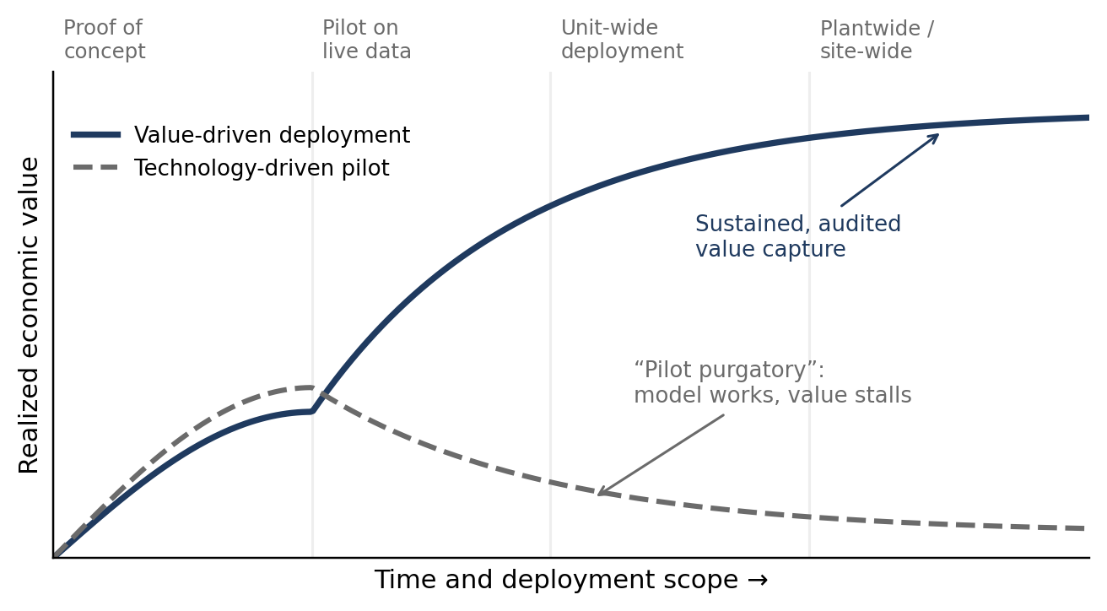
Figure 1. Conceptual value trajectory of a technology-driven pilot versus a value-driven deployment
General-Purpose Versus Purpose-Built Industrial AI
General-purpose AI, including large language models, is designed for breadth. Industrial value comes from depth: one decision, made correctly every time, at the frequency the process demands. Purpose-built industrial AI embeds process physics and constraints, is configured for a specific asset, is tied to a specific economic decision, and runs unattended while reporting its own health. Figure 2 shows the cracking-furnace agent of olefinX360, the olefins solution within ingeneroX360AI, decomposed into narrow modules: calculations, rigorous and run-length optimization, run-length forecasting, tube, burner, transfer-line exchanger (TLE) and convection health, benchmarking, and ranked operator suggestions. None tries to do everything; together they own one asset class completely. General-purpose AI still has a role, but as the interface (Layer 5), not as the optimizer.
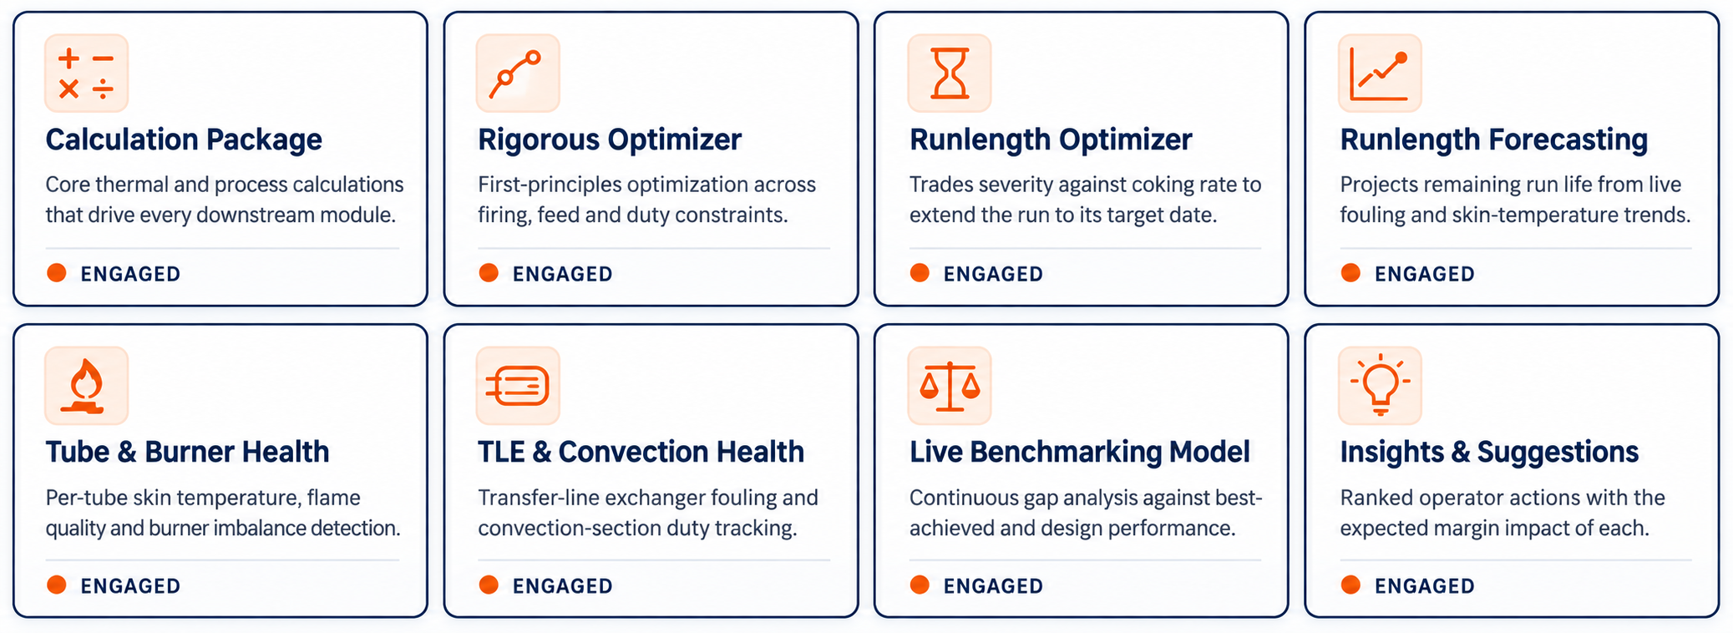
Figure 2. Purpose-built modules of the olefinX360 cracking-furnace agent; each module does one job well
A Six-Layer Framework for Value-Driven Industrial AI
Figure 3 and Table 1 summarize the six layers, the questions each must answer, the most common gaps and the practices that bridge them. The gaps usually sit at the interfaces, for example a good model with no owner (Layers 2 and 4) or a unit optimum that costs the plant money (Layers 1 and 6). Cross-domain plant knowledge is the conductor of the orchestra.
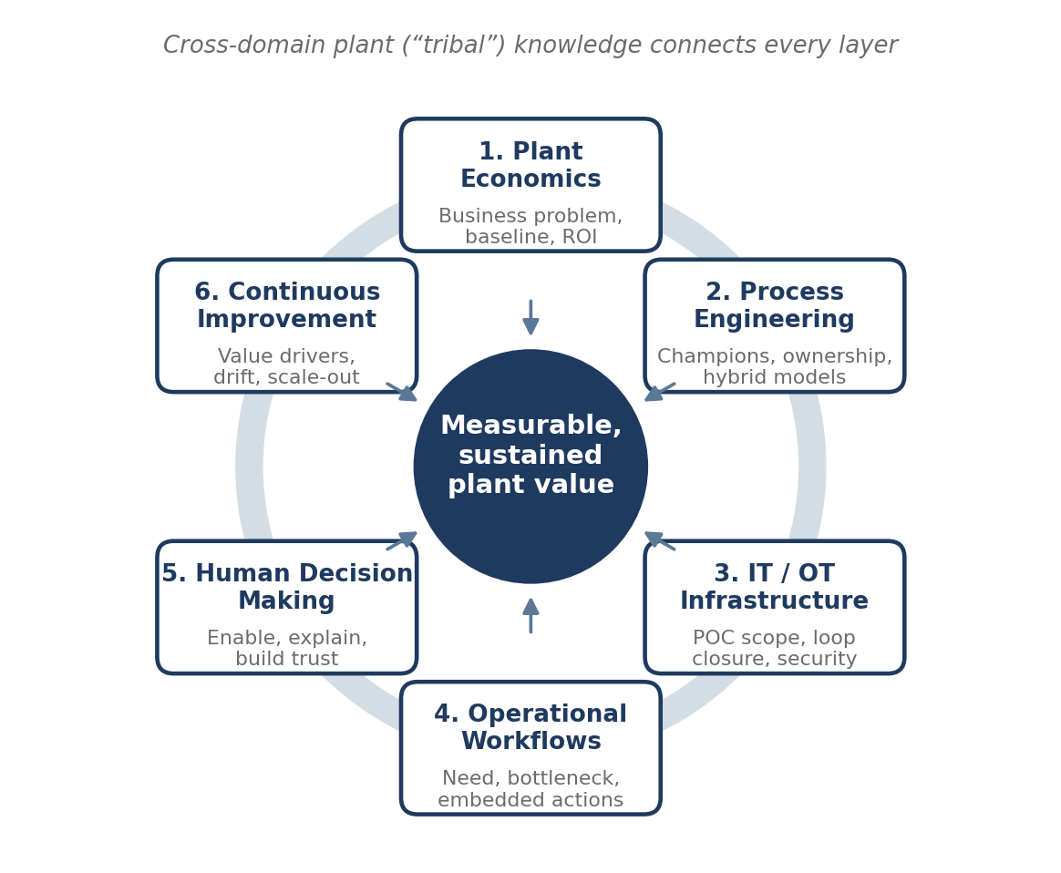
Figure 3. The six interconnected layers of value-driven industrial AI
Table 1. Six Layers: Key Questions, Common Gaps and Bridging Practices
Layer | Key questions | Common gap | Bridging practice
1. Plant economics | What business problem is solved? What is the baseline? What is the ROI and time to value? | Value judged against static averages; unit-level optimization | Counterfactual baseline; margin KPI in $/h; audited value tracking
2. Process engineering | Who are the champions? Who owns the tool? Use case or platform first? | No owner; tribal knowledge not encoded; black-box models | Named site champion; hybrid first-principles / ML models; use-case-led, platform-enabled
3. IT/OT infrastructure | Right POC scope? Open or closed loop? Future state and timeline? Cost of doing nothing? | POC on an offline extract; security rejection at scale-up | Live-data POC on target architecture; zone-aware deployment; staged loop closure
4. Operational workflows | Is there a real need? Does it make a business case? Is it a bottleneck? | Dashboards nobody opens; recommendations sent by e-mail | Bottleneck test; actions embedded in shift and morning meetings; tracked close-out
5. Human decision making | Is this automation? Does the operator become redundant? | The “automation myth”; unexplained advice; loss of trust | Decision support with engineering explanations; operator authority; grounded AI assistant
6. Continuous improvement | What is the improved state? What are the value drivers? | Model drift; unit sub-optimization; value decays after go-live | Model operations with drift retraining; multi-agent plantwide coordination; value reviews

Layer 1: Plant Economics
What Business Problem Is the AI Solving?
Value-driven deployment starts from the margin equation, not the data. In olefins the levers are throughput at the constraining equipment, yield through severity, energy intensity, run length, and avoided losses from outages, flaring or off-specification product. A use case qualifies only if it maps to a lever with a named decision maker and decision frequency. “Predict TMT” is not a business problem; “raise furnace throughput within TMT and cracked gas compressor (CGC) limits every shift” is.
What Is the Baseline?
The most common economic gap is the baseline. Comparing performance with a historical average credits or penalizes the AI for changes in feed, ambient conditions or prices. A counterfactual baseline, meaning what the plant would have done under the same conditions without the recommendation, removes that bias. It is computed with the same hybrid models used for optimization and normalized for feed slate, fuel gas heating value, cooling water temperature and day of run. Captured value is actual minus counterfactual performance at current margins, in $/day, using a method agreed with operations and plant economics before go-live.
What Is the ROI, and How Long Is the Journey to Value?
ROI must include the full program cost: licenses, integration, engineering and change management. In the enterprise program described later, first-year realized benefits exceeded $43 MM with 6.3× gross return. Value lags deployment while the baseline and operator trust are established, so the expected value curve (Figure 1) should be agreed at the outset, and value should be measured at plant margin rather than unit performance (Layer 6).
Layer 2: Process Engineering
Who Are the Champions?
Every successful deployment we have seen had a named site champion, usually a senior process engineer with credibility in the control room, backed by an executive sponsor who protects that person’s time. The champion translates between data scientists and operators, validates recommendations and carries the tool into operating meetings. Without one, AI remains a vendor project.
Who Owns the Tool: Operations, Technical or Maintenance?
Ownership should follow the decision, not the department that funded the project. Table 2 shows the model that has worked across our deployments; it is agreed before any model is built.
Table 2. Ownership Model by Use-Case Type
Use-case type | Owns models and targets | Acts on recommendation | Consulted / informed
Process optimization (furnace severity, feed allocation, column targets) | Technical / process engineering | Operations (console operators, shift supervisor) | Planning and economics; maintenance
Asset health and early warning (compressors, TLEs, burners) | Reliability / maintenance | Maintenance planning; operations | Technical
Energy and utilities (steam, fuel, cooling water) | Technical / energy coordinator | Operations; utilities | Site management
Quality and soft sensors (polymer properties, impurities) | Technical with laboratory | Operations | Quality / customer service

Encoding Tribal Knowledge with Hybrid Models
Purely data-driven models extrapolate poorly and can recommend setpoints that violate mass and energy balances or equipment limits. Hybrid models combine first principles (balances, kinetics, thermodynamics, or a rigorous simulator the site already trusts) with data-driven components that learn what the physics misses, such as fouling, burner imbalance or feed effects [7, 8]. Tribal knowledge, such as a column’s flooding tendency, a sticky valve or a thermocouple that reads low, is encoded as features, constraints and rules. In the ingeneroX360AI reliability models, inferred tags are engineered per asset and deviation from design is tracked alongside learned normal behavior.
What Comes First: The Use Case or the AI Platform?
Platform-first programs stall without visible value; use-case-first programs leave scripts nobody can maintain. Our answer is “use-case-led, platform-enabled”: start with the highest-value bottleneck, on a platform that will host the next twenty use cases. Our project history shows that 80 to 90% of digitalization enquiries share common requirements. That is the basis on which ingeneroX360AI was productized: reusable KPI libraries and configurable asset templates shorten each deployment, whether the asset is a cracking furnace in olefinX360 or a synthesis loop in ammoniaX360.
Layer 3: IT/OT Infrastructure
What Is the Correct Scope for a POC?
A POC run on a historian extract in a notebook proves that a model fits, not that value can be captured. A correctly scoped POC has:
- one asset or unit with a clear value lever and decision owner;
- live data through the interface that production will use;
- deployment on the target architecture, accepted by site cybersecurity;
- a baseline and value metric agreed before the start; and
- explicit exit criteria: scale, adjust or stop.
This costs a few extra weeks up front, but it removes the re-platforming step that ends many pilots.
Open Loop or Closed Loop?
Start open loop, in advisory mode. Close the loop to APC or the distributed control system (DCS) only after recommendations are proven, operators trust them and management of change (MOC) is complete [9]. A practical progression is (1) monitoring and insight, (2) advisory recommendations that the operator accepts or rejects, (3) supervised write-back of targets to APC or RTO, and (4) closed-loop action within an approved envelope, mirroring how APC and RTO matured [1, 2]. Most value in petrochemicals today is captured at stages 2 and 3.
Zone-Aware Deployment
Security teams rightly reject software inside the control network or uncontrolled writes to controllers. Figure 4 shows a zone-aware deployment aligned with the Purdue model and ISA-95 [10, 11] and the ISA/IEC 62443 zones-and-conduits approach [12]. Services run in an application zone behind the demilitarized zone (DMZ), read the historian through a read-only interface, and write back only through a governed path. In ingeneroX360AI deployments this means containerized microservices without a mandatory Kubernetes dependency, scale-out by adding compute nodes, and a software bill of materials with each release.
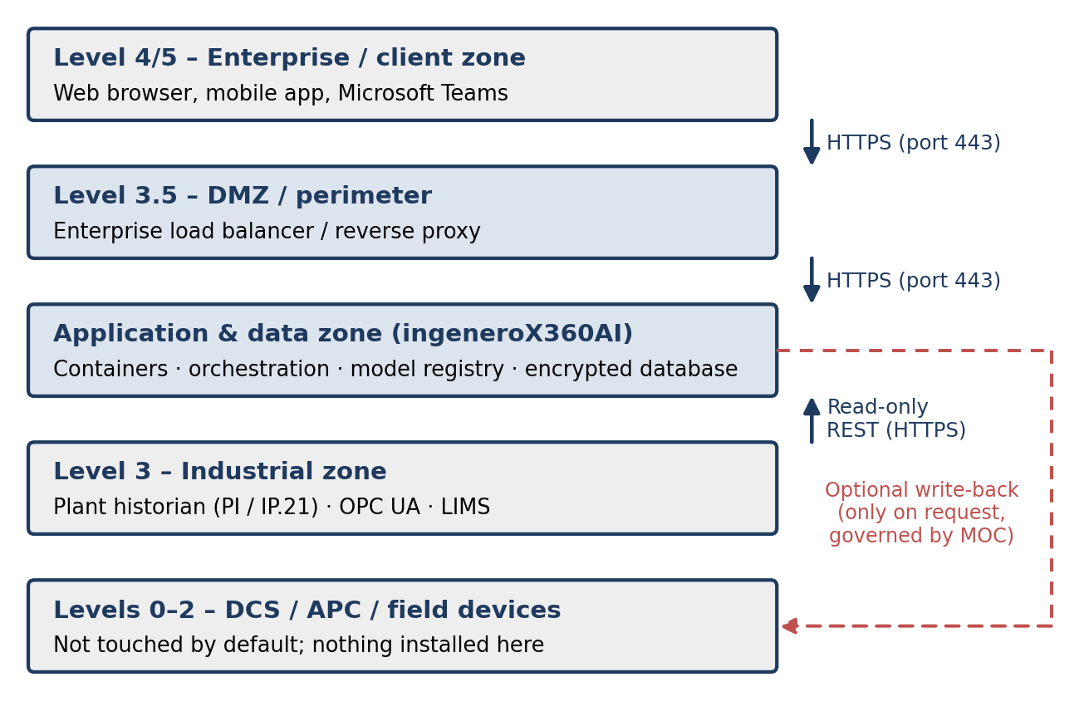
Figure 4. Zone-aware deployment of ingeneroX360AI outside the process control layer
Figure 5 shows the corresponding ingeneroX360AI platform architecture: configuration, data-science and insight layers over shared data, metadata and security services built on open-source components.
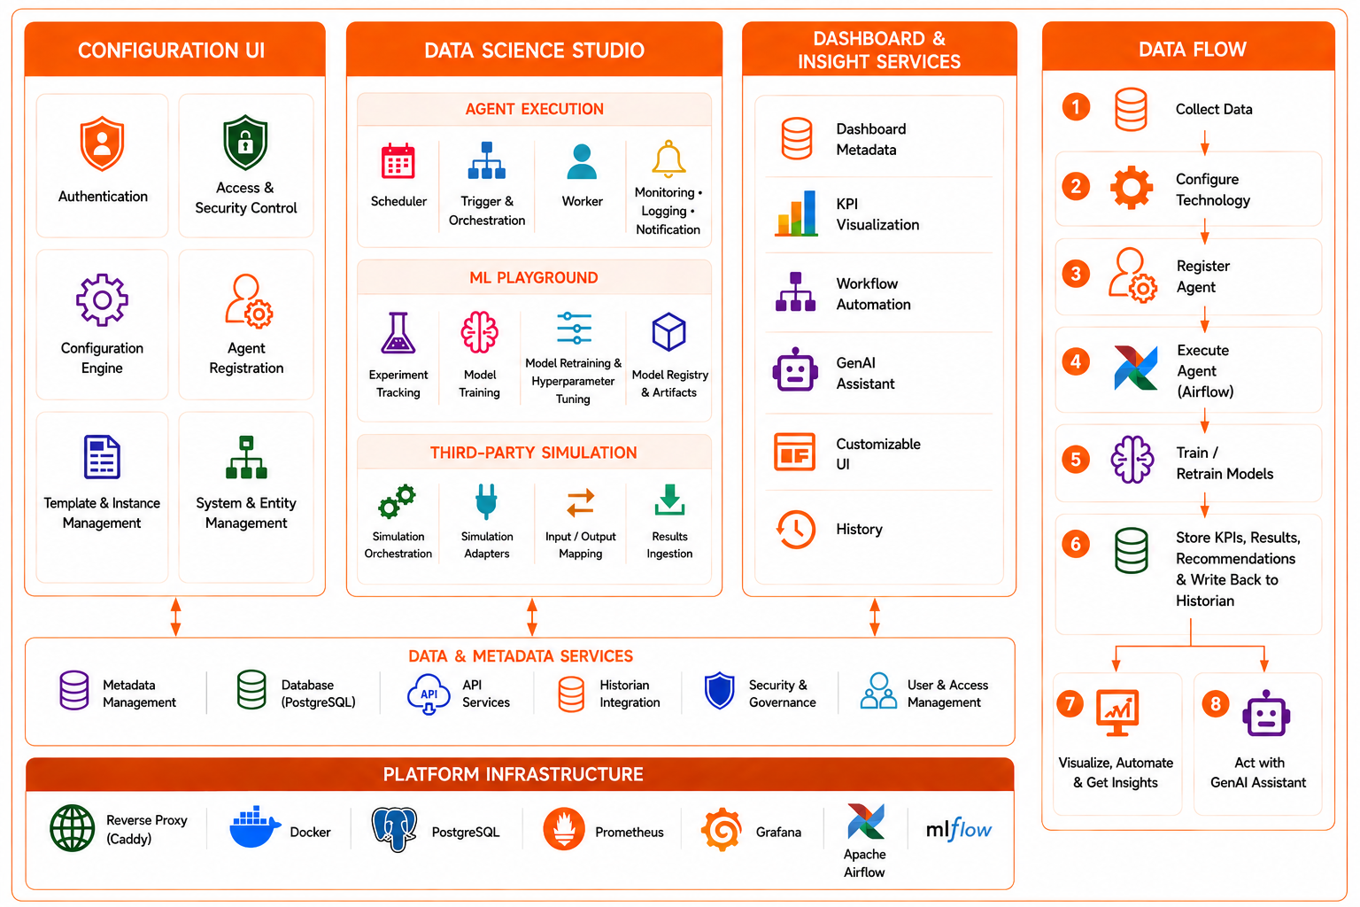
Figure 5. ingeneroX360AI platform architecture: configuration, data science and insight services over a shared data and metadata core
What Is the Future State, and What If We Do Nothing?
Every POC proposal should state the target end state and timeline, so that choices made for the POC need not be undone. It should also quantify the cost of doing nothing: continued margin leakage (at a 2 to 3% fleet production gain potential, each month of delay forgoes that margin), loss of expertise as experienced engineers retire, and growing digital debt.
Layer 4: Operational Workflows
Is There a Real Need, and Is It a Bottleneck?
Each candidate should pass a simple test. Is there a recurring decision? Is it made late or with incomplete information? Is it a bottleneck to margin, reliability or safety? Can the value be measured against a baseline? If not, it is analytics, not a business case. In the enterprise program described below, 39 of 149 identified use cases were deployed in the first year, selected by value and readiness.
Embedding AI into the Way the Plant Works
Another dashboard rarely changes behavior. Value appears only when recommendations enter the plant’s existing rhythm: shift handover, the morning meeting, the weekly optimization review and maintenance planning. Each recommendation is an accountable item stating what changed, why it matters, the action, the expected value in $/day, the remaining constraint margin, and an owner and due date. It is closed as accepted or rejected with a reason, which feeds model improvement, and calculated KPIs are written back to the historian so operators see them in familiar tools.
Layer 5: Human Decision Making
Automation or Enablement?
Presenting AI as a replacement for operators creates resistance and is usually wrong. Bainbridge’s “ironies of automation” warned that automating routine work leaves humans with the hardest situations [13]. Of the four functions identified by Parasuraman et al. (information acquisition, analysis, decision selection and action implementation) [14], industrial AI pays most in analysis and decision selection, turning thousands of tags into a few explained choices while operators keep authority over action. Operators are not made redundant; their role shifts from gathering data to exercising judgment.
Explainability and Trust
Operators ignore advice they cannot explain to their supervisor. Each recommendation should state the binding constraint, the physics behind the change and the expected response. Hybrid models make this natural, because their explanations are in physical variables such as COT or compressor suction pressure.
Generative AI as the Interface, Not the Optimizer
Generative AI is most valuable as the interface. Asked why coil 4 TMT on furnace 3 is trending high, the ingeneroX360AI assistant retrieves live data, calls the purpose-built models and what-if engines through standard tool interfaces such as the Model Context Protocol, and composes an answer grounded in plant data [15, 16]. The engineering models do the calculation; the language model orchestrates and explains.
Layer 6: Continuous Performance Improvement
What Does the Improved State Look Like?
The vision should be stated in operating terms: every furnace at its economic optimum on every shift, decokes scheduled by forecast, compressor degradation detected weeks earlier, and site feed allocation that reflects real-time constraints. Each value driver (throughput, yield, energy, run length, reliability and engineering productivity) needs an owner and a baseline.
Keeping Models Honest
Models drift as feeds, catalysts and equipment change [17]. Deployed solutions therefore need scheduled and monitored pipelines, data-quality and drift checks, a registry of every model version that produced a recommendation, evaluation before promotion, and retraining on demand. A pilot is run by hand; a product reports when it is unhappy.
From Unit Optimum to Plant Optimum: Multi-Agent Coordination
Optimizing units in isolation leads to plantwide sub-optimization: a furnace pushed for throughput can drive the CGC to its governor-valve limit or cost cold-section recovery. A multi-agent architecture addresses this [18]. In olefinX360, each unit agent (furnace, quench and TLE, CGC and cold section) owns its data, models, constraints and optimization logic. A plant coordinator runs a propose–query–resolve loop in every cycle (Figure 6), and a site coordinator negotiates feed and resources across olefins plants and polymer units.
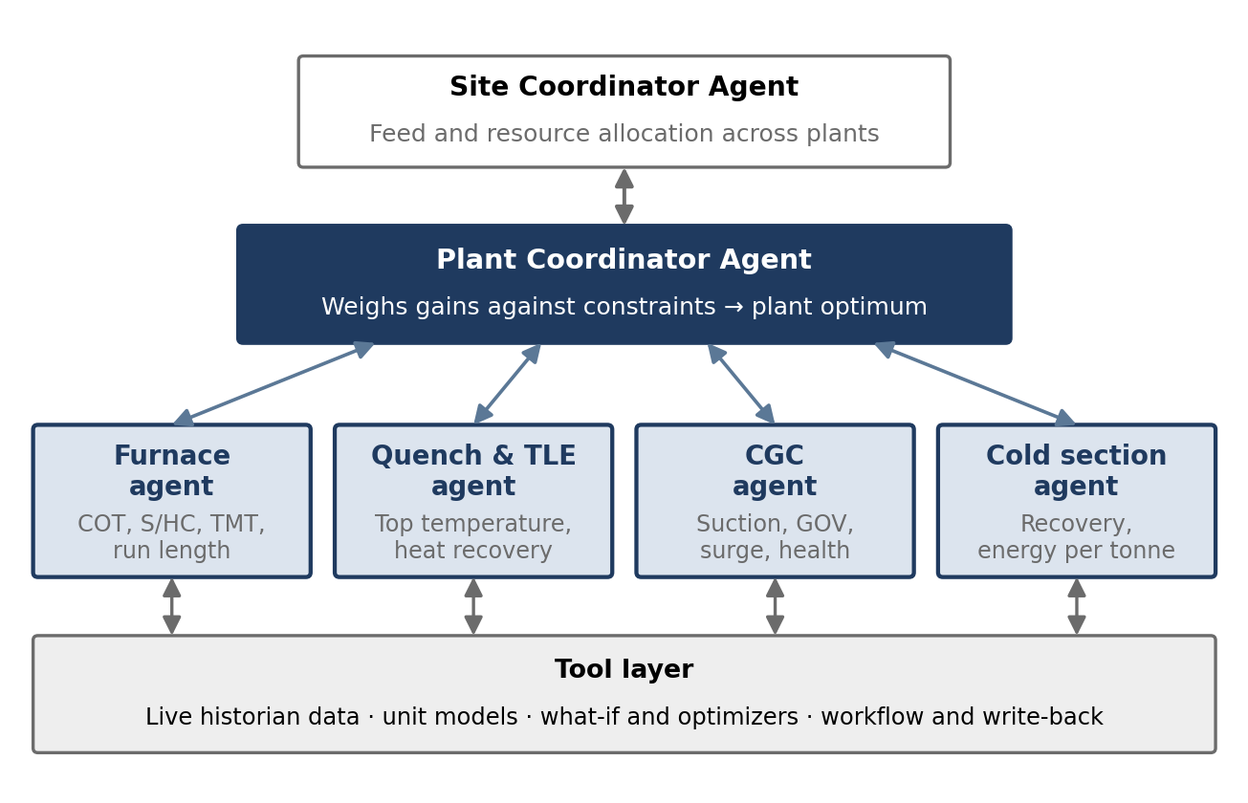
Figure 6. olefinX360 unit agents coordinated by plant and site coordinator agents through a shared tool layer
In the illustrative sequence of Table 3, the coordinator reduces the furnace agent’s local estimate of +$12,500/day to a feasible plantwide gain of +$8,900/day. The gain is smaller but real, and it avoids pushing a health-limited compressor toward a trip. At site level the same mechanism produces traced insights such as “site ethylene is 3% below target because the Plant 1 CGC is health-capped while Plant 2 has spare capacity,” which translate directly into feed and maintenance priorities.
Table 3. Illustrative Multi-Agent Negotiation Sequence (Values Are Illustrative)
Step | Exchange | Content
1 | Furnace agent → coordinator | Propose +4 t/h feed and +5 °C COT; estimated local gain +$12,500/day
2 | Coordinator ↔ quench and TLE agent | Headroom at proposed load? Quench tower top-temperature margin acceptable (+4.2 °C)
3 | Coordinator ↔ CGC agent | Suction capacity and asset health? Governor valve at 94% of limit; vibration near alarm ceiling
4 | Coordinator ↔ cold section agent | Recovery and energy impact? Ethylene recovery loss of 0.12% at proposed load
5 | Coordinator → furnace agent | Resolution: cap increase at +2.1 t/h to honor CGC limit; feasible plantwide gain +$8,900/day

Bringing the Layers Together
Figure 7 shows how ingeneroX360AI is organized so that these layers are served without rebuilding each solution. Process-specific domain agents, such as olefinX360 for olefins and ammoniaX360 for ammonia and urea, form the foundation. Functional agents, model agents (digital twins, optimizers, outlier and benchmarking tools), a results layer, an action-governance layer and a conversational decision layer sit above them. Domain specificity at the bottom and reusable services at the top let a new use case be deployed in weeks rather than months.
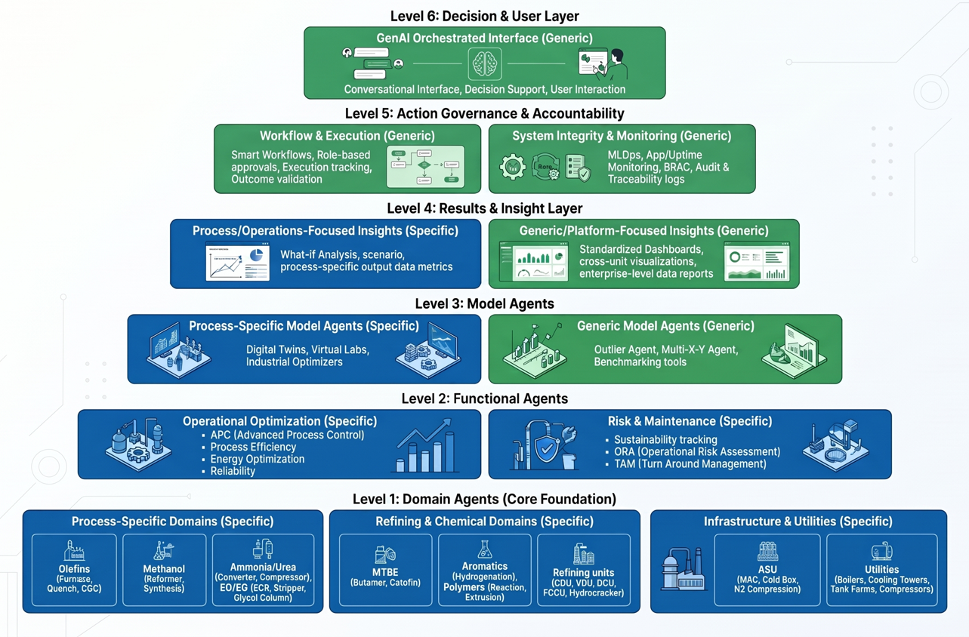
Figure 7. Six-level industrial AI hierarchy of ingeneroX360AI: process-specific foundations with reusable governance and interface layers
Field Experience
Cracking Furnace Fleet
A single set of olefinX360 furnace optimization agents was deployed across every cracking furnace of a major Middle East petrochemical enterprise: 107 furnaces in 11 plants, with four cracker technologies, sixteen furnace configurations and ethane, propane, butane, liquid and mixed feeds. Levers included pass balancing, feed relocation across furnaces, decoke effectiveness, reliability models and energy optimization. The client-validated benefit was approximately $70 MM in the first year, with a further 2 to 3% production gain potential identified at fleet level. The key enablers were configurable asset templates, an auditable counterfactual baseline and recommendations embedded in the engineers’ daily routine.
Enterprise Program Across 14 Complexes
A two-year program across 14 petrochemical complexes in Europe and Asia covered ethylene, polyethylene, EO/EG, methanol, MTBE, ammonia, boilers, utilities and wastewater (Table 4). Explicit prioritization concentrated scarce site attention on the highest-value bottlenecks, and the gap between identified and realized value is managed as a pipeline, with later waves funded from audited first-year results.
Table 4. First-Year Results of an Enterprise AI Program
Metric | Value
Petrochemical complexes (Europe and Asia) | 14
Operating units covered | 46
Use cases identified | 149
Use cases deployed in the first year | 39
Potential value identified | > $100 MM
First-year benefits realized | > $43 MM
Gross return on program cost | 6.3×

An AI Implementation Playbook for Petrochemicals
These lessons consolidate into a four-phase playbook of about 90 days for each deployment wave (Figure 8, Table 5). Each phase ends with a value checkpoint rather than a technical milestone; later waves extend the scope to adjacent units, multi-agent coordination and other sites.
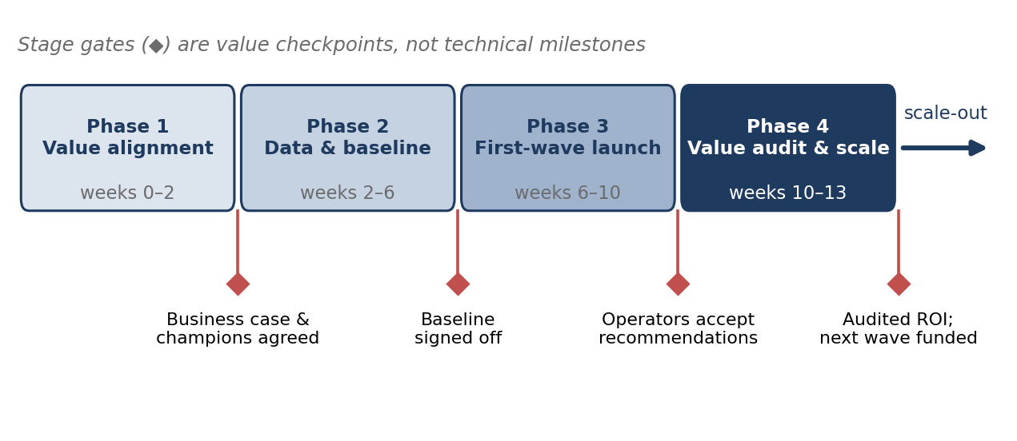
Figure 8. Ninety-day implementation playbook with value-based stage gates
Table 5. Implementation Playbook: Activities, Exit Gates and Stakeholders
Phase | Key activities | Exit gate | Primary stakeholders
1. Value alignment (weeks 0–2) | Select bottleneck and value lever; name champion and owner; confirm IT/OT security model; define future state and do-nothing cost | Business case and champions agreed | Executive sponsor, site director, lead process engineer
2. Data and baseline (weeks 2–6) | Connect read-only historian interface; configure asset templates and tag context; build hybrid models; establish counterfactual baseline | Baseline and value metric signed off | OT / IT administrator, data engineer, process engineer
3. First-wave launch (weeks 6–10) | Deploy agents in advisory mode; embed recommendations in shift and morning meetings; enable AI assistant; capture accept / reject feedback | Operators accept and act on recommendations | Console operators, shift supervisors, reliability lead
4. Value audit and scale (weeks 10–13) | Audit realized value against baseline; decide on supervised write-back under MOC; plan next wave and multi-agent coordination | Audited ROI; next wave funded | VP operations, chief digital officer, site champions

Ten principles summarize the playbook:
- Start from the margin equation, not from the data.
- Agree the counterfactual baseline before go-live.
- Name a champion and an owner for every use case.
- Encode physics and tribal knowledge; make models hybrid by default.
- Scope the POC on live data and on the target architecture.
- Advise first; close the loop only after trust is established and MOC is complete.
- Embed actions in existing operating routines rather than in new dashboards.
- Explain every recommendation in engineering terms.
- Monitor, retrain and audit: run AI as a product, not a pilot.
- Optimize the plant, not the unit.
Conclusions
The hard part of industrial AI is not fitting a model to history; it is making six layers work together in a live plant. Plant economics defines the problem and the baseline. Process engineering supplies champions, ownership and physics. IT/OT infrastructure makes deployment secure and sustainable. Operational workflows turn insight into action. Human decision making keeps operators in authority, and continuous improvement keeps models honest while lifting the optimum from unit to plant to site. Purpose-built industrial AI, the design principle behind ingeneroX360AI and process-specific solutions such as olefinX360 and ammoniaX360, connects these layers far more reliably than general-purpose tools, with cross-domain plant knowledge as the conductor. Results from a 107-furnace fleet and a 14-complex program show audited first-year returns several times the program cost. For petrochemical organizations, the decisive step is the shift from technology-driven experimentation to value-driven deployment.
References
- Qin, S.J. and T.A. Badgwell (2003), “A Survey of Industrial Model Predictive Control Technology,” Control Engineering Practice, 11(7), pp. 733–764.
- Darby, M.L., M. Nikolaou, J. Jones and D. Nicholson (2011), “RTO: An Overview and Assessment of Current Practice,” Journal of Process Control, 21(6), pp. 874–884.
- Venkatasubramanian, V. (2019), “The Promise of Artificial Intelligence in Chemical Engineering: Is It Here, Finally?” AIChE Journal, 65(2), pp. 466–478.
- Gartner, Inc. (2024), “Gartner Predicts 30% of Generative AI Projects Will Be Abandoned After Proof of Concept by End of 2025,” press release, Stamford, CT, July 29, 2024.
- Challapally, A., C. Pease, R. Raskar and P. Chari (2025), “The GenAI Divide: State of AI in Business 2025,” MIT NANDA, Cambridge, MA.
- Sculley, D., et al. (2015), “Hidden Technical Debt in Machine Learning Systems,” in Advances in Neural Information Processing Systems 28, pp. 2503–2511.
- von Stosch, M., R. Oliveira, J. Peres and S. Feyo de Azevedo (2014), “Hybrid Semi-Parametric Modeling in Process Systems Engineering: Past, Present and Future,” Computers & Chemical Engineering, 60, pp. 86–101.
- Kadlec, P., B. Gabrys and S. Strandt (2009), “Data-Driven Soft Sensors in the Process Industry,” Computers & Chemical Engineering, 33(4), pp. 795–814.
- Center for Chemical Process Safety (2008), Guidelines for the Management of Change for Process Safety, New York, NY, AIChE / Wiley.
- Williams, T.J. (1994), “The Purdue Enterprise Reference Architecture,” Computers in Industry, 24(2–3), pp. 141–158.
- International Society of Automation (2010), ANSI/ISA-95.00.01-2010 (IEC 62264-1 Mod), Enterprise-Control System Integration – Part 1: Models and Terminology, Research Triangle Park, NC.
- International Society of Automation, ISA/IEC 62443 Series of Standards, Security for Industrial Automation and Control Systems, Research Triangle Park, NC.
- Bainbridge, L. (1983), “Ironies of Automation,” Automatica, 19(6), pp. 775–779.
- Parasuraman, R., T.B. Sheridan and C.D. Wickens (2000), “A Model for Types and Levels of Human Interaction with Automation,” IEEE Transactions on Systems, Man, and Cybernetics – Part A, 30(3), pp. 286–297.
- Lewis, P., et al. (2020), “Retrieval-Augmented Generation for Knowledge-Intensive NLP Tasks,” in Advances in Neural Information Processing Systems 33, pp. 9459–9474.
- Anthropic (2024), “Introducing the Model Context Protocol,” November 25, 2024, https://www.anthropic.com/news/model-context-protocol.
- Gama, J., I. Žliobaitė, A. Bifet, M. Pechenizkiy and A. Bouchachia (2014), “A Survey on Concept Drift Adaptation,” ACM Computing Surveys, 46(4), Article 44.
- Wooldridge, M. (2009), An Introduction to MultiAgent Systems, 2nd ed., Chichester, UK, John Wiley & Sons.

