**HOW TO INSTALL FIREWALL CERTIFICATE IN MOZILLA FIREFOX BROWSER?**

Step 1

Open Mozilla Firefox browser

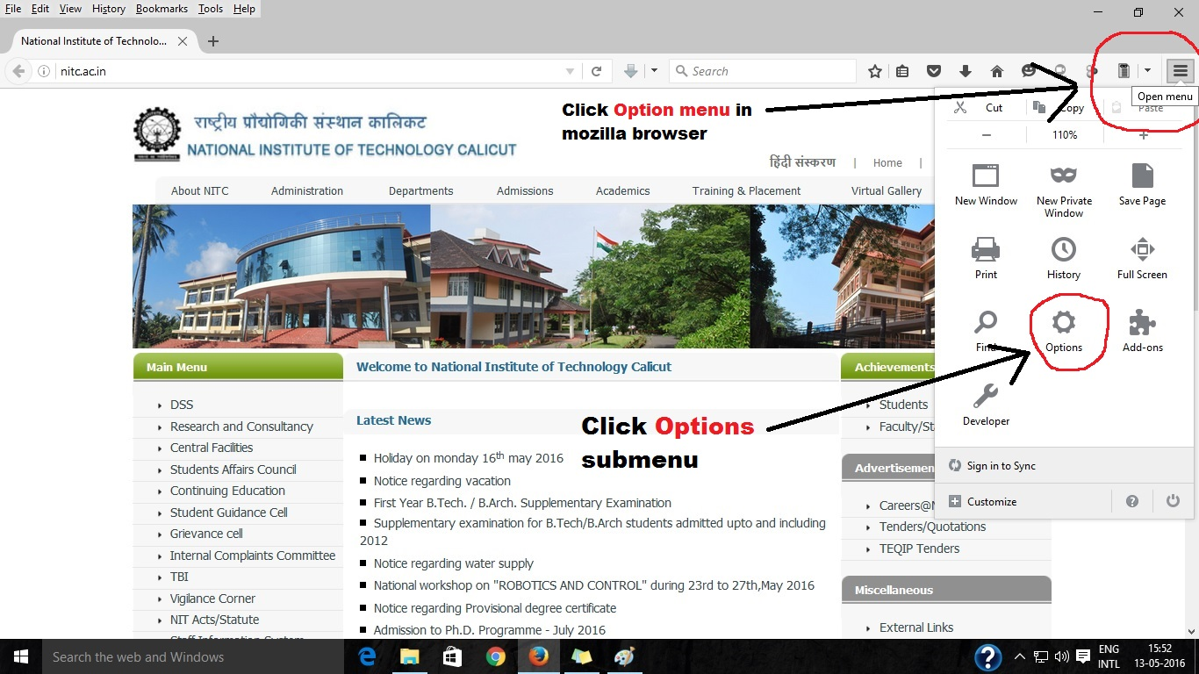

Step 2

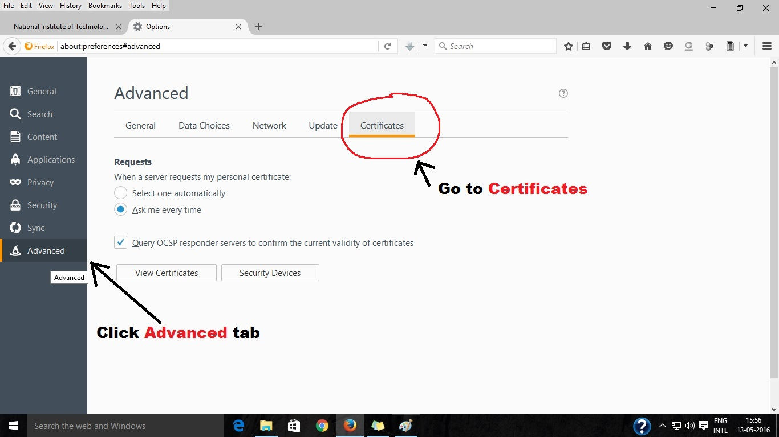

Step 3

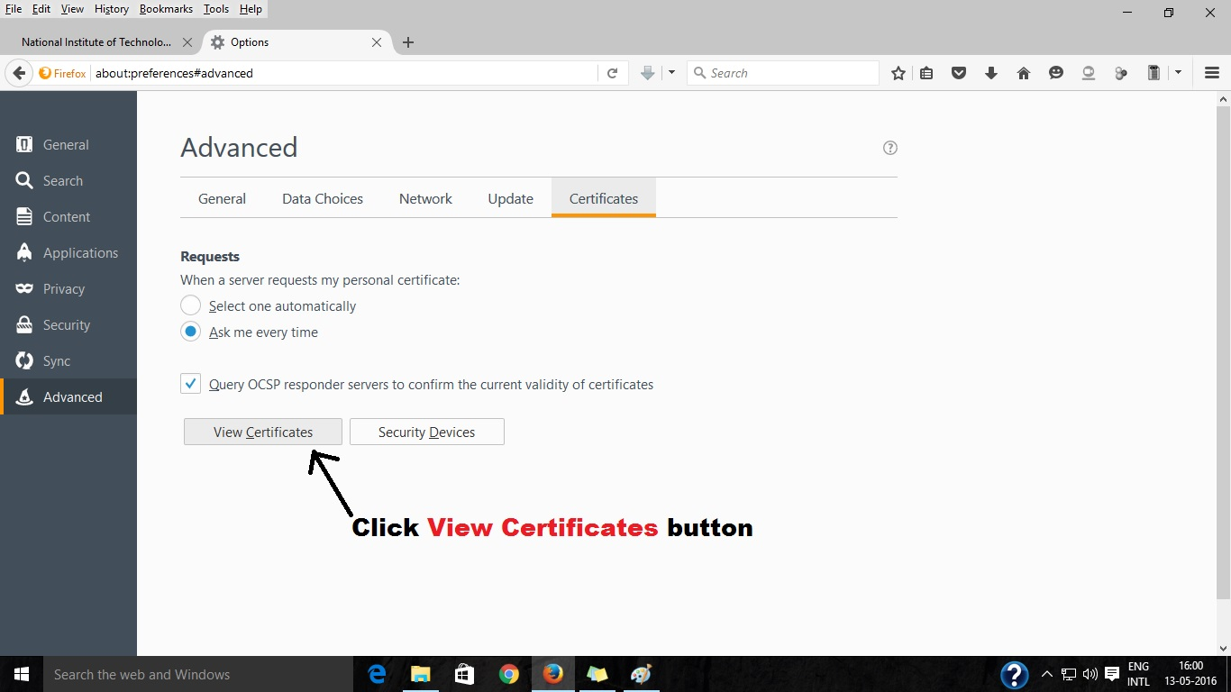

Step 4

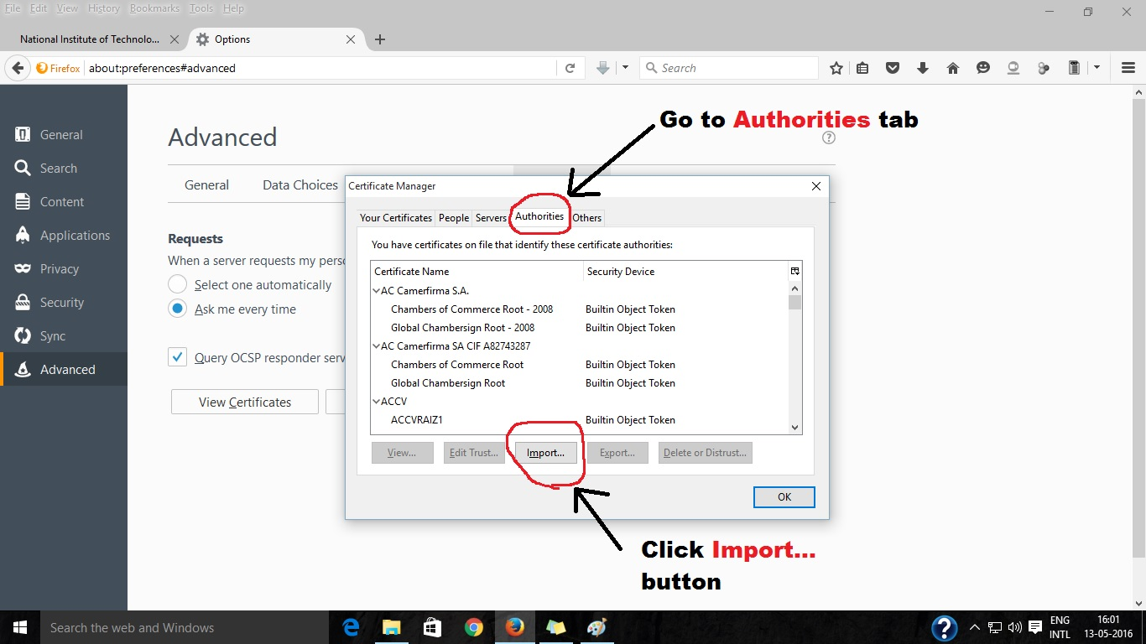

Step 5

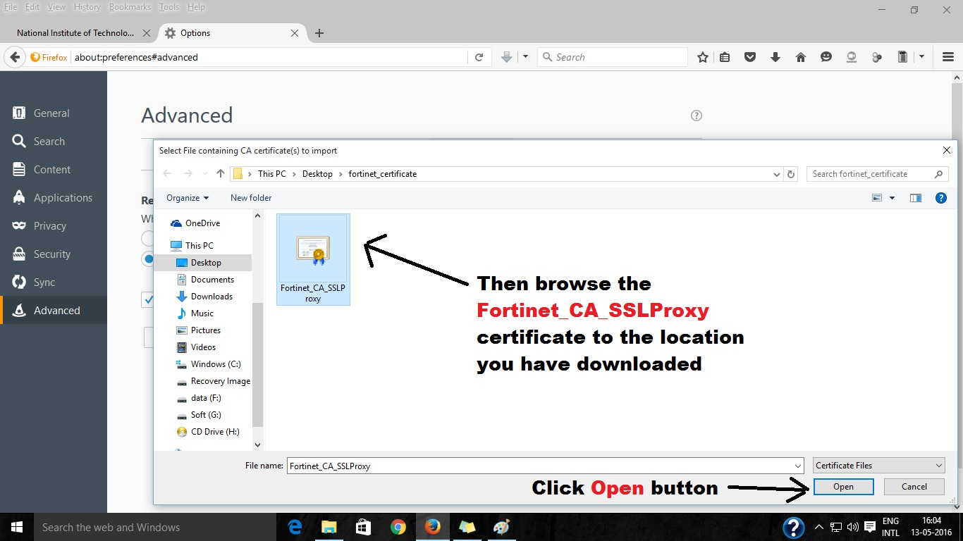

Step 6

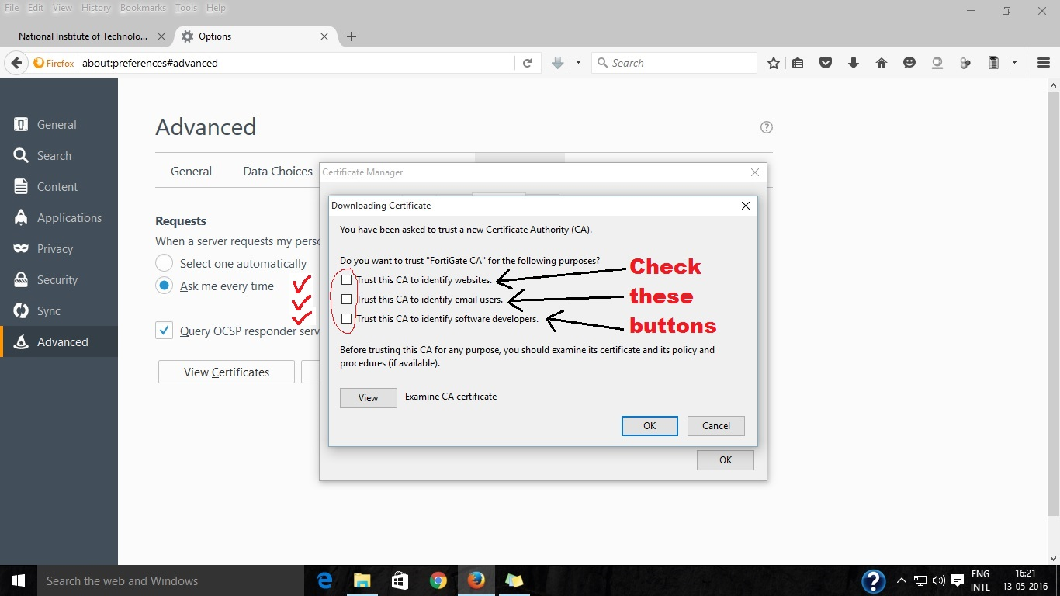

Step 7

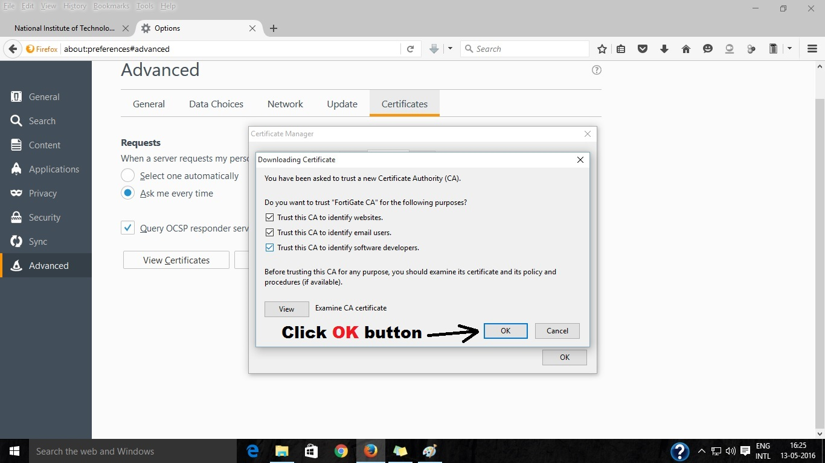

Step 8

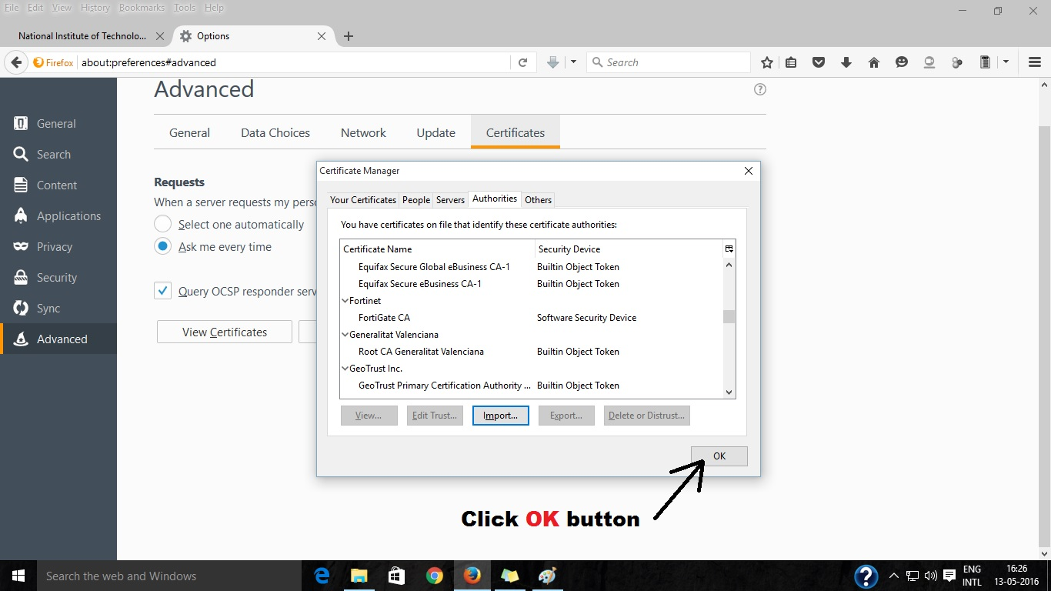

Then restart your Mozilla Firefox browser and start browsing.