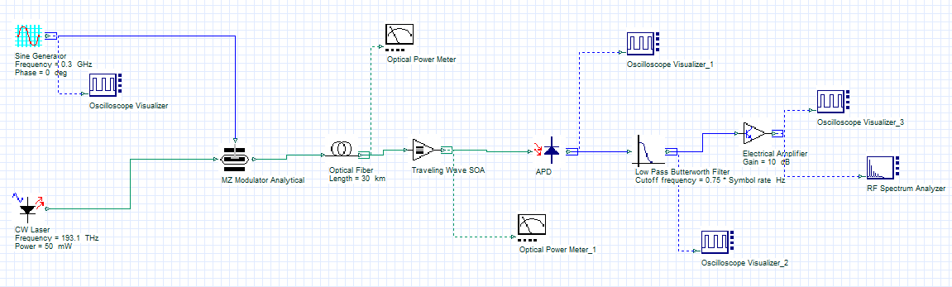
Analog optical link: Layout
Output:
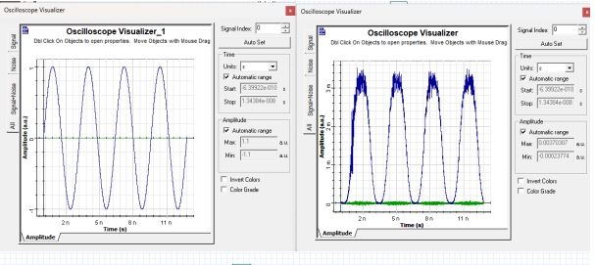
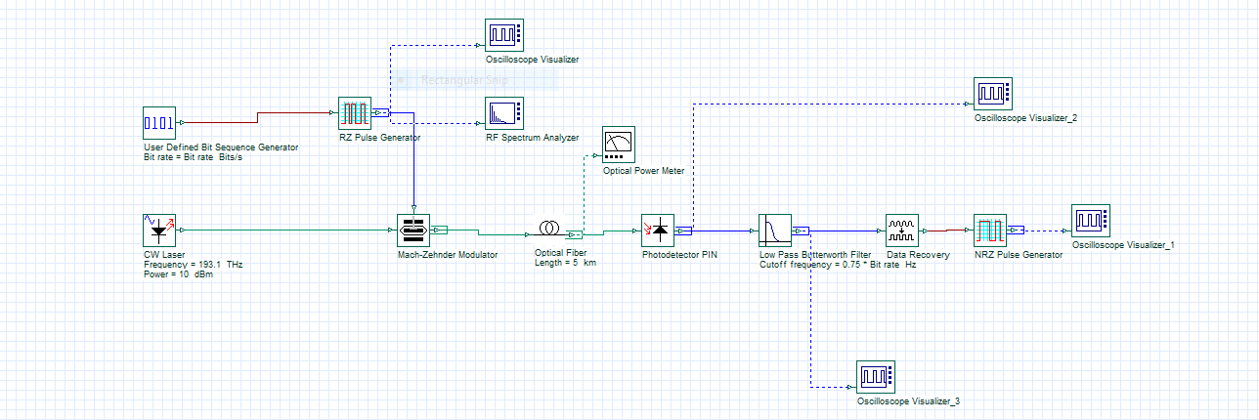
Digital optical link:Layout
Output:
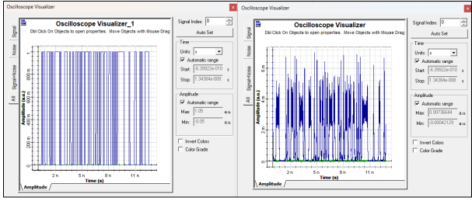
Ex. No: 1 | Roll No : 2020105501 | Date : 02/08/24
ANALOG AND DIGITAL OPTICAL LINK
AIM:
To simulate analog and digital optical link using optisystem software and to analyse the output of the receiver.
SOFTWARE USED:
OPTISYSTEM
COMPONENTS USED:
- Sine Wave Generator
- CW Laser
- Mach-Zender Modulator
- Photo detector PIN
- Low Pass Filter
- Optical power meter and Oscilloscope Visualizer
- Optical fiber
- Bit Sequence Generator
- RZ pulse generator

PROCEDURE:
- Open Optisystem and create a new layout.
- The analog links are constructed as shown in the layout diagram.
- The CW laser is found in the Transmitter Library Optical source.
- Properties can be changed by double clicking the component.
- Sine wave is selected from Transmitter
Library -Pulse Generator →Electrical →Sine Generator.
- Component Library-
- Transmitter library→ Optical Module → MZM Modulator.
- Visualizer library → Oscilloscope Visualizer.
- Filters Library→ Electrical→ Low pass Filter.
- Optical Fiber Library → Optical Fiber.
- Receivers Library → Photodetectors → Photodetector PIN.
- Connect Oscilloscope to the output of Sine Generator and Low Pass Filter.
- To run the simulation, click the button from tool bar or click Ctrl+F5.

TABULATION:
Analog optical link
S.No. | Distance (Km) | Input Power  (dBm) | Output Power  (dBm) | Attenuation  (dB)
1 | 5 | 6 | 6.127 | 0.862
2 | 10 | 6 | 5.051 | 1.938
3 | 15 | 6 | 3.802 | 3.187
4 | 10 | 6 | 1.760 | 5.229
5 | 25 | 6 | 0.79 | 6.199

Digital optical link

S.No. | Distance (Km) | Input Power  (dBm) | Output Power  (dBm) | Attenuation  (dB)
1 | 5 | 4.92 | 3.970 | 0.938
2 | 10 | 4.92 | 3.105 | 1.999
3 | 15 | 4.92 | 2.467 | 2.998
4 | 20 | 4.92 | 1.959 | 3.999
5 | 25 | 4.92 | 1.556 | 4.999

- Project is calculated.
- Click the oscilloscope to see the waveform.
- Input and output spectrums are compared.
- The digital links are constructed as shown in the layout diagram,
- Bit Sequence is selected from Transmitter Library →Bit Sequence Generators →User Defined Bit Sequence Generator

RESULT:
Hence digital and analog optical link is designed and simulated using Optisystem and plotted the output characteristics.

NUMERICAL APETURE MEASUREMENT

$ϴ_{a}\sqrt{r^{2}+h^{2}}$
h

TABULATION:
Plastic Fiber cable |  |  | Glass Fiber Cable
r1(cm) | h1(cm) | sin θ_{a}  r  =  √r² + ℎ² | r1(cm) | h1(cm) | sin θ_{a}  r  =  √r² + ℎ²
0.4 | 0.2 | 0.89 | 0.2 | 0.4 | 0.447
0.6 | 0.4 | 0.83 | 0.4 | 0.7 | 0.496
0.8 | 0.8 | 0.707 | 0.7 | 1 | 0.573
1.5 | 1.1 | 0.806 | 0.8 | 1.4 | 0.496
1.9 | 2 | 0.690 | 1.1 | 2 | 0.4819
Mean |  | 0.785 | Mean |  | 0.4988

Ex. No : 2 | Roll No : 2020105501 | Date : 09/08/24
NUMERICAL APERTURE AND ATTENUATION MEASUREMENT

AIM:
To find the numerical aperture and attenuation coefficient of glass and plastic fiber

COMPONENTS REQUIRED:
- Helium and Neon gas Laser
- Optical Power Meter
- Glass and Plastic Fiber optic cable

FORMULA

$n_{0}=1 \left(for air\right)$
$NA= n_{0}\sin{θ_{a}}$=$\sin{θ_{a}}$
$NA=\frac{r}{\sqrt{r^{2}+h^{2}}}$
Where,
$θ_{a}$ = Maximum acceptance angel in air
r = radius of the circular light spot
h = height of the cone

PROCEDURE:

Numerical Aperture Measurement:

- He-Ne gas laser is switched on using the plastic fiber cable, the laser beam is focused on to the graph sheet
- A circle is drawn on the graph sheet tracing the circular light spot. The radius of the circle is measured
- The numerical aperture is calculated using formula as mention above
- This procedure is repeated for different heights and the mean of the numerical aperture is taken
The same procedure is repeated for glass fiber optic cable.

MODEL CALCULATION :
Plastic fiber cable:
- $\sin{θ_{a}}= \frac{r}{\sqrt{r^{2}+h^{2}}}$ = $\frac{0.4}{\sqrt{{(0.4)}^{2}+{(0.2)}^{2}}}$ = 0.89
- $\sin{θ_{a}}= \frac{r}{\sqrt{r^{2}+h^{2}}}$ = $\frac{0.6}{\sqrt{{(0.6)}^{2}+{(0.4)}^{2}}}$ = 0.832
Glass fiber cable :
- $\sin{θ_{a}}= \frac{r}{\sqrt{r^{2}+h^{2}}}$ = $\frac{0.2}{\sqrt{{(0.2)}^{2}+{(0.4)}^{2}}}$ = 0.447
- $\sin{θ_{a}}= \frac{r}{\sqrt{r^{2}+h^{2}}}$ = $\frac{0.4}{\sqrt{{(0.4)}^{2}+{(0.7)}^{2}}}$ = 0.496

RESULT:

Thus the numerical aperture and attenuation coefficient of both glass and plastic optic fiber are measured
Numerical aperture of glass fiber = 0.4988
Numerical aperture of Plastic fiber = 0.785

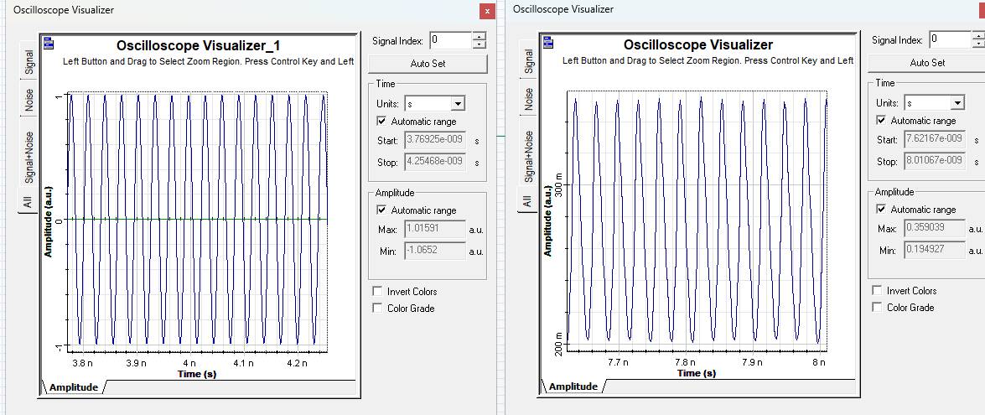
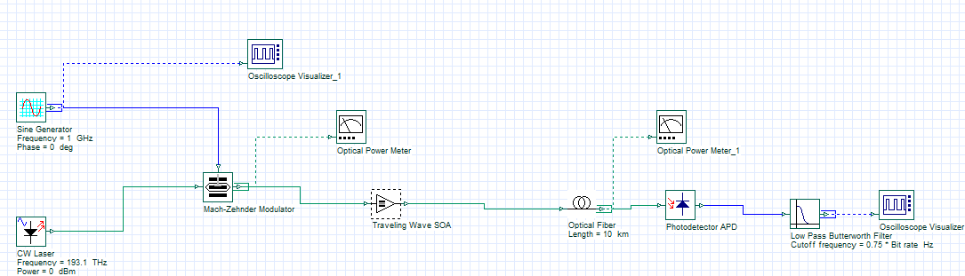
ANALOG OPTICAL LINK WITH PRE AMPLIFIER

ANALOG OPTICAL LINK WITH INLINE AMPLIFIER
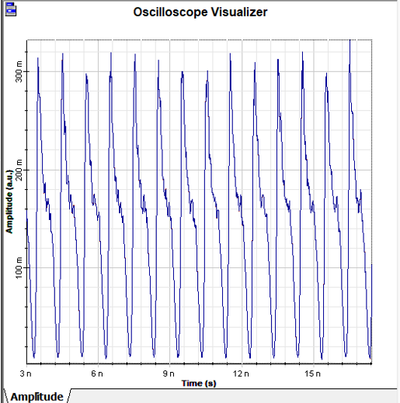
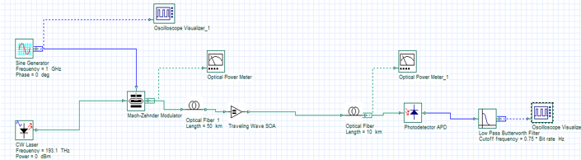
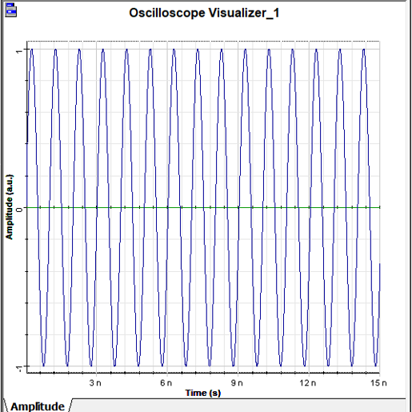

Ex. No : 3 Roll No : 2020105501 Date : 16/08/24
ANALOG AND DIGITAL OPTICAL LINK WITH AMPLIFIER (SOA)
AIM:
To understand the characteristics of travelling wave SOA optical amplifier in an analog and a digital optical link.
SOFTWARE USED:
OPTISYSTEM
COMPONENTS USED:
- Bit Sequence Generator
- CW Laser
- Mach-Zender Modulator
- NRZ pulse generator
- SOA
- Photo detector PIN
- Optical power meter and Oscilloscope Visualizer
- Optical fiber
- Sinewave Generator
- Lowpass filter

PROCEDURE for DIGITAL LINK:
- The components required are taken from Default Component Library.
- The digital links are constructed as shown in the layout diagram.
- The CW laser is found in the Transmitter Library Optical source. Properties can be changed by double clicking the component.
- Bit Sequence is selected from Transmitter Library → Bit Sequence Generators →User Defined Bit Sequence Generator.
- Component Library-
- Transmitter Library → Pulse Generator→ Electrical→ NRZ Pulse Generator.
- Transmitter library→ Optical Module→ MZM Modulator.
- Visualizer library → Oscilloscope Visualizer.
- 4.Filters Library→ Electrical→ Low pass Filter.
- Optical Fiber Library → Optical Fiber.
- Receivers Library→ Photodetectors → Photodetector PIN.
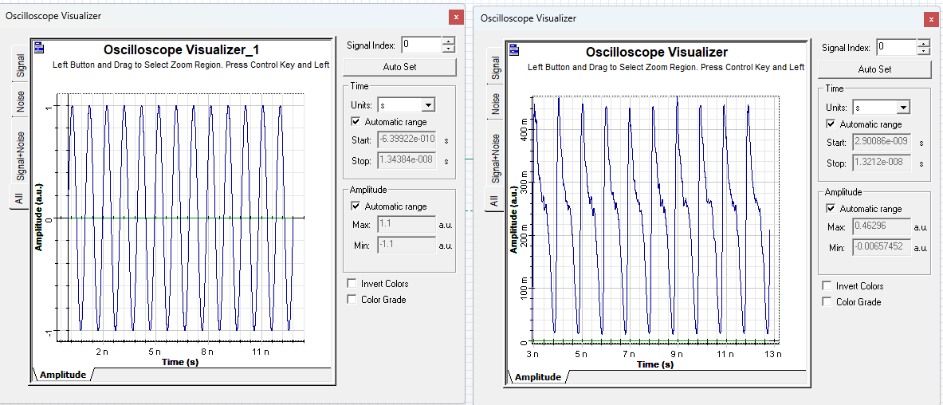
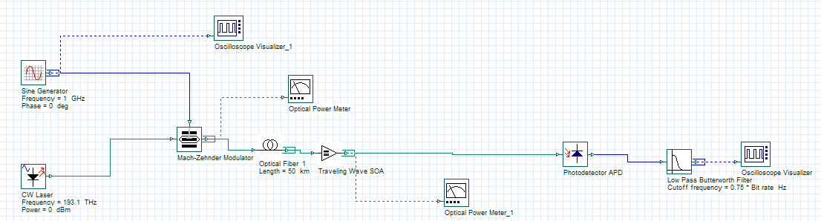
ANALOG OPTICAL LINK WITH INLINE AMPLIFIER

Tabulation:
 | Without amplifier | With post amplifier | With pre amplifier | With inline amplifier
Length  (km) | Output Power (dBm) | Output Power (dBm) | Output Power (dBm) | Output Power (dBm)
5 | -0.010 | 19.065 | 18.983 | 19.983
10 | -1.010 | 18.065 | 17.900 | 19.900
15 | -2.009 | 18.065 | 10.901 | 19.901
20 | -3.010 | 18.065 | 15.842 | 19.842
25 | -4.009 | 17.065 | 14.742 | 19.724

- Receiver Library → Regenerators Data Recovery.
- Amplifiers Library → Optical→ EDFA / SOA.
- The SOA amplifier is placed at the modulated end where we transmit the signal through optical fiber.
- After being amplified, the photo detector PIN detects the output and matches with the input.
- Connect the power meter before and after the amplifier.
- Connect Oscilloscope to the output of NRZ Generator and Data Recovery.
- To run the simulation, click the button from tool bar or click Ctrl+F5.
- Project is calculated.
- Click the oscilloscope to see the waveform.
- Click on the power meter to see the power difference after placing amplifier.
- Vary the length of fiber and tabulate the readings from power meter.
- And again, by varying the LASER power and amplifier gain, the output power is noted with help of power meter.

PROCEDURE for ANALOG LINK:
- The components required are taken from Default Component Library.
- The Analog links are constructed as shown in the layout diagram.
- The CW laser is found in the Transmitter Library Optical source. Properties can be changed by double clicking the component.
- Sine wave is selected from Transmitter Library → Pulse Generator →Electrical - Sine Generator.
- Component Library-
- Transmitter library→ Optical Module→ MZM Modulator.
- Visualizer library → Oscilloscope Visualizer.
- Filters Library→ Electrical→ Low pass Filter.
- Optical Fiber Library → Optical Fiber.
- Receivers Library→ Photodetectors → Photodetector PIN.
- Amplifiers Library → Optical→ EDFA / SOA.
- Visualizer Library→ Optical → Optical Power meter
- The SOA amplifier is placed at the modulated end where we transmit the signal through optical fiber.
- After being amplified, the photo detector PIN detects the output and matches with the input.
- Connect the power meter before and after the amplifier.
- Connect Oscilloscope to the sine generator and LFP.
- To run the simulation, click the button from tool bar or click Ctrl+F5.
- Project is calculated.

- Click the oscilloscope to see the waveform. Click on the power meter to see the power difference after placing amplifier.

- Vary the length of fiber and tabulate the readings from power meter.And again, by varying the LASER power and amplifier gain, the output power is noted with help of power meter.

RESULT:
Thus, the characteristics of SOA optical amplifiers for digital link and analog link with pre-amplifier, inline amplifier, post amplifier have been analyzed for various lengths.
CIRCUIT DIAGRAM:
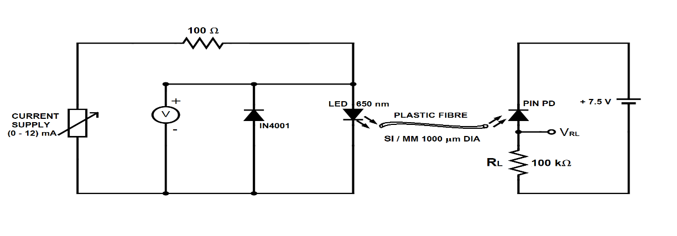
V-I Characteristic of LED :

I_{LED}(mA)

V_{LED}(V)
P-I Characteristic of LED :

P_{o}(μW)

I_{LED}
Responsivity of PIN photodiode:
I_{PD}(μA)

I_{LED}(mA)

DC CHARACTERISTICS OF LED AND PIN PHOTODIODE

Ex. No : 4 | Roll No : 202005501 | Date : 20/08/24
AIM
To study the DC characteristics and to determine the parameters of the given LED and Photodiode
COMPONENTS REQUIRED:
- LED
- PIN Photodiode
- PN junction
- Plastic Fiber cable
EQUIPMENTS REQUIRED:
- Current Supply
- Resistor
- Multimeter
FORMULA:
Forward Resistance of LED
R_{f =ΔVLED/ ΔILED}
Efficiency of LED
η= η_{LED}= P_{o}/( _{ΔVLED} * _{ΔILED})
Responsivity of PIN Photodiode
R_{PN} = I_{PD}/P_{IN}
I_{PD} = Photo Diode Current
P_{IN} = Optical Power incident on Pin Photodiode
Dark Current
I_{D}= V_{RL}/R_{L} , when P_{in} = 0 mW

TABULATION:
R_{s}= R_{L}= 220 kΩ
I_{LED}(mA) | V_{LED}(V) | P_{o}(dBm) | P_{o}(μW) | V_{RL}(mV) | I_{pd}(μA)
0.1 | 0.247 | -46.3 | 23.4 | 0.01 | 0.0454
0.2 | 0.256 | -45.3 | 29.5 | 0.02 | 0.0909
0.3 | 1.181 | -44.2 | 38 | 0.03 | 0.136
1.0 | 1.216 | -43.3 | 46.7 | 0.04 | 0.181
2.0 | 1.242 | -39.9 | 102 | 0.104 | 0.472
3.0 | 1.259 | -37-7 | 169 | 0.168 | 0.76
4.0 | 1.271 | -36.2 | 239 | 0.236 | 1.072
5.0 | 1.282 | -34.9 | 323 | 0.308 | 1.4
6.0 | 1.291 | -34.1 | 389 | 0.394 | 1.7
7 | 1.298 | -33.3 | 467 | 0.462 | 2.1
8 | 1.305 | -32.6 | 549.5 | 0.527 | 2.3
9 | 1.313 | -32 | 630 | 0.608 | 2.7
10 | 1.318 | -31 | 794 | 0.672 | 3.05

PROCEDURE:
- The source side of the setup is calculated initially.
- It consists of an LED source with a diode connected in parallel and a 100 Ω resistance is series connected
- By varying the current source slowly the corresponding voltage is calculated across the diode.
- The values are tabulated and the P-I, V-I characteristics is plotted.
- Similarly, the setup is made for the photodiode detector.
- The values are tabulated and the respective values are plotted.

RESULT:
The DC characteristics of LED and PIN diode is constructed and Verified

LAYOUT:

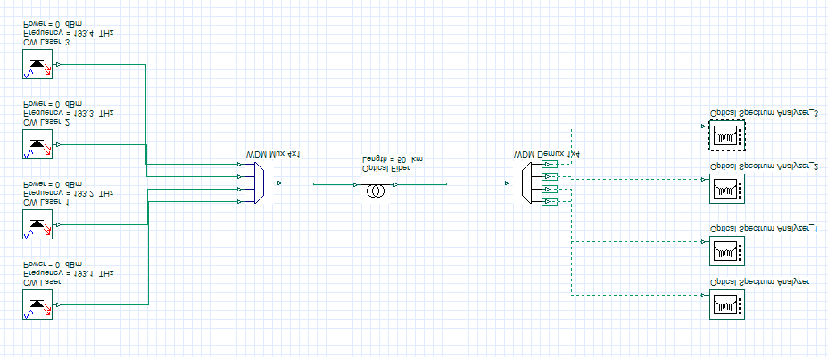
WITHOUT ADD & DROP:

WITH ADD & DROP:
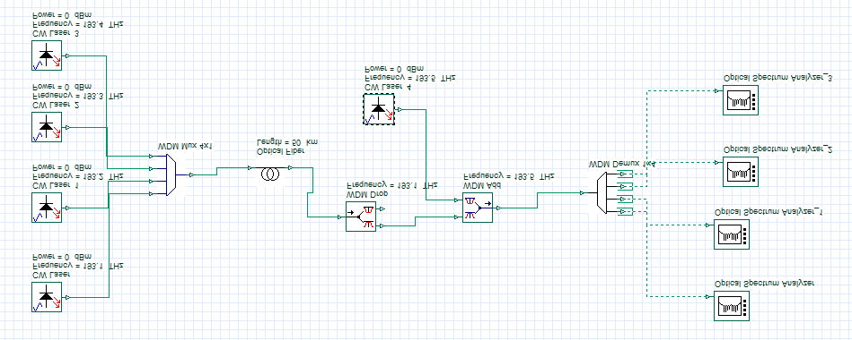

Ex. No : 5 | Roll No : 2020105501 | Date : 30/08/24
SIMULATION OF WDM MULTIPLEXER AND DEMULTIPLEXER
AIM:
To study the characteristics of WDM multiplexer and Demultiplexer in case of 4 users in transmitting and receiving the signals.
SOFTWARE USED:
OPTISYSTEM
COMPONENTS USED:
- CW Laser- 4
- WDM multiplexer
- WDM demultiplexer
- Oscilloscope Visualizer
- Optical fiber

PROCEDURE:
- Open Optisystem and create a new layout. Components are placed in the main layout and links are made as shown in layout diagram.
- Component Library:
  - Visualizer library- Optical- Optical Spectrum Analyzer.

  - WDM Multiplexers Library- Multiplexers- WDM Mux 4x1.

  - WDM Multiplexers Library- Demultiplexers -WDM Demux 1x4.
- Four Laser sources are selected from Transmitter Library→ Optical Sources →CW Laser.
- The four Laser sources are
CW Laser (1) 193.1 THz
CW Laser (2) 193.2 THZ
CW Laser(3) 193.3 THz
CW Laser (4) 193.4 THz

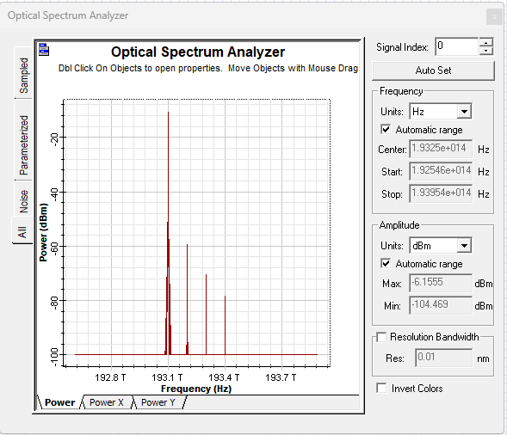
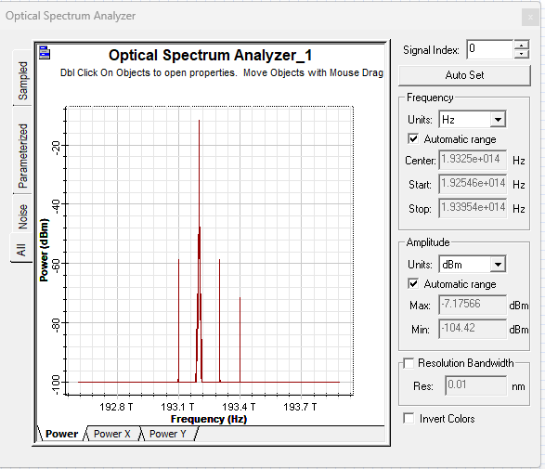
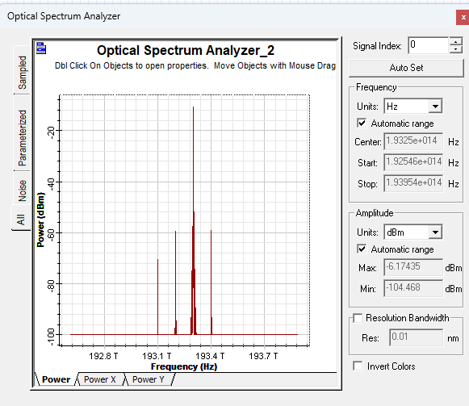
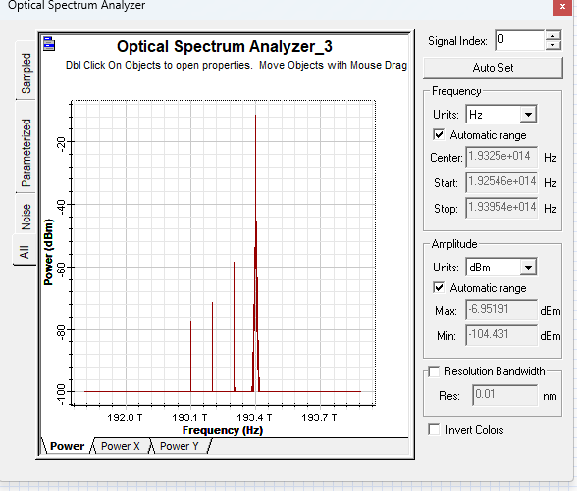
- The sources are connected to 4x1 WDM Mux.
- The output of Multiplexer is connected to 1x4 Demultiplexer through fiber.
- Four Spectrum Analyzers are connected to the output of Demux.

INFERENCE:
- As length of optical fiber increases, attenuation, dispersion and noise cause signal degradation. So BER increases and SNR decreases.
- Each Component add a delay in signal transmission.

RESULT:
Thus, the characteristics of WDM Multiplexer and Demultiplexer were studied using Opti system for a 4-user scenario.
OUTPUT:
1.GRID PLOT:
2.POLAR PLOT:

Ex. No : 6 | Roll No : 2020105501 | Date : 13/09/24
DESIGN AND SIMULATION OF A CIRCULAR LOOP ANTENNA
AIM:
To design and simulate a circular loop antenna and visualize the impact of design parameters using CST MWS.
SOFTWARE REQUIRED:
CST MWS
DESIGN PROCEDURE:
- To design the circular loop antenna radius of the loop is important parameter. Radius of the circular loop antenna can be calculated using below formulae.
- Loop antenna frequency f.
- c=f*λ
- λ=c/f
- λ-length of total loop.
- Total length of loop=circumference of circle
- λ=2*pi*r
- r=λ÷(2*pi)

PERFORMANCE PARAMETERS
- S-parameters.
- Surface current in 2D/3D results.
- Directivity.
- Far-field radiation pattern (E-plane and H-plane).

PROCEDURE:
- Start the CST application and create project.
- Choose MF & RF & Optical and choose antennas.
- Select workflow and domain needed for measurement.
- Select the units of measurement.

3.S-PARAMETER [dB]:
4.DIRECTIVITY:
-Directivity Abs [Phi=90*]:
-Directivity Abs [Theta=90*]:

- Select the frequency range and monitors far field at resonant frequency or any frequency need to monitor the operation.
- Click Finish after creating a template.
- Select Modelling-shapes click create cylinder then press Esc from the keyboard.
- Enter the inner and outer radius depending on the radius what we found.
- Then preview the structure.
- By selecting the brick shape we can cut small amount of loop.
- Pick the face center of the loop by clicking pick points a two cutting edges of circular loop is connected.
- Then the antenna is ready for simulate.
13. Click simulation->Setup solver and observe the results.

5.GAIN RESULTS:
-Gain Abs [Phi=90*]:
-Gain Abs [Theta=90*]:
6.FAR-FIELD RADIATION PATTERN:
-Far-field E-Field Abs [Phi=90*]:

-Far-field E-field Abs [Theta=90*]:

TABULATION:
S.No | Frequency (GHz)  f | Radius of the loop  (mm) | Gain(dB) | Bandwidth (Hz) | Directivity  (dB)
1 | 3.1 | 16.92 | 3.60 | 750 | 3.62

CALCULATION:
f= 3.1GHz
wavelength= c/f= 96.77 mm
length of loop= 2*pi*r= 96.77 mm
r= 16.92 mm

RESULT:
Thus the circular loop antenna was designed and simulated successfully. The impact of design parameters also visualized
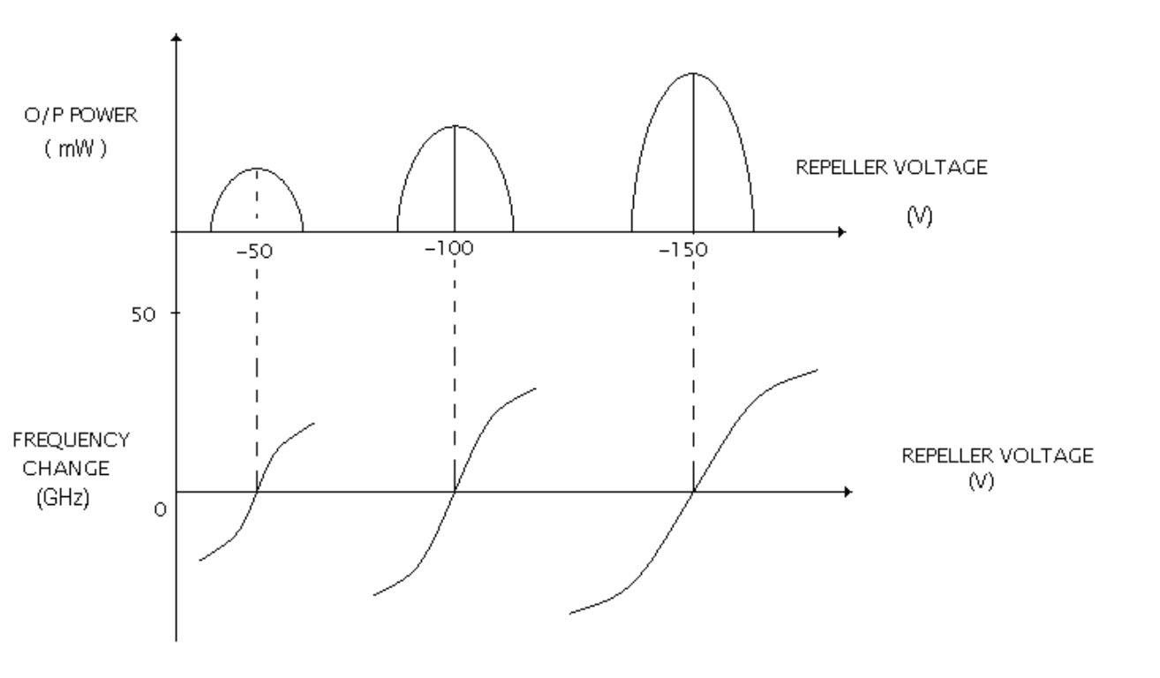
BLOCK DIAGRAM AND MODEL GRAPH:
Mode graph:
Reflex Klystron Power Supply
Reflex Klystron Source
Frequency Meter
Attenuator
Slotted Line Section

Detector
CRO
Isolator
Ex. No : 7 | Roll No : 2021105302 | Date : 13/09/24
DETERMINATION OF MODE CHARACTERISTICS OF REFLEX KLYSTRON OSCILLATOR
AIM: -
To study the mode Characteristics of Reflex Klystron
COMPONENTS REQUIRED: -
- Klystron tube
- Klystron power supply
- Klystron oscillator
- Isolator, Frequency Meter
- Variable Attenuator

FORMULA:
Electronic tuning range= (f1-f1) MHz
Electronic tuning sensitivity: (f2-f1)/(V2-V1) MHz/V
THEORY: -
The reflex Klystron makes use of velocity modulation to transform a continuous electron beam in to microwave power. Electron Beam emitted is accelerated towards the anode cavity. After passing the gap in the cavity electron travel towards the repeller electrode which is at a high negative potential (Vr ). The electron beam never reach the repeller because of the negative field and returned back towards the gap. The accelerated electrons leave the resonator at an increased velocity and the retarded electrons leave at the reduced velocity. the electrons leaving the resonator will need different time to return, due to change in velocities. as a result, returning electrons group together in bunches. As the electron bunches pass through resonator, they interact with voltage at resonator grids. If the bunches pass the grid at such time that the electrons are slowed down by the voltage, energy will be delivered to the resonator; and klystron will oscillate. The dimension of resonant cavity primarily determines the frequency. A small frequency change can be obtained by adjusting the reflector voltage. This is called Electronic Tuning Range (ETR)

TABULATION
 | REPELLER VOLTAGE (V) | POWER(W) | FREQUENCY (GHz)
MODE 1 | -10  -46  -50 | 0.02  0.04  0.05 | 8.45  8.387  8.41
MODE 2 | -82  -96  -129 | 0.05  0.075  0.09 | 8.4  8.55  8.45
MODE 3 | -165  -190  -267 | 0.11  0.12  0.14 | 8.5  8.4  8.45

PROCEDURE:
Initial Settings:
- Ensure that the Beam voltage is minimum and the Repeller voltage is maximum before switching ON the power supply.
- Amplitude of AM modulation should also be set at minimum condition.
- After switching on the power supply, set the repeller voltage to 260V and beam voltage to about 70V.
- Set the modulation to AM
- Also set the amplitude of the AM knob to maximum position.
- Release the attenuator knob such that it is at minimum attenuation position.
- Tune the knob in the slotted line section and adjust the same to get maximum square wave output.
Measurement of Reflex Klystron Mode Characteristics
- Now vary the repeller voltage and note down the output power in the CRO and the corresponding dip frequency.
- Continue until you have noted three distinct Modes.
- Plot the graph
(i) Repeller voltage versus output voltage.
(ii) Repeller voltage versus Dip frequency

RESULT:
Thus, the mode characteristics of reflex klystron oscillator are studied

BLOCK DIAGRAM AND MODEL GRAPHS
Gunn Diode Power Supply
Gunn Source
Attenuator
Isolator
Frequency Meter
Slotted Line Section
Detector
PIN Modulator
CRO

Model Graph – VI Characteristics of Gunn Diode
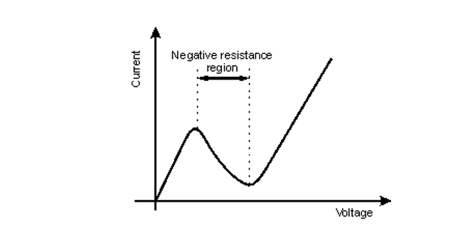

Power frequency characteristics of Gunn diode
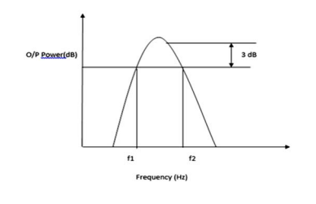

Ex. No : 8 | Roll No : 2021105302 | Date : 20/09/24
GUNN DIODE CHARACTERISTICS
Aim:
To study the VI characteristics of Gunn Oscillator and to determine the frequency response of Gunn Oscillator
Components required:
- GUNN Oscillator
- GUNN power supply
- CRO
- Frequency Meter
- Attenuator
- Detector
- Pin Modulator
Formula used:
Bandwidth = (f2-f1) Hz
THEORY
Gunn diodes, named after physicist J.B. Gunn who discovered the Gunn effect, are semiconductor devices that exhibit unique characteristics, primarily utilized in microwave and millimeter-wave electronic devices. The fundamental property of a Gunn diode is its negative differential resistance (NDR) region within the current - voltage (I-V) characteristic curve. In this region, a decrease in voltage corresponds to an increase in current, contrary to typical Ohm's law behavior. This distinctive feature is essential for microwave oscillators, amplifiers, and frequency multipliers. The NDR region arises due to the interplay between electron drift and negative differential mobility, a quantum mechanical effect observed in certain semiconductor materials like gallium arsenide (GaAs).
Gunn diode operation involves exploiting this NDR effect to generate microwave oscillations. When a sufficiently high voltage is applied across the diode, the electrons in the device exhibit a velocity-field characteristic that leads to the formation of electric domain structures. These domains move through the diode and produce microwave oscillations at the desired frequency. Understanding the voltage- current characteristics and the specific voltage ranges where NDR occurs is crucial

TABULATION
VI Characteristics
Gunn Bias Voltage (V) | Current (mA)
0.25 | 0.033
0.34 | 0.045
0.87 | 0.109
1.22 | 0.149
1.44 | 0.169
1.65 | 0.189
2.32 | 0.242
2.82 | 0.273
3.52 | 0.296
4.17 | 0.300
4.64 | 0.248
5.5 | 0.224
6.8 | 0.234

Power Frequency Tabulation:

Power(mW) | Frequency(Hz)
5 | 11.43
10 | 11.46
14 | 11.515
18 | 11.53
8 | 11.65

in designing and implementing Gunn diode-based microwave devices. Moreover, controlling the dimensions and material properties of the diode is vital to tailor its characteristics and optimize its performance for various applications in modern communication and radar systems.

Procedure:
- To observe the V-I characteristics of the Gunn diode the voltage from the GUNN power supply is increased in small steps.
- It is observed that the current increases to an extent and starts dropping after a point. The negative resistance region is noted down.
- The bias currents vs. bias voltage values are recorded. Graph is drawn for V-I characteristics.
- To find the frequency response, the voltage is set in the negative resistance region.
- The micrometer reading is adjusted to give different maximum power output.
- The frequency dip for the respective power is noted using the frequency meter. The readings are plotted.
- Plot the output power vs. frequency to get frequency response of Gunn Oscillator.

Result:
Thus, the VI characteristics of Gunn Oscillator is studied and the frequency response of the Gunn Oscillator is determined.
BLOCK DIAGRAM AND MODEL GRAPH
Reflex Klystron Power Supply

Reflex Klystron Source

Frequency Meter

Attenuator

Slotted Line Section

Detector

CRO

Isolator

ΩOBSERVATION AND CALCULATION:
x1 = 10.1 cm
x2 = 12.7 cm
x3 = 15.1
Vmax= (1.4 * 20m)^0.5 = 0.167
Vmin = (0*20m)^0.5 = 0
VSWR = V_{max}/V_{min} = ∞

Vmax = (0.4)*0.5
Vmin = (0.34)*0.5
λg = 2 (x₂ – x₁) = 2*2.6 = 5.2 cm
βΔl= 2π(x3-x2) / λg = 2.899
Z0 = 50Ω
Zl/Z0 = (1 – j1.130)/(1.08 + j0.050)

Ex. No : 9 | Roll No : 2021105302 | Date : 20/09/24
VSWR AND IMPEDANCE MEASUREMENT AND IMPEDANCE MATCHING
Aim:
To measure the unknown load impedance & VSWR for a given load.
Components and Equipments required:
- Gunn power supply
- Gunn oscillator
- Pin modulator
- Isolator
- Frequency meter
- Slotted section with detector and tuning pole
- CRO / Power meter
- Unknown load
FORMULA:
Distance between successive minima = x₂ – x₁ = λg/2 cm
VSWR = V_{max}/V_{min}
Unknown load impedance (Z_{L}) ={Zo[1 – j(VSWR + tan(βΔl))] / VSWR - j tan(βΔl) } ohms
βΔl= [ 2π(x3-x2) / λg ] radians
PROCEDURE:
- The microwave bench is setup as shown in the block diagram.
- The short plate is connected to the end port of the slotted carriage. The square wave output is observed in the CRO.
- The slotted carriage is move towards the source. The first minimum (the output power is zero) is observed in CRO. It is recorded as x1. And the

slotted carriage is moved further to observe the successive minima (the output power is zero). And it is noted as x2.
- The short plate is replaced by the given unknown load. The slotted carriage is move towards the source from the x2 position. The next successive minimum is observed and it is recorded as x3.
- The voltage maximum and minimum voltage is measured by moving the slotted carriage.
- The VSWR value is calculated.
- Substitute the recorded values in the equation given and the calculation are done to find the unknown impedance.
- The impedance is calculated and is verified theoretically using smith chart.

RESULT
Thus the impedance of the unknown load was found

BLOCK DIAGRAM:

Reflex Klystron Power Supply
Reflex Klystron Source
Frequency Meter
Attenuator
Slotted Line Section
Isolator
Detector
CRO
Transmitting Horn
Receiving Horn

Ex. No : 10 | Roll No : 2021105302 | Date : 27/09/24
RADIATION PATTERN MEASUREMENT OF AN ANTENNA – HORN ANTENNA
AIM:
To obtain the radiation pattern of Horn Antenna and to perform beam width measurements in H plane and E plane.

COMPONENTS AND EQUIPMENT REQUIRED:
1. Gunn Oscillator/Reflex Klystron
2. Gunn Power Supply
3. CRO
4. Frequency Meter
5. Attenuator / Isolator
6. Detector
7. Horn Antenna

FORMULA USED:
R=2D²/λ
R- far field distance between two antennas, m
D- largest aperture of horn antenna, m
λ - Operating wavelength, m

TABULATION
E-PLANE

Input Power = 60 mw
Frequency = 9.185 GHz

ANGLE (Degree) | RIGHT VOLTAGE POWER (mW) | NORMALIZED VOLTAGE POWER (mW) 10log(P_{j}/P_{i}) | LEFT VOLTAGE POWER (mW) | NORMALIZED VOLTAGE POWER (mW) 10log(P_{j}/P_{i})
3 | 2.5 | -13.8 | 2.5 | -13.8
6 | 2 | -14.77 | 2 | -14.77
9 | 0.5 | -20.79 | 0.5 | -20.79
12 | 0 | -∞ | 0 | -∞

$$R=\frac{2D^{2}}{λ}$$
$$R=\frac{2(10)}{32}$$
$$R=62.5 cm$$

PROCEDURE
1. Connections are made as per the block diagram.
2. Receiver antenna is placed in far field of transmitter horn antenna.
3. Output power is measured in voltage H-plane by placing the receiver in line of sight.
4. Receiver is then rotated in left and right directions with respect to the line of sight in step 2.
5. E to H convertor is connected in the transmitter side. The same procedure is repeated for the E plane.
6. The radiation pattern is recorded and plotted in a polar chart.
7. Calculate the Half power beam width (HPBW) from the plot

GAIN COMPUTATION
- Mount the horn antenna after the slotted line section.
- Place the receiving antenna at different distances from the receiving antenna (S)
- Measure the output power at every distance
- Calculate the gain of the antenna using the formula
- Plot the graph of Output Power vs. Distance.

RESULT:
Thus, the radiation characteristics of horn antenna is studied.
DIRECTIONAL COUPLER:

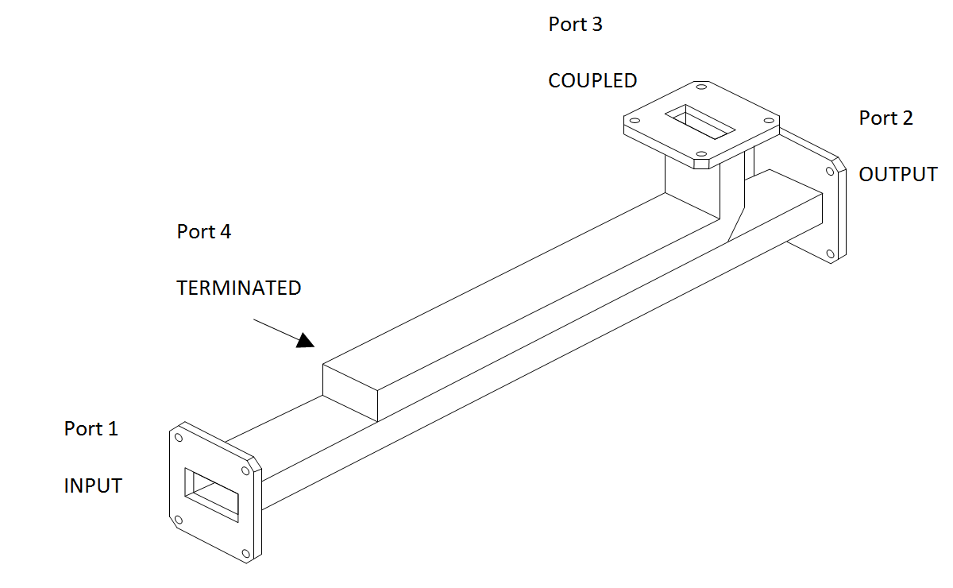
E PLANE AND H PLANE TEE:
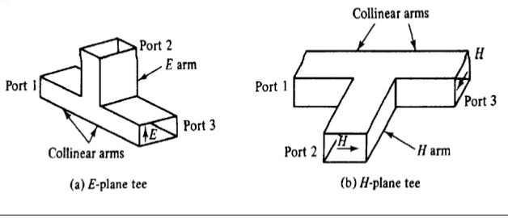

BLOCK DIAGRAM:
Reflex Klystron Power Supply
Reflex Klystron Source
Frequency Meter
Attenuator
Slotted Line Section
Detector
CRO
Isolator
E-Tee/H-Tee/Magic Tee

Ex. No : 11 | Roll No : 2021105302 | Date : 4/10/24
CHARACTERIZATION OF DIRECTIONAL COUPLER AND MULTIPORT JUNCTIONS

AIM
To study the function of multi hole directional coupler by measuring the following parameters.
- Coupling factor
- Directivity

APPARATUS
- Gunn power supply,
- Gunn oscillator,
- Isolator,
- Frequency meter,
- PIN modulator,
- Directional coupler,
- Tee junction,
- Detector,
- CRO

FORMULA
- Coupling factor: 10log(P_{in}/P_{max})dB
- Directivity: 10 log (P_{forward}/P_{reverse})

DESCRIPTION

DIRECTIONAL COUPLER:
A directional coupler is a 4-port device that is used to sample a small amount of input signal power for measurement purposes. As seen in the diagram below, Port 1 is the input port, port 2 is the output port, port 3 is the coupled port and port 4 is the isolated/terminated port. Their basic function is to sample RF signals at a predetermined degree of coupling, with high isolation between the signal ports and the sampled ports — which supports analysis, measurement and processing for many applications.

Advantages:
- Performance can be optimized for the forward path
- High directivity and isolation

TABULATION
E – Plane TEE:
InputPort(P_{i}) | OutputPort(P_{ij}) | Power at Output(W)
Port 1 | Port 2 | 0.2
Port 1 | Port 3 | 0.12
Port 2 | Port 1 | 0.22
Port 2 | Port 3 | 0.12
Port 3 | Port 1 | 0.14
Port 3 | Port 2 | 0.15
H – Plane TEE:
InputPort(P_{i}) | OutputPort(P_{ij}) | Power at Output(W)
Port 1 | Port 2 | 0.16
Port 1 | Port 3 | 0.15
Port 2 | Port 1 | 0.2
Port 2 | Port 3 | 0.14
Port 3 | Port 1 | 0.15
Port 3 | Port 2 | 0.14

- The directivity of a coupler is strongly affected by the impedance match provided by the termination at the isolated port. Furnishing that termination internally ensures high performance
- In waveguide systems, as in the electric circuits, it is often desirable to be able to split the circuit power into two or more fractions. In a waveguide system, an element called a junction is used for power division.
In a low frequency electrical network, it is possible to combine circuit elements in series or in parallel, thereby dividing the source power among several circuit components. In microwave circuits, a waveguide with three independent ports is called a TEE junction. The output of E-Plane Tee is 180° out of phase where the output of H-plane Tee is in phase.

E-Plane

For a linearly-polarized antenna, this is the plane containing the electric field vector (sometimes called the E aperture) and the direction of maximum radiation. The electric field or "E" plane determines the polarization or orientation of the radio wave. For a vertically polarized antenna, the E-plane usually coincides with the vertical/elevation plane. For a horizontally polarized antenna, the E-Plane usually coincides with the horizontal/azimuth plane. E- plane and H-plane should be 90 degrees apart.

H-plane

In he case of the same linearly polarized antenna, this is the plane containing the magnetic field vector (sometimes called the H aperture) and the direction of maximum radiation. The magnetizing field or "H" plane lies at a right angle to the "E" plane. For a vertically polarized antenna, the H-plane usually coincides with the horizontal/azimuth plane. For a horizontally polarized antenna, the H-plane usually coincides with the vertical/elevation plane.
PROCEDURE:
- Make connections as per circuit diagram.
- Connect the directional coupler and note down the output power in both forward and reveresedirections
- Connect E plane TEE guide and match the load in the side and calculate output power in the other port. Similarly do for E plane.
- DIRECTIONAL COUPLER
InputPort | Output Port | Output Power (W)
1 | 2 | 0.14
1 | 4 | 0.02
2 | 1 | 0.04
2 | 4 | 0

RESULT:
The directional coupler and tee junctions are studied and their S matrix is computed.

LPDA
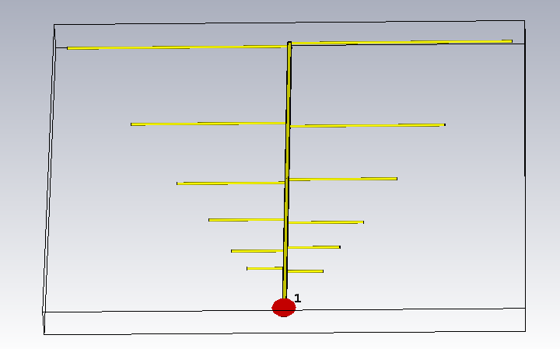
OUTPUT:
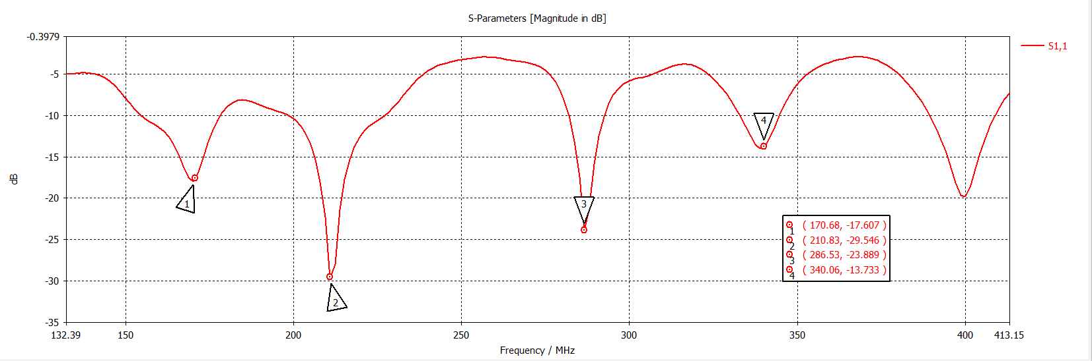
1.S-PARAMETERS:
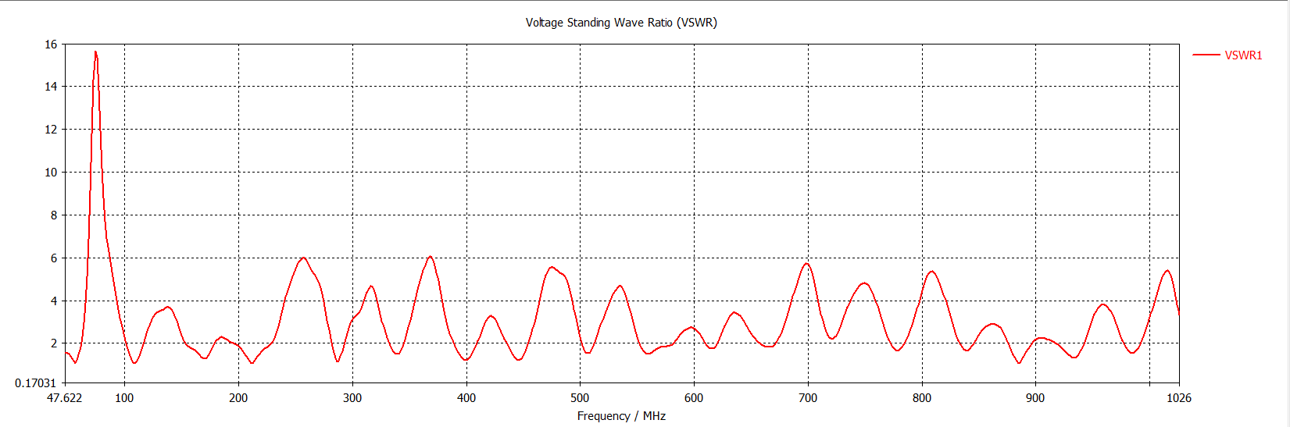
2.VSWR:

Ex. No : 12 | Roll No : 2021105302 | Date : 04/10/24
LPDA DESIGN USING CST MWS
AIM:
To design a log periodic dipole antenna and to visualize the impact of its design parameters using CST MWS.
SOFTWARE REQUIRED:
CST MWS
DESIGN PARAMETERS:
- Low cutoff frequency.
- Upper cutoff frequency.
- Spacing between the elements.
- The factor τ.

PERFORMANCE PARAMETERS
- S-parameters.
- VSWR.
- Far-field radiation pattern (E-plane and H-plane).
PROCEDURE:
- Start the CST application and create project.
- Choose MF & RF & Optical and choose antennas.
- Select workflow and domain needed for measurement.
- Select the units of measurement.
- Select the frequency range and monitors far field at resonant frequency or any frequency need to monitor the operation
- Click Finish after creating a template.
- Select Modelling- shapes click create brick then press Esc from the keyboard.
- Create ground plane.
- Create substrate.
- Create patch and an empty space.
- Cut away the empty space.
- Create empty space and feed line.

FAR-FIELD RADIATION:
I.First dip point(f1)

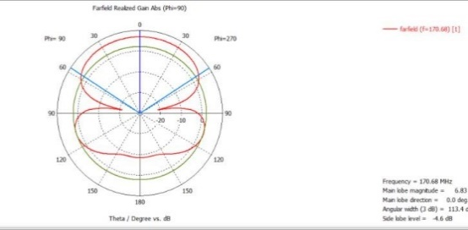
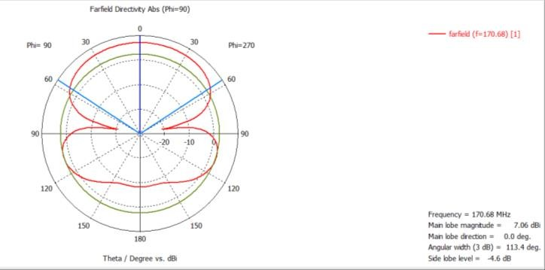
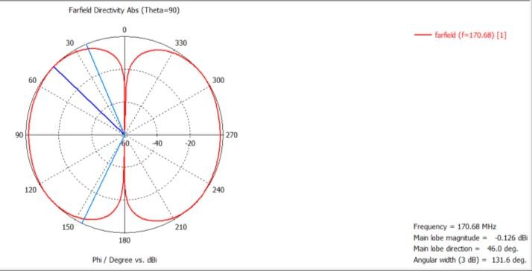
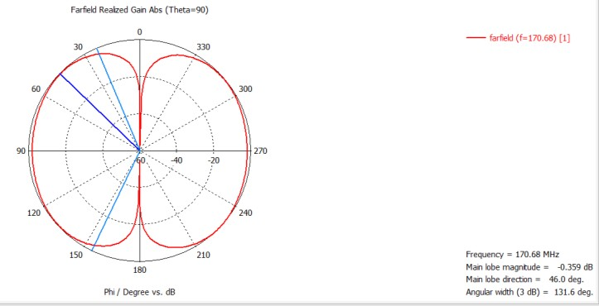
a) Directivity b) Gain

II. Second dip point(f2)
b) Gain
a)Directivity
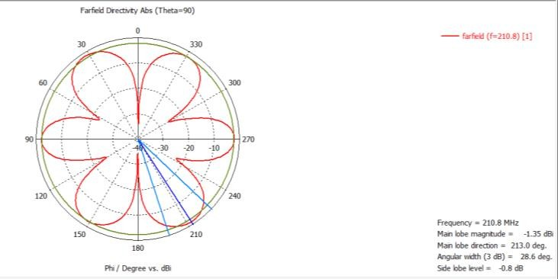 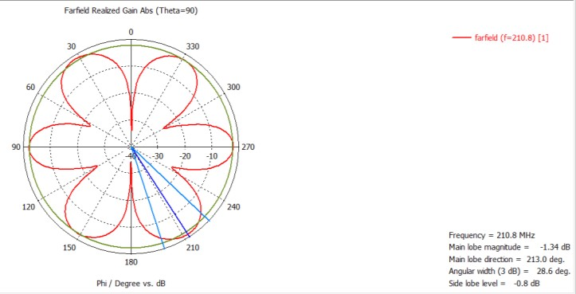
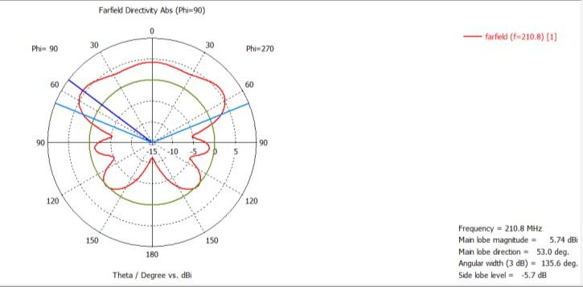
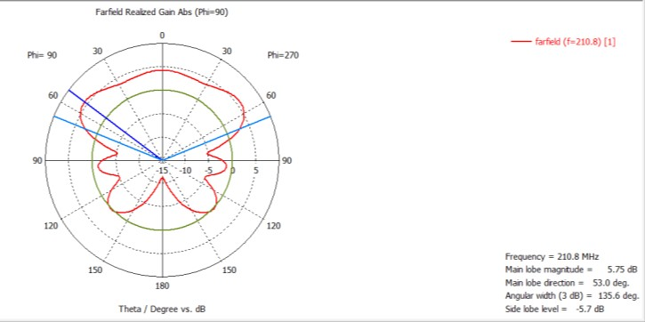

- The patch and feed line into one object
- Press to patch then add then feedline then press Enter.
- Click Simulation →waveguide port
- Provide the necessary values for the units in waveguide port.
- Then the antenna is ready for simulation.
- Click simulation->Setup solver and observe the results.

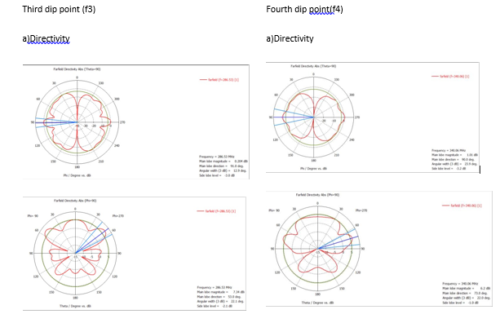
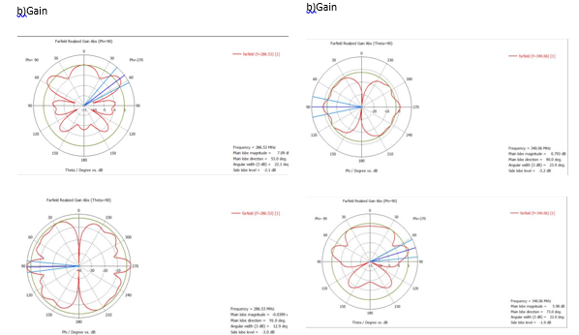

RESULT:
Thus the LPDA antenna was designed and simulated successfully. The impact of design parameters also visualized.
LAYOUT:
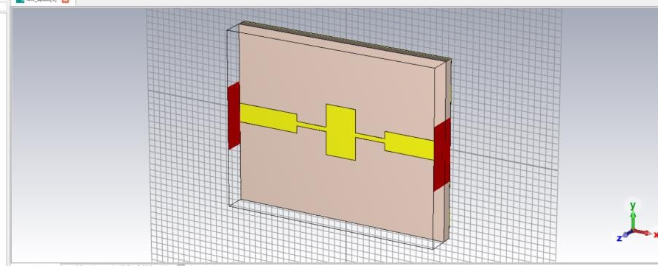

PARAMETERS:
Cut off frequency = 3Ghz
Passband ripple=0.1dB
Load impedance, Z0=50 ohm

Ex. No : 13 | Roll No : 2021105052 | Date : 04/10/24
MICROSTRIP FILTER-STEPPED IMPEDANCE LOW PASS FILTER DESIGN USING CST MWS
AIM:
To design a Microstrip filter -Stepped Impedance Low Pass Filter and visualize the impact of design parameters using CST MWS.
SOFTWARE REQUIRED:
CST MWS
DESIGN PARAMETERS:
- Cutoff frequency.
- Passband Ripple.
- Source/load impedance.
PERFORMANCE PARAMETERS
S-parameters.
PROCEDURE:
1. Start the CST application and create project.
2. Choose MF & RF & Optical and choose antennas.
3. Select workflow and domain needed for measurement.
4. Select the units of measurement.
5. Select the frequency range and monitors far field at resonant frequency or any frequency need to monitor the operation
6. Click Finish after creating a template.
7. Select impedance->Thin microstrip.
8. Select Modelling->shapes click create brick then press Esc from the keyboard.
9. Similarly, construct the bricks needed and form a filter.

OUTPUT:
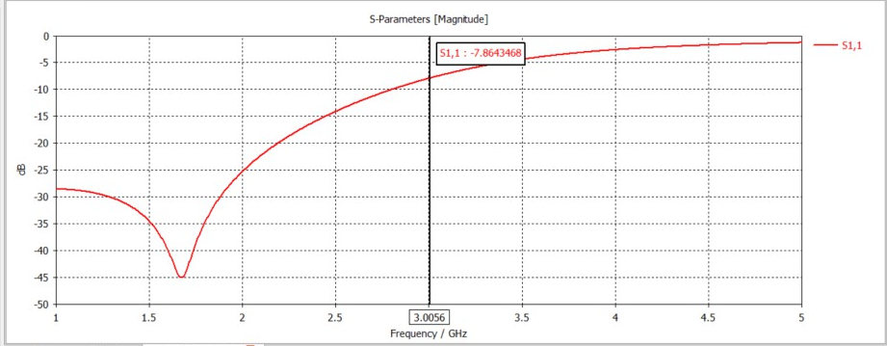
S-PARAMETERS:
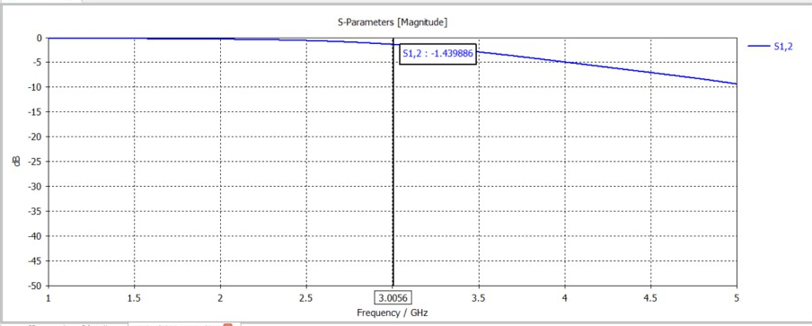
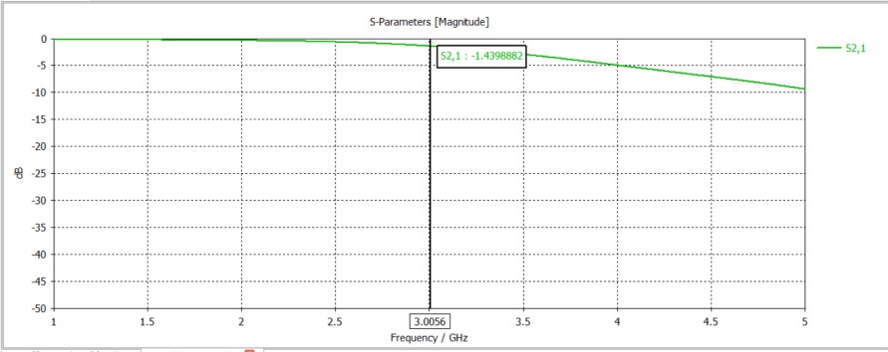
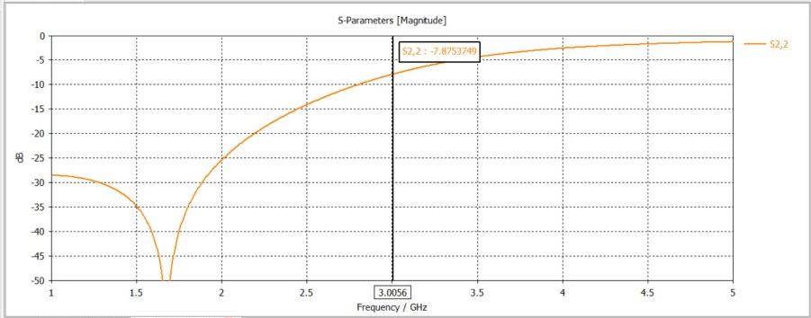

10.Click Simulation →waveguide port
11.Provide the necessary values for the units in waveguide port.
12.Then the antenna is ready for simulate.
13.Click simulation->Setup solver and observe the results.

RESULT:
Thus the Microstrip filter -Stepped Impedance Low Pass Filter was designed and simulated successfully. The impact of design parameters was also visualized.

