End-to-End Technical Explanation & Architecture
This document provides a rigorous, end-to-end technical overview of the Agentic AI Healthcare Platform. It covers the system architecture, machine learning pipelines, clinical decision support rules, database optimizations, role-based access control, and startup/testing procedures.
__________________________________________________________________

1. System & Integration Architecture
The application implements a decoupled client-server architecture with a stateless API layer and server-side state cache, backed by an optimized relational SQLite database.
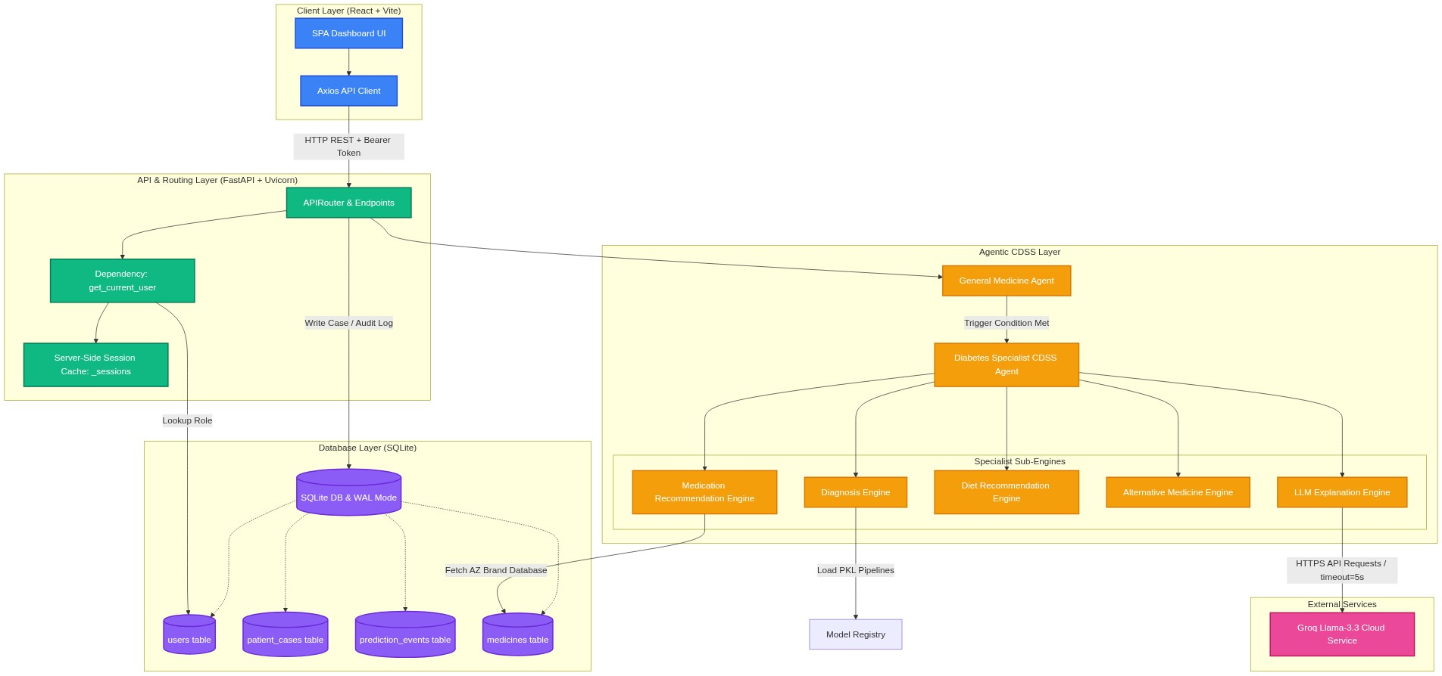
Figure: 1. System & Integration Architecture

Components Details
- Client Layer: Built as a Single Page Application (SPA) using React and Vite, running by default on http://localhost:5173. It initiates asynchronous REST API requests over HTTP using axios. It contains dedicated dashboard panels for Doctors (intake form, full reports) and Patients (care recommendations view).
- API & Routing Layer: Powered by FastAPI and executed using the Uvicorn ASGI server. It manages cross-origin resource sharing (CORS), applies Pydantic request-body structural validation, and evaluates role-based auth permissions using FastAPI's dependency injection (Depends(get_current_user)).
- Session Management: Authentication tokens are generated using secrets.token_urlsafe(32) on login and mapped in a transient server-side dictionary memory cache (_sessions). This structure avoids JWT storage while remaining highly secure against token modification attacks.
- Database Engine: Uses SQLite operating with Write-Ahead Logging (WAL) enabled (PRAGMA journal_mode=WAL). WAL allows multiple concurrent readers to query database records while a writer modifies tables, avoiding database locks on multi-threaded environments. Foreign key constraints are enforced (PRAGMA foreign_keys=ON).
- External LLM Integration: The LLM Explanation Engine connects to the Groq API utilizing an asynchronous-compatible HTTP Client (httpx.Client) pointing to llama-3.3-70b-versatile. It uses a strict 5.0 second execution timeout to prevent network failures or long API waits from blocking client threads, falling back automatically to local rules-based templates.
__________________________________________________________________

2. Machine Learning Training & Inference Pipelines
The platform maintains two ML models: a general medicine text classification model and a specialist diabetes risk assessment model.
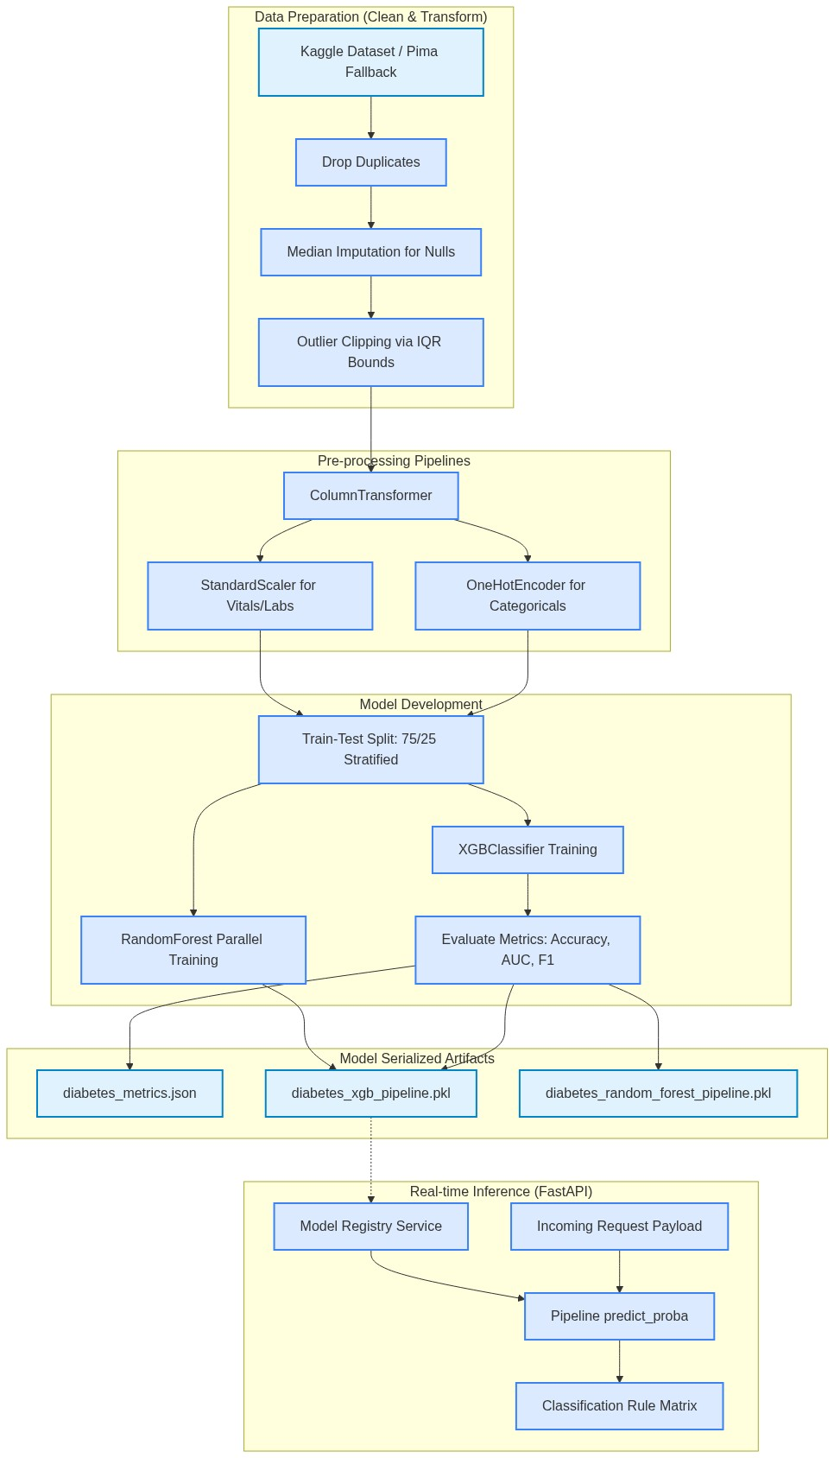
Figure: 2. Machine Learning Training & Inference Pipelines

2.1 General Medicine Classifier
- Purpose: Processes patient symptom descriptions to predict top-3 clinical candidate diagnoses.
- Data Source: general_symptom_disease.csv mapping text symptoms to target conditions.
- Algorithm: Logistic Regression Classifier.
- Text Preprocessing: TfidfVectorizer mapping word tokens to TF-IDF weights:
- ngram_range=(1, 2) to capture dual-word contexts (e.g., "muscle aches").
- min_df=1 to retain sparse or rare symptoms.
- Hyperparameters: C=20 (inversion of regularization strength to prevent underfitting), class_weight="balanced" (adjusts weights inversely proportional to class frequencies to handle imbalanced symptom classifications), and max_iter=1200.

2.2 Diabetes Risk Specialist Model
- Primary Data Source: Kaggle Dataset (iammustafatz/diabetes-prediction-dataset).
- Features: gender, age, hypertension, heart_disease, smoking_history, bmi, HbA1c_level, blood_glucose_level.
- Fallback Data Source: Pima Indian Diabetes Dataset (pima_diabetes.csv).
- Features: Pregnancies, Glucose, BloodPressure, SkinThickness, Insulin, BMI, DiabetesPedigreeFunction, Age.
- Pre-processing Pipeline:
- Imputation: Replaces clinical invalid placeholder zeroes (e.g., zero values in Blood Pressure or BMI) with feature medians.
- Outlier Mitigation: Features are clipped within Interquartile Range (IQR) boundaries:
$$\text{Lower Bound} = Q1 - 1.5 \times IQR$$
$$\text{Upper Bound} = Q3 + 1.5 \times IQR$$
- Standardization: Numeric features scaled to zero mean and unit variance via StandardScaler.
- One-Hot Encoding: Encodes categorical variables (gender, smoking_history) via OneHotEncoder(handle_unknown="ignore").
- Assembly: Columns are encapsulated into a cohesive ColumnTransformer execution unit.
- Classifier Algorithm: Extreme Gradient Boosting Classifier (XGBClassifier) with hyperparameters:
- n_estimators=80 (number of boosting rounds).
- max_depth=2 (maximum tree depth to limit high variance overfitting).
- learning_rate=0.04 (shrinkage step size to prevent gradient descent overshoot).
- subsample=0.8 (fraction of samples random-selected for tree building).
- colsample_bytree=0.8 (subsample ratio of features selected per tree).
- objective="binary:logistic" (binary logistic regression loss function).
- Model Serialization: Saved via joblib inside diabetes_xgb_pipeline.pkl. Model metrics (Accuracy, F1, Recall, Precision, ROC-AUC score, and Confusion Matrix) are written to diabetes_metrics.json.
__________________________________________________________________

3. Clinical Decision Support System (CDSS) Trigger & Diagnosis Flow
The agent utilizes a trigger-based activation gate to determine if a comprehensive diabetes risk assessment is required, subsequently routing through clinical classification logic.
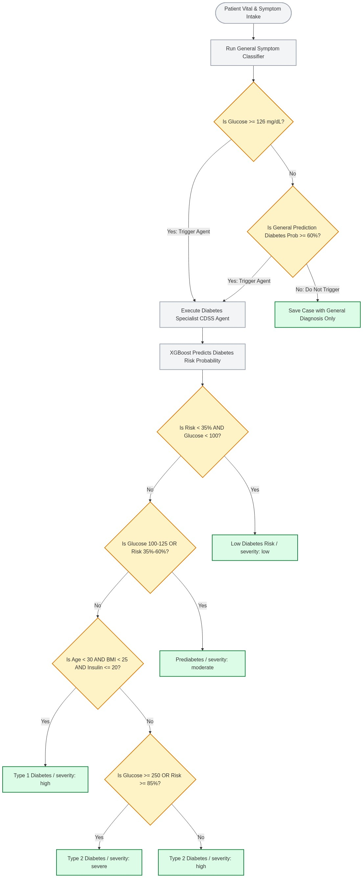
Figure: 3. Clinical Decision Support System (CDSS) Trigger & Diagnosis Flow

3.1 Gated Trigger Conditions
The system screens for diabetes triggers during the intake form check. The specialist agent is activated if either of these thresholds are crossed:
- Direct Glycemic Trigger: labs.glucose >= 126 mg/dL (configured via settings.diabetes_glucose_trigger).
- Symptom-Probability Trigger: The General Medicine Classifier returns a prediction probability of "Diabetes Mellitus" >= 0.60 (configured via settings.diabetes_probability_trigger).

3.2 Clinical Decision Support Classification Rules
Once triggered, the Specialist CDSS agent calculates classification categories and severity levels:
- Low Diabetes Risk: Risk probability $< 0.35$ AND glucose $< 100$ mg/dL.
- Prediabetes: Glucose is between $100$ mg/dL and $125$ mg/dL, OR Risk probability is between $0.35$ and $0.60$.
- Type 1 Diabetes: Patient's age $< 30$ AND BMI $< 25$ AND Insulin reading $\le 20$ uU/mL.
- Type 2 Diabetes: Classified if the patient does not fit the above and demonstrates elevated glucose and risk scores.
- Severity Gating:
- severe: Calculated if glucose $\ge 250$ mg/dL OR Risk probability $\ge 0.85$.
- high: Default for Type 1 and Type 2 classifications.
- moderate: Default for Prediabetes classification.
- low: Default for Low Diabetes Risk classification.
__________________________________________________________________

4. Authentication & RBAC Lifecycle Sequence
Role-Based Access Control (RBAC) enforces distinct read/write paths for Doctors and Patients. The backend filters prediction details dynamically based on user identity.
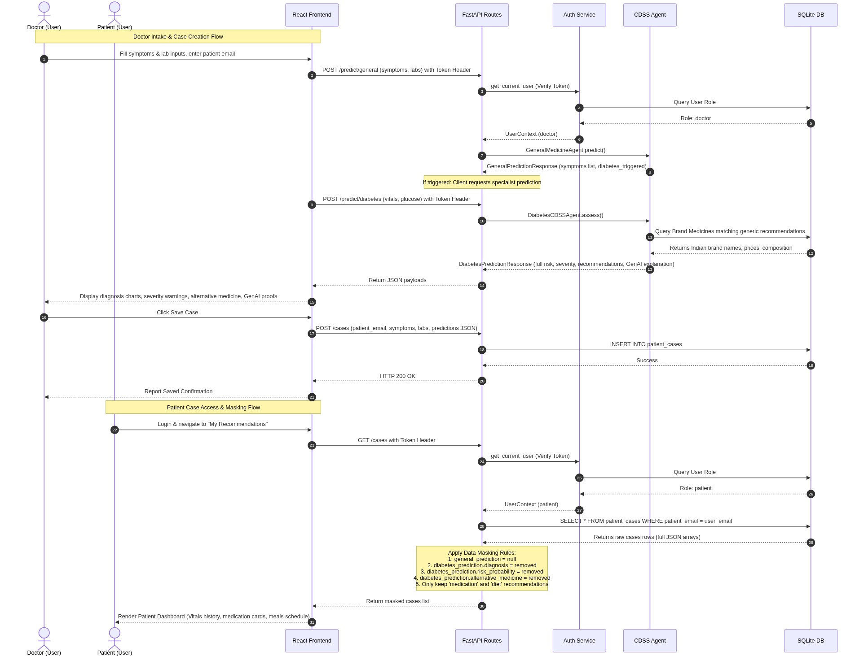
Figure: 4. Authentication & RBAC Lifecycle Sequence

Data Masking & Security Logic
- Doctor Privileges: Full access to all database fields. Doctors view diagnostic charts, probability curves, raw classifier predictions, alternative herbal remedies, and LLM clinical proofs.
- Patient Protections: Patients are barred from viewing clinical raw assessments to prevent self-diagnosing panic.
- general_prediction is set to null on response serialization.
- Within the diabetes_prediction JSON block, the backend removes keys: diagnosis, risk_probability, severity, model_used, model_metrics, and alternative_medicine.
- Only medication details (prescribed drug, dosage, warnings) and diet plans are returned.
__________________________________________________________________

5. Database Schema Design & Optimization
SQLite serves as the relational datastore. The schemas are modeled below:

5.1 Entity Relationship Diagram (ERD)
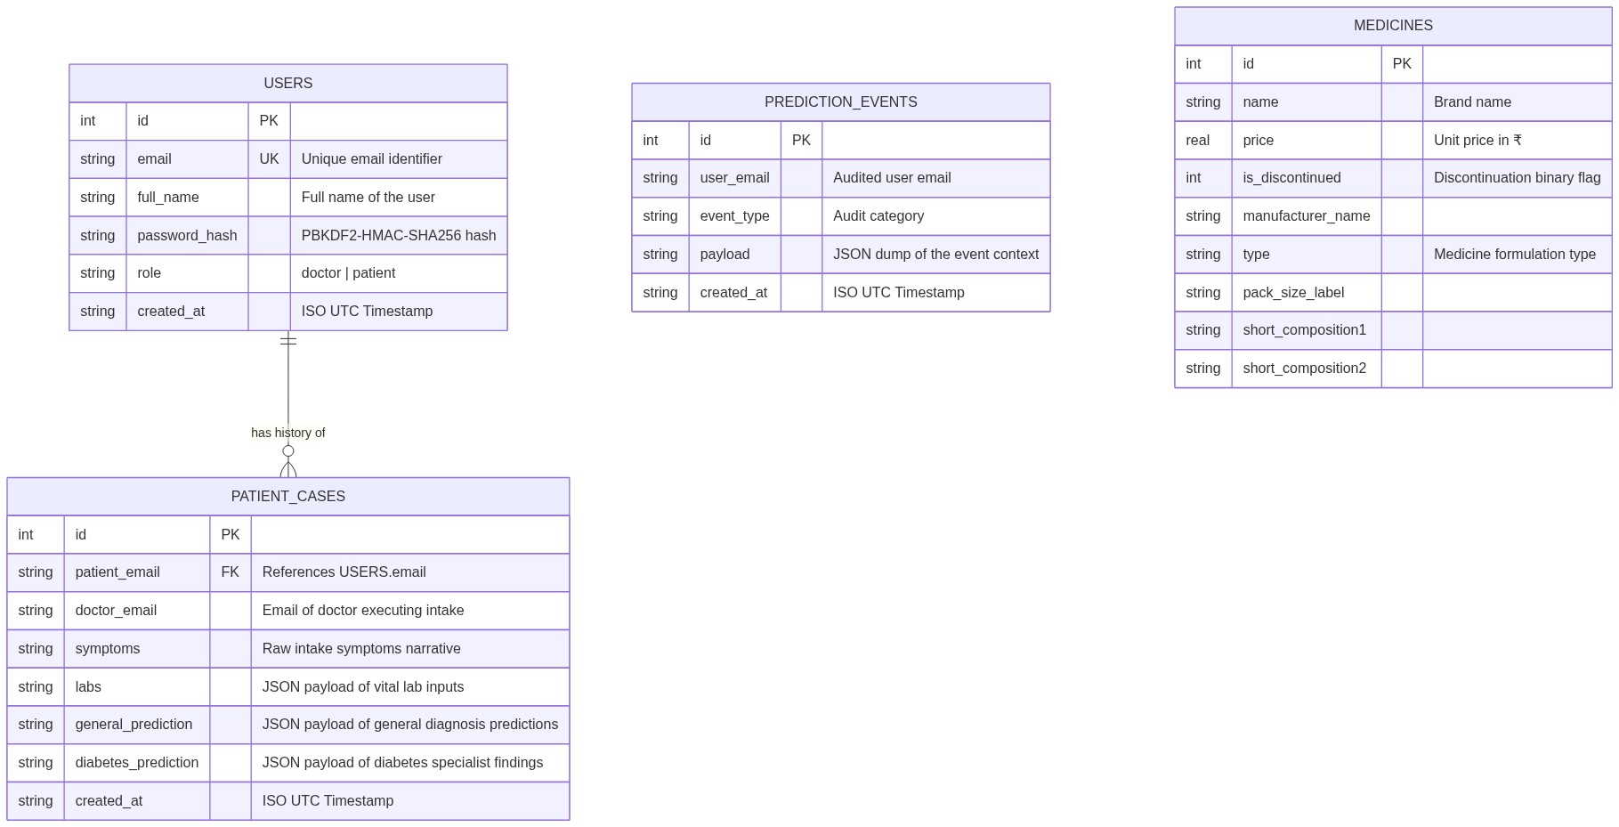
Figure: 5.1 Entity Relationship Diagram (ERD)

5.2 Hashing & Security Policies
User password protection implements a high-iteration hash routine to block offline brute-force attacks:
- Algorithm: PBKDF2-HMAC-SHA256.
- Salt Source: Cryptographically secure pseudo-random bytes generated using secrets.token_hex(16).
- Complexity: $120,000$ iterations.
- Format: salt$hash stored in the database.

5.3 Database Index Optimization
Three key database indices are implemented to ensure O(log N) lookup times during scaling:
- idx_patient_cases_email on patient_cases(patient_email):
- Purpose: Speeds up dashboard retrieval times when querying patient medical histories.
- Benefit: Avoids full table scans (O(N)) during patient queries, translating into sub-millisecond retrieval speeds as patient histories expand.
- idx_medicines_comp1 on medicines(short_composition1):
- Purpose: Indexes the main chemical ingredient (composition) of commercial medicines.
- Benefit: Accelerates search lookups when matching generic recommended medicines (e.g., Metformin) against commercial brand names.
- idx_medicines_comp2 on medicines(short_composition2):
- Purpose: Indexes co-formulated active ingredients.
- Benefit: Accelerates query performance when searching for combination therapy brands (e.g., Metformin + Sitagliptin).
__________________________________________________________________

6. Troubleshooting & Developer Notes

Issue A: WatchFiles Reload Storm
- Symptom: Uvicorn endlessly reloaded during startup.
- Root Cause: In Windows environments with OneDrive cloud-sync enabled, OneDrive continually updates folder access attributes within .venv upon package imports. Uvicorn's default file watcher flags these metadata adjustments as file changes, initiating infinite reloads.
- Solution: backend/main.py dynamically checks for the presence of .venv and adds its absolute path directly to Uvicorn's reload_excludes list.

Issue B: PowerShell Script Execution Policies
- Symptom: Virtualenv scripts like Activate.ps1 fail to execute.
- Solution: Execute python commands directly from the environment using .\.venv\Scripts\python.exe main.py rather than activating the shell script, bypassing system policies.

Issue C: Duplicate Database Initialization & Deprecation Warnings
- Symptom: Duplicate database operations and deprecated calls during startup.
- Solution: Bound database initialization routines to FastAPI's lifespan asynccontextmanager in backend/main.py, guaranteeing execution exactly once during worker thread launch.
__________________________________________________________________

7. Startup & Verification Guide

7.1 Running the Applications
- Launch Backend Services:
cd backend
.\.venv\Scripts\python.exe main.py
- Launch Frontend Services:
cd frontend
npm.cmd run dev
Access the application dashboard at http://localhost:5173.

7.2 Verifying via Automated Test Suites
Run the pytest test suite in the backend folder to verify registration, logins, roles, and patient data masking:
.\.venv\Scripts\python.exe -m pytest tests/
All tests should pass, confirming that RBAC is functioning correctly and data masking is successfully applied to patient roles.

