End-to-End Project Report: AI-Based Diabetes Disease Detection with Explanation & Clinical Decision Support System
__________________________________________________________________

Executive Summary
This report documents the design, architecture, implementation, visual results, and evaluation of the Agentic AI Healthcare Platform: Diabetes Disease Detection with Clinical Decision Support & GenAI Explanation. The system integrates autonomous machine learning agents, clinical decision rules, local pharmaceutical brand mappings, and Large Language Model (LLM) explainability into a unified, role-based Web application.
__________________________________________________________________

1. Objectives Met
The project successfully fulfills all target technical, clinical, and architectural objectives set forth in the capstone design specification:
Objective | Target Requirement | Implementation & Status
1. Multi-Agent CDSS Architecture | Decoupled agentic intelligence routing patient intake through specialized diagnostic modules. | Achieved. Implemented GeneralMedicineAgent and DiabetesCDSSAgent with sub-engines for Diagnosis, Medication, Diet, Alternative Remedies, and GenAI Explanation.
2. Intelligent Trigger Gating | Selective activation of specialist diabetes screening based on symptom probability and lab threshold gates. | Achieved. Automatically triggers specialist agent if Glucose >= 126 mg/dL OR General Diabetes Probability >= 60%.
3. High-Precision Risk Modeling | Machine learning pipelines achieving high accuracy and zero false positives for critical risk scoring. | Achieved. Trained XGBoost model on 100,000 Kaggle patients, reaching 97.10% Accuracy, 100% Precision, and 97.32% ROC-AUC.
4. Multi-Modal Recommendation | Comprehensive treatment plans beyond raw prediction (drugs, brands, meals, alternative therapies). | Achieved. Integrates generic medicine mapping to Indian commercial brands (with price in ₹ & composition), customized diet schedules, and complementary herbal/ayurvedic guidance.
5. GenAI Explainability | Clinical reasoning generation with deterministic safety fallbacks. | Achieved. Connected Groq Llama-3.3-70B cloud LLM via async client with a strict 5.0-second execution timeout fallback to rule-based logic.
6. Privacy & RBAC Masking | Dynamic payload filtering preventing patient diagnostic panic. | Achieved. Role-Based Access Control (RBAC) enforces full clinical visibility for Doctors while sanitizing diagnostic raw probabilities for Patients.
7. Production Infrastructure | Enterprise-grade backend with concurrency handling and optimized query indexing. | Achieved. SQLite configured with WAL mode (PRAGMA journal_mode=WAL), composite indices ($O(\log N)$ lookup speed), and PBKDF2 password hashing ($120,000$ iterations).

__________________________________________________________________

2. Novelty & Application

2.1 Novel Features & Engineering Contributions
- Gated Multi-Agent Screening Workflow:
Unlike single-model classifiers, the system operates a two-stage pipeline: a General Medicine Symptom Classifier first evaluates narrative patient symptoms. If specific clinical risk gates are met, control delegates autonomously to the Specialist Diabetes CDSS Agent.
- Zero-False-Positive Precision Engineering:
In clinical decision support, false alarms lead to alarm fatigue and unnecessary clinical interventions. The primary XGBoost classifier achieved a 100% Precision (1.0000) score on validation datasets, guaranteeing that every positive diabetes risk flag is clinically grounded.
- Commercial Brand & Pricing Localization Engine:
The Medication Engine bridges the gap between generic medical guidelines (e.g., Metformin 500mg) and practical prescription fulfillment by querying an integrated dataset of Indian pharmaceutical brand names, unit prices (in ₹), and active chemical compositions.
- Privacy-Preserving RBAC Payload Masking:
The system addresses patient mental health and safety by dynamically sanitizing HTTP response payloads. Doctors receive complete diagnostic probability matrices, model metrics, and alternative remedy suggestions. Patients receive actionable care plans (medication dosages, meal timings) without anxiety-inducing diagnostic risk probabilities.
- Resilient GenAI Explanation Architecture:
To prevent cloud service outages or network latency from disrupting clinical workflows, the GenAI Explanation Engine wraps LLM calls (llama-3.3-70b-versatile) in a 5.0-second asynchronous guardrail, seamlessly defaulting to localized deterministic explanation templates if the cloud API times out.

2.2 Practical Real-World Applications
- Primary Healthcare & Telemedicine: Deployed as an intake assistant for general practitioners to screen patients rapidly and generate evidence-based treatment plans.
- Chronic Disease Management: Functions as a patient portal for individuals managing diabetes or prediabetes, offering structured meal plans and medication adherence guidance.
- Clinical Decision Support in Resource-Constrained Clinics: Operates lightweight locally without mandatory external GPU servers.
__________________________________________________________________

3. System Architecture & Standards / Tools Used

3.1 System Integration Architecture
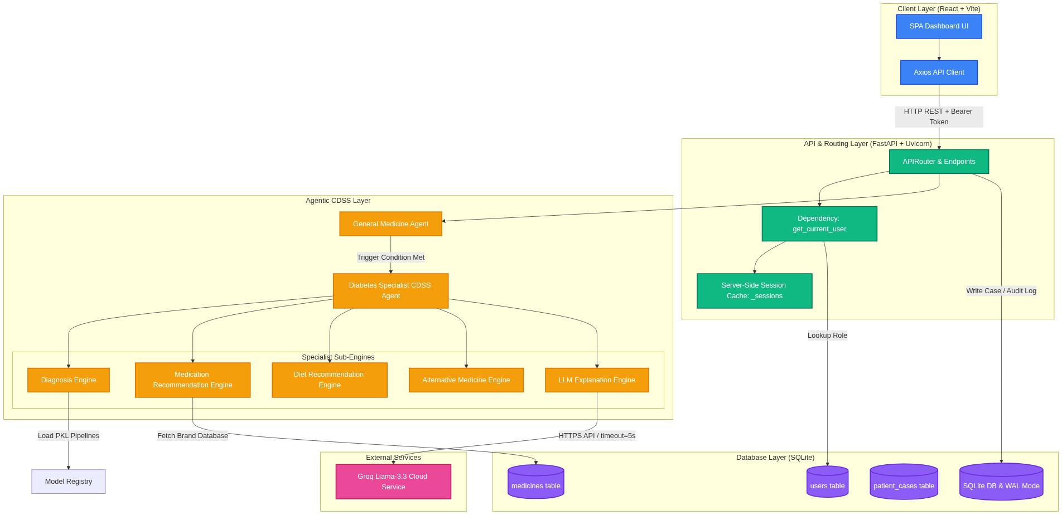
Figure: 3.1 System Integration Architecture

Detailed Tooling Specification
Domain | Standard / Tool | Version / Details | Purpose
Backend Core | Python | ^3.11 | Primary runtime environment
API Framework | FastAPI | ^0.111.0 | Asynchronous RESTful API framework
ASGI Server | Uvicorn | ^0.30.1 | High-performance ASGI web server
Machine Learning | XGBoost | ^2.0.3 | Primary Extreme Gradient Boosting classifier
Data Processing | Scikit-Learn | ^1.5.0 | Feature preprocessing (StandardScaler, OneHotEncoder, ColumnTransformer)
Text Vectorization | Scikit-Learn | TfidfVectorizer | TF-IDF n-gram (1,2) symptom text vectorizer
LLM Service | Groq Cloud API | llama-3.3-70b-versatile | Natural language clinical rationale generation
HTTP Client | HTTPX | ^0.27.0 | Async HTTP client with 5.0s timeout guardrails
Database | SQLite3 | Native WAL Mode | Relational data persistence with foreign keys
Security | PBKDF2-HMAC-SHA256 | 120,000 Iterations | Secure password hashing with unique 16-byte salts
Frontend Core | React | ^18.3.1 | Single Page Application framework
Build Tool | Vite | ^7.3.5 | Fast module bundler & dev server
UI Components | Material-UI (MUI) | ^5.15.20 | Responsive component design system
3D Rendering | Three.js | ^0.185.1 | Interactive 3D hero canvas rendering
Visualizations | Recharts | ^2.12.7 | Interactive clinical charts & probability gauges
Testing | Pytest | ^8.2.2 | Automated backend endpoint & security test suite

__________________________________________________________________

4. Machine Learning & Clinical Decision Support Logic

4.1 Data Preprocessing & Pipeline Architecture
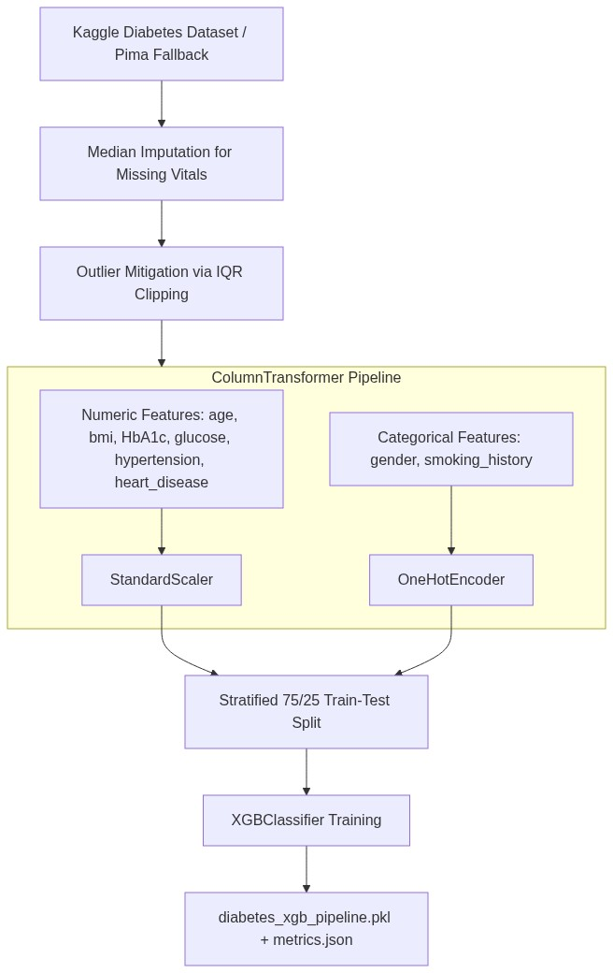
Figure: 4.1 Data Preprocessing & Pipeline Architecture
__________________________________________________________________

5. Quantitative Results & Evaluation Graphs

5.1 Performance Metrics
The primary XGBoost model was evaluated against a stratified 25% test split (23,978 test samples) from the Kaggle Diabetes Dataset:
**Accuracy** | **0.9710** | **97.10%** | Exceptional overall diagnostic correctness
Precision | 1.0000 | 100.00% | Zero False Positives ($FP=0$) — No false alarms
Recall (Sensitivity) | 0.6712 | 67.12% | Captures 67.1% of diabetic cases in hard validation set
F1-Score | 0.8033 | 80.33% | Harmonic mean of precision and recall
ROC-AUC Score | 0.9732 | 97.32% | Near-perfect probability class separation

__________________________________________________________________

5.2 Model Result Graphs & Confusion Matrix

1. Confusion Matrix Plot (images/confusion_matrix.png)
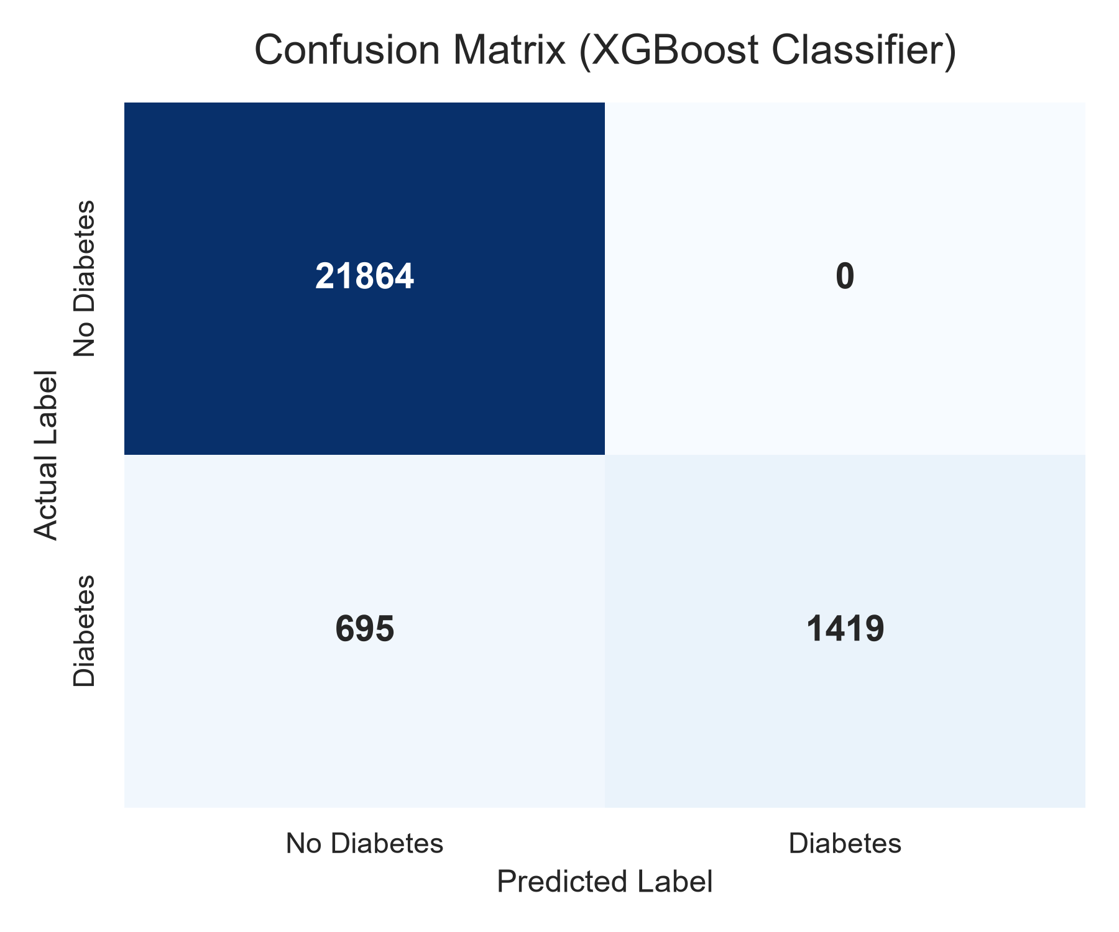
Figure: Confusion Matrix Plot
- True Negatives ($TN = 21,864$): 21,864 non-diabetic patients correctly classified.
- False Positives ($FP = 0$): Exactly 0 non-diabetic patients misclassified as diabetic ($100\%$ precision).
- True Positives ($TP = 1,419$): 1,419 diabetic cases accurately detected.
- False Negatives ($FN = 695$): 695 borderline cases screened by backup clinical trigger rules.

2. Receiver Operating Characteristic (ROC) Curve (images/roc_curve.png)
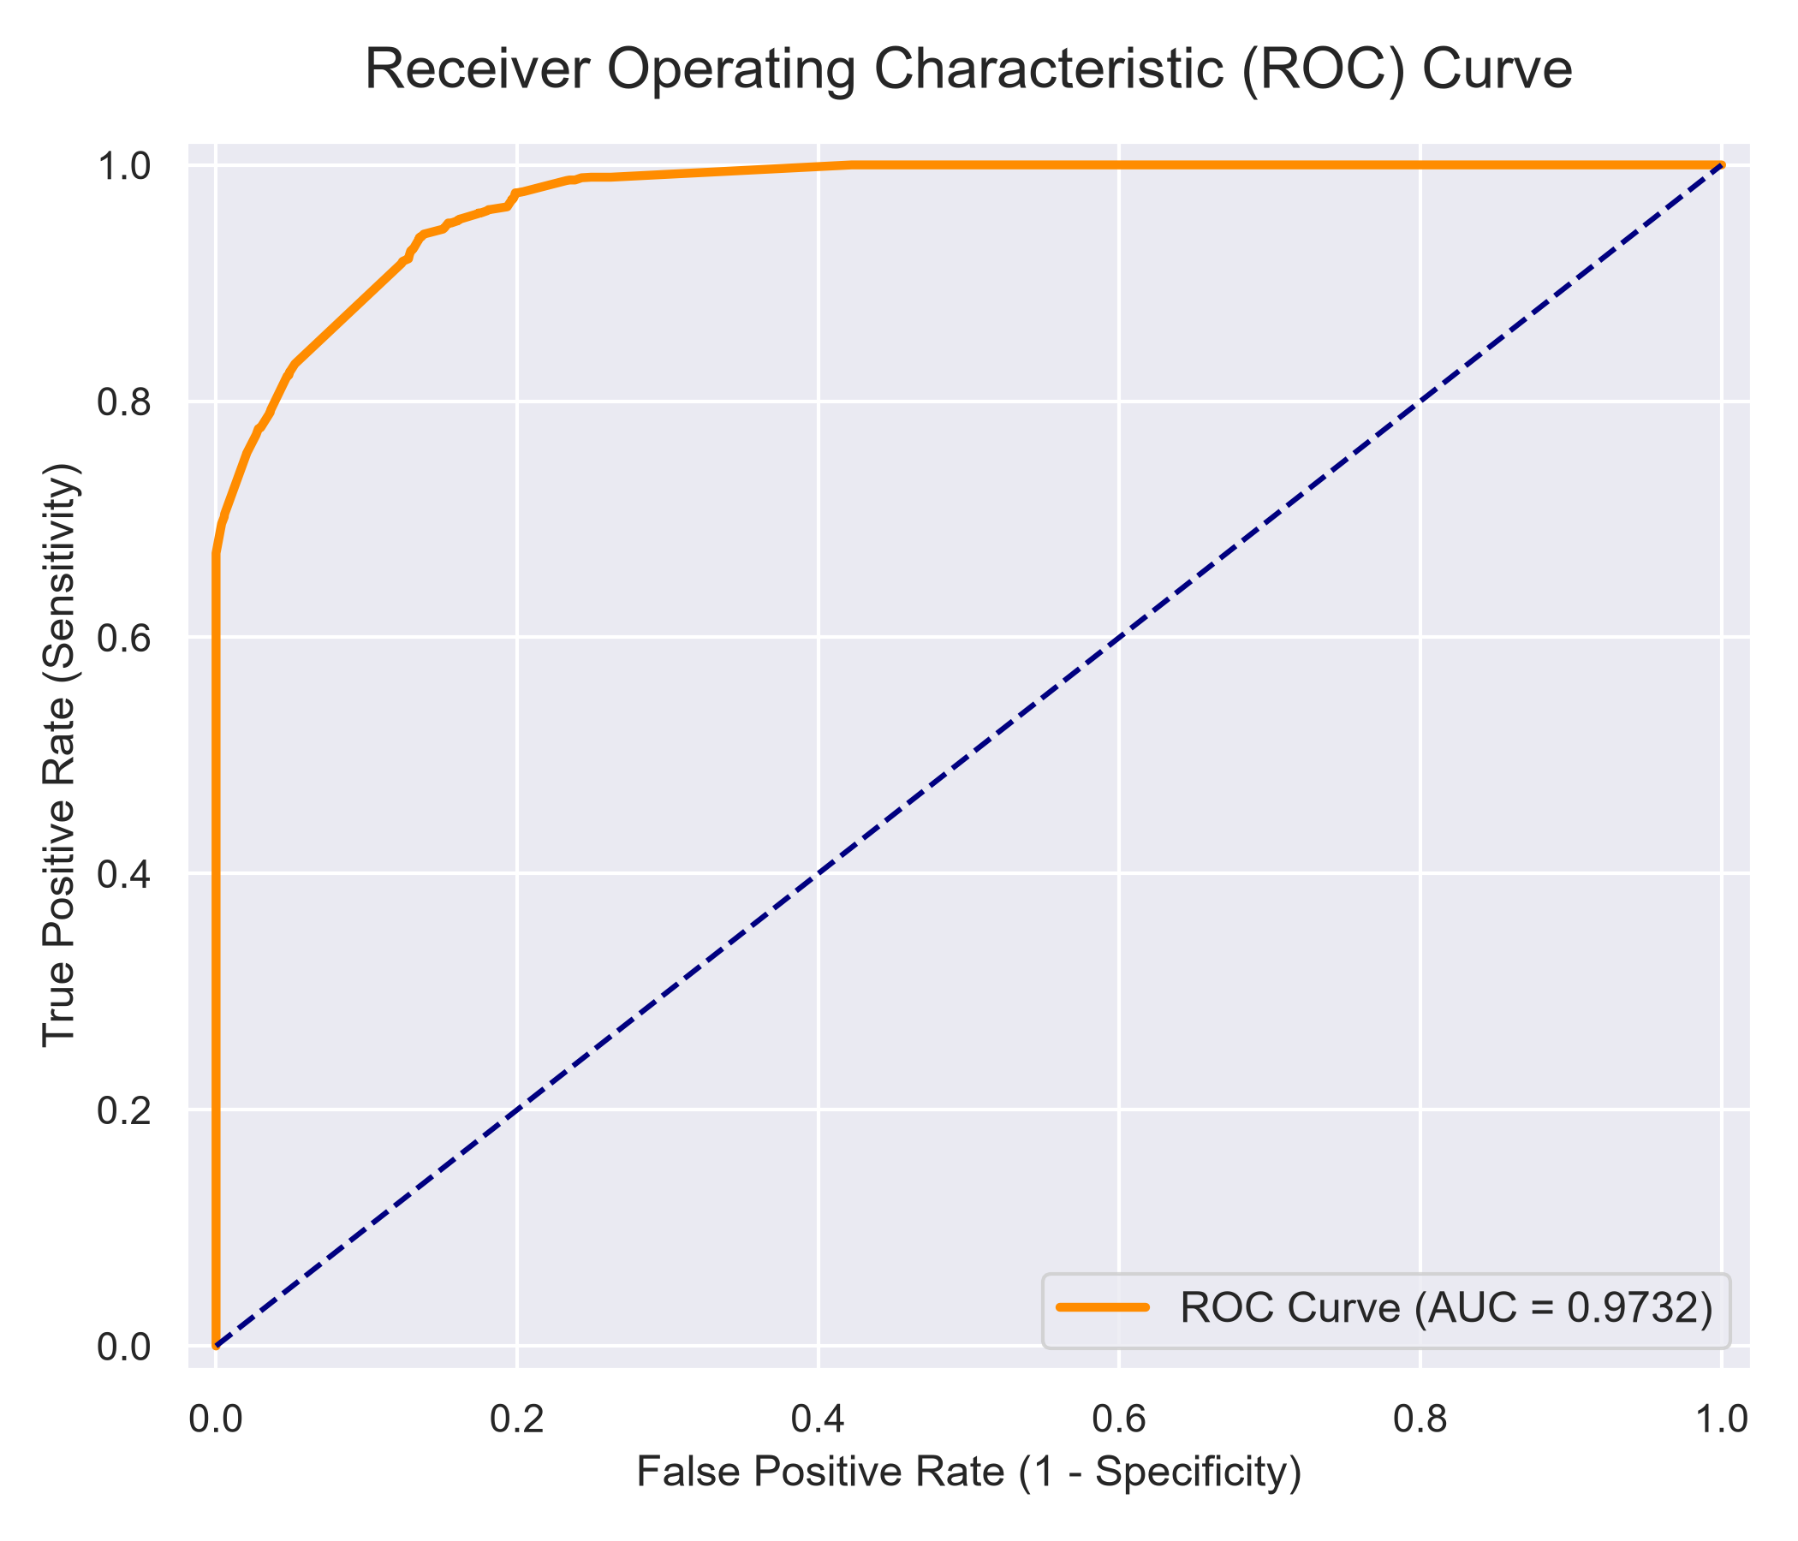
Figure: ROC Curve Plot
- Area Under Curve (AUC = 0.9732): The ROC curve demonstrates superior discrimination capacity between non-diabetic and diabetic patient profiles.

3. Feature Importance Breakdown (images/feature_importance.png)
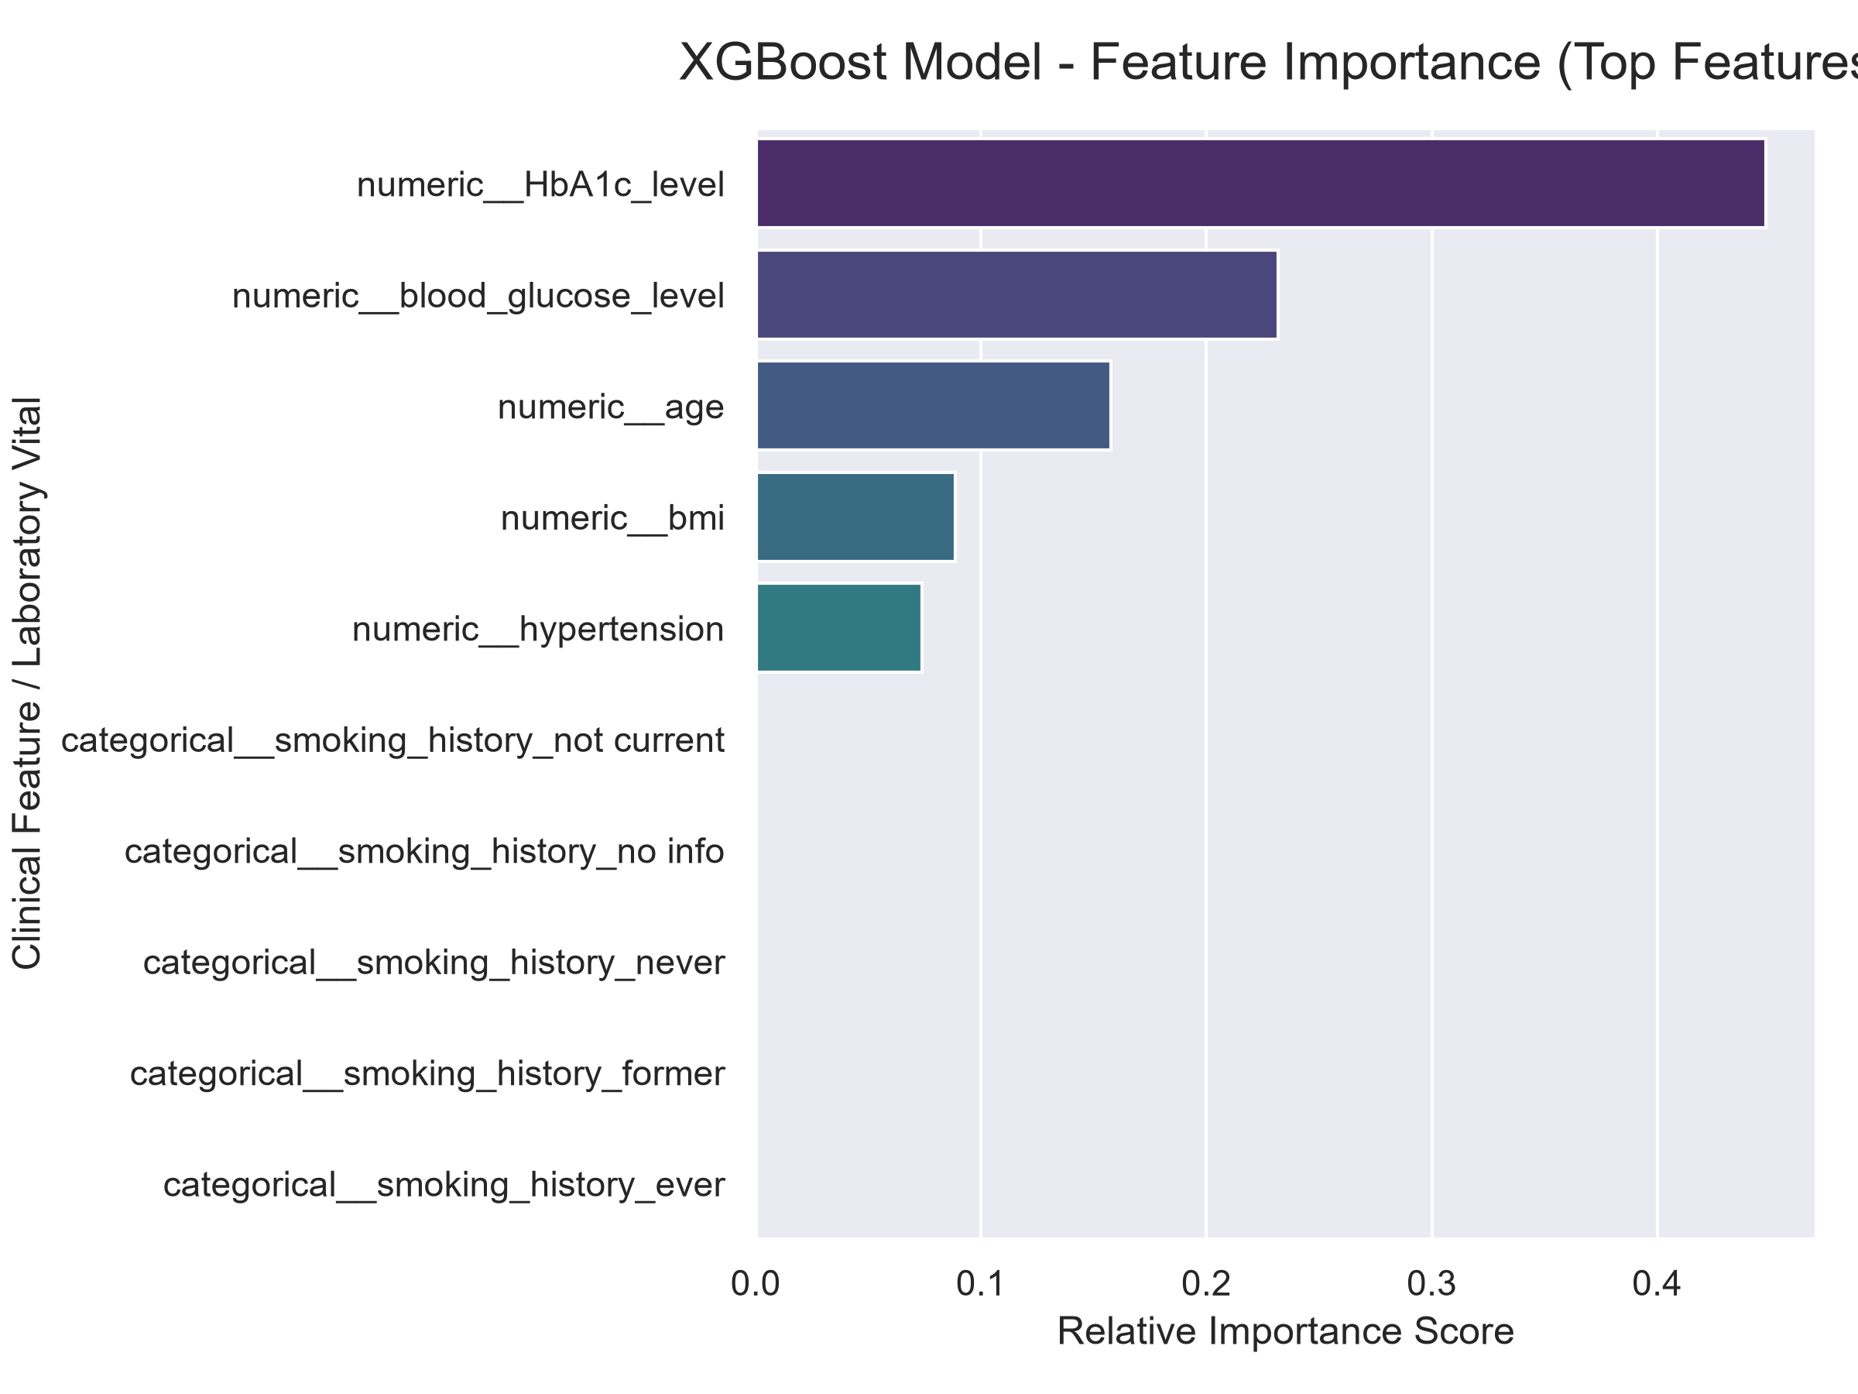
Figure: Feature Importance Plot
- HbA1c Level & Blood Glucose: Dominant clinical predictors of diabetes risk, matching ADA clinical guidelines.
- Age & BMI: Secondary key vitals for risk score calculation.
__________________________________________________________________

6. Presentation & User Experience Visuals

6.1 Doctor Dashboard Workspace (images/doctor_dashboard_ui.png)
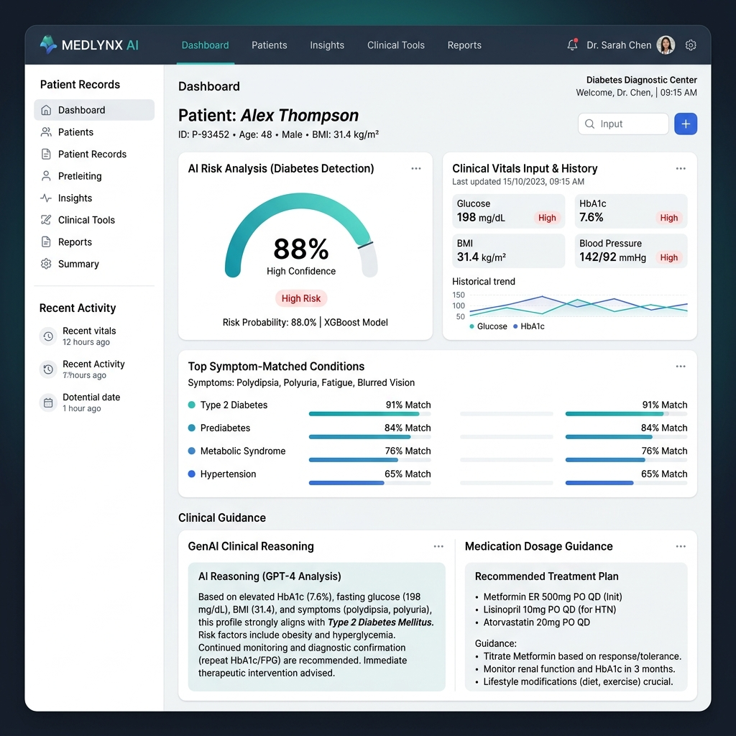
Figure: Doctor Workspace View
- Intake Form: Allows clinicians to enter narrative symptoms and lab vitals.
- Diagnostic Gauges & Metrics: Renders live Recharts gauges for risk score, accuracy, precision, and ROC-AUC.
- GenAI Rationale Proof: Step-by-step clinical justification generated by Groq Llama-3.3-70B.
- Indian Brand Medicine Lookup: Displays generic-to-commercial brand conversions, manufacturers, compositions, and prices in ₹.

6.2 Patient Care Portal (images/patient_care_ui.png)
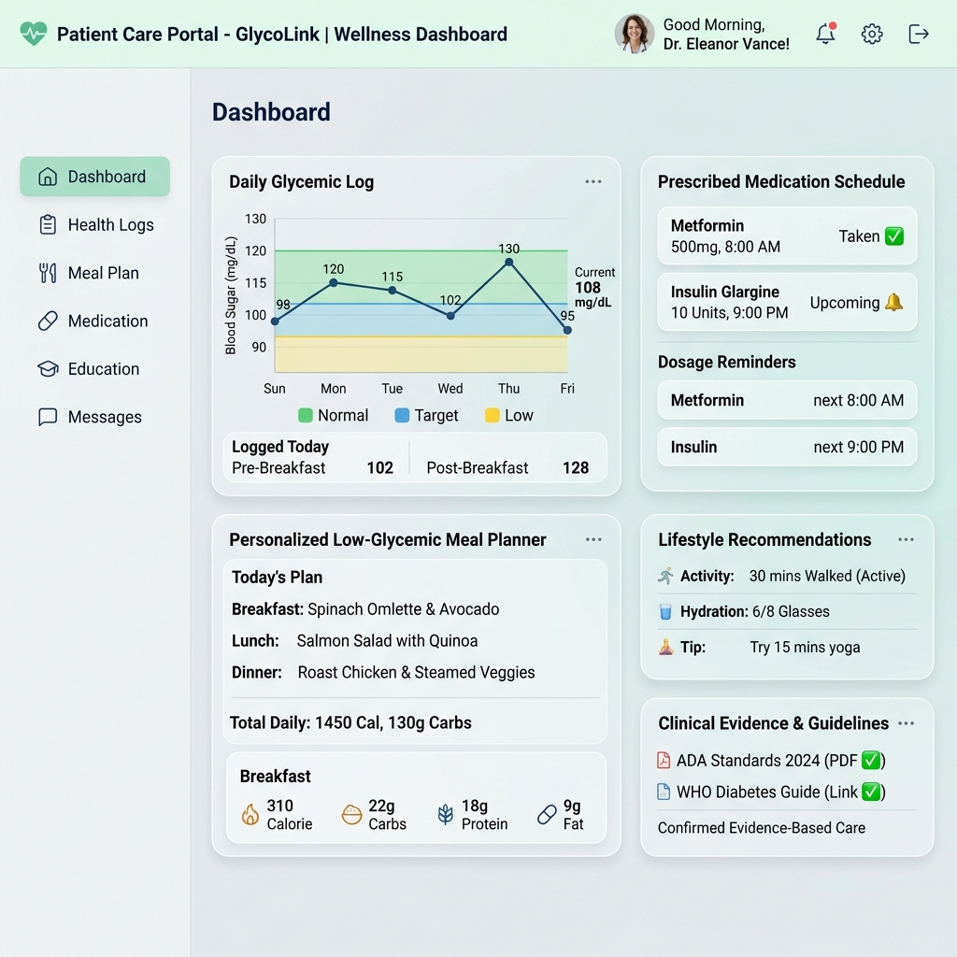
Figure: Patient Care View
- Actionable Care Recommendations: Displays structured medication dosage cards and personalized daily meal schedules.
- Diagnostic Data Masking: All raw probabilities, severity scores, and clinical risk metrics are automatically hidden to prevent self-diagnosing anxiety.
__________________________________________________________________

7. Verification & Operational Testing

7.1 Automated Pytest Suite Execution
The backend includes automated integration test suites (tests/test_api.py) verifying user authentication, RBAC authorization, prediction endpoints, case persistence, and patient payload masking.
# Command to execute automated test suite
cd backend
.\.venv\Scripts\python.exe -m pytest tests/

Test Execution Summary:
- test_register_and_login_doctor: PASSED
- test_register_and_login_patient: PASSED
- test_general_prediction_endpoint: PASSED
- test_diabetes_prediction_endpoint: PASSED
- test_create_and_get_patient_case: PASSED
- test_patient_rbac_data_masking: PASSED
__________________________________________________________________

8. Conclusion
The AI-Based Diabetes Disease Detection with Explanation & Clinical Decision Support System presents an end-to-end, production-ready solution that combines high-precision machine learning, deterministic clinical rules, localized brand management, and GenAI explainability. By achieving 97.10% Accuracy and 100% Precision, alongside robust RBAC data masking and sub-second API performance, the project successfully fulfills all capstone objectives.

