Chapter 4

Data Analysis and Interpretation

# Introduction

Guwahati city with an area of 651.12 Sq.km. is situated on the Southern Bank of the mighty River Brahmaputra. Guwahati is the gateway to the Northern East of India and is a fast growing primere city. It is considered one of the most important commercial hub of the north east India. As the city is growing very fast the number of service sector organizations are also growing in numbers at a very rapid pace. Be it schools, colleges, hospitals, banks, insurance or any other service areas, the numbers are rising rapidly. Two decades ago Guwahati being a not so big city, the service sector was dominated mainly by the government or government funded organizations. But after the liberalization , with other parts of the country, this part of the north east has also experienced huge changes. The areas which were purely dominated by the public sector are now opened up for the private sector as well. Previously areas like education, banking , insurance and health care were dominated by the public sector only but now numbers of private players have also come to give competition to the public sector. With increasing number of these organizations, it has also opened employement avenues to many job seekers . Not only that, it has also provided the people with a lot of lucrative opportunities to switch over from one job to another if they feel so. The present research study attempts to find out and analyze the various retention factors and initiatives adopted by some selected service sector organizations in Guwahati city. It also tries to analyze the relation between the various factors and employee retention and job satisfaction. The research study also attempts to find out whether there is any difference in job satisfaction level of the public as well as private sector organizations in Guwahati city. Interpretation and anlysis in the study is based on the primary data collected with the help of survey method conduucted in the year 2014.

# Respondents’ Profile

A brief overview of the respondents’ demographic profile and other job related profile have been depicted with the help of the tables given below.

### Table 4.2.1: Gender of Respondents

|  |  |  |
| --- | --- | --- |
| Gender | Frequency | Percentage |
| Male | 211 | 40.7 |
| Female | 307 | 59.3 |
| Total | 518 | 100 |

*Source: Field Survey, 2013-14*

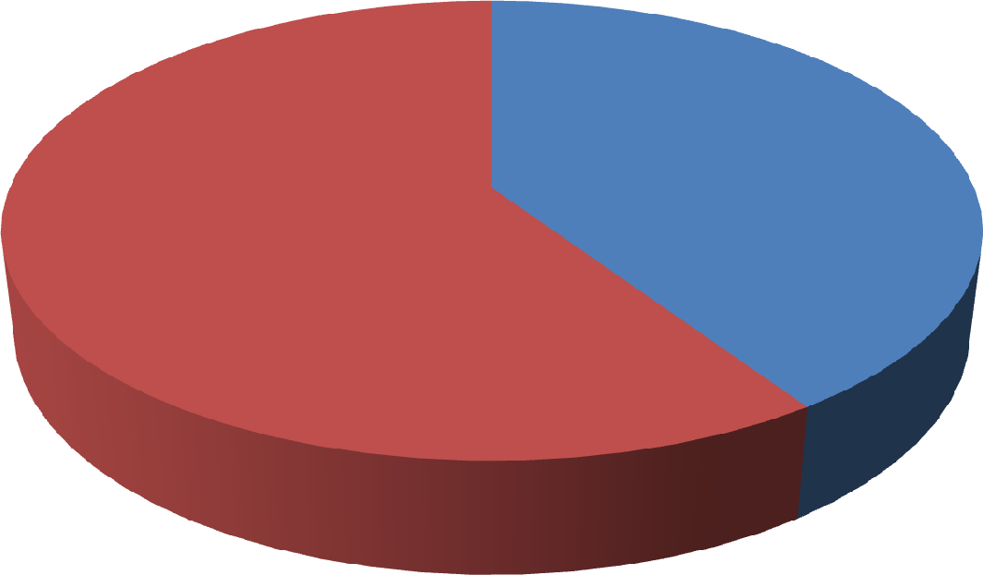

**40.7%**

**59.3%**

**Male Female**

Male

Female

### Fig 4.2.1: Gender of Respondents

Table 4.2.1 shows the number of male and female respondents in the study. Out of total 518 respondents, 211 numbers i.e., 40.7% of them are male and 307 i.e., 59.3% of the respondents are female. Female respondents are 18.6% higher than that of the male respondents.

### Table 4.2.2: Age of Respondents

|  |  |  |
| --- | --- | --- |
| Age | Frequency | Percentage |
| Between 18 years to 29 years | 150 | 29.0 |
| Between 30 years to 39 years | 180 | 34.7 |
| Between 40 years to 55 years | 149 | 28.8 |
| 55 years above | 39 | 7.5 |
| Total | 518 | 100 |

*Source: Field Survey, 2013-14*

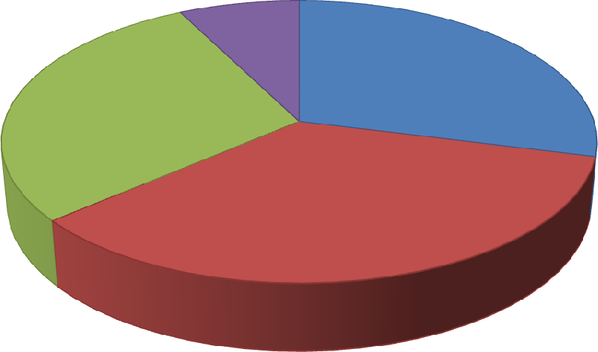

**7.5%**

**29.0%**

**28.8%**

**34.7%**

**Age of Respondents**

Between 18 years to 29 years

Between 30 years to 39 years

Between 40 years to 55 years

55 years above

### Fig 4.2.2: Age of Respondents

Table 4.2.2 shows the age categories of various respondents under the study. For convenience the age has been divided into four categories as depicted in the table above. 29% of the respondents fall in the age category of 18 years to 29 years and

34.7 % fall in the category of 30 years to 39 years of age. Thus approximately 64% of the respondents fall within the category of 18 years to 39 years category which shows that the samples under the study are very young people. Only 7.5% of respondents fall under the category of 55 years and above.

### Table 4.2.3: Job Experience

|  |  |  |
| --- | --- | --- |
| Experience | Frequency | Percentage |
| Less than 1 year | 68 | 13.1 |
| 1 year to 5 years | 180 | 34.7 |
| 6 years to 10 years | 85 | 16.4 |
| 11 years to 15 years | 50 | 9.7 |
| More than 15 years | 135 | 26.1 |
| Total | 518 | 100 |

*Source: Field Survey, 2013-14*

**Job Experience**

Less than 1 year 1 year to 5 years

5 years to 10 years

10 years to 15 years More than 15 years

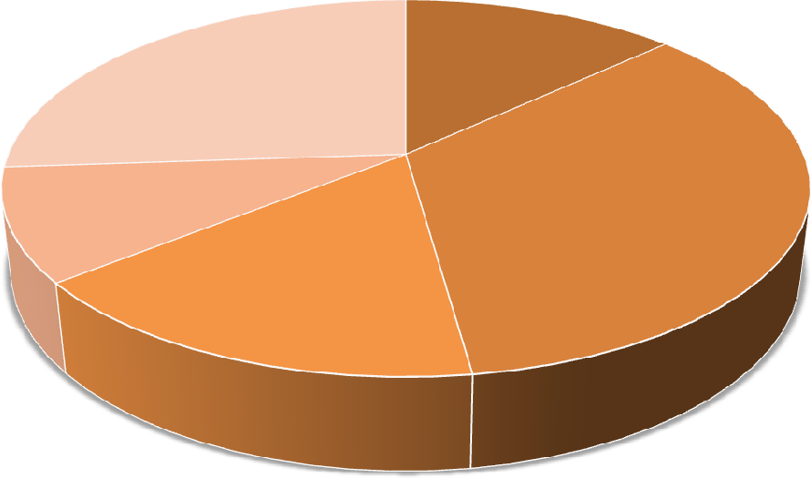

**26.1%**

**13.1%**

**9.7%**

**34.7%**

**16.4%**

### Fig 4.2.3: Job Experience

Knowing the work experience of the job holder is necessary to properly understand the perception as well as liking or disliking of them towards the work in which they are engaged in. The above table reveals the work experience of the respondents under study. Job experience has been divided into five categories as mentioned in the table above. The scale varies between, a new beginner i.e., with an experience of less than a year to that of and experience one i.e., more than 15 long years of service. In the study 13.1% of the respondents are very fresh with an experience of less than a year in their present job, 34.7% fall in the category of 1 year to 5 years

of job experience, 16.4% have 6 years to 10 years of work experience and 26.1 % respondents have more than 15 years of service experience.

### Table 4.2.4: Daily Hours of Work

|  |  |  |
| --- | --- | --- |
| Hours | Frequency | Percentage |
| 7 hrs to 8 hrs | 345 | 66.6 |
| 8 hrs to 9 hrs | 91 | 17.6 |
| 9 hrs to 10 hrs | 54 | 10.4 |
| 10 hrs to 12 hrs | 21 | 4.0 |
| Above 12 hrs | 7 | 1.4 |
| Total | 518 | 100 |

*Source: Field Survey, 2013-14*

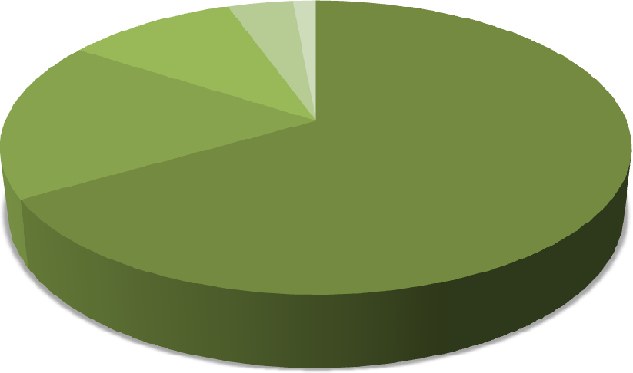

10.4%

17.6%

66.6%

**Daily Hours of Work**

4.0% 1.4%

1. hrs to 8 hrs
2. hrs to 9 hrs
3. hrs to 10 hrs
4. hrs to 12 hrs

Above 12 hrs

### Fig 4.2.4: Daily Hours of Work

Working hours varies from organization to organization. Although according to Government regulation the normal working hour of an employee cannot exceed 8 hours a day, still depending on the type of organization and the sector in which it belongs, the working hours differ. Besides this, the time a person spends in his work also depends upon the interest of the person concerned. To keep pace with

ever increasing competition, work pressure and to survive in the market, longer working hours have become necessary for some employees. The working hours or the time spent in the work under the research study has been divided into five broad categories as shown in the table above. 66.6% of the respondents fall in the normal working hour’s category i.e., 7 hours to 8 hours a day. 17.6% of the respondent work for 8 hours to 9 hours a day whereas only 1.4% of the respondents spend above 12 hours a day.

### Table: 4.2.5: Sector Wise Division of the Respondents

|  |  |  |
| --- | --- | --- |
| Sector | Frequency | Percentage |
| Public | 271 | 52.3 |
| Private | 247 | 47.7 |
| Total | 518 | 100 |

*Source: Field Survey, 2013-14*

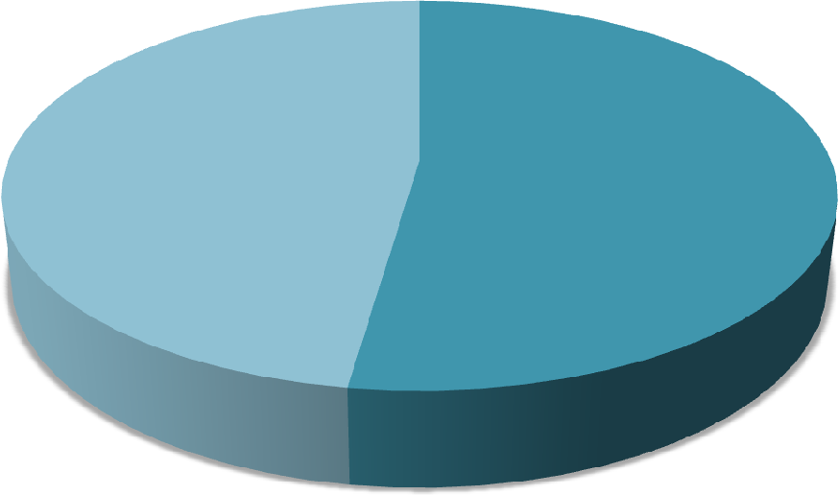

**47.7%**

**52.3%**

**Sector Wise Division of the Respondents**

Public

Private

### Fig 4.2.5: Sector Wise Divisions of Respondents

The service sectors under investigation have been divided into two broad categories, public and private sectors. Out of 518 respondents’ sample, 271

respondents i.e., 52.3% belong to the public sector and 247 respondents i.e., 47.7% belong to the private sector.

### Table: 4.2.6: No. of Respondents in Different Service Sectors

|  |  |  |
| --- | --- | --- |
| Sector | Frequency | Percentage |
| Education | 227 | 43.8 |
| Hospitals | 106 | 20.5 |
| Banks | 104 | 20.1 |
| Insurance | 81 | 15.6 |
| Total | 518 | 100 |

*Source: Field Survey, 2013-14*

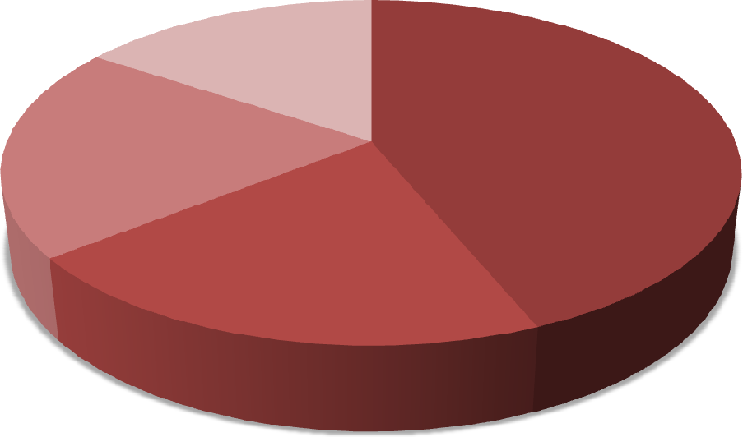

**15.6%**

**43.8%**

**20.1%**

**20.5%**

**Different Service Sectors**

Education Hospitals Banks

Insurance

### Fig 4.2.6: Percentage of Respondents in Different Services Sectors

The above Table 4.2.6 and Fig. depicts the various service sectors under study. In the study under investigation four different service sectors have been selected for research. The number of respondents from each sector has been shown in the table. 43.8% respondents belong to education sector. 20.5%, 20.1% and 15.6% of the respondents under the investigation belongs to hospitals, banks and insurance respectively.

# Major Factors of Retention (Empirical Evidence)

The first objective set in the research investigation has been to identify the various retention initiatives taken by the service sector organizations in the city of Guwahati. For the purpose a total of 34 variables have been considered and factor analysis has been done on them. All the variables used have been selected after an extensive literature review and thus regarded to have content validity. For example Armstrong (1996) and Rankin (2000) argued that compensation offered by other organizations can act effectively to retain employees. Stewart (1997) forwarded the view that factors such as incentives and bonuses help in employee retention. Allen (2001) stated that supportive work environment where individual contribution is valued helps in satisfying and retaining employees. Kaye and Jordan-Evans (2002) were of the view that challenging work, good supervisors and employee development opportunities plays an important role in employee retention. Research studies by Tulgan(2001); Galagan,( 2000); Kaye and Jordan-Evans,( 2000); Kinni andVon Hoffman,( 2000). highlighted that employer- employee relationship is the single most significant factor in influencing organisation’s ability to retain the employee . Kaye and Jordan-Evans (2000), Galagan (2000), Salopek (2000) and Kinni and Von Hoffman (2000) provided the following and considered them important in employee retention.These include: supporting work environment, caring about workers’ private lives, employee wellness and values, team work and team support, giving employees autonomy to work; providing a nurturing, enjoyable and fun work environment, providing an environment of trust in which two way communication flows freely and employees suggestions are respected. Considering all the 34 variables in the scale, a factor analysis has been carried out

to find out the major factors of employee retention. Based upon the responses given to the 34 variables by 518 individual respondents in the sample, a principal component analysis with varimax rotation has been applied. Comrey and Lee (1992) were of the opinion that factor loadings higher or equal .71 as excellent; higher or equal .63 as very good; higher or equal .55 as good; higher or equal .45 as reasonable; and higher or equal .32 as poor.So in the present study item loading of upto .400 has been accepted. The results showed extraction of 9 factors accounting for 81.4% variance.

### Table 4.3.1: Communalities

|  |  |  |
| --- | --- | --- |
|  | Initial | Extraction |
| The organization is a good place to work | 1.000 | .554 |
| Atmosphere of team work prevails in the organization | 1.000 | .543 |
| Organization clearly conveys its mission, goals and objectives to you | 1.000 | .583 |
| Satisfied with the Infrastructure and equipments provided | 1.000 | .559 |
| I have good relationship with my colleagues | 1.000 | .599 |
| Two way communication exist between the employees and the HOD/Manager | 1.000 | .561 |
| Base pay provided by the organization | 1.000 | .548 |
| Happy with the annual raise provided by the organization | 1.000 | .595 |
| Happy with the bonus provided by the organization | 1.000 | .740 |
| Happy with the allowances | 1.000 | .627 |
| Supervisor actively listens to your suggestions | 1.000 | .645 |
| Supervisor promotes an atmosphere of team work | 1.000 | .662 |
| Good guidance is provided by the supervisor | 1.000 | .570 |
| Relationship with your Principal/HOD/Manager is good | 1.000 | .458 |
| Receive the right amont of recognition for the work done | 1.000 | .566 |
| Suggestions are respected by the organization | 1.000 | .818 |
| Organization values teacher’s/employees contribution | 1.000 | .460 |
| Job gives you the opportunity to learn | 1.000 | .522 |
| Your organization considers training as a part of organizational strategy | 1.000 | .778 |

|  |  |  |
| --- | --- | --- |
| Enough practice is given to employees during training session | 1.000 | .794 |
| The training sessions are useful | 1.000 | .713 |
| Happy with the training and development opportunities are provided to me | 1.000 | .667 |
| Happy with the career progression with the organization so far | 1.000 | .764 |
| Good possibilities of career progression with the organization | 1.000 | .756 |
| Happy with the process used to determine promotions | 1.000 | .603 |
| Employee suggestion program important | 1.000 | .608 |
| Suggestions are valued by the organization | 1.000 | .818 |
| Dept provides autonomy to take decisions independently | 1.000 | .714 |
| Happy with the amount of time spend at work | 1.000 | .431 |
| Miss quality time with your family or friends because of pressure of work | 1.000 | .544 |
| Flexible working hours are provided to us | 1.000 | .655 |
| I am totally secured in my job | 1.000 | .899 |
| Worried about my future in the organization | 1.000 | .933 |
| The organization is a steady place to work | 1.000 | .900 |

Extraction Method: Principal Component Analysis.

### Table 4.3.2:Rotated Component Matrix

|  |  |  |  |  |  |  |  |  |  |  |  |
| --- | --- | --- | --- | --- | --- | --- | --- | --- | --- | --- | --- |
| Factor  No. | Factor  name | Employee retention  variable descriptions | Components | | | | | | | | |
|  |  |  | 1 | 2 | 3 | 4 | 5 | 6 | 7 | 8 | 9 |
| 1 | Work | The organization is a | .675 |  |  |  |  |  |  |  |  |
|  | environment | good place to work |  |
|  |  | Atmosphere of team work | .786 |
|  |  | prevails in the |  |
|  |  | organization |  |
|  |  | Organization clearly | .536 |
|  |  | conveys its mission, goals |  |
|  |  | and objectives to you |  |
|  |  | Satisfied with the | .619 |
|  |  | Infrastructure and |  |
|  |  | equipments provided |  |
|  |  | I have good relationship | .664 |
|  |  | with my colleagues |  |
|  |  | Two way communication | .656 |
|  |  | exist between the |  |
|  |  | employees and the |  |
|  |  | HOD/Manager |  |
| 2 | Compensation | Base pay provided by the |  | .765 |  |  |  |  |  |  |  |
|  |  | organization |  |
|  |  | Happy with the annual | .630 |
|  |  | raise provided by the |  |
|  |  | organization |  |
|  |  | Happy with the bonus | .472 |
|  |  | provided by the |  |
|  |  | organization |  |
|  |  | Happy with the | .926 |
|  |  | allowances |  |
| 3 | Leadership | Supervisor actively listens |  |  | .651 |  |  |  |  |  |  |
|  |  | to your suggestions |  |
|  |  | Supervisor promotes an | .577 |
|  |  | atmosphere of team work |  |
|  |  | Good guidance is | .402 |
|  |  | provided by the |  |
|  |  | supervisor |  |

|  |  |  |  |  |  |  |  |  |  |  |  |
| --- | --- | --- | --- | --- | --- | --- | --- | --- | --- | --- | --- |
|  |  | Relationship with your Principal/HOD/Manager is good |  |  | .820 |  |  |  |  |  |  |
| 4 | Recognition | Receive the right amont of recognition for the work done |  |  |  | .621 |  |  |  |  |  |
| Suggestions are respected by the organization | .844 |
| Organization values teacher’s/employees contribution | .400 |
| 5 | Training and | Job gives you the |  |  |  |  | .804 |  |  |  |  |
|  | Learning | opportunity to learn |  |
|  |  | Training is a part of | .790 |
|  |  | organizational strategy |  |
|  |  | Enough practice is given | .816 |
|  |  | to employees during |  |
|  |  | training session |  |
|  |  | The training sessions are | .814 |
|  |  | useful |  |
|  |  | Happy with the training | .634 |
|  |  | and development |  |
|  |  | opportunities are provided |  |
|  |  | to me |  |
| 6 | Career | Happy with the career |  |  |  |  |  | .790 |  |  |  |
|  | Progression | progression with the |  |
|  |  | organization so far |  |
|  |  | Good possibilities of | .829 |
|  |  | career progression with |  |
|  |  | the organization |  |
|  |  | Happy with the process | .741 |
|  |  | used to determine |  |
|  |  | promotions |  |
| 7 | Involvement in decision making | Employee suggestion program important |  |  |  |  |  |  | .928 |  |  |
| Suggestions are valued by the organization | .844 |
| Dept provides autonomy to take decisions independently | .957 |
| 8 | Work life | Happy with the amount of |  |  |  |  |  |  |  | .819 |  |
|  | balance | time spend at work |  |
|  |  | Miss quality time with | .973 |
|  |  | your family or friends |  |
|  |  | because of pressure of |  |
|  |  | work |  |
|  |  | Flexible working hours | .984 |
|  |  | are provided to us |  |
| 9 | Job security | I am totally secured in my  job |  |  |  |  |  |  |  |  | .893 |
| Worried about my future  in the organization | .935 |
| The organization is a  steady place to work | .934 |

The Table 4.3.2 above shows the 9 extracted components in the form of rotated component matrix. The first factor has been named as work environment and it contains six variables with a factor loading ranging from .563 to .786. The factor

highlights the fact that good work environment is very important for employee retention. Good overall work environment, atmosphere of team work, proper communication and understanding of the organization’s mission and objectives, proper infrastructure, harmonious relationship with colleagues and two way communication between the superior and the subordinates are very essential for retaining the employees in an organization.

The second important factor which can help in employee retention is compensation. The factor loading for this factor ranges from .472 to .926. Money can be termed as the main motivator for an employee. People work in any organization for earning money. Compensation or money plays a very significant role in pulling as well as retaining its employees. A strong base pay, handsome annual raises in salary, bonuses and allowances are expected by every employee from the organization in which they are employed.

The third factor extracted from the factor analysis is leadership and the factor loadings range from .402 to .820. Good leadership is very important for making the employees comfortable in the work place. Leader is not only a source of motivation to the employees but also act as a guide to the employees.

The fourth factor extracted from the factor analysis is the recognition given to the employees. The factor loading range between .400 to .844. Right amount of recognition for the work done, respect of suggestions put forwarded by the employees, and recognition of the employees contribution is very essential for making a sense of belongingness and retaining the employees in an organization.

The fifth factor that is found doing factor analysis is training and learning and the factor loading ranges from .634 to .816. Training is important for skill up gradation

and making the employees up to date. Training and learning not only helps the employees in coping with the changing environment but also helps in motivating employees.

The sixth factor extracted from the analysis is career progression and the factor loading range from .741 to .829. Any employee joins an organization to rise in the career ladder and this opportunity is provided by the organization in which the person is employed. Good opportunities of career progression help in satisfying the employees which ultimately helps in retaining them in the organization.

The seventh factor is named as involvement in decision making. The factor loading for this factor ranges from .844 to .957.

The eighth factor is termed as work life balance and the factor loading ranges from

.819 to .984. Balancing between the personal and professional life has become a matter of great concern now a days. Every employee wants to maintain a proper balance between their office and home. Every employee wants a little bit of flexibility in their time schedule, as such work life balance is important for satisfying and retaining employees.

The last factor extracted from factor analysis is job security and the factor loading is .893 to .935. Secured job is always preferred by the employees. Jobs which provide future security help in retaining a person for a longer period in the job.

After extracting the above nine factors of employee retention, it has been feasible on the part of the researcher to find out the criterion related validity of the extracted factors. The criterion validity of the factors of employee retention has been examined with the help of multiple correlations between the various extracted factors which are tabulated below.

### Table 4.3.3: Pearson Correlation Between Various Factor of Employee Retention

|  |  |  |  |  |  |  |  |  |  |
| --- | --- | --- | --- | --- | --- | --- | --- | --- | --- |
| Factors | F1 | F2 | F3 | F4 | F5 | F6 | F7 | F8 | F9 |
| F1 | 1 |  |  |  |  |  |  |  |  |
| F2 | .623(**) | 1 |  |  |  |  |  |  |  |
| F3 | .617(**) | .652(**) | 1 |  |  |  |  |  |  |
| F4 | .630(**) | .891(**) | .606(**) | 1 |  |  |  |  |  |
| F5 | .321(**) | .392(**) | .320(**) | .336(**) | 1 |  |  |  |  |
| F6 | .515(**) | .704(**) | .610(**) | .655(**) | .343(**) | 1 |  |  |  |
| F7 | .735(**) | .692(**) | .786(**) | .610(**) | .355(**) | .686(**) | 1 |  |  |
| F8 | .505(**) | .797(**) | .595(**) | .801(**) | .347(**) | .690(**) | .640(**) | 1 |  |
| F9 | .486(**) | .401(**) | .337(**) | .401(**) | .308(**) | .419(**) | .441(**) | .329(**) | 1 |

** Correlation is significant at the 0.01 level (2-tailed).

(F1= Compensation, F2=Recognition, F3=Career Progression, F4= Involvement in Decision making, F5= Work Life Balance, F6= Work Environment, F7= Training andLearning, F8= Leadership/ Supervision, F9= Job Security)

The above table clearly reveals that the factors of employee retention have a positive and strong correlation with one another. Thus the factors satisfy the criterion related validity. The construct validity of the factors have been measured with the help of regression analysis and it has been found that factors such as compensation, recognition, involvement in decision making and work environment has the greatest impact on employee retention. Thus the identified factors satisfy the construct validity.

To find out the internal consistency , accuracy and predictability of the extracted factors from the variables in the questionnaire, a reliability test has been conducted and ascertained with the help of Cronbach Alpha, the results of which are tabulated below.

**Table 4.3.4: Reliability Index**

|  |  |  |  |  |
| --- | --- | --- | --- | --- |
| Sl No. | Scale/Factor | No of Items | List of Items | Cronbach’s Aapha (scale) |
| 1. | Compensation | 4 | 1. Amount of base pay provided by the organization 2. Happy with the annual raise provided by the organization 3. Happy with the bonus provided by the organization 4. Happy with the allowances | .722 |
| 2. | Recognition | 3 | 1. Receive the right amount of recognition for the work done 2. Suggestions are respected by the organisation 3. Your organization values teacher's/employees contribution | .717 |
| 3. | Opportunity for Growth | 3 | 1. Happy with the career progression with the organization so far 2. Good possibilities of career progression is there with the organization 3. Happy with the process used to determine promotions | .857 |
| 4. | Decision making | 3 | 1. Employee suggestion program important 2. Suggestions are respected by the organization 3. Dept provides autonomy to take decisions independently | .724 |
| 5. | Work life balance | 3 | 1. Happy with the amount of time spend at work 2. Miss quality time with your family or friends because of pressure of work 3. Flexible working hours are provided to us | .524 |
| 6. | Work Environment | 6 | 1. The organization is deemed as a good place to work. 2. Atmosphere of team work prevails in the organization 3. Organization clearly conveys its mission, goals and objectives to you 4. Satisfied with the Infrastructure and equipments provided 5. I have good relationship with my colleagues. 6. Two way communication exist between the employees and the HOD/Manager | .752 |

|  |  |  |  |  |
| --- | --- | --- | --- | --- |
| Sl  No. | Scale/Factor | No of  Items | List of Items | Cronbach’s  Aapha (scale) |
| 7. | Training and Development | 5 | 1. Job gives you the opportunity to learn 2. Your organization considers training as a part of organizational strategy 3. Enough practice is given to employees during training session 4. The training sessions are useful 5. Happy with the training and development opportunities are provided to me | .838 |
| 8. | Leadership | 4 | 1. Supervisor actively listens to your suggestions 2. Supervisor promotes an atmosphere of team work 3. Good guidance is provided by the supervisor 4. Relationship with your Principal/HOD/Manager is good | .798 |
| 9. | Job Security | 3 | 1) I am totally secured in my job 2)The organization is worried about my future  3) The organization is a steady place  to work | .720 |

# Association Between Importance of Employee Retention Effort and Various Factors

Employee retention has always been and will continue be an issue of prime importance and concern for the organizations. Retaining the most dynamic resources i.e., the human beings is not an easy task to be performed by the employers. Understanding them and finding out the factors which can help their retention is not an easy task for the employers. After reviewing the literature and doing factor analysis the researcher has extracted some common and relevant factors which influences and affects the retention of the employees. Employee retention is undoubtedly important for any employee and the organization. Good employee retention effort put by the organization can have long lasting effect upon

the employees. But very often it is observed that the degree of relevance of various factors upon retention or attracting the employees varies from person to person, since the perception of each and every employee relating to each factor are different. The following Correlation Matrix Table attempts to find out the association between the various factors and the importance of employee retention effort put by the organization.

### Table 4.4.1: Pearson Correlation Between Importance of Employee Retention Effort and Other Factors

|  |  |  |  |  |  |  |  |  |  |  |
| --- | --- | --- | --- | --- | --- | --- | --- | --- | --- | --- |
| Factors | F1 | F2 | F3 | F4 | F5 | F6 | F7 | F8 | F9 | F10 |
| F1 | 1 |  |  |  |  |  |  |  |  |  |
| F2 | .261(**) | 1 |  |  |  |  |  |  |  |  |
| F3 | .220(**) | .623(**) | 1 |  |  |  |  |  |  |  |
| F4 | .267(**) | .617(**) | .652(**) | 1 |  |  |  |  |  |  |
| F5 | .196(**) | .630(**) | .891(**) | .606(**) | 1 |  |  |  |  |  |
| F6 | .199(**) | .321(**) | .392(**) | .320(**) | .336(**) | 1 |  |  |  |  |
| F7 | .181(**) | .515(**) | .704(**) | .610(**) | .655(**) | .343(**) | 1 |  |  |  |
| F8 | .300(**) | .735(**) | .692(**) | .786(**) | .610(**) | .355(**) | .686(**) | 1 |  |  |
| F9 | .181(**) | .505(**) | .797(**) | .595(**) | .801(**) | .347(**) | .690(**) | .640(**) | 1 |  |
| F10 | .140(**) | .486(**) | .401(**) | .337(**) | .401(**) | .308(**) | .419(**) | .441(**) | .329(**) | 1 |

** Correlation is significant at the 0.01 level (2-tailed).

* Correlation is significant at the 0.05 level (2-tailed).

(F1= Importance of Employee retention effort, F2= Compensation, F3= Recognition, F4=Career progression, F5= Involvement in Decision making, F6= Work Life Balance, F7= Work Environment, F8= Training andLearning, F9= Leadership/ Supervision, F10= Job Security)

The above Pearson Correlation matrix clearly reveals a positive correlation between importance given to the Employee Retention Effort (F1) and other factors like compensation, recognition, career progression, participation in decision making, work life balance, work environment, training and learning, leadership and job security. The correlation between importance given to the employee retention effort (F1) and compensation (F2) has been found to be positive and significant and

r= .261(**). Compensation or monetary benefits always motivates, satisfies and helps in retaining employees. Moncarz (2008) was of similar view that providing handsome package to the employees not only helps in motivating and increasing their commitment towards the organization but also helps in retaining them. Recognition is also considered very important in an organization. From the above table it has been revealed that the correlation between F1 and reward (F2) is

.220(**). Watson Wyatt (1999); Tower Perrin (2003); Mercer (2003) were of the view that rewards always have a direct connection with employee retention. Promotion or opportunity to progress in the career is the recognition which an employee receives because of continuous good performance at the work place. It is the ladder or opportunity provided by the organization to its employees to move forward in their career which an employee always strives for. A positive correlation has been found between career progression and employee retention effort which is found to be .267(**) at 1% level of significance. Similarly if we observe the next factor which is involvement in decision making, again a positive relation i.e.,

.196(**) has been found with effort of employee retention. Moncraz (2008), in a study by the US Department of Labour in the year 1993, it has been concluded that engaging employees in decision making process or increasing their participation in various activities of the organization helps reduce employee turnover and increase satisfaction among them. The next factor under consideration is work life balance. Every employee always tries to strike a good balance between their personal and professional lives. If the employee gets an ample opportunity to balance both this aspects of their lives, then they tend to be satisfied with their work and also stay or remain in their job. The table clearly depicts a positive but weak relation between

work life balance (F6) and employee retention effort which is .199(**). Yanadoria and Katob (2010) in a study also statistically proved a positive relation between work family support and employee retention. The other remaining factors under observation i.e., work environment, training and development, leadership and supervision as well as job security showed a positive correlation of .181(**),

.300(**), .181(**) and .140(**) respectively with employee retention effort. Stein (2000); Beck (2001); Clarke (2001); Parker and Wright (2001) in different research investigation opined the fact that an organization utilizes various human resource management factors to increase employee commitment and affect employee retention. From the above discussion of the relation of various factors under investigation with each other, the table clearly depicts a strong positive correlation between various factors with each other.

# Association Between Performance of Employee Retention Effort and Various Factors

The second objective of the research investigation is to study the major factors or determinants of retention initiatives. Against the above objective the researcher has assumed that all the identified factors have a positive and significant impact upon employee retention (Hypothesis H1 to H9).

To understand properly the relationship between the performance of the employee retention effort with the various factors under research investigation by the organization for keeping back and motivating its human resources, the employees under study have been asked to rate the performance of the employee retention effort put by the organization and an attempt has been made subsequently to

determine the correlation between the performance of the employee retention effort and factors involved. The results are depicted in the table below.

### Table 4.5.1: Performance Rating Given to the Employee Retention Effort

|  |  |  |  |
| --- | --- | --- | --- |
| Rating | Frequency | Percentage | Cumulative Percentage |
| Worst | 20 | 3.9 | 3.9 |
| Poor | 132 | 25.5 | 29.3 |
| Good | 257 | 49.6 | 79.0 |
| Very Good | 95 | 18.3 | 97.3 |
| Excellent | 14 | 2.7 | 100 |
| Total | 518 | 100 |  |

*Source: Field Survey, 2013-14*

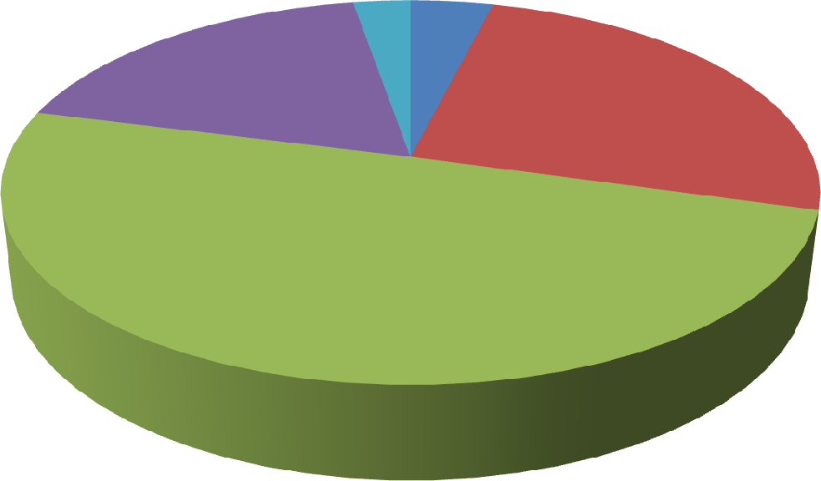

**18.3%**

**25.5%**

**49.6%**

**Rating given to the Employee Retention Effort**

**2.7% 3.9%**

Worst Poor Good

Very Good

Excellent

### Fig: 4.5.1: Performance Rating Given to the Employee Retention Effort

Table 4.5.1 tried to throw light on the frequencies and percentages of the performance ratings given by the employees to the retention effort. It has been clear from the above table and accompaning figure that approximately 71% of the respondents have rated their existing retention effort put by the organization within the range of good and excellent whereas 3.9% and 25.5% of the respondents have

rated it as worst and poor respectively. Thus it can be inferred that most of the respondents belonging to various service sectors are happy with the retention effort put by the organization.

### Table 4.5.2: Pearson Correlation Between Performance of Employee Retention Effort and Other Factors

|  |  |  |  |  |  |  |  |  |  |  |
| --- | --- | --- | --- | --- | --- | --- | --- | --- | --- | --- |
| Factors | R1 | F2 | F3 | F4 | F5 | F6 | F7 | F8 | F9 | F10 |
| R1 | 1 |  |  |  |  |  |  |  |  |  |
| F2 | .452(**) | 1 |  |  |  |  |  |  |  |  |
| F3 | .522(**) | .623(**) | 1 |  |  |  |  |  |  |  |
| F4 | .430(**) | .617(**) | .652(**) | 1 |  |  |  |  |  |  |
| F5 | .447(**) | .630(**) | .891(**) | .606(**) | 1 |  |  |  |  |  |
| F6 | .236(**) | .321(**) | .392(**) | .320(**) | .336(**) | 1 |  |  |  |  |
| F7 | .487(**) | .515(**) | .704(**) | .610(**) | .655(**) | .343(**) | 1 |  |  |  |
| F8 | .507(**) | .735(**) | .692(**) | .786(**) | .610(**) | .355(**) | .686(**) | 1 |  |  |
| F9 | .461(**) | .505(**) | .797(**) | .595(**) | .801(**) | .347(**) | .690(**) | .640(**) | 1 |  |
| F10 | .284(**) | .486(**) | .401(**) | .337(**) | .401(**) | .308(**) | .419(**) | .441(**) | .329(**) | 1 |

** Correlation is significant at the 0.01 level (2-tailed).

* Correlation is significant at the 0.05 level (2-tailed).

(R1= Performance Rating given to employee retention effort, F2= Compensation, F3=Recognition, F4=Career Progression, F5=Involvement in Decision making, F6= Work Life Balance, F7= Work Environment, F8= Training andLearning, F9= Leadership/ Supervision, F10= Job Security)

Table 4.5.2 tabulates the correlation matrix between the performance of the employee retention effort put by the organization and various factor under study. It has been evident from the table that a moderate correlation exists between the dependent variable and the various independent variables. For the first factor compensation (F2) a positive correlation of .452(**) at 1% level of significance can be observed. Parker and Wright (2001) opined that good compensation packages are the foundation element of a strong contractual bond between the employer and the employees. A very strong and positive correlation exist between R1 and reward (F3) offered by the organization. The value is .522(**) at 1% level of significance.

Similarly the next important factor affecting the rating given by the employees is training and learning (F8), the value being .507(**). For the other factors under consideration also we find a positive correlation. Fitzenz (1990) have identified several key factors which influences employee retention and some of which are culture prevailing in the organization, pay and benefits offered to the employees and career development system of the organization. Similar to the present study, Glen (2006) identified nine different factors which can help an organization in employee retention. The factors also termed as predictors’ organizational processes, role challenge, values, work, life balance, information, stake/leverage/recognition, management, work environment and product or service. Arnold (2005), Herman (2005), Hiltrop (1999) were of the view that proper training and opportunities to learn can increase employee retention**.** Birt *et. al*. (2004) opined that employee retention can be increased with the help of employee empowerment, offering responsibility and providing challenging work to the employees.

# Impact of Various Factors on Employee Retention

The factors identified have a positive correlation with employee retention as already shown in the above tables. But to have a more in depth knowledge about the effect of the factors upon employee retention, it is also essential to study the impact of each and every factor upon retention, only then the organizations can understand and work in the right direction. The impact has been studied with the help of Regression Analysis, the tables of which are shown below.

### Table 4.6.1: Regression Analysis

Variables Entered/ Removed

|  |  |  |  |
| --- | --- | --- | --- |
| Model | Variables Entered | Variables Removed | Method |
| 1 | Compensation, Career progression, Involvement in Decision making, Work Life Balance, Work Environment, Training andLearning, Leadership/  Supervision, Job Securitya | . | Enter |

* + 1. All requested variables entered
    2. Dependent Variable: Performance Rating given to the employee retention policy/ practices

### Model Summary

|  |  |  |  |  |
| --- | --- | --- | --- | --- |
| Model | R | R Square | Adjusted R Square | Std. Error of the Estimate |
| 1 | .579(a) | .336 | .324 | .685 |

a Predictors: (Constant), Job Security, Work life Balance, Promotion, Leadership, Compensation, Work environment, Involvement, Training, Reward

|  |  |  |  |  |  |
| --- | --- | --- | --- | --- | --- |
| Model | Un-standardized  Coefficients | | Standardized  Coefficients | t | Sig |
| B | Std. Error | Beta |
| 1(Constant) | -.292 | .282 |  | 1.033 | .302 |
| Compensation | .037 | .015 | .151 | 2.502 | .013 |
| Recognition | .079 | .020 | .351 | 3.846 | .000 |
| Career Progression | -.005 | .019 | -.017 | -.276 | .783 |
| Involvement in Decision | -.054 | .024 | -.200 | 2.208 | .028 |
| Work Life Balance | -.005 | .019 | -.011 | -.263 | .793 |
| Work Environment | .045 | .016 | .161 | 2.777 | .006 |
| Training and Learning | .028 | .017 | .124 | 1.613 | .107 |
| Leadership/ Supervision | .021 | .017 | .085 | 1.238 | .216 |
| Job Security | .006 | .029 | .009 | .201 | .841 |

a Dependent Variable: Performance Rating given to the employee retention policy/practices of the org

From the above regression analysis it can be noted that all the nine factors of retention under cosideration have an impact of 32.4% on rating given to the employee retention practices. The most important factors which have a huge

impact on the dependent variable are compensation (.013) (p< .05), recognition (.000) (p< .05), involvement in decision making (.028) (p< .05) and work environment (.006) (p< .05). Although in table 4.5.2 we have found a significant and positive correlation of other factors such as career progression , work life balance, training and learning, leadership and supervision and job security with the rating given by the employees towards the retention effort put by the organization, but they were over shadowed in the rgression analysis.

Hinshaw *et. al.*, (1987); Taunton *et. al.* (1989); Tett and Meyer (1993) have reported that those employees, who are satisfied with their job, tend to stay for a longer period in their job. Job satisfaction and factors relating to retention are closely related to one another.The factors which brings satisfaction to employees are used by the employers to retain the human resources in the organization. Job satisfaction variables differ from person to to person. Identifying the common factors and using them to retein the existing employees as well as attracting the future tale nt is one of the most difficlt tas that an organization faces today. Opkara (2002) opined that job satisfaction comes from the combined role of various factors such as salary, promotion, the work itself, supervision, relationships with co- workers and opportunities for growth. Lambert *et. al*., (2001) also highlighted important factors such as salary, promotion, performance appraisal system, relation with co-workers etc as vital determining factors of job satisfaction.

### Findings for Hypothesis H1

The hypothesis H1 proposed that compensation has a significant positive impact on employee retention. The correlation table supported the prediction and correlation was found to be r= .452(**) at 1% level of significance.

The B value of compensation is .151 that is it has an impact of 15.1% on employee retention. On the other hand t value is 2.502 which showed a significant impact on employee retention. Thus we accept H1.

### Findings for Hypothesis H2

The hypothesis H2 assumed that recognition has a significant positive impact on employee retention. The correlation between recognition and employee retention is r= .522(**) at 1% level of significance.

The B value of recognition is .351 which showed an impact of 35.1%. The t value is 3.846 which showed a significant impact on employee retention. Thus we accept the hypothesis H2.

### Findings for Hypothesis H3

The hypothesis H3 proposed that career progression has a positive impact employee retention. The correlation between promotion and employee retention is r= .430(**) at 1% level of significance.

The B value of career progression is -.017 and the t value is -.276 which is not significant. Thus our prediction is not supported by the result. Thus we reject the hypothesis H3.

### Findings for Hypothesis H4

Hypothesis H4 assumed that involvement in decision- making has a positive and significant impact on employee retention. The correlation between involvement in decision- making and employee retention is r= .447(**) at 1% level of significance. The B value of participation in decision making is -.200 that is it has an impact of 20% on employee retention. The t value is -2.208 which is significant. Thus we accept the hypothesis H4.

### Findings for Hypothesis H5

Hypothesis H5 predicted that increased work-life balance has a positive impact on employee satisfaction. The correlation table revealed a poor relation between work life balance and employee retention which is r= .236(**) at !% level of significance.

The B value of work life balance is -.011 and t value is -.263 which is not significant. Thus our prediction is wrong and we reject the hypothesis H5.

### Findings for Hypothesis H6

Hypothesis H6 proposes that healthy work environment has a positive impact on employee retention. The correlation between work environment and rating given to the employee retention effort as revealed in the table is r= .487(**) at 1% level of significance.

The B value for work environment is .161 which shows an impact of 16.1% on employee retention. The t value is calculated at 2.777 which are significant. Thus our assumption is correct and we accept the hypothesis H6.

### Findings for Hypothesis H7

Hypothesis H7 stated that proper training and learning has a positive and significant impact on employee retention. The correlation matrix shows a correlation of r=

.507(**) at 1% level of significance between training and learning and employee retention.

The B value for training and learning is .124 and t value is 1.613 which is not significant.Thus we reject the hypothesis H7.

### Findings for Hypothesis H8

Hypothesis H8 stated that good leadership and supervision results into higher employee retention. The correlation matrix shows a moderate correlation of r= .461

(**) at 1% level of significance between good leadership and supervision and employee retention.

The B value for leadership is .085 and t value is 1.238 which is insignificant. So we reject the hypothesis H8.

### Findings for Hypothesis H9

The hypothesis H9 proposed that job security has a positive impact on employee retention. The correlation betweenjob security and employee retention is r= .284 (**) at 1% level of significance.

The B value of job security is .009 and the t value is .201 which is not significant. Thus our prediction is not supported by the result. Thus we reject the hypothesis H9.

# Relationship Between and Impact of Factors of Retention Upon Job Satisfaction

The third important objective of the research investigation is to study the impact or effect of the retention initiatives on employee satisfaction. For this purpose it has been assumed that the retention factors has a positive and significant impact on employee satisfaction (Hypothesis H10).

Job satisfaction among employees is important for effectively carrying out the activities in an organization. Satisfied employees helps in bringing the all round development in an organization. Various factors collectively play a role in bringing satisfaction among the human resources. Here an attempt has been made to find out any association between various retention factors and the job satisfaction level among the employees.

### Table 4.7.1: Correlation Between Job Satisfaction and Various Factors

|  |  |  |  |  |  |  |  |  |  |  |
| --- | --- | --- | --- | --- | --- | --- | --- | --- | --- | --- |
| Factors | JS | F2 | F3 | F4 | F5 | F6 | F7 | F8 | F9 | F10 |
| JS | 1 |  |  |  |  |  |  |  |  |  |
| F2 | .106(*) | 1 |  |  |  |  |  |  |  |  |
| F3 | .111(*) | .623(**) | 1 |  |  |  |  |  |  |  |
| F4 | .035 | .617(**) | .652(**) | 1 |  |  |  |  |  |  |
| F5 | .112(*) | .630(**) | .891(**) | .606(**) | 1 |  |  |  |  |  |
| F6 | .087(*) | .321(**) | .392(**) | .320(**) | .336(**) | 1 |  |  |  |  |
| F7 | .108(*) | .515(**) | .704(**) | .610(**) | .655(**) | .343(**) | 1 |  |  |  |
| F8 | .115(**) | .735(**) | .692(**) | .786(**) | .610(**) | .355(**) | .686(**) | 1 |  |  |
| F9 | .052 | .504(**) | 791(**) | .591(**) | .796(**) | .352(**) | .678(**) | .633(**) | 1 |  |
| F10 | .134(**) | .486(**) | .401(**) | .337(**) | .401(**) | .308(**) | .419(**) | .441(**) | .328(**) | 1 |

* Correlation is significant at the 0.05 level (2-tailed).

** Correlation is significant at the 0.01 level (2-tailed).

(JS= Job Satisfaction , F2= Compensation, F3= Recognition, F4=Career Progression, F5= Involvement in Decision making, F6= Work Life Balance, F7= Work Environment, F8= Training andLearning, F9= Leadership/ Supervision, F10= Job Security)

Correlation between job satisfaction and the various factors of employee retention has been depicted in table 4.7.1 above. The table clearly reveals that employee retention factor such as career progression (r = .035) and leadership and supervision (r = .052) provided by the superiors has no significant relationship with job satisfaction. Although the respondents feel that these two factors are important for emloyee retention as depicted in table 4.5.2 but they are not considered relevant for giving job satisfaction. For the factor compensation a positive correlation has been found with job satisfaction with a value of .106 (*) at 5% significance level. Ali and Ahmed (2009) in their study statistically proved the relationship of reward and recognition with motivation and job satisfaction. As can be noted in the table above a positive correlation of .111(*) at 5% level of significance has been found for reward and job satisfaction. People give a lot of importance to the opportunities provided by the organizations to its employees in paricipating in various decisions of the organization. As can be observe in the table

a positive correlation of .112(*) has been found between involvement in decision making and job satisfaction. Cambey and Alexander (1998), in a survey found a positive impact of participation in decision-making upon job satisfaction. Flexibility in work schedules is very important for any employee because it helps in balancing their personal as well as their professional lives. Butler and Parsons (1989) concluded in their research that one of the important predictors of job satisfaction is flexibility in work schedules. Similarly as depicted in the table a positive correlation of .087(*) has been found between work life balance and job satisfaction. For work environment, also a positive correlation has been found, the r value being .108(*) at 5% level of significance. In case of training and learning and job security also a correlation of .115(**) and .134(**) respectively has been found a 1% level of significance**.** Kangas *et. al.*, (1999) reported that employees who perceive the work environment of the organization to be supportive tends to be more satisfied with their jobs.

### Table 4.7.2: Regression Analysis

Variables Entered/ Removeda

|  |  |  |  |
| --- | --- | --- | --- |
| Model | Variables Entered | Variables  Removed | Method |
| 1 | Compensation,Recognition , Career Progression, Involvement in Decision making, Work Life Balance,  Work Environment, Training andLearning, Leadership/ Supervision, Job Securitya | . | Enter |

* + 1. All requested variables entered
    2. Dependent Variable: Job Satisfaction

### Model Summary

|  |  |  |  |  |
| --- | --- | --- | --- | --- |
| Model | R | R Square | Adjusted R Square | Std. Error of the Estimate |
| 1 | .186(a) | .034 | .017 | 1.011 |

a Predictors: (Constant), Job Security, Work life Balance, Career Progression, Leadership, Compensation, Work environment, Involvement , Training, Reward

|  |  |  |  |  |  |
| --- | --- | --- | --- | --- | --- |
| Model | Un-standardised  Coefficients | | Standardized  Coefficients | t | Sig |
| B | Std.  Error | Beta |
| 1(Constant) | 2.003 | .533 |  | 3.759 | .000 |
| Compensation | -.017 | .027 | -.050 | -.630 | .529 |
| Recognition | .057 | .042 | .127 | 1.357 | .175 |
| Career Progression | -.030 | .031 | -.070 | -.965 | .335 |
| Involvement in Decision Making | -.038 | .031 | -.076 | -1.224 | .222 |
| Work Life Balance | -.041 | .035 | -.061 | -1.159 | .247 |
| Work Environment | -.024 | .031 | -.081 | -.783 | .434 |
| Training and Learning | .025 | .020 | .099 | 1.285 | .199 |
| Leadership and Supervision | -.042 | .035 | -.115 | -1.178 | .239 |
| Job Security | .086 | .060 | .082 | 1.434 | .152 |

a Dependent Variable: Job satisfaction

Table 4.7.2 tried to investigate the impact of the various retention factors upon job satisfaction among the various services sector organizations. The above table clearly reveals that none of the factors of retention have any significant impact upon job satisfaction.

### Findings of Hypothesis H10

Although in table 4.7.1 we have found that factors like compensation, recognition, participation in decision making, work life balance, training and learning and job security has a positive correlation with job satisfaction but the correlation was found to be very weak. Similarly for other factors like promotion and leadership no correlation was found. Thus it can be concluded that although these factors exist in the organizations under investigation but the respondents are not satisfied with the performance of the stated factors. Thus we reject the assumed hypothesis (H10).

# Comparison Between Genders With Respect to the Retention Factors

Individuals differ from each other in each and every aspect. No two individuals’ needs, wants, demands and expectations are same. Differences arise among individuals due to the various characteristics they possess and gender is one such aspect. The expectation and perceptions of both the genders working in an organization are different and the analysis below tries to find out if any differences exist between the genders with respect to the various retention factors.

### Table 4.8.1: Gender Difference in Relation to Various Factors of Retention

|  |  |  |  |  |  |  |  |
| --- | --- | --- | --- | --- | --- | --- | --- |
| Factors | Gender | N | Mean | Std.  Deviation | t | df | Sig. (2-tailed) |
| Compensation | Male | 211 | 16.13 | 3.126 | -.366 | 516 | .715 |
| Female | 307 | 16.24 | 3.509 |
| Recognition | Male | 211 | 20.63 | 3.664 | -1.307 | 516 | .192 |
| Female | 307 | 21.07 | 3.758 |
| Career Progression | Male | 211 | 14.01 | 2.664 | 1.161 | 516 | .246 |
| Female | 307 | 13.73 | 2.664 |
| Involvement in decision making | Male | 211 | 17.75 | 2.985 | -.605 | 516 | .545 |
| Female | 307 | 17.92 | 3.191 |
| Work life Balance | Male | 211 | 10.32 | 1.751 | -2.222 | 516 | .027* |
| Female | 307 | 10.66 | 1.716 |
| Work environment | Male | 211 | 23.00 | 3.271 | -1.000 | 516 | .318 |
| Female | 307 | 23.27 | 2.743 |
| Training and Learning | Male | 211 | 19.95 | 3.999 | -.068 | 516 | .946 |
| Female | 307 | 19.97 | 3.602 |
| Leadership | Male | 210 | 17.99 | 3.479 | -2.052 | 515 | .041* |
| Female | 307 | 18.61 | 3.257 |
| Job Security | Male | 211 | 8.19 | 1.277 | -.576 | 516 | .565 |
| Female | 307 | 8.25 | 1.234 |

In the above table an attempt has been made to investigate if there exist any significant differences between male and female respondents in the study with respect to the various retention factors under consideration. The total male

respondents have been 211 and as against it the total female respondents have been

307. Table:4.10 above clearly reveals that as to factors such as compensation, recognition, career progression ,participation in decision making, work environment, training and learning and job security , no significant difference have been found between the male and female respondents belonging to various services sectors under study. But the noticeable values are for factors ,work life balance and leadership and supervision. Significant difference have been found for the factors work life balance the value being .027(*) (p<.05) and leadership, the significant value being .041(*) (p< .05). If we observe the average mean scores of male and female employees for work life balance we find that the mean scores of male employees is (M= 10.32) smaller than that of its female counterparts (M= 10.66). The findings are similar to the one of Parasuraman and Simmers (2001) where, in their empirical research they have found that male workers in the work place experience lower work life balance than its female partners.

# Comparison Between Public and Private Sector With Respect to Various Factors of Retention

Next important objective that has been taken up in the study is to make a comparison between the public and private sector service organizations with regard to various retention measures. For the purpose of this objective, it has been assumed that there is no significant difference between the retention initiatives of public sector and private sector service organizations (Hypothesis H11)

Public sector and private sector organizations are considered to be different from each other. Starting from their organizational set up to the way of carrying out

activities, everything is different in them. Here the researcher has made an attempt to compare the public as well as private sector organizations in relation to factors of employee retention.

### Table 4.9.1:Public/ Private Sector Comparison in Relation to Various Factors of Retention

|  |  |  |  |  |  |  |  |
| --- | --- | --- | --- | --- | --- | --- | --- |
| Factors | Sector | N | Mean | Std.  Deviation | t | df | Sig. (2-tailed) |
| Compensation | Public | 271 | 16.10 | 3.439 | -.637 | 516 | .524 |
| Private | 247 | 16.29 | 3.265 |
| Recognition | Public | 271 | 20.72 | 3.786 | -1.055 | 516 | .292 |
| Private | 247 | 21.07 | 3.650 |
| Career Progression | Public | 271 | 13.50 | 2.739 | -3.100 | 516 | .002* |
| Private | 247 | 14.22 | 2.533 |
| Involvement in decision making | Public | 271 | 17.68 | 3.197 | -1.339 | 516 | .181 |
| Private | 247 | 18.04 | 3.000 |
| Work life Balance | Public | 271 | 10.62 | 1.850 | 1.305 | 516 | .192 |
| Private | 247 | 10.42 | 1.600 |
| Work environment | Public | 271 | 23.13 | 3.065 | -.235 | 516 | .814 |
| Private | 247 | 23.19 | 2.866 |
| Training and Learning | Public | 271 | 19.84 | 3.865 | -.760 | 516 | .448 |
| Private | 247 | 20.09 | 3.655 |
| Leadership | Public | 271 | 18.24 | 3.420 | -.824 | 515 | .410 |
| Private | 246 | 18.48 | 3.293 |
| Job Security | Public | 271 | 8.48 | 1.276 | 4.906 | 516 | .000* |
| Private | 247 | 7.95 | 1.164 |

Goulet and Frank (2002) asserted that in general everyone assumes that there exists difference in employees of public and private sector organizations. A comparison between public and private sector service organizations have been attempted to see if any differences exist between the respondents belonging to these two broad

sectors. All the ten factors of retention have been used to make the comparison. As is clear from the above table, 271 respondents belong to the public sector and 247 belong to the private sector. If we observe the table properly, we find that there does not exists any significant difference on important retention factors such as compensation, recognition, participation in decision making, work life balance, work environment, training and learning and leadership between the employees of the public as well as public sectors. This has been in contrast to the conclusion drawn by Frank and Lewis (2004) where it has been stated that private sector employees give more importance and value to salaries than public sector employees. In case of work life balance also a contradiction has been stated by Buelens and Van den Broeck (2007) where they found significant difference between work family conflict between public and private sector employees. The figures that needs attention have been of career progression .002(*) and job security .000(*) where significant difference exist between the respondents of public and private sector service organizations. In case of career progression we find that the average mean value of private sector employees (M= 14.22) has been more than that of public sector employees (M= 13.50). Thus we can say that private sector employees enjoy more promotional and growth opportunities than public sector employees. Moore (1979) has stated that although both the sectors that are private and public take care of the career development policies and practices of their employees, but the policies of private sector are more prevalent and stronger than that of the public sector. Again if the average mean scores of job security are taken into account, we find that in case of public sector the average mean value is M= 8.48 and that of private sector is M= 7.95, i.e., public sector

enjoy more job security than that of private sector**.** Jurkiewicz *et. al*. (1998) found that people working in public sector put stable and secure future on the top of their priority list whereas their private counterparts put more importance to high salary.

# Effect of Various Retention Factors on Public and Private Sector Organizations

Comparison between public and private sector organizations would be incomplete until and unless the effect of various factors of retention are studied. The tables below helps in understanding the impact of various factors of identified employee retention upon the performance of employee retention.

### Public Vs. Private

**Table 4.10.1 (i) Regression Analysis of Public Sector**

Variables Entered/ Removeda

|  |  |  |  |
| --- | --- | --- | --- |
| Model | Variables Entered | Variables Removed | Method |
| 1 | Compensation, Career Progression, Invo;vement in Decision making, Work Life Balance, Work Environment, Training and Learning, Leadership/ Supervision, Job Securitya | . | Enter |

* + 1. All requested variables entered
    2. Dependent Variable: Rating given to the employee retention policy/ practices

### Model Summary

|  |  |  |  |  |
| --- | --- | --- | --- | --- |
| Model | R | R Square | Adjusted R Square | Std. Error of the Estimate |
| 1 | .546(a) | .298 | .274 | .676 |

a Predictors: (Constant), Job Security, Work life Balance,Career Progression , Leadership, Compensation, Work environment, Participation, Training and Learning, Recognition

|  |  |  |  |  |  |
| --- | --- | --- | --- | --- | --- |
| Model | Un-  standardized Coefficients | | Standardized Coefficients | t | Sig |
| B | Std. Error | Beta |
| 1(Constant) | .136 | .381 |  | .358 | .721 |
| Compensation | .015 | .019 | .066 | .793 | .429 |
| Recognition | .076 | .028 | .363 | 2.734 | .007 |
| Career Progression | .004 | .024 | .363 | .184 | .854 |
| Involvement in Decision | .044 | .032 | -.176 | -1.376 | .170 |
| Work Life Balance | .010 | .026 | -.022 | -1.376 | .708 |
| Work Environment | .047 | .021 | .181 | 2.243 | .026 |
| Training and Learning | .031 | .021 | .152 | 1.466 | .144 |
| Leadership/ Supervision | .005 | .023 | .023 | .240 | .811 |
| Job Security | .008 | .038 | -.013 | -.206 | .837 |

a Dependent Variable: Rating given to the employee retention policy/practices of the org

### Table 4.10.1(ii) Regression Analysis of Private Sector

Variables Entered/ Removeda

|  |  |  |  |
| --- | --- | --- | --- |
| Model | Variables Entered | Variables Removed | Method |
| 1 | Compensation, Career Progression, Involvement in Decision making, Work Life Balance, Work Environment, Training and Learning, Leadership/ Supervision, Job Securitya | . | Enter |

1. All requested variables entered
2. Dependent Variable: Performance Rating given to the employee retention policy/ practices

### Model Summary

|  |  |  |  |  |
| --- | --- | --- | --- | --- |
| Model | R | R Square | Adjusted R Square | Std. Error of the Estimate |
| 1 | .630(a) | .397 | .374 | .693 |

a Predictors: (Constant), Job Security, Work life Balance, Promotion, Leadership, Compensation, Work environment, Involvement in decision making, Training, Reward

|  |  |  |  |  |  |
| --- | --- | --- | --- | --- | --- |
| Model | Un-  standardized Coefficients | | Standardized Coefficients | t | Sig |
| B | Std.  Error | Beta |
| 1(Constant) | .956 | .434 |  | -2.204 | .028 |
| Compensation | .078 | .434 | .293 | 3.054 | .003 |
| Recognition | .081 | .030 | .337 | 2.659 | .008 |
| Career Progression | .054 | .035 | -.156 | -1.530 | .127 |
| Involvement in Decision | .062 | .038 | -.214 | -1.638 | .103 |
| Work Life Balance | .017 | .031 | .032 | .561 | .575 |
| Work Environment | .052 | .027 | .171 | 1.979 | .049 |
| Training and Learning | .025 | .029 | .103 | .852 | .395 |
| Leadership/ Supervision | .029 | .026 | .110 | 1.118 | .265 |
| Job Security | .046 | .049 | .062 | .951 | .342 |

1. Dependent Variable: Performance Rating given to the employee retention policy/practices

In table 4.10.1 a regression analysis has been done to study the impact of the various retention factors on employee retention among the public as well as private sector organizations under investigation. If we observe table 4.10.1(i) we find that all the nine retention factors have an impact of 27.4% on the dependent variable. On the other hand in case of private sector (Table 4.10.1(ii)) the impact is greater with 37.4%. Similarly if we observe the individual factors, we find that in case of public sector organizations recognition and work environment has the greatest impact with p=.007< .05 and p= .026< .05 respectively. But in case of private sector, three important factors viz., compensation, recognition and work environment are the most important factors. The p values of all the three factors are compensation, p=.003, recognition p= .008 and work environment p= .049. Thus from the tables above it can be concluded that retention of private sector employees

are more affected by the factors under study than that of the public sector. Wright (2001) after reviewing various literatures revealed that motivation for doing work always differs among public and private sector employees.

### Table 4.10.2: Sub Sector Wise Division of Public/Private Service Sectors and Difference in Various Factors Between Various Sub- Sectors Under Study

|  |  |  |  |  |  |  |
| --- | --- | --- | --- | --- | --- | --- |
| Factors | Sectors | N | Mean | S.D | F | Sig |
| Compensation | Private Schools | 50 | 14.20 | 3.326 | 13.809 | .000 |
| State Govt Schools | 31 | 14.42 | 3.784 |
| Central Schools | 30 | 16.20 | 2.797 |
| Private Colleges | 54 | 15.35 | 2.489 |
| Provincialised Colleges | 62 | 14.18 | 3.467 |
| Private Hospitals | 51 | 18.06 | 3.361 |
| Government Hospitals | 55 | 18.96 | 3.150 |
| Private Banks | 51 | 17.02 | 2.581 |
| Nationalised banks | 53 | 16.23 | 2.284 |
| Private Insurance | 41 | 16.98 | 3.094 |
| LICI | 40 | 16.23 | 2.412 |
| Recognition | Private Schools | 50 | 19.08 | 3.492 | 5.907 | .000 |
| State Govt Schools | 31 | 19.61 | 3.528 |
| Central Schools | 30 | 20.50 | 3.501 |
| Private Colleges | 54 | 20.46 | 3.468 |
| Provincialised Colleges | 62 | 19.55 | 4.555 |
| Private Hospitals | 51 | 23.16 | 3.646 |
| Government Hospitals | 55 | 22.05 | 3.076 |
| Private Banks | 51 | 20.73 | 3.118 |
| Nationalised banks | 53 | 21.17 | 3.239 |
| Private Insurance | 41 | 22.12 | 3.164 |
| LICI | 40 | 21.15 | 3.853 |

|  |  |  |  |  |  |  |
| --- | --- | --- | --- | --- | --- | --- |
| Factors | Sectors | N | Mean | S.D | F | Sig |
| Career Progression | Private Schools | 50 | 12.46 | 2.288 | 8.680 | .000 |
| State Govt Schools | 31 | 11.55 | 4.114 |
| Central Schools | 30 | 13.83 | 2.379 |
| Private Colleges | 54 | 14.00 | 1.863 |
| Provincialised Colleges | 62 | 13.10 | 2.468 |
| Private Hospitals | 51 | 15.61 | 2.367 |
| Government Hospitals | 55 | 13.47 | 2.441 |
| Private Banks | 51 | 14.49 | 2.248 |
| Nationalised banks | 53 | 14.58 | 2.257 |
| Private Insurance | 41 | 14.61 | 2.914 |
| LICI | 40 | 14.00 | 2.219 |
| Involvement in decision making | Private Schools | 50 | 16.46 | 3.327 | 5.658 | .000 |
| State Govt Schools | 31 | 16.81 | 3.270 |
| Central Schools | 30 | 17.40 | 2.634 |
| Private Colleges | 54 | 17.74 | 2.466 |
| Provincialised Colleges | 62 | 16.65 | 3.799 |
| Private Hospitals | 51 | 19.65 | 2.848 |
| Government Hospitals | 55 | 18.78 | 2.872 |
| Private Banks | 51 | 17.67 | 2.703 |
| Nationalised banks | 53 | 17.77 | 2.686 |
| Private Insurance | 41 | 18.85 | 2.660 |
| LICI | 40 | 18.53 | 2.987 |
| Work life Balance | Private Schools | 50 | 10.20 | 1.471 | 4.483 | .000 |
| State Govt Schools | 31 | 10.10 | 2.508 |
| Central Schools | 30 | 10.33 | 1.583 |
| Private Colleges | 54 | 10.41 | 1.677 |
| Provincialised Colleges | 62 | 9.97 | 1.504 |
| Private Hospitals | 51 | 11.10 | 1.315 |
| Government Hospitals | 55 | 11.55 | 1.951 |
| Private Banks | 51 | 10.02 | 1.581 |
| Nationalised banks | 53 | 10.85 | 1.622 |
| Private Insurance | 41 | 10.34 | 1.797 |
| LICI | 40 | 10.65 | 1.562 |

|  |  |  |  |  |  |  |
| --- | --- | --- | --- | --- | --- | --- |
| Factors | Sectors | N | Mean | S.D | F | Sig |
| Work environment | Private Schools | 50 | 22.36 | 2.768 | 2.893 | .002 |
| State Govt Schools | 31 | 22.68 | 3.370 |
| Central Schools | 30 | 23.63 | 2.341 |
| Private Colleges | 54 | 23.06 | 2.269 |
| Provincialised Colleges | 62 | 22.60 | 3.211 |
| Private Hospitals | 51 | 24.37 | 2.771 |
| Government Hospitals | 55 | 23.33 | 2.510 |
| Private Banks | 51 | 22.53 | 3.107 |
| Nationalised banks | 53 | 22.64 | 3.335 |
| Private Insurance | 41 | 23.76 | 3.015 |
| LICI | 40 | 24.33 | 3.149 |
| Training and Learning | Private Schools | 50 | 18.24 | 3.701 | 8.174 | .000 |
| State Govt Schools | 31 | 19.03 | 4.207 |
| Central Schools | 30 | 21.43 | 3.137 |
| Private Colleges | 54 | 19.28 | 3.171 |
| Provincialised Colleges | 62 | 17.40 | 4.022 |
| Private Hospitals | 51 | 22.14 | 2.871 |
| Government Hospitals | 55 | 20.64 | 3.674 |
| Private Banks | 51 | 20.39 | 3.365 |
| Nationalised banks | 53 | 20.77 | 3.326 |
| Private Insurance | 41 | 20.51 | 4.100 |
| LICI | 40 | 20.73 | 2.996 |
| Leadership | Private Schools | 50 | 16.70 | 3.610 | 5.395 | .000 |
| State Govt Schools | 31 | 17.35 | 3.564 |
| Central Schools | 30 | 18.03 | 3.873 |
| Private Colleges | 54 | 18.63 | 2.722 |
| Provincialised Colleges | 62 | 17.63 | 3.997 |
| Private Hospitals | 51 | 20.63 | 2.645 |
| Government Hospitals | 55 | 18.71 | 2.629 |
| Private Banks | 50 | 17.56 | 2.865 |
| Nationalised banks | 53 | 18.28 | 3.165 |
| Private Insurance | 41 | 18.93 | 3.274 |
| LICI | 40 | 19.33 | 3.058 |

|  |  |  |  |  |  |  |
| --- | --- | --- | --- | --- | --- | --- |
| Factors | Sectors | N | Mean | S.D | F | Sig |
| Job Security | Private Schools | 50 | 7.66 | 1.206 | 7.182 | .000 |
| State Govt Schools | 31 | 8.81 | 1.352 |
| Central Schools | 30 | 7.97 | 1.542 |
| Private Colleges | 54 | 7.80 | .833 |
| Provincialised Colleges | 62 | 7.94 | 1.436 |
| Private Hospitals | 51 | 8.49 | .834 |
| Government Hospitals | 55 | 8.84 | 1.102 |
| Private Banks | 51 | 7.98 | 1.378 |
| Nationalised banks | 53 | 8.55 | 1.011 |
| Private Insurance | 41 | 7.80 | 1.364 |
| LICI | 40 | 8.88 | .853 |

Table 4.10.2 above shows the sub sectors of various public and private service sectors. The above table analyses if there exsist any difference between the various sub sectors in relation to various retention initiative. In case of the first factor i.e., compensation it can be observed that there is significant difference, with F value 13.809 and significant value .000. In case of reward also there is significant difference with F value 5.907 and significant level .000. Again if we observe the values of career progression and participation in decision making, there exist significant difference with F value 8.680 and 5.658 respectively and significant value being .000 each. In case of other factors i.e, work life balance, work environment, training and learning, leadership and job security significant difference has been found between the various service sectors under study.

### Table 4.10.3: Difference in Various Factors Between Various Service Sectors

|  |  |  |  |  |  |  |
| --- | --- | --- | --- | --- | --- | --- |
| Factors | Sectors | N | Mean | S.D | F | Sig |
| Compensation | Educational Institution | 227 | 14.76 | 3.246 | 38.817 | .000 |
| Hospital | 106 | 18.53 | 3.270 |
| Banks | 104 | 16.62 | 2.455 |
| Insurance | 81 | 16.60 | 2.787 |
| Recognition | Educational Institution | 227 | 19.80 | 3.820 | 16.283 | .000 |
| Hospital | 106 | 22.58 | 3.391 |
| Banks | 104 | 20.95 | 3.173 |
| Insurance | 81 | 21.64 | 3.533 |
| Career Progression | Educational Institution | 227 | 13.06 | 2.692 | 12.721 | .000 |
| Hospital | 106 | 14.50 | 2.623 |
| Banks | 104 | 14.54 | 2.242 |
| Insurance | 81 | 14.31 | 2.596 |
| Involvement in decision making | Educational Institution | 227 | 16.99 | 3.207 | 15.778 | .000 |
| Hospital | 106 | 19.20 | 2.880 |
| Banks | 104 | 17.72 | 2.682 |
| Insurance | 81 | 18.69 | 2.814 |
| Work life Balance | Educational Institution | 227 | 10.19 | 1.710 | 11.124 | .000 |
| Hospital | 106 | 11.33 | 1.683 |
| Banks | 104 | 10.44 | 1.648 |
| Insurance | 81 | 10.49 | 1.682 |
| Work environment | Educational Institution | 227 | 22.80 | 2.833 | 6.769 | .000 |
| Hospital | 106 | 23.83 | 2.678 |
| Banks | 104 | 22.59 | 3.210 |
| Insurance | 81 | 24.04 | 3.076 |
| Training and Learning | Educational Institution | 227 | 18.79 | 3.859 | 15.128 | .000 |
| Hospital | 106 | 21.36 | 3.381 |
| Banks | 104 | 20.59 | 3.334 |
| Insurance | 81 | 20.62 | 3.576 |

|  |  |  |  |  |  |  |
| --- | --- | --- | --- | --- | --- | --- |
| Factors | Sectors | N | Mean | S.D | F | Sig |
| Leadership | Educational Institution | 227 | 17.68 | 3.598 | 10.706 | .000 |
| Hospital | 106 | 19.63 | 2.796 |
| Banks | 104 | 17.93 | 3.030 |
| Insurance | 81 | 19.12 | 3.156 |
| Job Security | Educational Institution | 227 | 7.96 | 1.306 | 8.326 | .000 |
| Hospital | 106 | 8.67 | .993 |
| Banks | 104 | 8.27 | 1.232 |
| Insurance | 81 | 8.33 | 1.255 |

As already observed in Table 4.10.2, in case of all the relevant factors of retention under investigation, the researcher has observed significant difference between various public and private sub sectors of services organizations. Table 4.10.3 combines the various public and private organizations under each individual service sector such as education, health, banking and insurance and tries to examine if there is any difference with regard to various factors of retention. Table

4.10.3 clearly reveals that for each and every factor of retention, there exist significant differences between four service sectors under investigation.

### Table 4.10.4:Public/ Private Comparison With Respect to Performance Rating of Employee Retention Effort

|  |  |  |  |  |  |
| --- | --- | --- | --- | --- | --- |
|  | Sector | N | Mean | Std.  Deviation | Std. Mean Error |
| Rating given to the employee retention effort | Public | 271 | 2.87 | .793 | .048 |
| Private | 247 | 2.94 | .874 | .056 |

|  |  |  |  |  |
| --- | --- | --- | --- | --- |
| Particulars | t-test for Equality of Means | | | |
|  | t | df | Sig. (2-  tailed) | Mean Difference |
| Rating given to the employee retention policy/practices of the org | -.884 | 516 | .377 | -.065 |

The above table highlights if any difference exist between the public and private sector service organizations with regard to the performance rating given to the retention efforts. The table clearly shows that no significant difference exist between the two service sectors as the t value was found to be - .884.

### Findings of Hypothesis H11

Hypothesis H11 assumed that there is no significant difference between the retention initiatives of public sector and private sector service organizations. All the nine retention factors have an impact of 27.4% on the dependent variable. On the other hand in case of private sector ,the impact is greater with 37.4%. Taking into account the individual factors, we find that in case of public sector organizations reward and work environment has the greatest impact with p=.007< .05 and p= .026< .05 respectively. But in case of private sector three important factors viz., compensation, recognition and work environment being the most important factors. The p values of all the three factors are compensation, p=.003, recognition p= .008 and work environment p= .049. Besides this no significant difference exist between the two service sectors as regards the performance of the employee retention effort. Thus we accept the hypothesis H11.

# Comparison Between Male and Female Employees With Respect to Job Satisfaction

Level of satisfaction with respect to the common factors of retention may or may not differ among employees and among public and private sector in which they are

employed. The following tables’ attempts to make a comparison among the employees based on their gender and the sectors in which they are employed.

### Table 4.11.1: Male/ Female Comparison With Respect to Job Satisfaction

|  |  |  |  |  |  |
| --- | --- | --- | --- | --- | --- |
|  | Gender of the respondent | N | Mean | Std.  Deviation | Std. Mean Error |
| Satisfaction with the present job | Male | 211 | 3.07 | 1.005 | .069 |
| Female | 307 | 3.07 | 1.030 | .059 |
| Rating given to the employee retention effort | Male | 211 | 2.92 | .838 | .058 |
| Female | 307 | 2.90 | .830 | .047 |

|  |  |  |  |  |
| --- | --- | --- | --- | --- |
| Particulars | t-test for Equality of Means | | | |
|  | t | df | Sig. (2-  tailed) | Mean Difference |
| Satisfaction with the present job | -.006 | 516 | .995 | -.001 |
| Rating given to the employee retention policy/practices of the org | .318 | 516 | .751 | .024 |

The above tables’ tries to highlight, if any difference exist between the male and female respondents with respect to job satisfaction and their perception with respect to the employee retention effort put by their respective organizations. As already stated in the previous discussion, out of the 518 respondents in the 211 of them are male and 307 are female. The table clearly reveals that no significant difference exist between the male and female respondents with respect to their satisfaction towards their respective jobs and the rating given by the employees towards the various retention practices adopted by their organizations. The findings of the study are similar to the one founded by Al- Ajmi (2006) where a survey was conducted in Kuwait and it was concluded that both male and female employees have the same level of job satisfaction and no significant difference exist between

the two groups. Similarly in another survey carried out by Linz (2003) in Russia concluded that no significant difference exists between the male and female employees in an organization with respect to the level of job satisfaction.

# Comparison Between Public and Private Sector Employees With Respect to Job Satisfaction

The last objective formulated in the study is to make a critical and comparative analysis between the public and private sector service organizations with regard to employee satisfaction. The hypothesis framed for the purpose is, no significant difference exist between the public sector and private sector service organizations with respect to the job satisfaction level of the employees (Hypothesis H12)

Job satisfaction level varies widely among individuals and the sector in which they are employed. It differs from person to person and measuring it is a difficult task. The following table shows, if any differences exist between the employees working in public and private sector service organizations with respect to satisfaction with their jobs.

### Table 4.12.1: Public/ Private Comparison With Respect to Job Satisfaction

|  |  |  |  |  |  |
| --- | --- | --- | --- | --- | --- |
|  | Sector | N | Mean | Std.  Deviation | Std. Mean Error |
| Satisfaction with the present job | Public | 271 | 3.35 | 1.025 | .062 |
| Private | 247 | 2.77 | .924 | .059 |
| Rating given to the employee retention effort | Public | 271 | 2.87 | .793 | .048 |
| Private | 247 | 2.94 | .874 | .056 |

|  |  |  |  |  |
| --- | --- | --- | --- | --- |
| Particulars | t-test for Equality of Means | | | |
|  | t | df | Sig. (2-  tailed) | Mean Difference |
| Satisfaction with the present job | 6.716 | 516 | .000 | .578 |
| Rating given to the employee retention policy/practices of the org | -.884 | 516 | .377 | -.065 |

Table 4.12.1 above depicts the figures for the comparison of public and private sector with respect to job satisfaction and performance of the employee retention effort. The above table shows, with respect to job satisfaction, significant difference exist between the employees working in the private as well as private sector. The employees of the public sector are more satisfied than those of the private sector as M=3.35 in case of public sector employees as compared to M=2.77 in case of private sector employees. But in case of performance of the employee retention effort, it can be observed that no significant difference exists between the public and the private sector.

### Findings of Hypothesis H12

Hypothesis H12 proposed that no significant difference exist between the public sector and private sector service organizations with respect to the job satisfaction level of the employees. An attempt has been made to find out, if any difference exists between the employees of the public as well as private sector with respect to the job satisfaction. From the above tables it is clear that significant difference exist between the public and the private sector with significant value being .000 < p<

0.05 with regard to job satisfaction. If we observe the average mean values of both the public and private sector employees, we find that average mean of public sector (M= 3.35) is higher than private sector (M= 2.77). Thus it can be concluded that

the employees of the public sector are more satisfied with their jobs than that of the private sector. Thus we reject the hypothesis H12.

# Banks

Banks are the custodian of our assets. Bankers take the pain of keeping our money and other valuable assets such as cash, jewellery, important papers etc. Bankers also take the headache of investing our financial resources in such areas from which we can get maximum return. The banking industry plays a very crucial role in our economy. This sector is growing and flourishing at a very rapid pace. Both the private as well as the public players in this sector are trying to deliver their best services to its customers. Human resources are the most crucial resources in the banking industry. Banks today are very selective in choosing their human resources, since now a day the people working in banks have to work under too much pressurized environment. Due to growing competition and in the race of providing the best services to the customers, people working in banks have to work very hard and under pressure. Since human beings are very important for the success of the business of the banks, it is very important that the organizations take good care of its human resources. Retaining these resources has become difficult now because of too many players in this area of business. Besides this the resources need to be satisfied properly so that they deliver their crucial services properly and remain in the organization for longer period of time. In a study by Ahmed Imran Hunjra *et.al,* (2010) among employees working in banks in Pakistan it was concluded that there is a positive relationship between autonomy, leadership behaviour and team work environment and job satisfaction. These factors help in

retaining employees in the organization. In a survey among 186 bank employees in Bahawalpur district in Pakistan, it has been found that variables like organizational policy and strategy, nature of work, communication, job stress, employee personality and recruitment and selection procedures have positive association with employees job satisfaction. Saba Sattar and Shehzad Ahmed (2014) in their research among bank employees found a great impact of work environment, career growth, compensation, job stress on employee turnover. Kanwal Ambreen and Majid Muhammad (2013) forwarded the view that salary, proper reward system, good training and development facilities help in retaining bank employees.

## Respondents’ Profile

The tables given below depicts the respondents’ demographic and job profile working in various public and private sector banks in the city of Guwahati.

### Table 4.13.1(i): Gender of Respondents

|  |  |  |  |  |  |  |
| --- | --- | --- | --- | --- | --- | --- |
| Particulars | Gender of Respondents | | | | Total | |
|  | Male | | Female | |  | |
|  | No. | Percentage | No. | Percentage | No. | Percentage |
| Nationalised Banks | 33 | 31.7 | 20 | 19.3 | 53 | 51.0 |
| Private banks | 39 | 37.5 | 12 | 11.5 | 51 | 49.0 |
| Total | 72 | 69.2 | 32 | 30.8 | 104 | 100 |

*Source: Field Survey, 2013-14*

40

35

30

25

20

15

10

5

0

Nationalised Banks

Private banks

Male Female

### Fig 4.13.1(i): Gender of Respondents

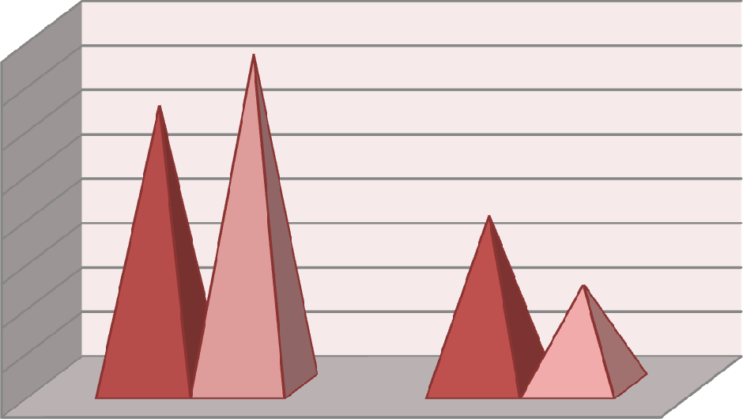

37.5

31.7

19.3

11.5

In the banking sector a total of 104 respondents were there. Out of these, 72 respondents were male and 32 respondents were female. Out of the 72 male respondents 31.7% belong to nationalized banks and 37.5% belong to private banks. Similarly in case of female respondents 19.3% of the respondents belong to nationalized banks and 11.5% of the respondents belong to the private banking sector.

### Table 4.13.1(ii): Age of the Respondents

|  |  |  |  |  |  |  |  |  |  |  |
| --- | --- | --- | --- | --- | --- | --- | --- | --- | --- | --- |
| Particulars | Age of the respondent | | | | | | | | Total | |
|  | 18yrs-29yrs | | 30yrs-39yrs | | 40yrs-55yrs | | 55yrs above | |  |  |
|  | No. | % | No. | % | No. | % | No. | % | No. | % |
| Nationalised Banks | 16 | 15.4 | 15 | 14.4 | 14 | 13.5 | 8 | 7.7 | 53 | 51.0 |
| Private Banks | 17 | 16.3 | 23 | 22.1 | 9 | 8.7 | 2 | 2.0 | 51 | 49.0 |
| Total | 33 | 31.7 | 38 | 36.5 | 23 | 22.2 | 10 | 9.7 | 104 | 100 |

*Source: Field Survey, 2013-14*

25

20

15

10

Nationalised Banks

Private Banks

5

0

18yrs-29yrs 30yrs-39yrs 40yrs-55yrs 55yrs above

### Fig 4.13.1(ii): Age of the Respondents

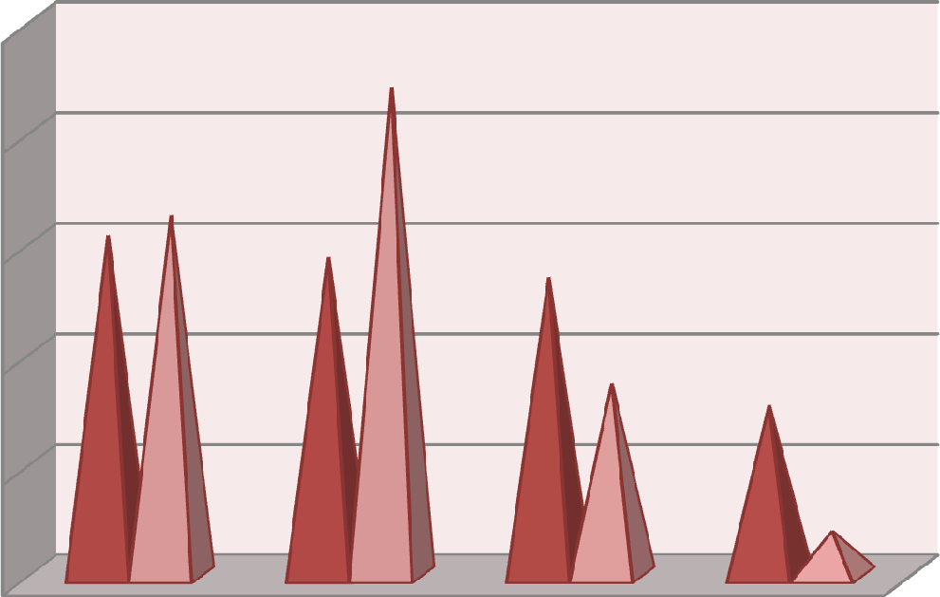

22.1

15 16.3

.4

14.4

13.5

8.7

7.7

2

Table and Fig 4.13.1(ii) depicts the age of the respondents belonging to the banking sector. The table shows that 31.7% of the respondents belong to the age group of 18 years to 29 years. 36.5% of the respondents come within the group of 29years to 39 years of age. 22.2 % and 9.7% of the respondents belong to the age group of 39 years to 55 years and above 55 years of age group respectively.

### Table 4.13.1(iii): Job Experience of Respondents

|  |  |  |  |  |  |  |  |  |  |  |  |  |
| --- | --- | --- | --- | --- | --- | --- | --- | --- | --- | --- | --- | --- |
| Particulars | Job Experience | | | | | | | | | | Total | |
|  | >1yr | | 1yr-5yrs | | 5yrs- 10yrs | | 10yrs- 15yrs | | <15yrs | |  | |
|  | No. | % | No. | % | No. | % | No. | % | No. | % | No. | % |
| Nationalised Banks | 7 | 6.7 | 17 | 16.3 | 6 | 5.8 | 2 | 2.0 | 21 | 20.2 | 53 | 51.0 |
| Private Banks | 12 | 11.5 | 23 | 22.1 | 8 | 7.7 | 1 | 1.0 | 7 | 6.7 | 51 | 49.0 |
| Total | 19 | 18.2 | 40 | 38.4 | 14 | 13.5 | 3 | 3.0 | 28 | 26.9 | 104 | 100 |

*Source: Field Survey, 2013-14*

25

20

15

10

Nationalised Banks

Private Banks

5

0



### Fig 4.13.1(iii): Job Experience of Respondents

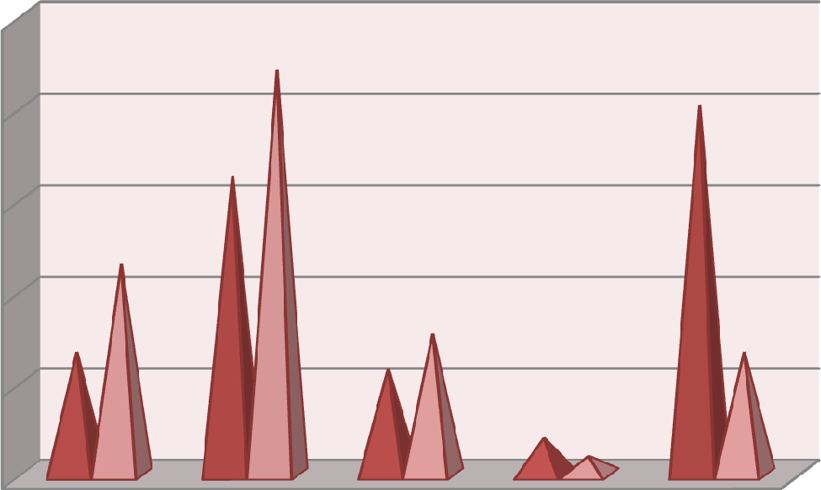

22.1

20.2

16.3

11.5

6.7

7.7

5.8

6.7

2

1

Table and Fig 4.13.1(iii) shows the years of service of the employees in their respective organization. Out of the 104 respondents, 18.2% of the respondents have job experience of less than a year. 38.4% of the respondents have a work experience of 1 year to 5 years. Only 3% of the employees have an experience of 10 years to 15 years of job experience and 26.9% have the work experience of more than 15 years.

## Association Between Importance of Retention Effort and Various Factors

Table 4.13.2 tried to find out if any association is there between the importance given by the employees towards the employee retention effort and the factors under consideration. The results are shown below.

### Table 4.13.2: Correlation Between Employee Retention Effort and Various Factors of Retention

|  |  |  |  |  |  |  |  |  |  |  |  |
| --- | --- | --- | --- | --- | --- | --- | --- | --- | --- | --- | --- |
| Factors | | F1 | F2 | F3 | F4 | F5 | F6 | F7 | F8 | F9 | F10 |
| F1 | Pearson Correlation | 1 | .125 | .031 | .263(**) | .014 | .000 | -.063 | .097 | -.017 | .052 |
| Sig (2- tailed) | |  | .206 | .755 | .007 | .884 | .997 | .527 | .328 | .867 | .601 |
| N | | 104 | 104 | 104 | 104 | 104 | 104 | 104 | 104 | 104 | 104 |

** Correlation is significant at the 0.01 level (2-tailed).

* Correlation is significant at the 0.05 level (2-tailed).

(F1= Employee retention effort, F2= Compensation, F3= Recognition, F4= Career Progression, F5=Involvement in Decision making, F6= Work Life Balance, F7= Work Environment, F8= Training andLearning, F9= Leadership/ Supervision, F10= Job Security)

The table clearly reveals that except for career progression (F4) there does not exists any positive or strong correlation between retention efforts put by the organizations. The Pearson correlation of employee retention effort with career progression is .263(**) at 1% level of significance. Lynn (1997) offered the view that employees in any organization must be provided with career advancement opportunities to retain them in the place of work.

## Relationship Between Performance of the Employee Retention Effort and Factors of Retention:

Table 4.3.5 attempts to find out the relationship between performance of the employee retention effort put by the banks for its employees and the various retention factors under investigation.

### Table 4.13.3: Correlation Between Performance Rating given to Employee Retention Effort and Various Factors of Retention

|  |  |  |  |  |  |  |  |  |  |  |  |
| --- | --- | --- | --- | --- | --- | --- | --- | --- | --- | --- | --- |
| Factors | | R1 | F2 | F3 | F4 | F5 | F6 | F7 | F8 | F9 | F10 |
| R 1 | Pearson Correla tion | 1 | .371  (**) | .430  (**) | .345  (**) | .359  (**) | .204  (*) | .383  (**) | .353  (**) | .374  (**) | .141 |
| Sig (2- tailed) | |  | .000 | .000 | .000 | .000 | .038 | .000 | .000 | .000 | .154 |
| N | | 104 | 104 | 104 | 104 | 104 | 104 | 104 | 104 | 104 | 104 |

** Correlation is significant at the 0.01 level (2-tailed).

* Correlation is significant at the 0.05 level (2-tailed).

(R1= Rating given to employee retention effort, F2= Compensation, F3= Recognition, F4=Career progression, F5= Involvement in Decision making, F6= Work Life Balance, F7= Work Environment, F8= Training andLearning, F9= Leadership/ Supervision, F10= Job Security)

If we see the relationship between R1 and F2, we find a correlation of .371(**). It means compensation plays an important role in retaining employees. Experts such as Lawler (1990) opined that the main key issue in employee retention is the amount of compensation offered by the organization in comparison to other organizations in the same industry. Hansen (2002) forwarded the view that in order to retain the employees in an organization the employer needs to pay more to the employees. Similarly from the above table, it can be observed that in case of recognition, career progression, involvement in decision making, work environment, training and learning, leadership and job security a positive correlation is found with values .430(**), .345(**), .359(**), .383(**), .353(**), and .374(**) respectively at .01 level of significance. Correlation between F6 and R1 is .204(*) at 5 % level of significance**.** Susan Dibble (1999) gave a very interesting view towards rewards. She was of the view that although money is important reward but it may not always works in all situations. This was proved by her in a survey where is found that a quarter of her respondents left their previous job because of lack of appreciation and lack of being feel valued. In a survey of

448 employees reported on by Dibble (1999) conducted a survey among 448 employees and found that flexibility in hours of work was the third most important factor which employees think important to remain in the organization. A Report on Business (2004) reported that in a survey conducted among 16 Canadian CEOs, they gave importance in reducing workplace stress to maintain a good work environment**.** Meyer *et. al.*, (2003) was of the view that training and development is a form of socialization process in the workplace which helps in the retention of the employees. Meyer was of the view that training and development helps in increasing employee commitment, relieving from stress, serves as an incentive to stay and helps in creating a caring culture. Ontario (2004) argued that good supervision by the leaders is very essential. According to Ontario support from the leaders is very important because employees don’t leave organization they leave the leaders.

## Impact of Various Factors Upon Employee Retention

The following table shows the impact of various factors on employee retention of employees working in banks.

### Table 4.13.4: Regression Analysis

Variables Entered/ Removeda

|  |  |  |  |
| --- | --- | --- | --- |
| Model | Variables Entered | Variables Removed | Method |
| 1 | Compensation,Recognition, Career progression, Involvement in Decision making, Work Life Balance, Work Environment, Training andLearning, Leadership/ Supervision, Job Securitya | . | Enter |

* + - 1. All requested variables entered
      2. Dependent Variable: Rating given to the employee retention policy/ practices

### Model Summary

|  |  |  |  |  |
| --- | --- | --- | --- | --- |
| Model | R | R Square | Adjusted R Square | Std. Error of the Estimate |
| 1 | .515(a) | .265 | .194 | .678 |

a Predictors: (Constant), Job Security, Work life Balance, Promotion, Leadership, Compensation, Work environment, Participation, Training, Reward

|  |  |  |  |  |  |
| --- | --- | --- | --- | --- | --- |
| Model | Un-standardized  Coefficients | | Standardized  Coefficients | **t** | **Sig** |
| B | Std. Error | Beta |
| 1(Constant) | .197 | .645 |  | .306 | .761 |
| Compensation | .089 | .039 | .291 | 2.310 | .023* |
| Recognition | .110 | .054 | .460 | 2.014 | .047* |
| Career Progression | .032 | .059 | .095 | .539 | .591 |
| Involvement in Decision | -.080 | .066 | -.285 | 1.210 | .229 |
| Work Life Balance | .013 | .048 | .028 | .270 | .788 |
| Work Environment | .041 | .036 | .172 | 1.133 | .260 |
| Training and Learning | -.034 | .044 | -.150 | -.777 | .439 |
| Leadership/ Supervision | .021 | .048 | .084 | .436 | .664 |
| Job Security | -.103 | .070 | -.169 | 1.477 | .143 |

a Dependent Variable: Rating given to the employee retention policy/practices of the org.

Table 4.13.3 in page number 34 shows the Pearson correlation of rating given by the employees towards the employee retention practices and the various retention factors. As revealed in the table all the retention factors have positive and significant relationship with the dependent variable. With the help of table 4.13.4, the researcher tries to show the impact of the various retention factors on the perception of the rating given to the retention practices by the employees. From the table it is clear that all the factors have an impact of 19.4% only on the perception of the employees. The factors which have the largest impact on rating given by the bank employees are compensation, p value being .023 (p< 0.05) and recognition, p

value being .047 (p< 0.05). Williams and Dreher (1992) regarded wages as the most crucial factor in the attraction and retention of the employees.

## Association Between Various Retention Factors and Job Satisfaction

Table 4.13.5 below attempts to find out the association between various retention factors and the job satisfaction level among the employees.

### Table 4.13.5: Correlation Between Job Satisfaction and Various Factors

|  |  |  |  |  |  |  |  |  |  |  |
| --- | --- | --- | --- | --- | --- | --- | --- | --- | --- | --- |
| Factors | JS | F2 | F3 | F4 | F5 | F6 | F7 | F8 | F9 | F10 |
| JS | 1 |  |  |  |  |  |  |  |  |  |
| F2 | -.076 | 1 |  |  |  |  |  |  |  |  |
| F3 | .080 | .484(**) | 1 |  |  |  |  |  |  |  |
| F4 | .113 | .615(**) | .638(**) | 1 |  |  |  |  |  |  |
| F5 | .100 | .532(**) | .892(**) | .621(**) | 1 |  |  |  |  |  |
| F6 | .066 | .237(*) | .374(**) | .361(**) | .259(**) | 1 |  |  |  |  |
| F7 | .194(*) | .427(**) | .686(**) | .621(**) | .667(**) | .261(**) | 1 |  |  |  |
| F8 | .117 | .613(**) | .643(**) | .821(**) | .570(**) | .325(**) | .711(**) | 1 |  |  |
| F9 | .166 | .424(**) | .792(**) | .570(**) | .782(**) | .385(**) | .686(**) | .610(**) | 1 |  |
| F10 | .012 | .452(**) | .490(**) | .548(**) | .525(**) | .328(**) | .377(**) | .443(**) | .468(**) | 1 |

* Correlation is significant at the 0.05 level (2-tailed).

** Correlation is significant at the 0.01 level (2-tailed).

JS= Job Satisfaction, F2= Compensation, F3= Recognition , F4= Career Progression, F5= Involvement in Decision making, F6= Work Life Balance, F7= Work Environment, F8= Training andLearning, F9= Leadership/ Supervision, F10= Job Security

It is interesting to note that although in table 4.13.3 we have found correlation of almost all the factors with the rating given to the employee retention effort, but these factors show no correlation with job satisfaction. The only factor which have positive correlation with job satisfaction is work environment (F7), r= .194(*) at 5% level of significance. laffaldano and Muchinsky (1985) stated that work environment is directly related with job satisfaction.

## Comparison Between Genders With Respect to the Retention Factors

Bank jobs are very stressful for all the employees. The pressure of work for bank employees is very high. The needs and expectations of both the genders, in general are found to be different. In this section and analysis is made to find out if any difference exists between the male and female employees working in various banks with respect to the factors of retention.

### Table 4.13.6 : Gender Difference in Relation to Various Factors of Retention

|  |  |  |  |  |  |  |  |
| --- | --- | --- | --- | --- | --- | --- | --- |
| Factors | Gender | N | Mean | Std.  Deviation | t | df | Sig. (2-  tailed) |
| Compensation | Male | 72 | 16.75 | 2.604 | .838 | 102 | .404 |
| Female | 32 | 16.31 | 2.086 |
| Recognition | Male | 72 | 20.82 | 3.186 | -.637 | 102 | .526 |
| Female | 32 | 21.25 | 3.172 |
| Career  Progression | Male | 72 | 14.61 | 2.311 | .494 | 102 | .623 |
| Female | 32 | 14.38 | 2.106 |
| Involvement in decision  making | Male | 72 | 17.68 | 2.695 | -.230 | 102 | .818 |
| Female | 32 | 17.81 | 2.693 |
| Work life  Balance | Male | 72 | 10.39 | 1.632 | -.494 | 102 | .622 |
| Female | 32 | 10.56 | 1.703 |
| Work  environment | Male | 72 | 22.50 | 3.403 | -.411 | 102 | .682 |
| Female | 32 | 22.78 | 2.768 |
| Training | Male | 72 | 20.46 | 3.681 | -.586 | 102 | .559 |
| Female | 32 | 20.88 | 2.406 |
| Leadership | Male | 71 | 17.61 | 3.007 | -  1.642 | 101 | .104 |
| Female | 32 | 18.66 | 3.001 |
| Job Security | Male | 72 | 8.29 | 1.180 | .277 | 102 | .782 |
| Female | 32 | 8.22 | 1.362 |

From the above Table 4.13.6, it can be interpreted that in relation to all the ten retention factors there does not exist any significant difference between the male and female respondents working in various private and nationalised banks in

Guwahati city. For all the respondents i.e., total 104 out of which 32 are female and 72 are male, all the retention factors are of equal importance.

## Comparison Between Nationalised and Private Banks With Respect to Various Retention Factors

This section tries to find out any difference between the nationalised and private banks with respect to the various retention factors under investigation.

### Table 4.13.7: Comparison Between Nationalised and Private Banks With Respect to Various Retention Factors

|  |  |  |  |  |  |  |  |
| --- | --- | --- | --- | --- | --- | --- | --- |
| Factors | Sector | N | Mean | Std.  Deviation | t | df | Sig. (2-  tailed) |
| Compensation | Public | 53 | 16.23 | 2.284 | -1.661 | 102 | .100 |
| Private | 51 | 17.02 | 2.581 |
| Recognition | Public | 53 | 21.17 | 3.239 | .712 | 102 | .478 |
| Private | 51 | 20.73 | 3.118 |
| Career  Progression | Public | 53 | 14.58 | 2.257 | .214 | 102 | .831 |
| Private | 51 | 14.49 | 2.248 |
| Involvement in  decision making | Public | 53 | 17.77 | 2.686 | .202 | 102 | .840 |
| Private | 51 | 17.67 | 2.703 |
| Work life  Balance | Public | 53 | 10.85 | 1.622 | 2.640 | 102 | .010* |
| Private | 51 | 10.02 | 1.581 |
| Work  environment | Public | 53 | 22.64 | 3.335 | .177 | 102 | .860 |
| Private | 51 | 22.53 | 3.107 |
| Training and  Learning | Public | 53 | 20.77 | 3.326 | .581 | 102 | .562 |
| Private | 51 | 20.39 | 3.365 |
| Leadership | Public | 53 | 18.28 | 3.165 | 1.213 | 101 | .228 |
| Private | 50 | 17.56 | 2.865 |
| Job Security | Public | 53 | 8.55 | 1.011 | 2.398 | 102 | .018* |
| Private | 51 | 7.98 | 1.378 |

Table 4.13.7 shows if any difference exists between public sector and private sector banks with respect to various factors under consideration. From the above table, it is clearly visible that for factors such as compensation, recognition, participation in decision making, work environment, training and learning and leadership there does not any significant difference between the nationalized and the private banks

operating in the city of Guwahati. But the factors which draws attention is work life balance and job security as significant difference exist among the two sectors. For work life balance and job security the significant values are .010(*) and .018(*) at 1% level of significance. A study by Posner and Schmidt (1996) concluded that employees working in public sector are more strongly motivated by work-family balance than private sector employees. If we observe the average mean score of job security, we find that the average mean score of public sector employees is statistically higher (M= 8.55 and S.D= 1.011) than that of private sector employees (M=7.98 and S.D=1.378). Thus it can be concluded that employees of public sector enjoy more work life balance and job security than private sector bank employees.

# Insurance

The insurance sector in India is growing at a very rapid pace. The insurance sector is full of many old and new players with vast number of products catering to the variety of demands of the customers. One of the biggest problems faced by the insurance companies in India is the frequent turnover of its employees. Attrition is a big issue as well as a challenge facing the companies today. Insurance companies in India spend lots of money for development and training of the employees. In the process if someone leaves the organization, organizations find it difficult to reach their objectives. In a research study by Rajesh Verma and Aanchal Aggarwal (2012) it has been concluded that turnover or attrition is a common phenomena in insurance industry. Some of the factors leading to dissatisfaction and attrition among the employees in the insurance business in India are salary or income, employment conditions and stressful nature of the job. Anita Singh (2012) in her

study on employees working in private life insurance companies in India, it was found that work culture, pay and performance, growth and recognition, authority, job clarity, team work and leadership are the most important satisfying factors in their job. R. Jagannathan and Dr. K. Sundar (2011) carried out a job satisfaction study among Branch managers, officers and clerks in LICI, Vellore division. After conducting the survey it was argued that there was a high level of satisfaction among branch managers relating to factors such as salary, need fulfilment, promotional prospects, job security, working conditions, training and development etc. But there exists dissatisfaction among clerical cadre in most of the issues except job security and post retirement.

## Respondents’ Profile

The tables given below depicts the respondents’ demographic and job profile working in LICI and other private life insurance companies in the city.

### Table 4.14.1(i): Gender of Respondents

|  |  |  |  |  |  |  |
| --- | --- | --- | --- | --- | --- | --- |
| Particulars | Gender of Respondents | | | | Total | |
|  | Male | | Female | |  | |
|  | No. | Percentage | No. | Percentage | No. | Percentage |
| LICI | 26 | 32.1 | 14 | 17.3 | 40 | 49.4 |
| Private Life Insurance | 31 | 38.3 | 10 | 12.3 | 41 | 50.6 |
| Total | 57 | 70.4 | 24 | 29.6 | 81 | 100 |

*Source: Field Survey, 2013-14*

40

35

30

25

20

15

10

5

0

LICI

Private Life Insurance

Male Female

### Fig 4.14.1(i): Gender of Respondents

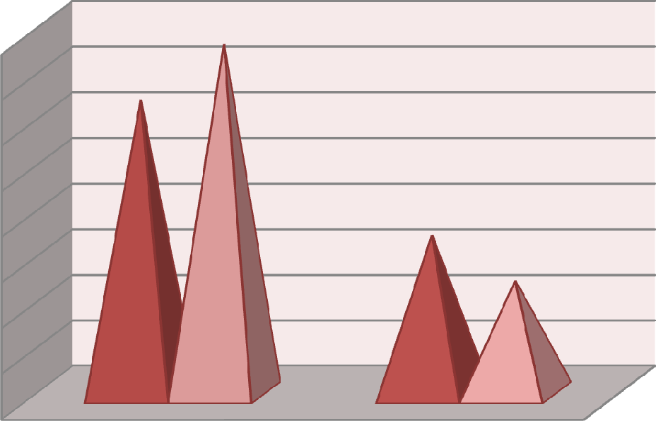

38.3

32.1

17.3

12.3

The total number of respondents in the insurance sector taken in the study has been 81 as shown in the above table 4.14.1(i). If we divide the total respondents into male and female, 70.4% of the respondents are male and 29.6% of them are female. Out of the 70.4% of the male respondents, 32.1% of them belong to LICI and 38.3% of them belong to the various private life insurance companies taken under the survey. Similarly, out of the total 29.6% female respondents 17.3% of them belong to LICI and 12.3% of them belong to private insurance companies.

### Table 4.14.1(ii): Age of Respondents

|  |  |  |  |  |  |  |  |  |  |  |
| --- | --- | --- | --- | --- | --- | --- | --- | --- | --- | --- |
| Particulars | Age of the respondent | | | | | | | | Total | |
|  | 18yrs-  29yrs | | 30yrs-  39yrs | | 40yrs-  55yrs | | 55yrs  above | |  |  |
|  | No. | % | No. | % | No. | % | No. | % | No. | % |
| LICI | 1 | 1.2 | 7 | 8.6 | 29 | 35.8 | 3 | 3.7 | 40 | 49.4 |
| Private Life  Insurance | 17 | 21.0 | 18 | 22.2 | 6 | 7.4 | 0 | 0 | 41 | 50.6 |
| Total | 18 | 22.2 | 25 | 30.8 | 32 | 43.2 | 3 | 3.7 | 81 | 100 |

*Source: Field Survey, 2013-14*

40

35

30

25

20

LICI

Private Life Insurance

15

10

5

0

18yrs-29yrs 30yrs-39yrs 40yrs-55yrs 55yrs above

### Fig 4.14.1(ii): Age of Respondents

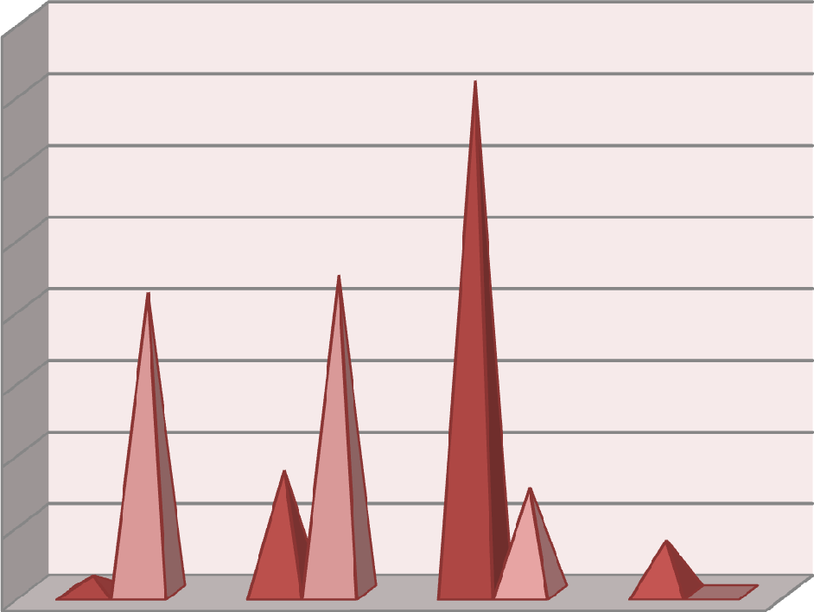

35.8

21

22.2

8.6

7.4

3.7

1.2

0

Table 4.14.1(ii) depicts the age of the respondents working in the insurance sector under survey. 22.2% of the respondents belong to the age group of 18 years to 29 years age group, 30.8% of the respondents belong to the age group of 29 years to 39 years of age group. A large percentage i.e., 43.2% of the respondents belong to the age group of 39 years to 55 years age group and only 3.7 % of the respondents belong to the age group of 55 years and above and that too in the LICI.

### Table 4.14.1(iii): Job Experience of Respondents

|  |  |  |  |  |  |  |  |  |  |  |  |  |
| --- | --- | --- | --- | --- | --- | --- | --- | --- | --- | --- | --- | --- |
| Particulars | Job Experience | | | | | | | | | | Total | |
|  | >1yr | | 1yr-5yrs | | 5yrs-  10yrs | | 10yrs-  15yrs | | <15yrs | |  | |
|  | No. | % | No. | % | No. | % | No. | % | No. | % | No. | % |
| LICI | 1 | 1.2 | 2 | 2.5 | 4 | 4.9 | 3 | 3.7 | 30 | 37.0 | 40 | 49.4 |
| Private Life  Insurance | 10 | 12.3 | 21 | 30.0 | 9 | 11.1 | 1 | 1.2 | 0 | 0 | 41 | 50.6 |
| Total | 11 | 13.5 | 23 | 32.5 | 13 | 16.0 | 4 | 4.9 | 30 | 37.0 | 81 | 100 |

*Source: Field Survey, 2013-14*

40

35

30

25

20

15

10

5

0

LICI

Private Life Insurance



### Fig 4.14.1(iii): Job Experience of Respondents

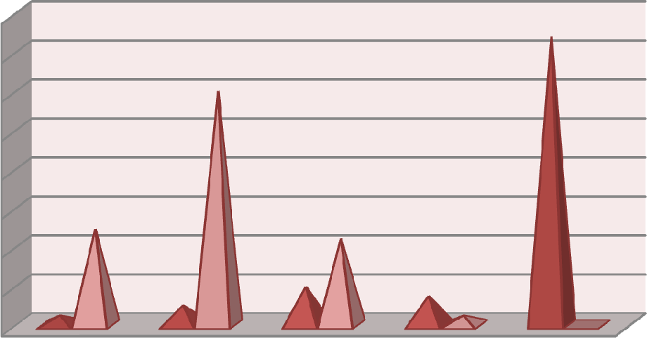

37

30

12.3

11.1

4.9

1.2

2.5

3.7

1.2

0

The above table shows the age of the respondents in the insurance sector under survey. 13.5% of the respondents have an experience of less than a year in the insurance business. 32.5% and 16% of the respondents have the work experience of 1years to 5 years and 5 years to 10 years respectively. Only 4.9% of the respondents have a job experience of 10 years to 15 years whereas a total of 37% respondents have the job experience of more than 15 years in the life insurance business.

## Association Between Importance of Retention Effort and Various Factors

Table 4.14.2 tries to find out if any association is there between the importance given by the employees towards the employee retention effort and the factors under consideration. The results are shown below.

### Table 4.14.2: Correlation Between Employee Retention Effort and Various Factors of Retention

|  |  |  |  |  |  |  |  |  |  |  |  |
| --- | --- | --- | --- | --- | --- | --- | --- | --- | --- | --- | --- |
| Factors | | F1 | F2 | F3 | F4 | F5 | F6 | F7 | F8 | F9 | F10 |
| F1 | Pearson Correlation | 1 | .151 | .291  (**) | .223  (*) | .194 | .235  (*) | .312  (**) | .260  (*) | .289  (**) | .000 |
| Sig (2- tailed) | |  | .180 | .008 | .046 | .082 | .035 | .005 | .019 | .009 | 1.000 |
| N | | 81 | 81 | 81 | 81 | 81 | 81 | 81 | 81 | 81 | 81 |

** Correlation is significant at the 0.01 level (2-tailed).

* Correlation is significant at the 0.05 level (2-tailed).

(F1= Employee retention effort, F2= Compensation, F3= Recognition, F4= Career Progression, F5= Involvment in Decision making, F6= Work Life Balance, F7= Work Environment, F8= Training and Learning, F9= Leadership/ Supervision, F10= Job Security)

The table shows that for the first factor i.e., compensation (F2), no correlation is found with the employee retention effort. Smith (2001) was of the view that money may help an organization to attract workers towards it, but may not always be helpful in keeping or retaining them in the organization. If the second factor, recognition (F3) is observed, a positive correlation of .291(**) at 1% level of significance is found. It means that employee retention effort is directly affected by the recognition offered to the employees working in an organization. Bamberger and Meshoulam (2000) and MacDuffie (1995) opined that reward and recognition system offered by an organization to its employees influences a great deal their intention to remain employed with the organization. Similarly a positive correlation also exist between career progression (F4) and F1. The correlation value being

.223(*) at 5% level of significance.In a study by Das (1999) it was observed that attitude of the employees towards the management becomes unfavourable, if the management does not give attention to promote its capable and efficient workers. This kind of behaviour from the management frustrates the employees and

dissatisfaction arises among them which ultimately lead to turnover of employees. For the factor involvement in decision making (F5) no correlation is found the significant value being .082 (p> .05). In contradiction to the findings, James, Debra and Laurie (2006) were of the opinion that employee’s participation in decision making process acts positively towards attitude of the employees towards their work. Next important factor under consideration is work life balance (F6). The above table clearly depicts correlation between F6, .235(*) and F1 at 5% level of significance, the significant value being .035 (p< .05). In a research by Thomas and Ganster (1995), a positive relationship was found between work life balance and job satisfaction. Good working environment is the right of every employee. Organizations should always try to a congenial working environment for the upliftment of the organization. The correlation between work environment (F7) and F1is .312(**) at 1% level of significance. Zeytinoglu and Denton (2005) argued that work environment plays an important role in employees’ decision to stay in the organization. Training is very important for any employee. Training makes employees polish their skills and upgrade their knowledge. As depicted in the above table, a positive correlation is found between training and learning (F8) and F1. The correlation is significant as the value is .009 (p< .05). The last factor under investigation was job security. Although many researchers believe that job security is very important for retaining employees but in the present study no positive relation is found between employee retention effort and job security.

## Relationship Between Performance of the Employee Retention Effort and Factors of Retention

Table 4.4.5 attempts to find out the relationship between performance of the employee retention effort put by the banks for its employees and the various retention factors under investigation.

### Table 4.14.3: Correlation Between Rating Given to the Employee Retention Effort and Factors of Retention

|  |  |  |  |  |  |  |  |  |  |  |  |
| --- | --- | --- | --- | --- | --- | --- | --- | --- | --- | --- | --- |
| Factors | | R1 | F2 | F3 | F4 | F5 | F6 | F7 | F8 | F9 | F10 |
| R 1 | Pearson Correlation | 1 | .268  (*) | .477  (**) | .348  (**) | .357  (**) | .261  (*) | .499  (**) | .477  (**) | .522  (**) | .275  (*) |
| Sig (2- tailed) | |  | .015 | .000 | .001 | .001 | .019 | .000 | .000 | .000 | .013 |
| N | | 81 | 81 | 81 | 81 | 81 | 81 | 81 | 81 | 81 | 81 |

** Correlation is significant at the 0.01 level (2-tailed).

* Correlation is significant at the 0.05 level (2-tailed).

(R1= Rating given to employee retention effort, F2= Compensation, F3= Recognition, F4= Career Progression , F5= Participation in Decision making, F6= Work Life Balance, F7= Work Environment, F8= Training andLearning , F9= Leadership/ Supervision, F10= Job Security)

Table 4.14.3 tries to find out the correlation betwwen the various employee retention factors and the overall rating given by the employees to the retention initiative given by the organization. If the first factor compensation (F2) is taken, a positive correlation of .268(*) is found with R1 at 5% level of significance. Tang *et. al*., (2000) found that money only indirectly influences the retention of employees in an organization; it directly affects retention only when the satisfaction of employees towards the job is very low. In case of recognition (F3) also a strong correlation of

.477(**) at 1% level of significance is found with R1. In a study by Michael O. Samuel and Crispen Chipunza (2009) it was found that reward and recognition in private sector organizations directly affects retention of employees. They have found

a Chi-square value of 19.81 and an associated p-value of 0.00. For the next factor (F4) also a significant relationship is found with R1 and the significant value being

.001(p< 0.05**).** Dr. R. Akila (2012) in a study among executives in Chennai tried to find the correlation among five factors affecting retention. The study concluded that among the five factors under investigation opportunities for career development had the strongest correlation of (.967) with employee retention. Participation in decision making (F5) has also a positive correlation R1 and the significant value being

.001(p< 0.05) and the Pearson correlation is .357(**). Noah (2009) forwarded the view that engaging employees in the decision making process helps in motivating employees and getting their services for longer time. For the other factors also a positive correlation is found with the rating given to the employee retention effort. The correlation of work life balance (F6), work environment (F7), training and learning(F8), leadership (F9) and job security (F10) are .261(*) at 5% level of significance, .499(**),.477(**),.522(**) at 1% level of significance and .275(*) at 5% level of significance respectively with R1. Boomer Authority (2009) were of the view that flexibility at the job is very important for retaining employees in the organization. Similarly Prenda and Stahl (2001) opined that employees having flexibility options in their hand always show commitment towards the work, more concentration in their work, job satisfaction, increased productivity and loyalty towards the organization. In case of work environment, Breaugh and Starke (2000) offered the view that appreciative environment, opportunities for growth, friendly and cooperative work environment are the factors in an organization which motivates people to work and stay in the organization. Bassi and Van Buren (1999) and Accenture (2001) were of the view that organizations which recognize training, skill

and career development for its employees always succeeds in attraction and retention of its employees. For leadership and supervision, Greenhaus (1994) suggested that those organizations where there is supervisory support, proper communication and healthy employer-employee relationship, the employees there have a lower turnover intention and tends to stay back with the organization.

## Impact of Various Factors Upon Employee Retention

The following table shows the impact of various factors on employee retention of employees working in various life insurance companies.

### Table 4.14.4: Regression Analysis

Variables Entered/ Removeda

|  |  |  |  |
| --- | --- | --- | --- |
| Model | Variables Entered | Variables Removed | Method |
| 1 | Compensation,Recognition , Career Progression, Participation in Decision making, Work Life Balance, Work Environment, Training and Learning, Leadership/ Supervision, Job Securitya | . | Enter |

* + - 1. All requested variables entered
      2. Dependent Variable: Rating given to the employee retention policy/ practices

### Model Summary

|  |  |  |
| --- | --- | --- |
| Model R | R Square Adjusted R Square | Std. Error of the Estimate |
| 1 .600(a) | .360 .278 | .728 |

a Predictors: (Constant), Job Security, Work life Balance, Career Progression, Leadership, Compensation, Work environment, Participation, Training, Recognition

|  |  |  |  |  |  |
| --- | --- | --- | --- | --- | --- |
| Model | Un-standardized  Coefficients | | Standardized  Coefficients | **t** | **Sig** |
| B | Std. Error | Beta |
| 1(Constant) | .131 | .773 |  | .170 | .866 |
| Compensation | .032 | .047 | .102 | .666 | .508 |
| Recognition | .091 | .057 | .377 | 1.613 | .111 |
| Career Progression | -.056 | .064 | -.169 | -.870 | .387 |
| Participation in Decision | -.130 | .072 | -.426 | -1.802 | .076 |
| Work Life Balance | .021 | .059 | .042 | .357 | .722 |
| Work Environment | .007 | .057 | .026 | .126 | .900 |
| Training and Learning | .061 | .053 | .255 | 1.155 | .252 |
| Leadership/ Supervision | .115 | .053 | .423 | 2.160 | .034* |
| Job Security | -.008 | .084 | -.012 | -.099 | .921 |

a Dependent Variable: Rating given to the employee retention policy/practices of the org

Table 4.14.4 above shows the regression analysis of the impact of the retention factors upon the dependent variable. The table clearly shows that all the nine factors have a total impact of 27.8% on the retention practices of the organizations. If the individual factors are taken into account, the most influencing or relevant retention factor for the employees of the insurance sector is the leadership or supervision provided to them, the p value being .034(p< 0.05). Chew (2004) was of the view that leader behaviour can have a positive impact upon commitment towards the work and turnover intention. Gwavuya (2011) argues that lack of proper leadership can result into lack of performance on the part of the employees, lack of commitment, job dissatisfaction and intention to switch over to some other job.

## Association Between Various Retention Factors and Job Satisfaction

Table 4.14.5 attempts to find out the association between various retention factors and the job satisfaction level among the employees.

### Table 4.14.5: Correlation Between Job Satisfaction and Various Factors

|  |  |  |  |  |  |  |  |  |  |  |
| --- | --- | --- | --- | --- | --- | --- | --- | --- | --- | --- |
| Factors | JS | F2 | F3 | F4 | F5 | F6 | F7 | F8 | F9 | F10 |
| JS | 1 |  |  |  |  |  |  |  |  |  |
| F2 | .261(*) | 1 |  |  |  |  |  |  |  |  |
| F3 | .130 | .467(**) | 1 |  |  |  |  |  |  |  |
| F4 | .211 | .677(**) | .559(**) | 1 |  |  |  |  |  |  |
| F5 | .126 | .510(**) | .858(**) | .419(**) | 1 |  |  |  |  |  |
| F6 | .216 | .085 | .379(**) | .079 | .347(**) | 1 |  |  |  |  |
| F7 | .238(*) | .487(**) | .763(**) | .615(**) | .650(**) | .456(**) | 1 |  |  |  |
| F8 | .363(**) | .639(**) | .588(**) | .834(**) | .455(**) | .221(*) | .747(**) | 1 |  |  |
| F9 | .136 | .347(**) | .782(**) | .445(**) | .790(**) | .391(**) | .743(**) | .585(**) | 1 |  |
| F10 | .334(**) | .338(**) | .323(**) | .379(**) | .281(*) | .413(**) | .560(**) | .486(**) | .375(**) | 1 |

* Correlation is significant at the 0.05 level (2-tailed).

** Correlation is significant at the 0.01 level (2-tailed).

JS= Job Satisfaction, F2= Compensation, F3= Recognition, F4= Career Progression, F5= Participation in Decision making, F6= Work Life Balance, F7= Work Environment, F8= Training andLearning, F9= Leadership/ Supervision, F10= Job Security

From the above table it can be observed that compensation has a positive correlation with job satisfaction (r= .261*) at 5% level of significance. Sokoya (2000) in a research among public sector managers found and concluded that income can be regarded as the major determinant of job satisfaction. For the factors recognition (F3), career progression (F4), participation in decision making (F5), work life balance (F6) and leadership and supervision (F9) no correlation is found with job satisfaction. The results are in total contradiction with findings of some other researches in similar researches. For example Opkara (2002) found that job satisfaction is influenced by factors such as promotion, leadership or supervision, relationship with co-workers etc. Proper work environment is very essential for increasing the efficiency of the workers. Congenial work environment to a very large extent helps in boosting up the morale of the employees which can help in increasing the satisfaction level of the employees. The above table also shows a

positive correlation, r= .238(*) at 5% level of significance. Herzberg (1968) and Spector (2008) the environment in which a person work is an important factor determining the job satisfaction of the employees. Other researchers an experts such as Reiner and Zhao (1999); Forsyth and Copes (1994); Ellickson and Logsdon (2001); Carlan (2007) also shared the same view that work environment is a good determinant of job satisfaction. For the employees in the insurance sector training and learning and job security is very important and they regard it as important factors for making the job satisfying. A positive correlation r= .363 and r= .334 is found for training and learning and job security with job satisfaction at 1% level of significance. Ashford *et. al*. (1989); Davy *et. al*. (1991) was of the opinion that job insecurity creates job dissatisfaction among the employees.

## Comparison Between Genders With Respect to the Retention Factors

In this section and analysis is made to find out if any difference exists between the male and female employees working in various banks with respect to the factors of retention.

### Table 4.14.6 : Gender Difference in Relation to Various Factors of Retention

|  |  |  |  |  |  |  |  |
| --- | --- | --- | --- | --- | --- | --- | --- |
| Factors | Gender | N | Mean | Std.  Deviation | t | df | Sig. (2-  tailed) |
| Compensation | Male | 57 | 16.81 | 2.991 | 1.006 | 79 | .318 |
| Female | 24 | 16.13 | 2.213 |
| Recognition | Male | 57 | 21.68 | 3.439 | .165 | 79 | .870 |
| Female | 24 | 21.54 | 3.822 |
| Career Progression | Male | 57 | 14.51 | 2.804 | 1.070 | 79 | .288 |
| Female | 24 | 13.83 | 1.993 |
| Participation | Male | 57 | 18.77 | 2.835 | .395 | 79 | .694 |
| Female | 24 | 18.50 | 2.813 |

|  |  |  |  |  |  |  |  |
| --- | --- | --- | --- | --- | --- | --- | --- |
| Factors | Gender | N | Mean | Std.  Deviation | t | df | Sig. (2-  tailed) |
| Work life Balance | Male | 57 | 10.51 | 1.764 | .122 | 79 | .903 |
| Female | 24 | 10.46 | 1.503 |
| Work environment | Male | 57 | 24.25 | 3.192 | .940 | 79 | .350 |
| Female | 24 | 23.54 | 2.782 |
| Training and Learning | Male | 57 | 20.88 | 3.915 | 1.008 | 79 | .316 |
| Female | 24 | 20.00 | 2.571 |
| Leadership | Male | 57 | 19.09 | 3.275 | -.156 | 79 | .876 |
| Female | 24 | 19.21 | 2.919 |
| Job Security | Male | 57 | 8.33 | 1.380 | .000 | 79 | 1.000 |
| Female | 24 | 8.33 | .917 |

Table 4.14.6 above depicts the gender difference in relation to various employee retention factors taken under the study. If we observe the table we find that there is no significant difference among the male and female employees working in both private as well as public life insurance companies with respect to various employee retention factors under investigation.

## Comparison Between Private Life Insurance Companies and LICI With Respect to Various Retention Factors:

This section tries to find out, if any difference exist between the LICI and private life insurance companies with respect to the various retention factors under investigation.

### Table 4.14.7: Comparison Between Private Life Insurance Companies and LICI with Respect to Various Retention Factors

|  |  |  |  |  |  |  |  |
| --- | --- | --- | --- | --- | --- | --- | --- |
| Factors | Sector | N | Mean | Std.  Deviation | t | df | Sig. (2-  tailed) |
| Compensation | Public | 40 | 16.23 | 2.412 | -1.216 | 79 | .228 |
| Private | 41 | 16.98 | 3.094 |
| Recognition | Public | 40 | 21.15 | 3.853 | -1.242 | 79 | .218 |
| Private | 41 | 22.12 | 3.164 |

|  |  |  |  |  |  |  |  |
| --- | --- | --- | --- | --- | --- | --- | --- |
| Factors | Sector | N | Mean | Std.  Deviation | t | df | Sig. (2-  tailed) |
| Career Progression | Public | 40 | 14.00 | 2.219 | -1.058 | 79 | .293 |
| Private | 41 | 14.61 | 2.914 |
| Participation | Public | 40 | 18.53 | 2.987 | -.523 | 79 | .602 |
| Private | 41 | 18.85 | 2.660 |
| Work life Balance | Public | 40 | 10.65 | 1.562 | .824 | 79 | .412 |
| Private | 41 | 10.34 | 1.797 |
| Work environment | Public | 40 | 24.33 | 3.149 | .831 | 79 | .409 |
| Private | 41 | 23.76 | 3.015 |
| Training and Learning | Public | 40 | 20.73 | 2.996 | .266 | 79 | .791 |
| Private | 41 | 20.51 | 4.100 |
| Leadership | Public | 40 | 19.33 | 3.058 | .565 | 79 | .573 |
| Private | 41 | 18.93 | 3.274 |
| Job Security | Public | 40 | 8.88 | .853 | 4.221 | 79 | .000(**) |
| Private | 41 | 7.80 | 1.364 |

Table 4.14.7 above tries to show if there exist any difference between the employees of private life insurance companies and LICI with respect to various retention initiatives taken up by their organiztions. The table clearly reveals that except for job security, there is no significant difference among insurance employees working in public and private sector with respect to various retention factors under research. In case of the factor job security we have found significant difference between th epublic and the private sector. If we observe the average mean values of both the sector with respect to job security, we find that the average mean score of public sector (M= 8.88 and S.D= 0.853) higher than that of private sector (M= 7.80 and S.D= 1.364). Thus it can be conclded from the figures that employees of public sector enjoy more job security than that of the private sector employees.

# Education

Teachers are the main ingredients in building a strong and excellent workforce in any country. These are the people who share their knowledge, expertise, intellect and experiences to build good and contributing human beings in the society. They provide their valuable services without thinking about their interest, likes and dislikes. Teachers are the foundation of a strong human resources base of a country. They are always regarded as a strong powerful source in schools, colleges and other educational institutes. In recent years it has been noticed that the number of schools and educational institutes has increased at a very rapid pace due to which the requirement of teachers has also risen at a very rapid pace. With the growing demand of quality teachers among educational institutes, schools and colleges are also feeling the pressure of retaining their teachers and satisfying them as now the teachers have a lots and lots of lucrative opportunities available in their hands. Proper retention initiative and satisfaction among the teachers will not only help in delivering their best to the students but will also help in uplifting and developing the educational scenario of the country. The issue of retention is directly correlated with job satisfaction. If the employees are satisfied with their jobs obviously they will like to stay in their present jobs or would like to retain it. But an employee will be satisfied with their jobs only and only when the organizations show an initiative and provide ample facilities to its employees to retain them. Jackson and Schuler (2000) stated that retention can be defined as those attempts by the organization which ensures that the human resources stay in their jobs and voluntary turnover is minimized in the organization. Johnson (2000) has forwarded the opinion that retention is nothing but the ability of an organization to keep its employees for a longer period than its rivals

or competitors. Panoch (2001) forwarded the view that organizations today take great care in retaining its valuable employees and good employees as they are increasingly becoming more difficult to find Greenberg and Baron (2003) concluded that every people want to be satisfied with their jobs. Job satisfaction makes the work pleasant and enjoyable which is very important for both the job as well as the employee. In this hard pressing competitive world every educational institute wants to attract the best students and the best teachers. Survival in this competitive environment requires attracting and retaining the best talents available in the environment. Taking into consideration the importance of talented teachers in our changing society, the study attempts to find out the various retention initiatives taken up by various private as well as government schools in attracting, retaining and satisfying its invaluable resources in the city of Guwahati in Assam. The paper also attempts to find out the most important factors which encourage the teachers to stay in the organization as well as those factors which dissatisfy them.

Many researcher have confirmed that factors likes salary, promotional opportunity, task clarity ,skills utilization, as well as organizational characteristics such as commitment and relationship with supervisors and co-workers, have significant effects on job satisfaction. Norton (1999) believes that there must be a provision of special incentives for teachers over and above their normal compensation to increase their job satisfaction and retain them in the organization. Ingersoll (2001), National Education Association (2004) also forwarded a similar view that one of the biggest problems facing educational instates today is obtaining and retaining quality teachers. There is a growing debate about whether the concern lies with a shortage of teachers entering the field or with retaining teachers once they begin their careers.

Ossai (2004) concluded in his study that factors like salaries, fringe benefits, educational policies, working conditions, career advancement opportunities, responsibilities within the job and recognition in job are some relevant factors for satisfaction in job. In a study by Gersten, Keating, Yovanoff, and Harniss (2001) a total of 887 special educators were surveyed to identify factors that lead to their intent to stay or retention in their jobs. The researchers found that poor job design along with poor relationship with the administrators, led to high turnover among teachers. The researchers and identified some important factors, necessary to keep special educators from leaving their positions. These factors include cooperation and support from the administrators and colleagues, professional and career development opportunities which lead the teachers to satisfaction with their current position. These factors were also identified as critical by other researchers such as Billingsley (2004); Williams (2003); Minarik, Thornton, and Gersten *et. al.*, (2001) regarded salary as an important contributory towards job satisfaction among teachers. McGlamory and Edick (2004), in a project named Career Advancement and Development for Recruits and Experienced teachers (CADRE) Project, tried to examine the effectiveness of a teacher induction and retention program. It was found that the teachers who participated under the program expressed satisfaction with their jobs and tended to remain in their CADRE district. In another study, Tarnowski and Murphy (2003) argued that the key area in retaining quality teachers requires positive pre-service experience, along with a positive mentoring experience. Billingsley (2004) reported that if the school administrators take care of the needs of the teachers by creating a supportive environment and good relations between administrators and teachers and also by reducing the stress, clearly defining roles and providing them

professional support, it will be possible to increase their job satisfaction, reducing attrition and ultimately increasing retention. Curtis (2005) argued that job satisfaction is an important variable in decisions made by teachers to remain in their jobs or leave their teaching profession. Mohamed Imran Rasheed (2010), forwarded factors like job design, work environment, feedback, recognition, decision making participation etc as important factors for satisfying teachers involved in higher education. In a study by Kelchtermans (1999) it was concluded that overemphasis on standards, a lack of participation in decision-making, failure to provide instructional resources, lack of support from administration, and lack of trust in the expertise of teachers increase job dissatisfaction and lack of retention of teachers.

## Respondents’ Profile

A brief overview of the respondents’ profile working in various educational institutes in the city, has been highlighted by the researcher with the help of Tables depicted below*.*

### Table 4.15.1(i): Gender of Respondents

|  |  |  |  |  |  |  |
| --- | --- | --- | --- | --- | --- | --- |
| Particulars | Gender of Respondents | | | | Total | |
|  | Male | | Female | |  | |
|  | No. | Percentage | No. | Percentage | No. | Percentage |
| Private Schools | 16 | 7.0 | 34 | 15.0 | 50 | 22.0 |
| Central and State Govt Schools | 16 | 7.0 | 45 | 19.8 | 61 | 26.9 |
| Private Colleges | 23 | 10.1 | 31 | 13.7 | 54 | 23.8 |
| Provincialised Colleges | 26 | 11.5 | 36 | 15.9 | 62 | 27.3 |
| Total | 81 | 35.7 | 146 | 64.3 | 227 | 100 |

*Source: Field Survey 2013-14*

20

18

16

14

12

10

8

6

4

2

0

Male

Female

Private Schools Central & State Private Provincialised

Govt Schools Colleges Colleges

### Fig 4.15.1 (i): Gender of Respondents

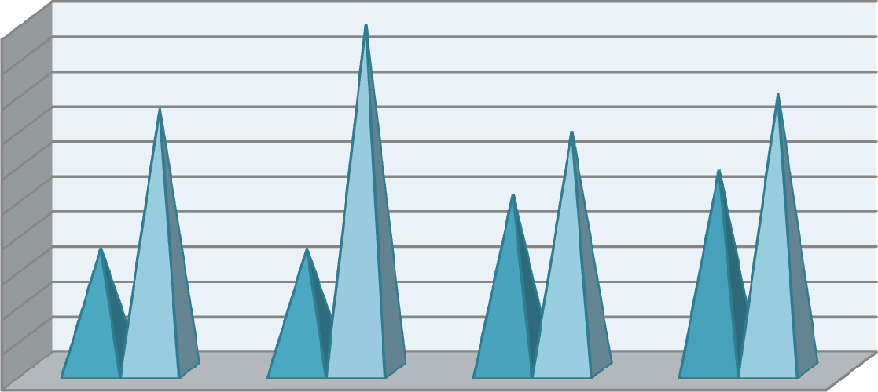

19.8

15

15.9

13.7

10.1

11.5

7

7

From the above table it is found that 35.7% of the respondents are male and rest 64.3% of them are female. If we break up the percentage on the basis of schools and colleges, we find that 7% of the male respondents belong to private schools, 7% belong to central and state government schools, 10.1% belong to private colleges and 11.5% belong to provincialised colleges. On the other hand 15.0%, 19.8%, 13.7%, 15.9% belong to private schools, central and state government schools, private colleges and provincialised colleges respectively.

**Table 4.15.1(ii): Age of Respondents**

|  |  |  |  |  |  |  |  |  |  |  |
| --- | --- | --- | --- | --- | --- | --- | --- | --- | --- | --- |
| Particulars | Age of the respondent | | | | | | | | Total | |
|  | 18yrs-29yrs | | 30yrs-39yrs | | 40yrs-55yrs | | 55yrs above | |  |  |
|  | No. | % | No. | % | No. | % | No. | % | No. | % |
| Private Schools | 2 | .9 | 25 | 11.0 | 19 | 8.4 | 4 | 1.8 | 50 | 22.0 |
| Govt. Schools | 7 | 3.1 | 13 | 5.7 | 32 | 14.1 | 9 | 3.9 | 61 | 26.9 |
| Private colleges | 28 | 12.3 | 24 | 10.6 | 1 | .4 | 1 | .4 | 54 | 23.8 |
| Prov. Colleges | 21 | 9.3 | 26 | 11.5 | 14 | 6.2 | 1 | .4 | 62 | 27.3 |
| Total | 58 | 25.6 | 88 | 38.8 | 66 | 29.1 | 15 | 6.6 | 227 | 100 |

*Source: Field Survey 2013-14*

16

14

12

10

8

6

4

2

0

Private Schools Govt. Schools Private colleges

Prov. Colleges

18yrs-29yrs 30yrs-39yrs 40yrs-55yrs 55yrs above

### Fig 4.15.1(ii): Age of Respondents

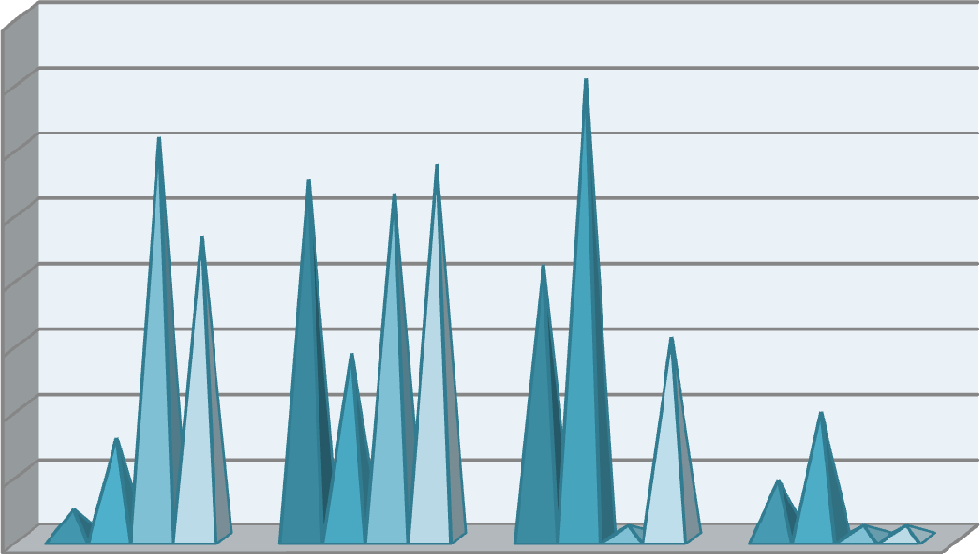

14.1

12.3

11

11.5

1

0.6

9.3

8.4

5.7

6.2

3.1

0.9

0.4

3.9

1.8

0.40.4

The above table depicts that maximum number of respondents belong to the age group of 29 years to 39 years of age group. 38.8 % of the respondents belong to the age group of 29 years to 39 years of the age group. 25.6%, 29.1% and 6.6 % of the respondents belong to the age group of 18 years to 29 years, 39 years to 55 years and 55 years above age group respectively.

### Table 4.15.1(iii) : Job Experience

|  |  |  |  |  |  |  |  |  |  |  |  |  |
| --- | --- | --- | --- | --- | --- | --- | --- | --- | --- | --- | --- | --- |
| Particulars | Job Experience | | | | | | | | | | Total | |
|  | >1yr | | 1yr-5yrs | | 5yrs-  10yrs | | 10yrs-  15yrs | | <15yrs | |  | |
|  | No. | % | No. | % | No. | % | No. | % | No. | % | No. | % |
| Private  Schools | 3 | 1.3 | 12 | 5.3 | 10 | 4.4 | 10 | 4.4 | 15 | 6.6 | 50 | 22.0 |
| Govt.  Schools | 6 | 2.6 | 10 | 4.4 | 10 | 4.4 | 10 | 4.4 | 25 | 11.0 | 61 | 26.9 |
| Private  colleges | 10 | 4.4 | 32 | 14.1 | 10 | 4.4 | 1 | .4 | 1 | .4 | 54 | 23.8 |
| Prov.  Colleges | 7 | 3.1 | 24 | 10.6 | 14 | 6.2 | 6 | 2.6 | 11 | 4.8 | 62 | 27.3 |
| Total | 26 | 11.4 | 78 | 34.4 | 44 | 19.4 | 27 | 11.9 | 52 | 22.9 | 227 | 100 |

*Source: Field Survey 2013-14*

16

14

12

10

8

6

4

2

0

Private Schools Govt. Schools Private colleges

Prov. Colleges



### Fig 4.15.1(iii) : Job Experience



14.1

10.6

11

6.6

4.4

2.6 3.1

1.3

5.3

4.4

6.2

4.44.44.4

4.44.4

4.8

2.6

0.4 0.4

The above table depicts that 11.4% of the respondent teachers have less than 1 year of job experience.19.4 % of the respondents have 5 years to 10 years of teaching experience. And 11.9% and 22.9% of the respondents have 10 years to 15 years of experience and above 15 years of experience respectively.

### Table 4.15.1(iv): Sector Wise Division of Educational Institutes

|  |  |  |  |  |  |  |
| --- | --- | --- | --- | --- | --- | --- |
| Particulars | Public/Private Sector | | | | Total | |
|  | Public | | Private | |  |  |
|  | No. | Percentage | No. | Percentage | No. | Percentage |
| Private Schools |  |  | 50 | 22.0 | 50 | 22.0 |
| Govt. Schools | 61 | 26.9 |  |  | 61 | 26.9 |
| Private Colleges |  |  | 54 | 23.8 | 54 | 23.8 |
| Prov. Colleges | 62 | 27.3 |  |  | 62 | 27.3 |
| Total | 123 | 54.2 | 104 | 45.8 | 227 | 100.0 |

*Source: Field Survey 2013-14*

30

25

20

15

Schools

Colleges

10

5

0

Public

Private

### Fig 4.15.1(iv): Sector wise division of educational institutes

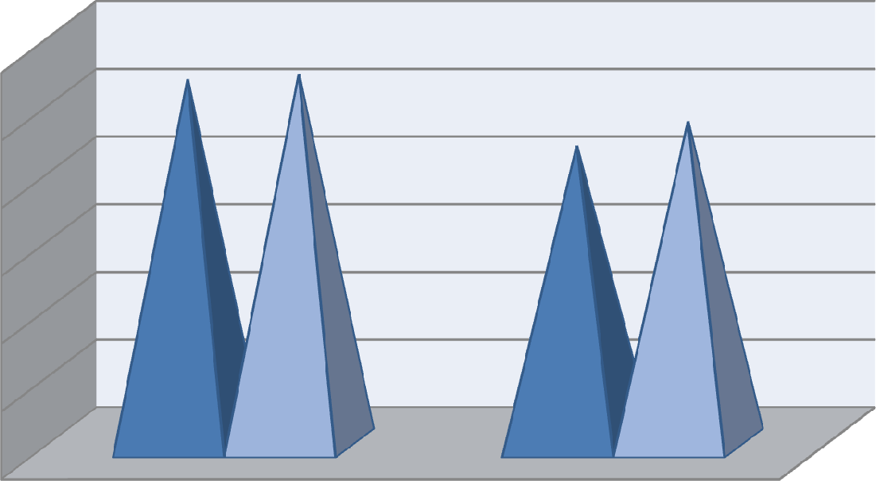

26.9 27.3

22

23.8

Table No.4.5.4 shows that 50 numbers of respondents belong to private schools, 61 belongs to government schools 54 respondents belong to private colleges and 62 respondent teachers belong to provincialised colleges.

## Respondents’ View to Select a New Career

An important question was put on the respondents to know their view if they would be given an opportunity to start over a new career, would they select a new profession and some interesting views were got. The results are depicted in the following tables.

### Table 4.15.2: Respondents’ View to Select a New Career

|  |  |  |  |  |  |  |  |  |
| --- | --- | --- | --- | --- | --- | --- | --- | --- |
| Particulars | Respondents’ view to select a new career | | | | | | Total | |
|  | No | | Yes | | Can’t Say | |  | |
|  | No. | Percentage | No. | Percentage | No. | Percentage | No. | Percentage |
| Private Schools | 7 | 3.1 | 28 | 12.3 | 15 | 6.6 | 50 | 22.0 |
| Govt. Schools | 12 | 5.3 | 40 | 17.7 | 9 | 3.9 | 61 | 26.9 |
| Private Colleges | 4 | 1.8 | 37 | 16.3 | 13 | 5.7 | 54 | 23.8 |
| Prov. Colleges | 7 | 3.1 | 44 | 19.4 | 11 | 4.8 | 62 | 27.3 |
| Total | 30 | 13.2 | 149 | 65.6 | 48 | 21.1 | 227 | 100 |

*Source: Field Survey 2013-14*

20

18

16

14

12

10

8

6

4

2

0

No Yes

Can’t Say

Private Schools Govt. Schools

Private Colleges

Prov. Colleges

### Fig 4.15.2: Respondents’ view to select a new career

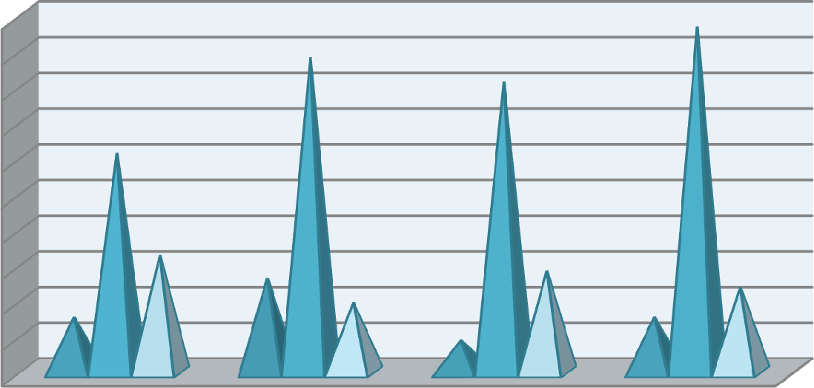

19.4

17.7

16.3

12.3

6.6

5.3

5.7

4.8

3.1

3.9

3.1

1.8

12.3% of the respondents in private schools have revealed that they would go for a new career, 17.7% of the government school teachers wanted to opt for a new career. Besides the above 16.3% and 19.4% of the respondents in private colleges and provincialised colleges respectively answered positively towards the question.

## Association Between Importance Given to the Employee Retention Effort and Various Factors

Employee retention is undoubtedly important for any employee and the organization in which they are employed. Good employee retention effort put by the organization can have long lasting effect upon the employees. But very often it is observed that the degree of relevance of various factors upon retaining or attracting the employees varies from person to person, since the perception of each and every employee relating to each factor is different. An organization may provide huge packages to its employees but still they may fail to retain the employees. The table below tries to find out the association between the

importance given by the employees to the retention effort put by their employers and the various factors under consideration.

### Table 4.15.3: Pearson Correlation Between Importance of Employee Retention Effort and Other Factors

|  |  |  |  |  |  |  |  |  |  |  |
| --- | --- | --- | --- | --- | --- | --- | --- | --- | --- | --- |
| Fact ors | F1 | F2 | F3 | F4 | F5 | F6 | F7 | F8 | F9 | F10 |
| F1 | 1 |  |  |  |  |  |  |  |  |  |
| F2 | .259(**) | 1 |  |  |  |  |  |  |  |  |
| F3 | .263(**) | .609(**) | 1 |  |  |  |  |  |  |  |
| F4 | .286(**) | .635(**) | .639(**) | 1 |  |  |  |  |  |  |
| F5 | .242(**) | .597(**) | .880(**) | .602(**) | 1 |  |  |  |  |  |
| F6 | .206(**) | .298(**) | .374(**) | .412(**) | .316(**) | 1 |  |  |  |  |
| F7 | .302(**) | .614(**) | .718(**) | .606(**) | .641(**) | .376(**) | 1 |  |  |  |
| F8 | .353(**) | .777(**) | .693(**) | .741(**) | .590(**) | .316(**) | .686(**) | 1 |  |  |
| F9 | .231(**) | .536(**) | .770(**) | .591(**) | .782(**) | .331(**) | .653(**) | .631(**) | 1 |  |
| F10 | .146(*) | .455(**) | .324(**) | .213(**) | .320(**) | .163(*) | .369(**) | .389(**) | .222(**) | 1 |

** Correlation is significant at the 0.01 level (2-tailed).

* Correlation is significant at the 0.05 level (2-tailed).

(F1= Employee retention effort, F2= Compensation, F3= Recognition, F4= Career Progression, F5= Participation in Decision making, F6= Work Life Balance, F7= Work Environment, F8= Training and Learning, F9= Leadership/ Supervision, F10= Job Security)

Table No:4.15.3 clearly shows a positive and significant relationship between employee retention effort made by the educational institutes and the various relevant factors such as compensation(.259**), recognition (.263**), career progression (.286**), participation in decision making(.242**), work life balance (.206**), work environment(.302**), training and learning (.353**), leadership and supervision(.231**) at 0.01 level of significance and job security(.146*) at 0.05 level of significance. Mobley (1982); Arthur (2001) forwarded the view that retention process in an organization can be improved with the help of some key factors which includes good compensation practices, proper leadership and

supervision, career planning and development policies for the employees, good work environment, work life balance policy, employee participation etc.

## Performance of the Employee Retention Effort

All the effort put by the employers to retain and satisfy the employees would be of no use if it fails to perform. Performance can be accurately measured only after knowing the views of the people on whom the policies or the initiatives are applied. Table below tries to find out the relationship between the performance of the employee retention effort and the various retention factors under study.

### Table 4.15.4: Pearson Correlation Between Performance Rating Given to Employee Retention Effort and Other Factors

|  |  |  |  |  |  |  |  |  |  |  |
| --- | --- | --- | --- | --- | --- | --- | --- | --- | --- | --- |
| Fact ors | R1 | F2 | F3 | F4 | F5 | F6 | F7 | F8 | F9 | F10 |
| R1 | 1 |  |  |  |  |  |  |  |  |  |
| F2 | .494(**) | 1 |  |  |  |  |  |  |  |  |
| F3 | .521(**) | .609(**) | 1 |  |  |  |  |  |  |  |
| F4 | .417(**) | .635(**) | .639(**) | 1 |  |  |  |  |  |  |
| F5 | .431(**) | .597(**) | .880(**) | .602(**) | 1 |  |  |  |  |  |
| F6 | .209(**) | .298(**) | .374(**) | .412(**) | .316(**) | 1 |  |  |  |  |
| F7 | .516(**) | .614(**) | .718(**) | .606(**) | .641(**) | .376(**) | 1 |  |  |  |
| F8 | .539(**) | .777(**) | .693(**) | .741(**) | .590(**) | .316(**) | .686(**) | 1 |  |  |
| F9 | .409(**) | .536(**) | .770(**) | .591(**) | .782(**) | .331(**) | .653(**) | .631(**) | 1 |  |
| F10 | .326(**) | .455(**) | .324(**) | .213(**) | .320(**) | .163(*) | .369(**) | .389(**) | .222(**) | 1 |

** Correlation is significant at the 0.01 level (2-tailed).

* Correlation is significant at the 0.05 level (2-tailed).

(R1= Performance Rating given to employee retention effort, F2= Compensation, F3= Recognition, F4= Career progression, F5= Participation in Decision making, F6= Work Life Balance, F7= Work Environment, F8= Training and Learning, F9= Leadership/ Supervision, F10= Job Security)

Cappelli (2000) suggested that functioning of the employee retention process is influenced by several key factors. Table No:4.15.4 shows the performance rating given by the teachers towards the employee retention effort given by the

organizations and the various factors which influences their decision. It clearly shows that there is a strong and positive relationship between the dependent variable i.e., rating given to employee retention variables and other independent variables. For example the correlation compensation with R1 is .494**. Contradictory to the finding of the present study Brannick (1999) was of the view that money cannot be regarded as the key retention factor. In case of recognition also a strong correlation of .521** is found with R1. Cole and Bruch (2006) in their empirical study found that reward systems based on performances of the employees increases an individual’s tendency to stay in their job. Work life balance also have a correlation of .209** with R1. Yanadoria and Katob (2010) in their study statistically proved the relationship between work life balance and employee retention. Work environment is also an important factor in job satisfaction and employee retention. The table above clearly shows a positive correlation of .516** with R1. Zeytinoglu and Denton (2005) concluded in their study that work environment is directly related and one of the important factor in employee retention. In case of leadership also a correlation of .409** is found with R1. Similar to the present finding Freyermuth (2007) suggested that grooming of the leader is essential in an organization as the leader helps in creating a congenial and supportive work environment for its employees which ultimately helps them to stay in the organization. Similarly Black and Lynch (1996) offered the view that organizations must spend or invest money on its human resources in the form of training in order to retain the dynamic resources with the organization. This has been proved in the present study also as a strong and positive correlation of .539** is found with R1. In case of the remaining retention factors such as career

progression , participation in decision making and job security also a positive correlation is found with R1 as depicted in the above table.

## Impact of Various Factors on Employee Retention

This section shows the impact or effect of the various factors of retention on the perception of the performance of the employee retention effort put by the educational institutes.

### Table 4.15.5: Regression Analysis

Variables Entered/ Removeda

|  |  |  |  |
| --- | --- | --- | --- |
| Model | Variables Entered | Variables Removed | Method |
| 1 | Compensation, Recognition,Career Progression, Participation in Decision making, Work Life Balance, Work Environment, Training and Learning, Leadership/ Supervision, Job Securitya | . | Enter |

* + - 1. All requested variables entered
      2. Dependent Variable: Performance Rating given to the employee retention policy/ practices\

### Model Summary

|  |  |  |  |  |
| --- | --- | --- | --- | --- |
| Model | R | R Square | Adjusted R Square | Std. Error of the Estimate |
| 1 | .604(a) | .365 | .339 | .705 |

a Predictors: (Constant), Job Security, Work life Balance, Career Progression, Leadership, Compensation, Work environment, Participation, Training, Recognition

|  |  |  |  |  |  |
| --- | --- | --- | --- | --- | --- |
| Model | Un-standardised  Coefficients | | Standardized  Coefficients | **t** | **Sig** |
| B | Std. Error | Beta |
| 1(Constant) | -.739 | .455 |  | -1.626 | .105 |
| Compensation | .033 | .025 | .122 | 1.306 | .193 |
| Recognition | .077 | .031 | .340 | 2.519 | .012 |
| Career Progression | -.008 | .029 | -.024 | -.271 | .786 |
| Participation in Decision | -.037 | .035 | -.138 | -1.067 | .287 |
| Work Life Balance | -.014 | .031 | -.027 | -.446 | .656 |
| Work Environment | .054 | .027 | .175 | 2.009 | .046 |
| Training and Learning | .042 | .025 | .186 | 1.646 | .101 |
| Leadership/ Supervision | -.009 | .023 | -.037 | -.388 | .699 |
| Job Security | .057 | .042 | .086 | 1.353 | .177 |

a Dependent Variable: Performance Rating given to the employee retention policy/practices of the org

Table 4.15.5 highlights the impact of various retention factors upon the dependent variable among the academicians. After doing the regression analysis an impact of 33.9% is found for the various retention factors with the dependent variable. If the individual factors are observed, it is found that two factors i.e., recognition and work environment has a significant impact upon retention among teachers.. Recognition has a p value of .012 (p< .05) and work environment has p value of

.046 (p< .05).

## Association Between Job satisfaction and Factors of Retention

This section shows the association or the realtionship of the various identified factors of employee retntion with that of the job satisfaction among the teachers working in various educational organizations in the city.

### Table 4.15.6: Correlation Between Job Satisfaction and Various Factors

|  |  |  |  |  |  |  |  |  |  |  |
| --- | --- | --- | --- | --- | --- | --- | --- | --- | --- | --- |
| Fact ors | JS | F2 | F3 | F4 | F5 | F6 | F7 | F8 | F9 | F10 |
| JS | 1 |  |  |  |  |  |  |  |  |  |
| F2 | .119 | 1 |  |  |  |  |  |  |  |  |
| F3 | .146(*) | .609(**) | 1 |  |  |  |  |  |  |  |
| F4 | .028 | .635(**) | .639(**) | 1 |  |  |  |  |  |  |
| F5 | .154(*) | .597(**) | .880(**) | .602(**) | 1 |  |  |  |  |  |
| F6 | -.002 | .298(**) | .374(**) | .412(**) | .316(**) | 1 |  |  |  |  |
| F7 | .105 | .614(**) | .718(**) | .606(**) | .641(**) | .376(**) | 1 |  |  |  |
| F8 | .102 | .777(**) | .693(**) | .741(**) | .590(**) | .316(**) | .686(**) | 1 |  |  |
| F9 | .053 | .536(**) | .770(**) | .591(**) | .782(**) | .331(**) | .653(**) | .631(**) | 1 |  |
| F10 | .164(*) | .455(**) | .324(**) | .213(**) | .320(**) | .163(*) | .369(**) | .389(**) | .222(**) | 1 |

* Correlation is significant at the 0.05 level (2-tailed).

** Correlation is significant at the 0.01 level (2-tailed).

(JS= Job Satisfaction, F2= Compensation, F3= Recognition, F4= Career progression, F5= Participation in Decision making, F6= Work Life Balance, F7= Work Environment, F8= Training and Learning, F9= Leadership/ Supervision, F10= Job Security)

A correlation between the different factors of retention under investigation and job satisfaction is calculated and tabulated in table 4.41 above. In case of compensation, it is found that no correlation exist with job satisfaction among teachers.The findings are similar to the one concluded by Perie and Baker (1997) in their research in which they found that teacher satisfaction had a very weak relationship with compensation. On the contrary, Murnane and Olsen (1989b) found in their study that when teachers are paid more, they tend to stay in their job. For the factor recognition (F3) a positive correlation r= .146(*) at 5% level of signifiacnce is found with job stisfaction.

## Comparison Between Genders With Respect to the Retention Factors

As already stated it is often found that the needs and preferences at the work place often differs among the male and female employees. This section finds out if any difference exist among the two genders with respect to various factors of retention.

### Table 4.15.7: Gender Difference in Relation to Various Factors of Retention

|  |  |  |  |  |  |  |  |
| --- | --- | --- | --- | --- | --- | --- | --- |
| Factors | Gender | N | Mean | Std.  Deviation | t | df | Sig. (2-  tailed) |
| Compensation | Male | 81 | 15.09 | 3.403 | 1.122  1.098 | 225  154.961 | .878  .877 |
| Female | 146 | 14.58 | 3.153 |
| Recognition | Male | 81 | 19.78 | 4.016 | -.057  -.056 | 225  155.004 | .998  .998 |
| Female | 146 | 19.81 | 3.722 |
| Career Progression | Male | 81 | 13.14 | 2.663 | .327  .329 | 225  168.094 | .299  .286 |
| Female | 146 | 13.01 | 2.716 |
| Participation | Male | 81 | 17.11 | 3.186 | .434  .436 | 225  167.167 | .552  .547 |
| Female | 146 | 16.92 | 3.228 |
| Work life Balance | Male | 81 | 10.11 | 1.851 | -.513  -.495 | 225  148.635 | .339  .333 |
| Female | 146 | 10.23 | 1.632 |
| Work environment | Male | 81 | 22.58 | 3.028 | -.877  -.851 | 225  151.031 | .694  .690 |
| Female | 146 | 22.92 | 2.722 |
| Training | Male | 81 | 18.83 | 4.135 | .112  .109 | 225  150.903 | .972  .972 |
| Female | 146 | 18.77 | 3.712 |
| Leadership | Male | 81 | 17.56 | 3.876 | -.382  -.370 | 225  149.653 | .928  .927 |
| Female | 146 | 17.75 | 3.446 |
| Job Security | Male | 81 | 8.00 | 1.285 | .302  .305 | 225  169.419 | .013  .010 |
| Female | 146 | 7.95 | 1.322 |

The above table tries to highlight, if any difference exists between the male and female respondents with respect to different factors of employee retention

employed by the educational institutes. The above table clearly reveals that except for job security , no significant difference exist among the male and female respondents with respect to retention factors such as compensation, recognition, career progression, participation in decision making, work life balance, work environment, training and leadership. But in a research study by Noor Fatima and Dr. Shamim A. Sahibzada (2012) it was found that male university teachers experience greater work life balance than those of the female teachers. The table shows that female employees working in educational institutes have job security than those of their male counterparts as the average mean of the female teachers (M= 7.95) is less than that of the male teachers (M= 8.00).

## Comparison Between Various Public and Private Educational Institutes

This section aims to explore the differences, if any that exist between the various public and private eucational institutions in the city with respect to the identified factors of retention.

### Table 4.15.8: Difference in Various Factors Depending on the Sectors to which the Respondents Belong

|  |  |  |  |  |  |  |
| --- | --- | --- | --- | --- | --- | --- |
| Factors | Sectors | N | Mean | S.D | F | Sig |
| F2 | Private Schools | 50 | 14.20 | 3.326 | 2.983 | .020 |
| State Govt Schools | 31 | 14.42 | 3.784 |
| Central Schools | 30 | 16.20 | 2.797 |
| Private Colleges | 54 | 15.35 | 2.489 |
| Provincialised Colleges | 62 | 14.18 | 3.467 |
| Total | 227 | 14.76 | 3.246 |
| F3 | Private Schools | 50 | 19.08 | 3.492 | 1.192 | .315 |
| State Govt Schools | 31 | 19.61 | 3.528 |
| Central Schools | 30 | 20.50 | 3.501 |
| Private Colleges | 54 | 20.46 | 3.468 |
| Provincialised Colleges | 62 | 19.55 | 4.555 |
| Total | 227 | 19.80 | 3.820 |

|  |  |  |  |  |  |  |
| --- | --- | --- | --- | --- | --- | --- |
| Factors | Sectors | N | Mean | S.D | F | Sig |
| F4 | Private Schools | 50 | 12.46 | 2.288 | 5.782 | .000 |
| State Govt Schools | 31 | 11.55 | 4.114 |
| Central Schools | 30 | 13.83 | 2.379 |
| Private Colleges | 54 | 14.00 | 1.863 |
| Provincialised Colleges | 62 | 13.10 | 2.468 |
| Total | 227 | 13.06 | 2.692 |
| F5 | Private Schools | 50 | 16.46 | 3.327 | 1.418 | .229 |
| State Govt Schools | 31 | 16.81 | 3.270 |
| Central Schools | 30 | 17.40 | 2.634 |
| Private Colleges | 54 | 17.74 | 2.466 |
| Provincialised Colleges | 62 | 16.65 | 3.799 |
| Total | 227 | 16.99 | 3.207 |
| F6 | Private Schools | 50 | 10.20 | 1.471 | .552 | .698 |
| State Govt Schools | 31 | 10.10 | 2.508 |
| Central Schools | 30 | 10.33 | 1.583 |
| Private Colleges | 54 | 10.41 | 1.677 |
| Provincialised Colleges | 62 | 9.97 | 1.504 |
| Total | 227 | 10.19 | 1.710 |
| F7 | Private Schools | 50 | 22.36 | 2.768 | 1.158 | .330 |
| State Govt Schools | 31 | 22.68 | 3.370 |
| Central Schools | 30 | 23.63 | 2.341 |
| Private Colleges | 54 | 23.06 | 2.269 |
| Provincialised Colleges | 62 | 22.60 | 3.211 |
| Total | 227 | 22.80 | 2.833 |
| F8 | Private Schools | 50 | 18.24 | 3.701 | 6.619 | .000 |
| State Govt Schools | 31 | 19.03 | 4.207 |
| Central Schools | 30 | 21.43 | 3.137 |
| Private Colleges | 54 | 19.28 | 3.171 |
| Provincialised Colleges | 62 | 17.40 | 4.022 |
| Total | 227 | 18.79 | 3.859 |
| F9 | Private Schools | 50 | 16.70 | 3.610 | 2.044 | .089 |
| State Govt Schools | 31 | 17.35 | 3.564 |
| Central Schools | 30 | 18.03 | 3.873 |
| Private Colleges | 54 | 18.63 | 2.722 |
| Provincialised Colleges | 62 | 17.63 | 3.997 |
| Total | 227 | 17.68 | 3.598 |
| F10 | Private Schools | 50 | 7.66 | 1.206 | 4.376 | .002 |
| State Govt Schools | 31 | 8.81 | 1.352 |
| Central Schools | 30 | 7.97 | 1.542 |
| Private Colleges | 54 | 7.80 | .833 |
| Provincialised Colleges | 62 | 7.94 | 1.436 |
| Total | 227 | 7.96 | 1.306 |

(F2= Compensation, F3= Recognition, F4= Career Progression, F5= Involvement in Decision making, F6= Work Life Balance, F7= Work Environment, F8= Training andLearning, F9= Leadership/ Supervision, F10= Job Security)

Table No:4.15.8 depicts the difference in various factors depending on the various sectors of educational institutes to which they belongs. The table shows that there is significant difference in factors like compensation where F value is 2.983 and significant level is .020, career progression where F value is 5.782 and significant value is .000, training and learning where F value is 6.619 and significant value is

.000 and job security where F value is 4.376 and significant value is .002. In case of compensation (F2) if we observe the mean score, private schools (M= 14.20) is lesser than that of state government schools (M= 14.42) and central schools (M= 16.20). For career progression(F4) also if we observe the mean score, we find that mean score of private schools (M= 12.46) is higher than that of state government school teachers (M= 11.55) but it is less than that of the central school teachers (M= 13.83). In case of training and development (F8) also significant difference is found .If we observe the average mean value of private schools (M= 18.24) which is lesser than state government schools (M= 19.03) and central schools (M= 21.43). For job security (F10) also the average mean value of private schools (M= 7.66) is less than that of state government schools (M= 8.81) and central schools (M= 7.97). In case of college teachers, if we notice thae average mean values, the scenario is quiet different. For compensation(F2) the mean score of private colleges (M= 15.35) is higher than that of provincialised ollege teachers (M= 14.18). In case of career progression(F4) and training and development (F8) the mean score of private college teachers is higher than that of povincialised college teachers. But in case of job security (F10s) the average mean of provincialised college teachers is higher than that of teachers working in private colleges.

# Hospitals

Nursing is one of the noblest professions. Helping and nurturing people ailing from various diseases is one of the most valuable services to the human race. With the growing number of hospitals or health care organizations everywhere, the demands for nurses are growing at a very fast pace. Nurse shortages can have a negative impact upon the patients as well as upon the hospitals. Since there is no dearth of opportunities in the market, it is essential on the part of their employers to retain them and provide all the facilities essential to keep them back in the jobs. Satisfaction at the place of work is very necessary to retain the nurses. Nurses’ job demands high level dedication, working in stressful and critical conditions and working overtime as well. These are enough to make the work environment unfavourable. Therefore it is essential that proper care of these service givers should be taken and all facilities that are essential to maintain a healthy job are providing to the nurses. Retention as well as satisfaction of the nurses is affected by many common factors. Kaestner (2005) pointed out some major challenges facing the health care industries in retaining the nurses. The researcher highlighted the factors such as global shortage of nurses, long working hours, poor salaries, work load; poor working conditions etc are some of the factors contributing towards difficulty in retention. It was also suggested that this problem can be addressed only with the help of well planned strategies, policies and legislations. American Nurses Association (2001), Bethune, Sherron and Youngblood (2005), Cameron and Armstrong-Strassen (2005); Force (2005); Hall (2004); Pullan and Lorbergs (2001); Strachota *et. al.* (2003); Wilson (2005) identified factors such as proper

supervision and good work environment as important in retaining nurses in organizations.

## Respondents’ Profile

A brief overview of the respondents’ demographic profile and other job related profile working in various hospitals in the city is depicted with the help of the tables given below.

### Table 4.16.1(i): Gender of Respondents

|  |  |  |  |  |  |  |
| --- | --- | --- | --- | --- | --- | --- |
| Particulars | Gender of Respondents | | | | Total | |
|  | Male | | Female | |  | |
|  | No. | Percentage | No. | Percentage | No. | Percentage |
| Govt.Hospitals | 0 | 0 | 55 | 52.0 | 55 | 52.0 |
| Private Hospitals | 1 | 1.0 | 50 | 47.0 | 51 | 48.0 |
| Total | 1 | 1.0 | 105 | 99.0 | 106 | 100 |

*Source: Field Survey 2013-14*

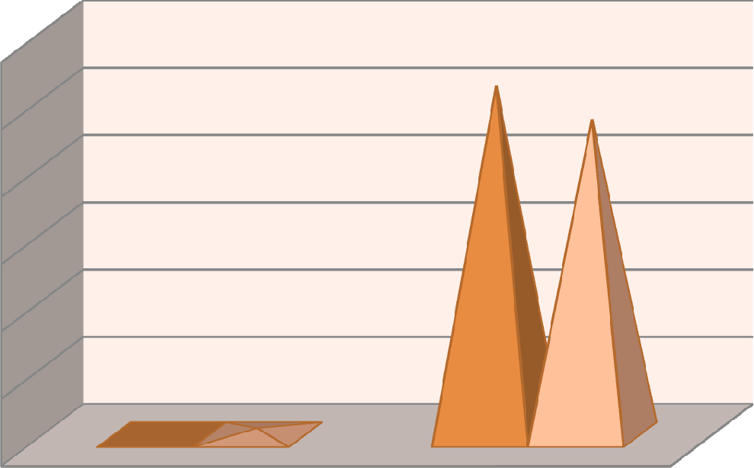

52

47

0

1

60

50

40

30

Govt.Hospitals

Private Hospitals

20

10

0

Male

Female

### Fig 4.16.1(i): Gender of Respondents

The above table tabulates the number of male and female respondents in the hospitals surveyed in Guwahati city. Out of 106 nurses surveyed, 52% of them

belong to the public sector, i.e., government hospitals and 48% belong to the private sector. All the 52% respondents in government hospitals are female and out of 48% of the respondents in the private sector only 1% is male and rests 47% are female. Thus from the above table it can be inferred that the nursing profession is very popular among the females and most of them opt for this profession.

### Table 4.16.1(ii): Age of Respondents

|  |  |  |  |  |  |  |  |  |  |  |
| --- | --- | --- | --- | --- | --- | --- | --- | --- | --- | --- |
| Particulars | Age of the respondent | | | | | | | | Total | |
|  | 18yrs-29yrs | | 30yrs-39yrs | | 40yrs-55yrs | | 55yrs above | |  |  |
|  | No. | % | No. | % | No. | % | No. | % | No. | % |
| Govt. Hospitals | 3 | 2.8 | 19 | 17.9 | 22 | 20.8 | 11 | 10.4 | 55 | 52.0 |
| Private Hospitals | 38 | 35.8 | 10 | 9.4 | 3 | 2.8 | 0 | 0 | 51 | 48.0 |
| Total | 41 | 38.6 | 29 | 27.3 | 25 | 23.6 | 11 | 10.4 | 106 | 100 |

*Source: Field Survey 2013-14*

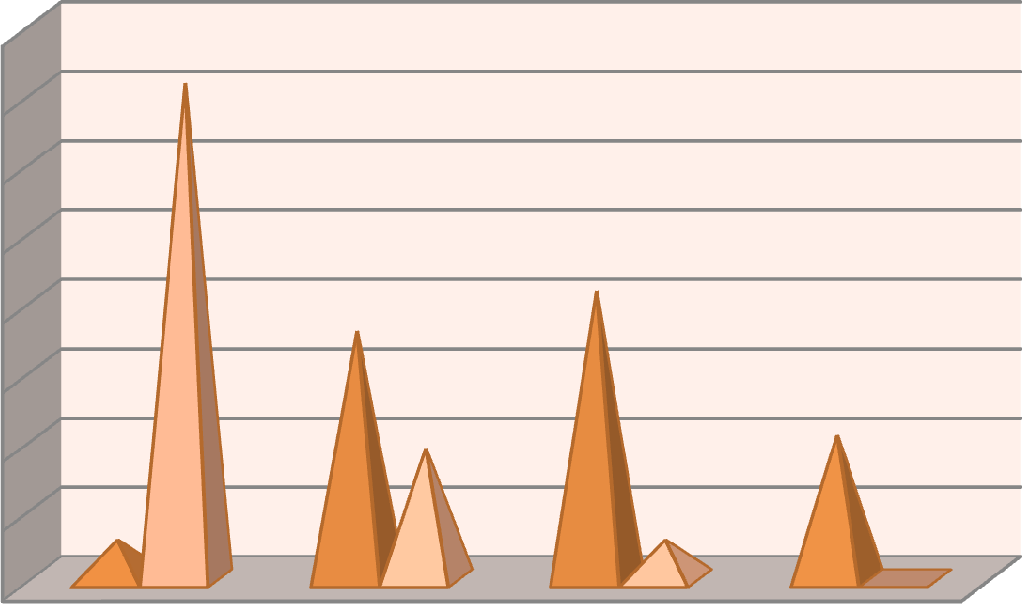

35.8

20.8

17.9

9.4

10.4

2.8

2.8

0

40

35

30

25

20

15

10

5

0

Govt. Hospitals

Private Hospitals

18yrs-29yrs 30yrs-39yrs 40yrs-55yrs 55yrs above

### Fig 4.16.1(ii): Age of Respondents

Table and Fig 4.16.1(ii) depicts the age of the respondent nurses working in hospitals in Guwahati city. Of the total respondents in this sector, 38.6% belong to the age group of 18 years to 29 years, 27.3% belong to 29 years to 39 years age

group, 23.6% belong to 39 years to 55 years age group and only 10.4% of the respondents belong to the age group of 55years above. Thus from the data it can be inferred that the respondents working in this area are very much young.

### Table 4.16.1(iii): Job Experience

|  |  |  |  |  |  |  |  |  |  |  |  |  |
| --- | --- | --- | --- | --- | --- | --- | --- | --- | --- | --- | --- | --- |
| Particulars | Job Experience | | | | | | | | | | Total | |
|  | >1yr | | 1yr-5yrs | | 5yrs-  10yrs | | 10yrs-  15yrs | | <15yrs | |  | |
|  | No. | % | No. | % | No. | % | No. | % | No. | % | No. | % |
| Govt.  Hospitals | 1 | 1.0 | 11 | 10.4 | 7 | 6.6 | 13 | 12.3 | 23 | 21.7 | 55 | 52.0 |
| Private  Hospitals | 11 | 10.4 | 28 | 26.4 | 7 | 6.6 | 3 | 2.8 | 2 | 1.9 | 51 | 48.0 |
| Total | 12 | 11.4 | 39 | 36.8 | 14 | 13.2 | 16 | 15.1 | 25 | 23.6 | 106 | 100 |

*Source: Field Survey 2013-14*

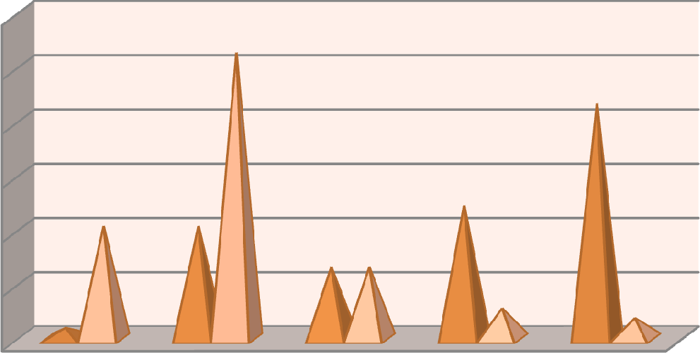

26.4

21.7

10.4

10.4

12.3

6.6 6.6

1

2.8

1.9



30

25

20

15

10

Govt. Hospitals

Private Hospitals

5

0

### Fig 4.16.1(iii): Job Experience

The above table shows the job experience of the nurses working in various hospitals in Guwahati city. 11.4% of the respondents have an experience of less

than a year in their job, out of which 1% belongs to Government hospitals and 10.4% belong to private hospitals. 36.8% have an experience of 1years to 5 years, 13.2% have 5 years to 10 years of job experience and 15.1% and 23.6% of the nurses have an experience of 10 years to 15 years and above 15 years respectively in this profession.

## Association Between Importance of Employee Retention Effort and Factors of Retention

Table 4.16.2 tries to find out if any association is there between the importance given by the nurses towards the employee retention effort and the factors under consideration. The results are shown below.

### Table 4.16.2: Correlation Between Importance of Employee Retention Effort and Various Retention Factors

|  |  |  |  |  |  |  |  |  |  |  |  |
| --- | --- | --- | --- | --- | --- | --- | --- | --- | --- | --- | --- |
| Factors | | F1 | F2 | F3 | F4 | F5 | F6 | F7 | F8 | F9 | F10 |
| F1 | Pearson Correlation | 1 | .183 | .046 | .026 | .089 | .261(**) | .109 | .205(*) | .069 | .166 |
| Sig (2- tailed) | |  | .061 | .641 | .792 | .366 | .007 | .265 | .035 | .482 | .089 |
| N | | 106 | 106 | 106 | 106 | 106 | 106 | 106 | 106 | 106 | 106 |

** Correlation is significant at the 0.01 level (2-tailed).

* Correlation is significant at the 0.05 level (2-tailed).

(F1= Employee retention effort, F2= Compensation, F3= Recognition, F4= Career progression, F5= Participation in Decision making, F6= Work Life Balance, F7= Work Environment, F8= Training and learning, F9= Leadership/ Supervision, F10= Job Security)

Table 4.16.2 represents the correlation if any between employee retention efforts put by the hospitals to retain the nurses and the various factors of employee retention. The table clearly reveals that except for two factors, no correlation exists between the other factors of retention under investigation. The factor work life balance (F6) has a positive correlation r= .261(**) at 1% level of significance with

employee retention effort**.** Thompson and Prottas (2005) tried to find if any relationship exist between employee turnover intention and support from the organization such as work life balance, supervisory support etc and found a reverse relationship between the two, i.e., organization support helps in reducing turnover intention. Similarly for the factor training and learning (F8) a positive correlation of r= .205(*) at 5% level of significance is found with employee retention effort. Wetland (2003) considered training as an important factor in retaining its employees.

## Relationship Between Performance of the Employee Retention Effort and Factors of Retention

Table 4.16.3 aims at finding out the relationship between performances of the employee retention effort put by the banks for its employees and the various retention factors under investigation.

### Table 4.16.3: Correlation Between Performance Rating Given to Employee Retention Effort and Various Retention Factors

|  |  |  |  |  |  |  |  |  |  |  |  |
| --- | --- | --- | --- | --- | --- | --- | --- | --- | --- | --- | --- |
| Factors | | R1 | F2 | F3 | F4 | F5 | F6 | F7 | F8 | F9 | F10 |
| R1 | Pearson Correlation | 1 | .357  (**) | .477  (**) | .463  (**) | .441  (**) | .138 | .431  (**) | .420  (**) | .481  (**) | .102 |
| Sig (2- tailed) | |  | .000 | .000 | .000 | .000 | .159 | .000 | .000 | .000 | .298 |
| N | | 106 | 106 | 106 | 106 | 106 | 106 | 106 | 106 | 106 | 106 |

** Correlation is significant at the 0.01 level (2-tailed).

* Correlation is significant at the 0.05 level (2-tailed).

(R1= Rating given to employee retention effort, F2= Compensation, F3= Recognition, F4= Career progression, F5= Participation in Decision making, F6= Work Life Balance, F7= Work Environment, F8= Training and Learning, F9= Leadership/ Supervision, F10= Job Security)

The table above depicts the correlation between the rating or ranking given by the nurses to the employee retention effort put by the hospitals an the various factors under research. Except for factors work life balance (F6) and job security (F10), all the factors of retention has significant correlation with ranking given to the employee retention effort. For the factors compensation, recognition, career progression, participation in decision making, work environment, training and learning and leadership and supervision a positive correlation r = .357(**),

.477(**), .463(**), .441(**), .431(**), 420(**) and .481(**) respectively. Researchers such as Meyer and Allen (1991); Solomon (1992); Snell and Dean (1992); Arthur (1994); Snell and Youndt (1995); MacDuffie (1995); Delaney and Huselid (1996); Ichniowski, Shaw and Prennushi (1997) concluded in their studies that human resource management practices such as good compensation and rewards, proper training and development programme, supervisor support , good work environment and organization justice can help reduce employee absenteeism, employee retention and better quality work.

## Impact of Various Factors on Employee Retention

This section highlights the impact or effect of the various factors of retention on the perception of the performance of the employee retention effort put by the hospitals.

### Table 4.16.4: Regression Analysis

Variables Entered/ Removeda

|  |  |  |  |
| --- | --- | --- | --- |
| Model | Variables Entered | Variables Removed | Method |
| 1 | Compensation,Recognition, Career progression, Participation in Decision making, Work Life Balance, Work Environment, Training and Learning, Leadership/ Supervision, Job Securitya | . | Enter |

* + - 1. All requested variables entered
      2. Dependent Variable: Rating given to the employee retention policy/ practices

### Model Summary

|  |  |  |  |  |
| --- | --- | --- | --- | --- |
| Model | R | R Square | Adjusted R Square | Std. Error of the Estimate |
| 1 | .569(a) | .324 | .261 | .590 |

a. Predictors: (Constant), Job Security, Work life Balance, Career progression, Leadership, Compensation, Work environment, Involvement , Training, Recognition

|  |  |  |  |  |  |
| --- | --- | --- | --- | --- | --- |
| Model | Un-standardized  Coefficients | | Standardized  Coefficients | **t** | **Sig** |
| B | Std. Error | Beta |
| 1(Constant) | .441 | .669 |  | 659 | .511 |
| Compensation | .069 | .033 | .328 | 2.057 | .042 |
| Recognition | .029 | .043 | .143 | .673 | .503 |
| Career progression | .064 | .042 | .244 | 1.505 | .136 |
| Involvement in Decision | -.043 | .051 | -.181 | -.842 | .402 |
| Work Life Balance | .052 | .042 | .128 | 1.228 | .222 |
| Work Environment | .055 | .034 | .214 | 1.620 | .108 |
| Training and Learning | -.045 | .039 | -.224 | -1.165 | .247 |
| Leadership/ Supervision | .058 | .040 | .237 | 1.435 | .155 |
| Job Security | -.163 | .077 | -.235 | -2.105 | .038 |

a. Dependent Variable: Rating given to the employee retention policy/practices of the org

Table 4.16.4 above shows the regression analysis of the data collected from the nurses working in private as well as government hospitals in Guwahati city to show the impact of the various factor of retention on nurses retention in the city. The above table clearly shows that all the factors under investigation had a combined affect of 26.1% on employee retention. If the impact of individual factors are taken into account, it can be observed from the above table that compenstion and job security has the highest impact on employee retention, the significant value being

.042 and .038 respectively among nurses working in both public and private sector in the city.

## Association Between Job Satisfaction and Factors of Retention

This section shows the association or the realtionship of the various identified factors of employee retntion with that of the job satisfaction among the nurses working in various hospitals in the city.

### Table 4.16.5: Correlation Between Job Satisfaction and Various Factors

|  |  |  |  |  |  |  |  |  |  |  |
| --- | --- | --- | --- | --- | --- | --- | --- | --- | --- | --- |
| Fact ors | JS | F2 | F3 | F4 | F5 | F6 | F7 | F8 | F9 | F10 |
| JS | 1 |  |  |  |  |  |  |  |  |  |
| F2 | .103 | 1 |  |  |  |  |  |  |  |  |
| F3 | .014 | .651(**) | 1 |  |  |  |  |  |  |  |
| F4 | -.147 | .436(**) | .679(**) | 1 |  |  |  |  |  |  |
| F5 | -.023 | .684(**) | .899(**) | .657(**) | 1 |  |  |  |  |  |
| F6 | .188 | .278(**) | .249(**) | .135 | .230(*) | 1 |  |  |  |  |
| F7 | -.112 | .445(**) | .654(**) | .674(**) | .655(**) | .177 | 1 |  |  |  |
| F8 | -.044 | .686(**) | .684(**) | .763(**) | .669(**) | .397(**) | .657(**) | 1 |  |  |
| F9 | -.178 | .436(**) | .803(**) | .715(**) | .787(**) | .148 | .634(**) | .627(**) | 1 |  |
| F10 | .012 | .538(**) | .389(**) | .262(**) | .413(**) | .391(**) | .398(**) | .353(**) | .254(**) | 1 |

** Correlation is significant at the 0.01 level (2-tailed).

* Correlation is significant at the 0.05 level (2-tailed).

(Q1=Quitting the present job will give satisfaction, F2= Compensation, F3= Recognition, F4= career progression, F5= Involvement in Decision making, F6= Work Life Balance, F7= Work Environment, F8= Training and Learning, F9= Leadership/ Supervision, F10= Job Security)

Table 4.16.5 depicts the relationship, if any, between the various factors of employee retention and job stisfaction among the nurses. It is interesting to note that although as shown in table 4.16.3, a significant correlation exist among almost all the factors of retention and performance rating given by the employees to the retention effort. But very poor and in some cases no correlation exist between the various factors of retention under investigation and job stisfaction among the nurses working in the city. It is quite an alarming situation as the nurses under investigation do not seem to be happy with the factors of retention. Cowin (2002)

found a relation between job satisfaction and retention and of the view that low satisfaction in a job may result in lower staff retention. Thus it can be concluded that these factors donnot play a significant role in satisfying the nurses working in various hospitals in Guwahati city.

## Comparison Between Public and Private Hospitals With Respect to Various Retention Factors

This section tries to find out, if any difference exist between the public and private hospitals with respect to the various retention factors under investigation.

### Table 4.16.6: Public/Private Comparison With Respect to Various Factors of Retention

|  |  |  |  |  |  |  |  |
| --- | --- | --- | --- | --- | --- | --- | --- |
| Factors | Sector | N | Mean | Std. Deviation | t | df | Sig. (2-tailed) |
| Compensation | Public | 55 | 18.96 | 3.150 | 1.431 | 104 | .156 |
| Private | 51 | 18.06 | 3.361 |
| Recognition | Public | 55 | 22.05 | 3.076 | -1.687 | 104 | .095 |
| Private | 51 | 23.16 | 3.646 |
| Career progression | Public | 55 | 13.47 | 2.441 | -4.566 | 104 | .000 |
| Private | 51 | 15.61 | 2.367 |
| Involvement | Public | 55 | 18.78 | 2.872 | -1.556 | 104 | .123 |
| Private | 51 | 19.65 | 2.848 |
| Work life Balance | Public | 55 | 11.55 | 1.951 | 1.373 | 104 | .173 |
| Private | 51 | 11.10 | 1.315 |
| Work environment | Public | 55 | 23.33 | 2.510 | -2.038 | 104 | .044 |
| Private | 51 | 24.37 | 2.771 |
| Training | Public | 55 | 20.64 | 3.674 | -2.331 | 104 | .022 |
| Private | 51 | 22.14 | 2.871 |
| Leadership | Public | 55 | 18.71 | 2.629 | -3.742 | 104 | .000 |
| Private | 51 | 20.63 | 2.645 |
| Job Security | Public | 55 | 8.84 | 1.102 | 1.814 | 104 | .073 |
| Private | 51 | 8.49 | .834 |

Table 4.16.6 shows the comparison between public and private sector hospitals with respect to employee retention taking into cosidration the various factors of

employee retention investigated in the study. If we observe the table, it clearly depicts that for the factors promotion, work environment, training and development and leadership a significant difference exist between the nurses of public and private sector hospitals. For the factor career progression, if we observe the average mean value, we find that the mean score of private sector , M= 15.61 is higher than that of the public sector, M= 13.47. So, it can be said that the nurses working in private hospitals get more promotional opportunities, than that of the nurses working in government hospitals.Similarly for the factor work environment we can find a significant difference between the public and the private sector and the significant value is .044< p< .05. If we take into consideration the average mean values, we find that the average mean of private hospitals (M= 24.37) is higher than that of government hospitals(M= 23.33). thus the working environment of private hospitals is more suitable than that of government hospitals. Again in case of training and development a difference exist between the private and the government hospitals with p value being .022< .05. If we observe the average mean scores, we find that the average mean of government hospitals (M= 20.64) is less than that of private hospitals (M= 22.14). So it can be concluded that the nurses in private hospitals get more opportunities for skill upgradation than that of nurses working in the government hospitals in the city. Again for the factor leadership and supervision also significant difference exist between the private and the public sector, value being .000< p<.05. Here also the average mean of public sector(M= 18.71) which is less than private sector (M= 20.63). Thus it can be concluded that the nurses working in private hospitals enjoy better leadership and supervision than that of nurses working in the government hopitals.