**Kubernetes installation procedure:**

#!/bin/bash

# 2. PRE-Reqs: Disable - Firewall | Swap | SELinux

# Note: Execute on all nodes (master & worker)

# Disable Firewall

systemctl stop firewalld

systemctl disable firewalld

# OR - ensure ports [6443 10250] are open

# Disable Swap

swapoff -a

sed -i.bak -r 's/(.+ swap .+)/#\1/' /etc/fstab

# Disable SELinux

setenforce 0

sed -i 's/enforcing/disabled/g' /etc/selinux/config

***********************************************************************************************************************************************

3. Download & Install - Docker | Kubelet | Kubeadm | Kubectl

# Note: Execute on all nodes (master & worker)

# Kubernetes Repository – Copy and paste it in your kube master and nodes for the following config file and execute it.



# Installing Docker | Kubelet | Kubeadm | Kubectl

yum update -y

##yum install -y docker kubeadm kubelet kubectl --disableexcludes=kubernetes

yum install -y install -y kubelet kubeadm kubectl containerd --disableexcludes=kubernetes

systemctl enable containerd && systemctl start containerd

systemctl enable kubelet && systemctl start kubelet

systemctl restart containerd

# Start and enable docker and kubectl

##systemctl enable docker && systemctl start docker

##systemctl enable kubelet && systemctl start kubelet

# For CentOS and RHEL – Copy and paste it in your terminal – for the following text file contents.



enable br_netfilter to get this directory:

modprobe br_netfilter

sysctl net.bridge.bridge-nf-call-iptables=1

sysctl net.ipv4.ip_forward=1

sysctl --system

echo "1" > /proc/sys/net/ipv4/ip_forward

# Restart the systemd daemon and the kubelet service with the commands:

systemctl daemon-reload

systemctl restart kubelet

4. Configure Kubernetes "master" node

# Initializing master node

kubeadm init --pod-network-cidr=10.244.0.0/16

don’t change the IP address – this is related to flannel network.

# Note down Join command in below step.

# If you want to run kubectl as "regular" user. Then, execute below.

mkdir -p $HOME/.kube

sudo cp -i /etc/kubernetes/admin.conf $HOME/.kube/config

sudo chown $(id -u):$(id -g) $HOME/.kube/config

--------------------------------------------------------------------

# Installing Flannel network-plug-in for cluster network

If the nodes are not ready just run the below query:

kubectl apply -f <https://raw.githubusercontent.com/coreos/flannel/master/Documentation/kube-flannel.yml>

The kubeadm guide for installing flannel

<https://github.com/kubernetes/website/pull/16575/files>

kubectl get pods --all-namespaces

************************************************************************************************************************************************

5. Join "worker" nodes to the cluster

# Get exact join command from previous kubeadm init command output and execute it in the kube nodes.

kubeadm join <generated_token> --discovery-token-unsafe-skip-ca-verification

------------------------------------ end of Kubernetes setup --------------------------------------------------------------------

************----------------------------Troubleshooting Init command-----------------------------*********************

***************Install the containerd.io package ******************************************

yum install -y yum-utils

yum-config-manager --add-repo https://download.docker.com/linux/centos/docker-ce.repo

yum install -y containerd.io

sudo mkdir -p /etc/containerd

containerd config default | sudo tee /etc/containerd/config.toml

systemctl restart containerd

*********************************************************************************************

containerd config default > /etc/containerd/config.toml

echo """

runtime-endpoint: unix:///run/containerd/containerd.sock

image-endpoint: unix:///run/containerd/containerd.sock

""" > /etc/crictl.yaml

systemctl restart containerd

************----------------------------Troubleshooting ---------------------------------*********************

Possible errors when connect with node:

Error saying "Unable to connect to the server: x509: certificate signed by unknown authority"

**Solution**:

Make sure you execute these commands every time you recreate a cluster:

mkdir -p $HOME/.kube

sudo cp -i /etc/kubernetes/admin.conf $HOME/.kube/config

sudo chown $(id -u):$(id -g) $HOME/.kube/config

if you are not able to perform the join command with the nodes:

sudo kubeadm reset

sudo kubeadm init

To create a new token in the master:

kubeadm token create --ttl=0

 ttl=0 means, generated token will never expire.

kubeadm join <generated_token>

any error for verifying ca hash, then join as per below:

kubeadm join <generated_token> --discovery-token-unsafe-skip-ca-verification

************--------------------------- End _______________________________********************

cat /etc/kubernetes/admin.conf $HOME/.kube/config

**If nodes are not ready**: Perform the flannel network execution process.

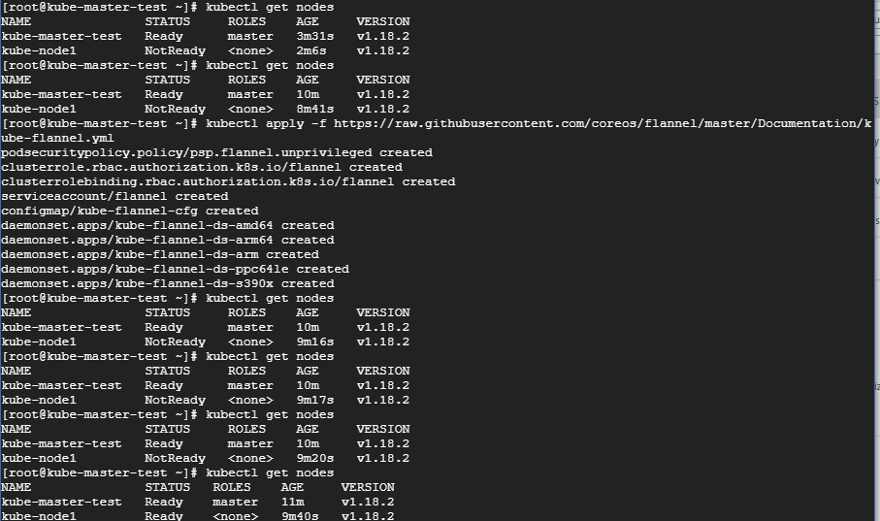

Other installation methods please follow the below links:

<https://kubernetes.io/docs/tasks/tools/install-kubectl/#install-kubectl-on-windows>

<https://kind.sigs.k8s.io/docs/user/quick-start/#installation>

export KUBECONFIG=/etc/kubernetes/kubelet.conf

**The connection to the server localhost:8080 was refused - did you specify the right host or port?**

Solution:

sudo cp /etc/kubernetes/admin.conf $HOME/  
sudo chown $(id -u):$(id -g) $HOME/admin.conf  
export KUBECONFIG=$HOME/admin.conf

-------------------------------------------------*********************************------------------------------------

Sources:

<https://gist.github.com/rkaramandi/44c7cea91501e735ea99e356e9ae7883>

kubeadm init --apiserver-advertise-address=172.16.16.100 --pod-network-cidr=192.168.0.0/16

##### Calico network

kubeadm init --pod-network-cidr=192.168.0.0/16