1. **Basic Calculator Code**

**.html**

<!DOCTYPE html>

<html lang="en" dir="ltr">

<head>

<meta charset="utf-8">

<title></title>

<link rel="stylesheet" href="styles.css">

</head>

<body>

<table class="calculator" >

<tr>

<td colspan="3"> <input class="display-box" type="text" id="result" disabled /> </td>

<!-- clearScreen() function clears all the values -->

<td> <input type="button" value="C" onclick="clearScreen()" id="btn" /> </td>

</tr>

<tr>

<!-- display() function displays the value of clicked button -->

<td> <input type="button" value="1" onclick="display('1')" /> </td>

<td> <input type="button" value="2" onclick="display('2')" /> </td>

<td> <input type="button" value="3" onclick="display('3')" /> </td>

<td> <input type="button" value="/" onclick="display('/')" /> </td>

</tr>

<tr>

<td> <input type="button" value="4" onclick="display('4')" /> </td>

<td> <input type="button" value="5" onclick="display('5')" /> </td>

<td> <input type="button" value="6" onclick="display('6')" /> </td>

<td> <input type="button" value="-" onclick="display('-')" /> </td>

</tr>

<tr>

<td> <input type="button" value="7" onclick="display('7')" /> </td>

<td> <input type="button" value="8" onclick="display('8')" /> </td>

<td> <input type="button" value="9" onclick="display('9')" /> </td>

<td> <input type="button" value="+" onclick="display('+')" /> </td>

</tr>

<tr>

<td> <input type="button" value="." onclick="display('.')" /> </td>

<td> <input type="button" value="0" onclick="display('0')" /> </td>

<!-- calculate() function evaluates the mathematical expression -->

<td> <input type="button" value="=" onclick="calculate()" id="btn" /> </td>

<td> <input type="button" value="*" onclick="display('*')" /> </td>

</tr>

</table>

<script type="text/javascript" src="scripts.js"></script>

</body>

</html>

**Styles.css**

.calculator {

padding: 10px;

border-radius: 1em;

height: 380px;

width: 400px;

margin: auto;

background-color: lightgrey;

box-shadow: rgba(0, 0, 0, 0.19) 0px 10px 20px, rgba(0, 0, 0, 0.23) 0px 6px 6px;

}

.display-box {

font-family: 'Orbitron', sans-serif;

background-color: lightgrey;

border: solid black 0.5px;

color: black;

border-radius: 5px;

width: 100%;

height: 65%;

}

#btn {

background-color: #fb0066;

}

input[type=button] {

font-family: 'Orbitron', sans-serif;

background-color: black;

color: white;

border: solid black 0.5px;

width: 100%;

border-radius: 5px;

height: 70%;

outline: none;

}

input:active[type=button] {

background: #e5e5e5;

-webkit-box-shadow: inset 0px 0px 5px #c1c1c1;

-moz-box-shadow: inset 0px 0px 5px #c1c1c1;

box-shadow: inset 0px 0px 5px #c1c1c1;

}

**Scripts.js**

// This function clears all the values

function clearScreen() {

document.getElementById("result").value = "";

}

// This function displays the values

function display(value) {

document.getElementById("result").value += value;

}

// This function evaluates the expression and returns the result

function calculate() {

var p = document.getElementById("result").value;

var q = eval(p);

document.getElementById("result").value = q;

}

**Output:**

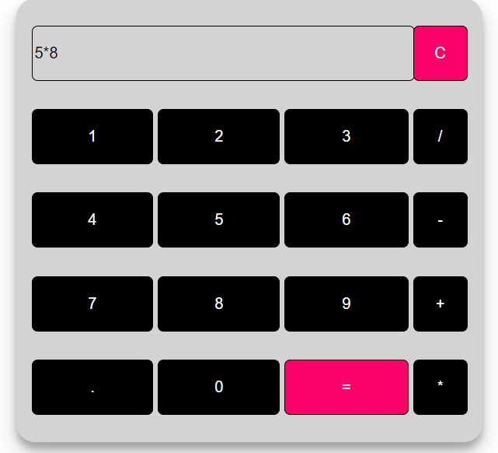

**2. SURVEY FORM HTML CODE**

**Index.html**

<!DOCTYPE html>

<html>

<head>

<link rel="stylesheet" type="text/css" href="style.css">

</head>

<body>

<div class="container">

<h2>Survey Form</h2>

<form id="surveyForm">

<div class="form-group">

<label for="firstName">First Name</label>

<input type="text" id="firstName" required>

</div>

<div class="form-group">

<label for="lastName">Last Name</label>

<input type="text" id="lastName" required>

</div>

<div class="form-group">

<label for="dob">Date of Birth</label>

<input type="date" id="dob" required>

</div>

<div class="form-group">

<label for="country">Country</label>

<select id="country" required>

<option value="india">INDIA</option>

<option value="usa">USA</option>

<option value="canada">Canada</option>

<option value="uk">UK</option>

<!-- Add more country options here -->

</select>

</div>

<div class="form-group">

<label>Gender</label>

<input type="checkbox" id="male" name="gender" value="Male">

<label for="male">Male</label>

<input type="checkbox" id="female" name="gender" value="Female">

<label for="female">Female</label>

</div>

<div class="form-group">

<label for="profession">Profession</label>

<input type="text" id="profession" required>

</div>

<div class="form-group">

<label for="email">Email</label>

<input type="email" id="email" required>

</div>

<div class="form-group">

<label for="mobile">Mobile Number</label>

<input type="tel" id="mobile" required>

</div>

<div class="buttons">

<button type="button" id="submitBtn" onclick="submitForm()">Submit</button>

<button type="button" id="resetBtn" onclick="resetForm()">Reset</button>

</div>

</form>

</div>

<script src="script.js"></script>

</body>

</html>

**Style.css**

body {

font-family: Arial, sans-serif;

background-color: #f4f4f4;

margin: 0;

padding: 0;

}

.container {

background-color: #fff;

max-width: 600px;

margin: 20px auto;

padding: 20px;

border: 1px solid #ccc;

border-radius: 5px;

box-shadow: 0 0 10px rgba(0, 0, 0, 0.1);

}

.form-group {

margin-bottom: 15px;

}

label {

display: block;

font-weight: bold;

}

input[type="text"],

input[type="date"],

select,

input[type="email"],

input[type="tel"] {

width: 100%;

padding: 10px;

border: 1px solid #ccc;

border-radius: 4px;

box-shadow: none;

font-size: 16px;

}

input[type="checkbox"] {

margin-right: 10px;

}

.buttons {

margin-top: 20px;

}

button {

background-color: #007BFF;

color: #fff;

padding: 10px 20px;

border: none;

border-radius: 4px;

cursor: pointer;

font-size: 16px;

}

.popup {

display: none;

position: fixed;

top: 0;

left: 0;

width: 100%;

height: 100%;

background-color: rgba(0, 0, 0, 0.7);

z-index: 1;

}

.popup-content {

background-color: #fff;

max-width: 400px;

margin: 10% auto;

padding: 20px;

border: 1px solid #ccc;

border-radius: 5px;

}

.close {

float: right;

font-size: 24px;

font-weight: bold;

cursor: pointer;

}

#popupData {

margin-top: 10px;

}

**Script.js**

function submitForm() {

const form = document.getElementById("surveyForm");

if (form.checkValidity()) {

const firstName = document.getElementById("firstName").value;

const lastName = document.getElementById("lastName").value;

const dob = document.getElementById("dob").value;

const country = document.getElementById("country").value;

const genderElements = document.querySelectorAll('input[name="gender"]:checked');

const profession = document.getElementById("profession").value;

const email = document.getElementById("email").value;

const mobile = document.getElementById("mobile").value;

const gender = Array.from(genderElements).map(el => el.value).join(", ");

const popupData = `

<p><strong>First Name:</strong> ${firstName}</p>

<p><strong>Last Name:</strong> ${lastName}</p>

<p><strong>Date of Birth:</strong> ${dob}</p>

<p><strong>Country:</strong> ${country}</p>

<p><strong>Gender:</strong> ${gender}</p>

<p><strong>Profession:</strong> ${profession}</p>

<p><strong>Email:</strong> ${email}</p>

<p><strong>Mobile Number:</strong> ${mobile}</p>

`;

document.getElementById("popupData").innerHTML = popupData;

document.getElementById("popup").style.display = "block";

form.reset();

} else {

alert("Please fill in all required fields.");

}

}

function resetForm() {

document.getElementById("surveyForm").reset();

}

function closePopup() {

document.getElementById("popup").style.display = "none";

}

// Close the popup when clicking outside the content

window.onclick = function(event) {

if (event.target == document.getElementById("popup")) {

closePopup();

}

}

Output:

