**JavaScript:**

1. **Take a sentence as an input and reverse every word in that sentence. Example - This is a sunny day > shiT si a ynnus yad.**

function reverseWordsInSentence(sentence) {

const words = sentence.split(/\s+/);

const reversedWords = words.map(word => {

return word.split('').reverse().join('');

});

return reversedWords.join(' ');

}

const inputSentence = "This is a sunny day";

const reversedSentence = reverseWordsInSentence(inputSentence);

console.log("Reversed Sentence:", reversedSentence);

**output:**

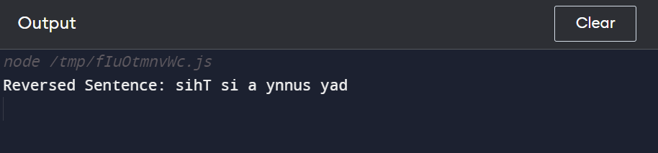

1. **Perform sorting of an array in descending order.**

const arr = [5, 2, 9, 1, 5, 6];

// Sort the array in descending order

arr.sort(function(a, b) {

return b - a;

});

console.log("Array sorted in descending order:", arr);

**Output:**

