**ADC-DAC**

Step 1: Create a MPLAB Project and Open MHC (Refer to Creating First project).

Step 2: Clock Configuration:

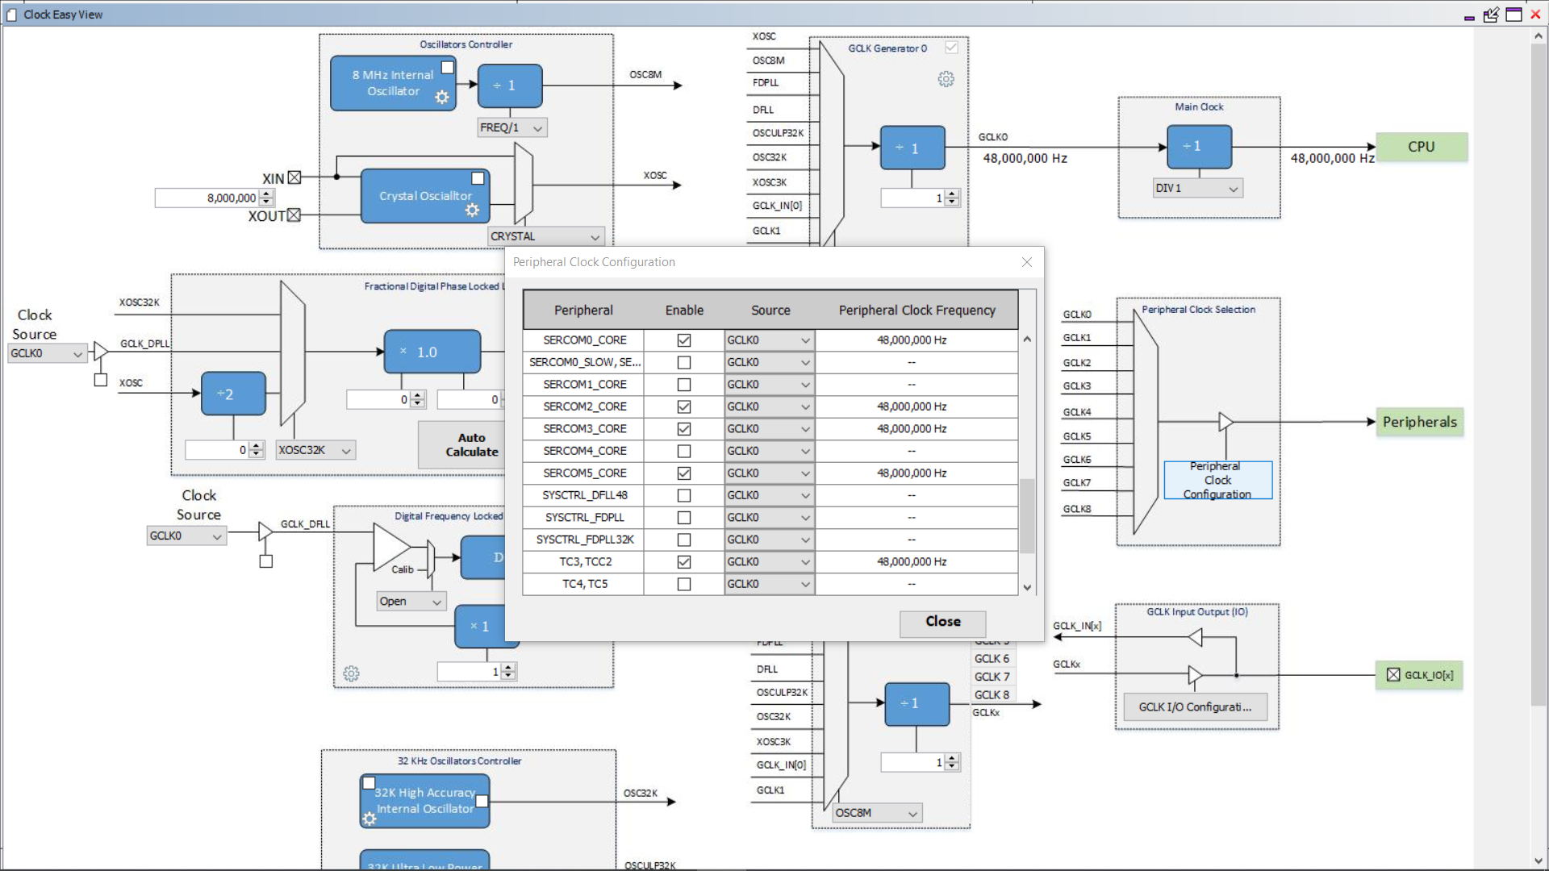

Step 3: Set the pin configurations as shown below.

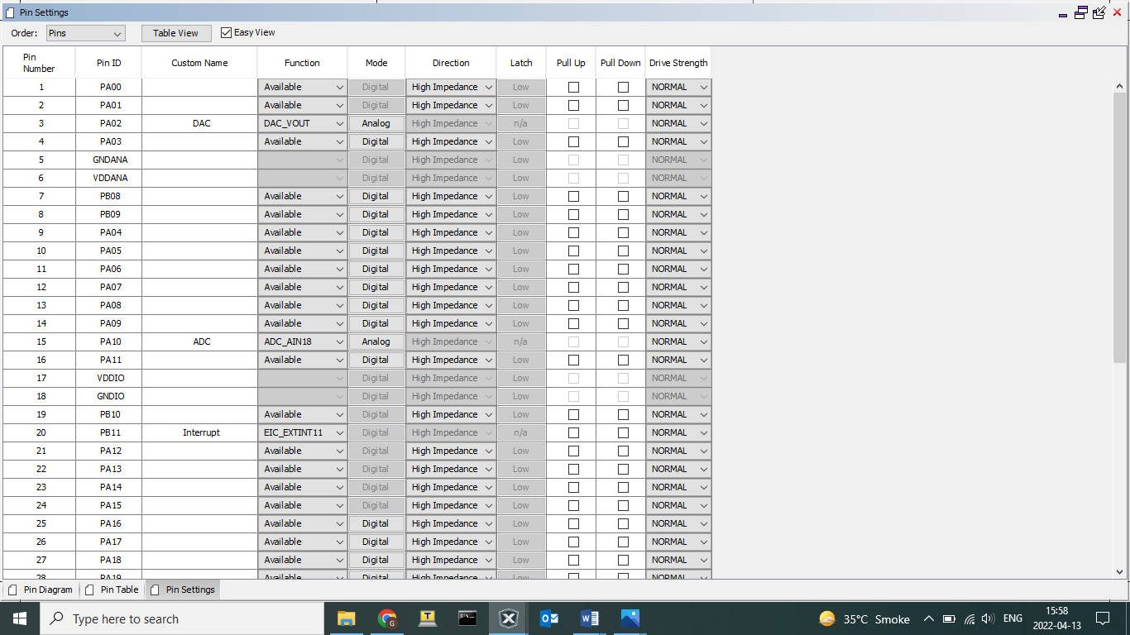

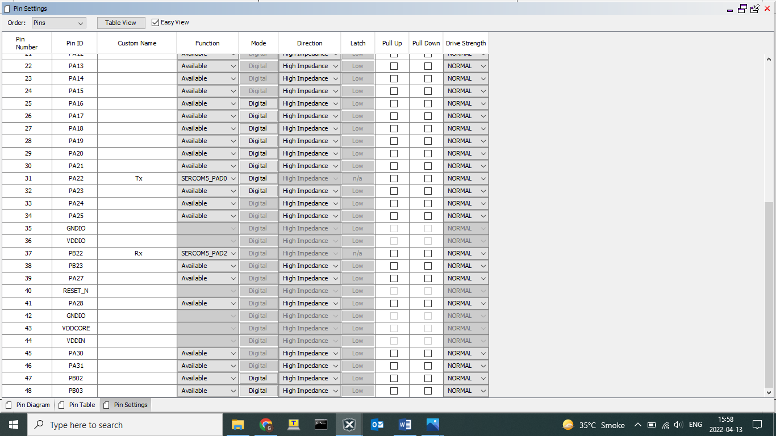

Step 4: Click on Peripherals and select ADC, DAC, EIC and SERCOM. Select the configurations as shown below.

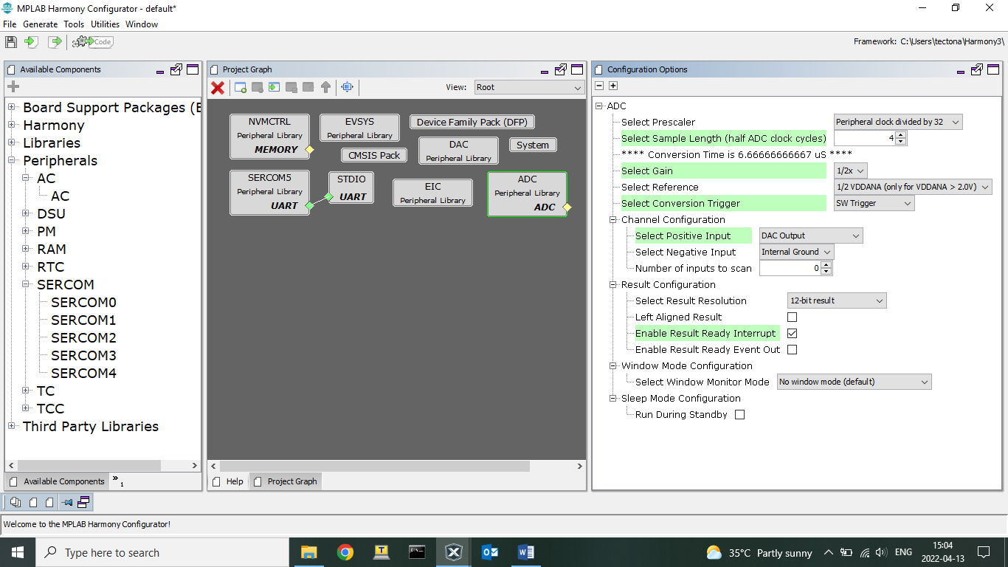

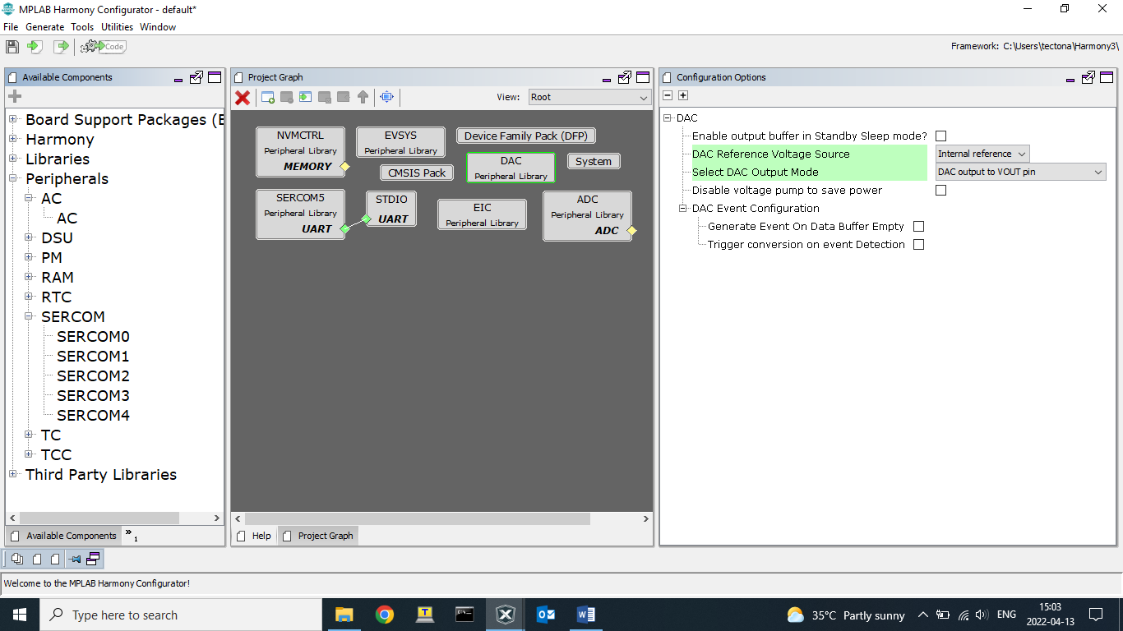

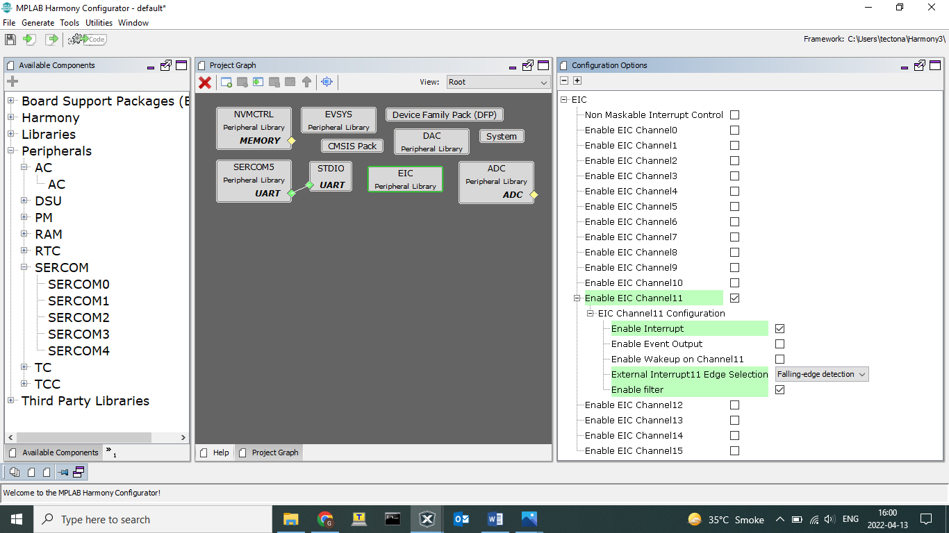

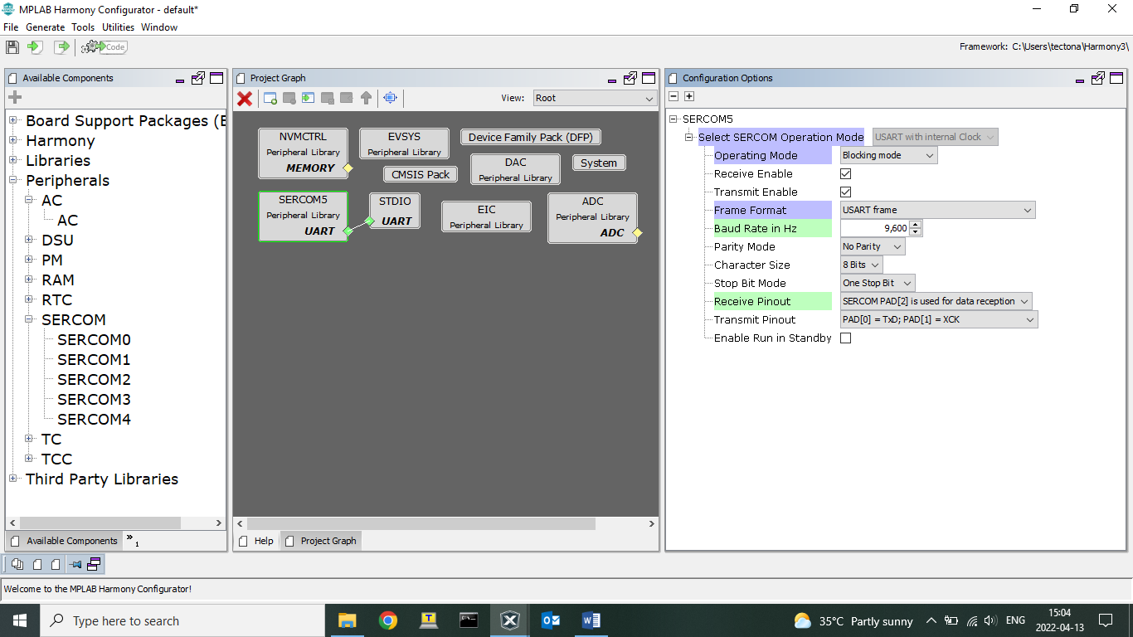

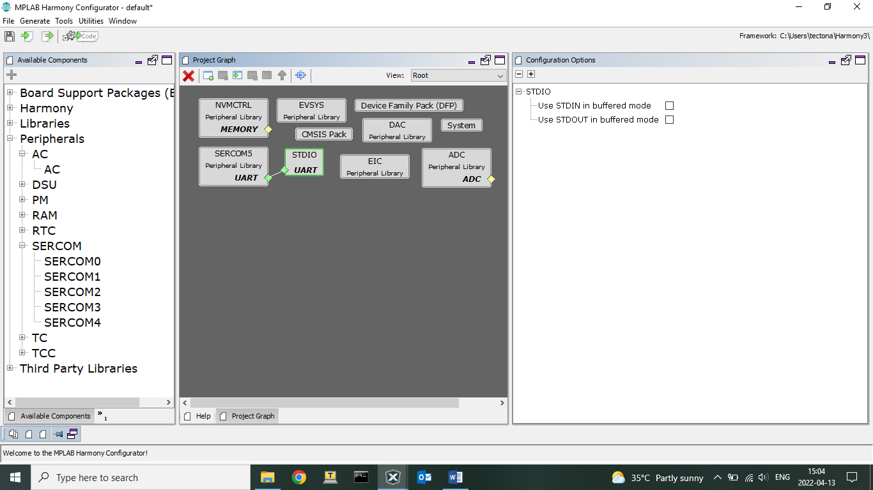

Step 5: Click on Generate Code.

You should be able to see MHC generated files under

Project->Source Files->config->default->peripheral->adc->plib_adc.c.

Project->Source Files->config->default->peripheral->dac->plib_dac.c.

Project->Source Files->config->default->peripheral->sercom->plib_sercom5_usart.c.

Project->Source Files->config->default->peripheral->eic->plib_eic.c.

Code:

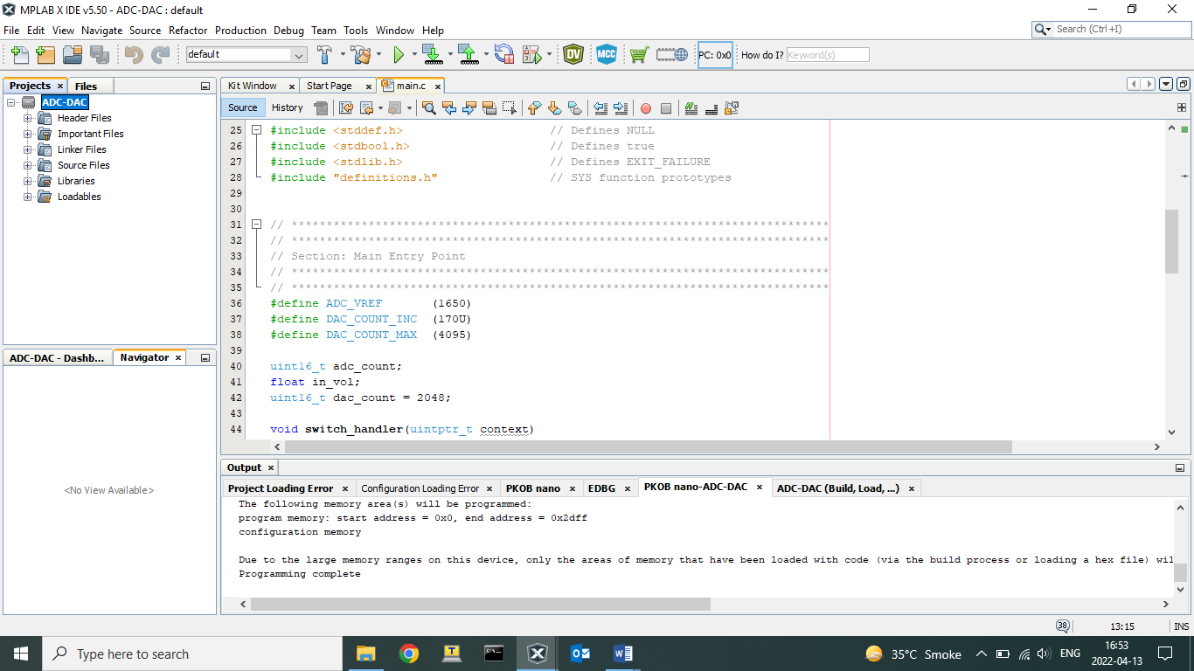

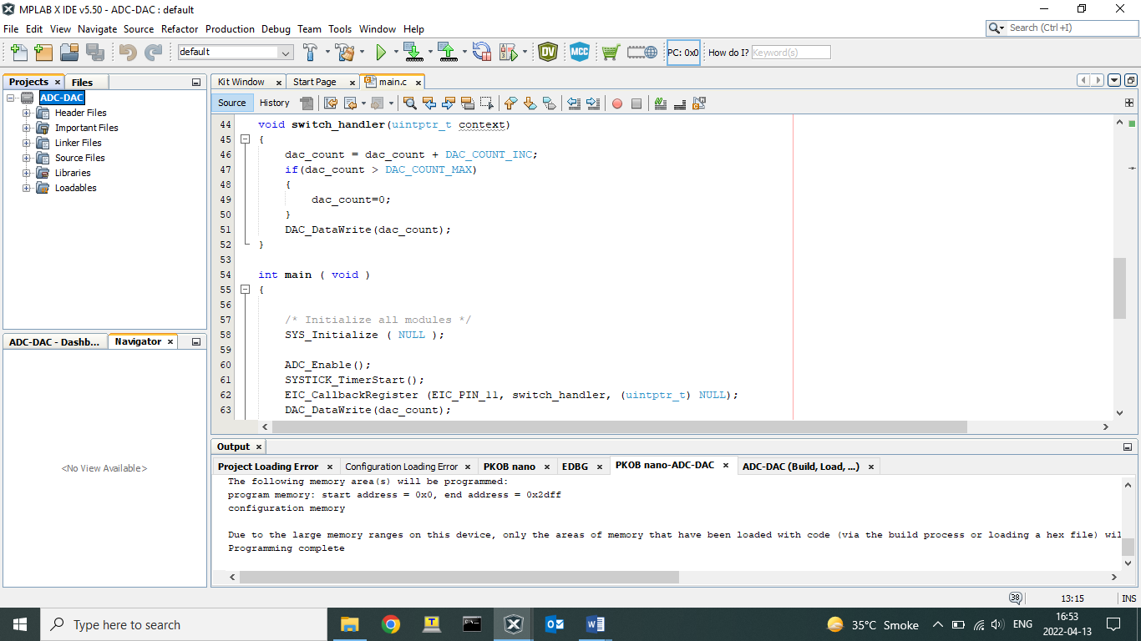

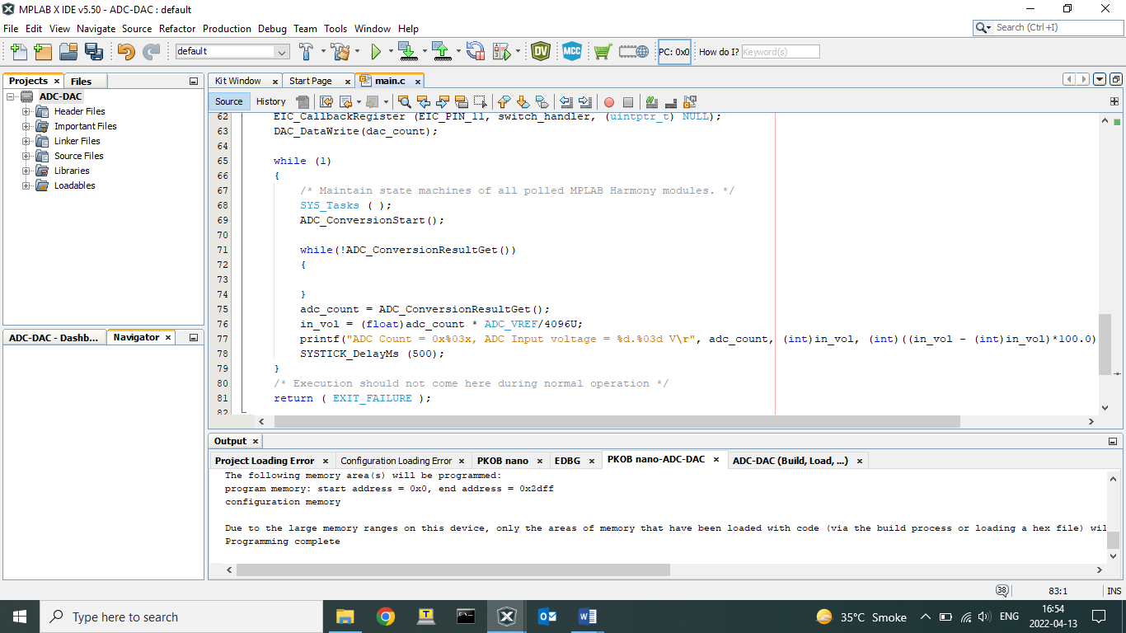

You can see the output using TeraTerm application.

Connect PA02: DAC VOUT to PA03: ADC.

Press the switch to change the DAC value.

Output:

