**I2C**

Step 1: Create a MPLAB Project and Open MHC (Refer to Creating First project).

Step 2: Clock Configuration:

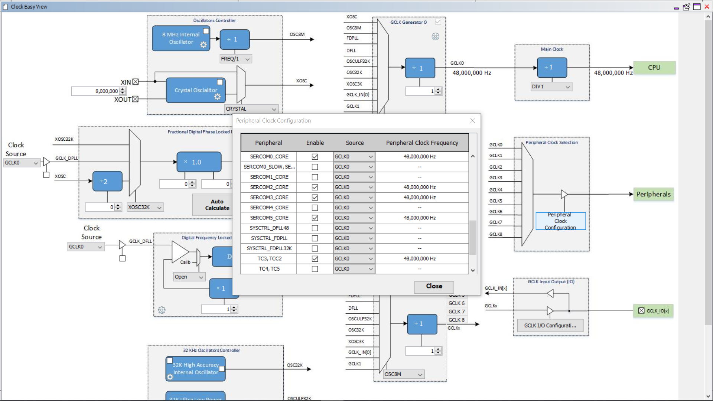

**I2C Master:**

Step 3: Set PA16 as SDA and PA17 as SCK.

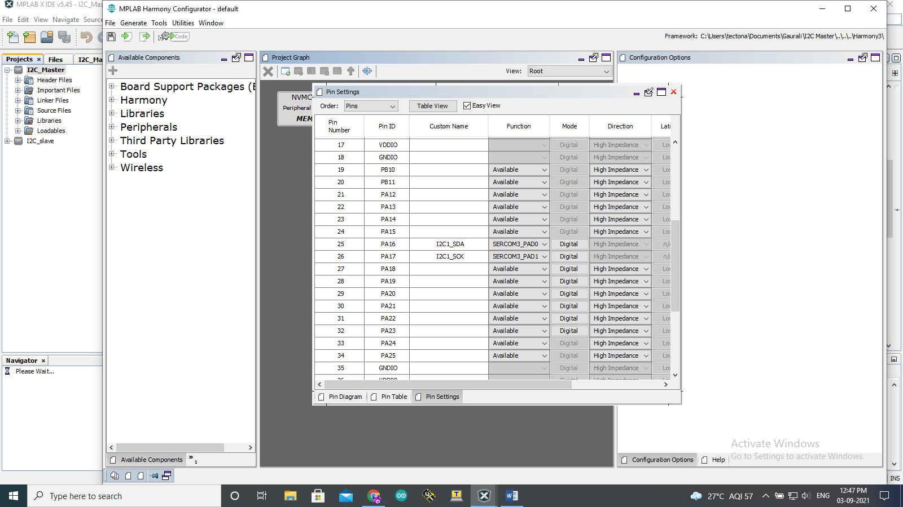

Step 4: Click on Peripherals and select the SERCOM3 and set the configurations as shown below.

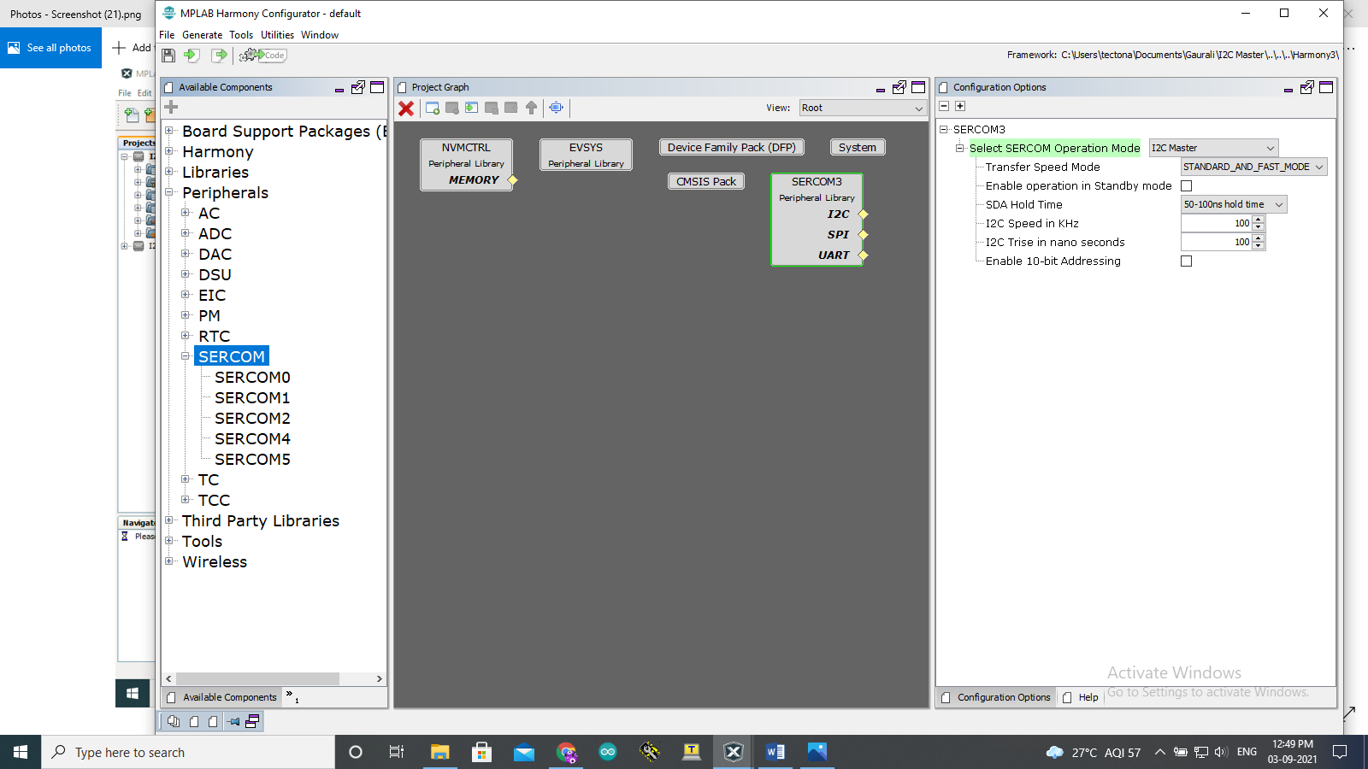

Step 5: Click on Generate Code.

You should be able to see MHC generated files under Project->Source Files->config->default->peripheral->sercom3->plib_i2c_master.c

Master code:

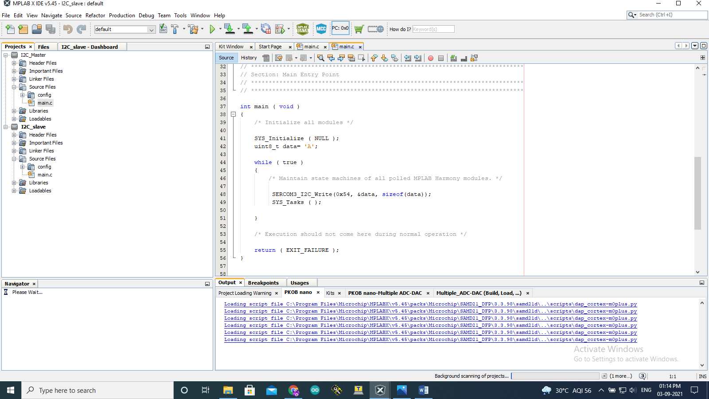

**I2C Slave:**

Step 3: Set PA12 as SDA, PA13 as SCK and PA22 as Print.

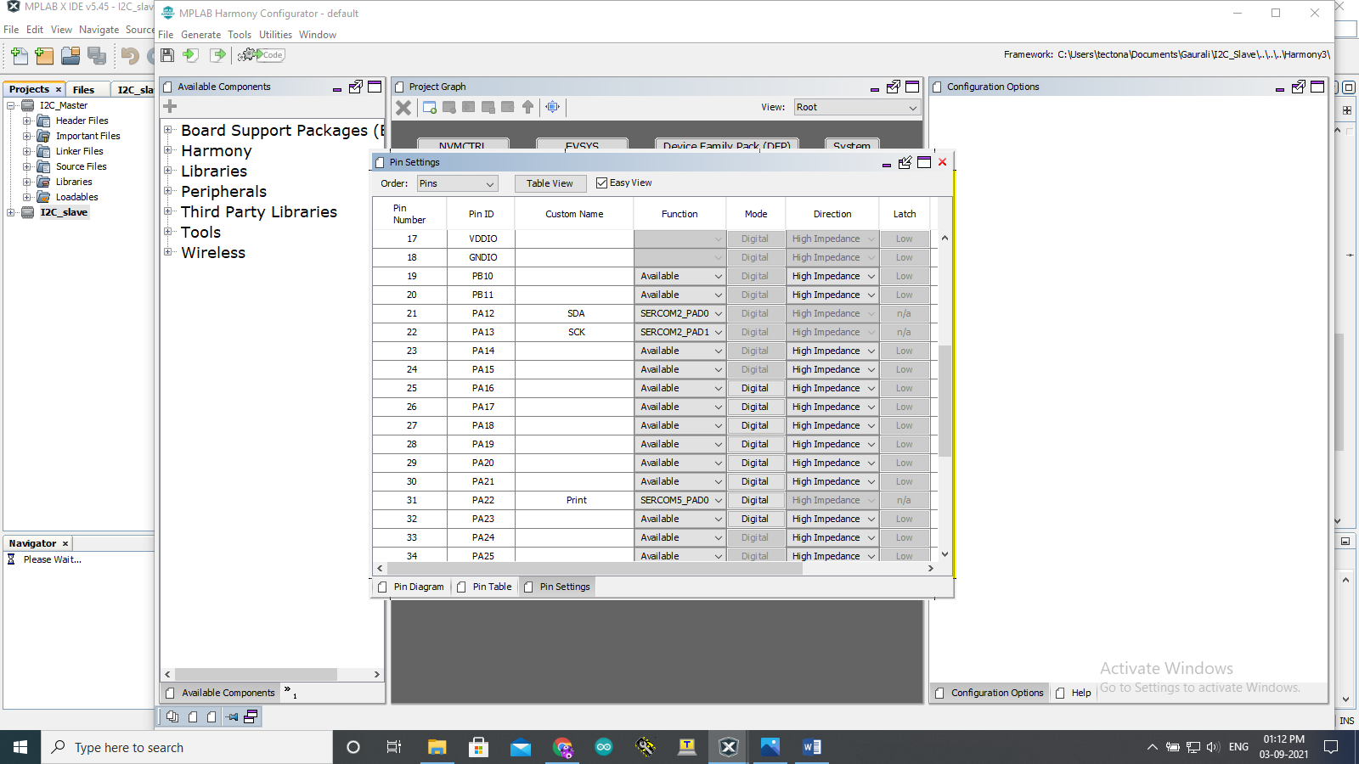

Step 4: Click on Peripherals and select SERCOM2 & SERCOM5. Configure them as shown below.

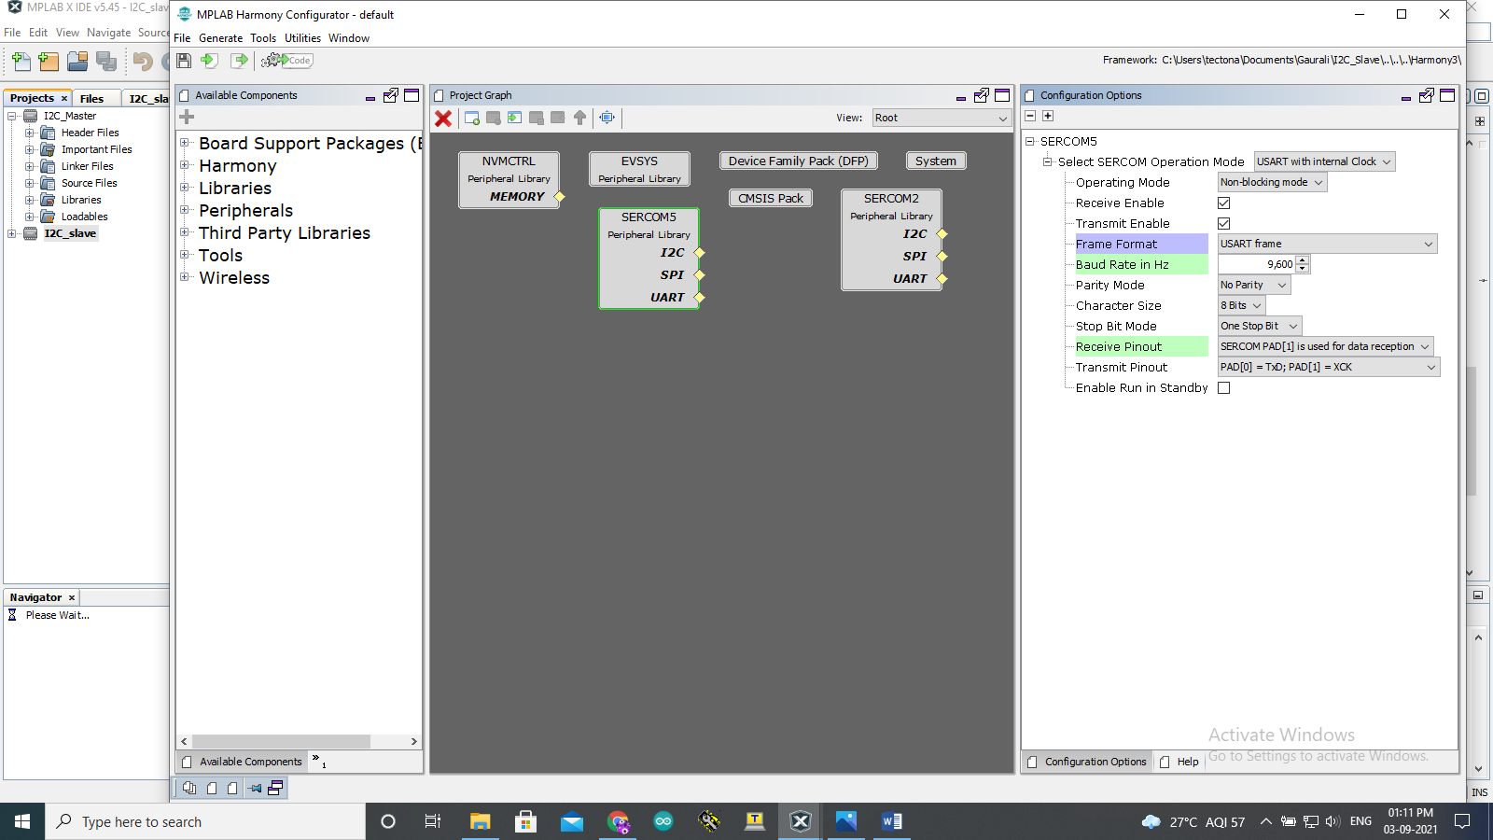

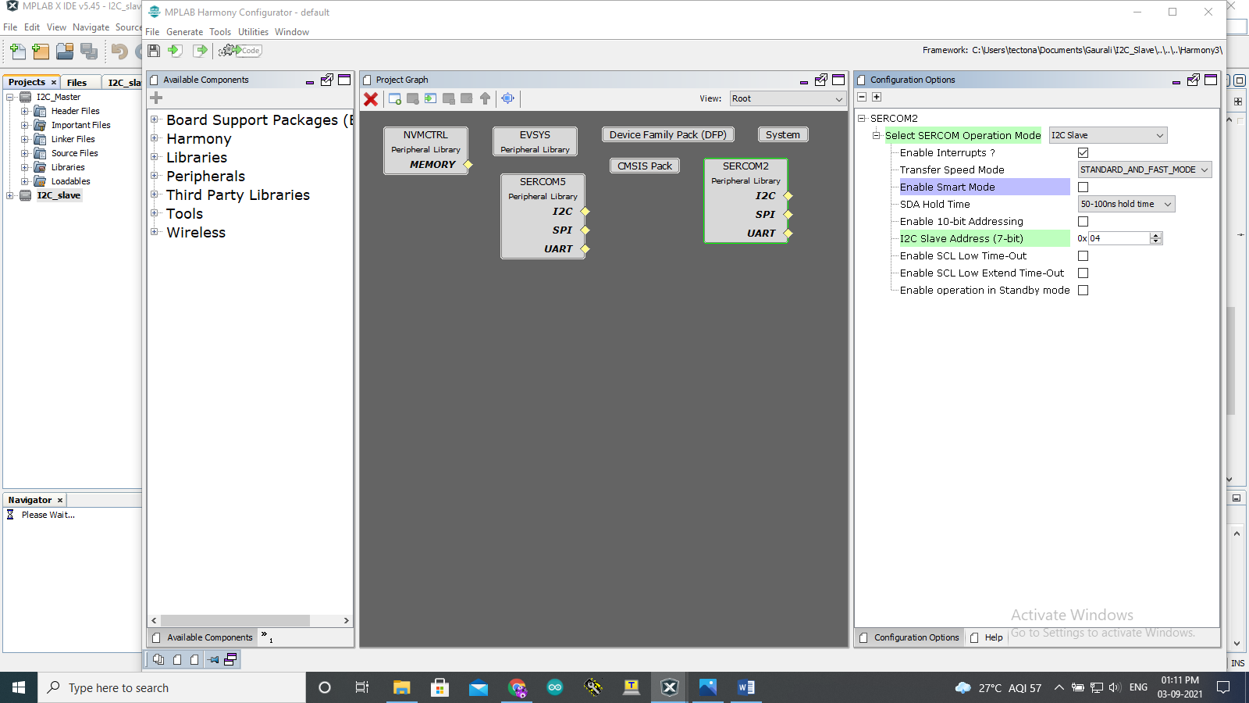

Step 5: Click on Generate Code.

You should be able to see MHC generated files under

Project->SourceFiles->config->default->peripheral->sercom2->plib_i2c_slave.c

Project->SourceFiles->config->default->peripheral->usart- >plib_sercom5_usart.c.

Slave code:

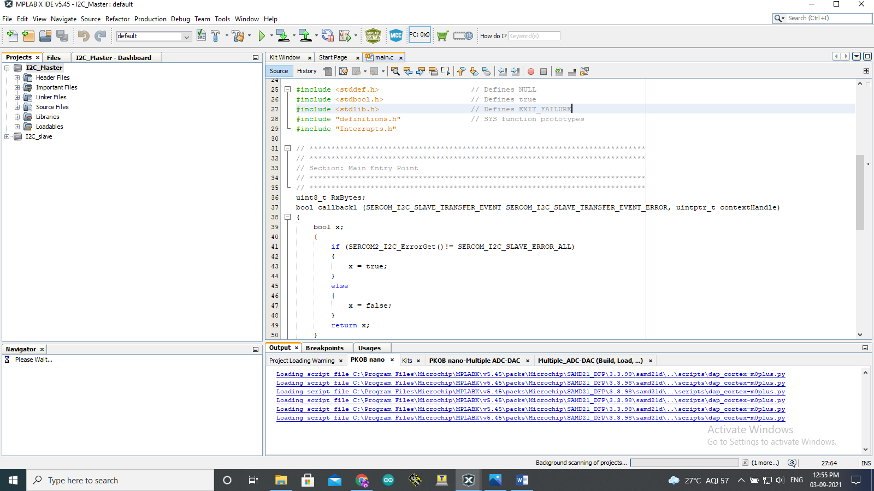

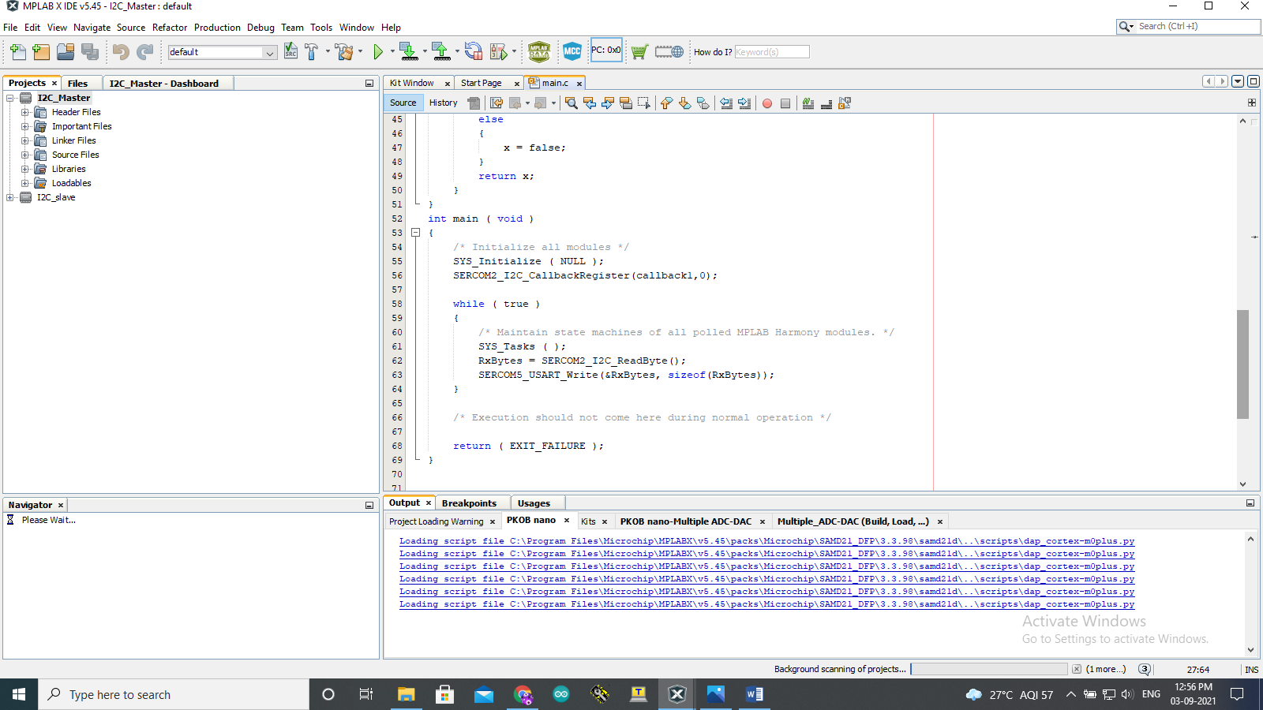

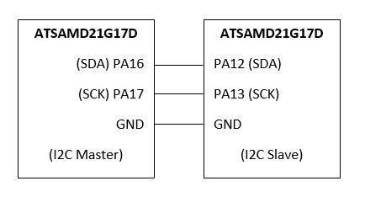

You can see the output using TeraTerm on the COM of Slave board.

If I2C doesn't work with normal connection , add pull up resistors between master and slave connection as shown in the image below:

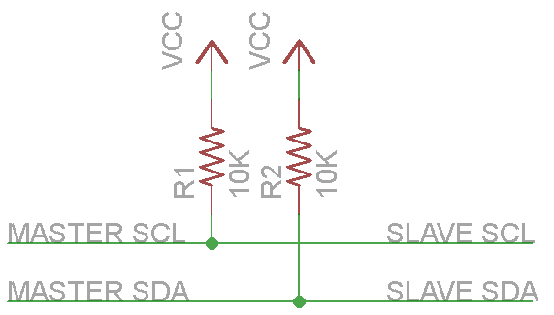

Output:

