**SPI**

Step 1: Create a MPLAB Project and Open MHC (Refer to Creating First project).

Step 2: Clock Configuration:

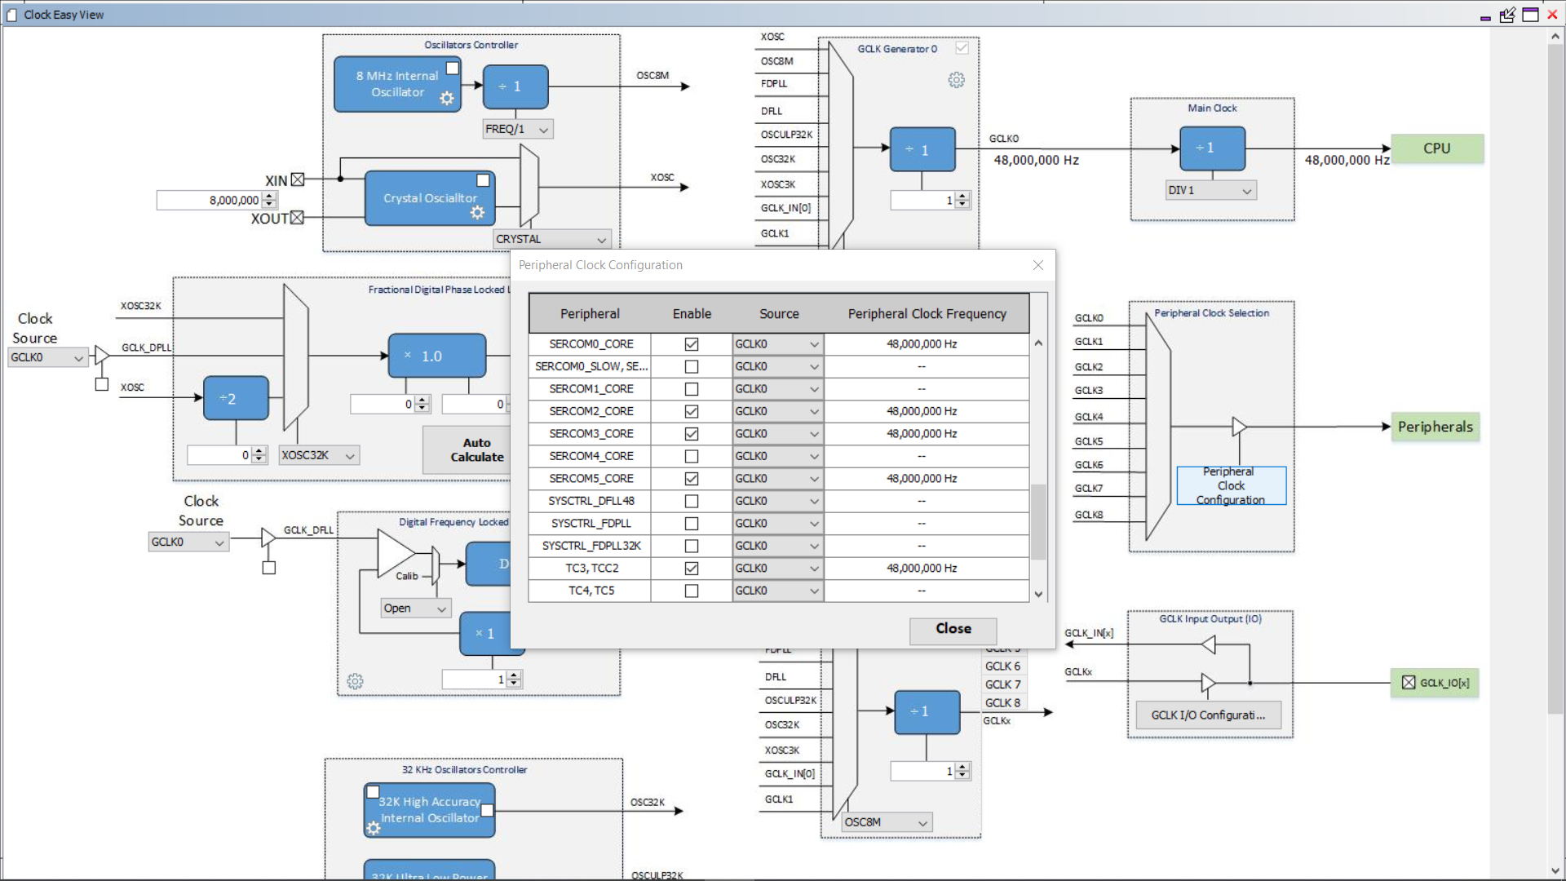

**SPI Master:**

Step 3: Set PA04 as MOSI, PA05 as SCK, PA06 as SS and PA07 as MISO.

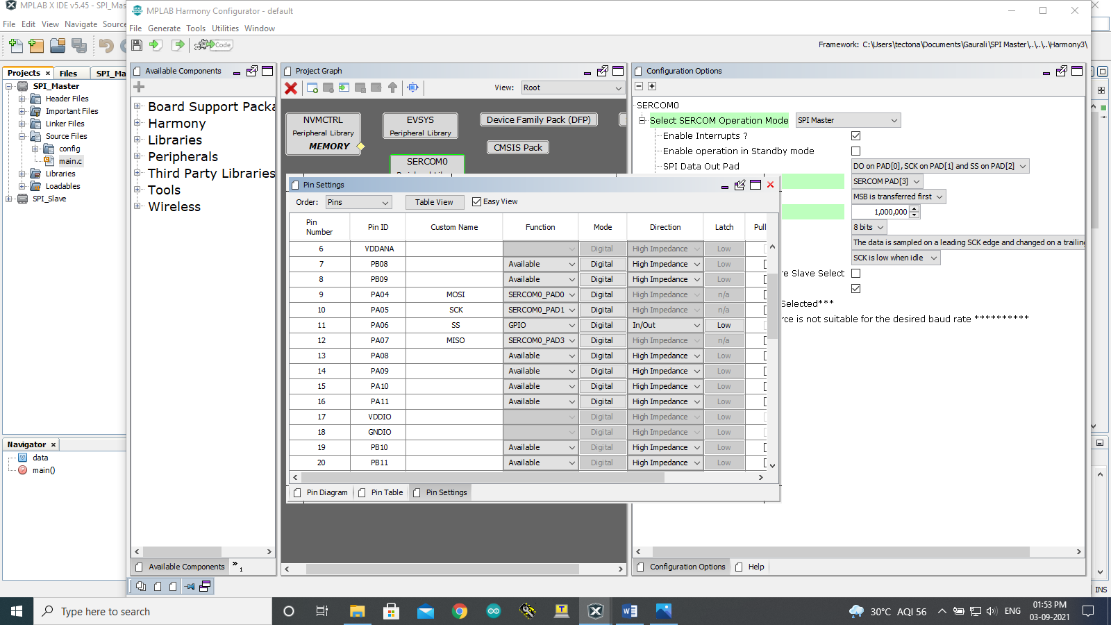

Step 4: Click on Peripherals and select the SERCOM0 and set the configurations as shown below.

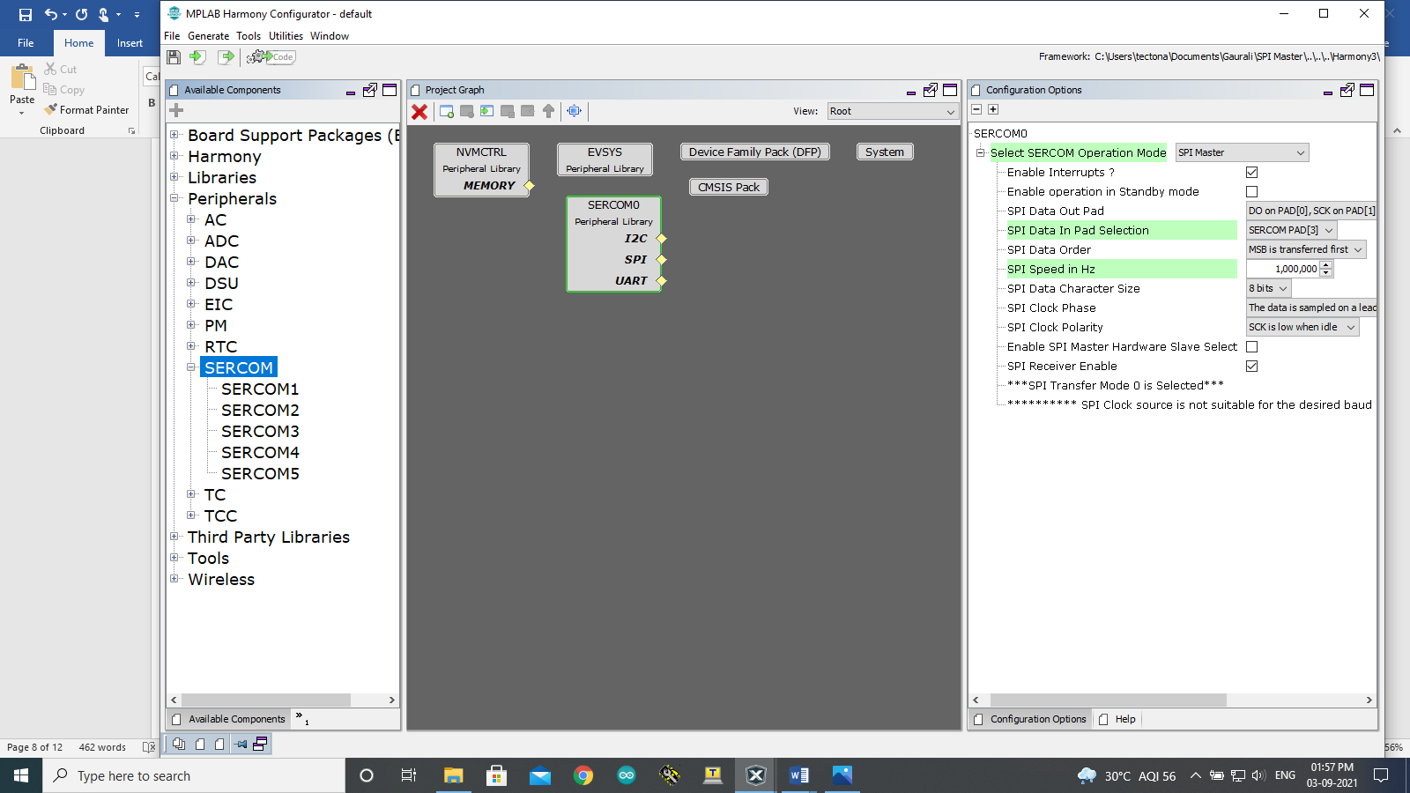

Step 5: Click on Generate Code.

You should be able to see MHC generated files under Project->Source Files->config->default->peripheral->sercom0->plib_spi_master.c

Master code:

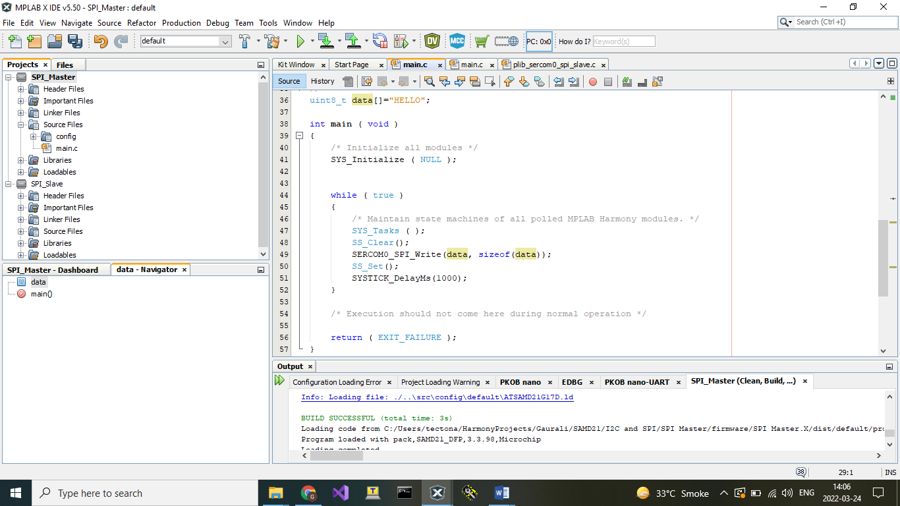

**SPI Slave:**

Step 3: Set PA04 as MOSI, PA05 as SCK, PA06 as SS, PA07 as MISO and PA22 as Tx.



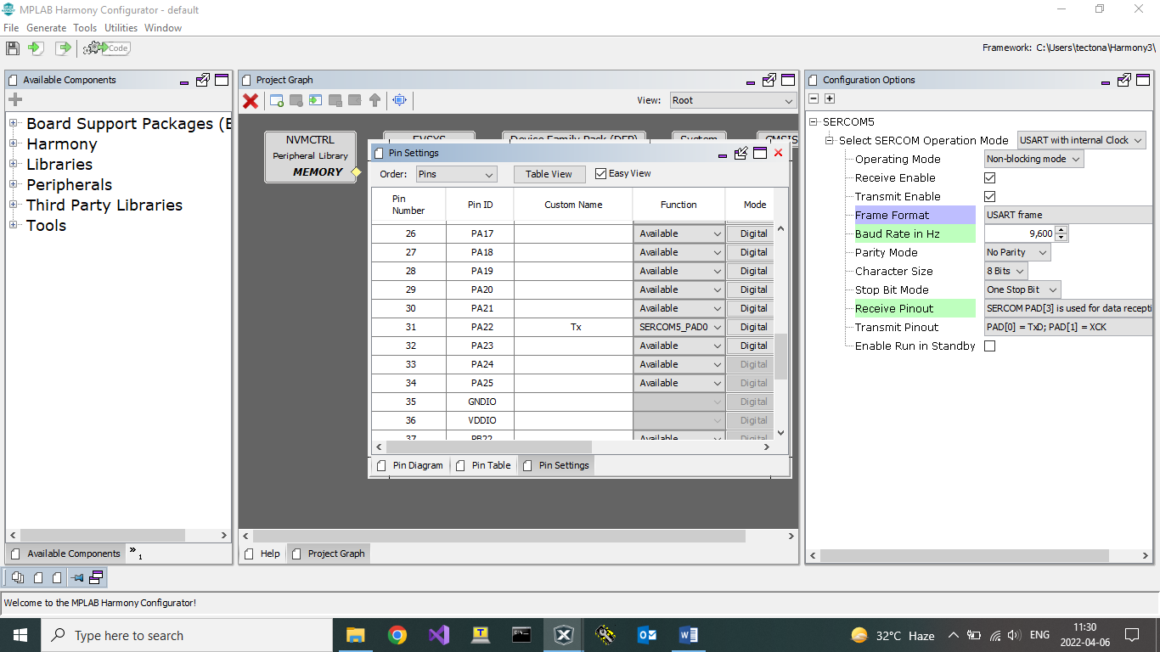

Step 4: Click on Peripherals and select SERCOM0 and SERCOM5. Configure them as shown below.

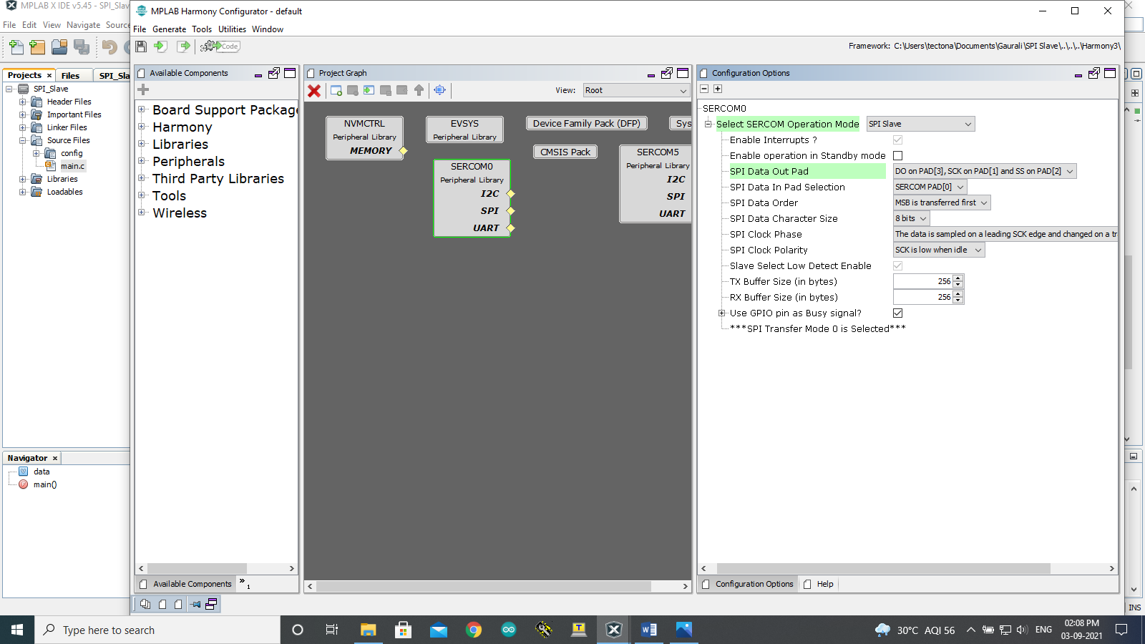

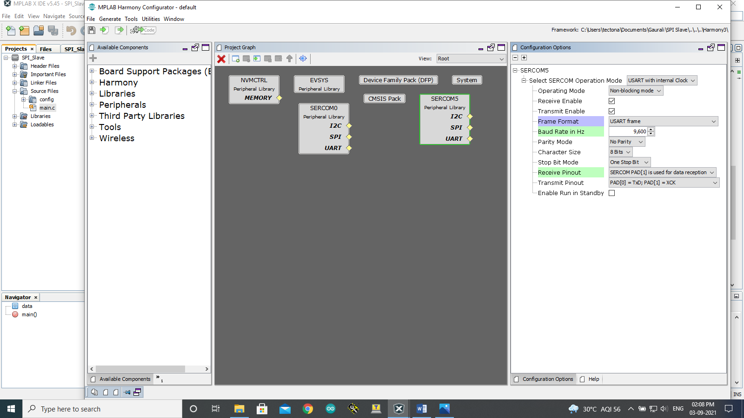

Step 5: Click on Generate Code.

You should be able to see MHC generated files under

Project->Source Files->config->default->peripheral->sercom2->plib_spi_slave.c

Project->Source Files->config->default->peripheral->usart- >plib_sercom5_usart.c.

Slave code:

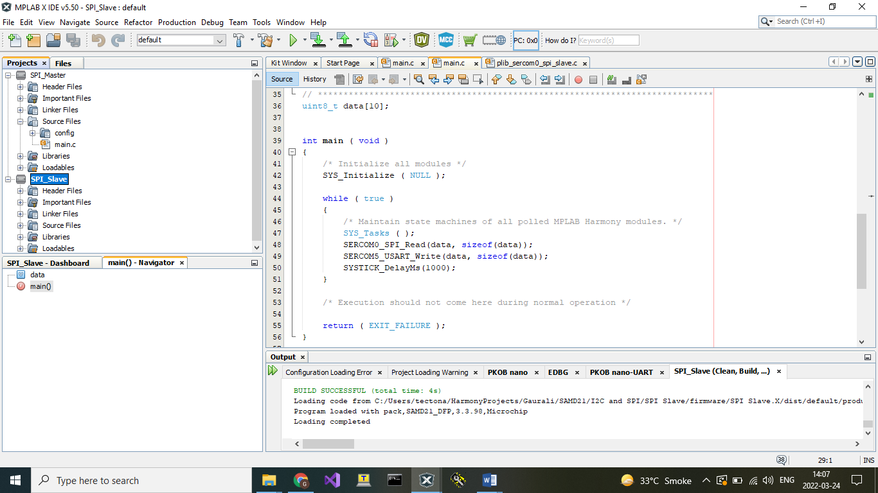

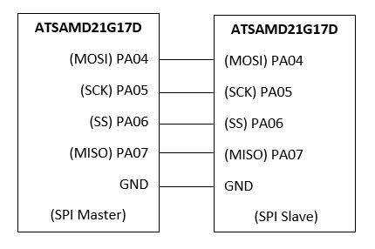

You can see the output using TeraTerm on the COM of Slave board.

Output:

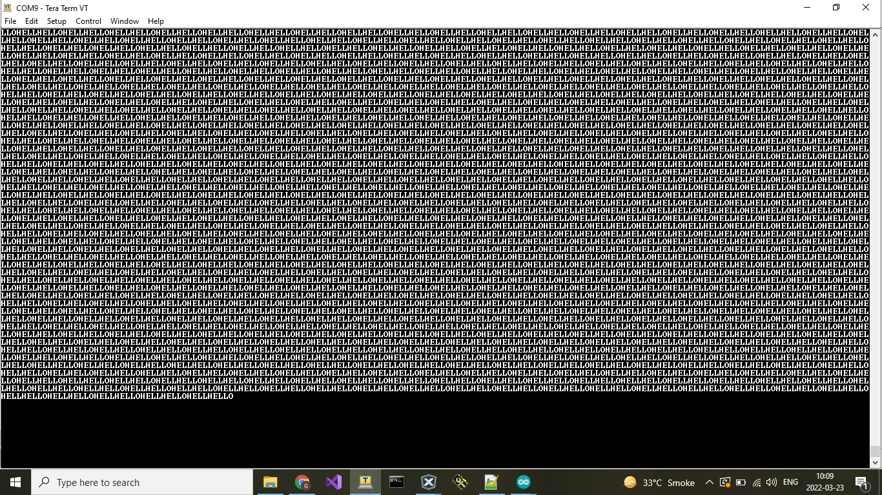

**SPI DMA – Master:**

Step 1: Create a MPLAB Project and Open MHC (Refer to Creating First project).

Step 2: Clock Configuration:

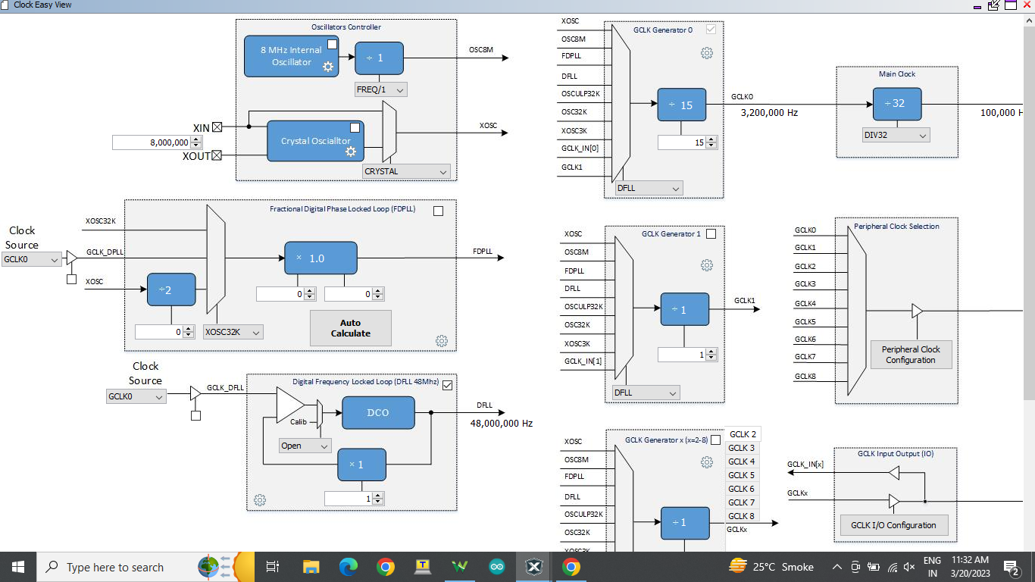

Step 3: Set PA16 as MOSI, PA17 as SCK, PA18 as SS and PA19 as MISO. PA22 as CDC TX and PB22 as CDC RX.

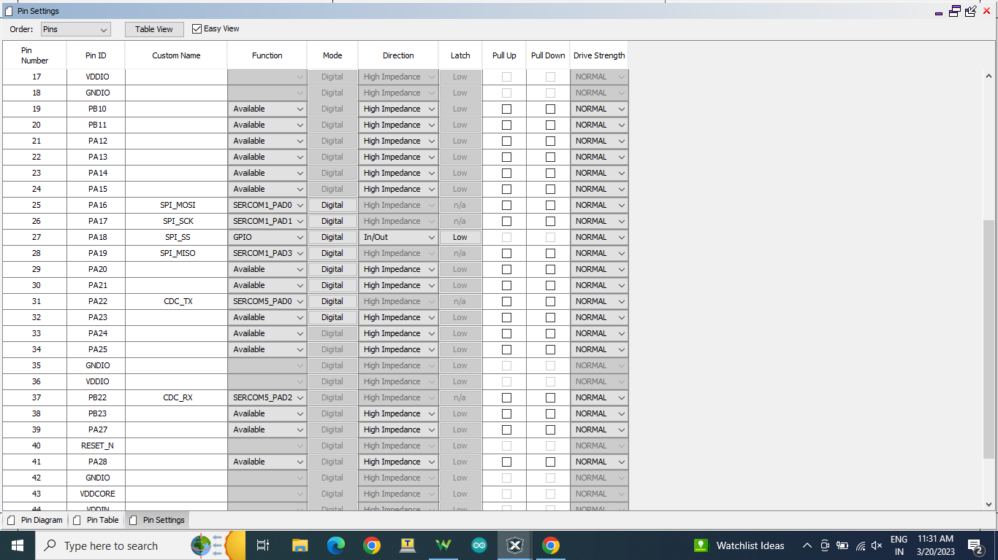

Step 4: Click on Peripherals and select the SERCOM1 and SERCOM5 and set the configurations as shown below.

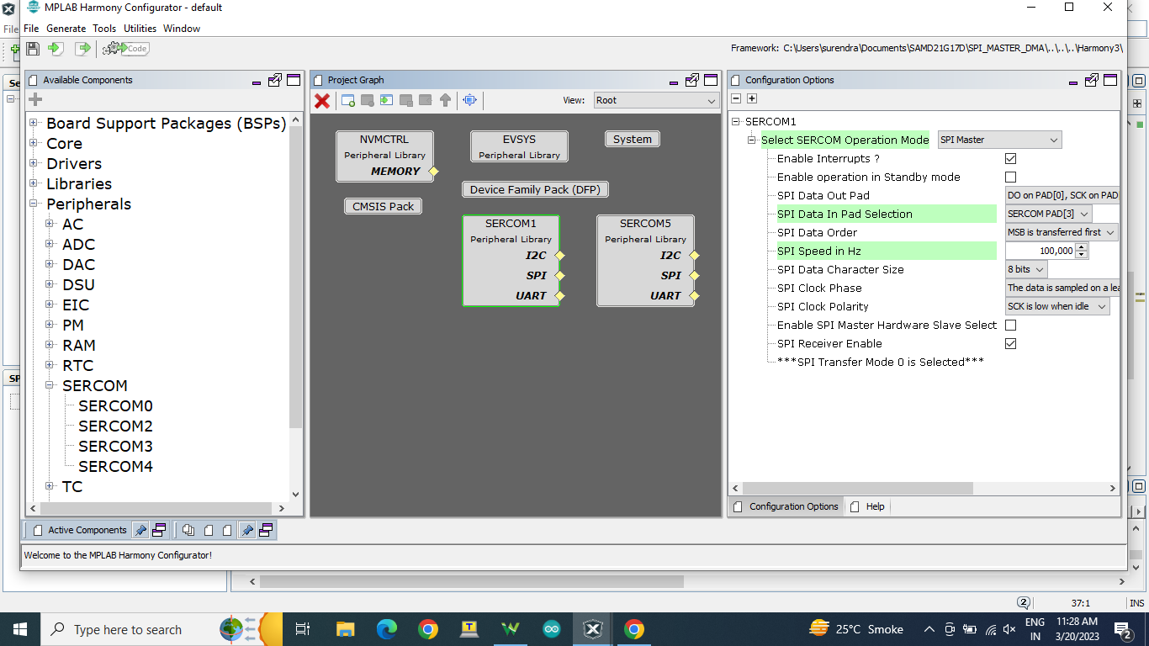

Step 5 : Set DMA configuration as per shown below.

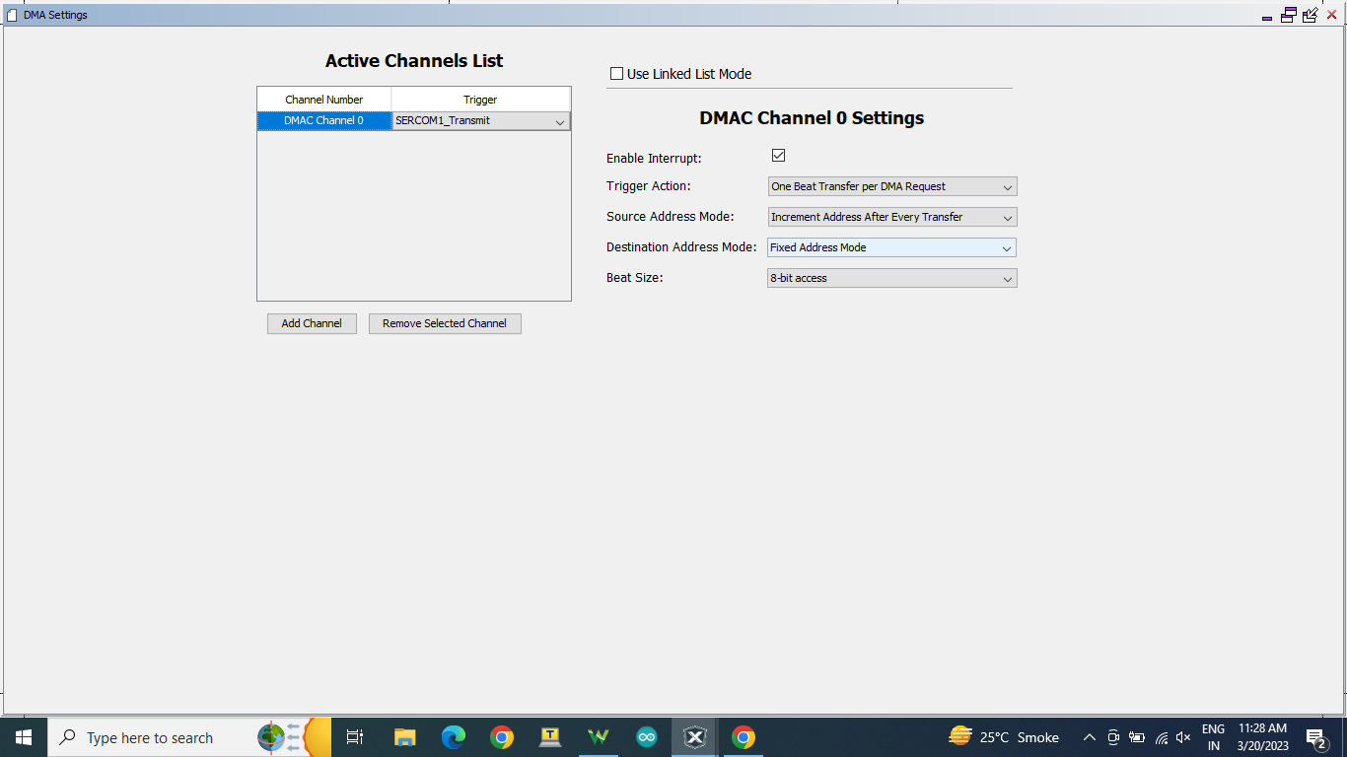

Step 6: Click on Generate Code.

You should be able to see MHC generated files under Project->Source Files->config->default->peripheral->sercom0->plib_spi_master.c is used for function and main.c is used for code.

Master code:

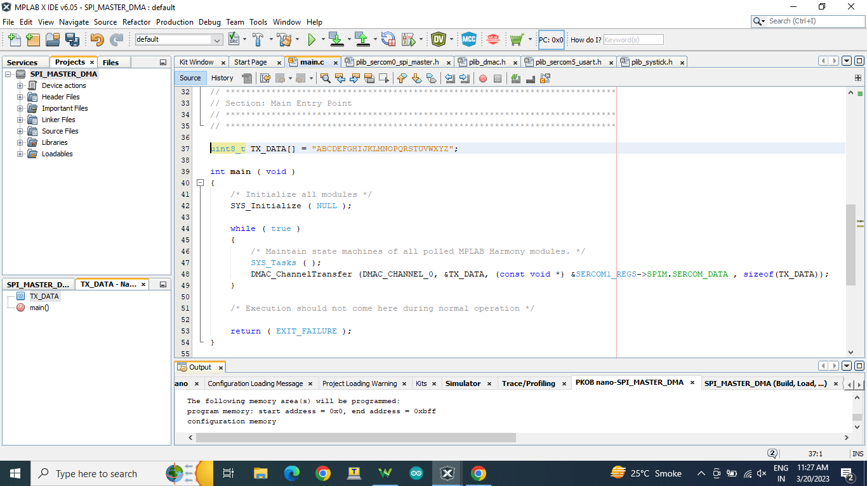

**Master Sample Code:**

uint8_t TX_DATA[] = "ABCDEFGHIJKLMNOPQRSTUVWXYZ\n";

int main ( void )

{

/* Initialize all modules */

SYS_Initialize ( NULL );

while ( true )

{

/* Maintain state machines of all polled MPLAB Harmony modules. */

SYS_Tasks ( );

DMAC_ChannelTransfer (DMAC_CHANNEL_0, &TX_DATA, (const void *) &SERCOM1_REGS->SPIM.SERCOM_DATA , sizeof(TX_DATA));

}

/* Execution should not come here during normal operation */

return ( EXIT_FAILURE );

}

**OUTPUT :**

Master will send data to Slave.