Category | List | Tuple | Set | Dictionary | String
Create | [], list() | (), tuple() | {}, set() | {}, dict() | " ", ' '
Mutable | Yes | No | Yes | Yes | No
Ordered | Yes | Yes | No | Yes (Python 3.7+) | Yes
Indexed | Yes | Yes | No | By keys | Yes
Add element | append(x) | Not allowed | add(x) | dict[k]=v | Not allowed
Add multiple | extend(iter) | Not allowed | update(iter) | update({}) | Not allowed
Remove element | remove(x) | Not allowed | remove(x) | pop(key) | Not allowed
Safe remove | pop(i) | Not allowed | discard(x) | get(key) | Not allowed
Clear all | clear() | Not allowed | clear() | clear() | Not allowed
Access | lst[i] | tpl[i] | Not possible | dict[key] | str[i]
Length | len(lst) | len(tpl) | len(set) | len(dict) | len(str)
Search | x in lst | x in tpl | x in set | key in dict | sub in str
Index / Position | index(x) | index(x) | Not possible | Not applicable | find()
Sort | sort() | Not allowed | Not allowed | Not allowed | Not allowed
Sorted copy | sorted(lst) | sorted(tpl) | sorted(set) | sorted(dict) | sorted(str)
Copy | copy() | tuple(x) | copy() | copy() | str()
Combine | + | + | union() | {**d1,**d2} | +
Looping | for x in lst | for x in tpl | for x in set | for k,v in d.items() | for c in str

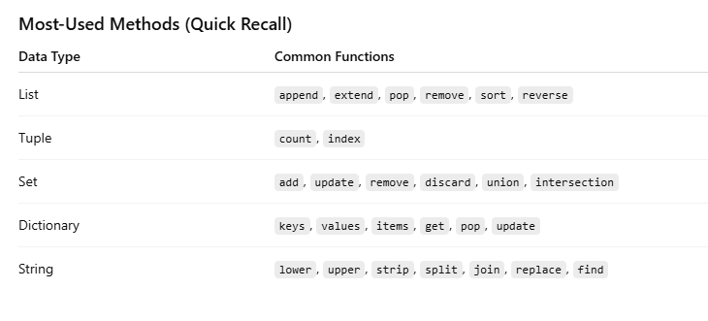
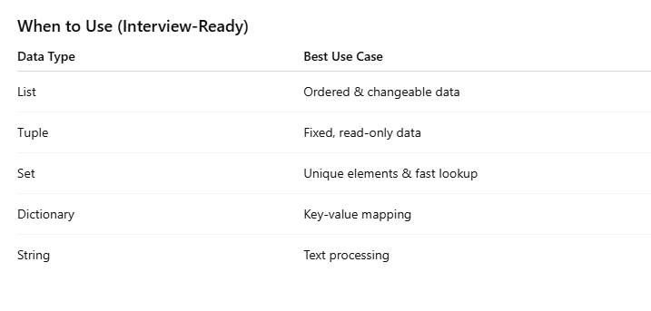

Part 1: Core Python & Data Types (Q1–Q50)
1. What is the difference between is and ==?
- is checks if two variables point to the same object.
- == checks if their values are equal.
a = [1,2]
b = [1,2]
print(a == b) # True
print(a is b) # False

2. Why can’t lists be used as dictionary keys?
- Lists are mutable (can change). Dictionary keys must be constant.
my_list = [1,2,3]
my_dict = {}
# my_dict[my_list] = "value" # Error

3. Can tuples be used as keys?
- Yes, if all items are immutable.
my_tuple = (1,2,3)
my_dict = {}
my_dict[my_tuple] = "value"

Immutable Objects in Python
Definition:
An object is immutable if its value cannot be changed after it is created. Any operation that seems to modify it actually creates a new object.
Common immutable types in Python:
- int → integer numbers
- float → decimal numbers
- str → strings
- tuple → ordered sequence (if all elements inside are immutable)
- frozenset → immutable version of set
- bool → True / False

Example:
# Immutable integer
x = 10
y = x
x = 20 # x now points to a new object
print(y) # 10, original object unchanged

# Immutable string
s = "hello"
s = s.upper() # returns a new string "HELLO"
print(s) # "HELLO"

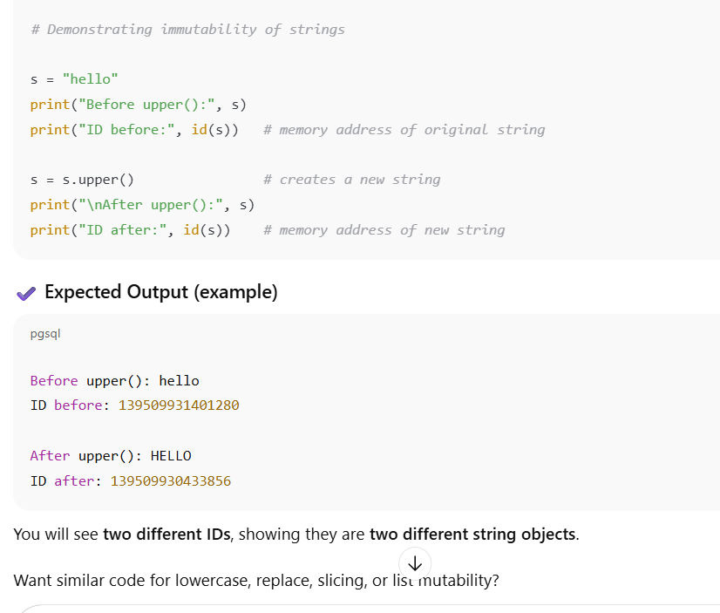
Key points:
- You cannot change the content of immutable objects.
- They are hashable (can be used as dictionary keys or set elements).

Why tuples can be used as dictionary keys
- Tuples themselves are immutable.
- But: all items inside the tuple must also be immutable.
- If the tuple contains a list (mutable), it cannot be used as a key.
t1 = (1, 2, 3) # immutable items → hashable
t2 = (1, [2, 3]) # contains list → not hashable

my_dict = {t1: "ok"} # Works
# my_dict = {t2: "fail"} # Error

4. Why are strings immutable?
- Strings cannot be changed once created.
- Helps with hashability, memory efficiency, and thread safety.
s = "hello"
# s[0] = 'H' # Error
s = "Hello" # Creates a new string

Hashability in Python
Definition:
An object is hashable if it has a hash value that never changes during its lifetime. Hashable objects can be used as dictionary keys or set elements.
- Hashable objects must implement:
  - __hash__() → returns integer hash value
  - __eq__() → compares equality with another object
- Immutable objects are usually hashable:
  - int, float, str, tuple (if all elements are hashable)
- Mutable objects are not hashable:
  - list, dict, set → because their content can change, hash would change

Example:
# Immutable (hashable)
s = "hello"
print(hash(s)) # some integer
my_dict = {s: 1} # works fine
# Mutable (not hashable)
lst = [1, 2, 3]
# print(hash(lst)) # Error: TypeError
my_dict = {lst: 1} # Error
Why hashability matters:
- Dictionaries and sets use hash values to quickly check for equality and look up keys.
- If an object can change, its hash would change, breaking the dictionary or set.

✅ In short:
Hashable = can be used as dictionary key or set element, must be immutable and have a fixed hash.

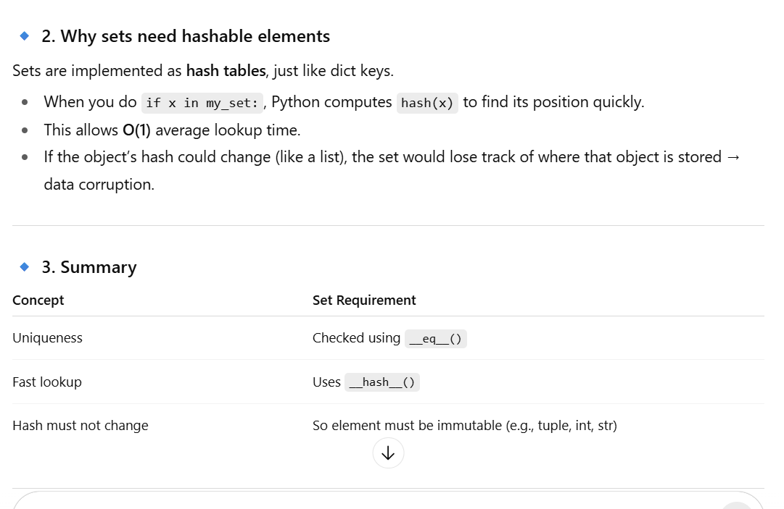

5. What is a Python variable?
- A name referring to a value stored in memory.
x = 10
y = "Python"

6. What are Python data types?
- Common types: int, float, str, bool, list, tuple, dict, set
a = 10 # int
b = 3.14 # float
c = "hi" # str
d = [1,2] # list

7. Mutable vs Immutable objects
- Mutable: can change (list, dict, set)
- Immutable: cannot change (str, tuple, int)

8. What is a Python function?
- A block of reusable code that performs a task.
def greet(name):
print(f"Hello {name}")

greet("Sara")

9. Difference between append() and extend()?
- append() adds one item, extend() adds multiple items.
lst = [1,2]
lst.append([3,4]) # [1,2,[3,4]]
lst = [1,2]
lst.extend([3,4]) # [1,2,3,4]

10. What is a dictionary?
- Collection of key-value pairs; keys must be immutable.
my_dict = {"name":"Sara", "age":25}
print(my_dict["name"]) # Sara

11. What is a list?
- Ordered collection of items; mutable.
lst = [1,2,3]

12. What is a tuple?
- Ordered collection of items; immutable.
t = (1,2,3)

13. What is a set?
- Unordered collection of unique items.
s = {1,2,3}

14. What is a boolean?
- Represents True or False.
a = True
b = False

15. What is the type() function?
- Returns the type of an object.
print(type(10)) # <class 'int'>

16. What is the id() function?
- Returns the memory address of an object.
a = 10
print(id(a))

17. What is None?
- Represents absence of value.
x = None

18. How to check if a variable is None?
- Use is operator.
x = None
print(x is None) # True

19. What is slicing in Python?
- Extract a part of a sequence.
lst = [1,2,3,4,5]
print(lst[1:4]) # [2,3,4]

20. What is negative indexing?
- Access elements from the end.
lst = [1,2,3]
print(lst[-1]) # 3

21. What is a Python comment?
- Text ignored by Python, used for explanation.
# This is a comment
22. What is the difference between = and ==?
- = assigns value, == compares values.
23. What are Python literals?
- Fixed values like 100, "Hello", 3.14, True.
24. What is the difference between int() and float()?
- int() converts to integer, float() converts to decimal.
25. What is a Python expression?
- Combination of values and operators that produces a result.
x = 5 + 3
26. What is a Python statement?
- Instruction executed by Python.
x = 5
27. What is operator precedence?
- Determines the order in which operations are done.
28. What is the difference between // and /?
- / → float division, // → integer division.
print(5/2) # 2.5
print(5//2) # 2
29. What is the difference between ** and ^?
- ** → exponent, ^ → bitwise XOR
30. What is a Python keyword?
- Reserved word with special meaning (if, for, def).
31. What is the difference between mutable and immutable default arguments?
- Mutable defaults can retain changes across calls; immutable are safe.
32. What is string concatenation?
- Joining strings with + operator.
s = "Hello" + " World"
33. What is string replication?
- Repeat strings using *.
s = "Hi" * 3 # "HiHiHi"
34. How to find length of a sequence?
- Use len() function.
len([1,2,3]) # 3
35. What is the difference between list() and []?
- Both create lists; list() can convert other sequences.
36. What is a Python module?
- File containing Python code (.py) that can be reused.
37. What is Python package?
- Folder containing modules and __init__.py.
38. What is a Python namespace?
- Space holding names of variables and functions.
39. What is Python scope?
- Where a variable is accessible: Local, Enclosing, Global, Built-in.
40. What is the difference between global and local variables?
- Local → defined inside function, accessible only there.
- Global → defined outside, accessible anywhere.
41. What is Python’s pass statement?
- Does nothing; used as a placeholder.
def func():
pass
42. What is Python’s del statement?
- Deletes a variable or object.
x = 10
del x
43. What is Python’s identity operator?
- is and is not check if two variables are the same object.
44. What is Python’s membership operator?
- in and not in check if a value exists in a sequence.
45. What is Python’s type casting?
- Convert one type to another: int(), float(), str().
46. What is Python’s dynamic typing?
- Variable type is determined at runtime, no need to declare type.
47. What is Python’s strong typing?
- Python doesn’t allow automatic type conversion between incompatible types.
x = "5"
y = 2
# x + y # Error, cannot add str and int
48. What is Python’s implicit type conversion?
- Python automatically converts compatible types.
x = 5
y = 2.5
z = x + y # 7.5, int converted to float
49. What is Python’s explicit type conversion?
- Manually converting types using functions like int(), str().
50. What is Python’s docstring?
- String that describes a module, function, or class; accessible via __doc__.
def func():
"""This is a docstring"""
pass

print(func.__doc__)

Part 2: Functions, Loops, Comprehensions, Exceptions (Q51–Q100)
51. What is a Python lambda function?
- Anonymous, small function written in one line.
f = lambda x: x*2
print(f(5)) # 10
52. Difference between def and lambda?
- def: normal function, can have multiple statements
- lambda: single expression, anonymous
**53. What are Python *args and kwargs?
- *args: pass multiple positional arguments
- **wags: pass multiple keyword arguments
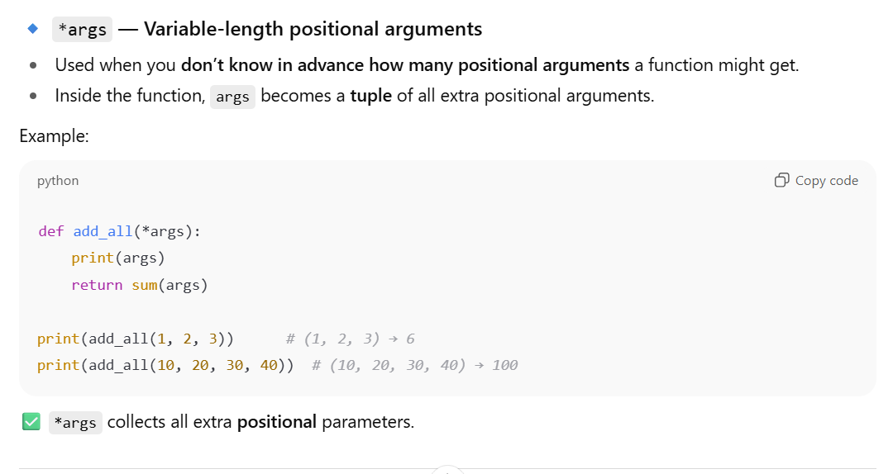
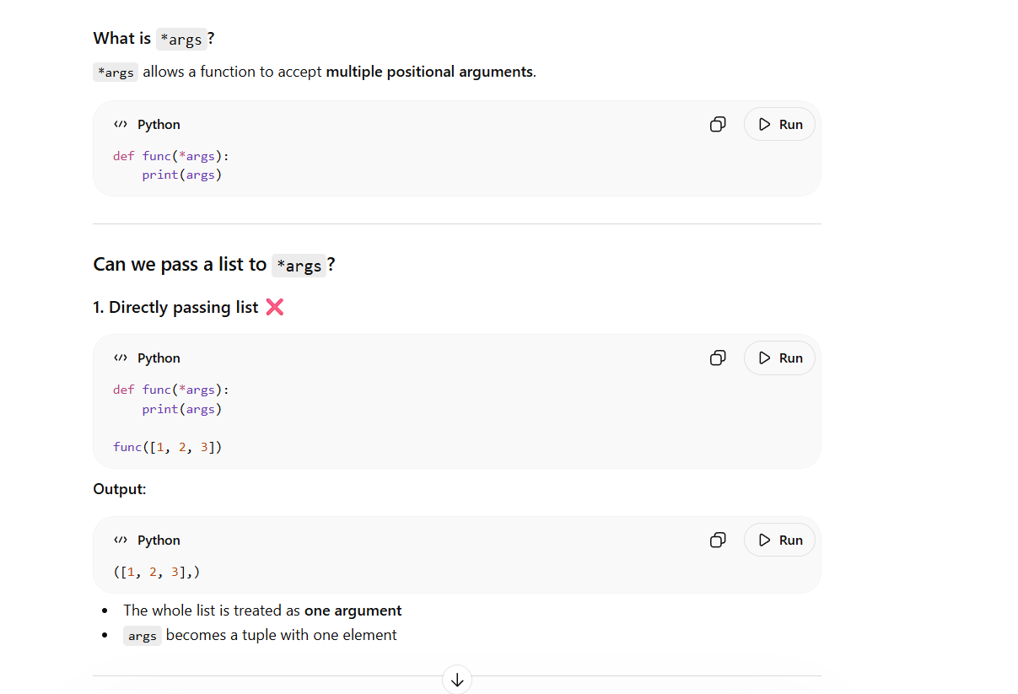
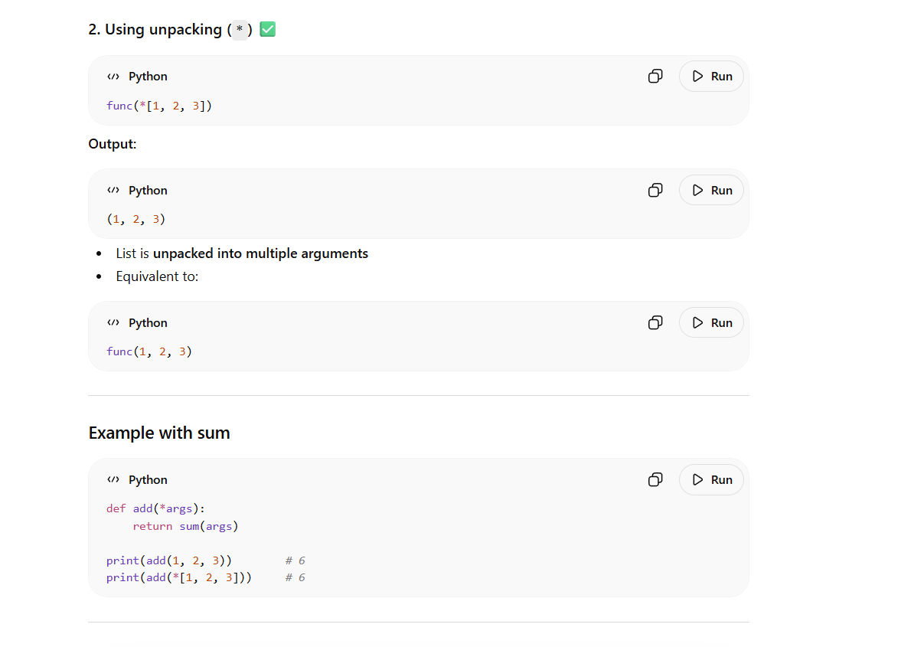
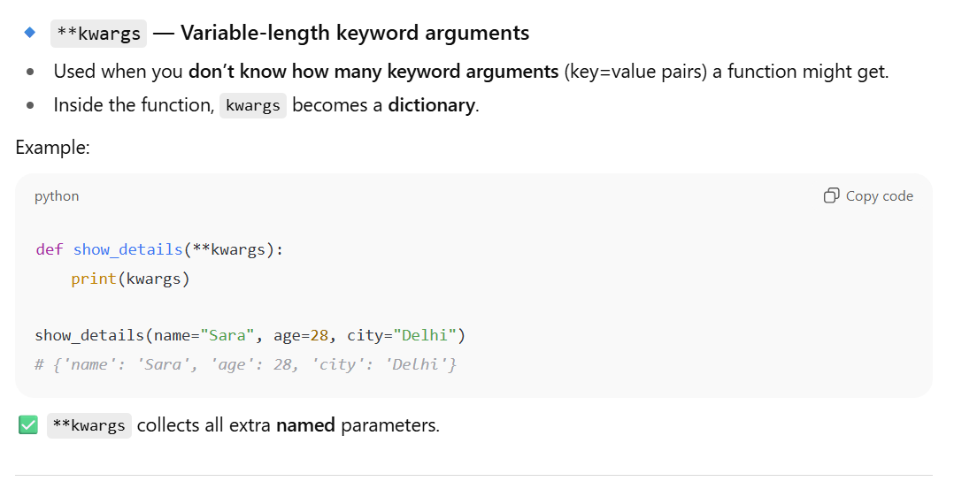
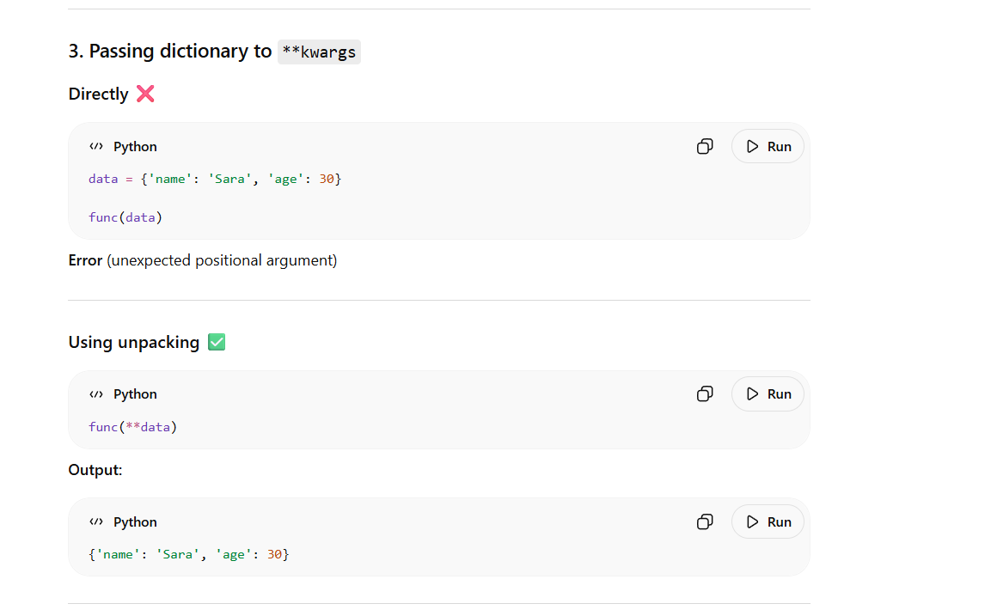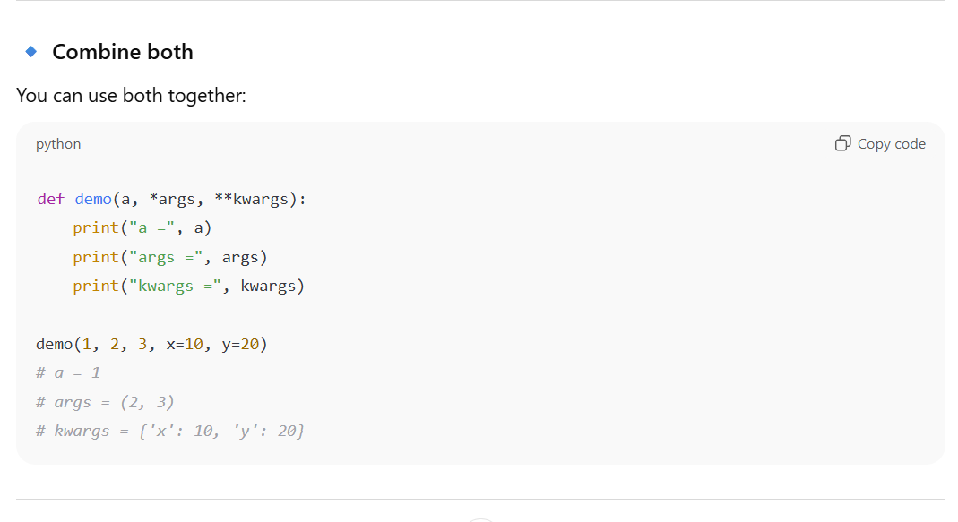

54. What is recursion?
- Function calling itself.
def factorial(n):
if n == 0:
return 1
return n * factorial(n-1)

print(factorial(5)) # 120
55. What is Python’s default argument?
- Value assigned to parameter if not passed.
def greet(name="Guest"):
print(f"Hello {name}")

greet() # Hello Guest
56. What are Python loops?
- for → iterate over sequence
- while → iterate while condition is true
57. Difference between while and for loop?
- for → iterates over sequence
- while → iterates based on condition
58. What is loop else in Python?
- Executes after loop ends normally (no break).
for i in range(3):
print(i)
else:
print("Done")
59. What is Python list comprehension?
- Compact way to create list.
lst = [x*2 for x in range(5)]
print(lst) # [0,2,4,6,8]
60. What is Python dictionary comprehension?
- Compact way to create dictionary.
d = {x: x*2 for x in range(5)}
print(d) # {0:0,1:2,...}
61. What is Python set comprehension?
- Create sets compactly.
s = {x for x in range(5)}
62. What is Python generator expression?
- Creates generator object for memory-efficient iteration.
g = (x*2 for x in range(5))
63. What is Python iterator?
- Object you can iterate using next().
64. What is Python iterable?
- Object that can return iterator (list, tuple, dict, str).
65. Difference between iterator and iterable?
- Iterable → can return iterator
- Iterator → used to fetch elements one by one
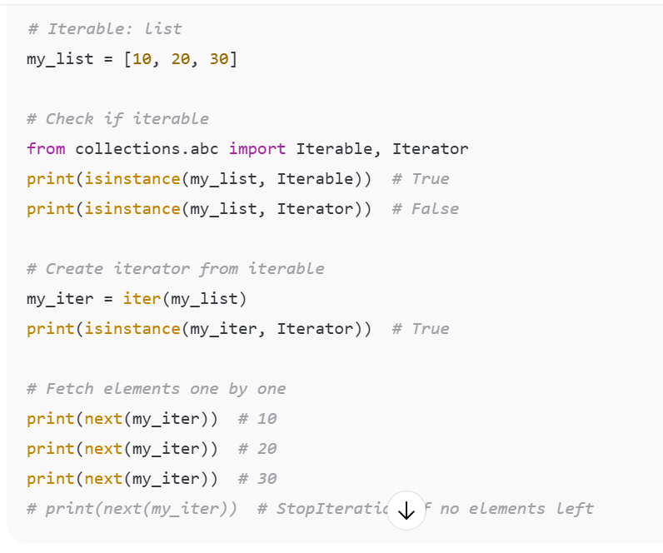
66. What is Python exception?
- Error occurring during execution.
67. What is try-except block?
- Handle exceptions to prevent program crash.
try:
x = 10/0
except ZeroDivisionError:
print("Cannot divide by zero")
68. What is finally block?
- Executes no matter what, usually for cleanup.
69. What is else block in try-except?
- Executes if no exception occurs.
70. What is Python raise statement?
- Manually raise exception.
raise ValueError("Invalid value")
71. Common built-in exceptions?
- ValueError, TypeError, IndexError, KeyError, ZeroDivisionError
72. What is assert statement?
- Debugging tool to check condition.
x = 5
assert x>0, "x must be positive"
73. What is Python pass statement?
- Placeholder; does nothing.
74. What is Python break statement?
- Exit loop immediately.
75. What is Python continue statement?
- Skip current iteration, continue loop.
76. What is Python range() function?
- Generate sequence of numbers.
for i in range(5):
print(i)
77. What is Python enumerate()?
- Get index and value during iteration.
lst = ['a','b']
for i, val in enumerate(lst):
print(i,val)

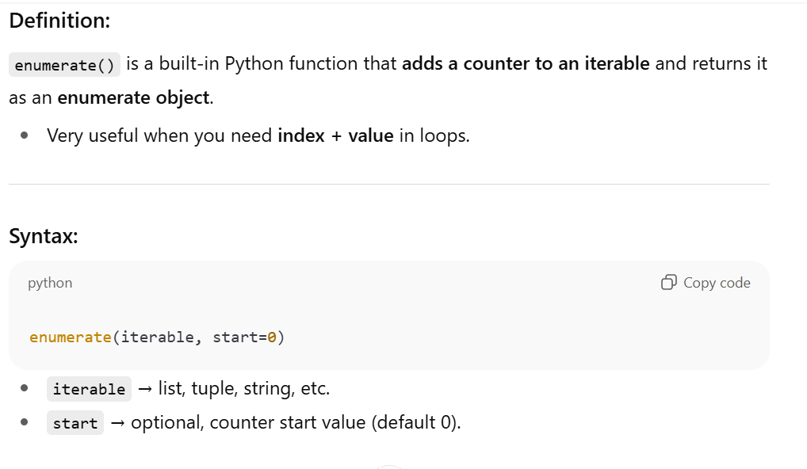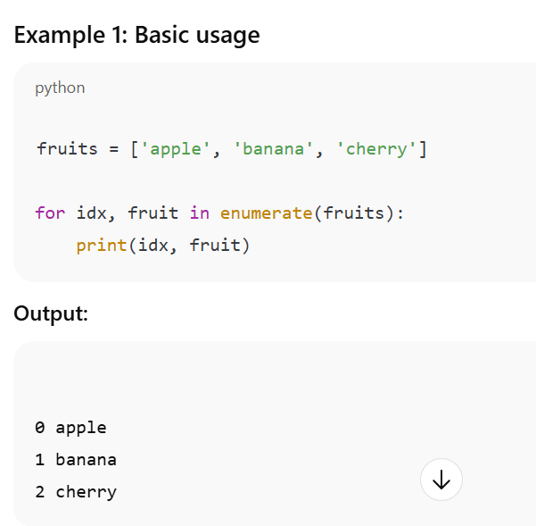

78. What is Python zip()?
- Combine multiple iterables element-wise.
- zip() is a built-in Python function that aggregates elements from two or more iterables (lists, tuples, etc.) into tuples, pairing elements by their position.
- Stops when the shortest iterable is exhausted.

a=[1,2]; b=[3,4]
for x,y in zip(a,b):
print(x,y)
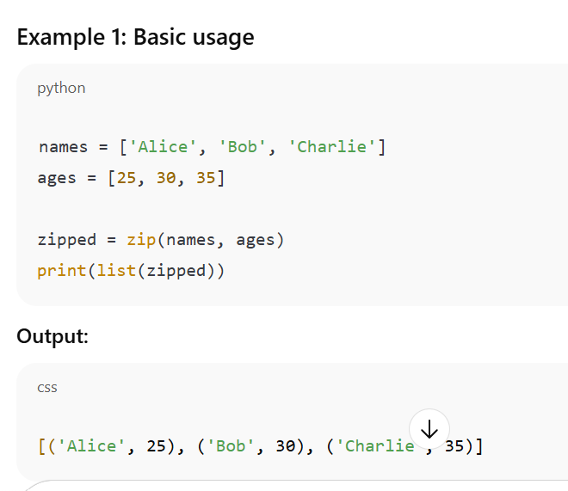
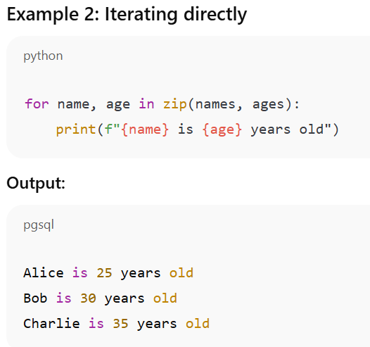

79. What is Python map()?
- Apply function to each item in iterable.
- map() is a built-in Python function that applies a function to each item of an iterable (like list, tuple) and returns a map object (iterator).
- map(function, iterable, ...)
lst = [1,2,3]
print(list(map(lambda x: x*2, lst))) # [2,4,6]
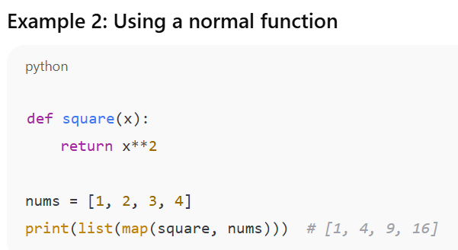

80. What is Python filter()?
- Filter elements based on condition.
- filter() is a built-in Python function that selects elements from an iterable for which a function returns True.
- Returns a filter object, which is an iterator.
- filter(function, iterable)

lst = [1,2,3,4]
print(list(filter(lambda x:x%2==0, lst))) # [2,4]

81. What is Python reduce()?
- Apply function cumulatively to items (needs functools).
from functools import reduce
lst = [1,2,3,4]
print(reduce(lambda x,y:x+y,lst)) # 10

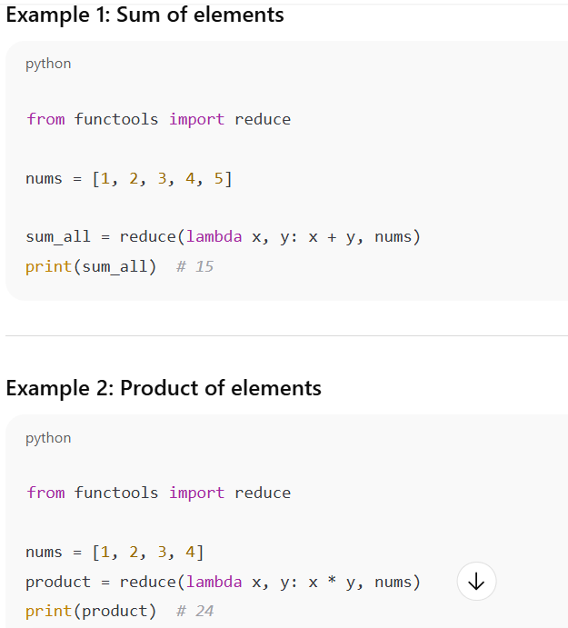

82. What is Python comprehension vs map/filter?
- Comprehension is more readable; map/filter are functional style.
83. What is Python nested function?
- Function defined inside another function.
84. What is closure?
- Inner function remembers outer function’s variables.
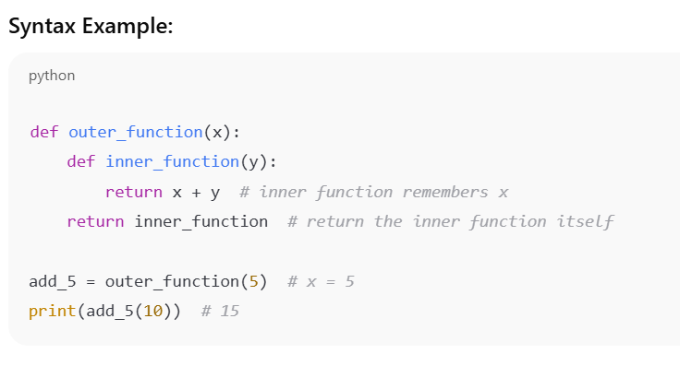

85. What is Python decorator?
- Function modifying another function.
- A decorator in Python is a function that modifies another function’s behavior — without changing its actual code.
- It’s a clean and powerful way to add functionality (like logging, timing, authentication) around existing functions.

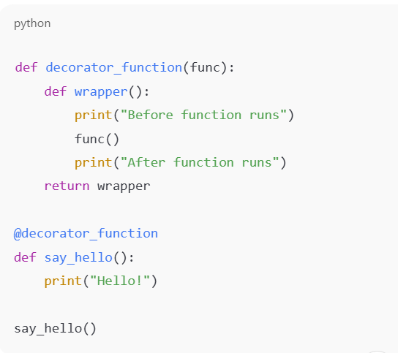
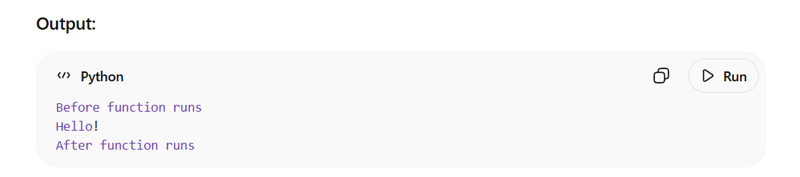
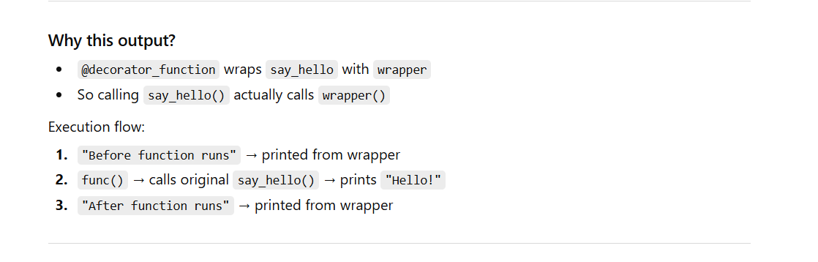
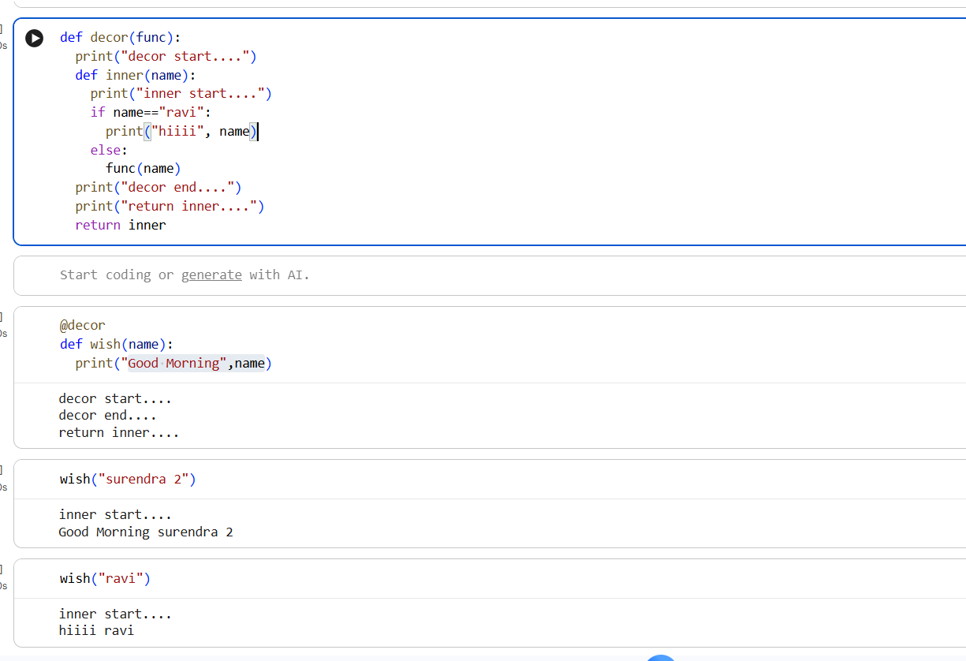

Step-by-step execution
1. Decoration time (when function is defined)
@decor
def wish(name):
This runs immediately, even before calling wish():
- decor(wish) is executed
- Prints:
decor start....
decor end....
return inner....
- Returns inner
- Now wish = inner

2. Function call
wish("surendra 2")
Actually calls:
inner("surendra 2")
Execution:
- Prints:
inner start....
- Condition:
if name == "ravi":
→ False
- So:
func(name)
→ calls original wish(name)
- Prints:
Good Morning surendra 2

Key interview concept
Decorator code (outside inner function) runs at function definition time, not at function call time.

86. What is Python docstring?
- String documenting function/module/class; accessed via __doc__.
87. What is Python help()?
- Shows documentation.
help(len)
88. What is Python dir()?
- Lists attributes and methods of object.
dir([])
89. What is Python id()?
- Returns memory address of object.
90. What is Python globals()?
- Returns dictionary of global names.
91. What is Python locals()?
- Returns dictionary of local names.
92. What is Python callable()?
- Checks if object is callable.
- callable() is a built-in Python function that checks whether an object can be called like a function.
If the object can be invoked using parentheses (), it returns True; otherwise, False.
print(callable(len)) # True
93. What is Python eval()?
- Evaluates string as Python expression.
eval("2+3") # 5
94. What is Python exec()?
- Executes string as Python code.
exec("x=5; print(x)")
95. What is Python pass by reference/value?
- Python passes object reference, behaves like pass-by-value for immutable, pass-by-reference for mutable.
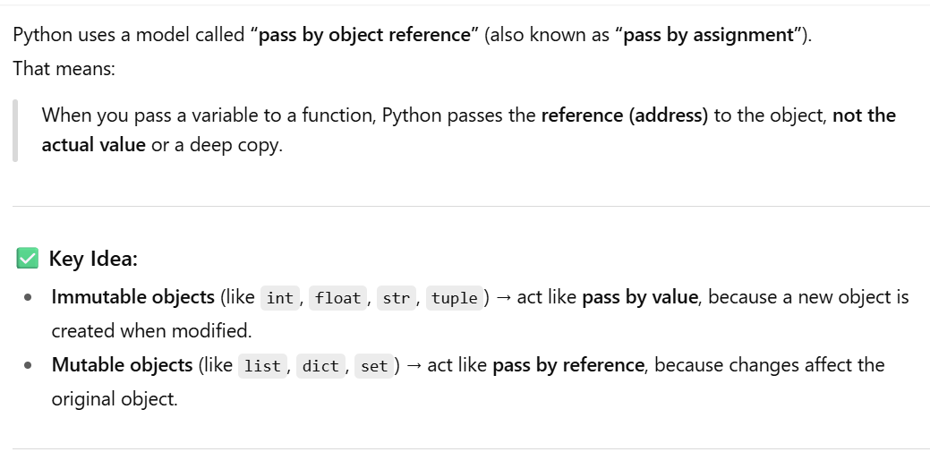
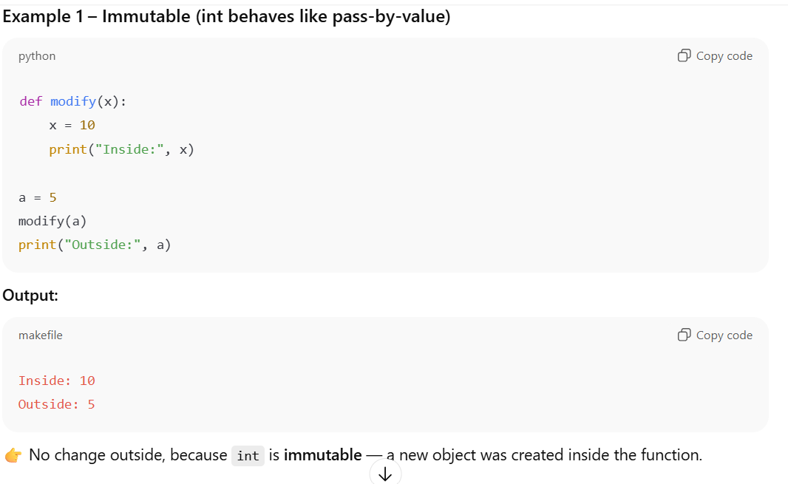

x inside the function is a local variable.
Code:

def modify(x):
x = 10
print(f"inside function {x}")

When you call:
a = 5
modify(a)
print(a)

Here is what happens step-by-step:
Step 1
a = 5
Memory:
a → 5

Step 2
modify(a)

Python passes the value of a to parameter x.

So inside function:
x → 5

At this moment:
a → 5
x → 5

Both contain same value, but they are different variables.

Step 3
Inside function:
x = 10
Now only local variable x changes.

Memory becomes:
a → 5
x → 10

So:
inside function 10
gets printed.

Step 4
Function ends.
Local variable x is destroyed.
a was never modified.
So:
print(a)
prints:
5
Final output:
inside function 10
outside function 5
Important concept:
- Integers are immutable in Python
- Reassigning x = 10 creates a new local reference
- It does not change original variable a outside the function

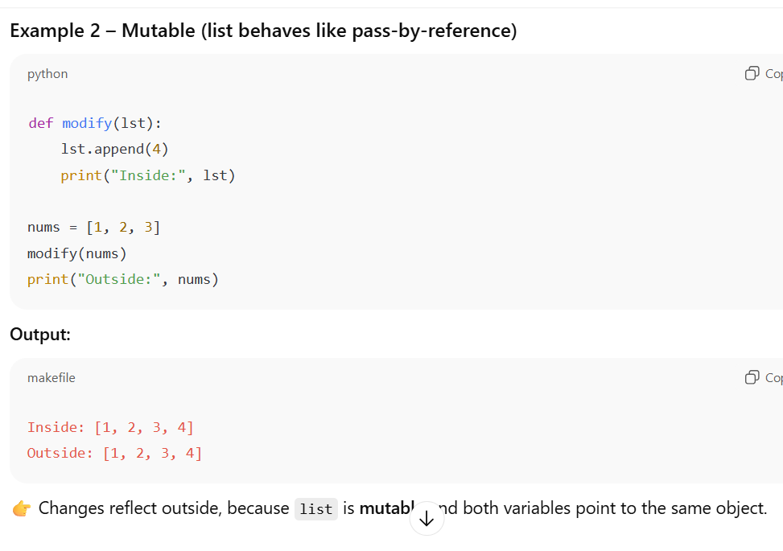

Because lists are mutable.

In this example:
def modify(lst):
lst.append(4)
print(lst)
nums = [1, 2, 3]
modify(nums)
print(nums)

lst and nums both point to the SAME list object.

Initial memory:

nums ───► [1, 2, 3]
When function is called:
modify(nums)

Python passes the reference of the same list.
Now:

nums ──┐
├──► [1, 2, 3]
lst ───┘

Inside function:
lst.append(4)
append() does NOT create new list.
It modifies existing list object itself.
So actual object becomes:
[1, 2, 3, 4]
Since both variables point to same object:
nums ──┐
├──► [1, 2, 3, 4]
lst ───┘
Therefore:
Inside: [1, 2, 3, 4]
Outside: [1, 2, 3, 4]

Main difference:
Integer example
x = 10
This creates NEW object/reference.
It does not modify original integer.

List example
lst.append(4)
This modifies SAME object in memory.

Very important comparison:
This changes original list
lst.append(4)
This does NOT change original list
lst = [10, 20]
because now lst points to a completely new list.
Example:
def modify(lst):
lst = [10, 20]
nums = [1, 2, 3]
modify(nums)
print(nums)
Output:
[1, 2, 3]
because reassignment creates new object instead of modifying existing one.

96. What is Python global keyword?
- Access global variable inside function.
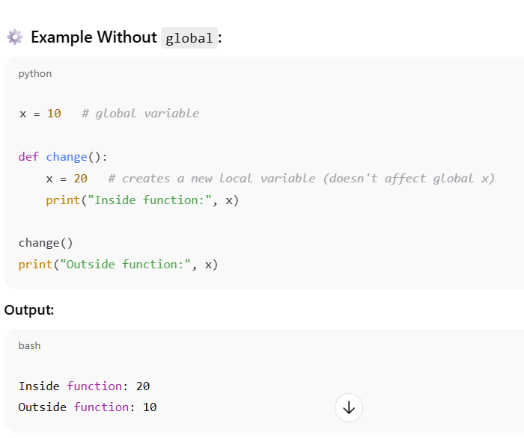
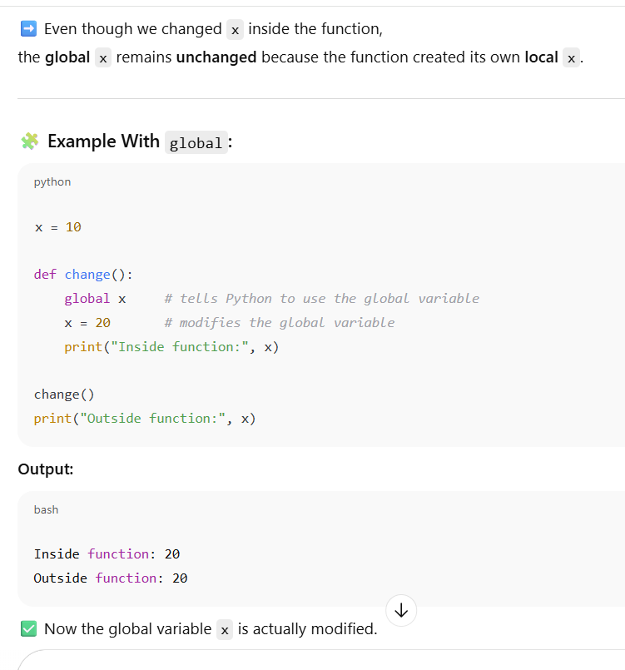

97. What is Python nonlocal keyword?
- Access variable in enclosing function.
98. What is Python iterator protocol?
- Object with __iter__() and __next__() methods.
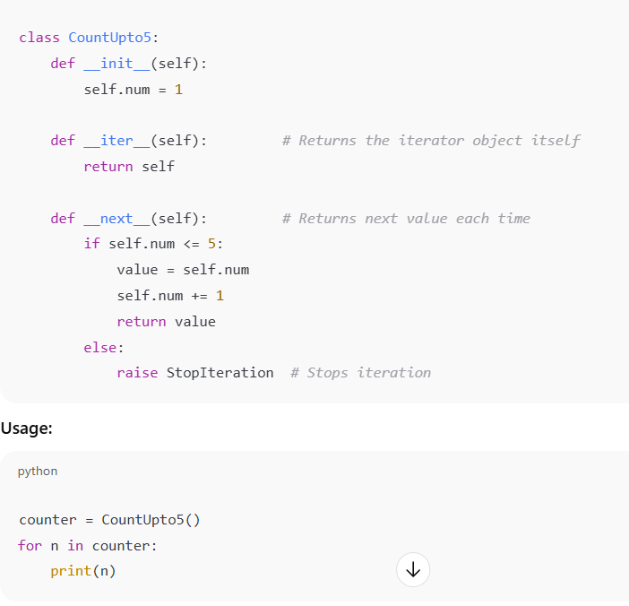

99. What is Python generator?
- Function using yield to produce values lazily.
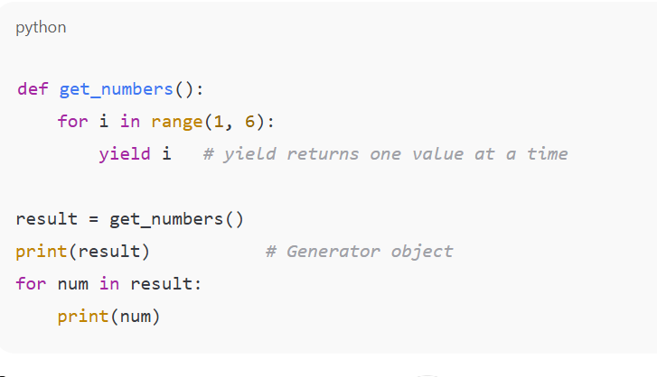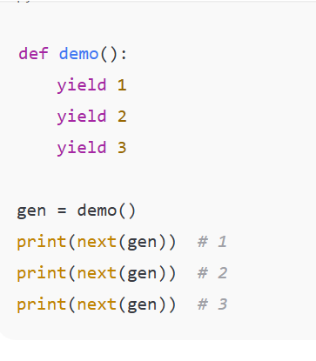

100. Difference between return and yield?
- return → exits function, returns value
  - ➡️ The entire list is created in memory and returned at once.
➡️ Function ends after returning.
- yield → pauses function, returns generator
  - ➡️ The function returns a generator object, not a list.
➡️ Each time you loop over it, it yields one value and then pauses until the next call.

🧠 How yield Works Internally
- When Python sees a yield keyword in a function, it turns it into a generator.
- The function’s state (variables, position, etc.) is saved after each yield.
- When you call next() again, it resumes from the last yield.

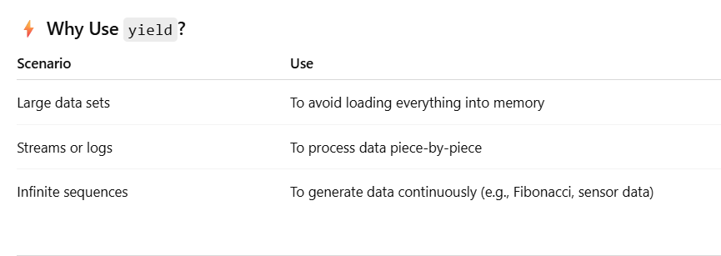
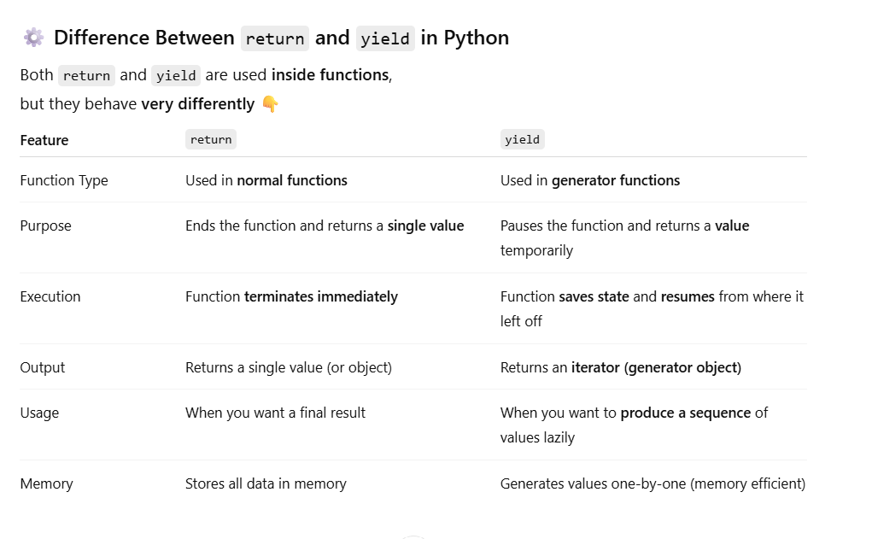

Part 3: OOP, Modules, Decorators, Memory, Collections (Q101–Q150)
101. What is class in Python?
- Blueprint to create objects.
class Student:
pass
102. What is object in Python?
- Instance of class.
103. Difference between class and object?
- Class → blueprint, Object → instance
104. What are instance variables?
- Belong to object; different per object

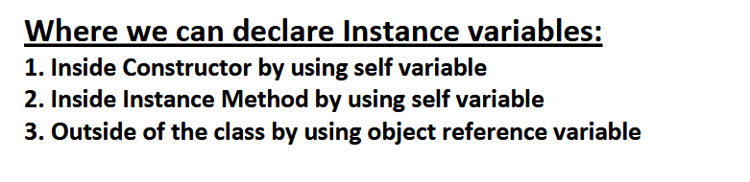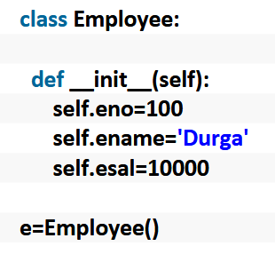

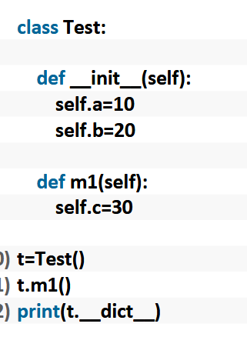

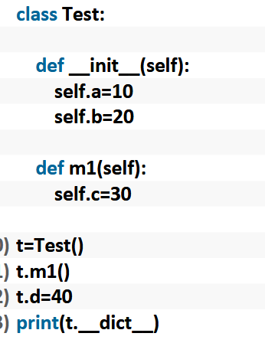

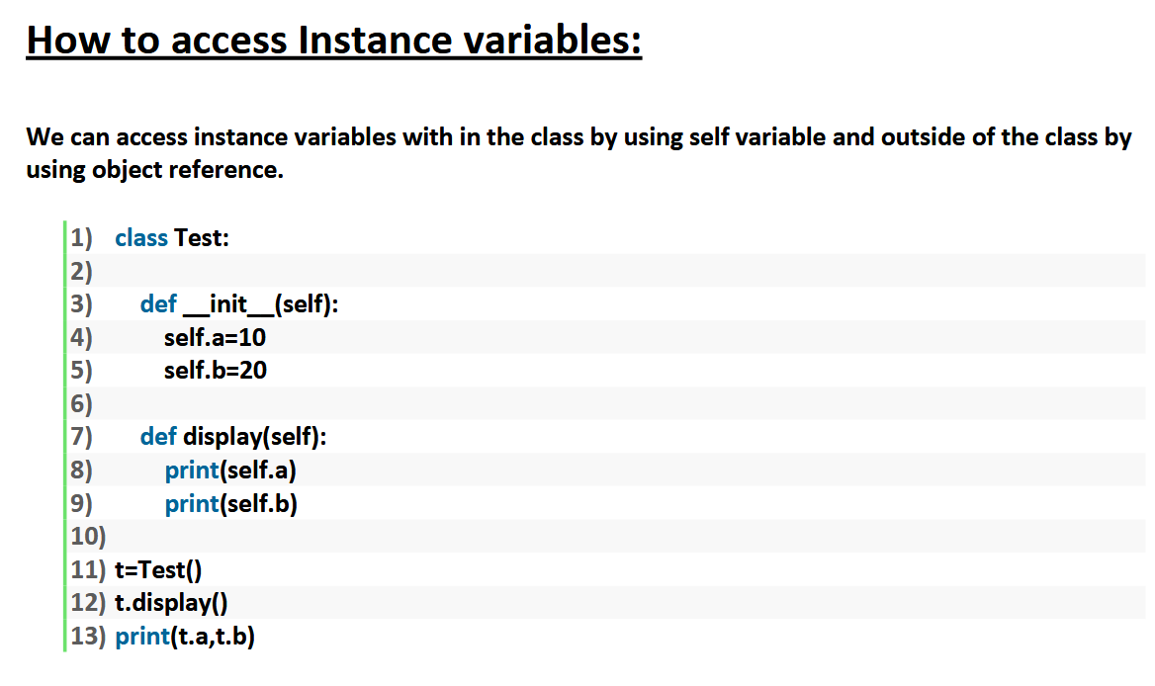
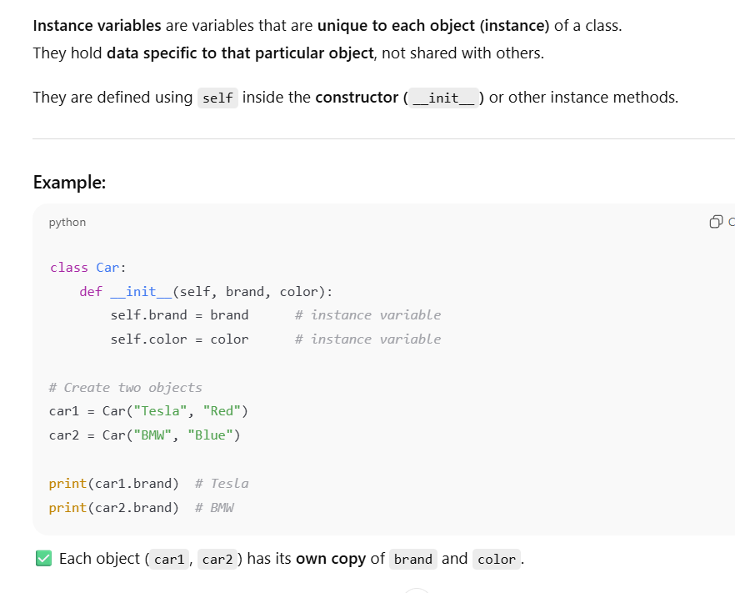
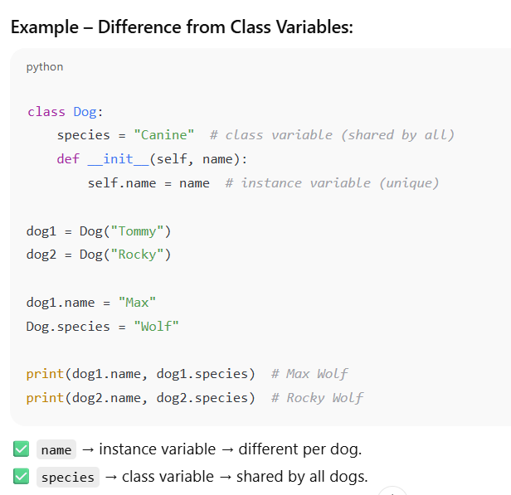

105. What are class variables?
- Belong to class; shared by all objects

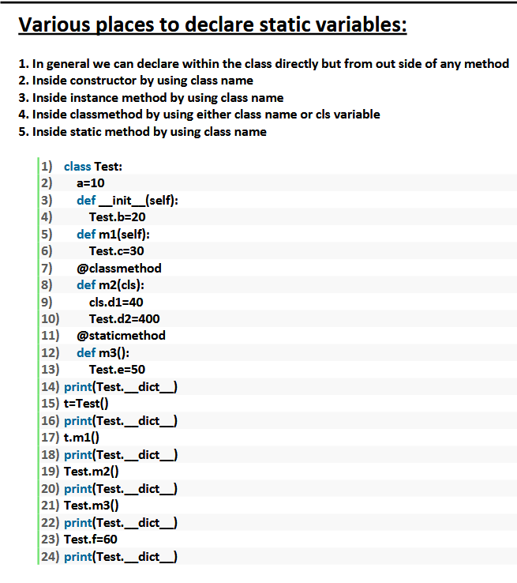
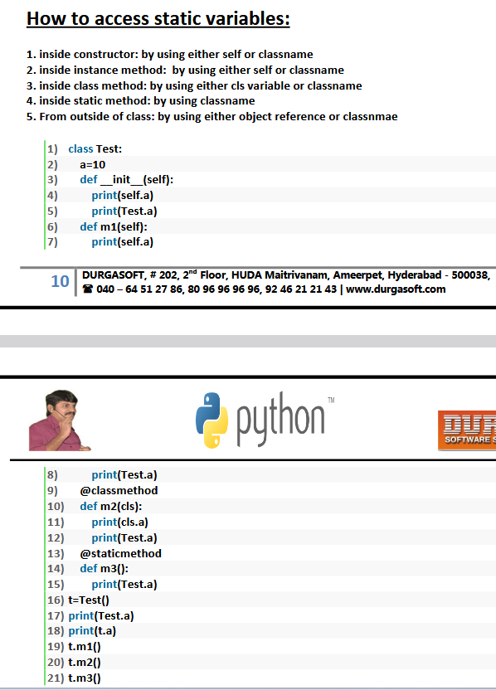

106. What are instance methods?
- Operate on object, first param is self
107. What are class methods?
- Operate on class, use @classmethod and cls
108. What are static methods?
- Use @staticmethod; no self or cls

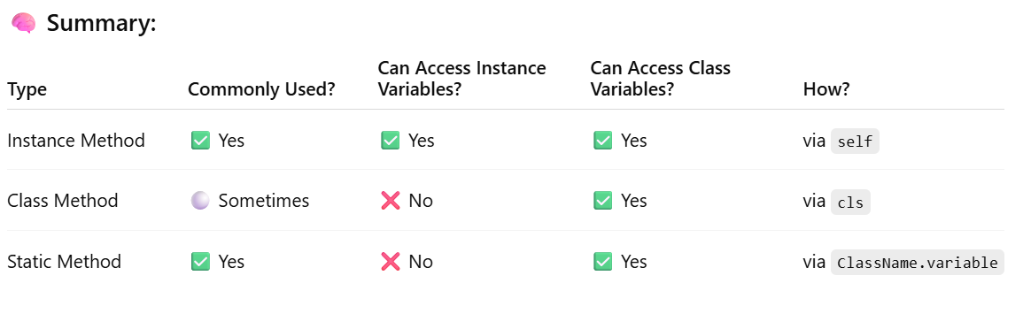
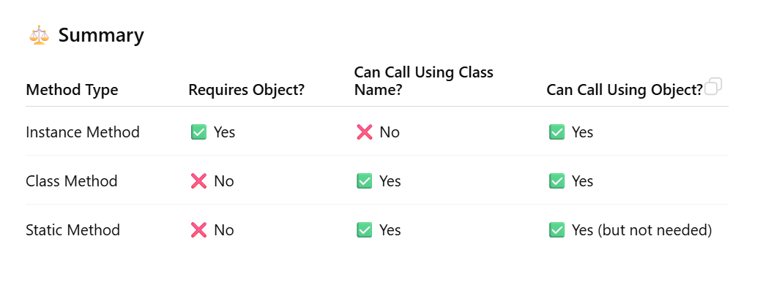

109. What is __init__ method?
- Constructor called when object is created
class A:
def __init__(self):
print("Init called")
110. What is __str__ method?
- Returns string representation of object
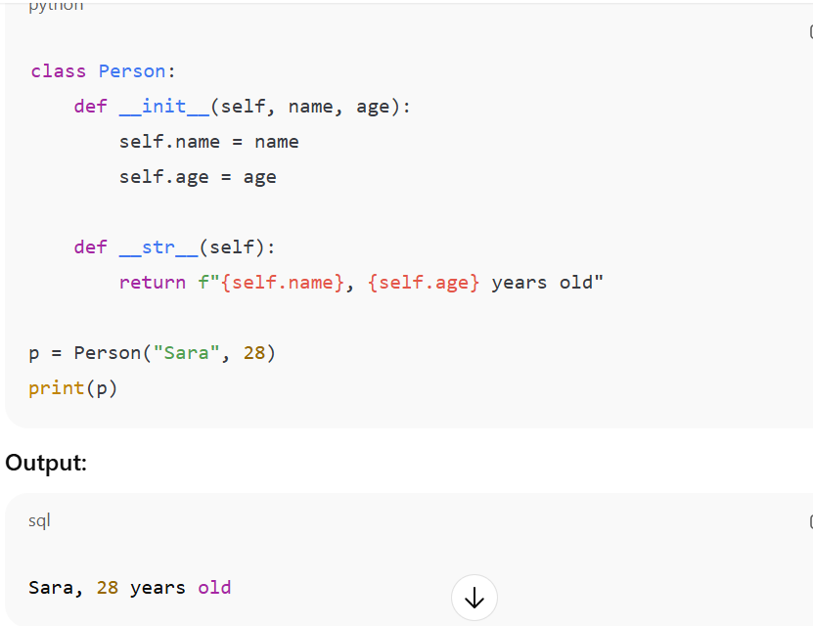

111. What is __repr__ method?
- Returns official representation for debugging
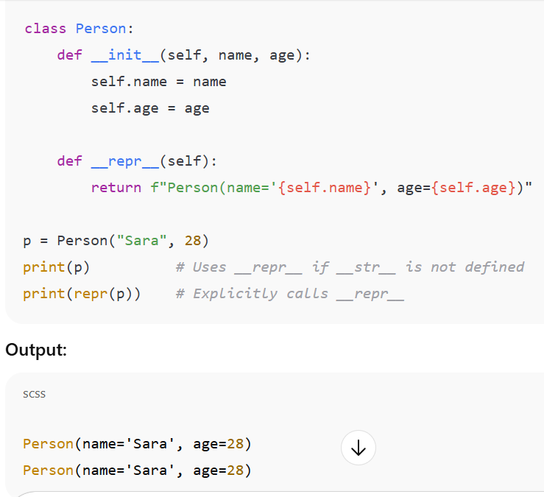

112. What is inheritance?
- Child class inherits attributes/methods from parent
113. What is multiple inheritance?
- Class inherits from multiple classes
114. What is method overriding?
- Child class redefines parent method
115. What is super()?
- Call parent class method
116. What is encapsulation?
- Restrict access to object data (private variables)
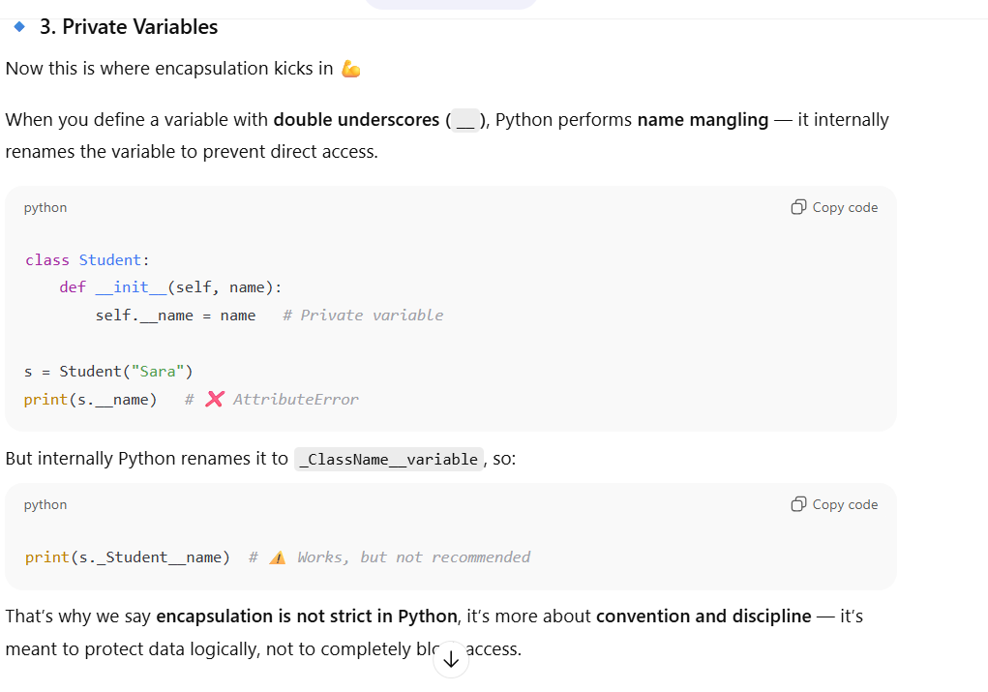

117. What is abstraction?
- Hide complex implementation, show only essentials
- Abstraction is another key concept in Object-Oriented Programming (OOP) — and it’s closely related to encapsulation, though they serve different purposes.

- 🔹 Definition:
- Abstraction means hiding the internal implementation details and showing only the essential features to the user.
- In simple words — it lets you focus on what an object does, not how it does it.

- 🔹 Real-life Example:
- Think of a car 🚗
- You use the steering wheel, accelerator, and brakes (what it does).
- You don’t need to know how the engine, transmission, or brake system works (how it does it).
- That’s abstraction — hiding complexity behind a simple interface.

- 🔹 In Python:
- We achieve abstraction mainly using abstract classes and abstract methods — provided by the abc (Abstract Base Class) module.

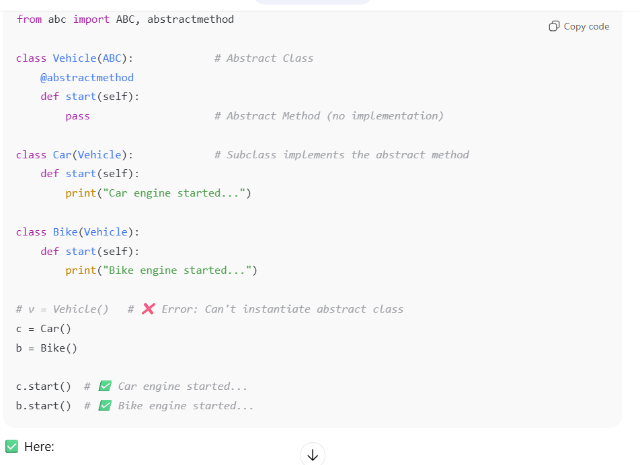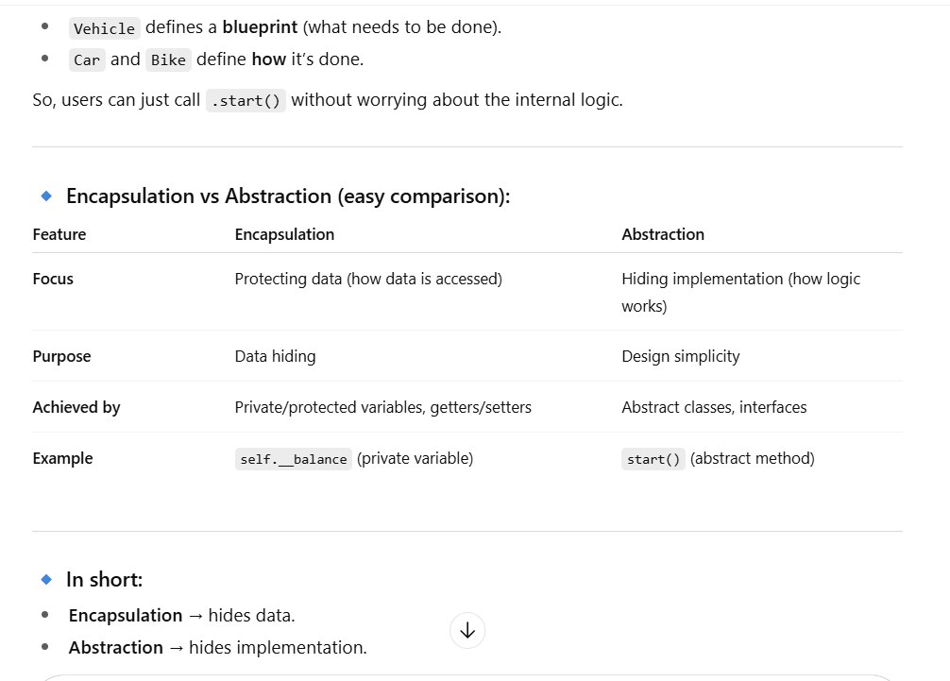

118. What is polymorphism?
- Same interface, multiple behaviors
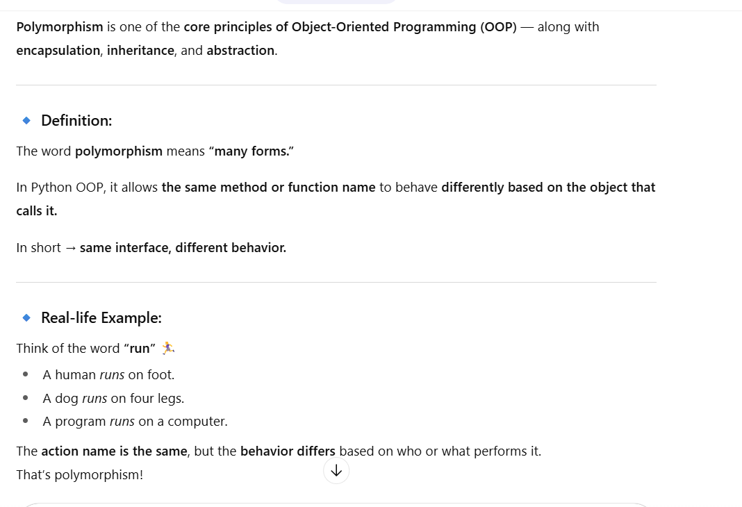
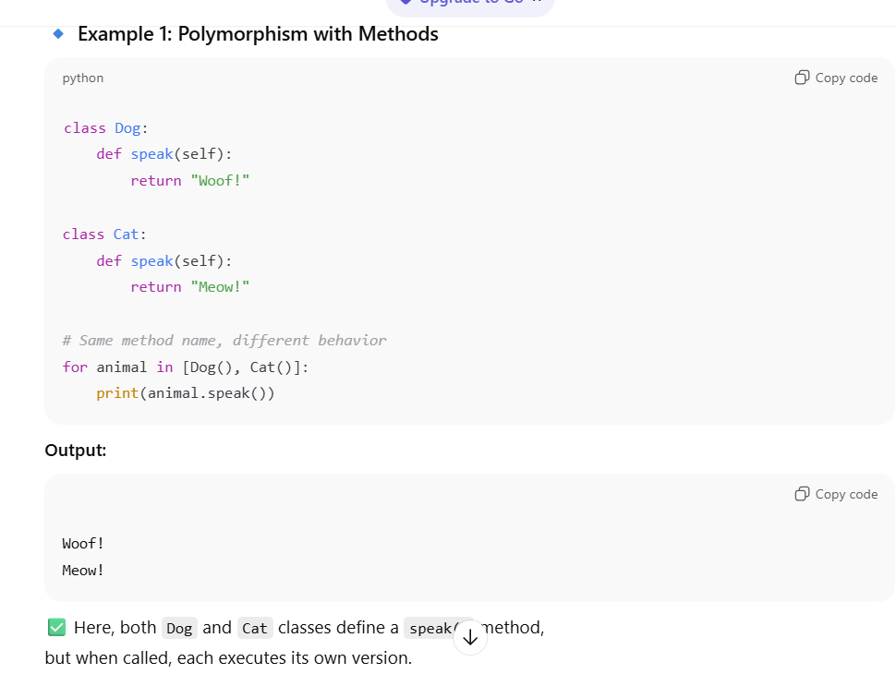
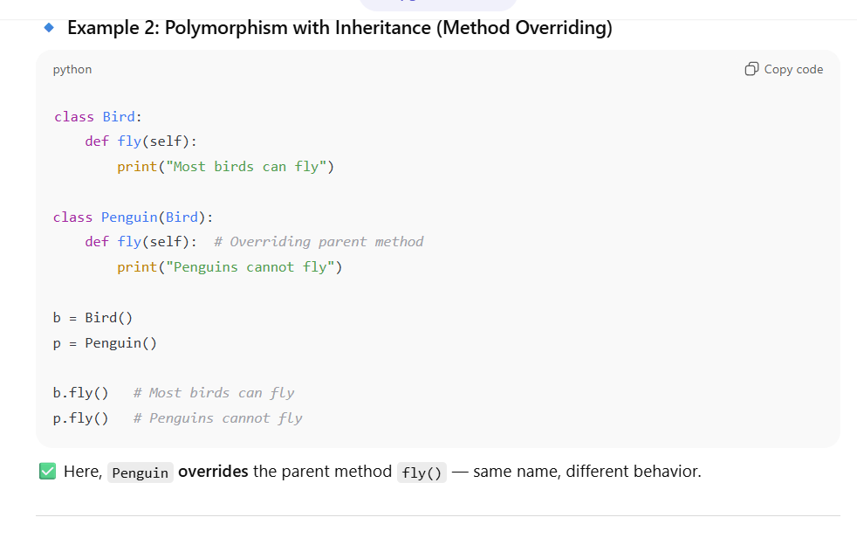
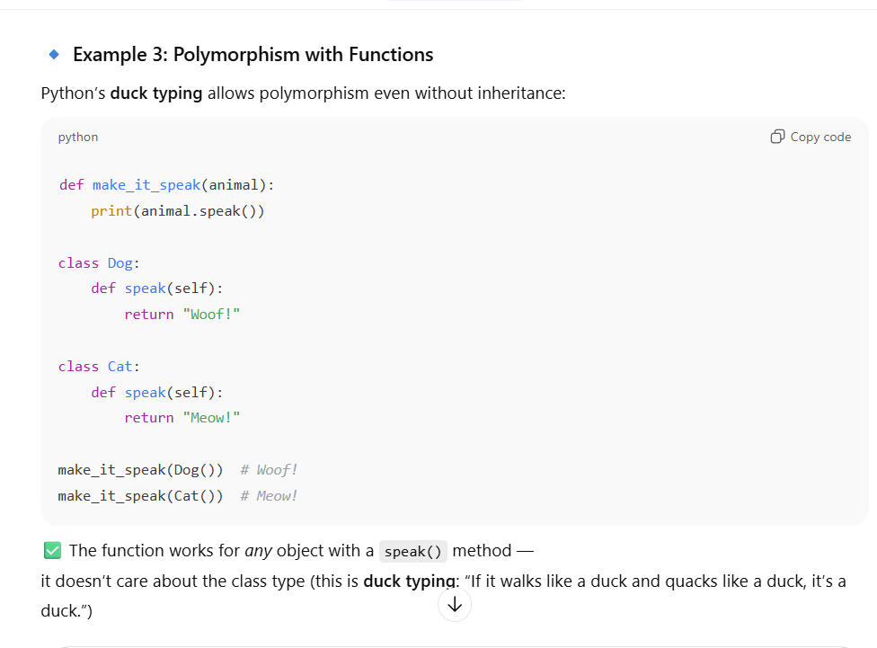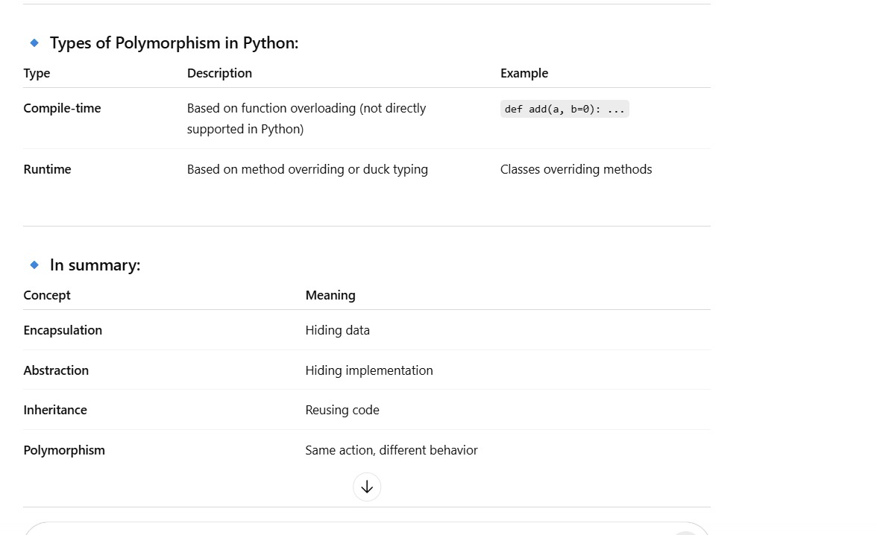

119. Difference between shallow and deep copy?
- Shallow → copies references
- Deep → copies recursively
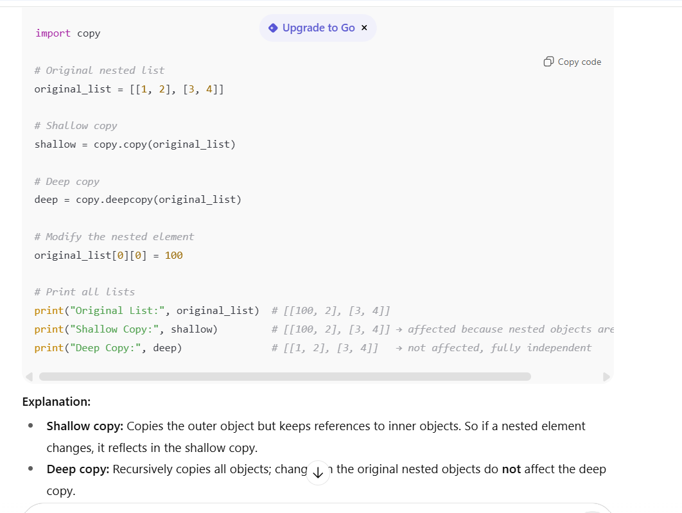

120. What is Python module?
- File with Python code (.py)
121. What is Python package?
- Folder with modules and __init__.py
122. Difference between import and from-import?
- import module → access with module.name
- from module import name → direct access
123. What is Python sys module?
- Provides system-specific functions
124. What is Python os module?
- Provides operating system related functions
125. What is Python math module?
- Math functions like sqrt, ceil, floor
126. What is Python random module?
- Generate random numbers
127. What is Python datetime module?
- Work with date and time
128. What is Python collections module?
- Specialized container datatypes (deque, Counter)
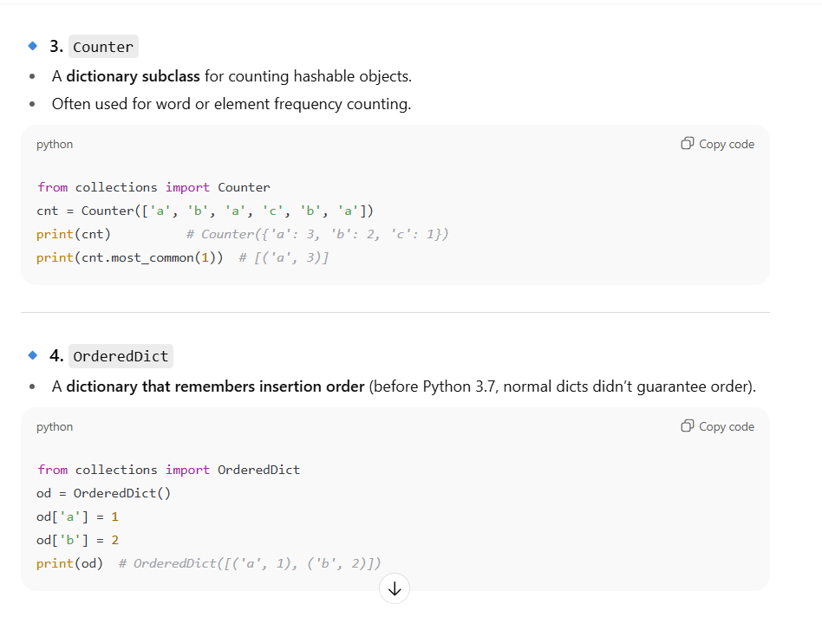
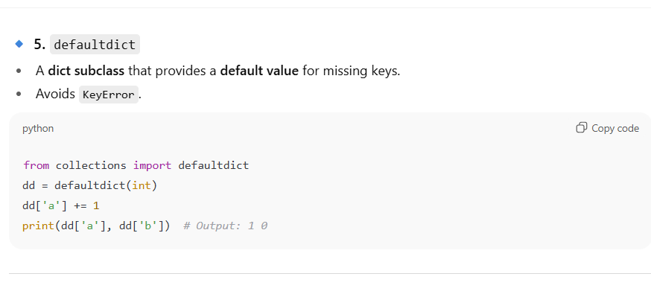
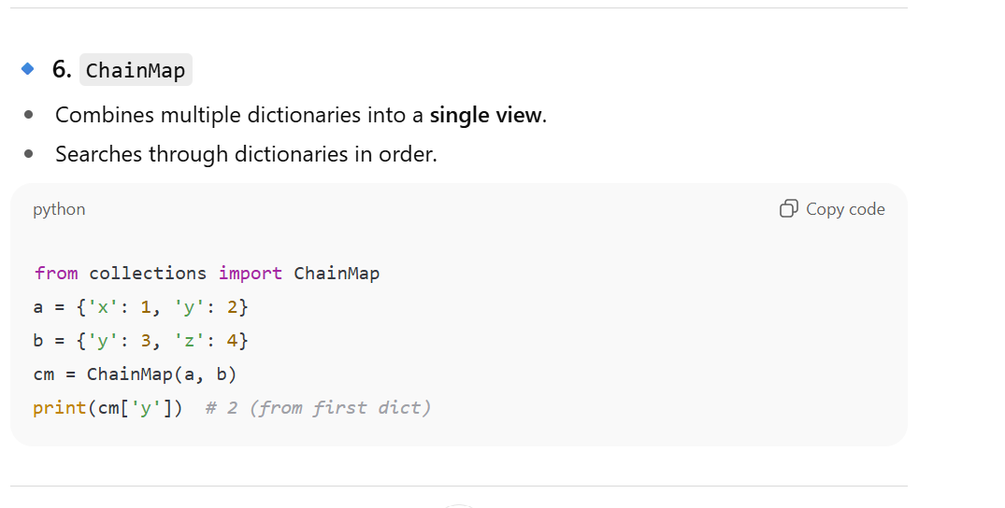
129. What is Python Counter?
- Counts frequency of items
130. What is Python defaultdict?
- Dictionary with default value for missing keys
131. What is Python OrderedDict?
- Dictionary preserving insertion order
132. What is Python namedtuple?
- Tuple with named fields
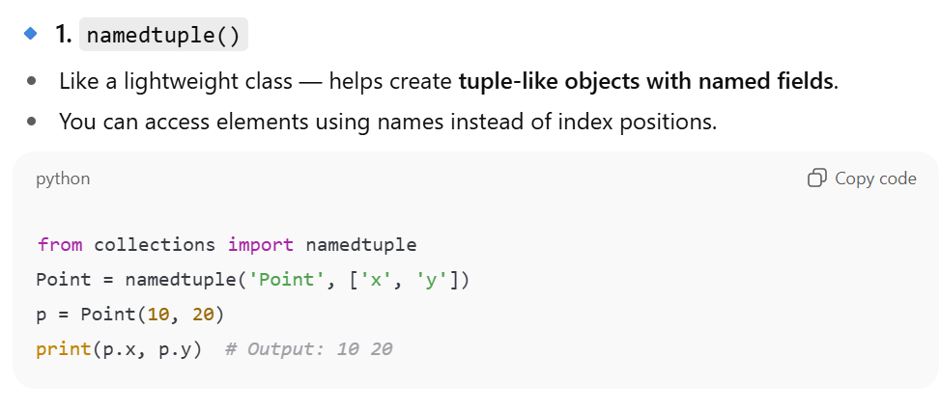
133. What is Python deque?
- Double-ended queue, faster insert/delete at both ends
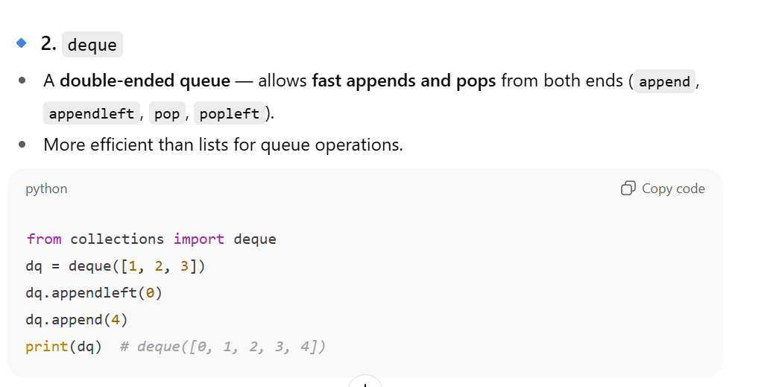

134. What is Python property() function?
- Create getter/setter for attributes
- The property() function in Python is used to manage access to instance attributes — it lets you define getter, setter, and deleter methods in an elegant way without changing how the attribute is accessed.
- 👉 In simple terms, it helps you control access to a class variable (encapsulation) while still allowing attribute-like access syntax.

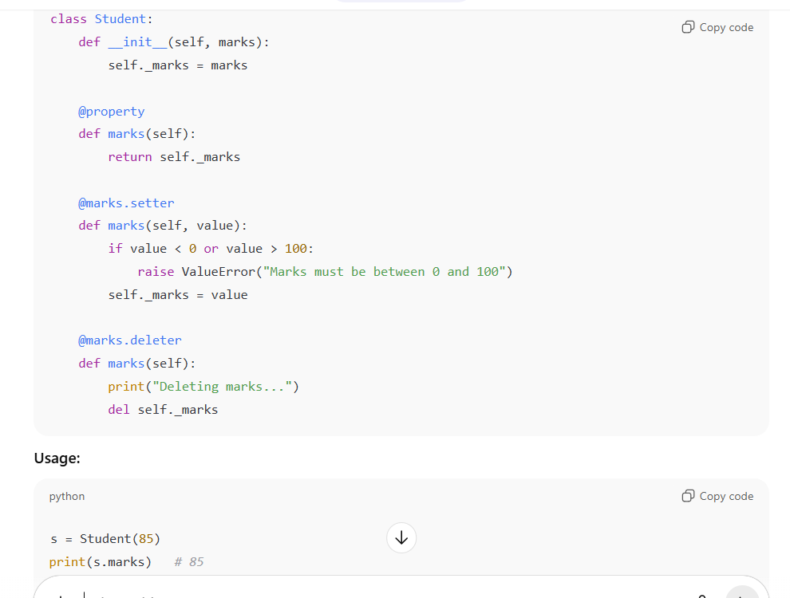

135. What is Python garbage collection?
- Automatically frees memory of unused objects
136. What is Python memory management?
- Automatic, via reference counting and garbage collector
137. What is Python weakref?
- Reference to object that doesn’t prevent garbage collection
138. What is Python slots?
- Restrict object attributes for memory efficiency
139. What is Python metaclass?
- Class of class; controls class creation
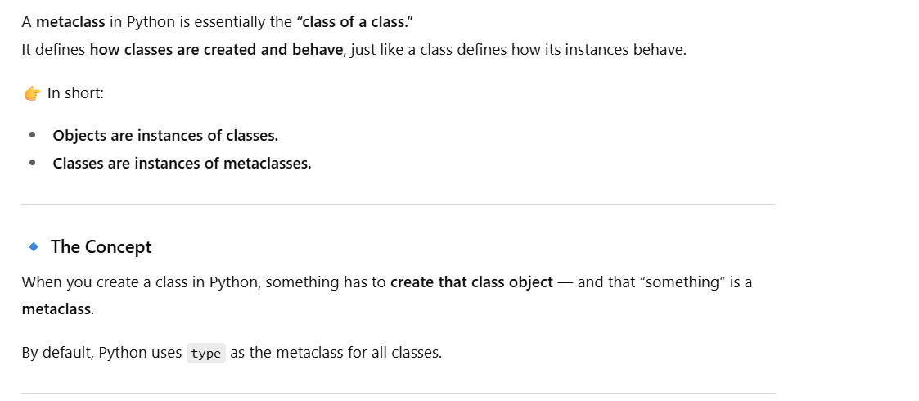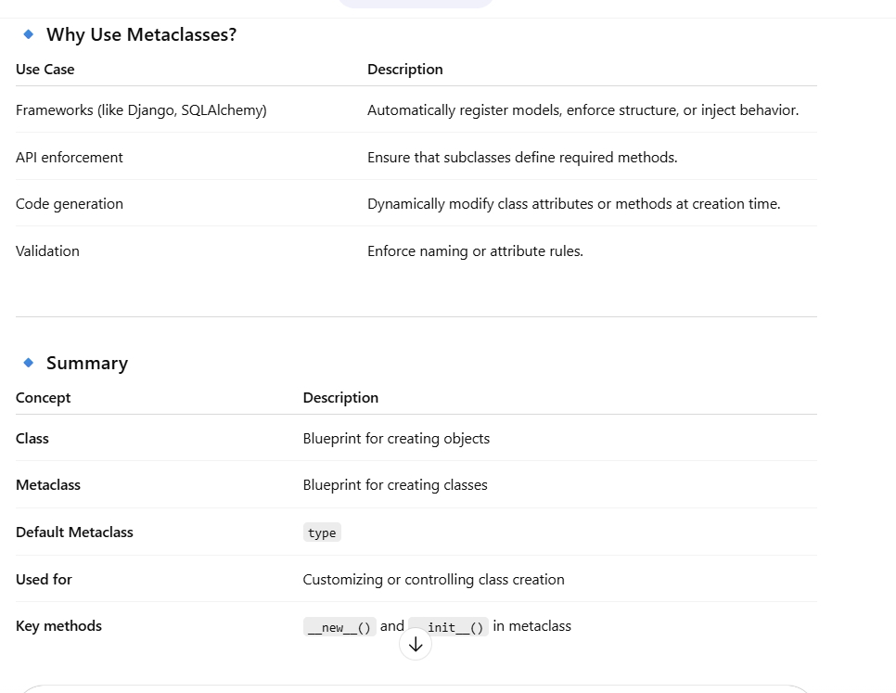

140. What is Python decorator pattern?
- Add behavior to function/class without modifying it
141. What is Python @property decorator?
- Access method like attribute
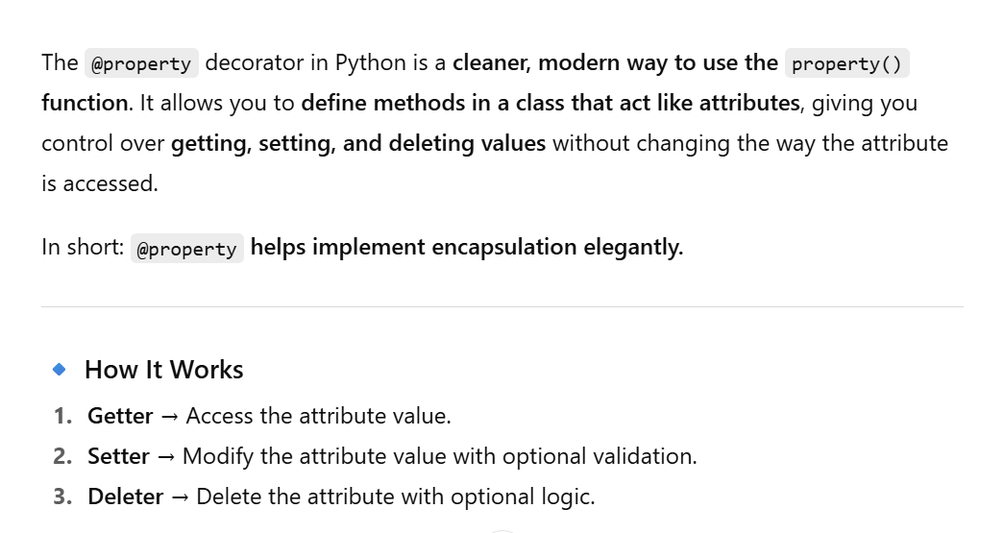
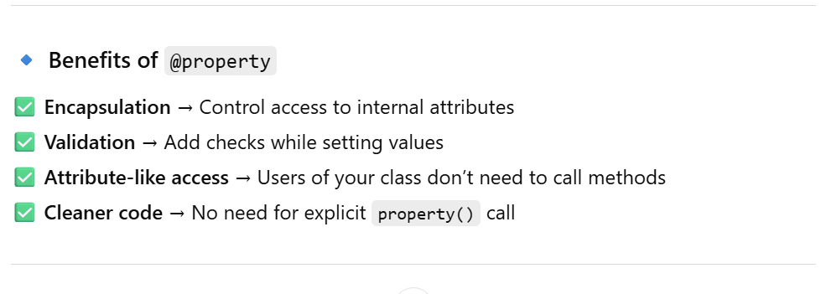

142. What is Python @staticmethod decorator?
- Defines static method
143. What is Python @classmethod decorator?
- Defines class method
144. What is Python context manager?
- Object used with with statement
with open("file.txt") as f:
data = f.read()
145. What is Python enter and exit?
- Methods used in context managers
146. What is Python singleton?
- Only one instance of class exists
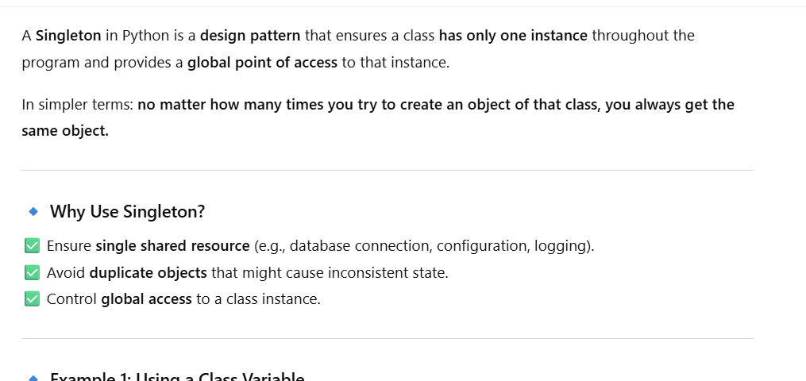
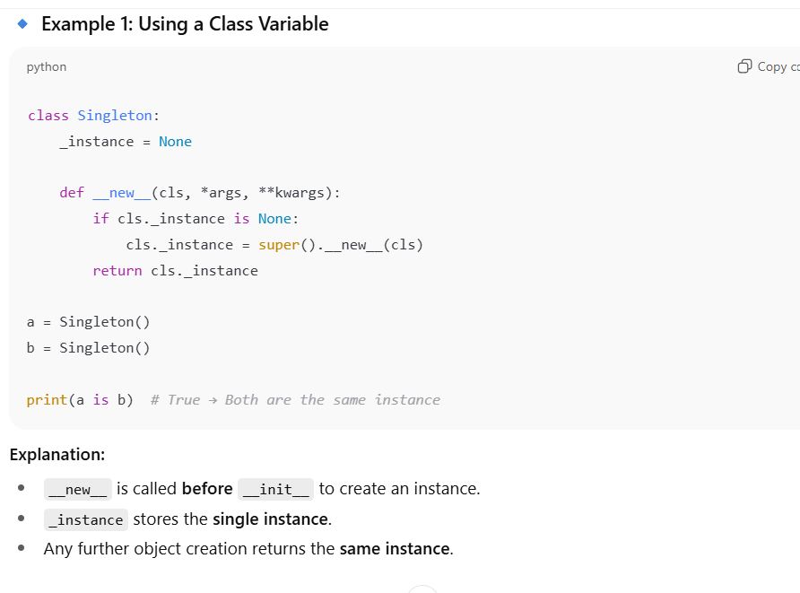

147. What is Python mixin?
- Class providing extra functionality for multiple classes
148. Difference between composition and inheritance?
- Composition → has-a relationship
- Inheritance → is-a relationship
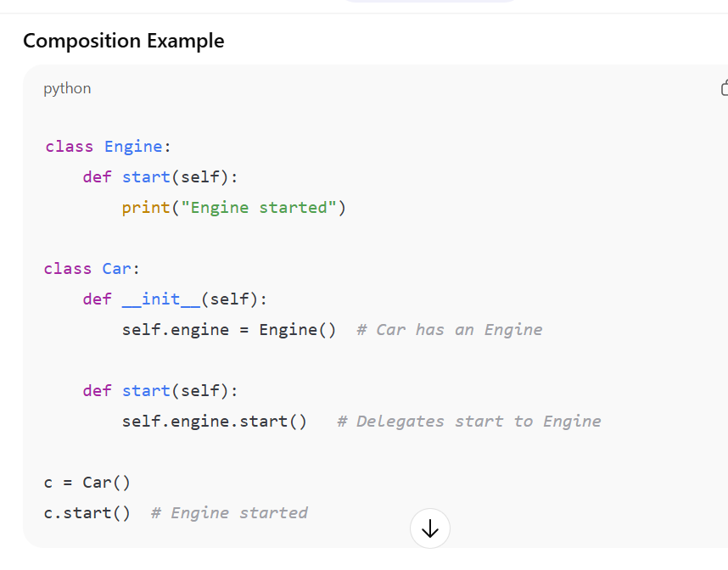

149. What is Python introspection?
- Examine objects at runtime (type(), dir(), id())
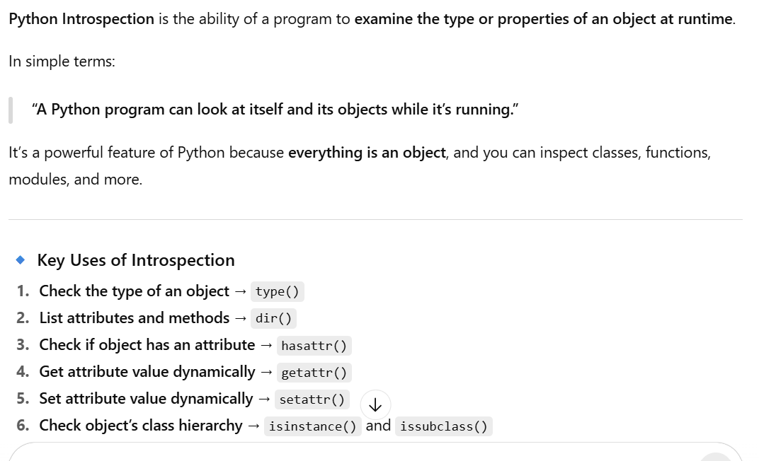

150. What is Python duck typing?
- Object behavior matters, not type (if it quacks like a duck…)

Part 4: Concurrency, Async, Built-ins, Advanced Tricks (Q151–Q200)
151. What is Python multithreading?
- Run multiple threads in same process
152. What is Python multiprocessing?
- Run multiple processes in parallel
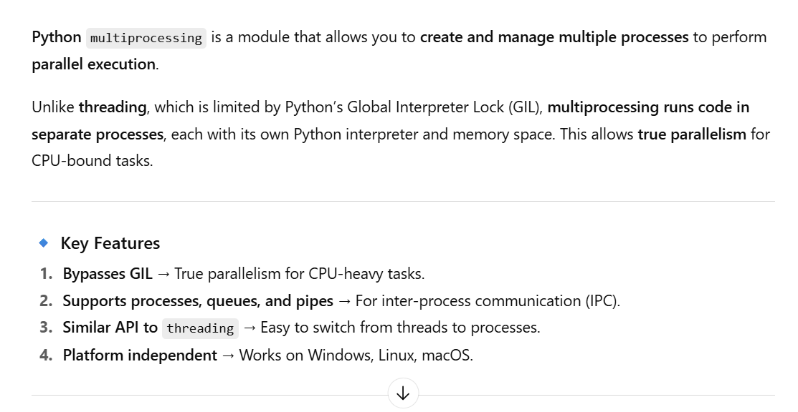
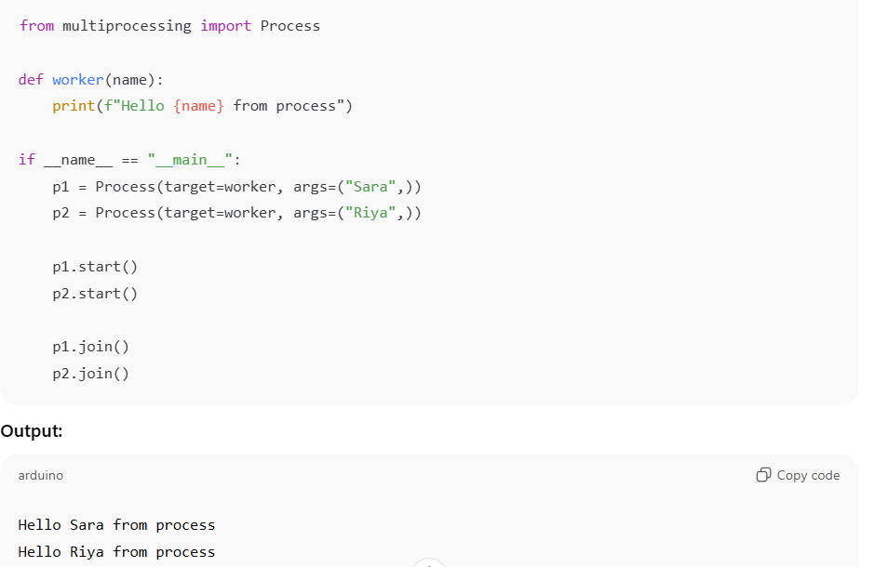

153. Difference between threading and multiprocessing?
- Thread → shared memory
- Process → separate memory

- Threading: Shares memory → good for I/O-bound tasks.
- Multiprocessing: Separate memory → good for CPU-bound tasks.

154. What is GIL in Python?
- Global Interpreter Lock, allows only one thread to execute Python bytecode at a time
155. What is Python async/await?
- Asynchronous programming to handle IO efficiently
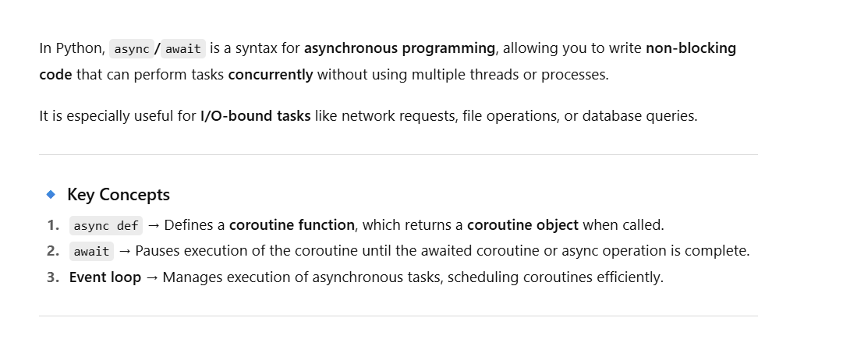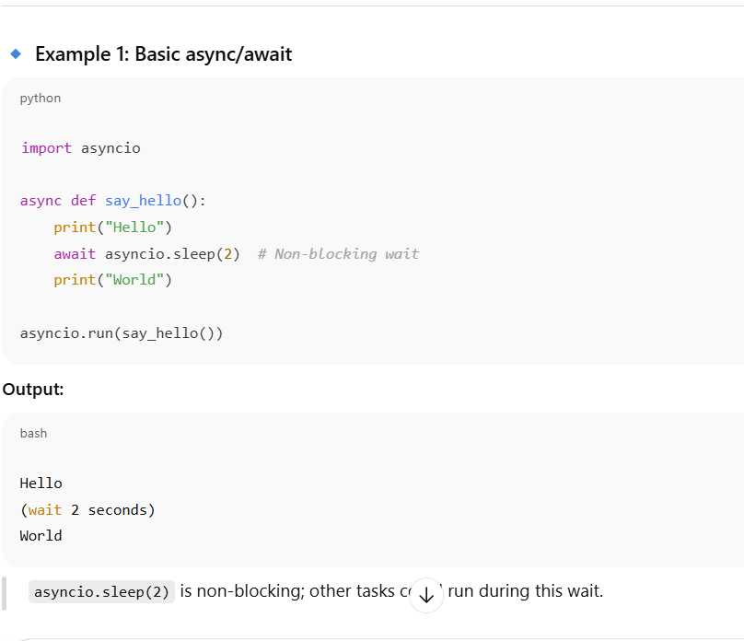
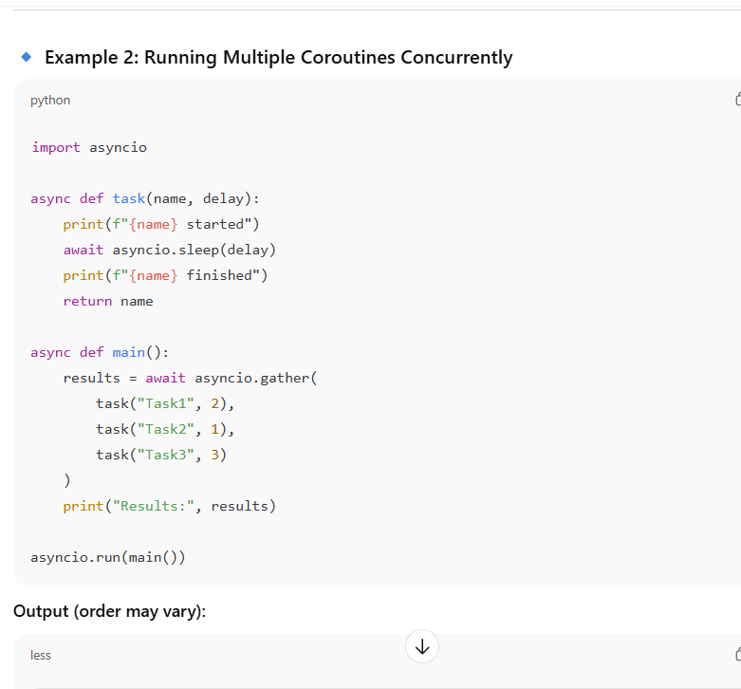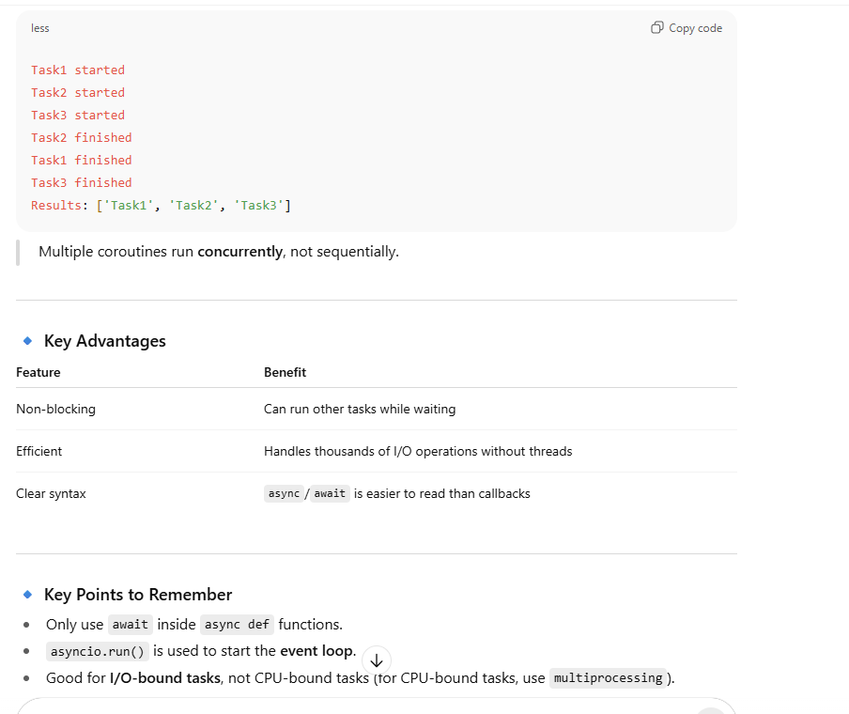

156. What is Python coroutine?
- Function using async def that can pause and resume
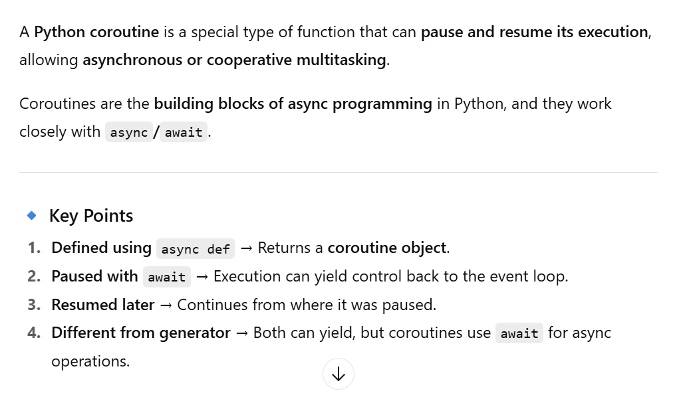

157. Difference between generator and coroutine?
- Generator → yields values
- Coroutine → awaits other async operations
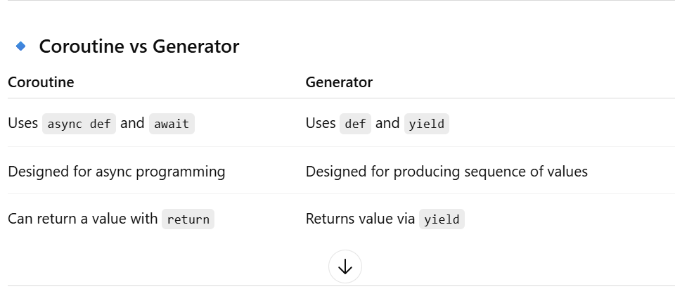
158. What is Python yield from?
- Delegate generator to another generator
159. What is Python map vs list comprehension?
- Map → functional style, comprehension → readable
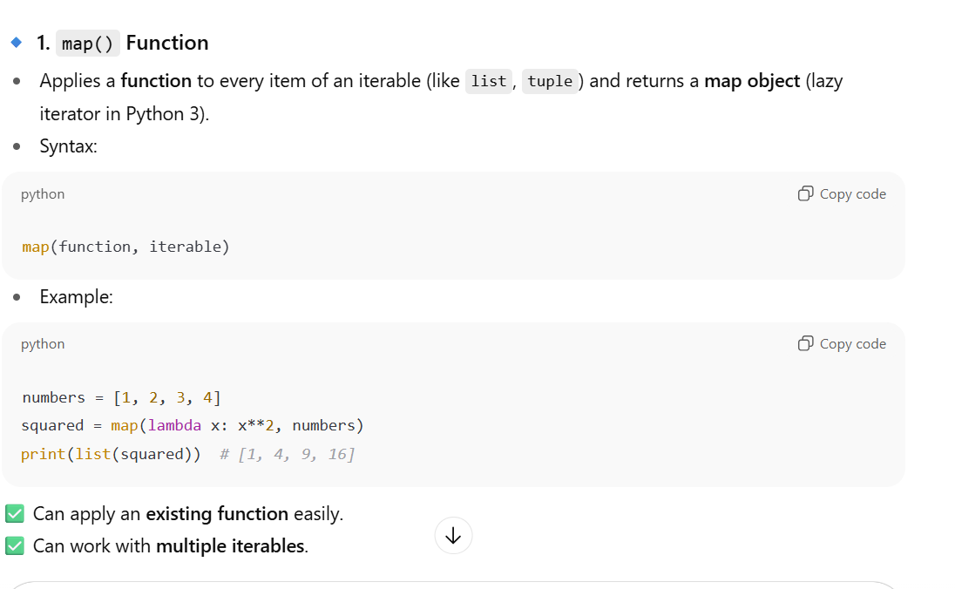
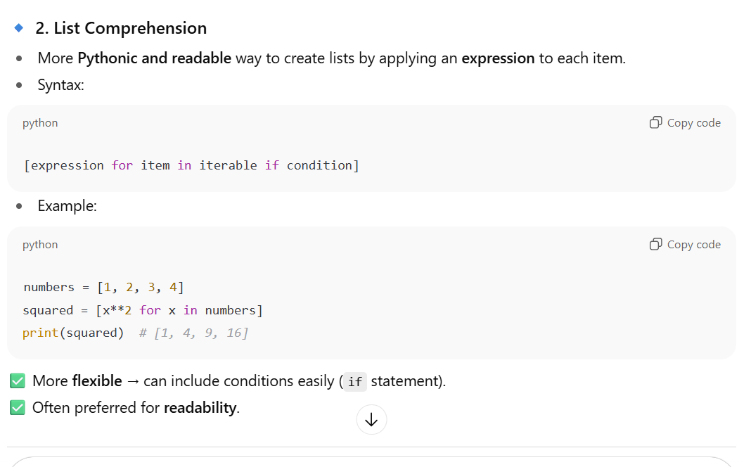
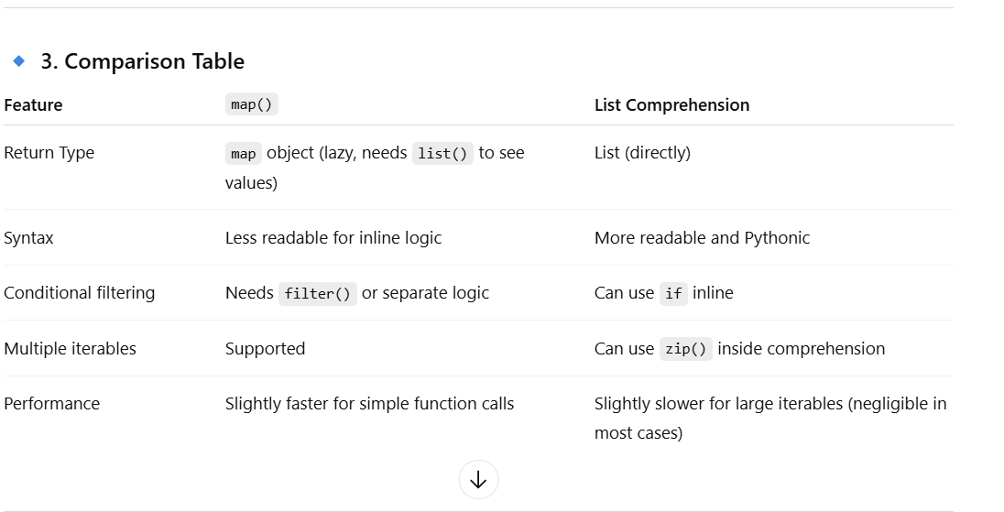

160. What is Python zip vs enumerate?
- Zip → combine sequences
- Enumerate → get index + value
161. What are Python built-in functions?
- Functions like len(), sum(), max(), min()
162. What is Python filter vs reduce?
- Filter → select items
- Reduce → aggregate items
163. What is Python any() and all()?
- any() → True if any item True
- all() → True if all items True
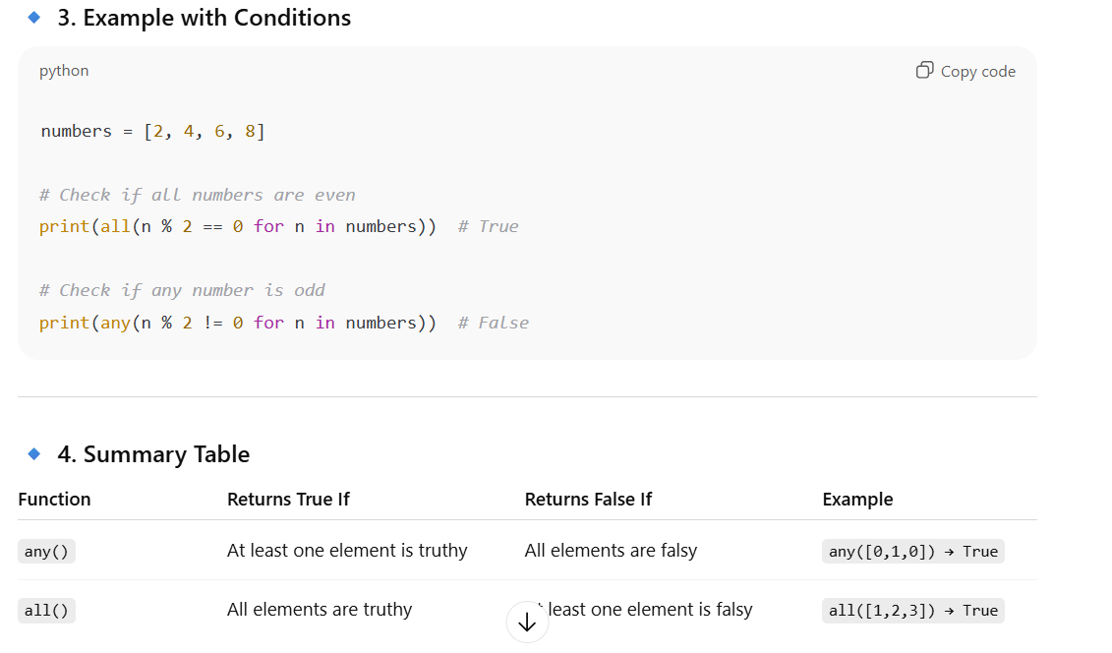

164. What is Python sorted()?
- Return sorted list, original unchanged
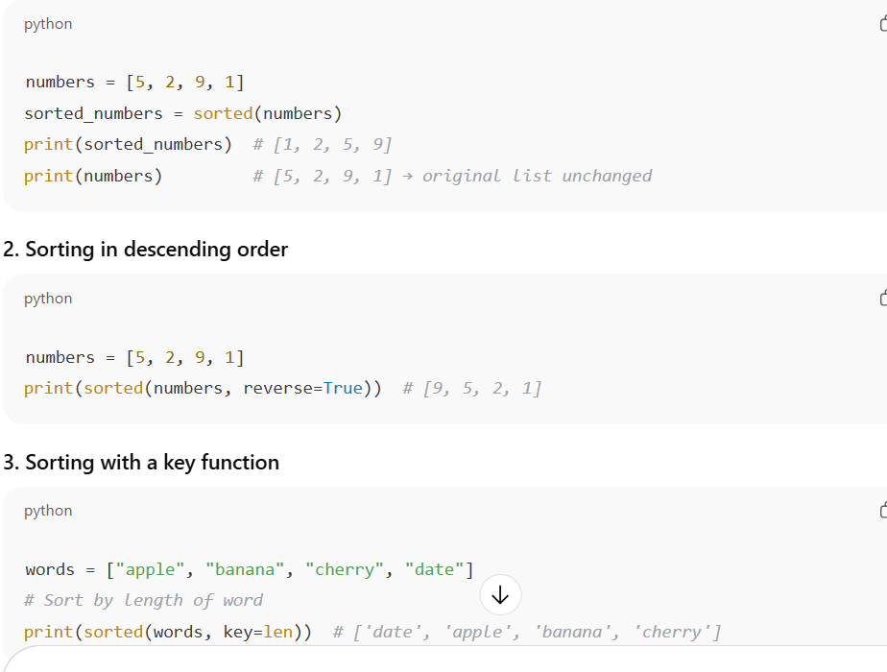

165. What is Python reversed()?
- Return reverse iterator
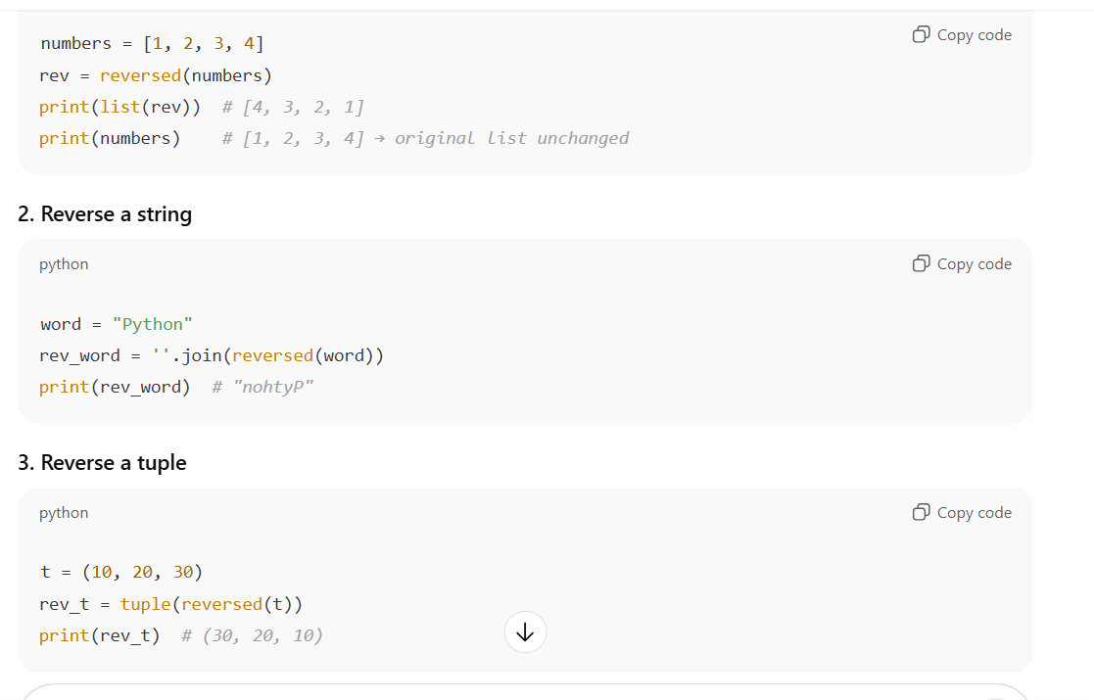

166. What is Python iter()?
- Return iterator from iterable
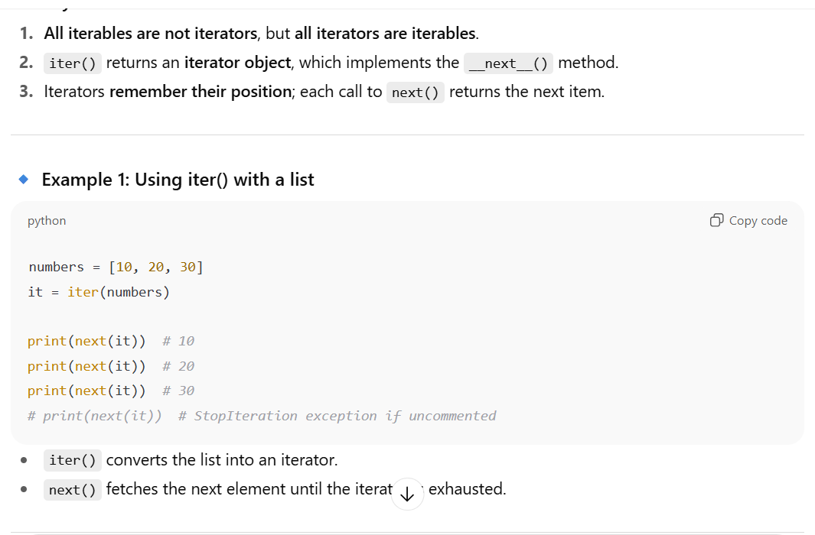
167. What is Python next()?
- Get next item from iterator
168. What is Python comprehension with if-else?
- Conditional in comprehension
lst = [x if x%2==0 else 0 for x in range(5)]
169. What is Python walrus operator :=?
- Assign value inside expression (Python 3.8+)
if (n := len([1,2,3])) > 2:
print(n)
170. What is Python f-string?
- Formatted string literal
name = "Sara"
print(f"Hello {name}")
171. What is Python string formatting with format()?
"Hello {}".format("Sara")
172. What is Python slicing with step?
lst = [0,1,2,3,4]
lst[::2] # [0,2,4]
173. What is Python extended unpacking?
a,b,*rest = [1,2,3,4]
174. What is Python chain comparison?
x = 5
print(1 < x < 10) # True
175. What is Python underscore _ usage?
- _ in REPL → last result
- _var → private by convention
176. What is Python docstring multi-line?
"""This is
multi-line docstring"""
177. What is Python assert vs raise?
- Assert → debugging, raise → manual exception
178. What is Python slicing negative step?
lst[::-1] # reverse list
179. What is Python chain assignment?
a = b = 0
180. What is Python ternary operator?
x = 5
y = "Even" if x%2==0 else "Odd"
181. What is Python unpacking in function arguments?
def func(a,b):
print(a,b)
lst = [1,2]
func(*lst)
182. What is Python set operations?
- Union |, intersection &, difference -, symmetric difference ^
183. What is Python dict.get()?
- Returns value if key exists, else default
184. What is Python dict.items()?
- Returns key-value pairs
185. What is Python dict.keys() / values()?
- Return keys or values
186. What is Python ternary in list comprehension?
[x if x>0 else 0 for x in [-1,2,-3]]
187. What is Python unpacking in dict?
d = {'a':1,'b':2}
print(*d) # prints keys
output: a b
188. What is Python else in loop?
- Executes if loop ends normally (no break)
189. What is Python else in try-except?
- Executes if no exception occurs
190. What is Python name == "main"?
- Ensures code runs only when script is executed directly
191. What is Python dir vs vars?
- dir() → all attributes
- vars() → dict of object
192. What is Python hasattr, getattr, setattr?
- Check, get, set attribute dynamically
193. What is Python zip(*) trick?
- Transpose lists
a = [(1,2),(3,4)]
x,y = zip(*a)
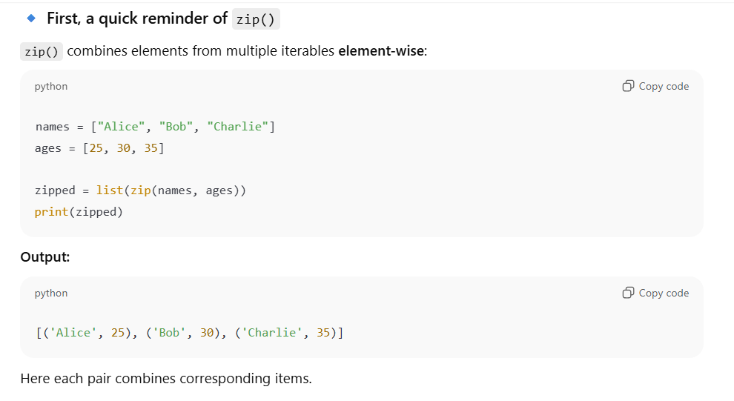
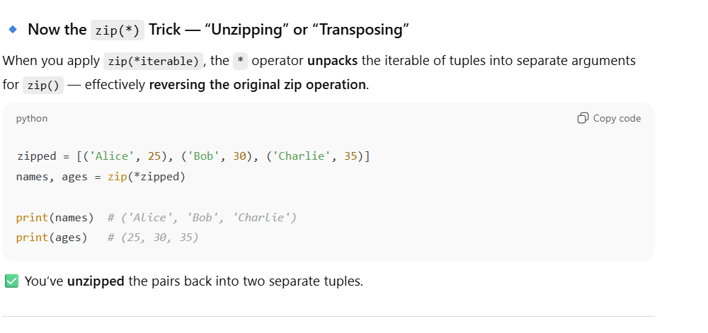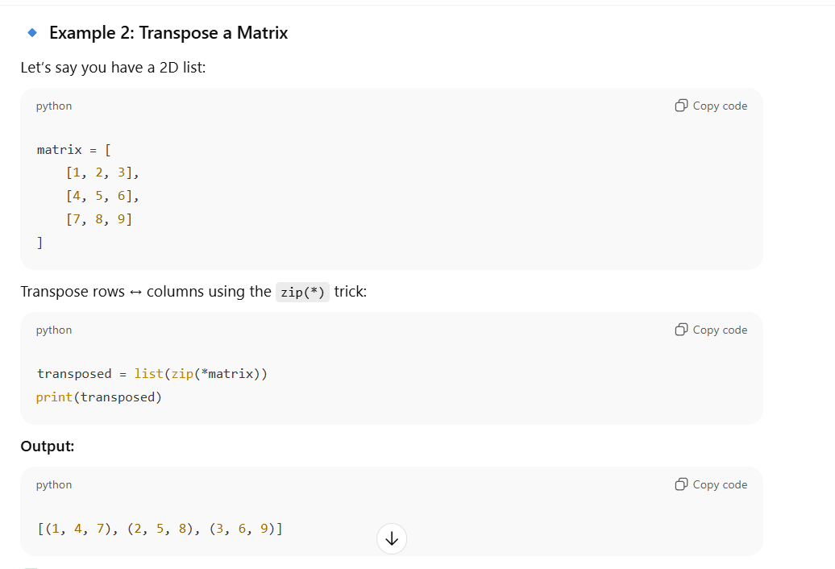

194. What is Python list multiplication?
[0]*5 # [0,0,0,0,0]
195. What is Python string split/join?
s = "a b c"
s.split() # ['a','b','c']
"-".join(["a","b"]) # "a-b"
196. What is Python map with lambda?
list(map(lambda x:x*2,[1,2]))
197. What is Python filter with lambda?
list(filter(lambda x:x>0,[-1,0,1]))
198. What is Python comprehension with nested loops?
[(x,y) for x in [1,2] for y in [3,4]]
199. What is Python swap variables?
a,b = b,a
200. What is Python one-liner if-else?
x = 5
print("Even" if x%2==0 else "Odd")

***************************************************************************----
***************************************************************************----

Tricky Python Questions: Lists, Tuples, Sets, Dictionaries

Lists
1. Can a list be used as a dictionary key?
- Answer: No
- Reason: Lists are mutable → their hash value can change → not hashable
my_list = [1,2]
# my_dict = {my_list: "value"} # Error

2. What happens if you multiply a list containing a mutable object?
lst = [[0]] * 3
lst[0][0] = 5
print(lst)
- Answer: [[5], [5], [5]]
- Explanation: All elements point to the same list object, not separate copies.

3. Difference between append() and extend()
lst = [1,2]
lst.append([3,4])
print(lst) # [1,2,[3,4]]
lst = [1,2]
lst.extend([3,4])
print(lst) # [1,2,3,4]
- Answer: append() adds as single element, extend() adds multiple elements.

4. What is shallow copy vs deep copy for lists?
import copy
lst1 = [[1,2], [3,4]]
lst2 = copy.copy(lst1) # shallow
lst3 = copy.deepcopy(lst1) # deep
- Shallow copy: Copies top-level only, nested objects share references
- Deep copy: Recursively copies all objects

5. Can list elements be tuples or sets?
- Answer: Yes, any object can be an element of a list
lst = [(1,2), {3,4}]

Tuples
6. Can a tuple be used as a dictionary key?
- Answer: Yes, if all elements inside are immutable
t1 = (1,2,3) # works
t2 = (1,[2,3]) # fails, because list is mutable

7. Difference between single-element tuple and a value in parentheses
t1 = (5)
t2 = (5,)
print(type(t1)) # int
print(type(t2)) # tuple
- Answer: Use a trailing comma for single-element tuple

8. Can you modify a tuple after creation?
- Answer: No
- But, if it contains a mutable element, you can modify that element
t = ([1,2], 3)
t[0].append(3) # [1,2,3]. Final output: ([1, 2, 3], 3)

9. Why are tuples faster than lists?
- Tuples are immutable → Python can optimize memory and access speed

10. Can you unpack a tuple?
a, b, c = (1,2,3)
- Answer: Yes, unpacking is common and handy

Sets
11. Can sets contain duplicate elements?
- Answer: No, sets store unique elements only
s = {1,2,2,3}
print(s) # {1,2,3}

12. Can a set contain a list or a dictionary?
- Answer: No, sets are hashable → elements must be immutable
s = {[1,2]} # Error

13. How to find intersection, union, difference of sets?
a = {1,2,3}
b = {2,3,4}
print(a & b) # intersection {2,3}
print(a | b) # union {1,2,3,4}
print(a - b) # difference {1}

14. Can sets be elements of another set?
- Answer: No, because sets are mutable. Use frozenset instead
s1 = {1,2}
s2 = {frozenset(s1), 3} # works

15. How to remove duplicates from a list using set?
lst = [1,2,2,3]
lst = list(set(lst)) # [1,2,3]

Dictionaries
16. Can dictionary keys be mutable?
- Answer: No, keys must be hashable (immutable)
d = {[1,2]: "a"} # Error

17. Difference between get() and [] access
d = {"a":1}
print(d.get("b")) # None
# print(d["b"]) # KeyError

18. Can dictionary values be mutable?
- Answer: Yes, values can be anything
d = {"a":[1,2,3]} # valid

19. How to iterate over dictionary keys, values, items?
d = {"a":1,"b":2}
for k in d: print(k) # keys
for v in d.values(): print(v) # values
for k,v in d.items(): print(k,v) # both

20. What happens if duplicate keys exist in a dictionary literal?
d = {"a":1,"a":2}
print(d) # {"a":2} -> last value overwrites

21. Can you merge two dictionaries?
d1 = {"a":1}
d2 = {"b":2}
d1.update(d2) # {'a':1,'b':2}

22. Dictionary comprehension example:
d = {x:x*2 for x in range(5)}

23. Tricky: mutable value in dict
d = {"a":[]}
d["a"].append(1)
print(d) # {"a":[1]} -> even though key immutable, value can change

24. Can you use dict.fromkeys() with a mutable default value?
d = dict.fromkeys(['a','b'], [])
d['a'].append(1)
print(d) # {'a':[1], 'b':[1]} -> same list shared
- Trick: Avoid using mutable default values

25. Tricky: ordering of dictionary keys
- Python 3.7+ preserves insertion order
- Before 3.7, dictionary order was arbitrary

LISTS (Q1–Q30)
1. Can a list be used as a dictionary key?
- Answer: No, lists are mutable → not hashable.
2. Difference between append() and extend()
lst = [1,2]
lst.append([3,4]) # [1,2,[3,4]]
lst.extend([3,4]) # [1,2,3,4]
3. Shallow copy vs deep copy
import copy
lst1 = [[1,2],[3,4]]
lst2 = copy.copy(lst1) # shallow
lst3 = copy.deepcopy(lst1) # deep
4. List multiplication with mutable objects
lst = [[0]] * 3
lst[0][0] = 5
print(lst) # [[5],[5],[5]]
5. Can a list contain tuples or sets?
- Answer: Yes, any object can be inside a list
6. List slicing returns a new object?
yes
lst1 = [1,2,3]
lst2 = lst1[:]
print(lst1 is lst2) # False

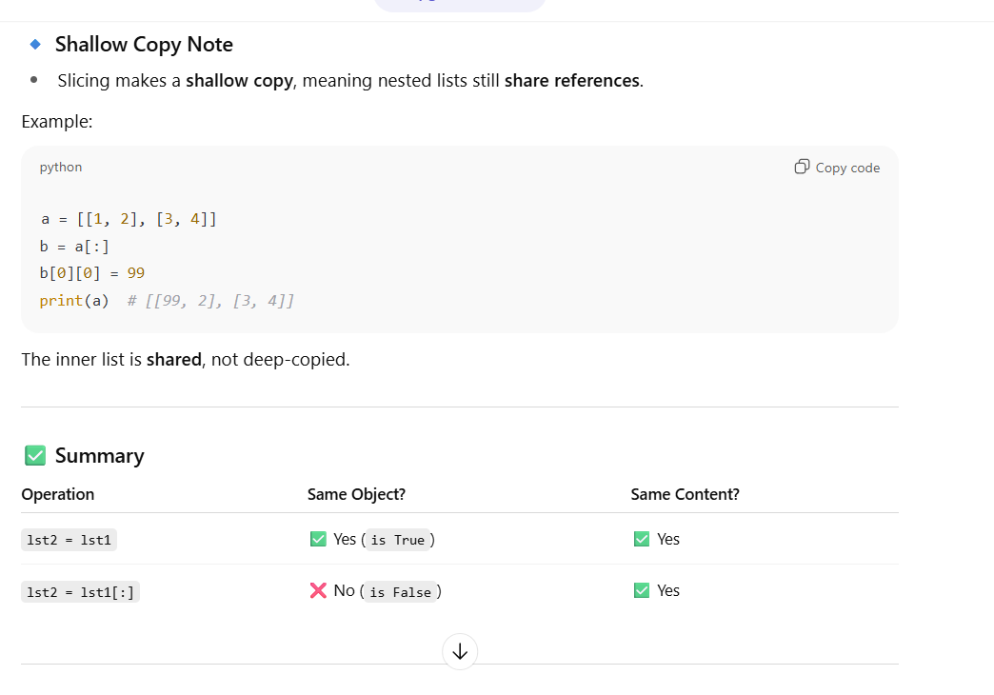

7. Difference between lst1 = lst2 and lst1 = lst2[:]
- = → both variables point to the same object
- [:] → creates a copy
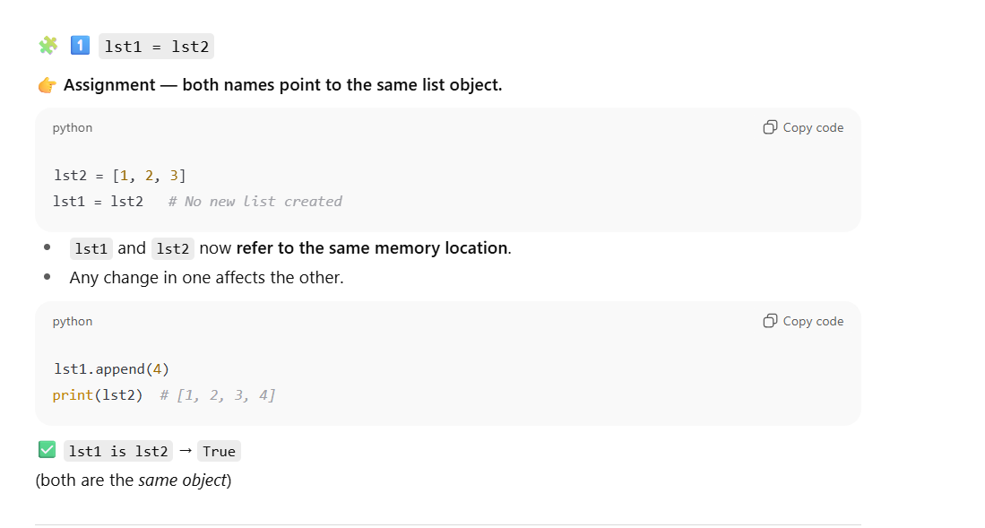
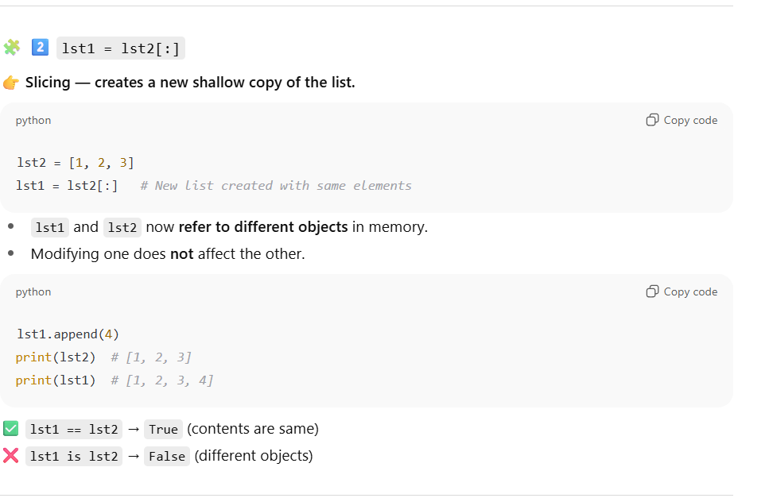
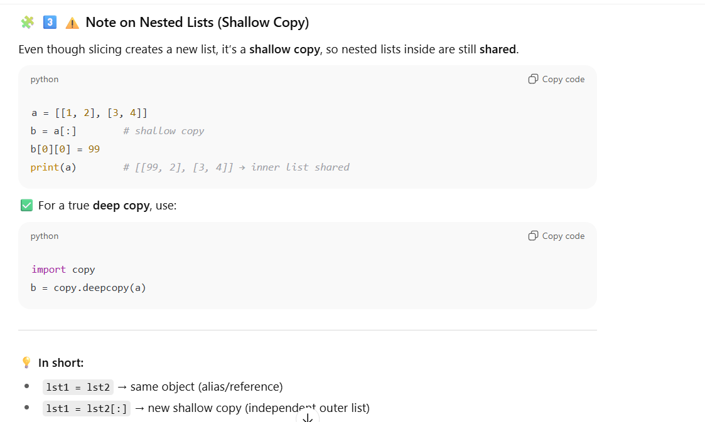

8. Negative index in list
lst = [1,2,3]
print(lst[-1]) # 3
9. Nested list flattening
lst = [[1,2],[3,4]]
flat = [x for sub in lst for x in sub] # [1,2,3,4]
10. Using * operator to unpack list
lst = [1,2,3]
print(*lst) # 1 2 3
11. Sort list without modifying original
lst = [3,1,2]
sorted_lst = sorted(lst) # [1,2,3]
12. List comprehension with if-else
[x if x%2==0 else 0 for x in range(5)] # [0,2,0,4,0]
13. Can list contain itself?
lst = []
lst.append(lst)
print(lst) # [[...]]
14. Using del on list slices
lst = [1,2,3,4]
del lst[1:3]
print(lst) # [1,4]
15. Difference between remove() and pop()
lst = [1,2,3]
lst.remove(2) # remove by value
lst.pop(1) # remove by index
16. Using list.count()
lst = [1,2,2,3]
lst.count(2) # 2
17. List reverse in-place vs reversed()
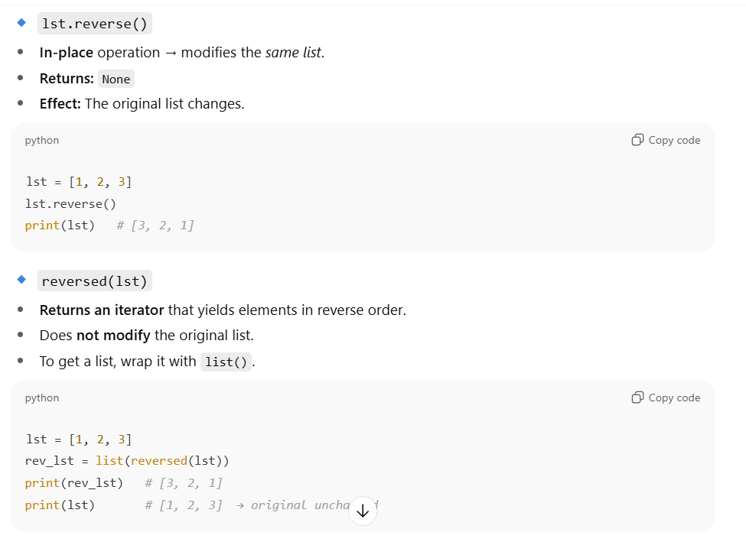
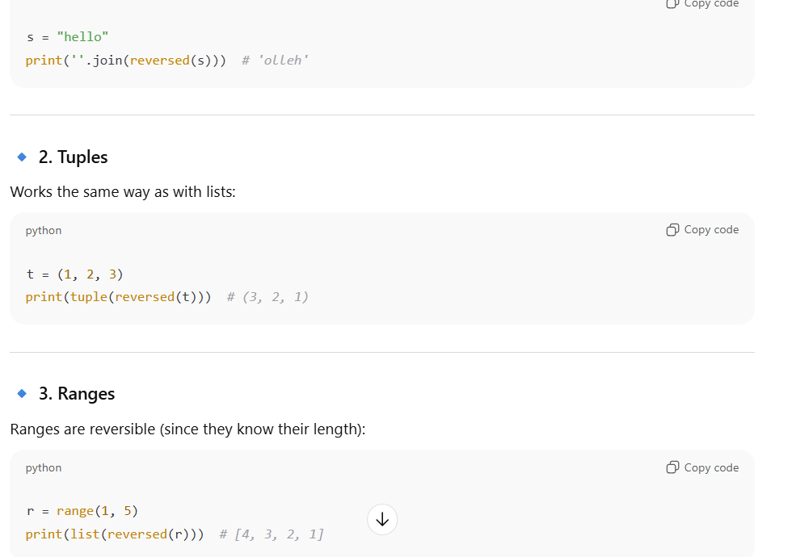
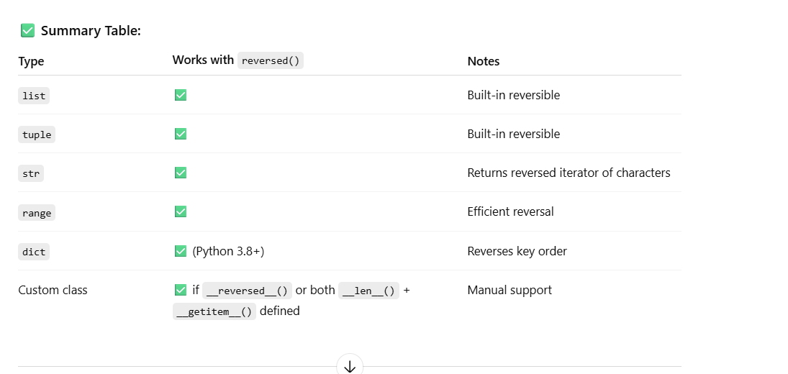
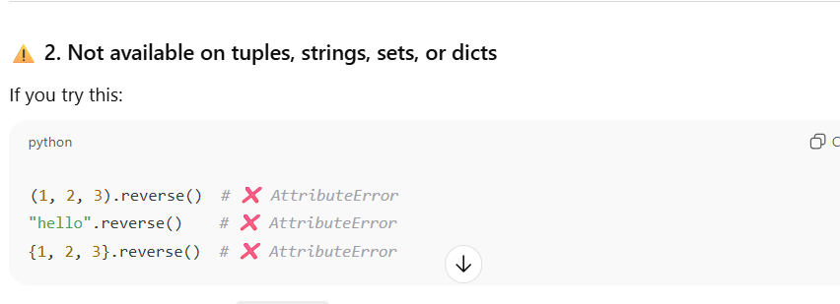
18. Copy list using list() constructor
lst2 = list(lst1)
19. Difference between == and is for lists
- == → checks values
- is → checks identity
20. Extend vs concatenation
lst1 = [1]
lst2 = [2]
lst1 += lst2 # same as extend
lst3 = lst1 + lst2 # returns new list
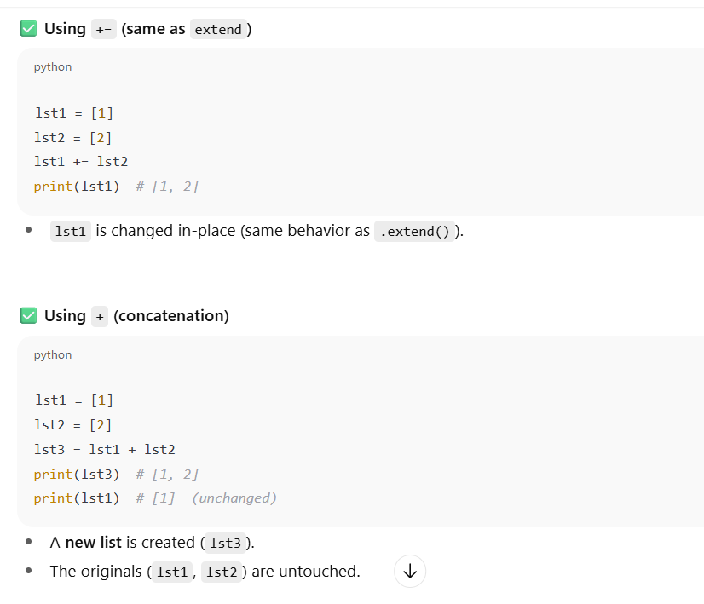
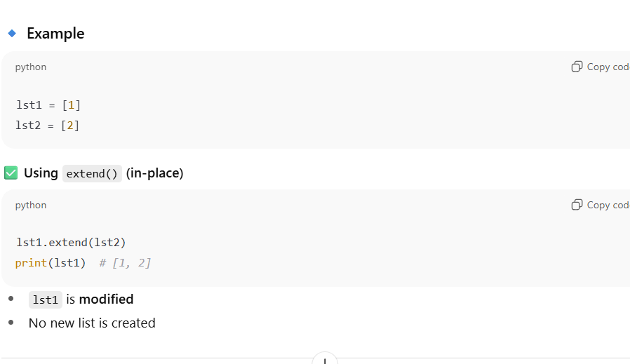
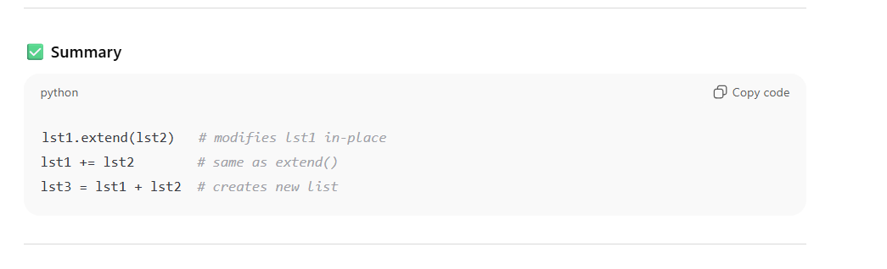

21. Using min() and max() with key function
lst = ["apple","banana"]
min(lst,key=len) # "apple"
22. List with repeated mutable objects
lst = [[0]]*3
lst[0].append(1)
print(lst) # [[0,1],[0,1],[0,1]]
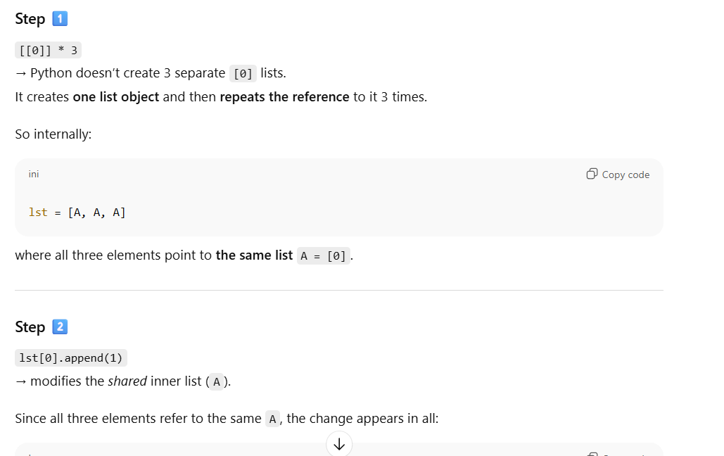
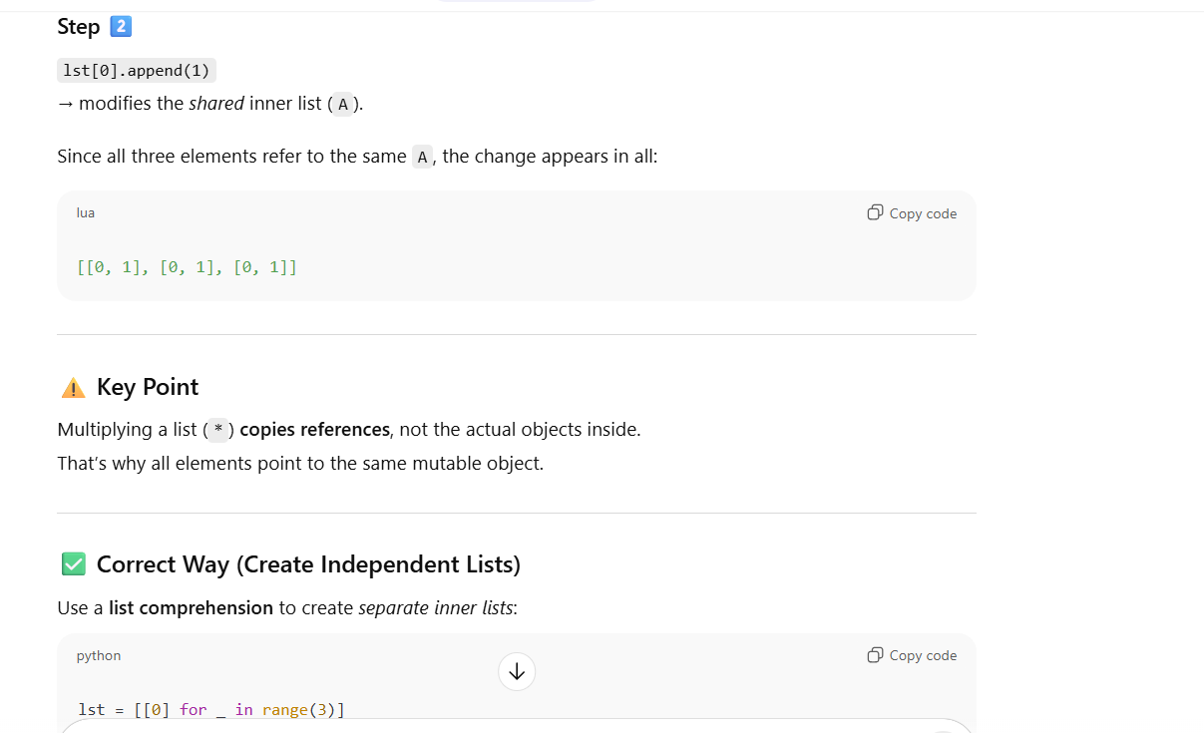

23. Using list as stack
stack = []
stack.append(1)
stack.pop() # 1
24. Using list as queue (inefficient)
queue = []
queue.append(1)
queue.pop(0) # O(n)
25. List comprehension with nested loops
[(x,y) for x in [1,2] for y in [3,4]] # [(1,3),(1,4),(2,3),(2,4)]
26. Check if list is empty
if not lst:
print("Empty")
27. List concatenation vs extend with comprehension
lst = [1,2]
lst += [x*2 for x in [3,4]] # [1,2,6,8]
28. Reversing list using slicing
lst[::-1]
29. Nested list assignment effect
a = [[0]*3]*2
a[0][0] = 1
print(a) # [[1,0,0],[1,0,0]]
30. Trick: list(range(0,10,2))
- Generates [0,2,4,6,8]

TUPLES (Q31–Q50)
31. Can tuple be used as dictionary key?
- Yes, if all elements are immutable
32. Single-element tuple
t = (5,) # tuple
t2 = (5) # int
33. Tuple with mutable element
t = ([1,2],3)
t[0].append(3) # allowed
34. Tuple unpacking
a,b,c = (1,2,3)
35. Nested tuple access
t = ((1,2),(3,4))
t[1][0] # 3
36. Swapping values with tuple
a,b = 1,2
a,b = b,a
37. Tuple concatenation
(1,2) + (3,4) # (1,2,3,4)
38. Tuple repetition
(1,2)*3 # (1,2,1,2,1,2)
39. Slicing tuple returns tuple
t = (1,2,3)
print(t[1:]) # (2,3)
40. len(), min(), max() on tuple
41. Check if element exists
x in t
42. Immutable vs mutable in tuple key
- Tuple key is valid only if all items immutable
43. Tuple iteration
for i in t: print(i)
44. Nested tuple comprehension trick
- Cannot directly modify tuple elements
45. tuple() constructor from list
tuple([1,2,3]) # (1,2,3)
46. Tuple comparison
- Compares element by element
47. count() and index() for tuple
t.count(1)
t.index(2)
48. Memory advantage over list
- Tuples are slightly faster and use less memory
49. Can tuple contain itself?
- No, direct circular reference not allowed
50. Tuple packing and unpacking
t = 1,2,3 # packing
a,b,c = t # unpacking
SETS (Q51–Q80)
51. Can sets contain duplicate elements?
- Answer: No, sets store unique elements only.
s = {1,2,2,3}
print(s) # {1,2,3}

52. Can a set contain a list or dictionary?
- Answer: No, elements must be immutable.
s = {[1,2]} # Error

53. Using add() vs update()
s = {1,2}
s.add(3) # adds single element
s.update([4,5]) # adds multiple elements

54. Set intersection, union, difference
a = {1,2,3}
b = {2,3,4}
print(a & b) # {2,3} intersection
print(a | b) # {1,2,3,4} union
print(a - b) # {1} difference

55. Symmetric difference
a ^ b # {1,4}

56. Check subset and superset
a = {1,2}
b = {1,2,3}
a.issubset(b) # True
b.issuperset(a) # True

57. Removing elements: remove() vs discard()
s = {1,2,3}
s.remove(4) # KeyError
s.discard(4) # No error

58. Pop element from set
s.pop() # removes arbitrary element

59. Frozen set
- Immutable set → hashable → can be dictionary key
fs = frozenset([1,2,3])
d = {fs: "value"} # works

60. Convert list to set to remove duplicates
lst = [1,2,2,3]
set(lst) # {1,2,3}

61. Iterating over a set
for x in {1,2,3}:
print(x)

62. Trick: set literal with repeated mutable objects
# not allowed
s = {{1,2}} # Error

63. Empty set creation
s = set() # correct
s = {} # creates empty dict

64. Check element existence
3 in {1,2,3} # True

65. Set comprehension
{x*x for x in range(5)} # {0,1,4,9,16}

66. Intersection update
a &= b # modifies a
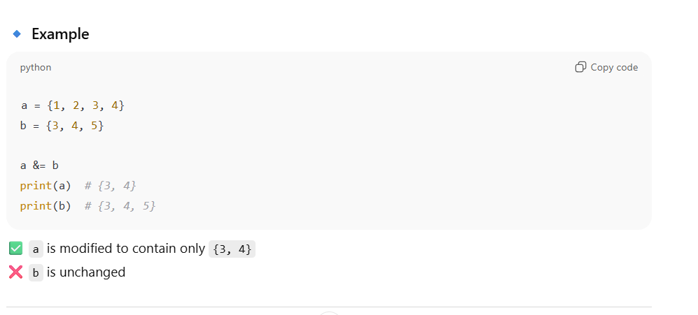
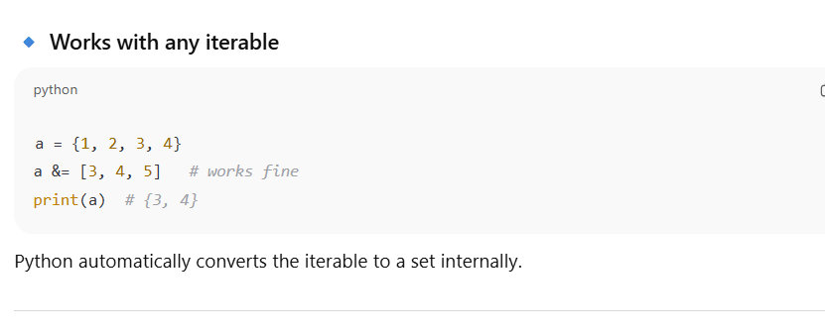

67. Union update
a |= b # modifies a

68. Difference update
a -= b # modifies a

69. Symmetric difference update
a ^= b # modifies a

70. Copy set
s2 = s.copy()

71. Clear set
s.clear() # empty set

72. Trick: multiple sets inside list
lst = [{1,2}]*3
lst[0].add(3)
print(lst) # [{1,2,3},{1,2,3},{1,2,3}]

73. Using set as a key
- Use frozenset, not normal set

74. Set difference vs discard
a = {1,2,3}
b = {2,3}
a - b # {1}, does not modify a

75. Set with mixed immutable types
s = {1, 2.5, "hello", (1,2)}

76. Trick: set comparison operators
a = {1,2}
b = {1,2,3}
a < b # True (proper subset)
a <= b # True (subset)

77. Trick: order of set elements
- Unordered, may print differently each time

78. Convert set to sorted list
sorted({3,1,2}) # [1,2,3]

79. Difference between in for set vs list
- in is O(1) for set, O(n) for list
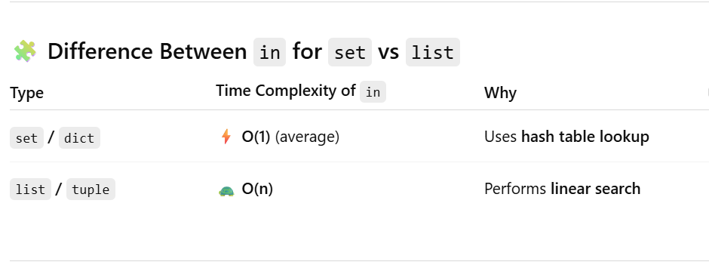

80. Remove duplicates from list keeping order
lst = [1,2,2,3]
seen = set()
res = [x for x in lst if not (x in seen or seen.add(x))]
# [1,2,3]

DICTIONARIES (Q81–Q110)
81. Can dictionary keys be mutable?
- Answer: No, keys must be hashable

82. Dictionary values can be mutable?
- Yes, values can be anything

83. Access missing key: get() vs []
d = {"a":1}
d.get("b") # None
d["b"] # KeyError

84. Iterating keys, values, items
for k in d: print(k)
for v in d.values(): print(v)
for k,v in d.items(): print(k,v)

85. Duplicate keys in dictionary literal
- Last value overwrites
{"a":1,"a":2} # {'a':2}

86. Merging dictionaries
d1 = {"a":1}
d2 = {"b":2}
d1.update(d2) # {'a':1,'b':2}

87. Dictionary comprehension
{x:x*2 for x in range(3)} # {0:0,1:2,2:4}

88. Keys view vs values view vs items view
- d.keys(), d.values(), d.items() return view objects

89. Mutable value shared in fromkeys()
d = dict.fromkeys(['a','b'], [])
d['a'].append(1)
print(d) # {'a':[1],'b':[1]}

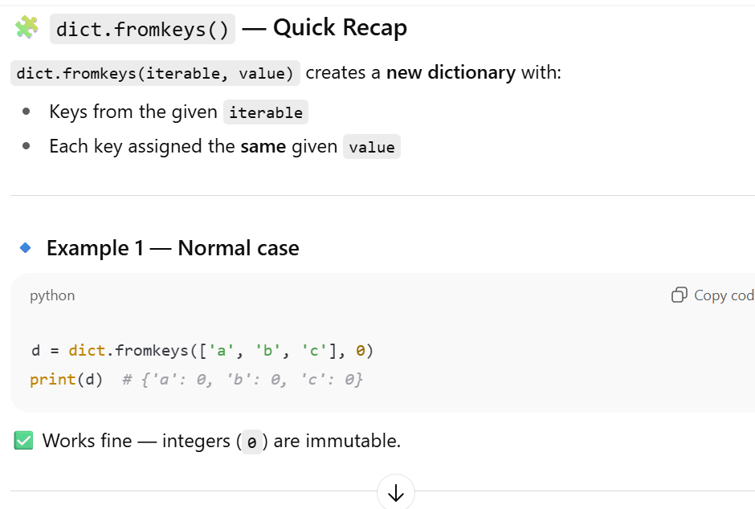

90. Using pop() vs popitem()
d.pop('a') # removes key 'a'
d.popitem() # removes last inserted item

91. Check key existence
'a' in d

92. Dictionary view reflects changes
view = d.items()
d['c'] = 3
list(view) # updated view

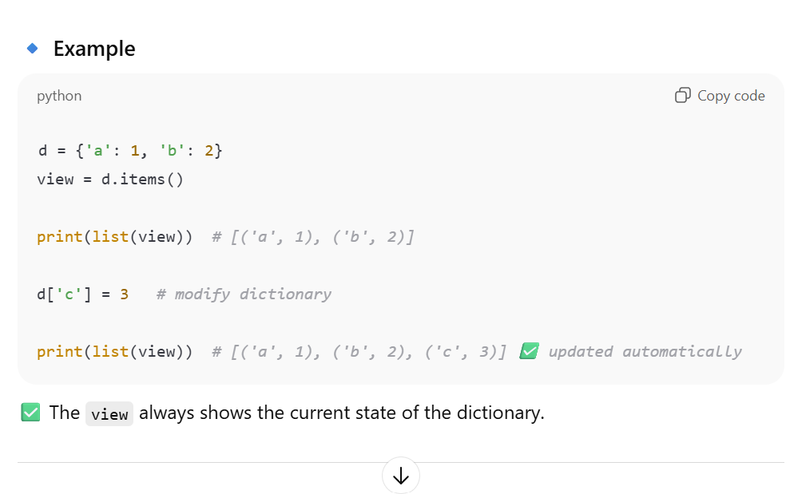

93. Sorting dictionary by key/value
sorted(d.items()) # by key
sorted(d.items(), key=lambda x:x[1]) # by value

94. Nested dictionary access
d = {'a':{'b':2}}
d['a']['b'] # 2

95. Copy dictionary
d2 = d.copy() # shallow copy

96. Deep copy nested dictionary
import copy
d2 = copy.deepcopy(d)

97. setdefault() method
d.setdefault('x', 0) # if 'x' missing, set to 0

98. Trick: dict keys are order-preserved (Python 3.7+)
d = {'b':1,'a':2}
list(d.keys()) # ['b','a']

99. Delete key from dictionary
del d['a']

100. Merging two dictionaries in Python 3.9+
d3 = d1 | d2

#***********************************************

-----------------------------*
Multiple inheritance:
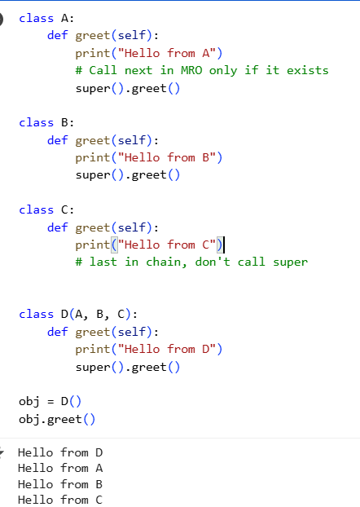

If we pass super().greet() in class C then it wont work:
Problem:
- super().greet() looks for the next class in the MRO that has a greet method.
- MRO for C(A, B) is: C → A → B → object.
- object does not have a greet() method.
- So when B.greet() calls super().greet(), Python tries to call object.greet() → AttributeError, because object has no greet.
✅ This is why your first code fails.

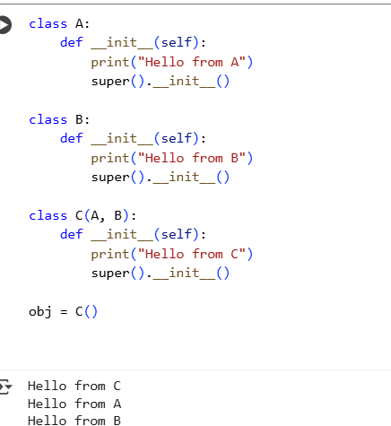

Why it works:
- object.__init__() does exist, and it’s a valid method.
- So when B.__init__() calls super().__init__(), it successfully calls object.__init__(), which does nothing.
- That’s why the chain of super() works here.

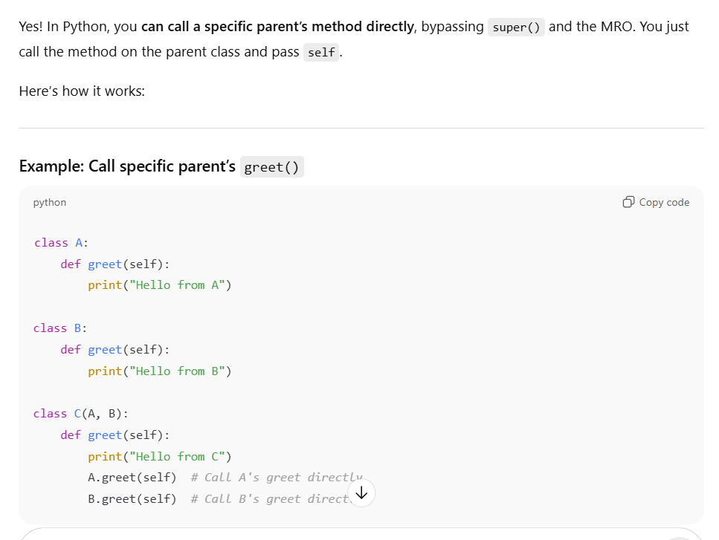

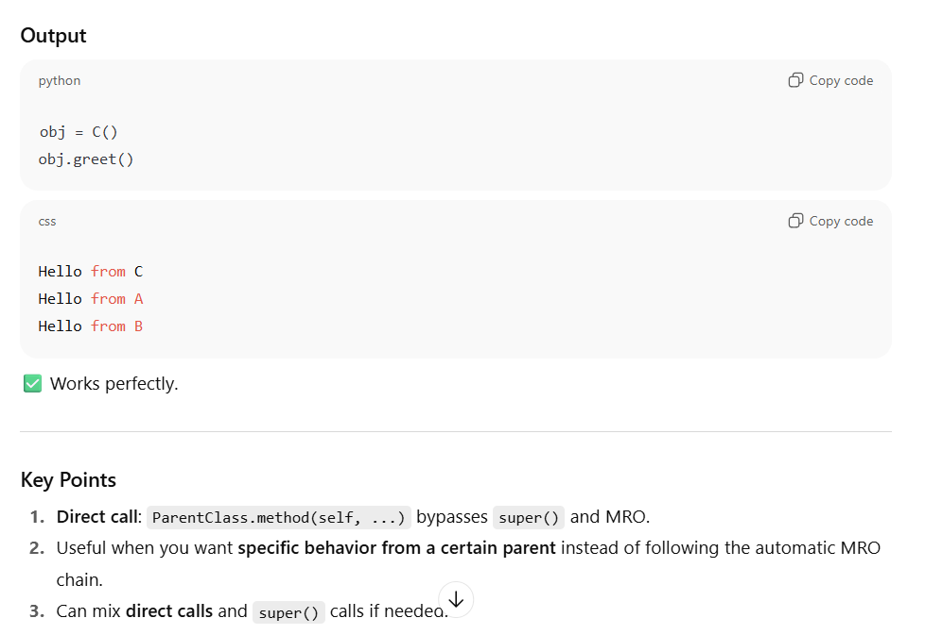
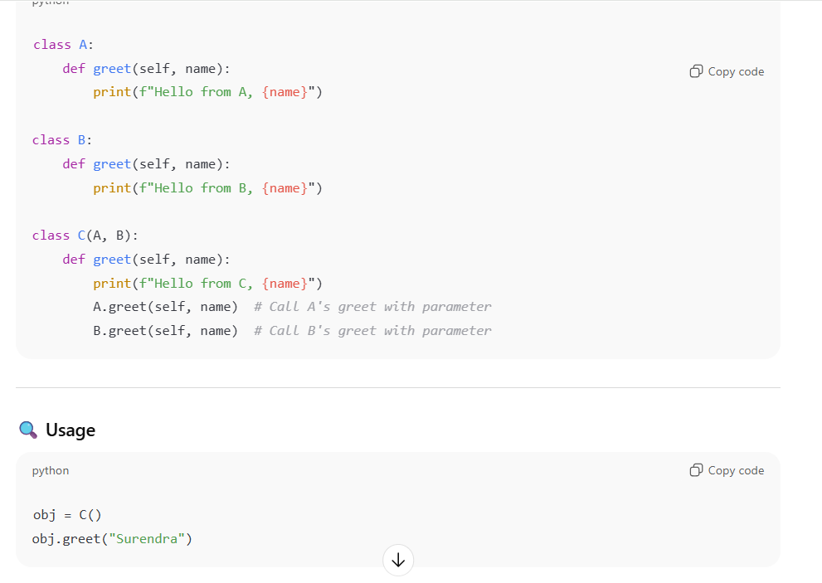
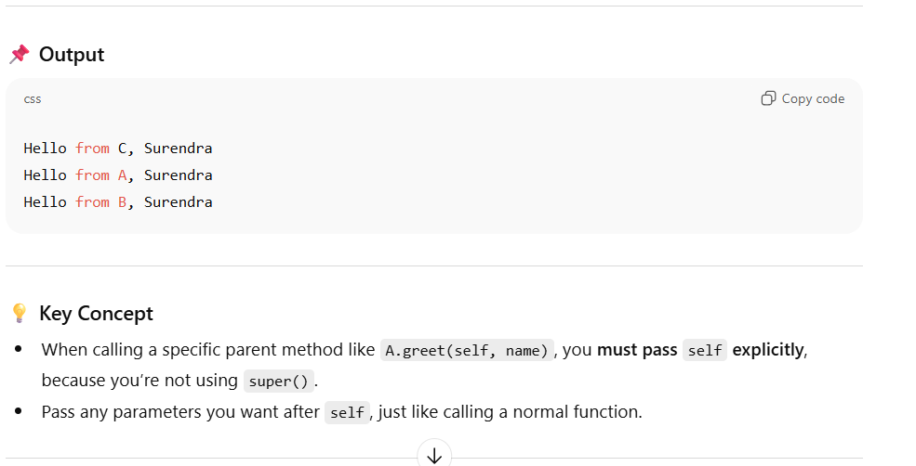

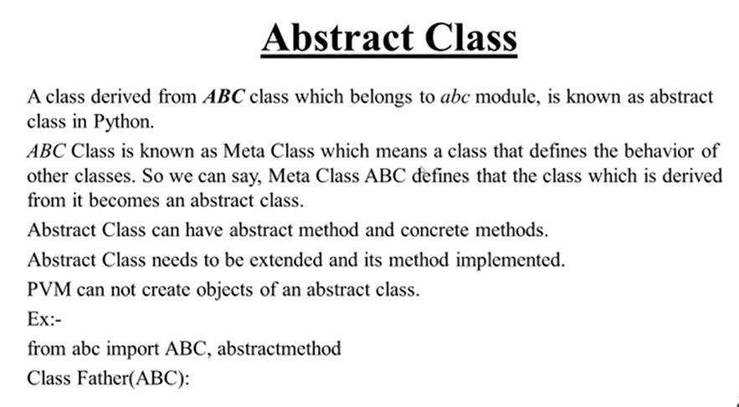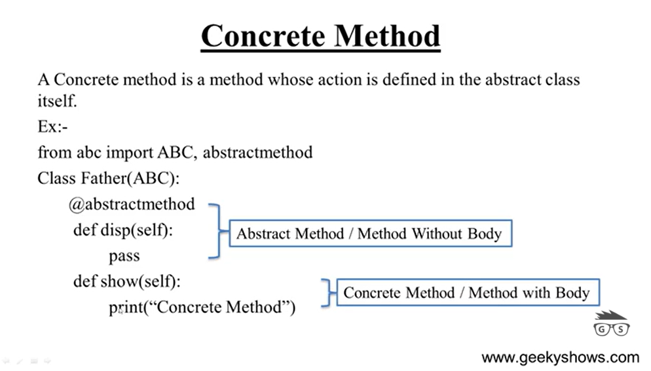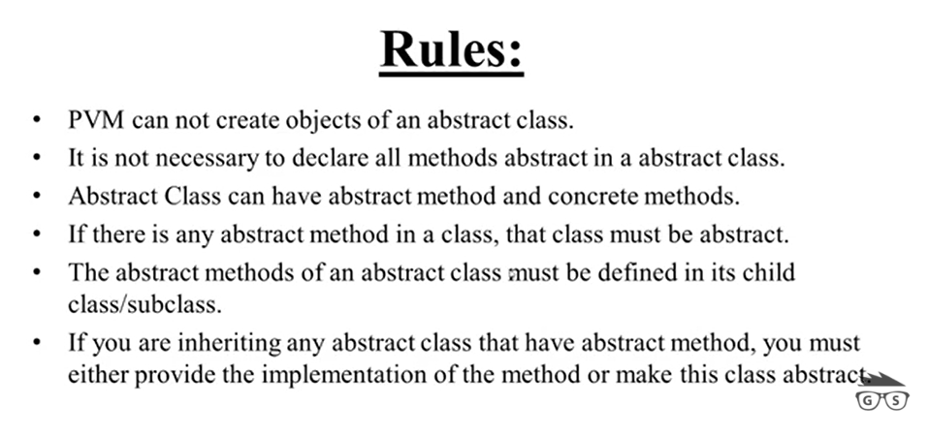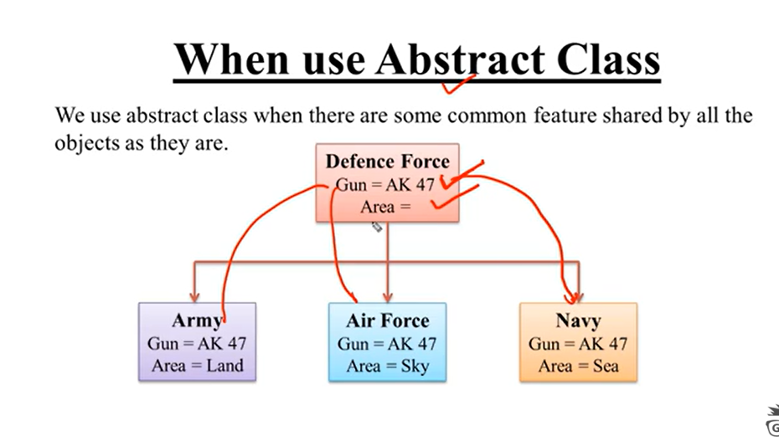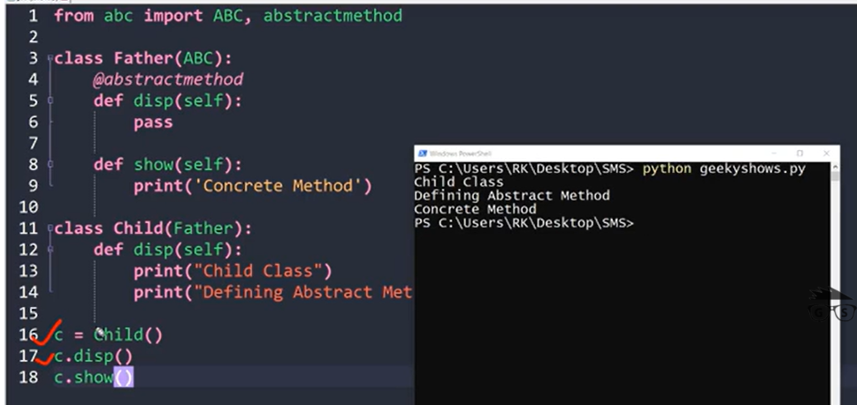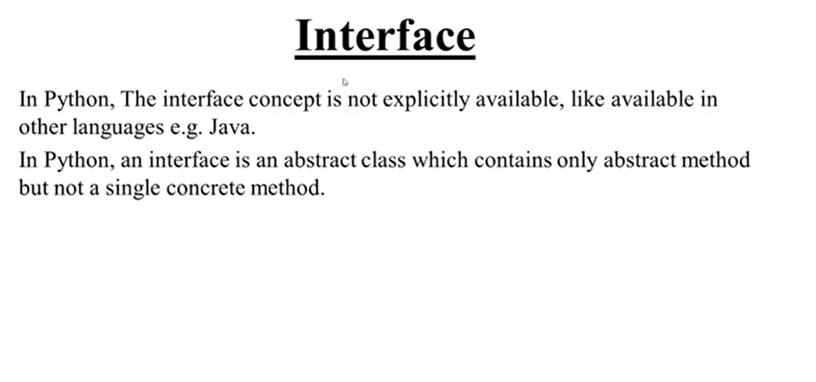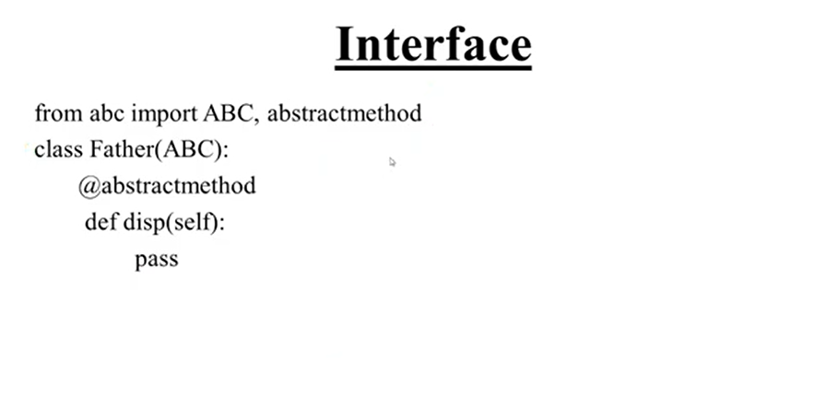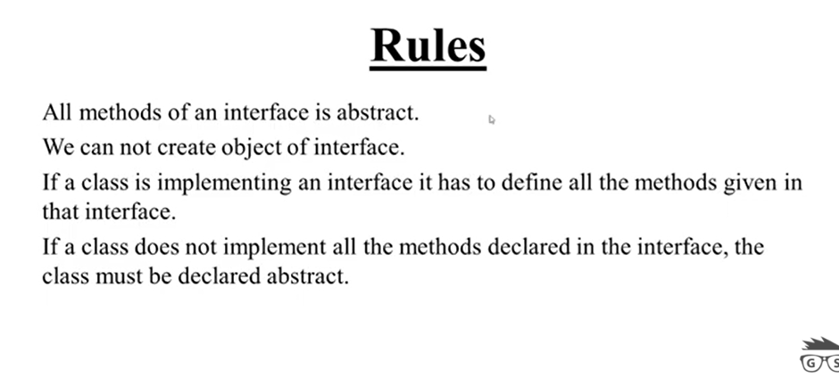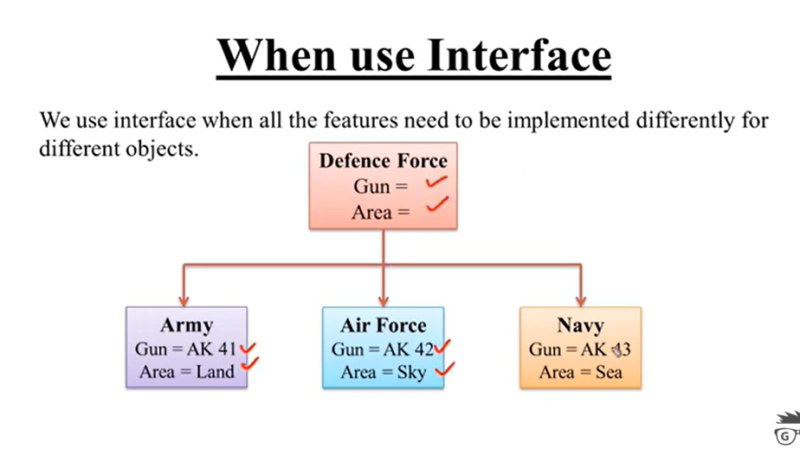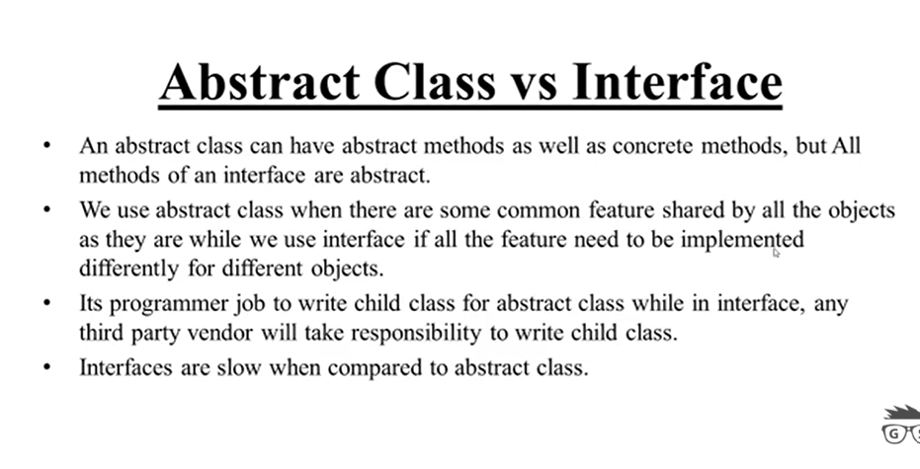

MultiThreading:

