What is a JOIN (absolute beginner)
A JOIN is how SQL combines rows from multiple tables using a related column.
Think in plain English:
- One table has employees
- Another table has departments
- You want: Employee name + department name
The common column (link) is usually an ID.
Example tables:
employees
emp_id | name | dept_id
1 | Rahul | 10
2 | Anjali | 20
3 | Amit | 10
departmentsl
dept_id | dept_name
10 | IT
20 | HR
The relationship:
employees.dept_id = departments.dept_id

INNER JOIN (most important – 80% interview questions)
INNER JOIN returns only matching rows from both tables.
SQL:
SELECT e.emp_id, e.name, d.dept_name
FROM employees e
INNER JOIN departments d
ON e.dept_id = d.dept_id;
Result:
emp_id | name | dept_name
1 | Rahul | IT
3 | Amit | IT
2 | Anjali | HR
Key interview line:
INNER JOIN = intersection (only common data)
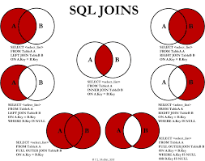
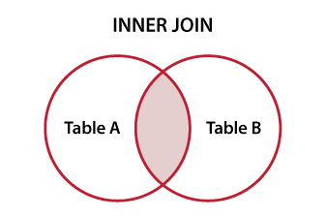

LEFT JOIN (very common interview trap)
LEFT JOIN returns:
- All rows from LEFT table
- Matching rows from RIGHT table
- If no match → NULL
Example: employee without department.
employees
emp_id | name | dept_id
4 | Neha | NULL
SQL:
SELECT e.name, d.dept_name
FROM employees e
LEFT JOIN departments d
ON e.dept_id = d.dept_id;
Result:
name | dept_name
Rahul | IT
Anjali | HR
Amit | IT
Neha | NULL
Key interview line:
LEFT JOIN keeps all records of the left table
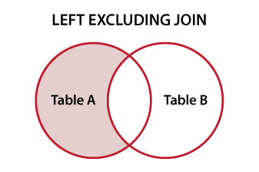


RIGHT JOIN (same logic, opposite direction)
RIGHT JOIN keeps all rows from the right table.
SQL:
SELECT e.name, d.dept_name
FROM employees e
RIGHT JOIN departments d
ON e.dept_id = d.dept_id;
Interview tip:
- Many companies avoid RIGHT JOIN
- You can rewrite using LEFT JOIN by swapping tables

FULL OUTER JOIN (advanced but asked conceptually)
Returns:
- All matching rows
- Plus unmatched rows from both tables
SQL:
SELECT e.name, d.dept_name
FROM employees e
FULL OUTER JOIN departments d
ON e.dept_id = d.dept_id;
Key interview line:
FULL JOIN = union of both tables with NULLs
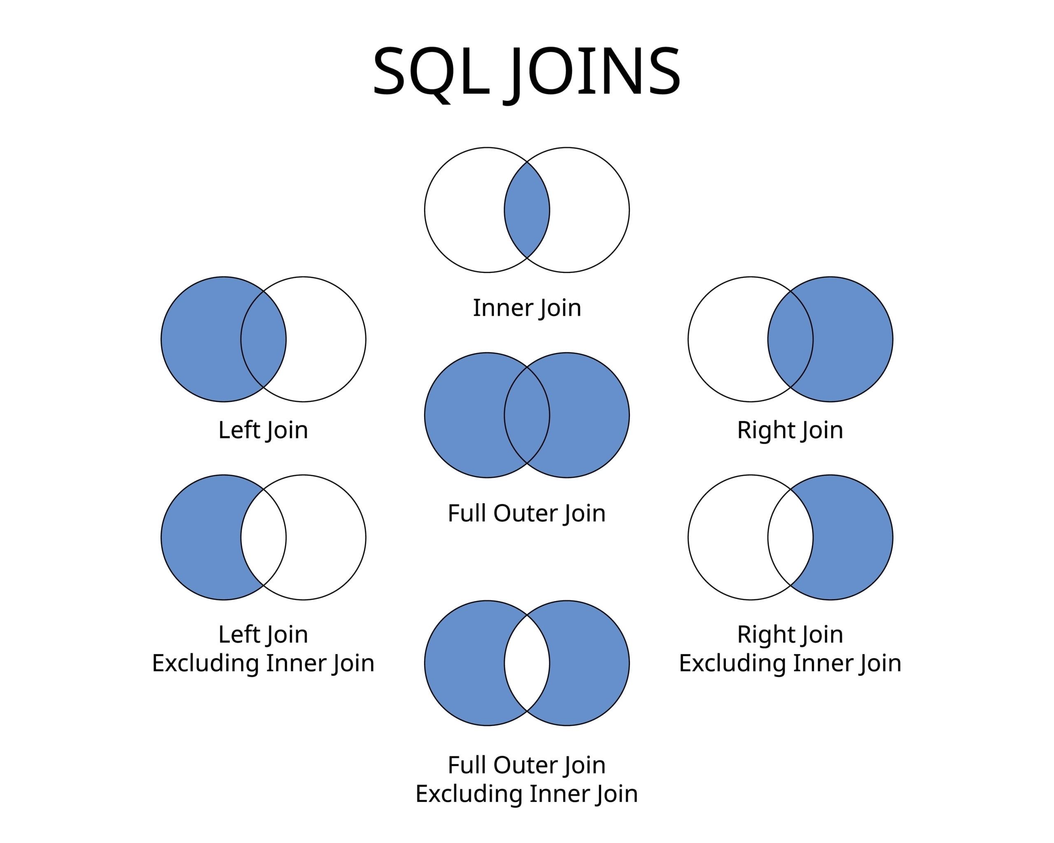
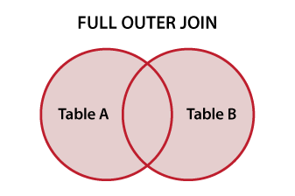

JOIN vs WHERE condition (very important)
Correct:
FROM employees e
JOIN departments d
ON e.dept_id = d.dept_id
Wrong (old style, avoid in interviews):
FROM employees e, departments d
WHERE e.dept_id = d.dept_id
Interview reason:
JOIN syntax is clearer, safer, and avoids accidental cartesian products.

JOIN of THREE TABLES (the one you missed — let’s master it)
Tables:
employees
| emp_id | name | dept_id |
departments
| dept_id | dept_name | location_id |
locations
| location_id | city |
Goal:
Employee name + department + city
Step-by-step logic:
- employees → departments (via dept_id)
- departments → locations (via location_id)
SQL:
SELECT
e.name,
d.dept_name,
l.city
FROM employees e
JOIN departments d
ON e.dept_id = d.dept_id
JOIN locations l
ON d.location_id = l.location_id;
Interview explanation (say this calmly):
We join tables one by one using their foreign key relationships.
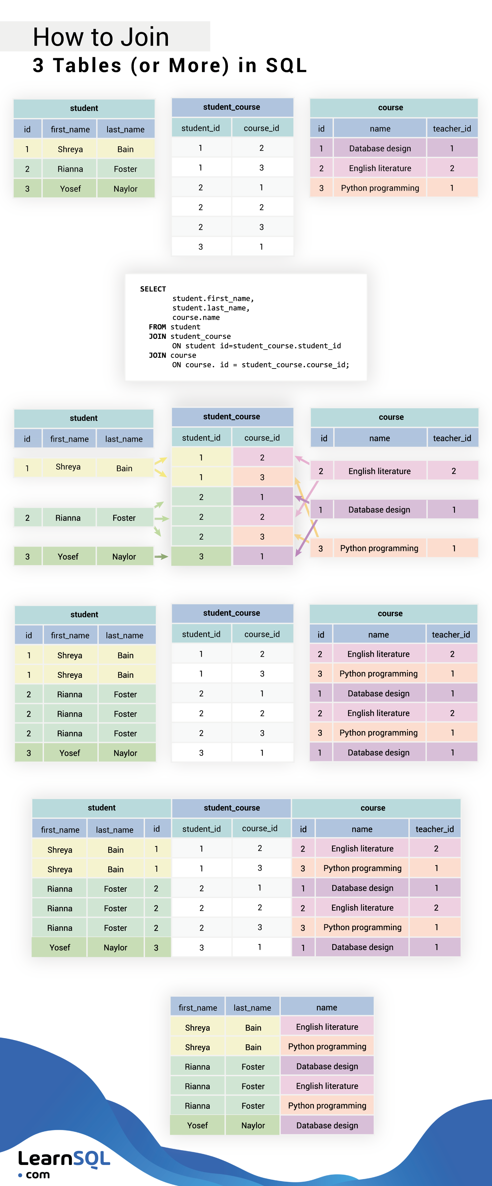
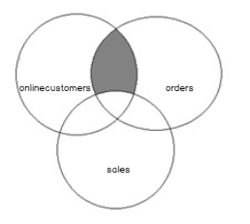

LEFT JOIN with three tables (real-world scenario)
Question:
Show all employees even if department or location is missing.
SQL:
SELECT
e.name,
d.dept_name,
l.city
FROM employees e
LEFT JOIN departments d
ON e.dept_id = d.dept_id
LEFT JOIN locations l
ON d.location_id = l.location_id;
Rule:
Once you use LEFT JOIN, all further joins should usually be LEFT JOIN.

Self JOIN (advanced, interview favorite)
Table:
employees
| emp_id | name | manager_id |
Find employee and manager name.
SQL:
SELECT
e.name AS employee,
m.name AS manager
FROM employees e
LEFT JOIN employees m
ON e.manager_id = m.emp_id;
Key interview line:
Self join uses the same table with different aliases.

JOIN with aggregation (very common)
Question:
Count employees per department.
SQL:
SELECT
d.dept_name,
COUNT(e.emp_id) AS emp_count
FROM departments d
LEFT JOIN employees e
ON d.dept_id = e.dept_id
GROUP BY d.dept_name;
Why LEFT JOIN?
To keep departments with zero employees.

JOIN interview mistakes (please read carefully)
- Forgetting ON condition
→ Causes cartesian product
- Using WHERE instead of ON in LEFT JOIN
Wrong:
LEFT JOIN departments d ON e.dept_id = d.dept_id
WHERE d.dept_name = 'IT'
This turns LEFT JOIN into INNER JOIN.
Correct:
LEFT JOIN departments d
ON e.dept_id = d.dept_id AND d.dept_name = 'IT'
- Not explaining relationship verbally
Always say:
employee.dept_id references department.dept_id

