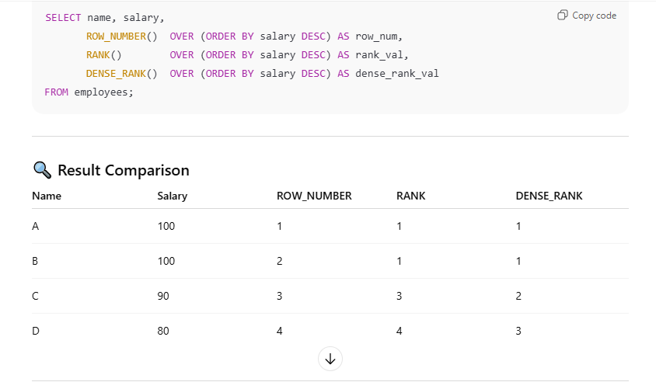

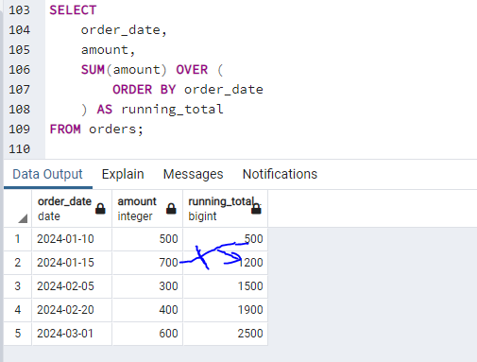

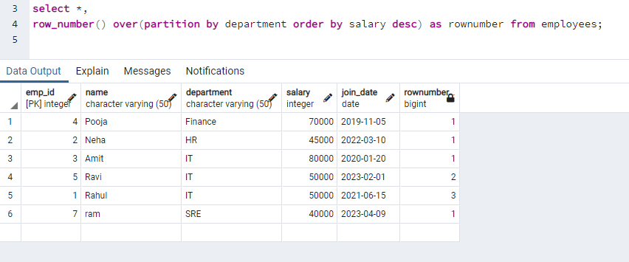

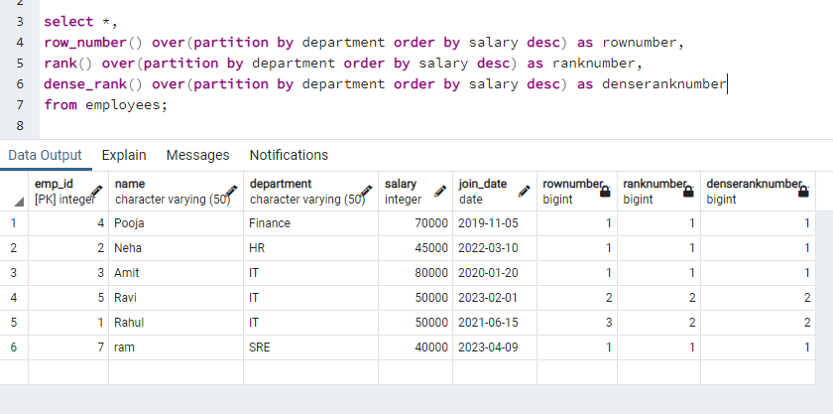

What Are Window Functions in SQL?
Window functions perform calculations across a set of related rows while keeping each row in the result.
They do NOT collapse rows like GROUP BY.

Simple Table Example
employees
-------------------------
emp_id | department | salary

Example data:
emp_id | dept | salary
1 | IT | 100
2 | IT | 90
3 | HR | 80
4 | HR | 70

Aggregate Function (Without Window)

SELECT department, AVG(salary)
FROM employees
GROUP BY department;

Output:
IT | 95
HR | 75

Rows collapsed ❌

Window Function (With OVER)

SELECT
emp_id,
department,
salary,
AVG(salary) OVER (PARTITION BY department) AS dept_avg_salary
FROM employees;

Output:
emp_id | dept | salary | dept_avg_salary
1 | IT | 100 | 95
2 | IT | 90 | 95
3 | HR | 80 | 75
4 | HR | 70 | 75

✔ Rows preserved
✔ Extra calculation added

Why Are They Called “Window” Functions?
Because:
- They work on a window (subset) of rows
- Window is defined using OVER()

Anatomy of a Window Function
function_name(column) OVER (
PARTITION BY ...
ORDER BY ...
)

PARTITION BY
- Splits data into groups
- Like GROUP BY, but does not collapse rows

ORDER BY
- Defines row order inside each partition
- Required for ranking & running totals

Common Window Functions (Must Know)

1. Ranking Functions

ROW_NUMBER()
RANK()
DENSE_RANK()

Used for:
- Top-N queries
- De-duplication
- Salary ranking

2. Aggregate Window Functions

SUM() OVER()
AVG() OVER()
COUNT() OVER()

Used for:
- Running totals
- Moving averages
- % contribution

3. Value Functions

LAG()
LEAD()
FIRST_VALUE()
LAST_VALUE()

Used for:
- Previous vs current comparison
- Trend analysis

Example: Running Total
SELECT
order_date,
amount,
SUM(amount) OVER (ORDER BY order_date) AS running_total
FROM sales;

Key Differences: GROUP BY vs Window Function

Feature | GROUP BY | Window Function
Collapses rows | Yes | No
Uses OVER() | No | Yes
Row-level output | No | Yes
Used for analytics | Limited | Powerful

Interview Answer (Perfect)

Window functions perform calculations over a set of rows related to the current row without collapsing the result set, using the OVER clause.

Memory Trick
GROUP BY reduces rows
WINDOW keeps rows

+++++++++++++++++++++++++++++++++++++++++++++++++++++++++++++++++++++++++++++++++++++++++++++++++++++++++++++++++++++++++++++++++++++++++++++++++++++++++++++++++

Window Functions Overview
Window functions work on a set of rows (window) without collapsing rows like GROUP BY.
General syntax:
function_name(expression)
OVER (
PARTITION BY column_list
ORDER BY column_list
)

Sample Data (Employees)
emp_id | name | dept | salary | join_date
1 | Asha | IT | 60000 | 2020-01-01
2 | Ravi | IT | 65000 | 2021-01-01
3 | Neha | IT | 70000 | 2022-01-01
4 | Amit | HR | 50000 | 2020-02-01
5 | Pooja | HR | 55000 | 2021-02-01

1. LAG() — Previous row value

What it does
Returns a value from a previous row in the same window.

Example: Salary difference from previous employee (per department)
SELECT emp_id, name, dept, salary,
LAG(salary) OVER (
PARTITION BY dept
ORDER BY join_date
) AS prev_salary
FROM employees;

Output (IT department)
name | salary | prev_salary
Asha | 60000 | NULL
Ravi | 65000 | 60000
Neha | 70000 | 65000

Mental model
“Look backward by one row”

Common uses
- Month-over-month growth
- Salary increment
- Trend analysis

2. LEAD() — Next row value

What it does
Returns a value from a next row in the same window.

Example: Next employee’s salary
SELECT emp_id, name, dept, salary,
LEAD(salary) OVER (
PARTITION BY dept
ORDER BY join_date
) AS next_salary
FROM employees;

Output (IT department)
name | salary | next_salary
Asha | 60000 | 65000
Ravi | 65000 | 70000
Neha | 70000 | NULL

Mental model
“Look forward by one row”

3. FIRST_VALUE() — First value in window

What it does
Returns the first value in the window based on ordering.

Example: First joined salary in each department
SELECT emp_id, name, dept, salary,
FIRST_VALUE(salary) OVER (
PARTITION BY dept
ORDER BY join_date
) AS first_salary
FROM employees;

Output (IT)
name | salary | first_salary
Asha | 60000 | 60000
Ravi | 65000 | 60000
Neha | 70000 | 60000

Mental model
“Always show the starting point”

4. LAST_VALUE() — Last value in window ⚠️ TRICKY

What it does
Returns the last value in the current window frame, not entire partition by default

Wrong (default behavior)
SELECT emp_id, name, dept, salary,
LAST_VALUE(salary) OVER (
PARTITION BY dept
ORDER BY join_date
) AS last_salary
FROM employees;

Why wrong?
Default frame is:
RANGE BETWEEN UNBOUNDED PRECEDING AND CURRENT ROW
So result becomes current row’s salary, not last.

Correct usage (important!)
SELECT emp_id, name, dept, salary,
LAST_VALUE(salary) OVER (
PARTITION BY dept
ORDER BY join_date
ROWS BETWEEN UNBOUNDED PRECEDING AND UNBOUNDED FOLLOWING
) AS last_salary
FROM employees;

Output (IT)
name | salary | last_salary
Asha | 60000 | 70000
Ravi | 65000 | 70000
Neha | 70000 | 70000

Mental model
“Show the ending point for everyone”

Summary Table
Function | Direction | Purpose
LAG | Backward | Compare previous row
LEAD | Forward | Compare next row
FIRST_VALUE | Start | First value in window
LAST_VALUE | End | Last value (needs frame fix)

Interview traps
- Forgetting ORDER BY
  - Window functions without ordering are meaningless
- Wrong LAST_VALUE result
  - Must specify full frame
- Using GROUP BY instead
  - Window functions preserve rows

One-line interview explanation
LAG and LEAD compare neighboring rows, while FIRST_VALUE and LAST_VALUE return boundary values of a window without collapsing rows.

++++++++++++++++++++++++++++++++++++++++++++++++++++++++++++++++++++++++++++++++++

Advanced window functions (Amazon favorite)
We’ll do Advanced Window Functions the interview way:
- Short datasets
- Predict output
- Traps + fixes
- How to explain aloud
No fluff. By the end, you’ll think in windows.

GOLDEN RULE (say this in interview)
“Window functions don’t reduce rows.
They calculate values across related rows.”
If you say this confidently — interviewer nods.

LEVEL 1 — ROW_NUMBER vs RANK vs DENSE_RANK (Amazon loves this)

Data
emp | dept | salary
A | IT | 100
B | IT | 100
C | IT | 90
D | HR | 120

ROW_NUMBER
ROW_NUMBER() OVER (PARTITION BY dept ORDER BY salary DESC)

emp | dept | rn
A | IT | 1
B | IT | 2
C | IT | 3
D | HR | 1
No ties respected

IT department rows ordered by salary DESC:
emp | salary
A | 100
B | 100
C | 90
Even though A and B have the same salary, ROW_NUMBER must still number them differently:
emp | rn
A | 1
B | 2
C | 3
It does not care that A and B are tied on salary.
It arbitrarily picks an order and assigns different numbers.

RANK
RANK() OVER (PARTITION BY dept ORDER BY salary DESC)

emp | dept | rank
A | IT | 1
B | IT | 1
C | IT | 3
Gaps exist

DENSE_RANK
DENSE_RANK() OVER (PARTITION BY dept ORDER BY salary DESC)

emp | dept | dr
A | IT | 1
B | IT | 1
C | IT | 2
No gaps
Interview tip
- Top N rows → ROW_NUMBER
- Nth highest → DENSE_RANK

LEVEL 2 — TOP N PER GROUP (MOST ASKED)

Question
Top 2 salaries per department

Correct
SELECT *
FROM (
SELECT *,
ROW_NUMBER() OVER (PARTITION BY dept ORDER BY salary DESC) rn
FROM employees
) t
WHERE rn <= 2;
LIMIT does NOT work per group

LEVEL 3 — LAG / LEAD (Amazon metrics favorite)

Data (daily sales)
date | sales
1 Jan | 100
2 Jan | 130
3 Jan | 90

Day-over-day change
SELECT date,
sales,
sales - LAG(sales) OVER (ORDER BY date) AS diff
FROM sales;

date | diff
1 Jan | NULL
2 Jan | 30
3 Jan | -40

How to explain
“LAG accesses previous row without self-join.”

LEVEL 4 — Running Total (VERY COMMON)
SELECT date,
SUM(sales) OVER (ORDER BY date) AS running_total
FROM sales;
No GROUP BY needed

LEVEL 5 — Moving Average (Amazon dashboards)

3-day moving avg
SELECT date,
AVG(sales) OVER (
ORDER BY date
ROWS BETWEEN 2 PRECEDING AND CURRENT ROW
) AS mov_avg
FROM sales;
Say this:
“ROWS ensures row-based window, not value-based.”

LEVEL 6 — FIRST_VALUE vs LAST_VALUE (TRAP)

WRONG
LAST_VALUE(sales) OVER (PARTITION BY dept ORDER BY date)
Returns current row value

CORRECT
LAST_VALUE(sales) OVER (
PARTITION BY dept
ORDER BY date
ROWS BETWEEN UNBOUNDED PRECEDING AND UNBOUNDED FOLLOWING
)
Frame clause is mandatory

LEVEL 7 — Deduplication (VERY HOT)

Remove duplicates, keep latest record
SELECT *
FROM (
SELECT *,
ROW_NUMBER() OVER (PARTITION BY email ORDER BY updated_at DESC) rn
FROM users
) t
WHERE rn = 1;

LEVEL 8 — Percentiles (Amazon uses this)

Find top 10% customers by spend
SELECT *
FROM (
SELECT *,
NTILE(10) OVER (ORDER BY total_spend DESC) bucket
FROM customers
) t
WHERE bucket = 1;

LEVEL 9 — Cumulative % Contribution (ADVANCED)
SELECT customer_id,
SUM(amount) OVER (ORDER BY amount DESC)
/ SUM(amount) OVER () AS cumulative_pct
FROM orders;
Used in Pareto analysis (80/20)

LEVEL 10 — Interview Killer Question

Question
Find customers whose order amount is greater than their previous order

Query
SELECT *
FROM (
SELECT *,
LAG(amount) OVER (PARTITION BY customer_id ORDER BY order_date) prev_amt
FROM orders
) t
WHERE amount > prev_amt;

HOW TO SPEAK IN INTERVIEW (THIS MATTERS)
Say:
“I use window functions when I need row-level output with aggregated context.”
Do NOT say:
“I used GROUP BY and then…”

FINAL AMAZON RAPID QUESTIONS
Question | Function
Top N per group | ROW_NUMBER
Trend analysis | LAG / LEAD
Deduplication | ROW_NUMBER
Running total | SUM OVER
Percentile | NTILE
Nth highest | DENSE_RANK

++++++++++++++++++++++++++++++++++++++++++++++++++++++++++++++++++++++++++++++=

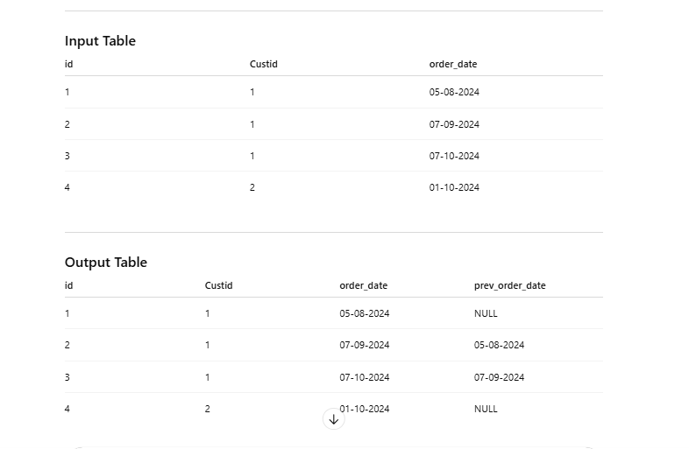
This is a classic window function (LAG) case
You want the previous order date per customer, ordered by date.

SQL Solution (Most Common)
SELECT
id,
Custid,
order_date,
LAG(order_date) OVER (
PARTITION BY Custid
ORDER BY order_date
) AS prev_order_date
FROM orders;

Why this works
- PARTITION BY Custid → resets calculation per customer
- ORDER BY order_date → defines the sequence
- LAG(order_date) → picks previous row’s date
- First row per customer → automatically NULL

PySpark / Databricks Solution
from pyspark.sql import functions as F
from pyspark.sql.window import Window

w = Window.partitionBy("Custid").orderBy("order_date")

df.withColumn(
"prev_order_date",
F.lag("order_date").over(w)
).show()

Input → Output Logic (Simple Explanation)
For each Custid:
- Sort orders by order_date
- Look one row back
- If no previous row → NULL

Important Interview Point
Why not use self join?
Window functions are:
- Faster
- Cleaner
- More readable
- Designed exactly for this use case

Final One-Line Answer
Use LAG(order_date) with PARTITION BY Custid and ORDER BY order_date to get previous order date.
++++++++++++++++++++++++++++++++++++++++++++++++++++++++++++++++++++++++++++++

In sql when to use only order by or only partition by or both ?
This is a very important SQL concept 👍 — once this clicks, window functions become easy.
I’ll explain it intuitively, not textbook-style.

Think of Window Functions like this
PARTITION BY → group boundary
ORDER BY → sequence inside that group
They answer different questions.

1. Use ONLY PARTITION BY
When you need group-level info, but row order does NOT matter.

Example: total orders per customer
SELECT
id,
Custid,
COUNT(*) OVER (PARTITION BY Custid) AS total_orders
FROM orders;

Output idea
Every row of the same Custid shows the same count.
✔ No ordering needed
✔ No concept of previous/next row

Use cases
- Total count per group
- Sum per group
- Max / Min per group (same value on every row)

2. Use ONLY ORDER BY
When you want running / cumulative results across the whole table.

Example: running total of all orders
SELECT
id,
order_date,
SUM(amount) OVER (ORDER BY order_date) AS running_total
FROM orders;

What this means
- No grouping
- One continuous timeline
- Each row builds on previous row

Use cases
- Running totals
- Global ranking
- Time-based cumulative metrics

3. Use BOTH PARTITION BY + ORDER BY (Most Common)
When you want row-by-row comparison inside each group.

Example: previous order date per customer
SELECT
id,
Custid,
order_date,
LAG(order_date) OVER (
PARTITION BY Custid
ORDER BY order_date
) AS prev_order_date
FROM orders;

What happens
- Data is split by Custid
- Inside each customer → ordered by date
- LAG() looks at previous row within that customer

Use cases
- LAG / LEAD
- Row-to-row comparison
- Ranking per group
- Deduplication logic

Very Important Rule (Interview Favorite)
Can LAG work without ORDER BY?
No — previous/next has no meaning without order
Can SUM work without ORDER BY?
Yes — because it’s just aggregation

Quick Decision Table
Requirement | PARTITION BY | ORDER BY
Group totals | ✅ | ❌
Running total (global) | ❌ | ✅
Previous / Next row | ✅ | ✅
Rank per group | ✅ | ✅
Overall rank | ❌ | ✅

One-Line Memory Trick
PARTITION BY = WHO
ORDER BY = WHEN

