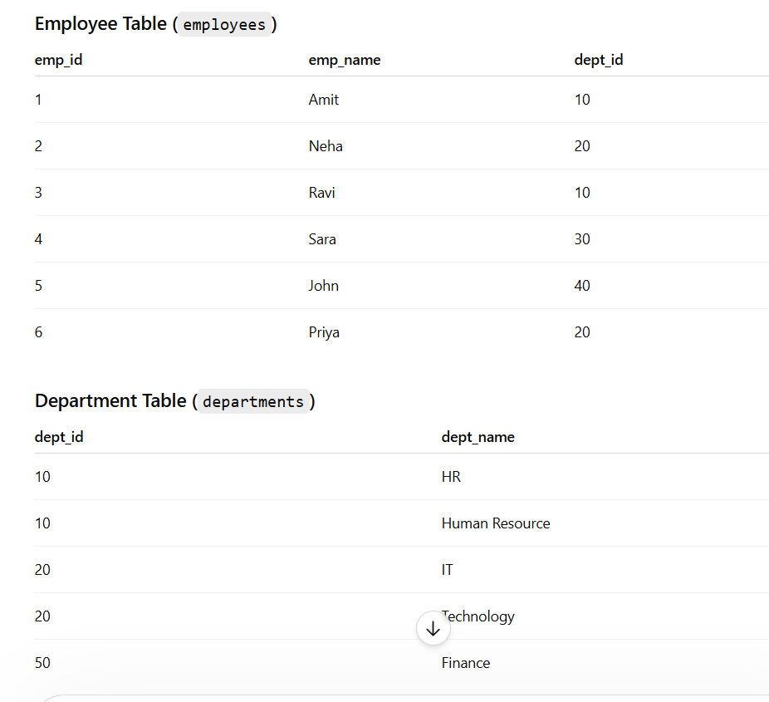
Notice:
- dept_id = 10 and 20 have duplicate rows in departments
- dept_id = 30 and 40 exist only in employees
- dept_id = 50 exists only in departments
1. INNER JOIN
Returns only matching rows.
SELECT
e.emp_id,
e.emp_name,
e.dept_id AS emp_dept_id,
d.dept_id AS dept_dept_id,
d.dept_name
FROM employees e
INNER JOIN departments d
ON e.dept_id = d.dept_id;
Output
emp_id | emp_name | emp_dept_id | dept_dept_id | dept_name
1 | Amit | 10 | 10 | HR
1 | Amit | 10 | 10 | Human Resource
3 | Ravi | 10 | 10 | HR
3 | Ravi | 10 | 10 | Human Resource
2 | Neha | 20 | 20 | IT
2 | Neha | 20 | 20 | Technology
6 | Priya | 20 | 20 | IT
6 | Priya | 20 | 20 | Technology
Important
Duplicate keys create multiple combinations.
Formula:
rows_from_left × rows_from_right
Example:
- dept_id 10 → 2 employee rows × 2 department rows = 4 rows

2. LEFT JOIN
Returns all rows from left table + matched rows from right.
SELECT
e.emp_id,
e.emp_name,
e.dept_id AS emp_dept_id,
d.dept_id AS dept_dept_id,
d.dept_name
FROM employees e
LEFT JOIN departments d
ON e.dept_id = d.dept_id;
Output
emp_id | emp_name | emp_dept_id | dept_dept_id | dept_name
1 | Amit | 10 | 10 | HR
1 | Amit | 10 | 10 | Human Resource
3 | Ravi | 10 | 10 | HR
3 | Ravi | 10 | 10 | Human Resource
2 | Neha | 20 | 20 | IT
2 | Neha | 20 | 20 | Technology
6 | Priya | 20 | 20 | IT
6 | Priya | 20 | 20 | Technology
4 | Sara | 30 | NULL | NULL
5 | John | 40 | NULL | NULL

3. RIGHT JOIN
Returns all rows from right table + matched rows from left.
SELECT
e.emp_id,
e.emp_name,
e.dept_id AS emp_dept_id,
d.dept_id AS dept_dept_id,
d.dept_name
FROM employees e
RIGHT JOIN departments d
ON e.dept_id = d.dept_id;
Output
emp_id | emp_name | emp_dept_id | dept_dept_id | dept_name
1 | Amit | 10 | 10 | HR
3 | Ravi | 10 | 10 | HR
1 | Amit | 10 | 10 | Human Resource
3 | Ravi | 10 | 10 | Human Resource
2 | Neha | 20 | 20 | IT
6 | Priya | 20 | 20 | IT
2 | Neha | 20 | 20 | Technology
6 | Priya | 20 | 20 | Technology
NULL | NULL | NULL | 50 | Finance

4. FULL OUTER JOIN
Returns:
- matching rows
- unmatched rows from left
- unmatched rows from right
SELECT
e.emp_id,
e.emp_name,
e.dept_id AS emp_dept_id,
d.dept_id AS dept_dept_id,
d.dept_name
FROM employees e
FULL OUTER JOIN departments d
ON e.dept_id = d.dept_id;
Output
emp_id | emp_name | emp_dept_id | dept_dept_id | dept_name
1 | Amit | 10 | 10 | HR
1 | Amit | 10 | 10 | Human Resource
3 | Ravi | 10 | 10 | HR
3 | Ravi | 10 | 10 | Human Resource
2 | Neha | 20 | 20 | IT
2 | Neha | 20 | 20 | Technology
6 | Priya | 20 | 20 | IT
6 | Priya | 20 | 20 | Technology
4 | Sara | 30 | NULL | NULL
5 | John | 40 | NULL | NULL
NULL | NULL | NULL | 50 | Finance

5. CROSS JOIN
Creates Cartesian Product.
SELECT
e.emp_id,
e.emp_name,
e.dept_id AS emp_dept_id,
d.dept_id AS dept_dept_id,
d.dept_name
FROM employees e
CROSS JOIN departments d;
Total Rows
6 employees × 5 departments = 30 rows
Example rows:
emp_id | emp_name | emp_dept_id | dept_dept_id | dept_name
1 | Amit | 10 | 10 | HR
1 | Amit | 10 | 10 | Human Resource
1 | Amit | 10 | 20 | IT
1 | Amit | 10 | 20 | Technology
1 | Amit | 10 | 50 | Finance

6. SELF JOIN
Joining same table with itself.
Example:
Find employees in same department.
SELECT
e1.emp_name AS employee1,
e1.dept_id AS emp1_dept_id,
e2.emp_name AS employee2,
e2.dept_id AS emp2_dept_id
FROM employees e1
JOIN employees e2
ON e1.dept_id = e2.dept_id
AND e1.emp_id <> e2.emp_id;
Output
employee1 | emp1_dept_id | employee2 | emp2_dept_id
Amit | 10 | Ravi | 10
Ravi | 10 | Amit | 10
Neha | 20 | Priya | 20
Priya | 20 | Neha | 20

7. LEFT SEMI JOIN
Returns only matching rows from LEFT table.
Cannot return right table columns.
Supported in:
- Spark SQL
- Hive
SELECT *
FROM employees e
LEFT SEMI JOIN departments d
ON e.dept_id = d.dept_id;
Output
emp_id | emp_name | dept_id
1 | Amit | 10
2 | Neha | 20
3 | Ravi | 10
6 | Priya | 20
Important
Even if duplicates exist in right table,
LEFT SEMI JOIN does NOT duplicate left rows.
so, left semi join will take the first match from right table, even though it is sorted or not
No.
LEFT SEMI JOIN does not “take first match” from the right table.
It only checks:
Does at least one matching row exist in right table?
If yes:
- return the left row once
If no:
- do not return the left row

8. LEFT ANTI JOIN
Returns non-matching rows from LEFT table.
SELECT *
FROM employees e
LEFT ANTI JOIN departments d
ON e.dept_id = d.dept_id;
Output
emp_id | emp_name | dept_id
4 | Sara | 30
5 | John | 40

Duplicate Key Join Visualization
For dept_id = 10
Employees
emp_id | emp_name | dept_id
1 | Amit | 10
3 | Ravi | 10
Departments
dept_id | dept_name
10 | HR
10 | Human Resource
Join Result
emp_name | dept_name
Amit | HR
Amit | Human Resource
Ravi | HR
Ravi | Human Resource
This is called:
Many-to-Many Join Explosion

