COALESCE is small but powerful, and interviewers love checking whether you really understand it or just copy-paste it.
Let’s break your exact query line by line and then generalize the concept.

1 What COALESCE actually means (in plain English)
COALESCE(value1, value2, value3, ...)
👉 Return the first value that is NOT NULL
That’s it. No magic.
Examples:
COALESCE(NULL, 10) → 10
COALESCE(NULL, NULL, 5) → 5
COALESCE(7, 0) → 7
COALESCE(NULL, NULL) → NULL

COALESCE can take any number of parameters (2 or more).
There is no fixed upper limit defined by SQL standard — practically, it’s limited only by the database engine and query length.

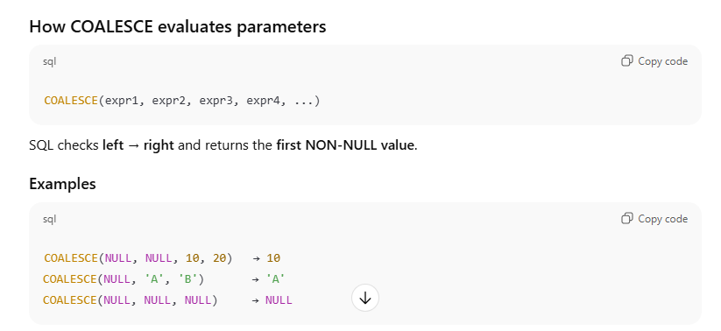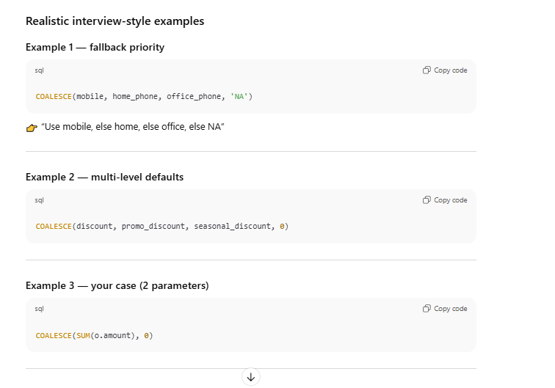

2 Why COALESCE is needed in YOUR query

Your query
SELECT c.customer_id,
c.name,
COALESCE(SUM(o.amount), 0) AS total_amount
FROM customers c
LEFT JOIN orders o
ON c.customer_id = o.customer_id
GROUP BY c.customer_id, c.name;
Let’s execute this step by step.

3 Step 1 — LEFT JOIN result (before aggregation)
LEFT JOIN guarantees every customer appears.
customer_id | name | amount
1 | Rahul | 500
1 | Rahul | 700
2 | Asha | NULL
3 | Neha | 300
4 | Amit | NULL

4 Step 2 — SUM(o.amount) per customer
Remember:
- SUM() ignores NULL
- If all values are NULL, result is NULL
name | SUM(o.amount)
Rahul | 1200
Neha | 300
Asha | NULL
Amit | NULL
So SQL says:
“I don’t know the total because there are no numbers.”

5 Step 3 — What COALESCE does here
COALESCE(SUM(o.amount), 0)
This reads as:
“If SUM(o.amount) is NOT NULL → use it
else → return 0”

Row-by-row evaluation
name | SUM(o.amount) | COALESCE
Rahul | 1200 | 1200
Neha | 300 | 300
Asha | NULL | 0
Amit | NULL | 0
🎯 That’s why customers with no orders show 0 instead of NULL.

6 Why COALESCE is better than other options

Wrong approach
SUM(CASE WHEN o.amount IS NOT NULL THEN o.amount ELSE 0 END)
Works, but:
- More complex
- Less readable
- Harder to explain in interviews

Preferred
COALESCE(SUM(o.amount), 0)
Simple. Clear. Intent is obvious.

7 Important subtle point (INTERVIEW FAVORITE)
❗ COALESCE is applied AFTER aggregation
Not before.
Meaning:
- SUM() runs first
- Result may be NULL
- COALESCE fixes the final value

8 COALESCE vs ISNULL (if asked)
COALESCE | ISNULL
ANSI standard | Database-specific
Multiple arguments | Only 2
Portable | Not portable
👉 Prefer COALESCE in interviews.

9 One-sentence interview answer (MEMORIZE)
“COALESCE returns the first non-NULL value. In this query, it converts NULL sums caused by missing orders into 0 for reporting.”
That’s a strong, confident explanation.

10 Mental model to remember 🧠
LEFT JOIN creates NULLs
SUM ignores NULLs
COALESCE replaces NULLs with business-friendly values

