100 LOGICAL SQL QUESTIONS & ANSWERS
(Execution order, GROUP BY, HAVING, JOIN, aggregates, NULLs)

SECTION 1: AGGREGATES & GROUP BY (Q1–Q25)

Q1. Is GROUP BY mandatory when using aggregate functions?
Answer:
No. GROUP BY is required only when non-aggregated columns appear in SELECT.
If you aggregate the entire table (e.g., COUNT(*)), SQL treats the whole table as one implicit group.

Q2. Why does this query fail?
SELECT department, COUNT(*) FROM employees;
Answer:
Because department has multiple values. SQL doesn’t know which department to show for the single COUNT result. GROUP BY is required.

Q3. Why does GROUP BY reduce rows?
Answer:
GROUP BY collapses multiple rows into one row per unique group key.

Q4. Does GROUP BY sort the data?
Answer:
No. GROUP BY only groups data. ORDER BY is required for sorting.

Q5. Does column order in GROUP BY matter?
Answer:
No. GROUP BY uses the combination of columns, not their order.

Q6. Why does GROUP BY require all selected columns?
Answer:
To avoid ambiguity. Each selected column must have one value per group.

Q7. Can GROUP BY work without aggregate functions?
Answer:
Yes. It behaves like DISTINCT.

Q8. Why does GROUP BY create a separate group for NULL?
Answer:
SQL treats NULL as a valid grouping value.

Q9. Why does GROUP BY on timestamp create too many rows?
Answer:
Because timestamps differ by seconds/milliseconds. Grouping is too granular.

Q10. Why does GROUP BY on floating numbers cause unexpected groups?
Answer:
Floating-point precision differences create distinct values.

Q11. Why is COUNT(*) preferred over COUNT(column)?
Answer:
COUNT(column) ignores NULLs and can silently give wrong counts.

Q12. Why does AVG ignore NULL values?
Answer:
NULL represents unknown, not zero. Including it would distort the average.

Q13. Why does SUM return NULL sometimes?
Answer:
If all values in the group are NULL, SUM returns NULL.

Q14. Why does GROUP BY with CASE work?
Answer:
CASE produces a deterministic value per row, which can be grouped.

Q15. Why does GROUP BY + JOIN sometimes inflate totals?
Answer:
Because JOIN duplicates rows before aggregation.

Q16. Why should aggregation often be done before JOIN?
Answer:
To avoid row multiplication and incorrect totals.

Q17. Why does GROUP BY on large tables slow queries?
Answer:
It requires scanning and grouping all rows, often using sorting or hashing.

Q18. Why is COUNT(DISTINCT) expensive?
Answer:
Because SQL must deduplicate values per group.

Q19. Can GROUP BY use expressions?
Answer:
Yes. SQL evaluates the expression per row, then groups by the result.

Q20. Why does GROUP BY fail with ambiguous columns?
Answer:
Because SQL cannot determine a single value per group.

GROUP BY fails with an ambiguous column error when SQL finds the same column name in multiple tables and cannot determine which one you mean.
Example:
SELECT dept_id, COUNT(*)
FROM employees e
JOIN departments d
ON e.dept_id = d.dept_id
GROUP BY dept_id
Problem:
Both tables may contain dept_id.
So SQL gets confused:
- e.dept_id ?
- or d.dept_id ?
This is called an ambiguous column.
Fix:
Specify the table alias explicitly.
SELECT e.dept_id, COUNT(*)
FROM employees e
JOIN departments d
ON e.dept_id = d.dept_id
GROUP BY e.dept_id
Now SQL clearly knows which column to group by.
Another example:
SELECT id, name
FROM table1 t1
JOIN table2 t2
ON t1.id = t2.id
GROUP BY id
If both tables contain id, SQL throws:
Column 'id' is ambiguous
because id exists in both tables.
Rule:
Whenever joined tables have same column names, always use:
table_alias.column_name
especially in:
- SELECT
- GROUP BY
- ORDER BY
- WHERE
- HAVING
This is a very common SQL interview concept.

Q21. Why does PostgreSQL allow grouping by primary key only?
Answer:
Because of functional dependency—other columns are uniquely determined.

Q22. Why is GROUP BY considered an aggregation boundary?
Answer:
Because row-level data is lost after grouping.
GROUP BY is called an aggregation boundary because it divides rows into groups, and after that boundary, SQL only allows:
- Grouped columns
- Aggregate results
Think of it as:
“Row-level data ends here. Group-level data starts here.”
Example:
Table:
dept | emp | salary
IT | A | 100
IT | B | 200
HR | C | 150
Query:
SELECT dept, SUM(salary)
FROM employees
GROUP BY dept
What happens internally:
Before GROUP BY:
IT A 100
IT B 200
HR C 150
After GROUP BY:
IT group -> [100, 200]
HR group -> [150]
Now SQL no longer works on individual rows.
It works on groups.
So:
SELECT dept, emp, SUM(salary)
FROM employees
GROUP BY dept
fails because emp is row-level data and does not exist uniquely after grouping.
For IT group:
A ?
B ?
Which employee should SQL return?
That is why aggregation boundary exists.
After GROUP BY, every selected column must be:
- Included in GROUP BY
OR
- Aggregated using:
  - SUM()
  - COUNT()
  - AVG()
  - MAX()
  - etc.
Valid:
SELECT dept, COUNT(*)
FROM employees
GROUP BY dept
Invalid:
SELECT dept, emp
FROM employees
GROUP BY dept
because emp crosses the aggregation boundary without aggregation.
Simple interview definition:
GROUP BY creates a boundary where row-level data is transformed into grouped/aggregated data, so only grouped columns or aggregate functions are allowed afterward.

+++++++++++++++++++++++++++++++++++++++++++++++++++++++++
“Boundary” here means a dividing line or transition point.
In GROUP BY, the boundary separates:
- Row-level data
from
- Group-level (aggregated) data
Example:
Before GROUP BY:
dept | emp | salary
IT | A | 100
IT | B | 200
These are individual rows.
After:
GROUP BY dept
SQL treats rows as groups:
IT -> [100, 200]
Now the query is working on the whole group, not individual rows.
So “aggregation boundary” means:
The point where SQL stops thinking in terms of individual rows and starts thinking in terms of grouped data.
That is why columns like emp become invalid unless:
- added in GROUP BY
or
- aggregated.
So boundary ≠ set of groups.
Boundary = transition point between:
- detailed rows
and
- aggregated groups.

Q23. Why does GROUP BY after LEFT JOIN change results?
Answer:
LEFT JOIN introduces NULLs that affect grouping and aggregates.

Q24. Why does GROUP BY + LIMIT without ORDER BY give random rows?
Answer:
SQL tables are unordered.

Q25. Why does GROUP BY sometimes hide data issues?
Answer:
Duplicates collapse silently into groups.
GROUP BY can hide data issues because it combines multiple rows into summarized results, making duplicates or bad data less visible.
Example table:
emp_id | dept | salary
1 | IT | 100
1 | IT | 100
2 | HR | 200
Notice:
- Employee 1 appears twice accidentally (duplicate data issue)
Now query:
SELECT dept, SUM(salary)
FROM employees
GROUP BY dept
Result:
dept | total_salary
IT | 200
HR | 200
At first glance, result looks fine.
But actually:
- IT total became incorrect because duplicate row was hidden inside aggregation.
Without GROUP BY:
SELECT *
FROM employees
you would clearly notice duplicate rows.
Another example:
Suppose customer table accidentally contains duplicate customers:
customer_id | city
101 | Delhi
101 | Delhi
Query:
SELECT city, COUNT(*)
FROM customers
GROUP BY city
Result:
city | count
Delhi | 2
You may think:
- “Oh, 2 customers from Delhi”
But actually it might be:
- same customer duplicated twice.
Why interviewers ask this:
Because aggregation can:
- mask duplicates
- hide null problems
- hide incorrect joins
- hide data quality issues
Common hidden issues:
- Duplicate rows
- Bad joins creating extra rows
- Incorrect primary keys
- Unexpected nulls
- Double-counting
Simple definition:
GROUP BY summarizes data, so underlying row-level problems can become hidden inside aggregate results.

🟡 SECTION 2: WHERE vs HAVING (Q26–Q50)

Q26. Why can’t WHERE use aggregate functions?
Answer:
WHERE executes before GROUP BY, so aggregates don’t exist yet.

Q27. Why can HAVING use aggregate functions?
Answer:
HAVING executes after GROUP BY, when aggregates are available.

Q28. Why does this fail?
HAVING salary > 50000;
Answer:
Salary is row-level data. HAVING works on groups, not rows.

Q29. Can HAVING be used without GROUP BY?
Answer:
Yes. The entire table becomes one implicit group.

Yes, HAVING can be used without GROUP BY.
In that case, SQL treats the entire table as one single group.
Example:
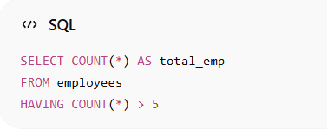
What happens:
- No GROUP BY
- Whole table becomes one group
- HAVING filters that aggregated result
If employee count > 5:
- result is shown
Otherwise:
- no rows returned
Another example:
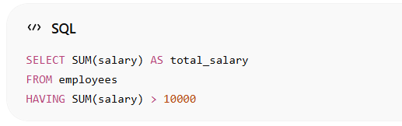
This is valid.
But this is invalid:
SELECT emp_name
FROM employees
HAVING salary > 100
because HAVING is meant for aggregate/group conditions.
Use cases:
- Filtering aggregate results without creating explicit groups
- Checking table-level aggregates
Difference:
Clause | Works On
WHERE | Individual rows
HAVING | Groups / aggregate results
Interview definition:
Yes, HAVING can be used without GROUP BY. In that case, SQL considers the entire result set as a single group.

Q30. Why is WHERE faster than HAVING?
Answer:
WHERE filters rows early, reducing data volume before grouping.

Q31. Why does filtering in HAVING give wrong averages?
Answer:
Because unwanted rows were already included in aggregation.

Q32. Why should row conditions always go in WHERE?
Answer:
To maintain correctness and performance.

Q33. Can HAVING reference grouped columns?
Answer:
Yes. Grouped columns have exactly one value per group.

Q34. Why does HAVING reject non-grouped columns?
Answer:
Because SQL cannot determine which row’s value to use.

Q35. Why does HAVING COUNT(*) > 0 usually do nothing?
Answer:
Every group has at least one row.

Q36. Why does HAVING COUNT(column) behave differently?
Answer:
It ignores NULLs, affecting group inclusion.

Q37. Why does WHERE affect GROUP BY result size?
Answer:
Because WHERE filters rows before grouping.

Q38. Why does HAVING affect result rows but not grouping?
Answer:
HAVING filters groups, not rows inside groups.

Q39. Why is using HAVING instead of WHERE a bug?
Answer:
It changes execution timing and can skew aggregates.

Q40. Why does HAVING hide performance problems?
Answer:
Because heavy aggregation already happened.

Q41. Can HAVING contain subqueries?
Answer:
Yes, if they return scalar or aggregate values.
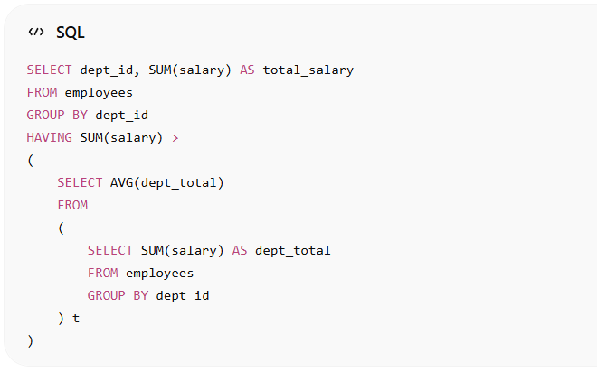
Meaning:
- First calculate total salary per department
- Then keep only departments whose total salary is greater than the average department salary
So subquery is used inside HAVING.

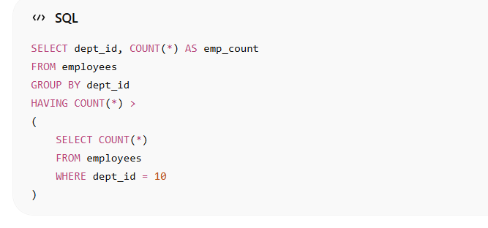
This compares:
- employee count of each department
with
- employee count of department 10

Q42. Why does HAVING without GROUP BY feel odd?
Answer:
Because it filters only one implicit group.

Q43. Why does HAVING AVG(salary) > 0 include NULL salaries?
Answer:
AVG ignores NULLs.

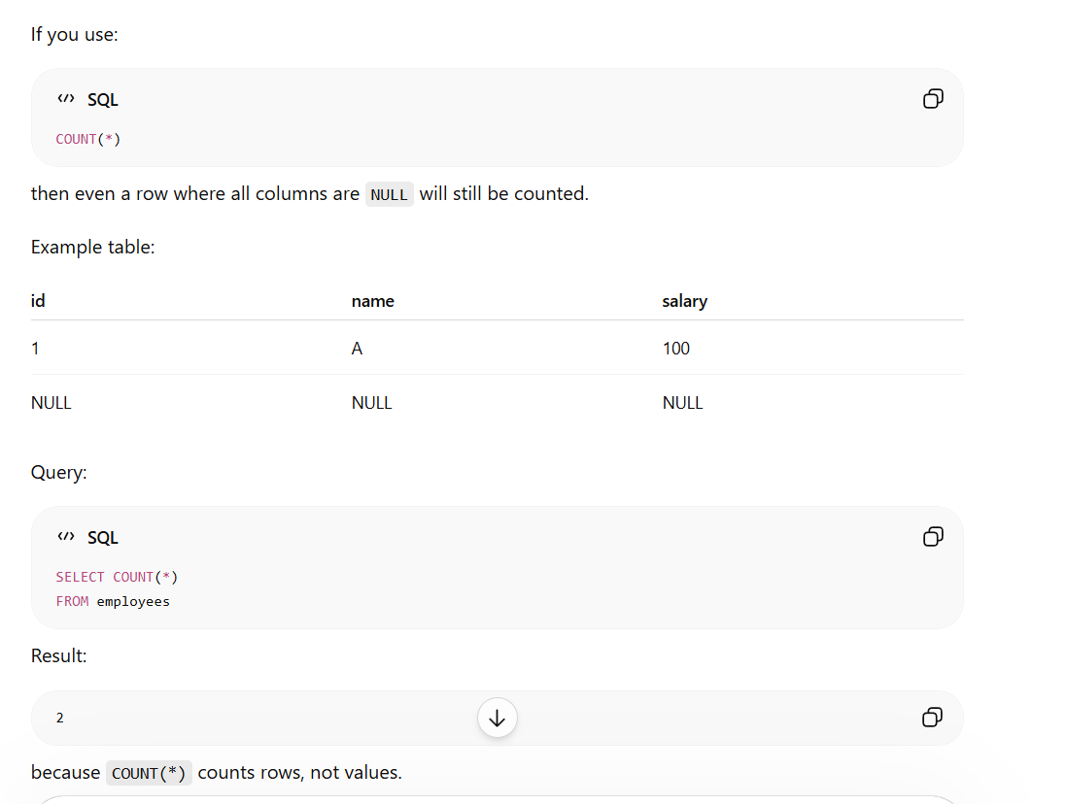

Q44. Why does HAVING COUNT(*) differ from COUNT(column)?
Answer:
COUNT(column) excludes NULLs.

Q45. Why does HAVING work after JOIN?
Answer:
JOIN happens in FROM, before GROUP BY and HAVING.

Q46. Why does HAVING not reduce input rows?
Answer:
It filters groups, not input rows.

Q47. Why does HAVING require GROUP BY context?
Answer:
It operates on grouped results.

Q48. Why does HAVING cause confusion for beginners?
Answer:
Because it looks like WHERE but works later.

Q49. Why is HAVING essential?
Answer:
Because WHERE cannot filter aggregates.

Q50. Why does HAVING define business rules?
Answer:
It applies conditions on summarized data.

🔵 SECTION 3: JOIN LOGIC (Q51–Q75)

Q51. Why is JOIN part of FROM?
Answer:
Because JOIN defines the dataset before filtering and grouping.

Q52. Why are INNER JOIN and WHERE interchangeable?
Answer:
Because unmatched rows are already removed.

Q53. Why does LEFT JOIN + WHERE break results?
Answer:
WHERE removes NULLs, converting it to INNER JOIN.

Q54. Why should LEFT JOIN conditions go in ON?
Answer:
To preserve unmatched rows.

Q55. Why does JOIN increase row count?
Answer:
One-to-many or many-to-many relationships.

Q56. Why does JOIN sometimes duplicate data?
Answer:
Because matching keys are not unique.

Q57. Why does JOIN order not matter logically?
Answer:
Optimizer determines execution plan.

Q58. Why does JOIN on NULL never match?
Answer:
NULL ≠ NULL in SQL logic.

JOIN on NULL never matches because in SQL:
NULL = NULL
is not TRUE.
It returns:
UNKNOWN
And JOIN only matches rows when condition is TRUE.
Example:
Table A:
id | dept_id
1 | NULL
2 | 10
Table B:
dept_id | dept_name
NULL | IT
10 | HR
Query:
SELECT *
FROM A
JOIN B
ON A.dept_id = B.dept_id
Result:
id | dept_id | dept_name
2 | 10 | HR
Why NULL rows did not match:
Because SQL evaluates:
NULL = NULL
as:
UNKNOWN
not TRUE.
And joins require:
ON condition = TRUE
Important SQL logic:
Expression | Result
10 = 10 | TRUE
10 = NULL | UNKNOWN
NULL = NULL | UNKNOWN
This is part of SQL’s three-valued logic:
- TRUE
- FALSE
- UNKNOWN
How to match NULLs intentionally:
Use:
ON A.dept_id IS NOT DISTINCT FROM B.dept_id
(PostgreSQL)
or:
ON COALESCE(A.dept_id, -1) = COALESCE(B.dept_id, -1)
Common interview statement:
NULL represents unknown/missing data, so SQL cannot assume two unknown values are equal. Therefore NULL = NULL is not TRUE, causing JOIN conditions on NULL to fail.

Q59. Why does CROSS JOIN explode rows?
Answer:
It creates a Cartesian product.

Q60. Why does JOIN before GROUP BY change totals?
Answer:
Because rows are duplicated before aggregation.

Q61. Why does JOIN direction matter in reporting?
Answer:
It determines which rows are preserved.
JOIN direction matters in reporting because it determines:
- which table’s rows are preserved
- which data may disappear
- how totals/counts are calculated
Especially with:
- LEFT JOIN
- RIGHT JOIN
Example:
Employees table:
emp_id | name
1 | A
2 | B
3 | C
Sales table:
emp_id | amount
1 | 100
1 | 200
2 | 300
Query 1:
SELECT e.name, s.amount
FROM employees e
LEFT JOIN sales s
ON e.emp_id = s.emp_id
Result:
name | amount
A | 100
A | 200
B | 300
C | NULL
All employees appear because:
- employees is on LEFT side
- LEFT JOIN preserves left table rows
Now reverse direction:
SELECT e.name, s.amount
FROM sales s
LEFT JOIN employees e
ON s.emp_id = e.emp_id
Result:
name | amount
A | 100
A | 200
B | 300
Employee C disappears because:
- sales is now preserved
- only employees having sales remain
Why this matters in reporting:
Suppose report asks:
“Show all employees including employees with zero sales.”
Correct:
employees LEFT JOIN sales
Wrong direction causes:
- missing employees
- incorrect totals
- biased KPIs
Real reporting examples:
Requirement | Correct Join Direction
Show all customers even without orders | customers LEFT JOIN orders
Show all products even without sales | products LEFT JOIN sales
Show all departments even without employees | departments LEFT JOIN employees
Important concept:
The preserved table should usually be:
- master table
- reporting base table
- business entity you must not lose
Interview definition:
JOIN direction matters because LEFT/RIGHT JOIN preserve rows from one side only, which directly affects reporting completeness, missing records, aggregates, and business metrics.

Q62. Why is LEFT JOIN common in analytics?
Answer:
To avoid losing data.

Q63. Why does joining dimension tables late cause loss?
Answer:
Aggregation removed row-level keys.

Q64. Why does DISTINCT not fix JOIN issues?
Answer:
It hides errors instead of fixing them.

Q65. Why does JOIN with mismatched data types fail?
Answer:
Implicit casting may prevent index usage.
JOIN with mismatched data types can fail because SQL cannot correctly compare incompatible values.
Example:
Table A:
emp_id
101
102
Datatype:
INT
Table B:
emp_id
"101"
"102A"
Datatype:
VARCHAR
Query:
SELECT *
FROM A
JOIN B
ON A.emp_id = B.emp_id
Possible issues:
- Conversion error
SQL may try converting:
"102A" → INT
which fails.
Error example:
Conversion failed
- No matching rows
Sometimes formatting differs:
101
vs
'00101'
Even though logically same, comparison may fail.
- Performance issue
SQL may perform implicit conversion:
CAST(A.emp_id AS VARCHAR)
during join.
This can:
- disable indexes
- cause full table scans
- slow queries heavily
Common mismatches:
Type 1 | Type 2
INT | VARCHAR
DATE | DATETIME
STRING | UUID
DECIMAL | FLOAT
Best practice:
Use same datatype in both tables.
Or explicitly cast:
ON CAST(B.emp_id AS INT) = A.emp_id
But explicit casts should be used carefully because bad values can still fail.
Safer approach:
ON TRY_CAST(B.emp_id AS INT) = A.emp_id
(SQL Server)
Interview definition:
JOINs fail with mismatched data types because SQL cannot reliably compare incompatible values, leading to conversion errors, incorrect matches, or performance problems due to implicit casting.

Q66. Why does JOIN require indexes?
Answer:
To avoid full table scans.

Q67. Why does self-JOIN work?
Answer:
A table can logically represent multiple roles.
A self-JOIN works because a table can be treated as two separate logical copies during query execution.
SQL uses aliases to distinguish them.
Example table:
emp_id | name | manager_id
1 | A | NULL
2 | B | 1
3 | C | 1
Goal:
Show employee and manager names.
Query:
SELECT
e.name AS employee,
m.name AS manager
FROM employees e
LEFT JOIN employees m
ON e.manager_id = m.emp_id
How it works:
Same table is used twice:
Alias | Role
e | employee rows
m | manager rows
SQL internally treats them like two virtual tables:
employees AS e
employees AS m
Then join condition:
e.manager_id = m.emp_id
matches:
- employee’s manager_id
with
- manager’s emp_id
Result:
employee | manager
A | NULL
B | A
C | A
Why self-join is useful:
- employee-manager hierarchy
- parent-child relationships
- comparing rows within same table
- finding duplicates
- sequential comparisons
Another example: finding duplicate emails
SELECT a.email
FROM users a
JOIN users b
ON a.email = b.email
AND a.user_id <> b.user_id
Key idea:
A self-join works because SQL allows the same table to participate multiple times in a query using different aliases, treating each alias as an independent logical instance of the table.

Q68. Why does JOIN logic matter more than syntax?
Answer:
Wrong logic gives correct-looking but wrong results.

Q69. Why does JOIN + GROUP BY need careful grain?
Answer:
To match business level of aggregation.

Q70. Why does FULL JOIN rarely used?
Answer:
Most use cases prefer LEFT JOIN with checks.

Q71. Why does JOIN create NULLs?
Answer:
When no matching row exists.

Q72. Why does WHERE filter after JOIN?
Answer:
JOIN is part of FROM and executes earlier.

Q73. Why does JOIN cause performance issues?
Answer:
Large tables + missing indexes.

Q74. Why does JOIN reorder data?
Answer:
SQL results are unordered.

Q75. Why is JOIN the biggest source of SQL bugs?
Answer:
Because it silently multiplies data.

🔴 SECTION 4: EXECUTION & NULL LOGIC (Q76–Q100)

Q76. Why does SQL use three-valued logic?
Answer:
To represent UNKNOWN (NULL).

what is three-valued logic
Three-valued logic is a logic system where every condition can produce three possible results instead of two.
Normal logic:
Result
TRUE
FALSE
SQL logic:
Result
TRUE
FALSE
UNKNOWN
SQL needs this because of NULL.
NULL means:
- unknown
- missing
- undefined
Example:
5 = 5
Result:
TRUE
Example:
5 = 7
Result:
FALSE
Now:
5 = NULL
SQL cannot determine answer because:
- NULL value is unknown
So result becomes:
UNKNOWN
That is called three-valued logic.
Important behavior in SQL:
WHERE keeps only TRUE rows.
Condition Result | Row Kept?
TRUE | Yes
FALSE | No
UNKNOWN | No
Example:
salary
100
NULL
Query:
SELECT *
FROM employees
WHERE salary > 50
Evaluation:
salary | Result
100 | TRUE
NULL | UNKNOWN
Only first row returns.
Common interview examples:
NULL = NULL
→ UNKNOWN
NULL <> NULL
→ UNKNOWN
NULL IS NULL
→ TRUE
Simple definition:
Three-valued logic is SQL’s logical system where expressions can evaluate to TRUE, FALSE, or UNKNOWN due to the presence of NULL values.

Q77. Why does = NULL fail?
Answer:
NULL is not a value.

Q78. Why does NOT IN behave strangely?
Answer:
NULL causes UNKNOWN comparisons.

NOT IN behaves strangely because of NULL and SQL’s three-valued logic.
Example:
Table:
id
1
2
3
Query:
SELECT *
FROM table1
WHERE id NOT IN (2, NULL)
You might expect:
1
3
But actual result:
No rows
Why?
SQL internally checks:
For id = 1:
1 NOT IN (2, NULL)
becomes:
1 <> 2
AND
1 <> NULL
Now:
1 <> 2 → TRUE
1 <> NULL → UNKNOWN
Final result:
TRUE AND UNKNOWN = UNKNOWN
WHERE only keeps TRUE rows.
So row is removed.
Same happens for all rows.
Key issue:
If NULL exists inside NOT IN, comparisons become UNKNOWN.
Important comparison:
Query | NULL-safe?
NOT IN | No
NOT EXISTS | Yes
Safer alternative:
SELECT *
FROM table1 t
WHERE NOT EXISTS(
SELECT 1
FROM table2 s
WHERE t.id = s.id
)
NOT EXISTS handles NULL properly.
Very common interview question.
Interview definition:
NOT IN behaves unexpectedly when the subquery/list contains NULL because comparisons with NULL return UNKNOWN in SQL’s three-valued logic, causing rows to be filtered out unexpectedly.

Q79. Why does EXISTS avoid NULL issues?
Answer:
It checks existence, not values.

EXISTS avoids NULL issues because it checks only whether rows exist, not value comparisons.
It returns:
- TRUE → if at least one row exists
- FALSE → if no rows exist
It does not care about NULL values inside those rows.
Example:
Table A:
id
1
2
3
Table B:
id
2
NULL
Query using NOT IN:
SELECT *
FROM A
WHERE id NOT IN
(
SELECT id
FROM B
)
Problem:
Subquery contains NULL.
SQL evaluates:
1 <> NULL → UNKNOWN
So query behaves unexpectedly and may return no rows.
Now using NOT EXISTS:
SELECT *
FROM A a
WHERE NOT EXISTS
(
SELECT 1
FROM B b
WHERE a.id = b.id
)
How it works:
For id = 1:
- SQL searches B for matching row
- no match found
- EXISTS = FALSE
- NOT EXISTS = TRUE
- row returned
For id = 2:
- matching row exists
- EXISTS = TRUE
- NOT EXISTS = FALSE
- row excluded
For NULL row in B:
- comparison:
a.id = NULL
becomes UNKNOWN
so it simply does not match any row.
But EXISTS does not fail because:
- it only checks whether matching rows exist
- NULL rows are ignored naturally
Key difference:
Operator | Problem with NULL
NOT IN | Yes
EXISTS / NOT EXISTS | No
Why EXISTS is safer:
- works row-by-row
- based on row existence
- not dependent on list comparisons involving NULL
Interview definition:
EXISTS avoids NULL issues because it checks only for the existence of matching rows rather than performing direct value comparisons against NULL-containing sets.

Q80. Why does ORDER BY allow aliases?
Answer:
ORDER BY runs after SELECT.

Q81. Why does GROUP BY usually not allow aliases?
Answer:
GROUP BY runs before SELECT.

Q82. Why does LIMIT need ORDER BY?
Answer:
Without order, results are non-deterministic.

Q83. Why does SQL not guarantee order?
Answer:
Relational model treats tables as unordered sets.

Q84. Why does function on indexed column disable index?
Answer:
Index stores raw column values.
Applying a function on an indexed column often disables index usage because the database can no longer use the index’s stored sorted values directly.
Example:
Suppose index exists on:
email
Query:
SELECT *
FROM users
WHERE LOWER(email) = 'abc@gmail.com'
Problem:
Index is built on original values:
ABC@gmail.com
John@test.com
But query is using:
LOWER(email)
So database must:
- Read each row
- Apply LOWER()
- Compare result
This prevents efficient index lookup.
Instead of:
Index Seek
database performs:
Full Scan / Index Scan
Another example:
Bad:
WHERE YEAR(order_date) = 2025
Why bad:
Database applies YEAR() to every row.
Better:
WHERE order_date >= '2025-01-01'
AND order_date < '2026-01-01'
Now index on order_date can be used directly.
Concept:
Indexes store raw column values in sorted structure.
When function changes the value:
YEAR(date)
LOWER(name)
TRIM(col)
CAST(col)
database cannot directly navigate index efficiently.
This concept is called:
- non-sargable query
SARGable =
Search ARGument Able
Meaning database can efficiently use index lookup.
Good (SARGable):
WHERE salary > 1000
Bad (non-SARGable):
WHERE ABS(salary) > 1000
Interview definition:
Functions on indexed columns often disable index usage because the database must compute the function result for every row, preventing efficient index seeks and leading to scans instead.

Q85. Why does COUNT(*) still scan table?
Answer:
Visibility checks are required.
COUNT(*) still scans the table (or index) because the database must determine how many rows actually exist.
SQL databases generally do not store an always-accurate “live row count” for transactional tables.
Example:
SELECT COUNT(*)
FROM employees
Database must verify:
- which rows exist
- which rows are visible to current transaction
- which rows are deleted/uncommitted
Especially in databases supporting:
- transactions
- MVCC (Multi-Version Concurrency Control)
Why scan is needed:
Suppose:
- one transaction inserted rows
- another deleted rows
- some changes not committed
Different users may see different row counts.
So database cannot always rely on stored metadata.
Instead it scans:
- table
or
- smallest available index
Optimization:
If a narrow index exists:
INDEX(emp_id)
database may scan index instead of full table because:
- index is smaller
- faster to read
But still a scan happens.
Important distinction:
Query | Usually Faster?
COUNT(*) | Yes
COUNT(column) | Slightly slower sometimes
Why?
COUNT(*) only counts rows.
It does not check column values.
But:
COUNT(salary)
must also check:
- whether salary is NULL
Special case:
Some databases/storage engines maintain approximate metadata counts, but:
- may be inaccurate
- may not work under transactions
Example:
- PostgreSQL → scans needed for exact count
- MySQL MyISAM → stored row count optimization existed
- InnoDB → usually scans/index scans
Interview definition:
COUNT(*) often scans the table or an index because the database must accurately determine visible rows under transactional consistency rules rather than relying on potentially outdated metadata.

Q86. Why does SQL rewrite queries?
Answer:
Optimizer improves performance.

Q87. Why does same SQL behave differently in Spark?
Answer:
Different execution engine and optimizer.

Q88. Why does SQL allow syntactically valid but logically wrong queries?
Answer:
SQL enforces syntax, not business logic.

Q89. Why does implicit casting hurt performance?
Answer:
Indexes may not be usable.

Q90. Why does SQL prefer declarative style?
Answer:
Optimizer chooses best execution plan.

Q91. Why does AVG(salary) differ from SUM/COUNT?
Answer:
NULL handling.
AVG(salary) can differ from:
SUM(salary) / COUNT(*)
because AVG() ignores NULL values, while COUNT(*) counts all rows.
Example:
emp | salary
A | 100
B | 200
C | NULL
Now:
SELECT AVG(salary)
FROM employees
Calculation:
(100 + 200) / 2 = 150
Why divide by 2?
Because AVG ignores NULL.
Now compare:
SELECT SUM(salary) / COUNT(*)
FROM employees
Calculation:
(100 + 200) / 3 = 100
because:
- COUNT(*) counts all rows including NULL row.
Correct equivalent of AVG:
SUM(salary) / COUNT(salary)
since:
COUNT(salary)
counts only non-null salaries.
Then:
300 / 2 = 150
matches AVG.
Important behavior:
Function | NULL Handling
SUM(column) | Ignores NULL
AVG(column) | Ignores NULL
COUNT(column) | Ignores NULL
COUNT(*) | Counts all rows
Interview definition:
AVG(column) differs from SUM(column)/COUNT(*) because AVG ignores NULL values internally, while COUNT(*) includes all rows, including rows with NULLs.

Q92. Why does GROUP BY after filtering change result?
Answer:
Filtered rows no longer contribute.

Q93. Why does HAVING after JOIN matter?
Answer:
Aggregates operate on joined data.

Q94. Why does SQL execution order confuse people?
Answer:
Written order ≠ logical order.

Q95. Why does SQL allow ambiguous logic?
Answer:
Because business meaning is user’s responsibility.

Q96. Why does SQL debugging require row counts?
Answer:
To detect duplication or loss.

Q97. Why does SQL correctness matter more than speed?
Answer:
Wrong fast results are worse than slow correct ones.

Q98. Why does SQL reward conceptual clarity?
Answer:
Because logic errors are silent.

Q99. Why does SQL interview focus on logic?
Answer:
Syntax can be learned; logic cannot be faked.

Q100. What defines a good SQL engineer?
Answer:
Someone who understands data flow, grain, and execution order, not just keywords.

