**Istio service mesh**

kubectl create namespace istio-system

helm repo add istio https://istio-release.storage.googleapis.com/charts

helm repo update

helm install istio-base istio/base -n istio-system

helm install istiod istio/istiod -n istio-system \

--set global.istioNamespace=istio-system

helm install istio-ingress istio/gateway -n istio-system

kubectl get deployment istio-ingress -n istio-system -o jsonpath='{.spec.selector.matchLabels}'

kubectl get pods -n istio-system

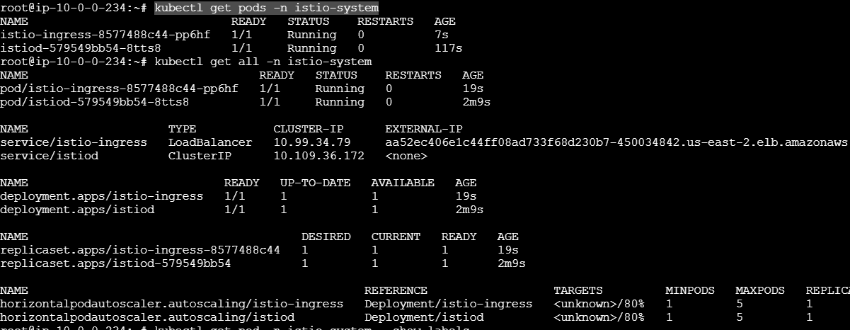

kubectl get pod -n istio-system --show-labels



kubectl get deployment istio-ingress -n istio-system -o jsonpath='{.spec.selector.matchLabels}'



* Modify the LoadBalancer IP inside the deployment.yml to new istio External IP generated above (line 53)
* Apply deployment.yml

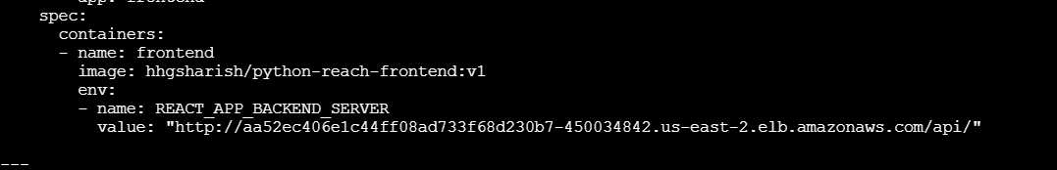

**Gateway Creation:**

**gateway.yml**

apiVersion: networking.istio.io/v1beta1

kind: Gateway

metadata:

name: myapp-gateway

namespace: default

spec:

selector:

istio: ingress # Use Istio default ingress gateway

servers:

- port:

number: 80

name: http

protocol: HTTP

hosts:

- "*"

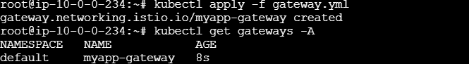

Virtual Service for Backend Service:

**virtual-svc.yml**

apiVersion: networking.istio.io/v1beta1

kind: VirtualService

metadata:

name: myapp-vs-be

namespace: default

spec:

hosts:

- "*"

gateways:

- myapp-gateway

http:

- match:

- uri:

prefix: /api/

route:

- destination:

host: backend-service

port:

number: 5005

Front End Virtual Service:

**virtual-svc-fe.yml**

apiVersion: networking.istio.io/v1beta1

kind: VirtualService

metadata:

name: myapp-vs-fe

namespace: default

spec:

hosts:

- "*"

gateways:

- myapp-gateway

http:

- match:

- uri:

prefix: /

route:

- destination:

host: frontend-service

port:

number: 3000

kubectl apply -f virtual-svc.yml

kubectl apply -f virtual-svc-fe.yml

kubectl get vs -A

