**Project Design Phase-II**

**Technology Stack (Architecture & Stack)**

| Date | 31 January 3035 |
| --- | --- |
| Team ID |  |
| Project Name |  |
| Maximum Marks | 4 Marks |

**Technical Architecture:**

The Deliverable shall include the architectural diagram as below and the information as per the table1 & table 2

**Example: Order processing during pandemics for offline mode**

**Reference:** [**https://developer.ibm.com/patterns/ai-powered-backend-system-for-order-processing-during-pandemics/**](https://developer.ibm.com/patterns/ai-powered-backend-system-for-order-processing-during-pandemics/)



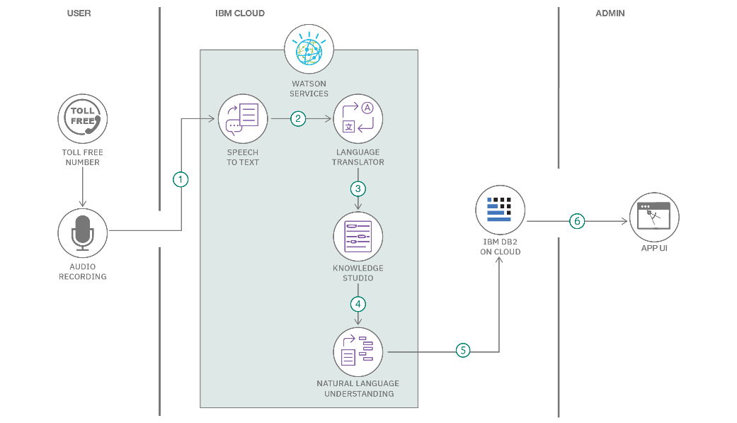

**Table-1 : Components & Technologies:**

| **S.No** | **Component** | **Description** | **Technology** |
| --- | --- | --- | --- |
|  | User Interface | How user interacts with application e.g.  Web UI, Mobile App, Chatbot etc. | HTML, CSS, JavaScript / Angular Js / React Js etc. |
|  | Application Logic-1 | Logic for a process in the application | Java / Python |
|  | Application Logic-2 | Logic for a process in the application | IBM Watson STT service |
|  | Application Logic-3 | Logic for a process in the application | IBM Watson Assistant |
|  | Database | Data Type, Configurations etc. | MySQL, NoSQL, etc. |
|  | Cloud Database | Database Service on Cloud | IBM DB2, IBM Cloudant etc. |
|  | File Storage | File storage requirements | IBM Block Storage or Other Storage Service or Local Filesystem |
|  | External API-1 | Purpose of External API used in the application | IBM Weather API, etc. |
|  | External API-2 | Purpose of External API used in the application | Aadhar API, etc. |
|  | Machine Learning Model | Purpose of Machine Learning Model | Object Recognition Model, etc. |
|  | Infrastructure (Server / Cloud) | Application Deployment on Local System / Cloud  Local Server Configuration:  Cloud Server Configuration : | Local, Cloud Foundry, Kubernetes, etc. |
| 1 | User Interface | Dashboard visualizations and filters | Tableau Public |
| 2 | Application Logic-1 | Data cleaning, filtering, and calculated fields | Tableau Calculated Fields |
| 3 | Application Logic-2 | Visual encoding and dashboard interactivity | Tableau Actions, Filters |
| 4 | Application Logic-3 | Insights derivation and story creation | Tableau Story Feature |
| 5 | Database | Student survey data | CSV file |
| 6 | Cloud Database | Not used | - |
| 7 | File Storage | Local storage of CSV and TWBX files | Local Filesystem |
| 8 | External API-1 | Not used | - |
| 9 | External API-2 | Not used | - |
| 10 | Machine Learning Model | Not applicable | - |
| 11 | Infrastructure (Server / Cloud) | Published on Tableau Public | Cloud |

**Table-2: Application Characteristics:**

| **S.No** | **Characteristics** | **Description** | **Technology** |
| --- | --- | --- | --- |
|  | Open-Source Frameworks | List the open-source frameworks used | Technology of Opensource framework |
|  | Security Implementations | List all the security / access controls implemented, use of firewalls etc. | e.g. SHA-256, Encryptions, IAM Controls, OWASP etc. |
|  | Scalable Architecture | Justify the scalability of architecture (3 – tier, Micro-services) | Technology used |
|  | Availability | Justify the availability of application (e.g. use of load balancers, distributed servers etc.) | Technology used |
|  | Performance | Design consideration for the performance of the application (number of requests per sec, use of Cache, use of CDN’s) etc. | Technology used |
| 1 | Open-Source Frameworks | Tableau Public is free to use with community support | Tableau Public |
| 2 | Security Implementations | No sensitive data used; secure Tableau Public access | NA |
| 3 | Scalable Architecture | Supports multiple dashboards and filters | Tableau Workbooks |
| 4 | Availability | Hosted on Tableau Public, accessible online | Cloud |
| 5 | Performance | Optimized by limiting number of visualizations per dashboard | Tableau Optimization |

**References:**

[**https://c4model.com/**](https://c4model.com/)

[**https://developer.ibm.com/patterns/online-order-processing-system-during-pandemic/**](https://developer.ibm.com/patterns/online-order-processing-system-during-pandemic/)

[**https://www.ibm.com/cloud/architecture**](https://www.ibm.com/cloud/architecture)

[**https://aws.amazon.com/architecture**](https://aws.amazon.com/architecture)

[**https://medium.com/the-internal-startup/how-to-draw-useful-technical-architecture-diagrams-2d20c9fda90d**](https://medium.com/the-internal-startup/how-to-draw-useful-technical-architecture-diagrams-2d20c9fda90d)