MAHARISHI VIDYA MANDIR

# DABC'S ARBORETUM

(Off. OMR) Medavakkarn, Marnbakkam Road, Polachery, Kanchipuram District, Chennai-600

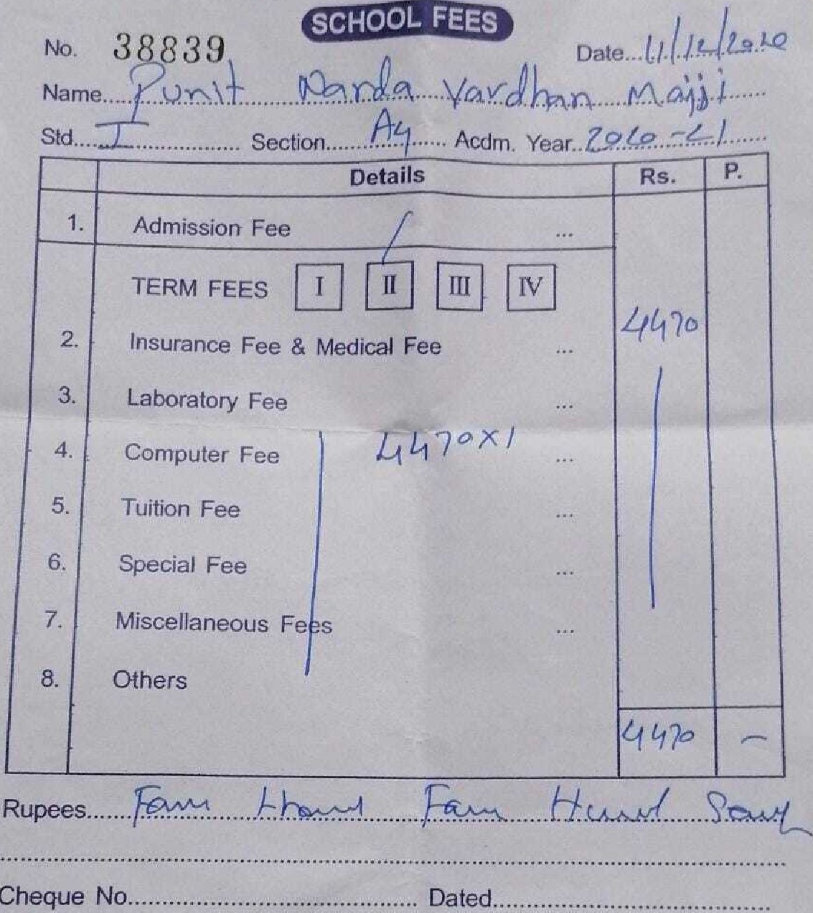

Cheque

Drawn on..... .. .

k9

Cashier