CASHLESS ECONOMY – PRACTICUM3 REPORT:

Analyzing patterns and shift towards cashless economy

Group Member IDs:

Srujana Nerella - 71710080

Varija Karampudi - 71710083

Surendra Dattatrey - 71710015

Table of Contents

EXECUTIVE SUMMARY: 3

OBJECTIVES OF THE STUDY: 4

DATA: 4

METHODOLOGY AND TOOLS: 4

ANALYSIS AND RESULTS: 5

Role of macro-economic factors: 5

Understanding Overall Transactions: 5

Understanding Digital Transactions: 5

Understanding Online Businesses: 6

Forecasting the future estimates: 7

Point of Sale (POS): 7

Card Statistics: 7

ATM: 8

CONCLUSION: 9

References 9

# EXECUTIVE SUMMARY:

In the course of past two decades, India has pushed strong to be a less–cash society. In the mid of 1990s, the Reserve Bank of India led the development of technological infrastructure that encouraged the initiation of a payment and settlement system.

As per the (Digital Payment Methods, 2017) website, The Digital India programme is a flagship programme of the Government of India with a vision to transform India into a digitally empowered society and knowledge economy. “Faceless, Paperless, Cashless” is one of professed role of Digital India. As part of promoting cashless transactions and converting India into less-cash society, various modes of digital payments are available.

These modes are:

* Banking Cards, USSD, AEPS,
* UPI, Mobile Wallets, Bank Pre-paid cards,
* Point of Sale,
* Internet Banking, Mobile Banking and Micro ATMs

Central Government has announced a package of incentives and measures like JAM Trinity: The Prime Minister’s Jan-Dhan Yojana, Aadhaar, and mobile connectivity etc. to promote digital payments through use of credit/debit cards and mobile phone applications/e-wallets etc.

On 8 November 2016, The Prime Minister of India, voided two of the highest denomination currency notes of Rs.500 and Rs.1000. Demonetization is the current generations unforgettable experience and is going to be matchless economic consequences of our time. All Indian citizens has experienced its effect. It affected liquidity side of our economy. This is a progressive move towards a cashless economy with a focal point on electronic transactions being imagined. The rise in usage of Credit Cards, Debit cards, Net Banking and Other online payment mechanisms is another beneficial outcome of demonetization, as these would not only minimize the transaction costs, but also could help gain remarkable other pays as well.

Greater usage of digital payments will save trillions of rupees for the Indian economy as it will help bring down the cost of cash, according to a report by payments company Visa Inc. titled (Accelerating the Growth of Digital Payments in India: A Five–year outlook, 2016).

# OBJECTIVES OF THE STUDY:

Our study aims at:

* Role of macro-economic factors (Demonetization, Infrastructure, Literacy etc.)
* Forecasting the future estimates (assuming ceteris paribus).

Is there any effect in banking transactions which are regulated by RBI post demonetization? How the other factors like Infrastructure, Literacy etc. helped cashless economy system. We would like to observe the transactions in banks and understand how much is the effect the demonetization has made to our Indian economy system, whether it is a positive sign or negative. Also, we would like to forecast the future estimates say Amount of cash per day that has be feed into ATM machines, with other conditions being same.

# DATA:

We have taken the data from <https://www.npci.org.in/statistics> from last year August 2016 to August 2017 for Bank-wise ATM/POS/Card Statistics.

# METHODOLOGY AND TOOLS:

The National Payment Corporation India provides data Bank-wise are under RBI. We have aggregated the data for the past one year (Aug 2016 – Aug 2017) and performed exploratory data analysis using Tableau to understand the role of macro-economic factors and forecasted the statistics of ATM/POS/Cards data using XL Miner using appropriate prediction methods.

# ANALYSIS AND RESULTS:

## **Role of macro-economic factors:**

## Understanding Overall Transactions:

During demonetization Nov’16- Jan’17,

* Amount that has spent has been reduced by 33%.
* The amount spent through banks in a month is above 2.5 Lakh Crores
* This has seen a drop by 30% during Nov’16 to Jan’17
* However, this looks like the economy is stabilized around Mar’17 as the total spend again reached around 3.5 Lakh Crores

## Understanding Digital Transactions:

During demonetization Nov’16- Jan’17,

* Demonetization has seen 15% increase in Digital transactions.
* Transactions has seen a spike in Dec’16
* This can be attributed to 2000 per transaction withdrawal rule
* We see that the POS sales picked up post demonetization and it seemed to take lead over money exchange

## Understanding Online Businesses:

Online business seemed to pick up by 100% post demonetization

## **Forecasting the future estimates:**

## Point of Sale (POS):

The small merchant usage of POS machines has been increased tremendously and the people usage of debit cards for payments has been increased by 92% when compared to previous year 2016 and according to the forecast the amount spent will increase to 125% more than its previous year. Payments using credit cards has been increased by 40% in the current year when compared to year 2016 and according to the forecast payments using credit cards would increase to 47% in the current year when compared to year 2016.

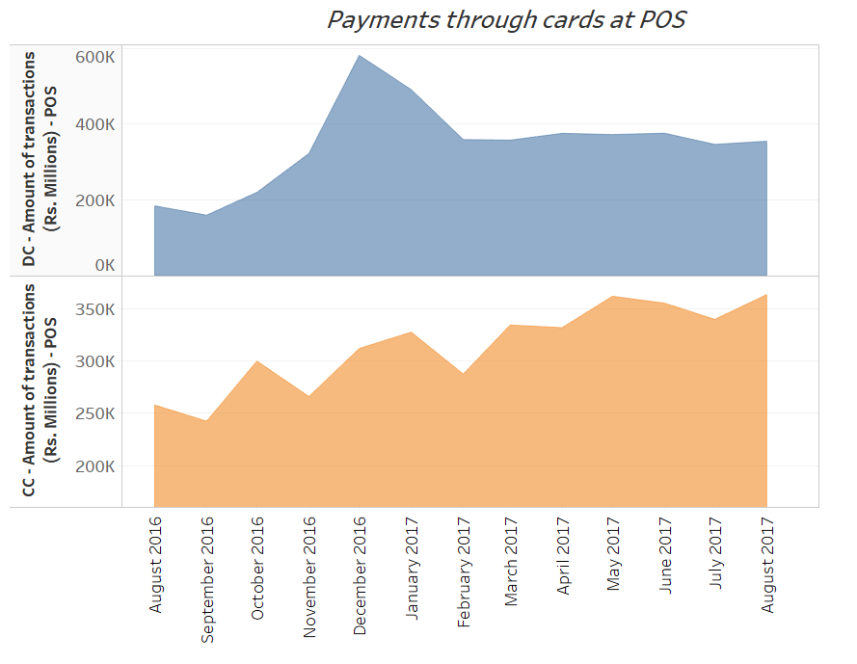

## Card Statistics:

There is an increase of 98 million debit cards issued by different banks over the last year and according to forecast there would be around 810 million debits cards which would be active. There is an increase of 6.2 million credit cards over the last year and according to the forecast there would be 33 million credit cards which would be active by next month.

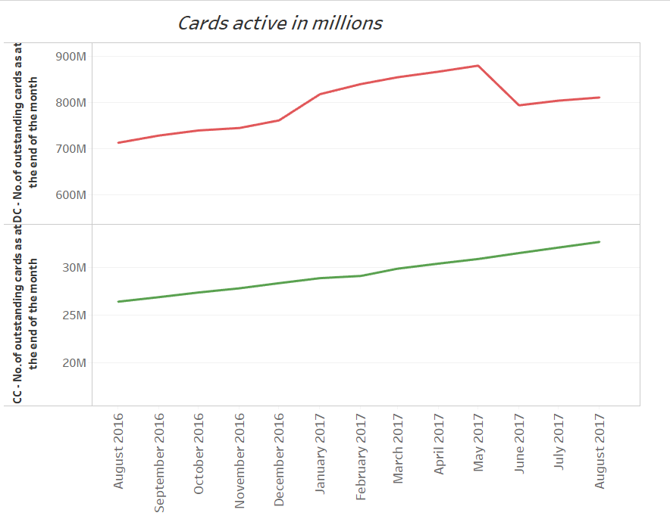

## ATM:

There is no much difference in the amount being withdrawn from ATM’s when compared to last year, it was low in the period of demonetization due to the government imposed restriction on the amount of withdrawal.

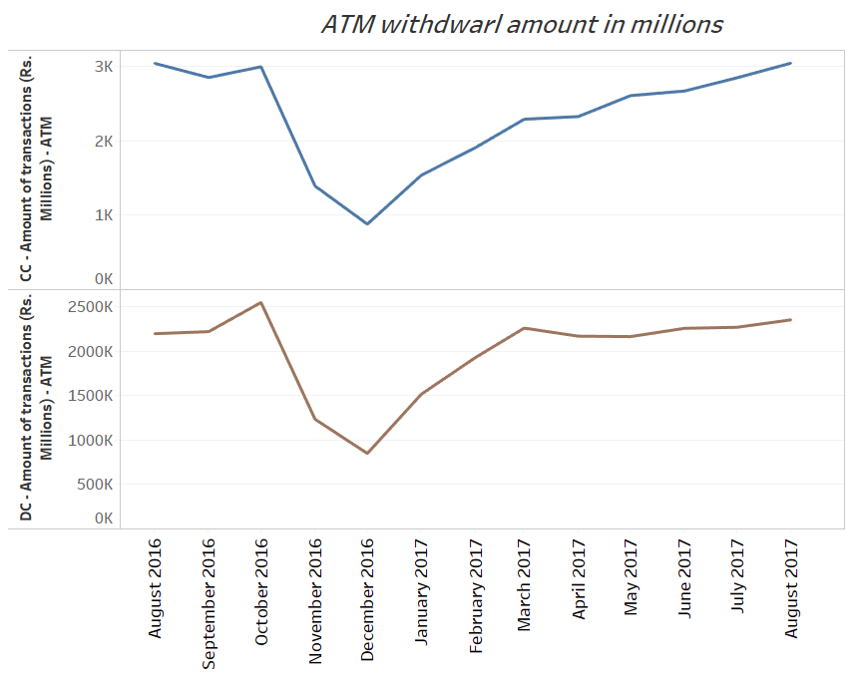

# CONCLUSION:

Based on our study, we conclude that the cashless economy system is rising day to day. The market is getting globalized, banking sector is upraising and hence more people are moving from cash transactions to cashless economy system. The cashless economy system is not only a demand but also becoming a necessity for the today’s system.

Entire online market is dependent on cashless transaction system. It doesn’t mean that cashless transitions are safest than the cash transactions, but it is less time consuming when compared to cash transactions and there is no difficulty of carrying cash and of no hassle of depreciation like paper money. It as well helps us to maintain record of all the transactions made. Post demonetization, we see a significant increase in digital transactions and online businesses. Our people are also getting comfortable in making cashless transactions.

So, we can say without uncertainty, cashless economy system is the growing and future economy system.

# References

Accelerating the Growth of Digital Payments in India: A Five–year outlook. (2016). *https://www.visa.co.in/dam/VCOM/regional/ap/india/global-elements/documents/digital-payments-india.pdf*.

*Digital Payment Methods*. (n.d.). Retrieved from http://cashlessindia.gov.in: http://cashlessindia.gov.in/digital_payment_methods.html