MLOps Assignment 01 – End-to-End ML Model Development, CI/CD, and Deployment

1. Introduction
This assignment demonstrates the design, development, and deployment of a scalable machine learning solution using modern MLOps practices. The project uses the UCI Heart Disease dataset to build a classifier predicting risk of heart disease. The pipeline covers EDA, model training, experiment tracking, containerization, CI/CD, Kubernetes deployment, and monitoring with Prometheus + Grafana.

2. Setup & Installation Instructions
Clone repository:
git clone https://github.com/surendragsr64/mlops-assignment1.git
cd mlops_heart_disease
Install dependencies:
pip install -r requirements.txt
Build Docker image (I used docker hub instead of ACR):
docker build -t username/repositoryname:imagetagname .
docker push username/ repositoryname:imagetagname
Deploy to Minikube:
kubectl apply -f k8s/deployment.yaml
kubectl apply -f k8s/service.yaml
minikube service heart-disease-service

3. Data Acquisition & EDA
- Dataset: UCI Heart Disease CSV with 14+ features.
- Cleaning: handled missing values, encoded categorical features.
- Visualizations:
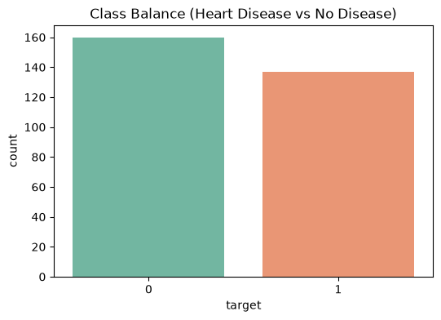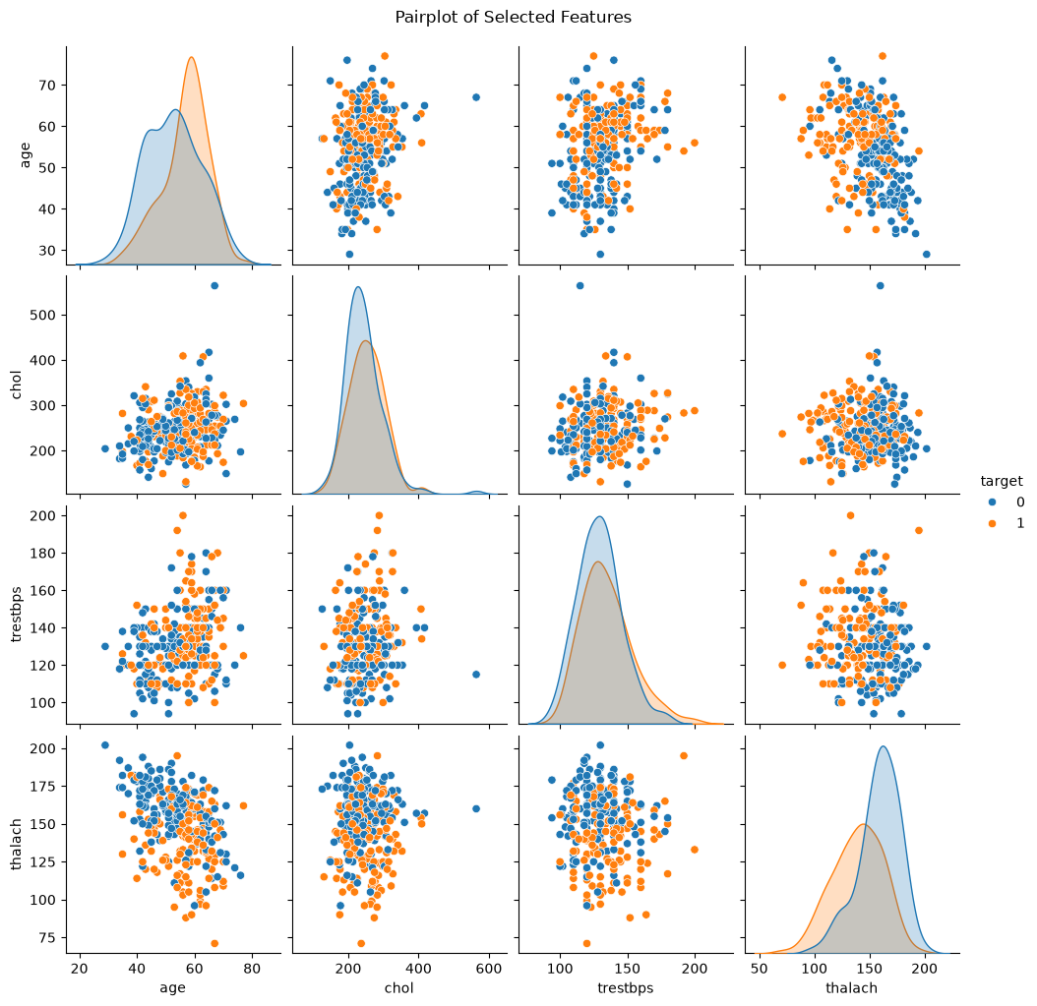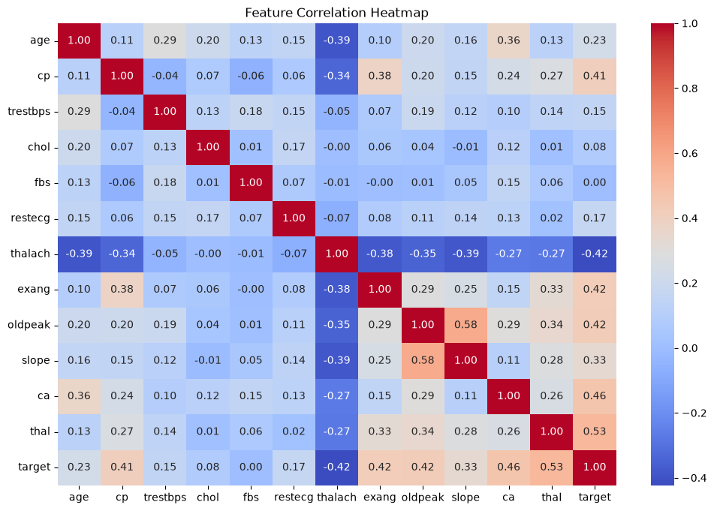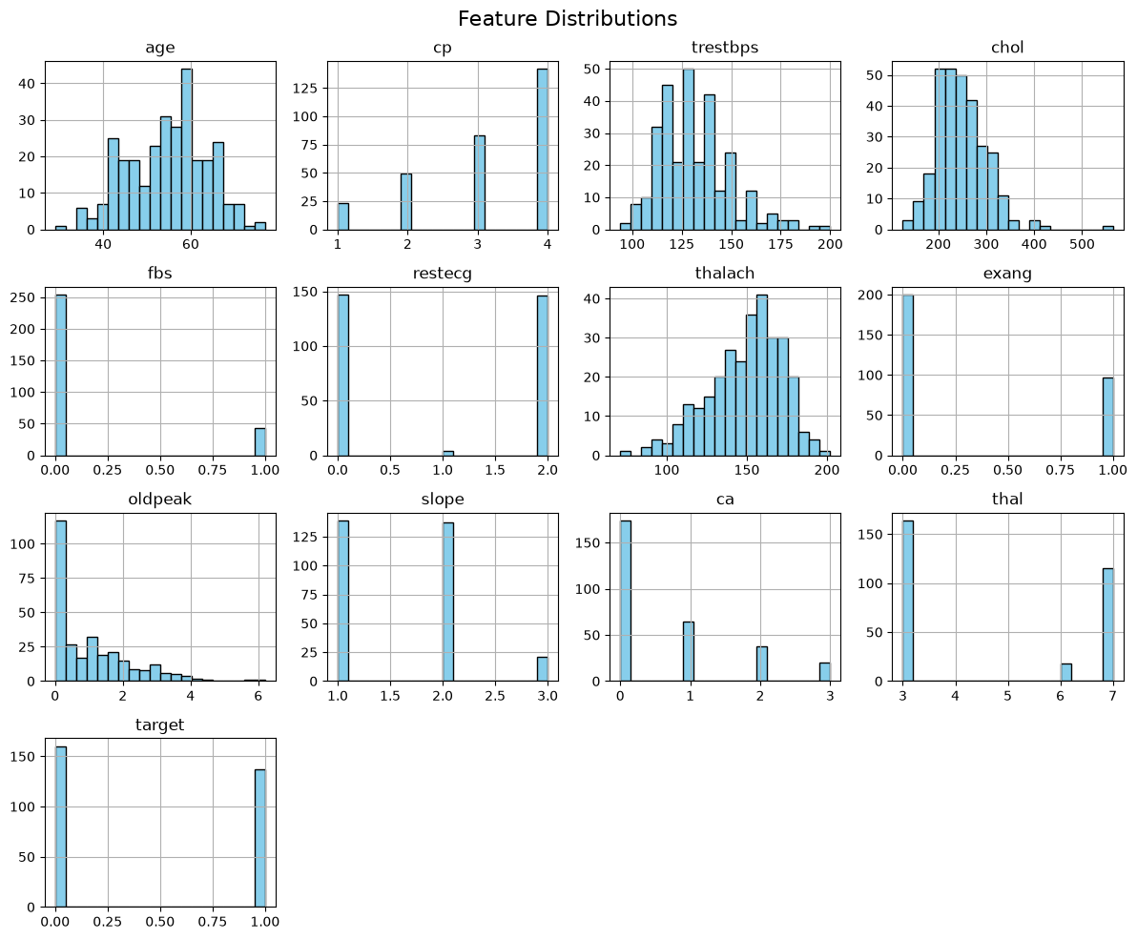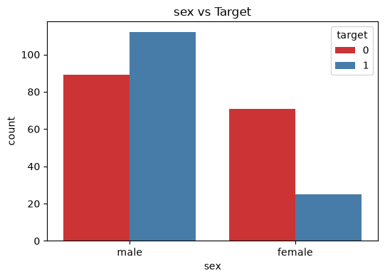

4. Feature Engineering & Model Development
- Features scaled using StandardScaler.
- Models trained: Logistic Regression, Random Forest.
- Evaluation metrics:
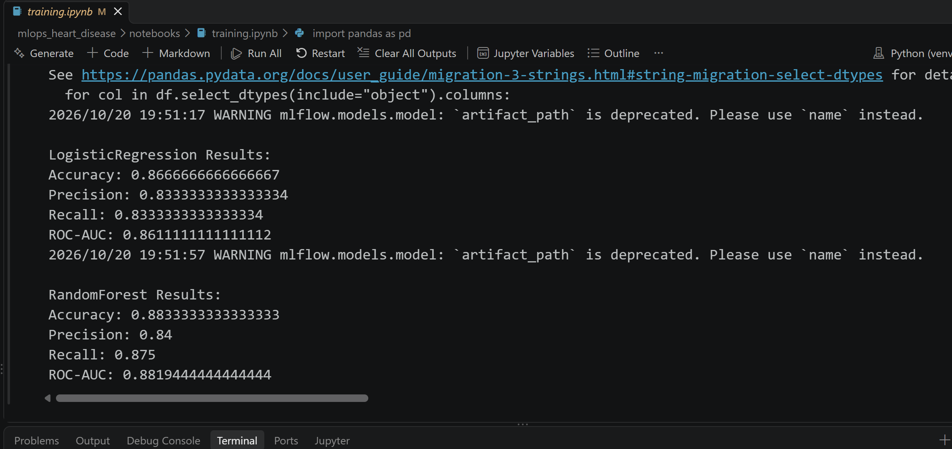

5. Experiment Tracking
- MLflow used to log parameters, metrics, and artifacts.
- Screenshot of MLflow UI showing multiple runs.
- 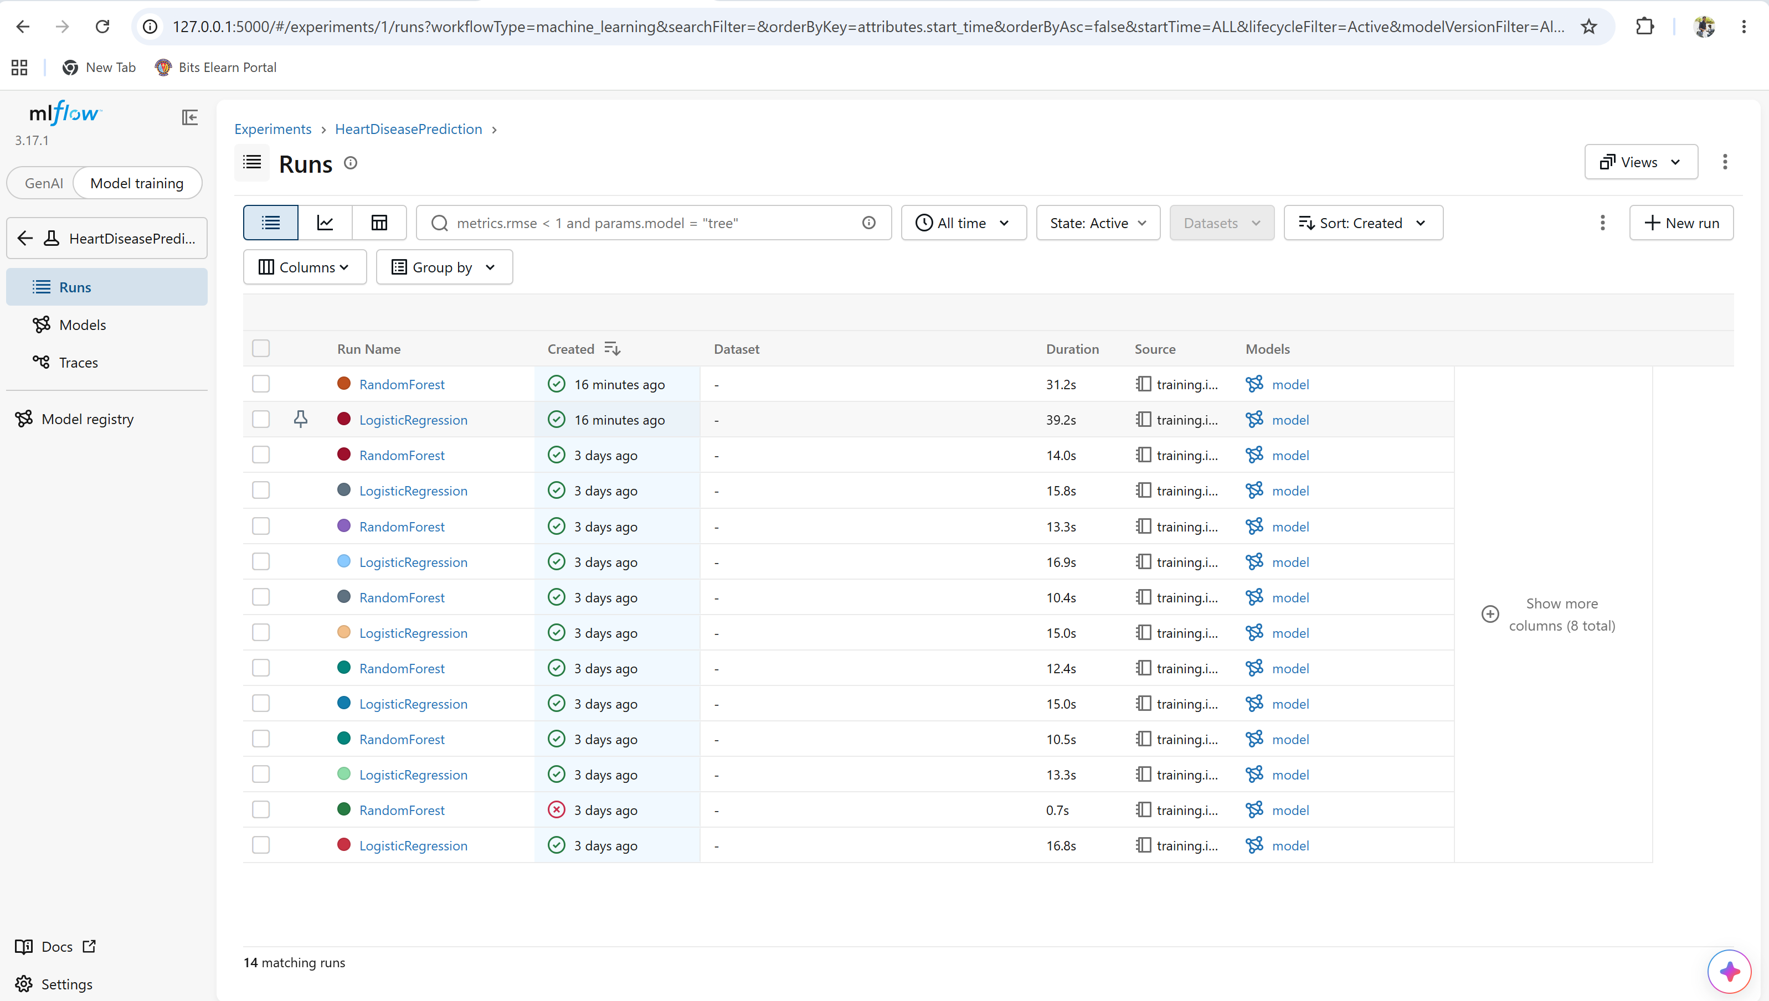
- Summary: Random Forest selected as final model due to higher ROC-AUC.

6. Model Packaging & Reproducibility
- Final model saved as model.pkl.
- Requirements listed in requirements.txt.
- Preprocessing pipeline ensures reproducibility across environments.

7. CI/CD Pipeline
- GitHub Actions workflow includes:
  - Linting with Flake8
  - Unit tests with Pytest

8. Containerization & Deployment
- FastAPI app exposes /predict and /metrics.
- Dockerfile builds container.
- Kubernetes manifests deploy API with LoadBalancer service.

Minikube container running screenshot:
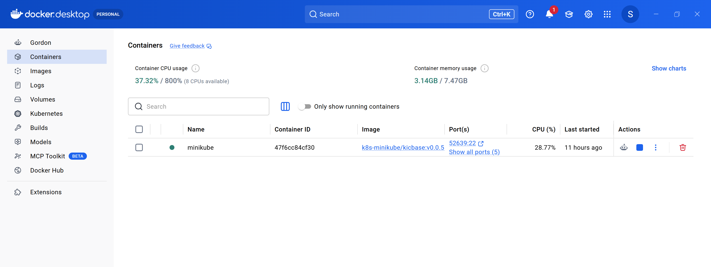
Pushed docker image into my docker hub personal account and reused the same image within the Kubernetes deployment yaml file:
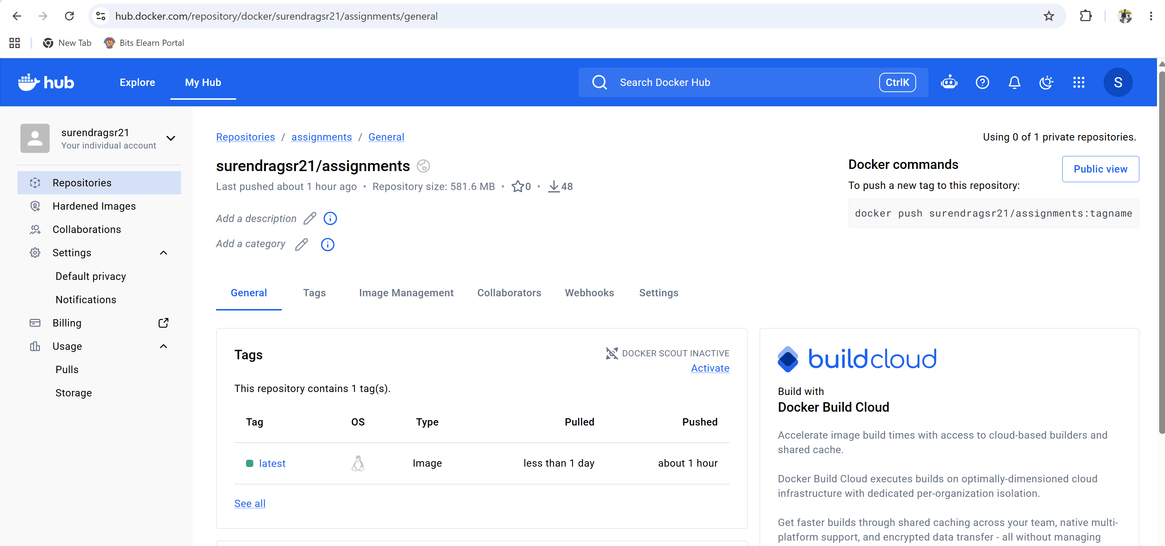
Fastapi Swagger UI docs screenshot:
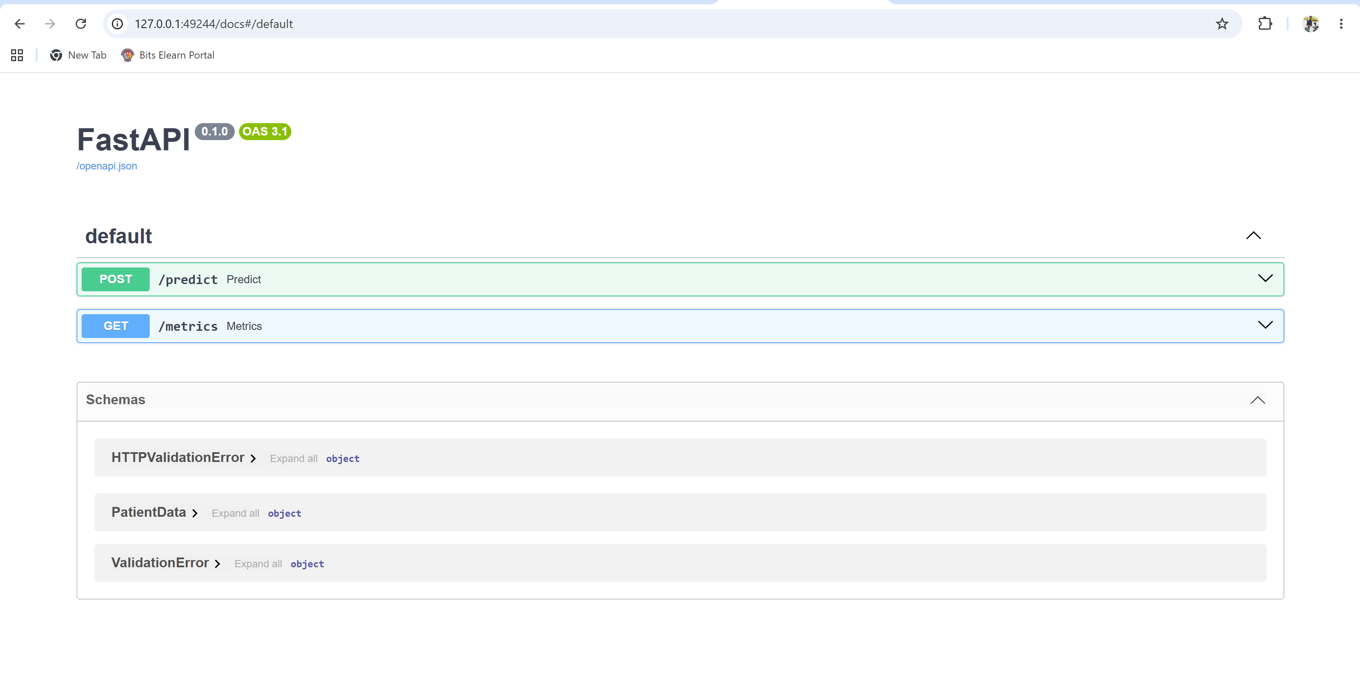
/predict endpoint response screenshot:
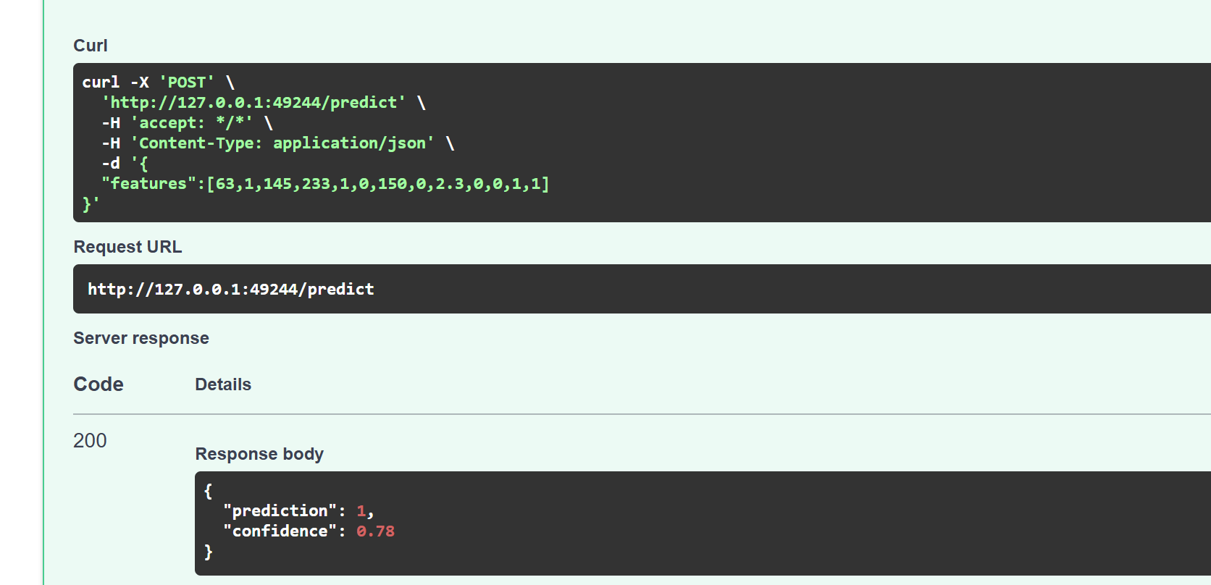
/metrics endpoint response screenshot:
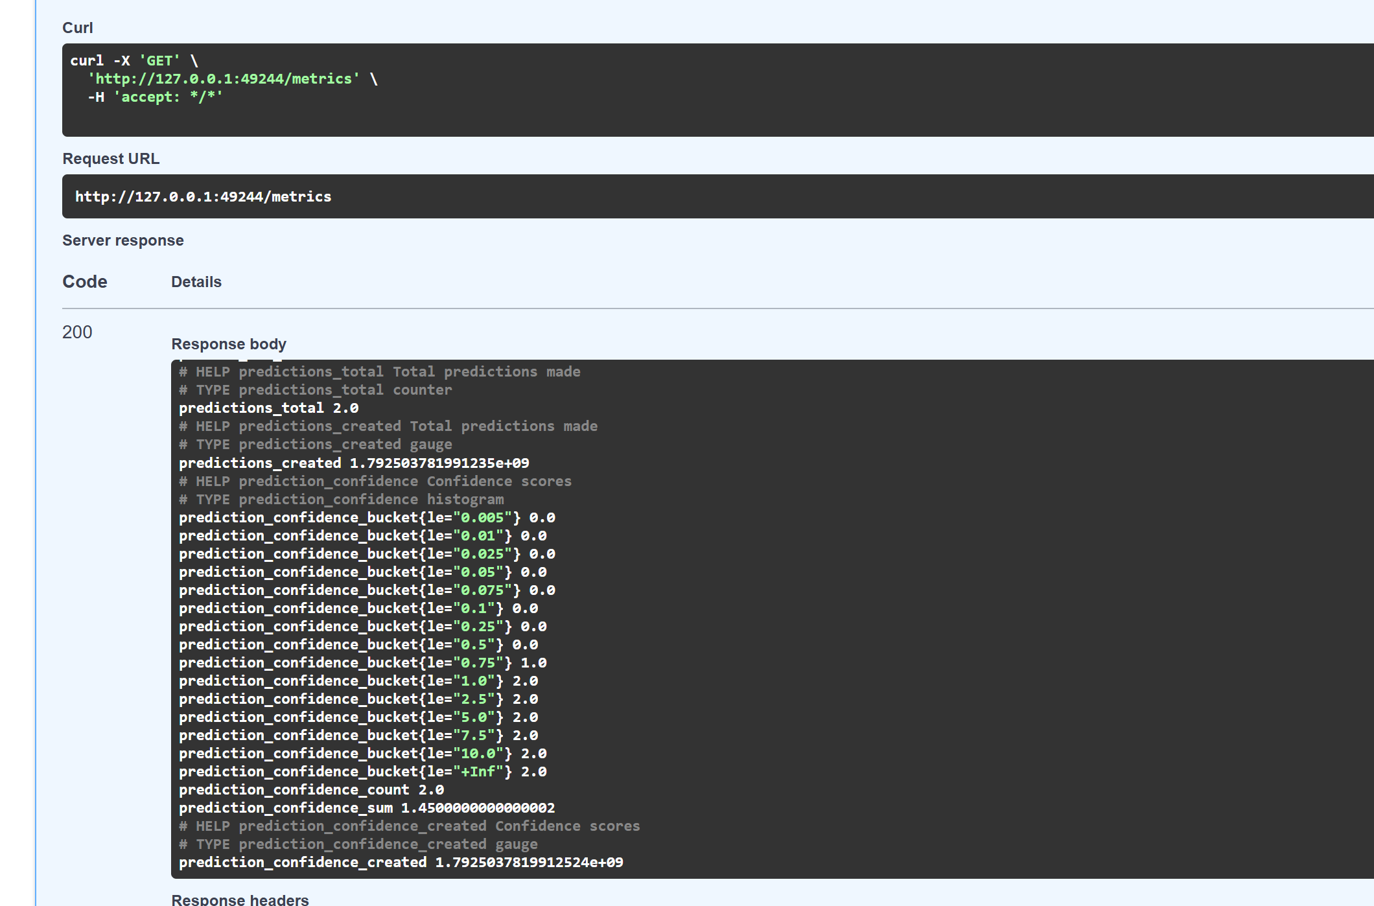

9. Monitoring & Logging
- Logging middleware records every request/response.
- Prometheus scrapes /metrics.
- Grafana dashboard shows:
  - Total predictions over time
  - Confidence histogram
Below screenshot displays log statements of predict endpoint
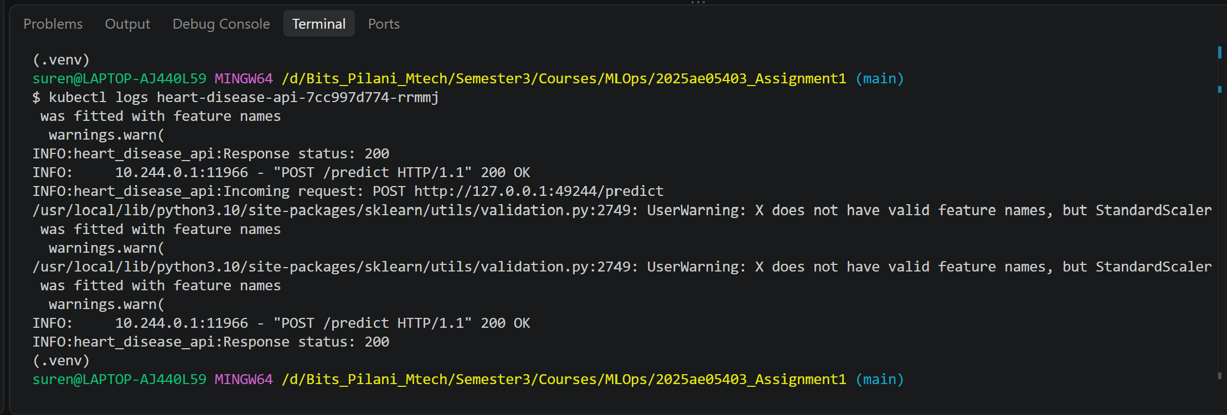

10. Architecture Diagram
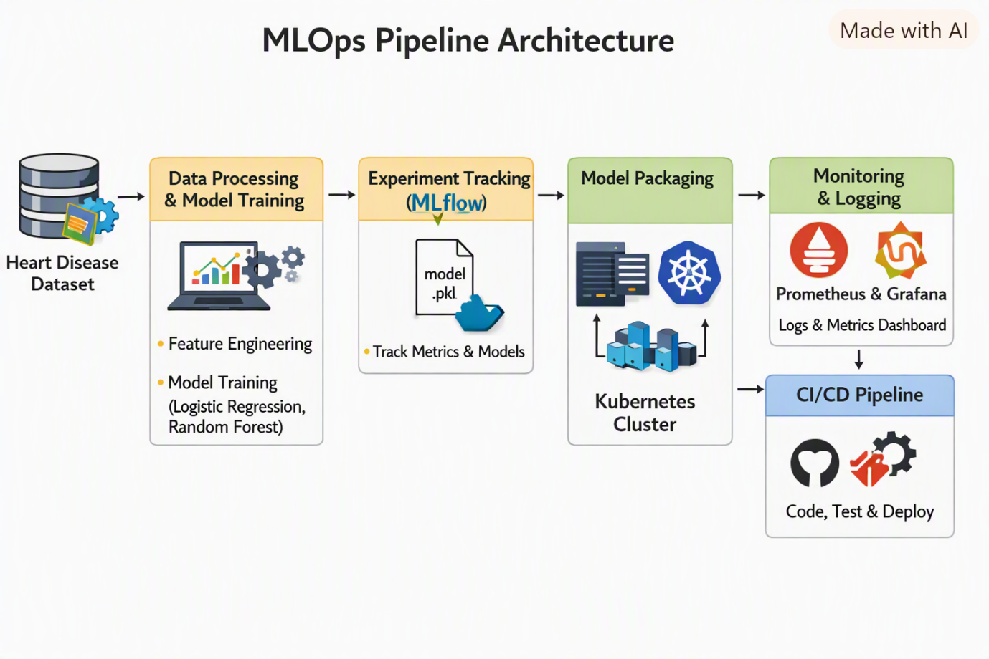

11. Conclusion
This project successfully demonstrates an end-to-end MLOps pipeline. Key achievements include reproducible training, automated CI/CD, containerized deployment, and real-time monitoring.

12. References
- UCI Heart Disease Dataset
- MLflow Documentation
- FastAPI Documentation
- Prometheus & Grafana Docs

