UPI FRAUD DETECTION USING MACHINE LEARNING

CONTENT | PAGE NO
Abstract
1.INTRODUCTION
1.1 Motivation
1.2 Problem Statement
1.3 Objective of the Project
1.4 Scope
1.5 Project Introduction
2.LITERATURE SURVEY
2.1 Related Work
3. SYSTEM ANALYSIS
3.1 Existing System
3.2 Disadvantages
3.3 Proposed System
3.4 Advantages
4. REQUIREMENT ANALYSIS
4.1 Function and non-functional requirements
4.2 Hardware Requirements
4.3 Software Requirements
4.4 Architecture
5. SYSTEM DESIGN
5.1 Introduction of Input design
5.2 UML Diagram(class, use case, sequence, collaborative, deployment, activity, ER diagram and Component diagram)
6. IMPLEMENTATION AND RESULTS
6.1 Modules
6.2 System
6.3 Algorithms (Decision Tree, Random Forest ,k-Nearest Neighbors)
- SYSTEM STUDY AND TESTING
7.1 Feasibility study
8. CONCLUSION
9. FUTURE ENHANCEMENT
REFERENCES

ABSTRACT:
With the rapid adoption of Unified Payments Interface (UPI) for digital transactions, the risk of fraudulent activities has also increased significantly. To address this challenge, we propose a novel approach to detect UPI fraud by analyzing transaction details such as the bank book name, transaction ID, and transaction amount. Our method employs three machine learning algorithms: Random Forest, K-Nearest Neighbors (KNN), and Decision Tree.The Random Forest classifier is known for its accuracy and resilience against overfitting, making it a robust choice for this application. It processes the provided transaction details to classify the transaction outcome as either "Transaction Failed: Incorrect Details Entered" or "Transaction Successful: Details Verified and Processed."In addition to Random Forest, the KNN algorithm provides a straightforward approach to classification based on the similarity of transaction details with previously labeled data. The Decision Tree algorithm, with its intuitive structure, offers clear decision-making pathways, enhancing interpretability.
This multi-algorithm approach not only helps in preventing fraudulent transactions but also ensures that legitimate transactions are processed smoothly. The proposed model aims to enhance the security of UPI transactions, providing users with an additional layer of protection against unauthorized activities. Initial evaluations suggest that these algorithms effectively distinguish between genuine and fraudulent transactions, demonstrating their potential for integration into real-world financial systems.
Keywords: UPI Digital Payments, Random Forest Algorithm, K-Nearest Neighbors, Decision Tree, Machine Learning.

- INTRODUCTION

1.1 Motivation:

The rapid growth of Unified Payments Interface (UPI) has revolutionized digital transactions, making them faster and more convenient. However, this convenience has also led to an alarming increase in fraudulent activities, posing significant risks to users and financial institutions. The motivation behind this project is to develop an effective fraud detection system that safeguards UPI transactions. By leveraging machine learning algorithms like Random Forest, K-Nearest Neighbors (KNN), and Decision Tree, we aim to analyze transaction details such as bank book name, transaction ID, and amount to accurately classify transactions as legitimate or fraudulent. The Random Forest classifier's resilience to overfitting enhances accuracy, while KNN offers a straightforward classification based on similarity to past transactions. The intuitive nature of Decision Trees aids in clear decision-making. This multi-algorithm approach seeks to ensure secure UPI transactions, providing users with peace of mind and fostering trust in digital payment systems.

1.2 Problem Statement:

With the rapid adoption of the Unified Payments Interface (UPI) for digital transactions, the increasing incidence of fraudulent activities poses a significant challenge to financial security. The complexity of transaction details, such as bank book names, transaction IDs, and amounts, creates opportunities for unauthorized transactions. To mitigate this risk, we propose a novel approach for detecting UPI fraud by leveraging machine learning techniques. Our system employs a combination of Random Forest, K-Nearest Neighbors (KNN), and Decision Tree classifiers to analyze transaction data. These algorithms are known for their effectiveness in classification tasks, enabling the system to accurately identify whether a transaction is "Transaction Failed: Incorrect Details Entered" or "Transaction Successful: Details Verified and Processed." By integrating these models, the proposed solution aims to enhance the security of UPI transactions, ensuring that legitimate transactions are processed efficiently while effectively preventing fraudulent activities.

1.3 Objective of the Project:
The primary objective of this project is to develop an effective fraud detection system for Unified Payments Interface (UPI) transactions by analyzing critical transaction details such as the bank book name, transaction ID, and transaction amount. We aim to implement a robust framework utilizing machine learning algorithms, including Random Forest, K-Nearest Neighbors (KNN), and Decision Tree, to classify transactions as either "Transaction Failed: Incorrect Details Entered" or "Transaction Successful: Details Verified and Processed." By leveraging the strengths of these algorithms, our model seeks to accurately identify fraudulent transactions while minimizing false positives for legitimate ones. This will not only enhance the security of UPI digital payments but also ensure a seamless user experience. Ultimately, we aim to integrate our proposed model into real-world financial systems, providing users with an additional layer of protection against unauthorized activities and instilling confidence in digital transactions.
  - Scope:
The scope of this project is to develop a robust system for detecting fraudulent activities in Unified Payments Interface (UPI) transactions by analyzing various transaction details, such as the bank book name, transaction ID, and transaction amount. We will implement three machine learning algorithms: Random Forest, K-Nearest Neighbors (KNN), and Decision Tree. Each algorithm will be evaluated for its effectiveness in classifying transactions as either "Transaction Failed: Incorrect Details Entered" or "Transaction Successful: Details Verified and Processed." The integration of these models aims to enhance the security of UPI transactions, providing users with a reliable mechanism to prevent fraud while ensuring legitimate transactions are processed smoothly. By comparing the performance of these classifiers, the project will identify the most effective approach for real-world application in financial systems, contributing to increased user trust and safety in digital payments.

1.4 Project Introduction
With the rapid adoption of the Unified Payments Interface (UPI) for digital transactions, the associated risk of fraudulent activities has surged significantly. To combat this challenge, we propose a robust approach to detect UPI fraud by analyzing critical transaction details, including the bank book name, transaction ID, and transaction amount. Our method employs three machine learning algorithms: Random Forest, K-Nearest Neighbors (KNN), and Decision Tree. The Random Forest classifier is renowned for its accuracy and resistance to overfitting, making it a strong candidate for distinguishing between legitimate and fraudulent transactions. KNN offers an intuitive distance-based classification, while the Decision Tree provides a clear, interpretable model that facilitates decision-making. This ensemble of techniques classifies transaction outcomes as either "Transaction Failed: Incorrect Details Entered" or "Transaction Successful: Details Verified and Processed." By integrating these methods, our model aims to enhance the security of UPI transactions, ensuring smoother processing of legitimate activities while mitigating the threat of fraud.

2. LITERATURE SURVEY

2.1 Related Work:
1. ALESKEROV E, FREISLEBEN, B., and, RAO B (1997) CARDWATCH: A neural network-based database mining system for credit card fraud detection. In Conference (pp. 220–226). IEEE, Piscataway, NJ
This paper introduces a proactive approach to detecting credit card fraud using the cortical learning algorithm, which identifies spatial and temporal patterns in data from the UCI Repository. Implemented in JAVA and simulated in Matlab, the model achieved over 91% accuracy, outperforming the Neural Network model's 89.6%. The object-oriented analysis and design methodology was employed, significantly improving fraud detection efficiency and minimizing misclassifications.
2. Sahin M (2017) Understanding Telephony Fraud as an Essential Step to Better Fight it [Thesis]. École Doctorale Informatique, Télécommunication et Électronique, Paris
SIMBox or Interconnect Bypass Fraud is a significant issue in the telecommunications industry, causing annual revenue losses between $3 and $7 billion. This fraud occurs when internet calls are redirected through SIM boxes, circumventing legitimate interconnect charges. This paper investigates the impact of SIMBox fraud on the telecom sector and economic development, analyzing fraud detection approaches and their shortcomings through a quantitative method, with literature covering 1994 to 2021.
3. Abdallah A, Maarof MA, Zainal A (2016) Fraud detection system: A survey. J Netw Computer Application 68:90–113
The increasing use of technology has made financial transactions through electronic commerce systems vulnerable to fraud. Fraud Detection Systems (FDSs), when combined with Fraud Prevention Systems (FPSs), can improve security. However, challenges like concept drift, real-time detection, and data imbalance hinder FDS performance. This survey examines fraud types and FDS approaches across five sectors—credit card, telecommunication, healthcare, automobile insurance, and online auctions—and discusses future research trends.
4. ANDREWS PP, PETERSON MB (eds) (1990) Criminal Intelligence Analysis. Palmer Enterprises, Loomis, CA
The shift to intelligence-led policing reflects concerns about transnational crime and new management strategies, analyzed through a cybernetic model focusing on targeting, gathering, analysis, and dissemination of information.
Research on policing has shifted focus from police action to intelligence activities due to factors like transnational policing developments, concerns about organized crime, and new management strategies. This transition to intelligence-led policing can be understood through a cybernetic model, emphasizing the components of targeting, gathering, analysis, and dissemination. The conclusion raises several research questions related to this evolving landscape in policing and governance.
5. ARTÍS M, AyUSO M, GUILLÉN M (1999) Modeling different types of automobile insurance fraud behavior in the Spanish market. Insurance Math Econ 24:67–81
This paper presents a discrete choice modeling framework to analyze repeated choices related to expensive automobile insurance policies (AIPs) using a four-year panel data set of 9,949 records from a Taiwanese non-life insurance company. The multinomial logit model reveals that factors like engine capacity, vehicle type, and age influence AIP bundle selections. The nested logit model indicates that individuals tend to consistently purchase the same physical damage coverage for multiple consecutive years.

3. SYSTEM ANALYSIS

3.1 Existing System
K-Nearest Neighbors (KNN) is a simple, non-parametric algorithm used for both classification and regression tasks. It operates by finding the 'k' closest data points (neighbors) to a query point and making predictions based on the majority class (for classification) or average value (for regression) of these neighbors. The algorithm is intuitive and easy to implement but can be computationally expensive, especially with large datasets, because it requires calculating the distance between the query point and all other points in the dataset. Additionally, KNN's performance can be heavily influenced by the choice of 'k' and the distance metric used, and it is sensitive to irrelevant or noisy features, which can mislead the distance calculations and reduce its accuracy. Despite these limitations, KNN is widely used due to its simplicity and effectiveness in certain scenarios.

3.2 Disadvantages
- Data Sensitivity: Existing systems may struggle with noisy or irrelevant features, which can lead to inaccurate predictions and decreased performance.
- Scalability Issues: Algorithms like KNN can become computationally expensive with large datasets, resulting in slower response times and inefficiencies in real-time applications.
- Overfitting Risk: While Random Forest is robust, decision trees can easily overfit to training data, leading to poor generalization on unseen transactions
- Limited Interpretability: Although Decision Trees provide some level of interpretability, ensemble methods like Random Forest can be less transparent, making it harder for users to understand the decision-making process.
- Imbalanced Data: Fraud detection systems often deal with imbalanced datasets, leading to biased predictions favoring legitimate transactions over fraudulent ones.

3.3 Proposed System:
Random Forest is a powerful machine learning algorithm that can be highly effective in detecting UPI fraud. It operates by building multiple decision trees during training and combining their predictions to make a final decision. This ensemble method improves accuracy and reduces the risk of overfitting, making it well-suited for complex tasks like fraud detection where the data can be noisy, imbalanced, and involve intricate relationships between features. In the context of UPI fraud detection, Random Forest can analyze various transaction attributes such as the bank book name, transaction ID, and amount, identifying patterns that distinguish between legitimate and fraudulent transactions. By leveraging the combined power of multiple trees, Random Forest can capture the subtle indicators of fraud that might be missed by simpler models.

3.4 Advantages:
- Enhanced Accuracy: Utilizing Random Forest, KNN, and Decision Tree algorithms improves classification accuracy by leveraging the strengths of each model, reducing the likelihood of false positives and negatives.
- Robustness Against Overfitting: Random Forest's ensemble approach mitigates overfitting, making the system resilient to noisy and imbalanced transaction data.
- Interpretability: Decision Trees provide clear decision-making pathways, allowing users to understand the rationale behind classification outcomes, which is crucial for trust in financial systems.
- Real-time Detection: The system can analyze transaction details in real time, enabling swift identification and prevention of fraudulent activities.
- Flexibility: The multi-algorithm approach can adapt to evolving fraud patterns by retraining with new data, ensuring continued effectiveness.
- User Protection: By accurately distinguishing between genuine and fraudulent transactions, the system enhances user confidence and security in digital transactions.

4. REQUIREMENT ANALYSIS

4.1 Functional and non-functional requirements
Requirement’s analysis is very critical process that enables the success of a system or software project to be assessed. Requirements are generally split into two types: Functional and non-functional requirements.
Functional Requirements: These are the requirements that the end user specifically demands as basic facilities that the system should offer. All these functionalities need to be necessarily incorporated into the system as a part of the contract. These are represented or stated in the form of input to be given to the system, the operation performed and the output expected. They are basically the requirements stated by the user which one can see directly in the final product, unlike the non-functional requirements.
Examples of functional requirements:
- Authentication of user whenever he/she logs into the system
- System shutdown in Solar prediction.
- A verification email is sent to user whenever he/she register for the first time on some software system.
Non-functional requirements: These are basically the quality constraints that the system must satisfy according to the project contract. The priority or extent to which these factors are implemented varies from one project to other. They are also called non-behavioral requirements.
They basically deal with issues like:
- Portability
- Security
- Maintainability
- Reliability
- Scalability
- Performance
- Reusability
- Flexibility
Examples of non-functional requirements:
- Emails should be sent with a latency of no greater than 12 hours from such an activity.
- The processing of each request should be done within 10 seconds
- The site should load in 3 seconds whenever of simultaneous users are > 10000
  - Hardware Requirements
Operating system : Windows 7 or 7+
RAM : 8 GB
Hard disc or SSD : More than 500 GB
Processor : Intel 3rd generation or high or Ryzen with 8 GB Ram
  - Software Requirements:
Software’s : Python 3.10 or high version
IDE : Visual Studio Code.
Framework : Flask
IDE/Workbench : PyCharm
Technology : Python 3.6+
Server Deployment : Xampp Server
Database : MySQL

4.4Architecture

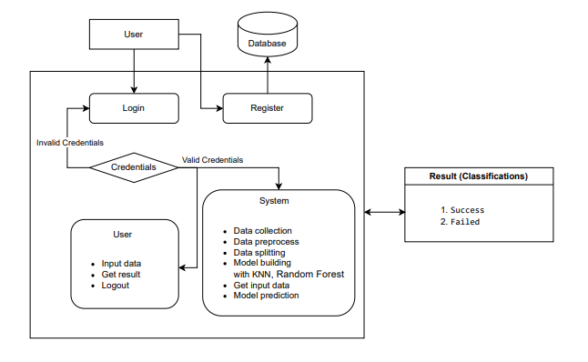

- SYSTEM DESIGN

5.1 Introduction of Input Design:
In an information system, input is the raw data that is processed to produce output. During the input design, the developers must consider the input devices such as PC, MICR, OMR, etc.
Therefore, the quality of system input determines the quality of system output. Well-designed input forms and screens have following properties −
- It should serve specific purpose effectively such as storing, recording, and retrieving the information.
- It ensures proper completion with accuracy.
- It should be easy to fill and straightforward.
- It should focus on user’s attention, consistency, and simplicity.
- All these objectives are obtained using the knowledge of basic design principles regarding −
  - What are the inputs needed for the system?
  - How end users respond to different elements of forms and screens.
Objectives for Input Design:
The objectives of input design are −
- To design data entry and input procedures
- To reduce input volume
- To design source documents for data capture or devise other data capture methods
- To design input data records, data entry screens, user interface screens, etc.
- To use validation checks and develop effective input controls.
Output Design:
The design of output is the most important task of any system. During output design, developers identify the type of outputs needed, and consider the necessary output controls and prototype report layouts.

The objectives of input design are:
- To develop output design that serves the intended purpose and eliminates the production of unwanted output.
- To develop the output design that meets the end user’s requirements.
- To deliver the appropriate quantity of output.
- To form the output in appropriate format and direct it to the right person.
- To make the output available on time for making good decisions.

5.2 UML Diagrams:
UML DIAGRAMS
UML stands for Unified Modelling Language. UML is a standardized general-purpose modelling language in the field of object-oriented software engineering. The standard is managed, and was created by, the Object Management Group.
The goal is for UML to become a common language for creating models of object-oriented computer software. In its current form UML is comprised of two major components: a Meta-model and a notation. In the future, some form of method or process may also be added to; or associated with, UML.
The Unified Modelling Language is a standard language for specifying, Visualization, Constructing and documenting the artefacts of software system, as well as for business modelling and other non-software systems.
The UML represents a collection of best engineering practices that have proven successful in the modelling of large and complex systems.
The UML is a very important part of developing objects-oriented software and the software development process. The UML uses mostly graphical notations to express the design of software projects.

GOALS:
The Primary goals in the design of the UML are as follows:
- Provide users a ready-to-use, expressive visual modelling Language so that they can develop and exchange meaningful models.
- Provide extendibility and specialization mechanisms to extend the core concepts.
- Be independent of particular programming languages and development process.
- Provide a formal basis for understanding the modelling language.
- Encourage the growth of OO tools market.
- Support higher level development concepts such as collaborations, frameworks, patterns and components.
- Integrate best practices.

5.3 USE CASE DIAGRAM
- A use case diagram in the Unified Modeling Language (UML) is a type of behavioral diagram defined by and created from a Use-case analysis.
- Its purpose is to present a graphical overview of the functionality provided by a system in terms of actors, their goals (represented as use cases), and any dependencies between those use cases.
- The main purpose of a use case diagram is to show what system functions are performed for which actor. Roles of the actors in the system can be depicted.

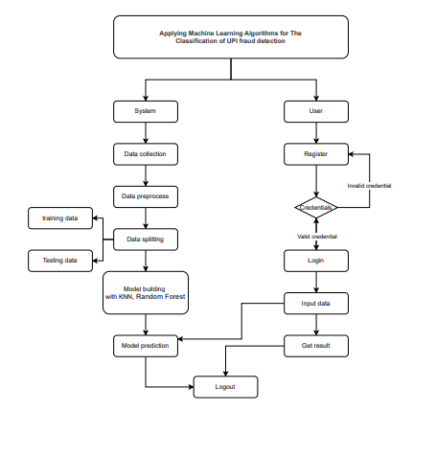

CLASS DIAGRAM
In software engineering, a class diagram in the Unified Modeling Language (UML) is a type of static structure diagram that describes the structure of a system by showing the system's classes, their attributes, operations (or methods), and the relationships among the classes. It explains which class contains information

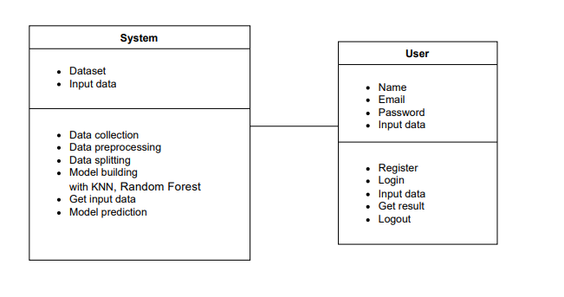

SEQUENCE DIAGRAM
- A sequence diagram in Unified Modeling Language (UML) is a kind of interaction diagram that shows how processes operate with one another and in what order.
- It is a construct of a Message Sequence Chart. Sequence diagrams are sometimes called event diagrams, event scenarios, and timing diagrams

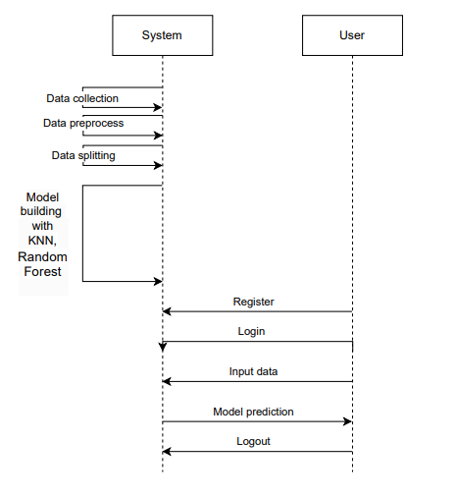
DEPLOYMENT DIAGRAM
Deployment diagram represents the deployment view of a system. It is related to the component diagram. Because the components are deployed using the deployment diagrams. A deployment diagram consists of nodes. Nodes are nothing but physical hardware’s used to deploy the application.
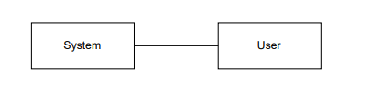

ACTIVITY DIAGRAM:
Activity diagrams are graphical representations of workflows of stepwise activities and actions with support for choice, iteration and concurrency. In the Unified Modelling Language, activity diagrams can be used to describe the business and operational step-by-step workflows of components in a system. An activity diagram shows the overall flow of control.

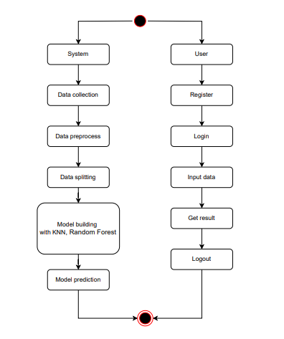

COMPONENT DIAGRAM:
A component diagram, also known as a UML component diagram, describes the organization and wiring of the physical components in a system. Component diagrams are often drawn to help model implementation details and double-check that every aspect of the system's required function is covered by planned development.

ER DIAGRAM:
An Entity–relationship model (ER model) describes the structure of a database with the help of a diagram, which is known as Entity Relationship Diagram (ER Diagram). An ER model is a design or blueprint of a database that can later be implemented as a database. The main components of E-R model are: entity set and relationship set.
An ER diagram shows the relationship among entity sets. An entity set is a group of similar entities and these entities can have attributes. In terms of DBMS, an entity is a table or attribute of a table in database, so by showing relationship among tables and their attributes, ER diagram shows the complete logical structure of a database. Let’s have a look at a simple ER diagram to understand this concept.
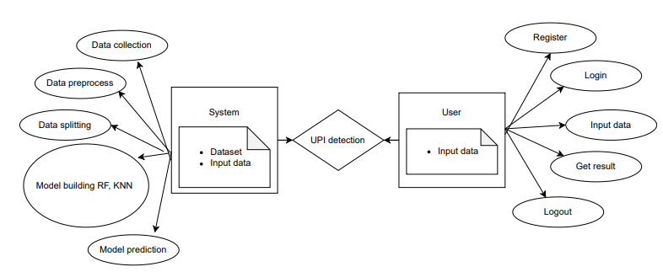

DFD DIAGRAM:
A Data Flow Diagram (DFD) is a traditional way to visualize the information flows within a system. A neat and clear DFD can depict a good amount of the system requirements graphically. It can be manual, automated, or a combination of both. It shows how information enters and leaves the system, what changes the information and where information is stored. The purpose of a DFD is to show the scope and boundaries of a system as a whole. It may be used as a communications tool between a systems analyst and any person who plays a part in the system that acts as the starting point for redesigning a system.
Contrast Level:

Level 1 Diagram

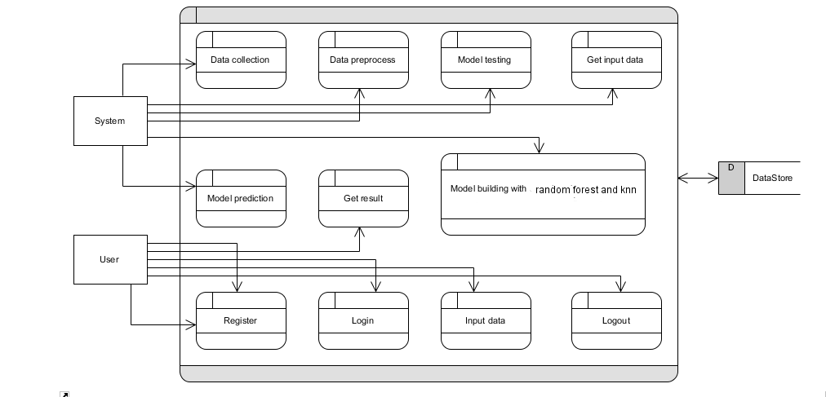
Level 2 Diagram
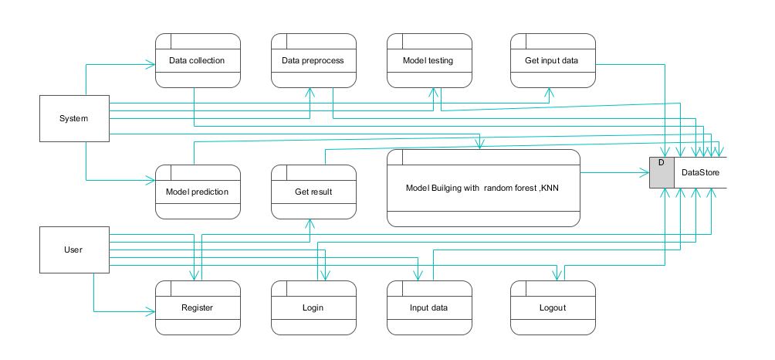

6. IMPLEMENTATION AND RESULTS

6.1 Modules

1. Users can upload a dataset, which is a crucial initial step for the system to work with relevant data. This dataset likely contains historical information or examples that the system will use for its predictions.
2. Users have the capability to view the dataset they've uploaded. This feature helps users confirm the data they've provided and ensures transparency in the process.
3. Users need to input specific values or parameters into the system to request predictions or results. These input values likely correspond to the variables or features in the dataset.

6.2 System

- Take the Dataset: The system accepts and processes the dataset provided by the user. This dataset forms the foundation for building the predictive model.
- Preprocessing: Before training a predictive model, the system preprocesses the dataset. This includes handling missing data, data cleaning, and feature extraction. Preprocessing ensures that the data is in a suitable format for modeling.
- Training: The system uses machine learning techniques and Python modules to train a model based on the preprocessed dataset. The model learns patterns and relationships within the data, allowing it to make predictions.
- Generate Results: Once the model is trained, the system can generate results based on user input values. These results typically indicate whether the input data corresponds to a specific condition, event, or prediction, such as Medical Insurance Cost

6.3 Algorithms:

6.3.1. Random Forest:
A random forest is a machine learning technique that’s used to solve regression and classification problems. It utilizes ensemble learning, which is a technique that combines many classifiers to provide solutions to complex problems.
A random forest algorithm consists of many decision trees. The ‘forest’ generated by the random forest algorithm is trained through bagging or bootstrap aggregating. Bagging is an ensemble meta-algorithm that improves the accuracy of machine learning algorithms.
The (random forest) algorithm establishes the outcome based on the predictions of the decision trees. It predicts by taking the average or mean of the output from various trees. Increasing the number of trees increases the precision of the outcome.
A random forest eradicates the limitations of a decision tree algorithm. It reduces the over fitting of datasets and increases precision. It generates predictions without requiring many configurations in packages (like Scikit-learn).
Features of a Random Forest Algorithm:
- It’s more accurate than the decision tree algorithm.
- It provides an effective way of handling missing data.
- It can produce a reasonable prediction without hyper-parameter tuning.
- It solves the issue of over fitting in decision trees.
- In every random forest tree, a subset of features is selected randomly at the node’s splitting point.

Decision trees are the building blocks of a random forest algorithm. A decision tree is a decision support technique that forms a tree-like structure. An overview of decision trees will help us understand how random forest algorithms work.
A decision tree consists of three components: decision nodes, leaf nodes, and a root node. A decision tree algorithm divides a training dataset into branches, which further segregate into other branches. This sequence continues until a leaf node is attained. The leaf node cannot be segregated further.
The nodes in the decision tree represent attributes that are used for predicting the outcome. Decision nodes provide a link to the leaves. The following diagram shows the three types of nodes in a decision tree.

The information theory can provide more information on how decision trees work. Entropy and information gain are the building blocks of decision trees. An overview of these fundamental concepts will improve our understanding of how decision trees are built.
Entropy is a metric for calculating uncertainty. Information gain is a measure of how uncertainty in the target variable is reduced, given a set of independent variables.
The information gain concept involves using independent variables (features) to gain information about a target variable (class). The entropy of the target variable (Y) and the conditional entropy of Y (given X) are used to estimate the information gain. In this case, the conditional entropy is subtracted from the entropy of Y.
Information gain is used in the training of decision trees. It helps in reducing uncertainty in these trees. A high information gain means that a high degree of uncertainty (information entropy) has been removed. Entropy and information gain are important in splitting branches, which is an important activity in the construction of decision trees.
Let’s take a simple example of how a decision tree works. Suppose we want to predict if a customer will purchase a mobile phone or not. The features of the phone form the basis of his decision. This analysis can be presented in a decision tree diagram.
Results:
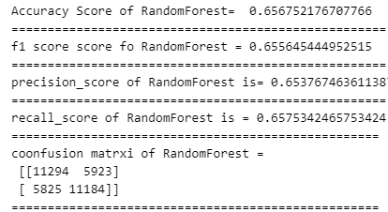
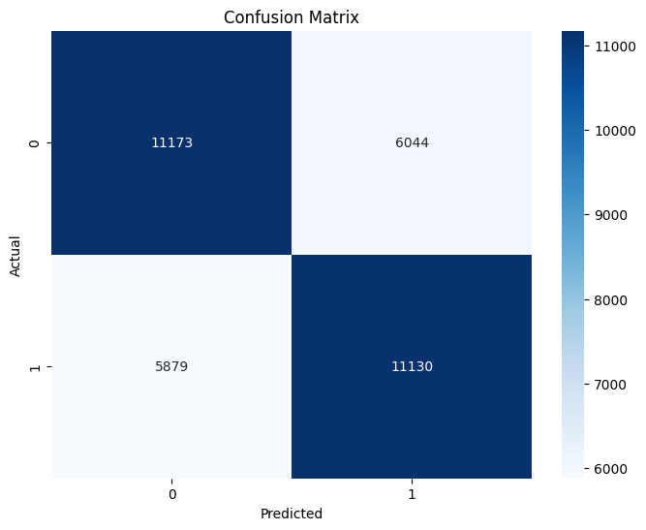

6.3.2. Decision Tree

A decision tree is a non-parametric supervised learning algorithm. It has a hierarchical, tree structure, which consists of a root node, branches, internal nodes and leaf nodes.
Decision Trees are the foundation for many classical machine learning algorithms like Random Forests, Bagging, and Boosted Decision Trees. His idea was to represent data as a tree where each internal node denotes a test on an attribute (basically a condition), each branch represents an outcome of the test, and each leaf node (terminal node) holds a class label.
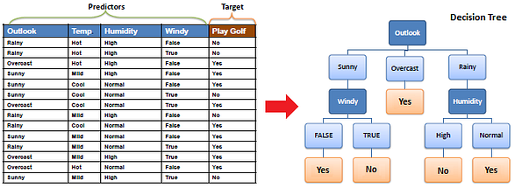
Types of Decision Trees
CART (Classification and Regression Trees) → uses Gini Index(Classification) as metric.
ID3 (Iterative Dichotomiser 3) → uses Entropy function and Information gain as metrics.
Before learning more about decision trees let’s get familiar with some of the terminologies.
- Root Nodes — It is the node present at the beginning of a decision tree from this node the population starts dividing according to various features.
- Decision Nodes — the nodes we get after splitting the root nodes are called Decision Node
- Leaf Nodes — the nodes where further splitting is not possible are called leaf nodes or terminal nodes
- Branch/Sub-tree — just like a small portion of a graph is called sub-graph similarly a sub-section of this decision tree is called sub-tree.
- Pruning — is nothing but cutting down some nodes to stop overfitting.
Results:

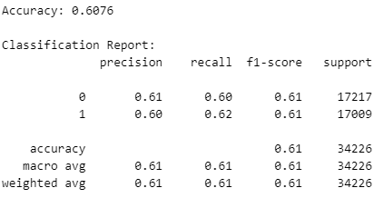

6.3.3 k-Nearest Neighbors (k-NN):

k-Nearest Neighbors (k-NN) is a simple, yet powerful, non-parametric algorithm used for both classification and regression tasks in machine learning. It operates on the principle that similar data points are located close to each other in feature space. This algorithm is particularly useful for tasks where the decision boundary is irregular and cannot be easily defined by a linear equation.

k-NN Works
Data Representation
Data point is represented as a point in a multi-dimensional space, with dimensions corresponding to the features of the data.
Choosing 'k':
- The user specifies the number of nearest neighbors, kkk. This value determines how many neighboring data points will influence the classification or prediction.
Distance Metric:
- A distance metric, such as Euclidean distance, Manhattan distance, or Minkowski distance, is used to calculate the distance between data points. The choice of distance metric can affect the performance of the algorithm.
Finding Neighbors:
- For a given input point (the point to classify or predict), the algorithm computes the distance from this point to all other points in the training dataset.
- It then identifies the kkk closest points (neighbors) based on the calculated distances.
Voting (for Classification):
- In classification tasks, the algorithm assigns a label to the input point based on the majority label among its kkk neighbors. Each neighbor votes for its class, and the class with the most votes is chosen as the predicted label.
Averaging (for Regression):
- In regression tasks, the algorithm calculates the average of the values of the kkk nearest neighbors and assigns this average as the predicted value for the input point.
Results:
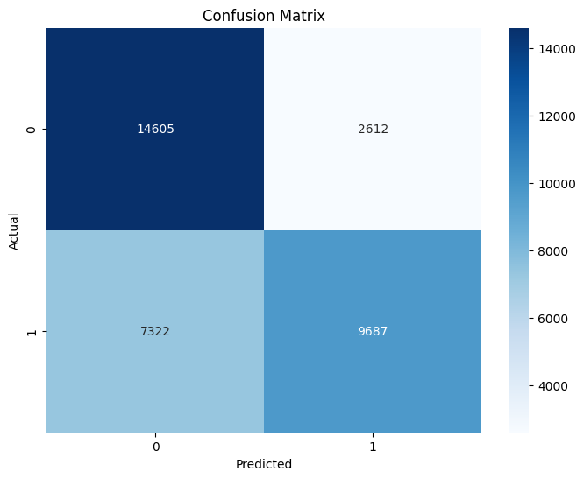
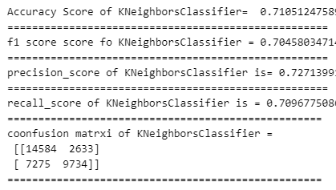

COMPARISON OF ALL MODELS
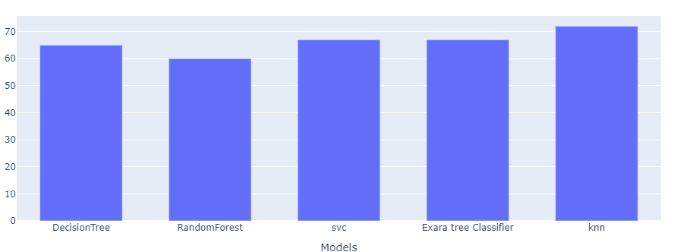
The diagram presents an accuracy comparison of different machine learning models:
The bar chart compares the performance of various machine learning models for a classification task. Each bar represents a different model: Decision Tree, Random Forest, Support Vector Classifier (SVC), Extra Tree Classifier, and K-Nearest Neighbors (KNN). The height of each bar indicates the accuracy achieved by each model, with all models showing similar performance levels, generally hovering around 60-70%. This visualization highlights the effectiveness of these algorithms in the context of the dataset used, suggesting that further tuning or ensemble methods could enhance performance. Overall, it provides a clear visual representation of the models' comparative accuracies. ​

7. SYSTEM STUDY AND TESTING

7.1 System Testing

The purpose of testing is to discover errors. Testing is the process of trying to discover every conceivable fault or weakness in a work product. It provides a way to check the functionality of components, sub-assemblies, assemblies and/or a finished product It is the process of exercising software with the intent of ensuring that the
Software system meets its requirements and user expectations and does not fail in an unacceptable manner. There are various types of test. Each test type addresses a specific testing requirement.

7.2.1 Unit testing

Unit testing involves the design of test cases that validate that the internal program logic is functioning properly, and that program inputs produce valid outputs. All decision branches and internal code flow should be validated. It is the testing of individual software units of the application .it is done after the completion of an individual unit before integration. This is a structural testing, that relies on knowledge of its construction and is invasive. Unit tests perform basic tests at component level and test a specific business process, application, and/or system configuration. Unit tests ensure that each unique path of a business process performs accurately to the documented specifications and contains clearly defined inputs and expected results.

7.2.2 Integration testing
Integration tests are designed to test integrated software components to determine if they actually run as one program. Testing is event driven and is more concerned with the basic outcome of screens or fields. Integration tests demonstrate that although the components were individually satisfaction, as shown by successfully unit testing, the combination of components is correct and consistent. Integration testing is specifically aimed at exposing the problems that arise from the combination of components.
Software integration testing is the incremental integration testing of two or more integrated software components on a single platform to produce failures caused by interface defects.
The task of the integration test is to check that components or software applications, e.g. components in a software system or – one step up – software applications at the company level – interact without error.
Test Results: All the test cases mentioned above passed successfully. No defects encountered.
Acceptance Testing
User Acceptance Testing is a critical phase of any project and requires significant participation by the end user. It also ensures that the system meets the functional requirements.
Test Results: All the test cases mentioned above passed successfully. No defects encountered.

7.2.3 Functional testing
Functional tests provide systematic demonstrations that functions tested are available as specified by the business and technical requirements, system documentation, and user manuals.
Functional testing is centered on the following items:
Valid Input : identified classes of valid input must be accepted.
Invalid Input : identified classes of invalid input must be rejected.
Functions : identified functions must be exercised.
Output : identified classes of application outputs must be exercised.
Systems/Procedures: interfacing systems or procedures must be invoked.
Organization and preparation of functional tests is focused on requirements, key functions, or special test cases. In addition, systematic coverage pertaining to identify Business process flows; data fields, predefined processes, and successive processes must be considered for testing. Before functional testing is complete, additional tests are identified and the effective value of current tests is determined.

7.2.4 White Box Testing
White Box Testing is a testing in which in which the software tester has knowledge of the inner workings, structure and language of the software, or at least its purpose. It is purpose. It is used to test areas that cannot be reached from a black box level.

7.2.5 Black Box Testing
Black Box Testing is testing the software without any knowledge of the inner workings, structure or language of the module being tested. Black box tests, as most other kinds of tests, must be written from a definitive source document, such as specification or requirements document, such as specification or requirements document. It is a testing in which the software under test is treated, as a black box. you cannot “see” into it. The test provides inputs and responds to outputs without considering how the software works.
Test objectives
- All field entries must work properly.
- Pages must be activated from the identified link.
- The entry screen, messages and responses must not be delayed.
Features to be tested
- Verify that the entries are of the correct format
- No duplicate entries should be allowed
- All links should take the user to the correct page.
- Test cases Model building:

S.NO | Test cases | I/O | Expected O/T | Actual O/T | P/F
1 | Read the datasets. | Dataset’s path. | Datasets need to read successfully. | Datasets fetched successfully. | It produced P. If this not F will come
2 | Registration | Valid username, email, password. | Verify that the registration form accepts valid user inputs and successfully creates a new account. | User is successfully registered, and an account is created | It produced P. If this is not, it will undergo F.
3 | Login | Valid username and password | Verify that users can log in with valid credentials | User is successfully logged in and redirected to the dashboard | It produced P. If this is not, it will undergo F.
4 | Find out  Success or failed | Input Related to the dataset | Output as predicted classification of Success or failed | Output as predicted classification of Success or failed | It produced 1 is Success or 0 is failed

8. CONCLUSION
In conclusion, the increasing reliance on Unified Payments Interface (UPI) for digital transactions necessitates robust fraud detection mechanisms to safeguard users against unauthorized activities. Our proposed multi-algorithm approach, utilizing Random Forest, K-Nearest Neighbors (KNN), and Decision Tree classifiers, effectively analyzes transaction details to identify fraudulent transactions while ensuring the smooth processing of legitimate ones. The Random Forest algorithm excels in accuracy and resilience against overfitting, while KNN offers a simple yet effective classification based on similarity, and Decision Trees provide intuitive decision pathways that enhance interpretability. The initial evaluations demonstrate the potential of these algorithms to significantly improve UPI transaction security. By implementing our model, financial institutions can enhance user confidence and protect their assets, ultimately fostering a safer digital payment environment. This research contributes to the ongoing efforts to mitigate fraud in digital transactions, ensuring the integrity and reliability of UPI as a preferred payment method.

9. FUTURE ENHANCEMENT
Future enhancements to the UPI fraud detection model could involve incorporating advanced machine learning techniques, such as ensemble methods or deep learning algorithms, to improve classification accuracy further. Additionally, leveraging real-time data analytics can enhance the model's responsiveness to emerging fraudulent patterns. Implementing feature engineering to identify additional transaction attributes, such as user behavior patterns and geographical location, could provide deeper insights into transaction legitimacy.
Moreover, integrating a feedback mechanism that continuously updates the model based on new transaction data can ensure adaptability to evolving fraud tactics. Collaborating with financial institutions to gather diverse datasets would enrich the training data and enhance model robustness. Finally, developing a user-friendly interface that provides real-time alerts and transaction verification options could improve user engagement and security awareness. These enhancements would not only strengthen the detection capabilities but also foster trust in UPI systems, ultimately promoting safer digital transactions.

References
1. ALESKEROV E, FREISLEBEN, B., and, RAO B (1997) CARDWATCH: A neural network-based database mining system for credit card fraud detection. In Conference (pp. 220–226). IEEE, Piscataway, NJ
2. Sahin M (2017) Understanding Telephony Fraud as an Essential Step to Better Fight it [Thesis]. École Doctorale Informatique, Télécommunication et Électronique, Paris
3. Abdallah A, Maarof MA, Zainal A (2016) Fraud detection system: A survey. J Netw Comput Appl 68:90–113
4. ANDREWS PP, PETERSON MB (eds) (1990) Criminal Intelligence Analysis. Palmer Enterprises, Loomis, CA
5. ARTÍS M, AyUSO M, GUILLÉN M (1999) Modeling different types of automobile insurance fraud behavior in the Spanish market. Insurance Math Econ 24:67–81
6. BARAO MI, TAWN JA (1999) Extremal analysis of short series with outliers: Sea-levels and athletics records. Appl Stat 48:469–487 Page 14/16
7. BLUNT G, HAND DJ (2000) The UK credit card market. Technical report, Department of Mathematics, Imperial College, London
8. BOLTON RJ, HAND DJ (2001) Unsupervised profiling methods for fraud detection. In Conference on Credit Scoring and Credit Control 7, Edinburgh, UK, 5–7 Sept
9. Phua C, Lee V, Smith K, Gayler R (2010) A comprehensive survey of data mining-based fraud detection research. https://doi.org/10.48550/ARXIV.1009.6119
10. Summers SL, Sweeney JT (1998) Fraudulently misstated financial statements and insider trading: An empirical analysis. 73(1):131–146https://www.jstor.org/stable/248345
11. BROCKETT PL, XIA X, DERRIG RA (1998) Using Kohonen's self-organizing feature map to unveil automobile bodily injury claims fraud. J Risk Insur 65:245–274
12. Sambra AV, Mansour E, Hawke S, Zereba M, Greco N, Ghanem A, Zagidulin D, Aboulnaga A, BernersLee T (2016) Solid:a platform for decentralized social applications based on linked data
13. Becker RA, Volinsky C, Wilks AR (2010) Fraud Detect Telecommunications 52(1):20–33
14. Dorronsoro JR, Ginel F, Sanchez C, Santa Cruz C (1997) Neural fraud detection in credit card operations. IEEE 8:827–834
15. Hand C, Whitrow DJ, Adams C, Juszczak NM, Weston P D (2008) Performance criteria for plastic card fraud detection. JORS 59(7):956–962

