1. Source – Web API file link - <https://gorest.co.in/public/v2/users>

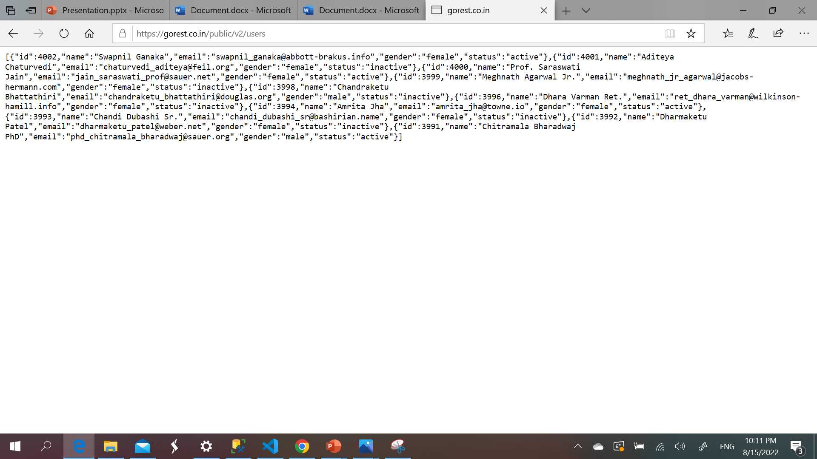

2. Executing the python script in VS CODE.

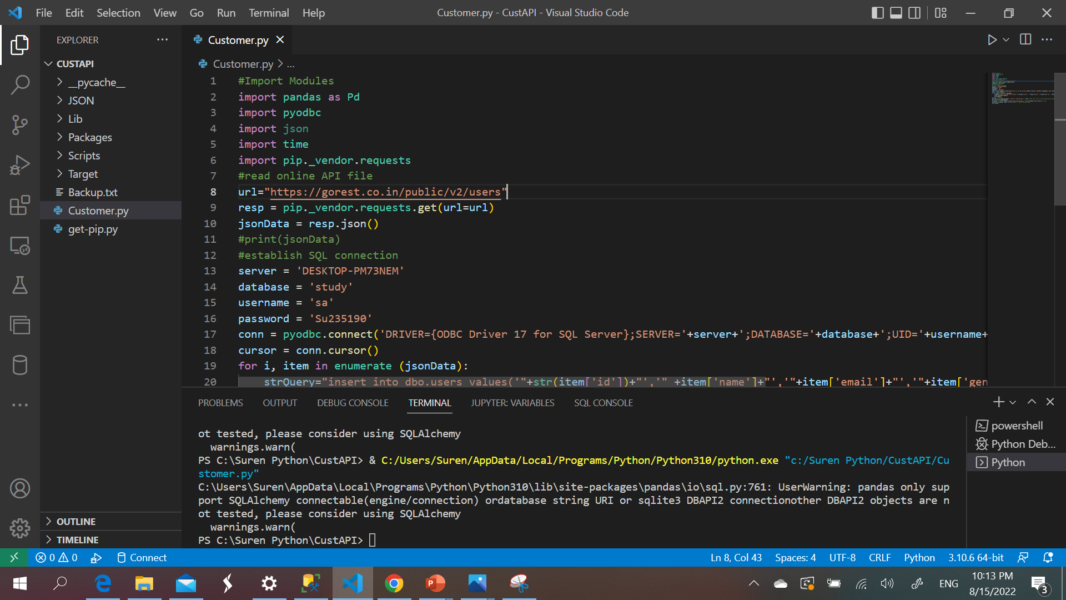

3. API data has been loaded in the SQL database

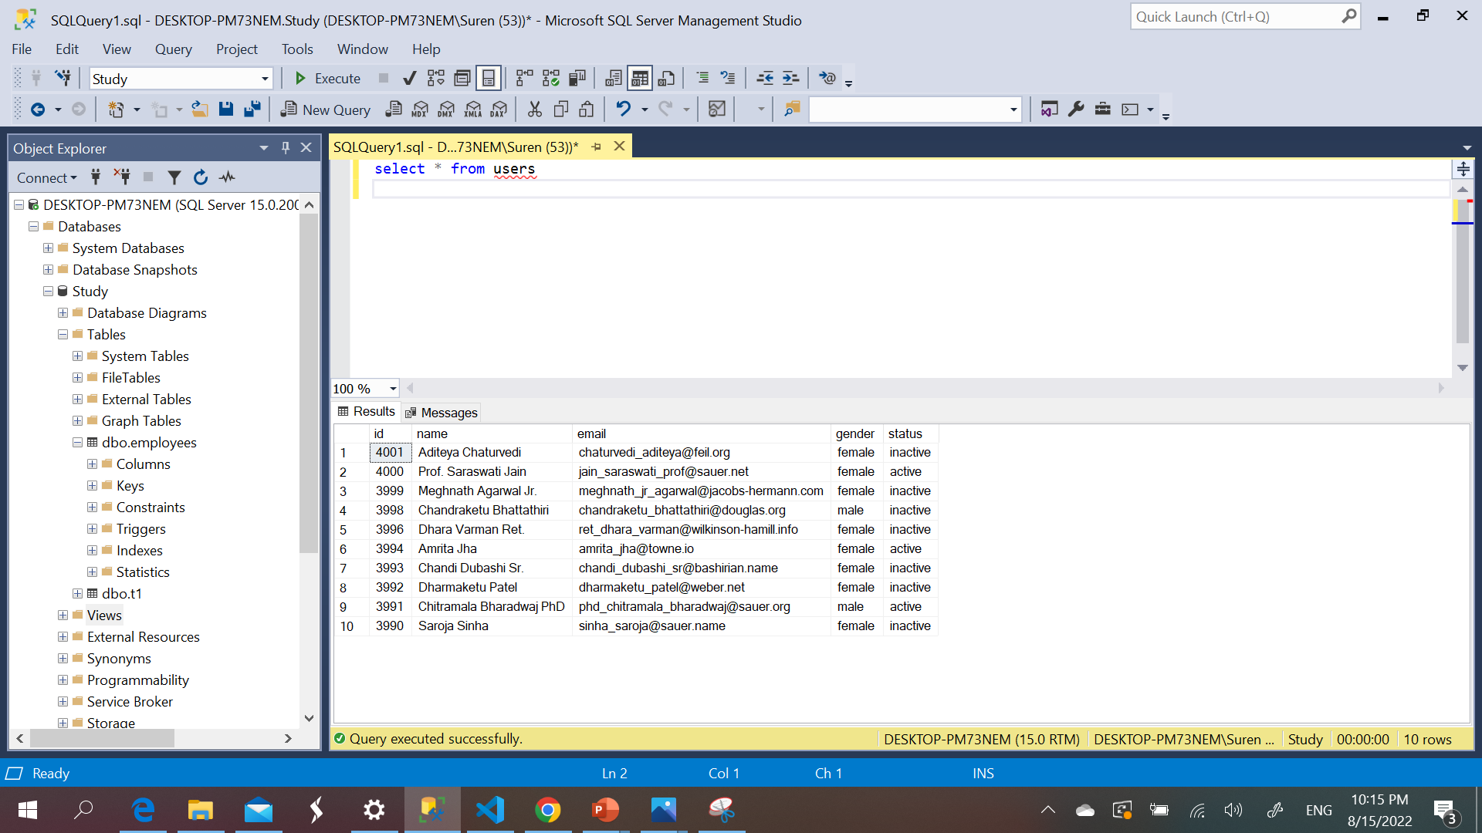

4. The data has been exported as .csv file

