1. Develop a system using UML for Personal Loan Management System. The admin should add new customers and view the customer's records. The admin should check the defaulters. The customer can see his/her account detail and apply for a new loan by providing the required documents, and pay slip. The admin should verify the document submitted and approve the loan after verifying the payback potential of the customer.

**Use case diagram:**

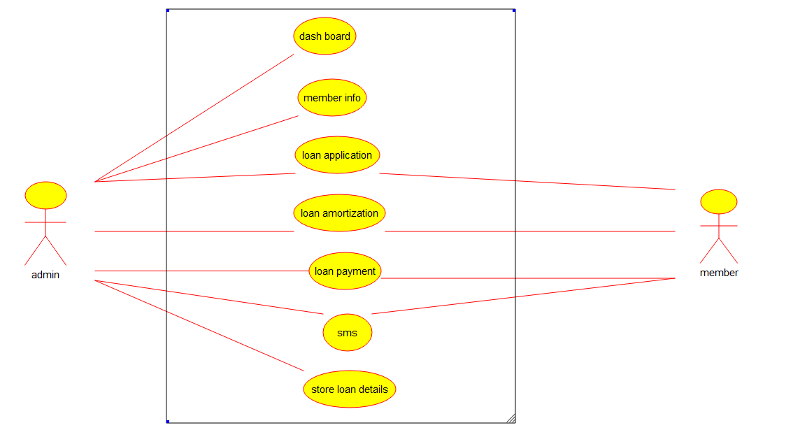

**Class diagram:**

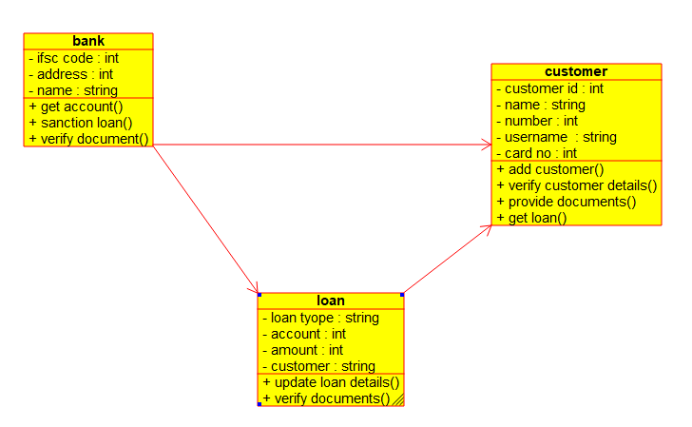

**Component diagram:**

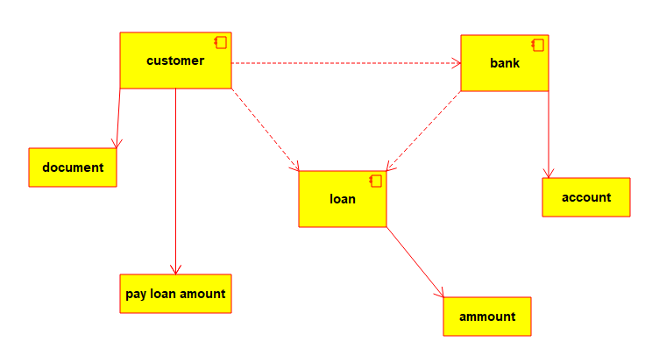

**Deployment diagram:**

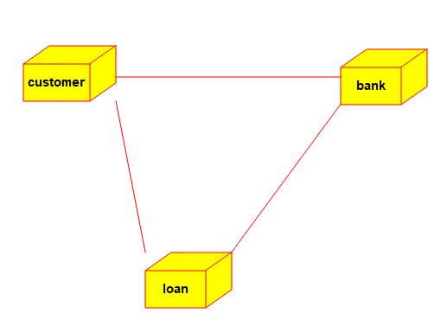

**State chart diagram:**

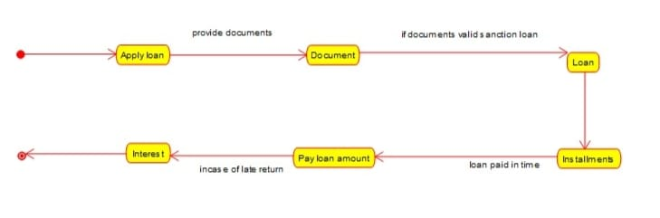

**Communication diagram:**

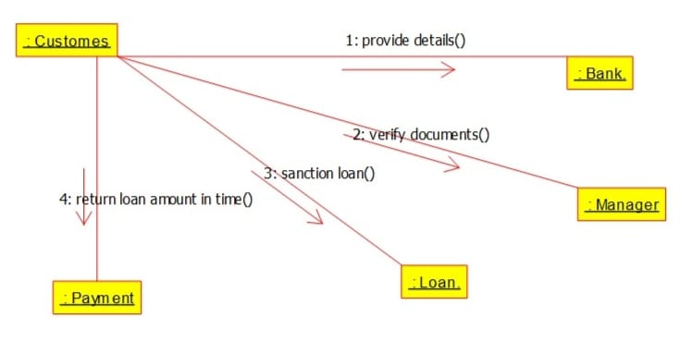

**Activity diagram:**

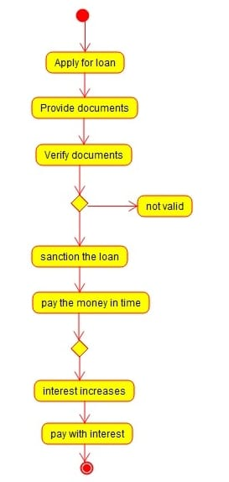

**Sequence diagram:**

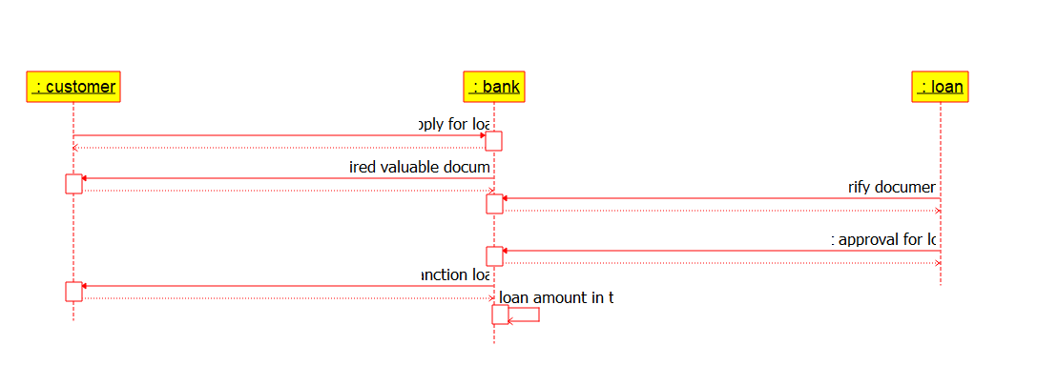

**Entity diagram:**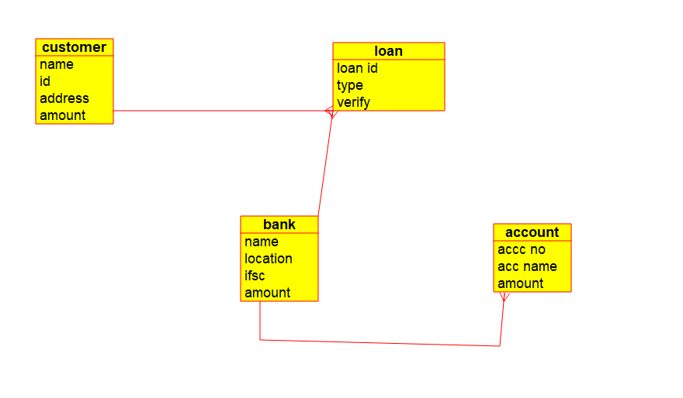

**Result:**

**Thus an UML diagrams for Loan Management System has been drawn successfully by using Umbrella software.**