EXERCISE 03

01)Insert the values as given below for all the tables. Use the dml.sql file to create the required schema. Experiment the various syntaxes in INSERT TABLE command.

MASTER TABLE:

INSERT INTO master (master_id, name, mtype, nationality) VALUES

(101, 'Adolf Hitler', 'person', 'Germany'),

(102, 'Guru', 'cartoon', 'USA'),

(103, 'Frankenstein', 'fictional', 'England'),

(104, 'Ivan Dracula', 'fictional', 'Russia'),

(105, 'Osama', 'person', 'Saudi Arabia'),

(106, 'Nero', 'cartoon', 'Europe'),

(107, 'Mojo Jojo', 'cartoon', 'USA'),

(108, 'Loki', 'fictional', 'USA'),

(109, 'Lex Luthor', 'fictional', 'USA'),

(110, 'Megatron', 'cartoon', 'Japan');

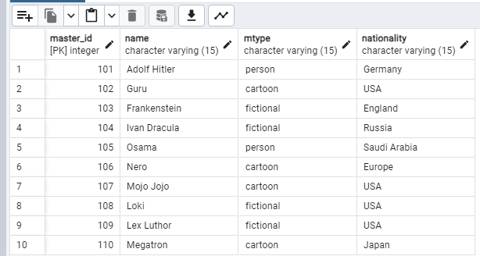

EVILNESS TABLE:

INSERT INTO evilness (evil_id, level, description) VALUES

(201, 1, 'Sneeze'),

(202, 2, 'Itch'),

(203, 3, 'Tickle'),

(204, 4, 'Yawn');

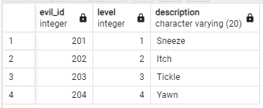

MINION TABLE:

INSERT INTO minion (minion_id, evilness, name, gender, age, nationality, hiring_charge) VALUES

(301, 203, 'Stuart', 'M', 6, 'USA', 100),

(302, 204, 'Bob', 'M', 8, 'Japan', 140),

(303, 202, 'Kevin', 'M', 4, 'India', 75),

(304, 204, 'Dave', 'M', 9, 'Russia', 120),

(305, 202, 'Mark', 'M', 5, 'Germany', 80),

(306, 201, 'Phil', 'M', 10, 'USA', 90),

(307, 204, 'Liza', 'F', 3, 'Japan', 150),

(308, 203, 'Mike', 'M', 6, 'India', 90),

(309, 202, 'Paul', 'M', 9, 'Russia', 85),

(310, 204, 'Lance', 'F', 6, 'England', 70),

(311, 202, 'Zugi', 'F', 9, 'India', 90),

(312, 203, 'Steve', 'M', 7, 'USA', 110);

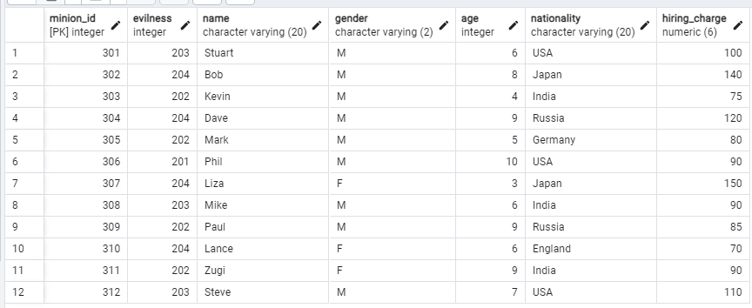

TRAINING TABLE:

INSERT INTO public.training (training_id, level, trainer, from_date, to_date) VALUES

(401, 4, 30, '2017-01-05', '2017-01-15'),

(402, 3, 30, '2017-01-07', '2017-01-10'),

(403, 2, 30, '2017-01-09', '2017-01-24'),

(404, 3, 20, '2017-01-11', '2017-01-15');

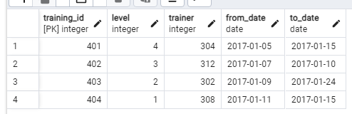

MISSION TABLE:

INSERT INTO mission (mission_id, pre_req, m_count, country, estimate, status, from_date, to_date) VALUES

(501, 3, 1, 'Japan', 1200, 'underway', '2017-01-14', '2017-01-18'),

(502, 4, 2, 'USA', 2500, 'underway', '2017-01-16', '2017-01-22'),

(503, 3, 1, 'England', 2200, 'underway', '2017-02-02', '2017-02-10'),

(504, 2, 3, 'India', 2400, 'completed', '2016-12-18', '2016-12-27'),

(505, 4, 4, 'China', 4000, 'cancelled', NULL, NULL);

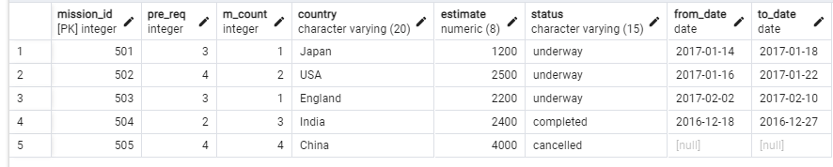

INVOLED IN TABLE:

INSERT INTO public.involved_in (minion_id, mission_id, master_id) VALUES

(302, 501, 110),

(301, 502, 107),

(306, 502, 107),

(310, 503, 103),

(304, 504, 104),

(308, 504, 104),

(311, 504, 104);

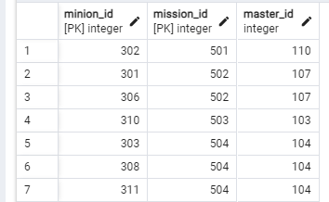

CURRENCY TABLE:

INSERT INTO currency (currency_id, name, country, b_currency) VALUES

(601, 'INR', 'India', 4.6),

(602, 'Japanese YEN', 'Japan', 8.6),

(603, 'Euro', 'Germany', 4.56),

(604, 'USD', 'USA', 7.6),

(605, 'Pound Sterling', 'England', 9.56),

(606, 'Ruble', 'Russia', 12),

(607, 'Riyal', 'Saudi Arabia', 10);

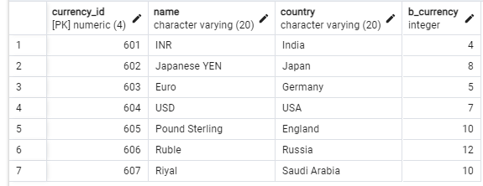

PAYMENT TABLE:

INSERT INTO public.payment (mission_id, payment_id, currency_id, amount, date) VALUES

(504, 73, 36, 1765, '2016-12-27'),

(504, 74, 36, 1765, '2016-12-27'),

(504, 75, 36, 1763.52, '2016-12-27');

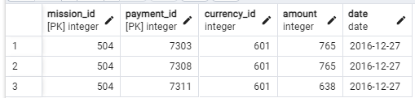

TAKES_TRAINING TABLE:

INSERT INTO public.takes_training (training_id, minion_id) VALUES

(402, 303),

(401, 301),

(403, 306),

(402, 311);

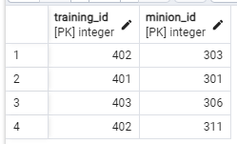

02) Insert a tuple to currency table, to depict the currency of Europe as Euro and the corresponding b_currencyas 15.

INSERT INTO currency (currency_id, name, country, b_currency) VALUES

(701, 'Euro', 'Europe', 15);

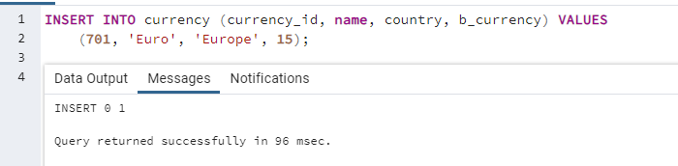

03) Commit the data:

COMMIT;

04) Update the nationality of Dave as Japan.

UPDATE minion

SET nationality = 'Japan'

WHERE name = 'Dave';

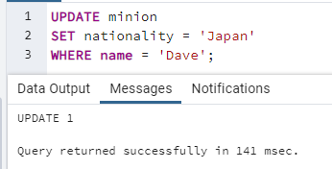

05)Create a Savepoint A:

CREATE SAVEPOINT A;

06) Modify the completion date of the training offered to acquire level 4 in evilness:

UPDATE training

SET to_date = '2017-07-27'

WHERE level = 4;

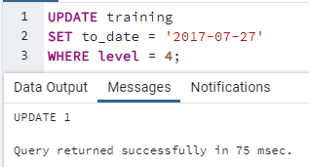

07)Create a Savepoint B:

SAVEPOINT B;

08) As the minion count is not sufficient to trigger Frankenstein‘s mission, revise the status as cancelled

UPDATE mission

SET status = 'cancelled'

WHERE mission_id = 503;

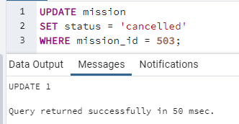

09) Create a new table “Country” with attributes country_code and country_name. populate two tuples of your choice.

CREATE TABLE Country (

country_code CHAR(2),

country_name VARCHAR(50)

);

INSERT INTO Country (country_code, country_name)

VALUES

('US', 'United States'),

('IN', 'INDIA');

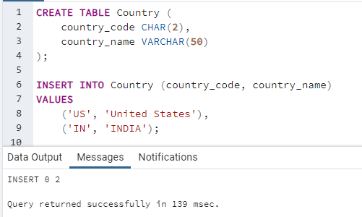

10)CREATE SAVEPOINT C:

SAVEPOINT C;

11) Delete some rows of the table “Country” using appropriate conditions.

DELETE FROM Country

WHERE country_code = 'US';

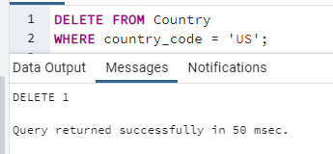

12)Roll back to C. Write the inference.

ROLLBACK TO C;

Inference: Rolling back to Savepoint C will restore the "Country" table to the state before the DELETE operation, and any changes made after Savepoint C was created will be undone.

13)Roll back to B. Write the inference w.r.t the Country table.

ROLLBACK TO B;

* sql

Inference: Rolling back to Savepoint B will undo changes made after Savepoint B was created, including the update to the mission's status and any other related changes.