EXERCISE 09

01)Find the masters and minions of nationality England

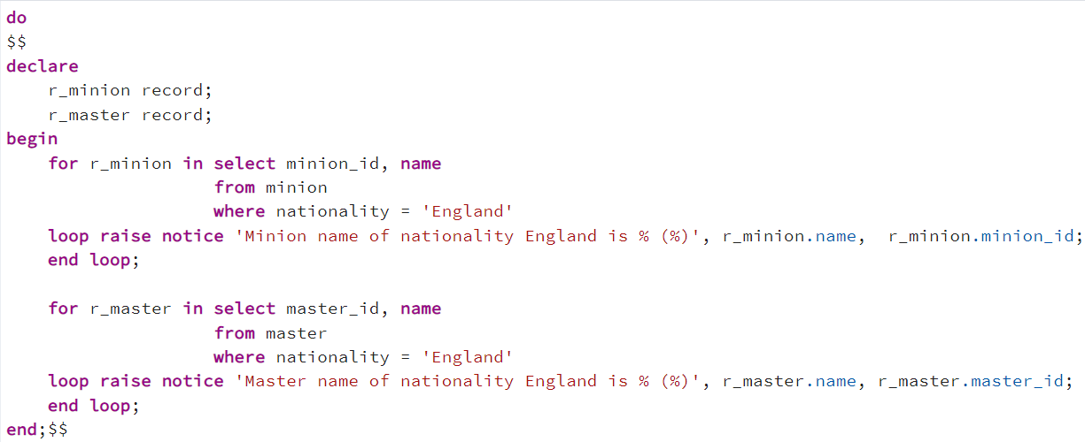



02)

Identify the minion with lowest lowest hiring charge for evilness – Tickle

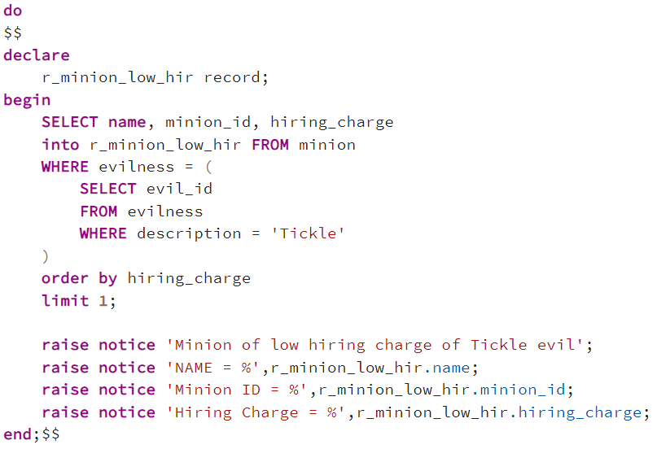

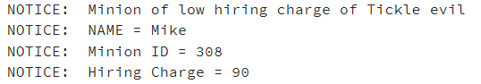

03)Identify all mission that did not happen in Germany

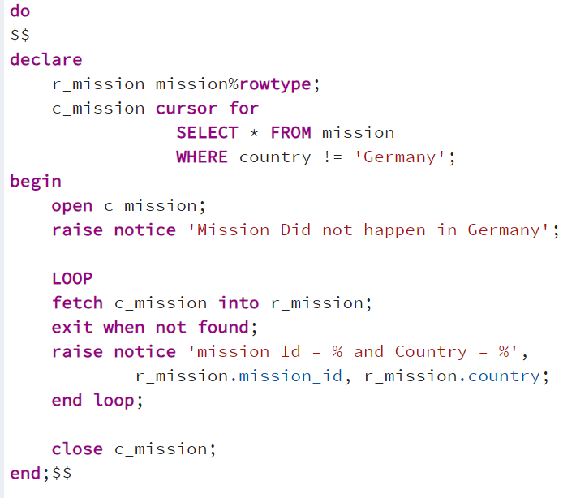

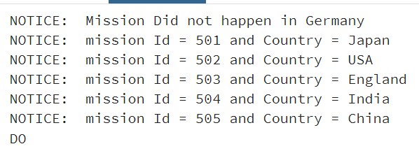

04) Find the duration of the training handled by Bob or Steve.

.

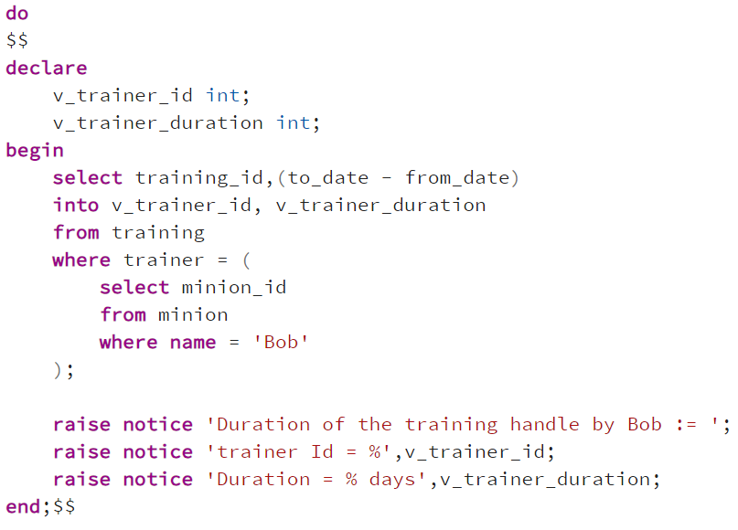

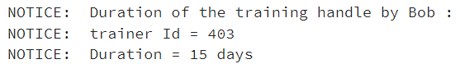

5. Calculate the amount in hand after the cancellation of mission 505. Assume each minion demands 10 as mission cancellation charge

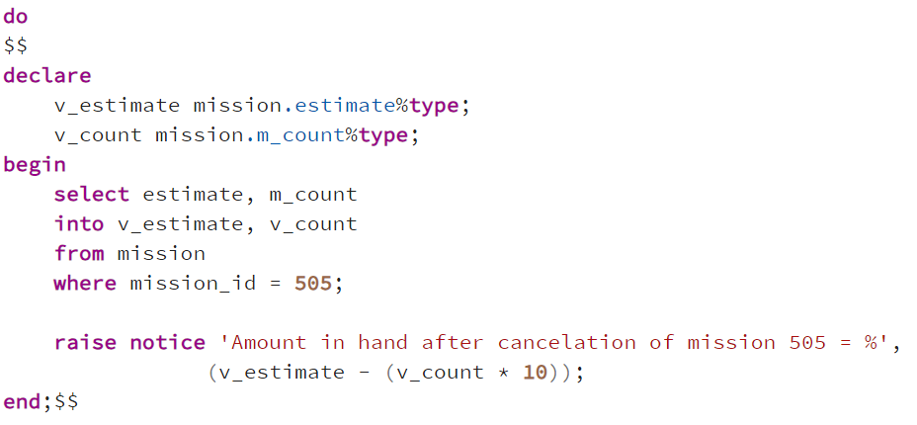



6. Did mission 504 overrun the estimated amount?

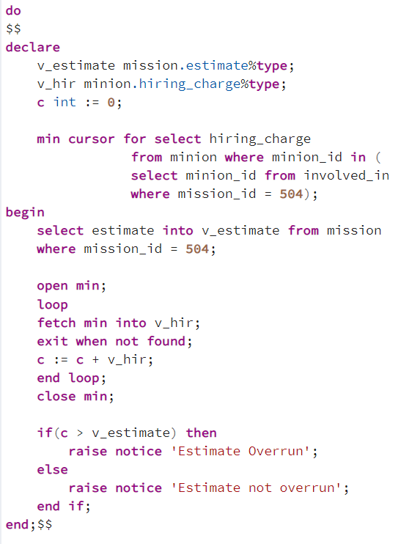



* 1. 7. Find the minion employed in more than one mission
  2. atleast one mission
  3. not participated

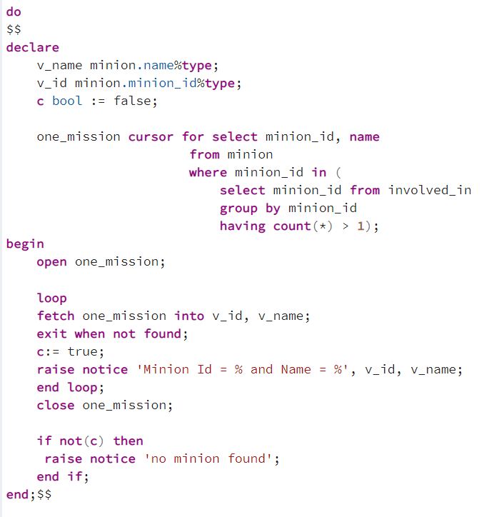



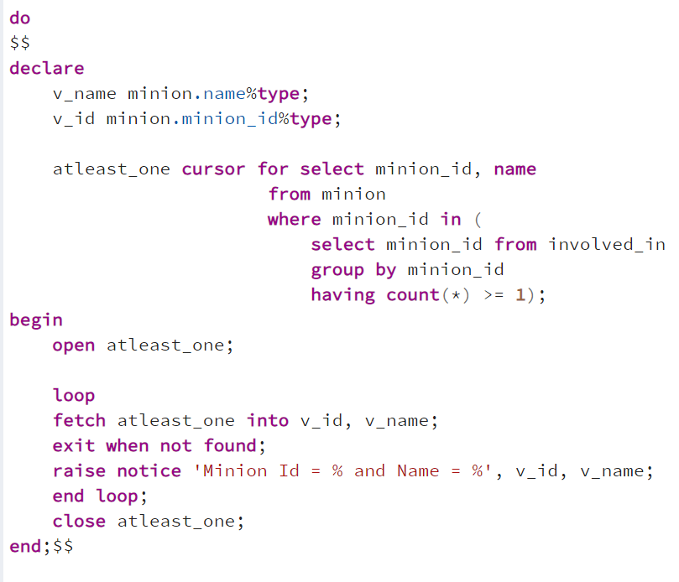

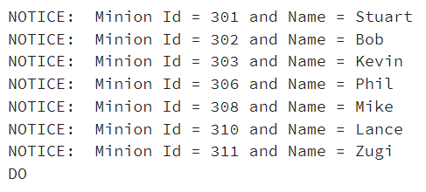

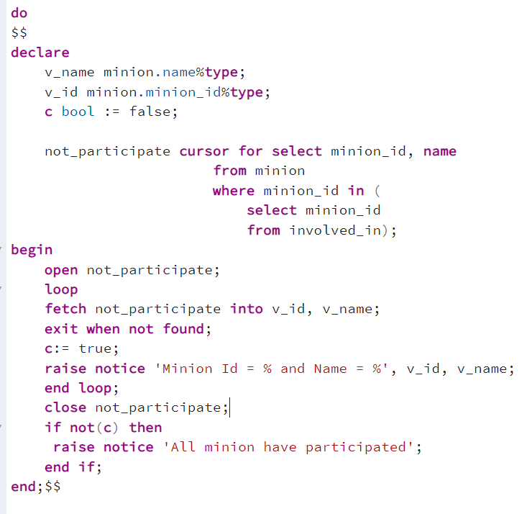

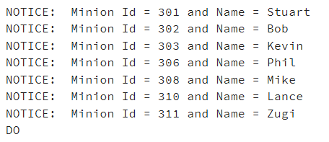

8. Find the currency rate of INR with respect to all the other currencies

