EXERCISE 08

1.Find all minions who have trained more than one minion.

CREATE VIEW trained_by_many_trainer AS

SELECT M.* FROM minion AS M

INNER JOIN takes_training USING(minion_id)

INNER JOIN training USING(training_id)

WHERE level != 4;

* SELECT * FROM trained_by_many_trainer;

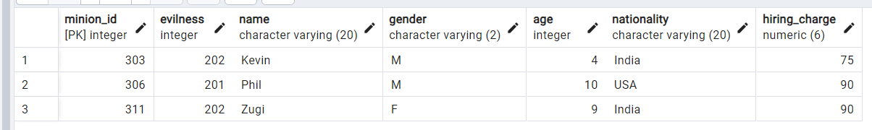

2.Identify and list the first three currencies that have the highest currency conversion rate.

CREATE VIEW Highest_Currency_Rate AS

SELECT name, country FROM currency

ORDER BY b_currency DESC

LIMIT 3;

* SELECT * FROM Highest_Currency_Rate;

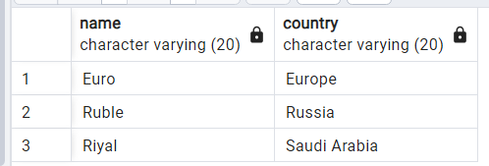

3.To extract the male minions of Japan or England who are committed in any mission.

CREATE VIEW Commited_in_mission AS

SELECT m.* FROM MINION as m

INNER JOIN involved_in USING(minion_id)

WHERE gender = 'M' and

(nationality = 'Japan' or nationality = 'England');

* SELECT * FROM Commited_in_mission;



4.Show the evilness description of all minions along with their hiring charge.

CREATE VIEW minion_evilness_description AS

SELECT minion_id,evilness, name, hiring_charge, description

FROM minion

JOIN evilness ON evilness = evil_id;

* SELECT * FROM minion_evilness_description;

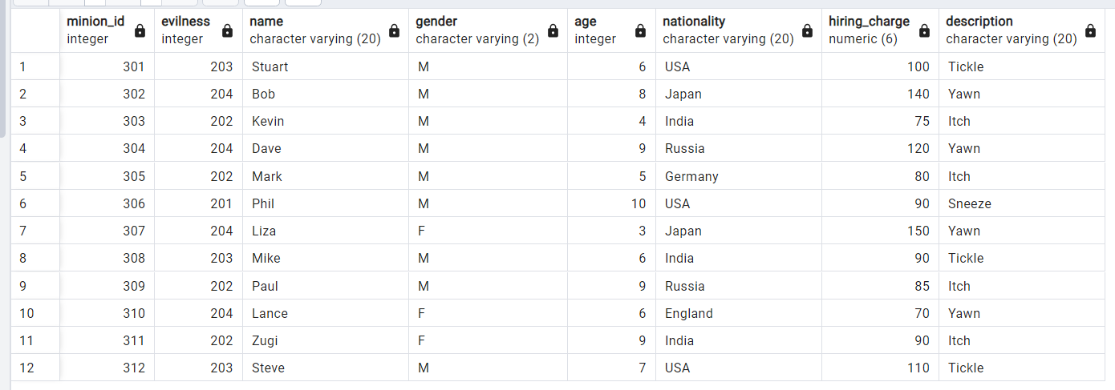

5.Which minion(s) are associated with any mission currently? Who are their masters?

CREATE VIEW minions_associated_with_mission AS

SELECT m.minion_id, m.name FROM MINION AS m

INNER JOIN involved_in USING(minion_id)

INNER JOIN mission USING(mission_id)

WHERE status = 'underway';

* SELECT * FROM minions_associated_with_mission;

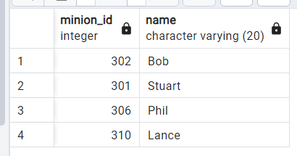

6.Find all masters whose mission(s) were a success.

CREATE VIEW success_mission_master AS

SELECT distinct m.* FROM MASTER AS m

INNER JOIN involved_in USING (master_id)

INNER JOIN mission USING (mission_id)

WHERE status = 'completed';

* SELECT * FROM success_mission_master;

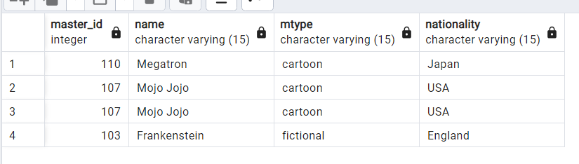

7.Create a save point.

SAVEPOINT savepoint_A;

8.Add a trainer to the relation and check whether the view (created in Question 1) gets updated.

INSERT INTO training VALUES(405,2,310,'26-11-2023','27-11-2023')

* SELECT * FROM trained_by_many_trainer;

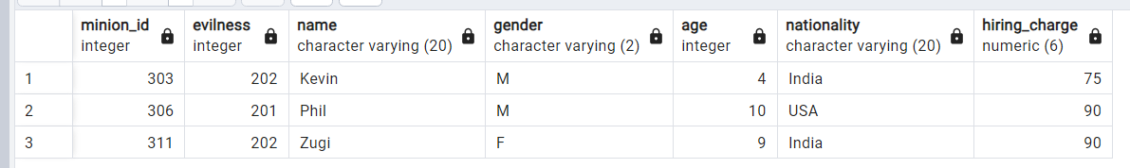

Conclusion: ***The view Does not get updated***

9.Add a male minion of Japan and check whether the view (created in Question 3) gets updated.

INSERT INTO minion VALUES

(042, 202, 'suren', 'M', 18, 'Japan', 100);

* SELECT * FROM Commited_in_mission;

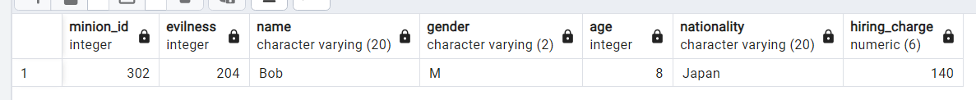

Conclusion: ***The view Does not get updated***

10.Create an updatable view for payment history.

CREATE VIEW updatable_payment_history AS

SELECT * FROM payment;

* SELECT * FROM updatable_payment_history;

