**CM Routing GIS Application**

**Functional Requirement Specifications:**

*Following are the functional specifications developed for CM Routing GIS Application under Version 1.0*

1. **Events**: This option gives the user the option to select a particular region of Interest. This will mainly be categorized based on division level (Ex. Bikaner/ Udaipur/Kota). After the selection it will zoom to Extent based on the selected Division.

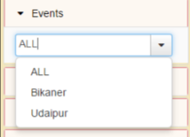

1. **Query Routes**: This option helps user to further classify or filter the proceedings and display the routes generated based on the following criteria:

* **Team Details**: This option has various team details which are to be selected like CM, CS or Minister. Query can also be initiated with “ALL” as an option which will display results by considering all the teams involved.

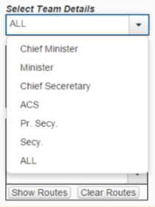

* **Area Details**: This option specifies the area details to which the Team is going to make a visit. This is further classified into following:
* District
* Division
* Block

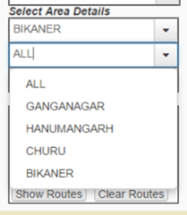

* **Date Details**: This option has the filtration based on the date range through which a team on a particular area is going to make a visit.

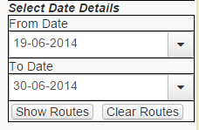

Users will have an options to chooses with entire options in consideration to query for a particular route. An Example query has been illustrated below.

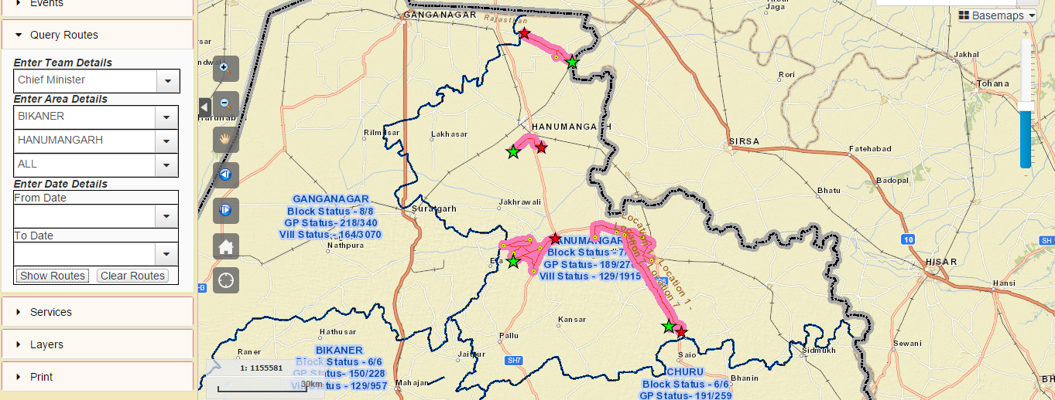

The green symbol represents the start position and red represents the stop position for chief Minister for any combination of choices.

1. **Services**: This option enables a user to switch between the services for which the result is on displayed on map. These services are as follows:

* Grievance
* Visit Route

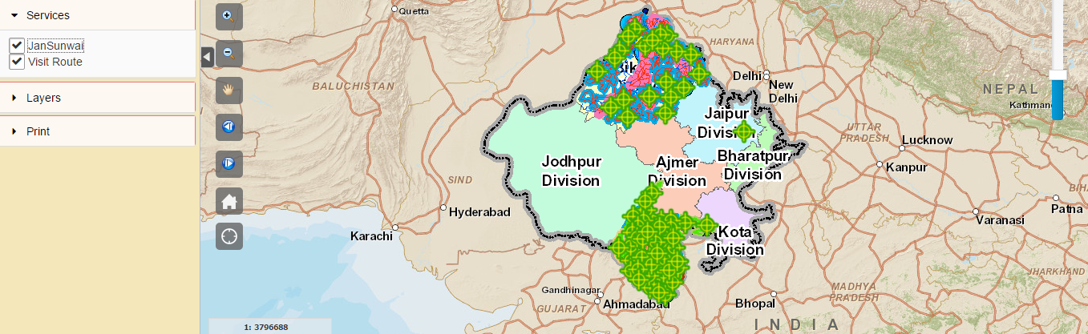

Checking or un-checking the options will result in the visual representation of respective layer.

1. **Layers**: This is general section where in user can see the symbolic notation of the markers or colours used in the map. There are also controls to control the opacity of the displayed services. Here too, Checking or un-checking the options will result in the visual representation of respective layer.

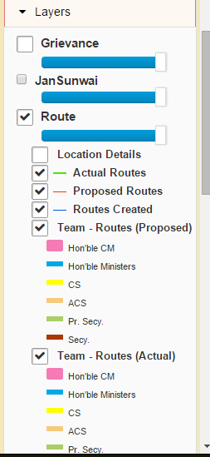

1. **Print**: This is advanced print functionality where in user can customized map-printing option into following categories:

* Map Scale/ Map Extent
* Layout Options
* Print Quality Options
* Height and width Option

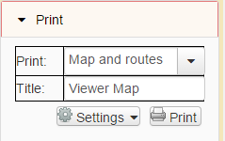

The Print out will contain map as well as the route details attached.

Basically user can set properties among which they want the print-out to be along with the route information involved with actual and proposed route details appending below the map section for only the resultant routes.

1. **Search Village*:*** This function helps in searching village and displaying the extent on map.

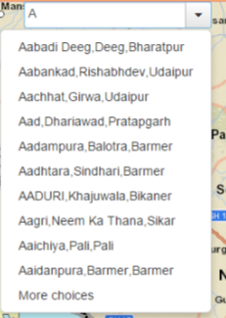

The options will be based on the villages located only in Rajasthan, hence easier to locate.

1. **Base Map Gallery*:*** Base map is a non-editable layer that is provided in the background only for reference information. It is typically designed to provide a visual reference for other layers to help orient the user.

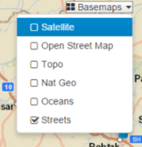

1. **Basic Map Navigational Tools*:*** Navigation tools that allow viewing an area of interest; zoom In, Zoom Out, Pan, previous extent, next extent, Full Extent, current location.

