NAME-LAASYA
ROLL NO:2620030160

ATM TRANSACTION SIMULATOR

1. Project Abstract
The ATM Transaction Simulator is a Java-based console application designed to demonstrate the basic operations performed through an Automated Teller Machine. The project provides a simple and interactive environment where a user can authenticate using a PIN and perform common banking operations such as checking balance, depositing money, withdrawing money, transferring money, and viewing transaction history.
The application applies important Java programming concepts including primitive data types, variables, operators, methods, conditional statements, switch-case, loops, Scanner-based input, and one-dimensional and two-dimensional arrays. The project helps demonstrate how these concepts can be combined to solve a practical problem using structured programming.

2. Project Objectives
- To simulate basic ATM operations using Java.
- To implement PIN-based user authentication.
- To perform balance inquiry, deposit, withdrawal, and transfer operations.
- To maintain and display transaction history.
- To apply operators, methods, conditional statements, loops, and arrays in one practical application.
- To improve understanding of problem-solving and menu-driven Java programs.

3. Advantages
- Simple and user-friendly: The menu-driven interface makes the application easy to operate.
- Secure authentication: A PIN verification step is included before accessing banking operations.
- Realistic simulation: The project represents common ATM activities in a simplified form.
- Concept integration: Multiple Java programming concepts are demonstrated in one project.
- Transaction tracking: The application can store and display transaction information.
- Validation: Conditions can prevent invalid operations such as withdrawing more money than the available balance.
- Easy to extend: Additional banking features can be added without changing the basic structure.

4. Implementation Details

Programming Language and Tools
Programming Language: Java
Input Method: Scanner class
Main Class: ATMTRANSACTIONSIMULATOR

Java Concepts Used
Java Concept | Application in the Project
Data types and variables | Store PIN, account details, balances, transaction amounts, and menu choices.
Operators | Arithmetic, relational, logical, assignment, and unary operators are used in calculations and validation.
Methods | Separate methods handle balance checking, deposit, withdrawal, transfer, and transaction display.
if-else | Validate PINs, balances, amounts, and transaction conditions.
switch-case | Handle the user's selected ATM menu option.
Loops | while/do-while loops control authentication and repeated menu operations; for loops display transaction records.
1D arrays | Store account information or transaction amounts/history.
2D arrays | Store transaction history for multiple accounts/records.
Scanner | Accept account numbers, PINs, amounts, and menu choices from the user.

Main Modules
- Authentication Module – accepts and validates the user's PIN.
- Balance Inquiry Module – displays the current account balance.
- Deposit Module – adds a valid deposit amount to the account balance.
- Withdrawal Module – checks available balance and deducts a valid withdrawal amount.
- Transfer Module – transfers an amount after validating the available balance.
- Transaction History Module – records and displays previous transactions.
- Menu Module – repeatedly displays available operations until the user chooses Exit.
.

5. Output Screenshots
Screenshot 1 – Deposit Money
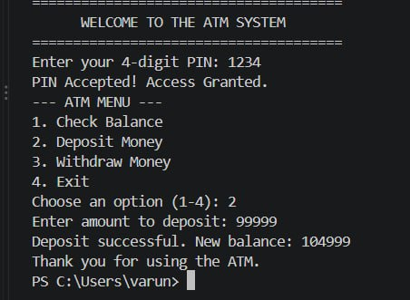
Screenshot 2 – Withdrawal Money
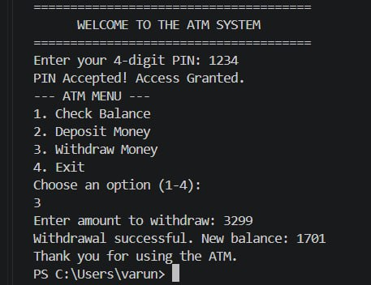
Screenshot 3 – Exit from ATM
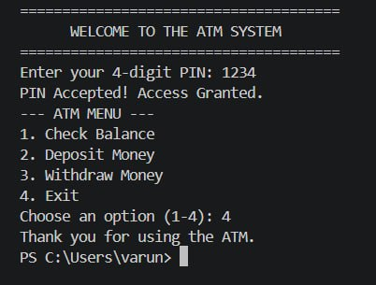
Screenshot 4 – PIN Validation and Balance Inquiry
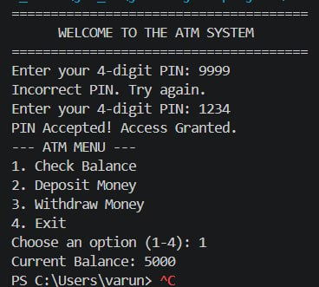
These screenshots demonstrate successful PIN authentication, balance inquiry, deposit, withdrawal, invalid-PIN handling, and exiting the ATM.

6. Conclusion
The ATM Transaction Simulator successfully demonstrates how Java programming concepts can be applied to a practical banking scenario. The project implements PIN authentication, balance inquiry, deposit, withdrawal, transfer, and transaction-history features through a menu-driven interface. It makes effective use of operators, data types, methods, conditional statements, loops, Scanner input, and one-dimensional and two-dimensional arrays. Overall, the project provides a clear understanding of program structure, decision making, repetition, data storage, and modular programming in Java.

7. Future Work
- Add support for multiple customers and multiple bank accounts.
- Store customer and transaction data permanently using files or a database.
- Add date and time to every transaction.
- Provide a more detailed mini statement with transaction type and amount.
- Add fund-transfer support between different customer accounts.
- Implement stronger authentication and account-locking rules.
- Develop a graphical user interface (GUI) for a more realistic ATM experience.
- Add features such as PIN change, account creation, balance alerts, and receipt generation.

