## How to generate stats per test set?

Expected Result:

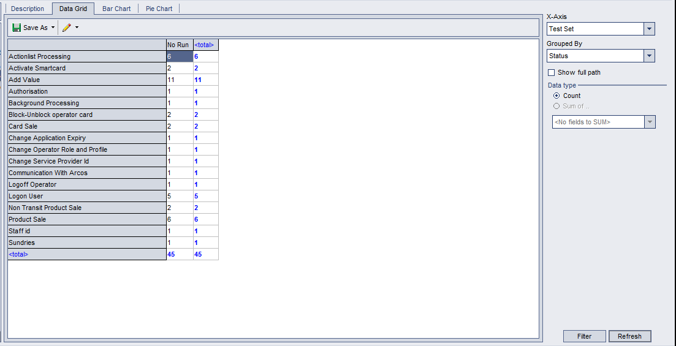

Steps:

Select Test Lab, and click menu ‘Analysis’ / Graphs / <Summary> - Cross test set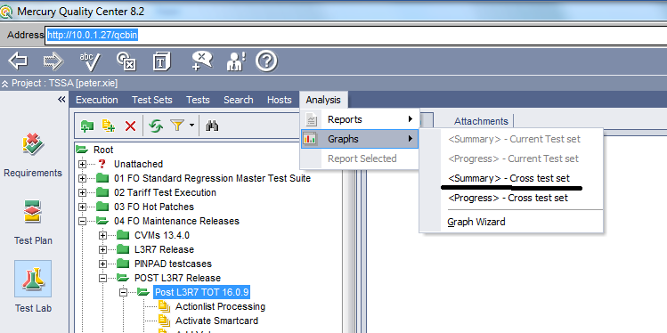

Then you will see the report graph below. Click Filter and set the filter with test set folder.

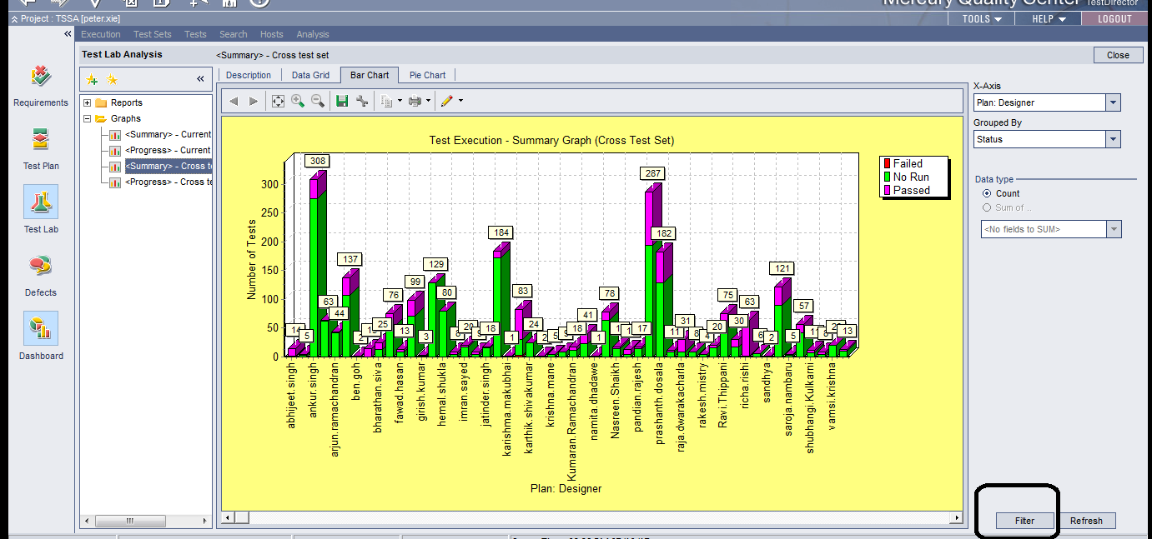

In the pop-up window, click Advanced and check Test Sets, and click it to change filter.

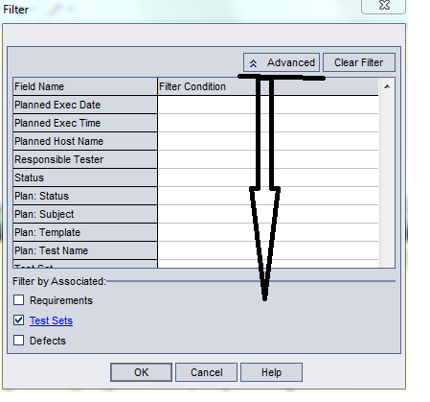

Click Filter Condition for ‘Test Set Folder’

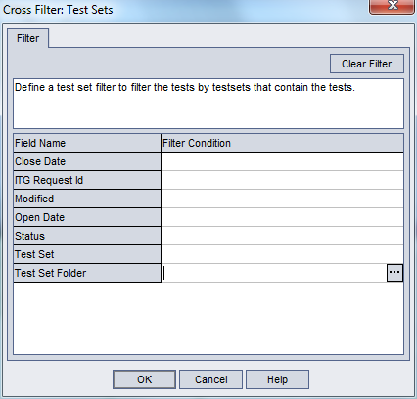

and select your test lab folder to analyse.

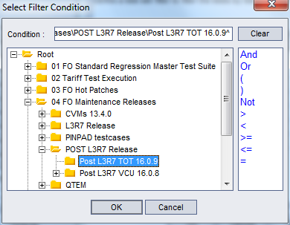

Click OK to go back to Bar Chart window, then Select ‘Test Set’ in X-Axis and click Refresh.

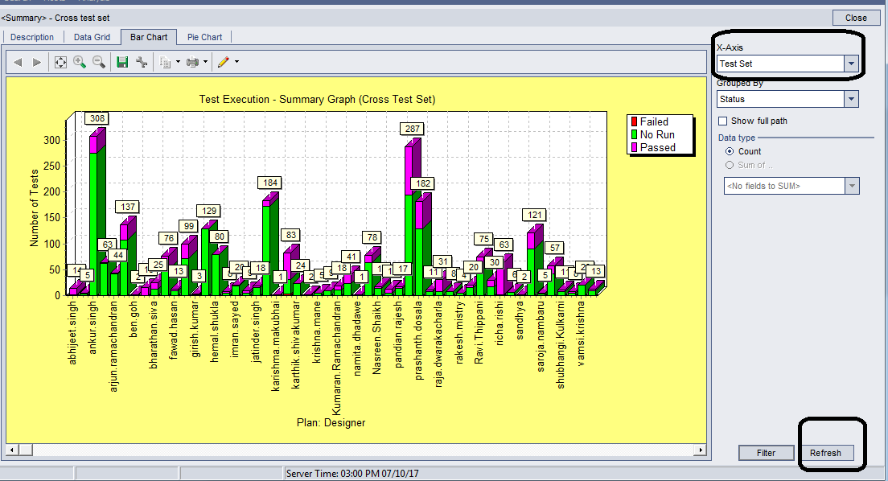

After Fresh is applied, you will see the change take effect and you will switch to Data Grid and export to excel format.

