Port difference between CMS-1000 and CMS-6000
There are 3 interfaces in convedia:
- Management: for web and telnet
- Control: Signaling,eg.,SIP.
- Media: RTP

CMS-1000:
3 interface can share one Ethernet port but media IP must be different from the other two’s. That means you must have at least two IP, one for Mgt and Control, one for media and only one lan cable.

CMS-6000:
Management interface need a separate Ethernet port, actually a slot-slot 1, and Control and media interface can share another port (slot) with flat topology or use two more separate ports.
So CMS-6000 needs at least two IP and two cables.

CMS-1000
Default web user/password: admin/convedia
telnet root/zac#61

Change IP

- Must be done through console
如果你临时只改IP试试,可是telnet修改.但重启后失效
ifconfig mseta0 <ip> netmask <netmask>
- Can done through conedia serial line or SUN console PIN+Ethernet cable.
- Console client
Note: If you are using a terminal emulator, make sure the emulator is set to
VT100. Refer to the documentation for your terminal emulation program for
details. [XJP]Only HyperTerminal works in my case.

- Console parameter
Table 9-1 RS-232 Craft Connection Characteristics
Characteristic Value
Speed 9600 bps
Data bits 8 bits
Parity No parity
Stop bit 1 bit
Flow control None

注意console登陆显示可能有*号,输入是每个字母之间有*,很难看, 但不会影响输入操作. 可以修改字体看起来舒服些.
中文XP,默认仿宋,显示为*号:
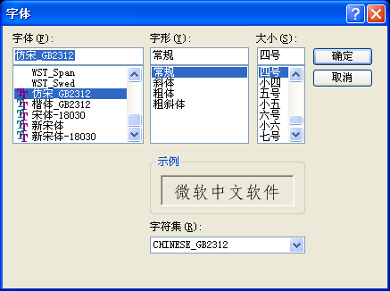
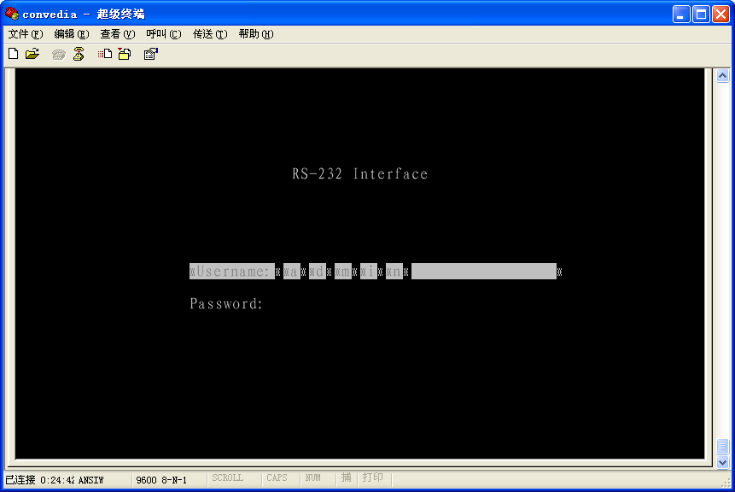

改一下,*变 | 好看点.
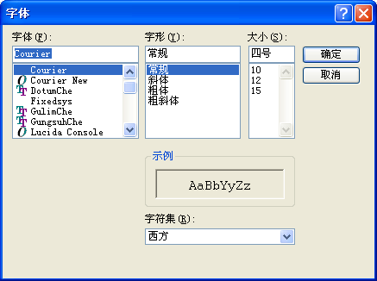

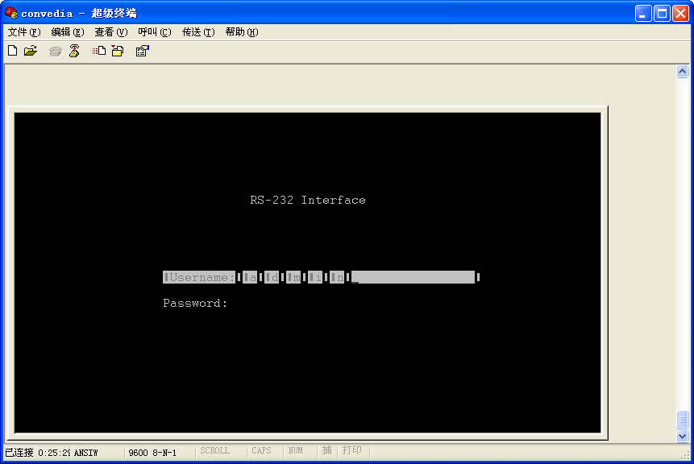

CMS-6000(Big one in D600):
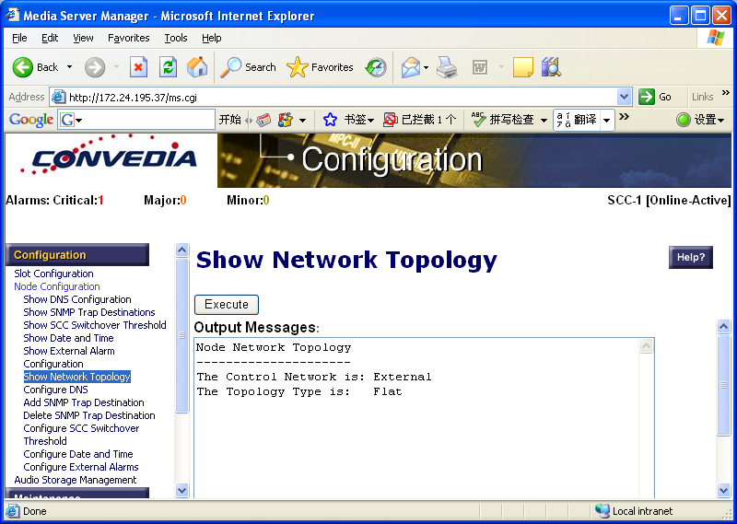

SIP and RTP runs on one network if topology type is flat. The type can be only set in console.
SCC(slot 1) is only for telnet and web access for management. MPC from slot 2 is for signaling and media .You can define SCC in private network and MPC in public network or vice versa.
You can use SIP control and management in the same port.

Default user/password: admin/convedia

