Convert compression: (file smaller but image keep the same size with lower compression)

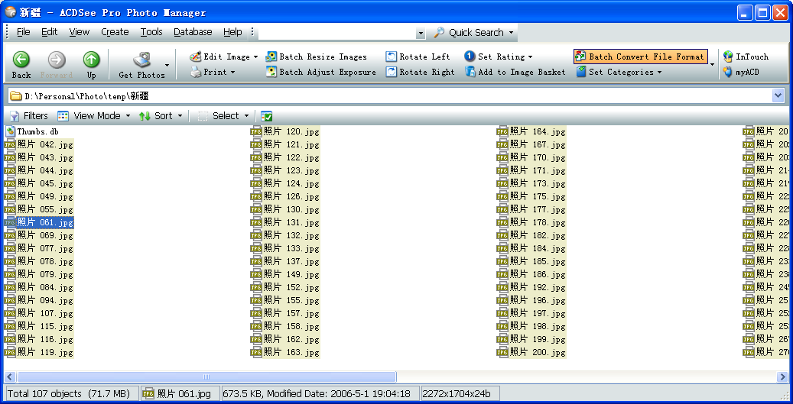

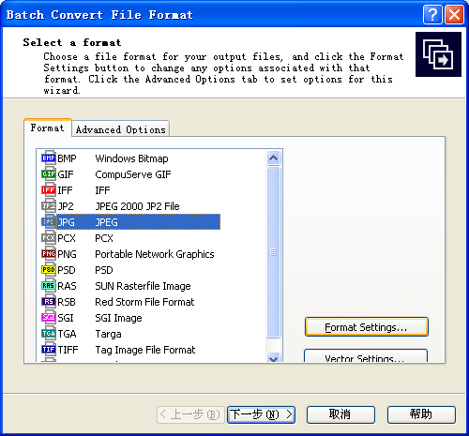
select the same file type jpg and select format settings to change the compression
For example 40%, for half file size.
