Basic usages:
- Count framerate:

Open Elecard StreamEye, and then open a file and play:

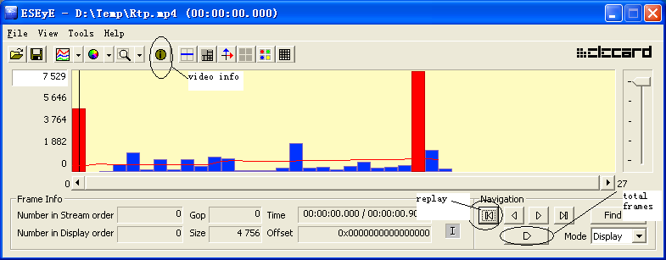

Total frames: After playing, you see the total frames.

Total time: Check the time printed on the video itself, not the ‘Time’ in StreamEye.

Frame Rate = Total frames / Total time.

- Video format information

Click info tool bar icon:

