How to disable auto-correction in syntax highlighting?
For example, if you edit a Genet xml file, you type <COMMENT>, when you save the file, it will automatically convert to <comment> and GeNet will not work.

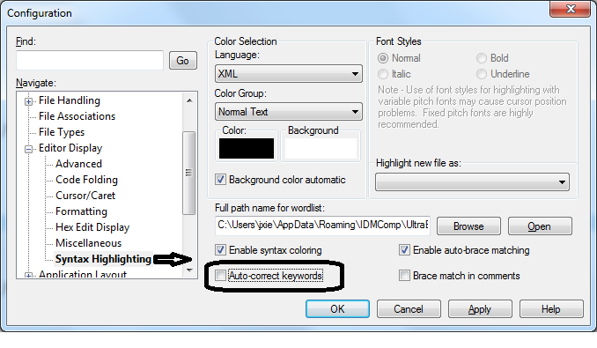

Show tab:
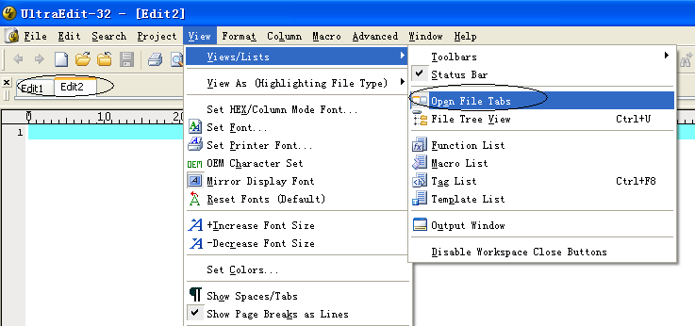

It happened once that this option did not work, and tabs were not shown.

The resolution I did is:
Open the configuration file uedit32.INI.
Change ‘Animate Tabs’ from 0 to 1, and save the file.
Restart uedit
Then the tabs come out and the ‘Open File Tabs’ works again.
Note: Then when I re-open uedit32.INI, ‘Animate Tabs’ is changed back to 0 even when ‘Open File Tabs’ is checked and tabs are shown. So maybe ‘Animate Tabs’ does not equal menu ‘Open File Tabs’ and it is not the root cause.

Configuration file:
C:\Documents and Settings\jiping.xie.NT\Application Data\IDMComp\UltraEdit\uedit32.INI

Find lines that contain string: Line number not correct?
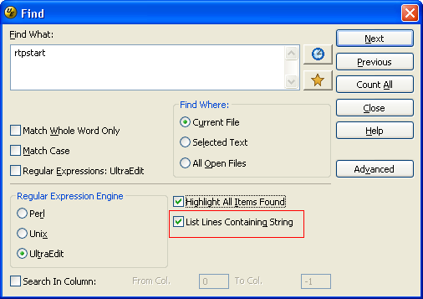

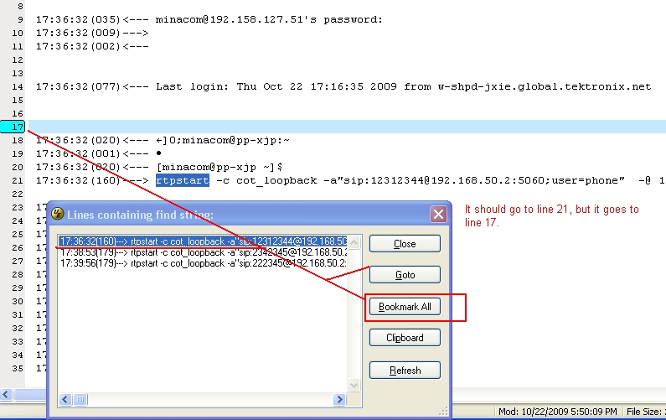

Solution:
Change to DOS format when opening a file, e.g. ssh005356_00001.dbg:
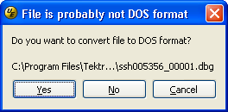

Click Yes.

启动慢
load printer问题，去掉即可：
去掉Load/Restore print setting.
菜单上Advanced->Configuration->Editor->Advanced.