How to enable UDP checksum:
Edit – Preference - Protocols:
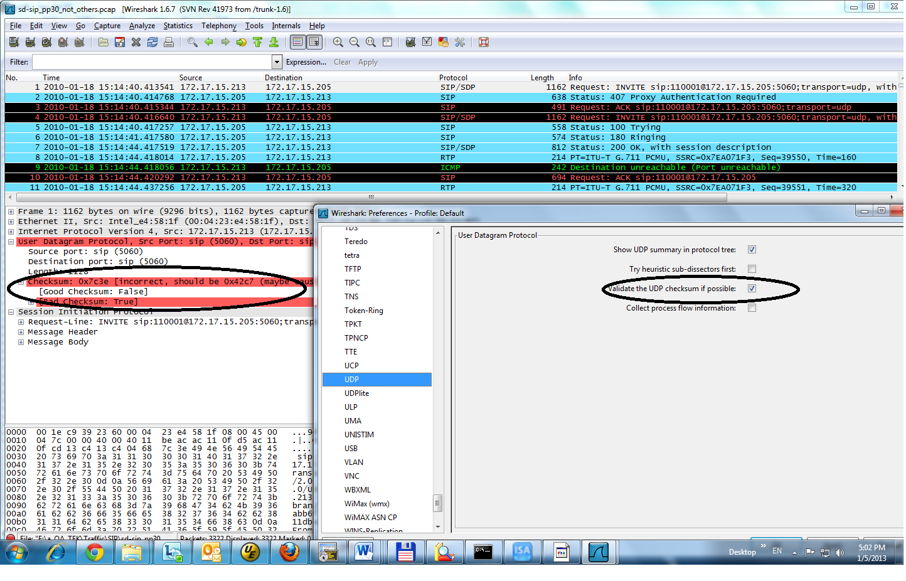

How to Save RTP:
Support only 711u and 711a.

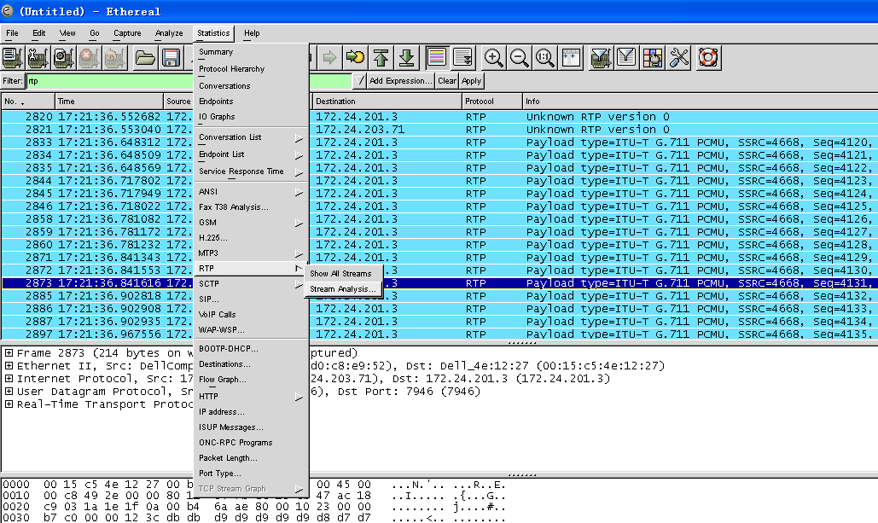

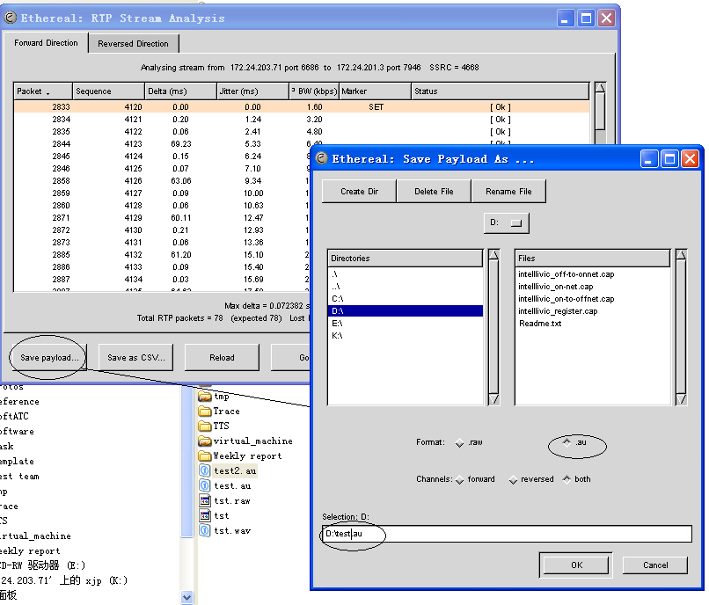

Play test.au with windows MediaPlay.

FAQ：
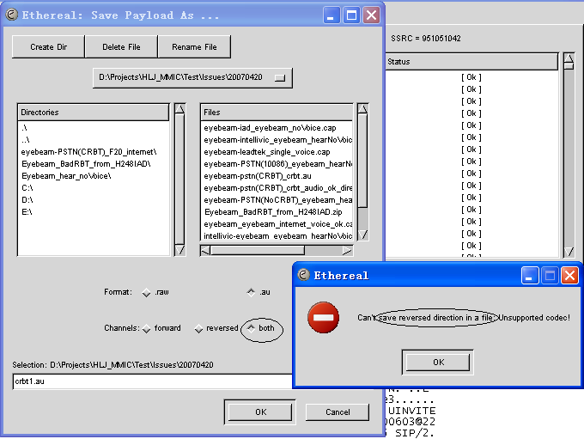
Because there is no RTP in reversed direction. Select Channels->forward and save.

