Xstart
Find where xterm is by locate *xterm*
and modify the command parameter:
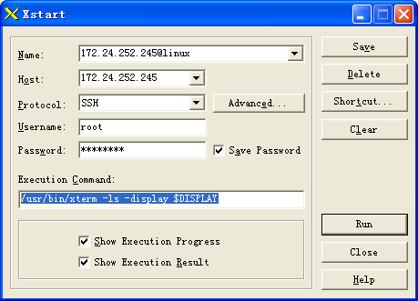

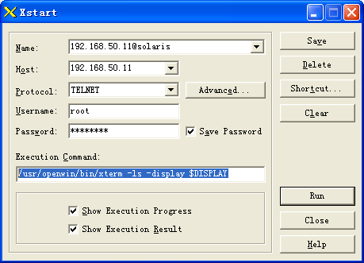

paste in xtem:
middle key in mouse.

