Testing

Testing Strategy
Functional testing was performed to verify the Laptop Request Catalog Item operations.

Security testing ensured proper role-based access to the Service Catalog and request submission.

Test Scenarios
- User login and Service Portal access verification.
- Laptop Request Catalog Item visibility check.
- Catalog form submission and record creation.
- Flow execution after laptop request submission.
- Impersonation testing for end-user access.
- 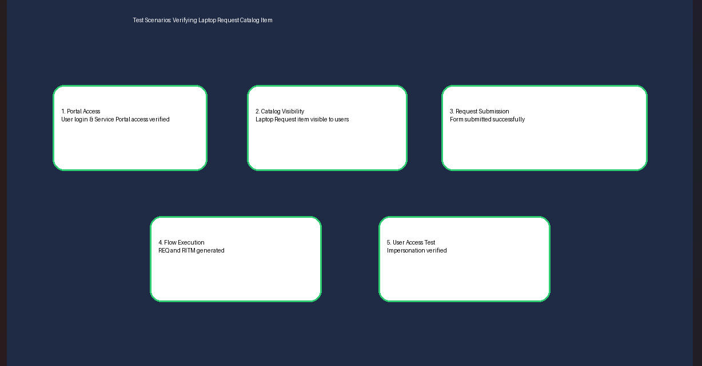

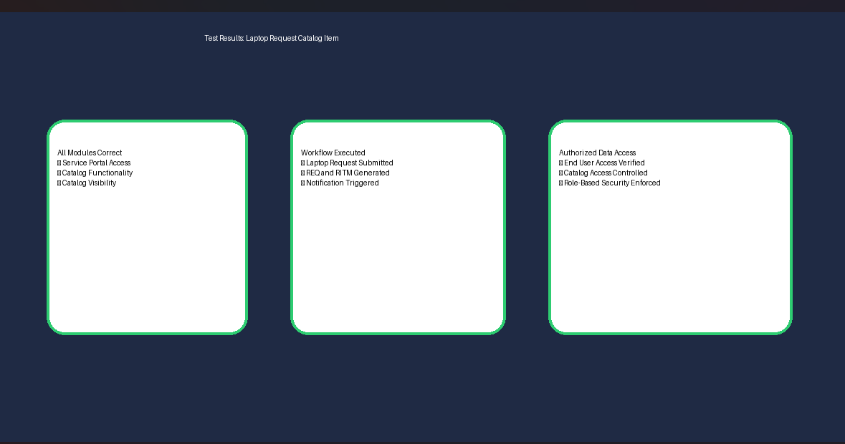
Test Results

The testing results confirm that the Laptop Request Catalog Item functions correctly.

- Laptop request form is accessible through the Service Portal.
- REQ and RITM records are generated successfully.
- Workflow automation executes as expected.
- Authorized users have appropriate access.
- Role-based security is properly enforced.

References
https://developer.servicenow.com https://docs.servicenow.com https://community.servicenow.com https://nowlearning.servicenow.com

