# Reproducible Research - Week 2 Assignment

## 1. Loading and preprocessing the data

fileurl <- "https://d396qusza40orc.cloudfront.net/repdata%2Fdata%2Factivity.zip"  
 zipfile <- "./course5week2/data.zip"   
 # for downloading the file as data.zip to the folder course4week4 under the working  
 # directory  
 filedir <- "./course5week2"  
 unzip_path <- "./course5week2/data" ##### path for storing the unzipped files #######  
 if (!file.exists(filedir)){  
 dir.create(filedir)  
 }  
 download.file(fileurl,file.path(zipfile))  
 unzip(zipfile,exdir=unzip_path) ####### exdir is the extract directory ##########  
 datafile <- file.path(unzip_path,"activity.csv")  
   
 activity <- read.csv(datafile)  
   
 activity$date <- ymd(activity$date)  
 activity$weekend <- as.factor(ifelse(weekdays(activity$date)=="Saturday" | weekdays(activity$date)=="Sunday","weekend","weekday"))  
 activity$dayofweek <- as.factor(weekdays(activity$date))

## 2. Histogram of the total number of steps taken each day

# Compute the total number of steps per day  
 stepsByDay <- activity %>% group_by(date) %>% summarise(stepsperday = sum(steps,na.rm = TRUE))  
 qplot(stepsperday,data=stepsByDay,na.rm=TRUE,binwidth=500,xlab='Total steps per day', ylab='Frequency using binwith 500',main = 'Histogram of the total number of steps taken each day')

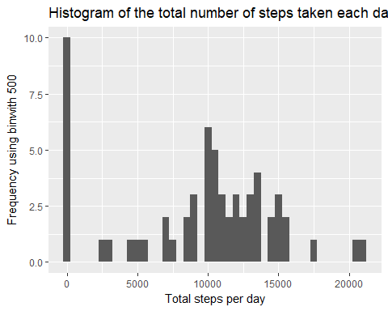

## 3. Mean and median number of steps taken each day

meanstepsperday <- stepsByDay %>% summarise(average = mean(stepsperday,na.rm = TRUE),median=median(stepsperday,na.rm = TRUE))  
 meanstepsperday

## # A tibble: 1 x 2  
## average median  
## <dbl> <int>  
## 1 9354.23 10395

## 4. Average daily activity pattern

### 4.1 time series plot of the 5-minute interval and the average number of steps across all days

interval_average <- activity %>% group_by(interval) %>% summarise(average = mean(steps,na.rm = TRUE))  
 qplot(interval,average,data=interval_average,geom="line",xlab = "5-minute intervals",ylab = "Average steps taken across all days")

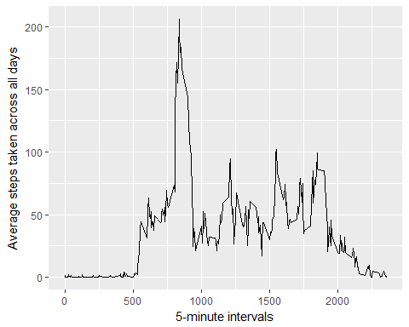

### 4.2 Which 5-minute interval, on average across all the days in the dataset, contains the maximum number of steps?

interval_average[which.max(interval_average$average),]

## # A tibble: 1 x 2  
## interval average  
## <int> <dbl>  
## 1 835 206.1698

## 5. Imputing missing values

# subset dataset where there are no NAs  
 activity_no_NA <- activity[which(!is.na(activity$steps)),]  
   
 # calculate the mean steps for each interval  
 interval_only <- activity_no_NA %>% group_by(interval) %>% summarise(average=mean(steps))  
  
 # convert the average to integer  
 interval_only$average <- as.integer(interval_only$average)  
   
 #subset dataset where steps have NAs  
 activity_na <- activity[which(is.na(activity$steps)),]  
   
 # fill NAs with average steps based on interval  
 activity_na$steps <- ifelse(activity_na$interval==interval_only$interval,interval_only$average)  
   
 # row bind the datasets that do not have NAs and the dataset where NAs are replaced with  
 # mean values  
 activity_impute <- rbind(activity_no_NA,activity_na)

### 5.1 Number of missing values in the dataset

# subset dataset where there are no NAs  
 nrow(activity_na)

## [1] 2304

## 6.1 Histogram of the total number of steps taken each day after missing values are imputed

# Compute the total number of steps per day  
 stepsByDay_impute <- activity_impute %>% group_by(date) %>% summarise(stepsperday = sum(steps))  
 qplot(stepsperday,data=stepsByDay_impute,na.rm=TRUE,binwidth=500,xlab='Total steps per day', ylab='Frequency using binwith 500',main = 'Histogram of the total number of steps taken each day')

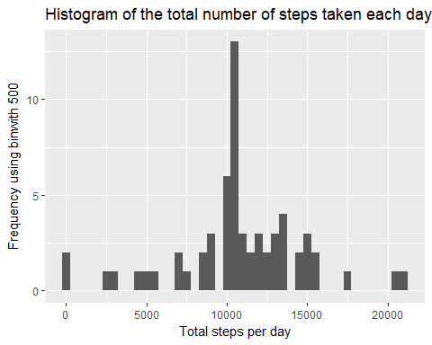

## 6.2 Mean and median number of steps taken each day

totalstepsperday_impute <- activity_impute %>% group_by(date) %>% summarise(stepsperday = sum(steps))  
 mean_n_median <- totalstepsperday_impute %>% summarise(average=mean(stepsperday),median=median(stepsperday))  
 mean_n_median

## # A tibble: 1 x 2  
## average median  
## <dbl> <int>  
## 1 10749.77 10641

## 7. Are there differences in activity patterns between weekdays and weekends?

meansteps <- activity_impute %>% group_by(interval,weekend) %>% summarise(average = mean(steps))  
 qplot(interval,average,data=meansteps,geom="line",facets=weekend~.,xlab="5-minute interval",ylab="average number of steps",main="Average steps pattern between Weekday and Weekend")

