1. Create VPC

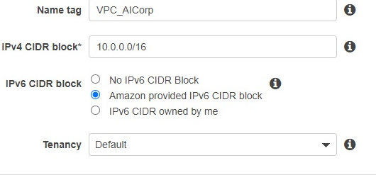

1. Create Subnet

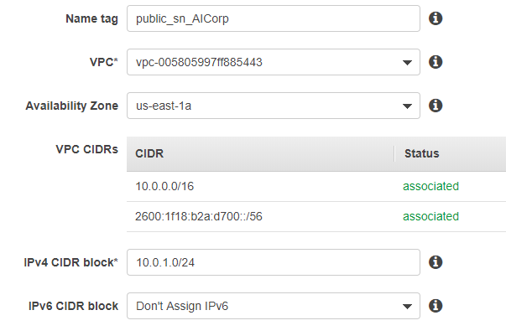

1. Create internet gateway

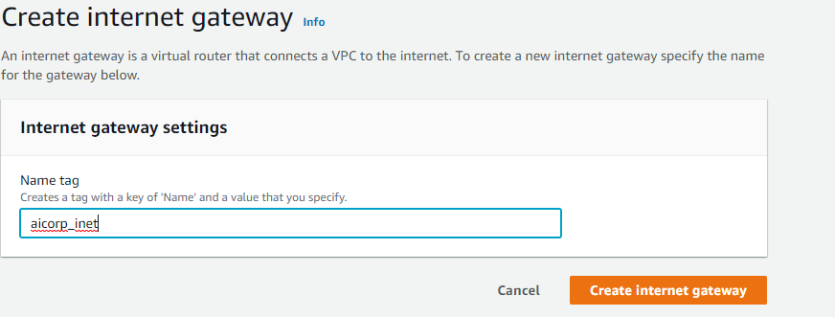

1. Attach VPC to gateway

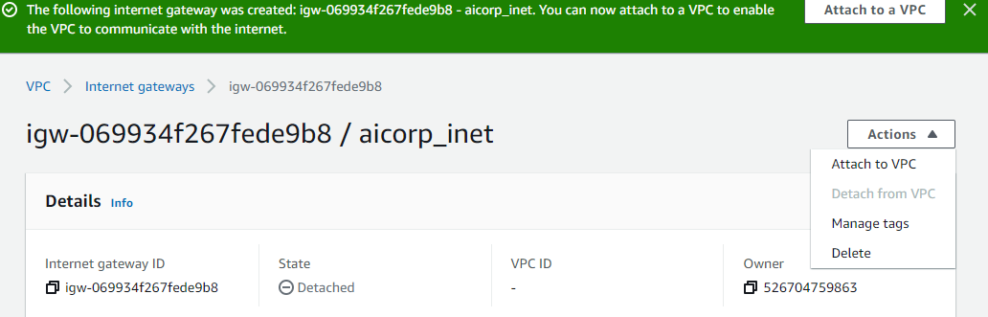

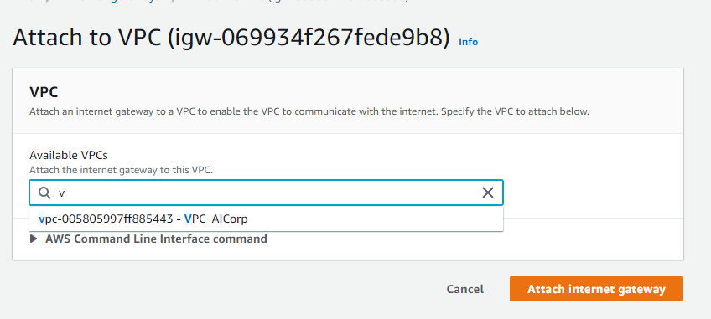

1. Create a route table

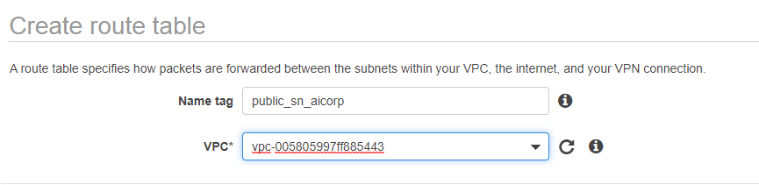

1. Edit routes, set all ip addresses to hit the internet gateway

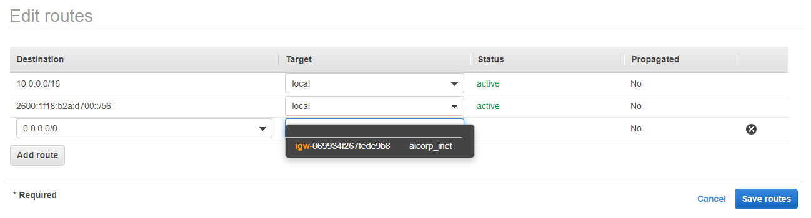

1. Edit route table association for public subnet, set it to the route table created above

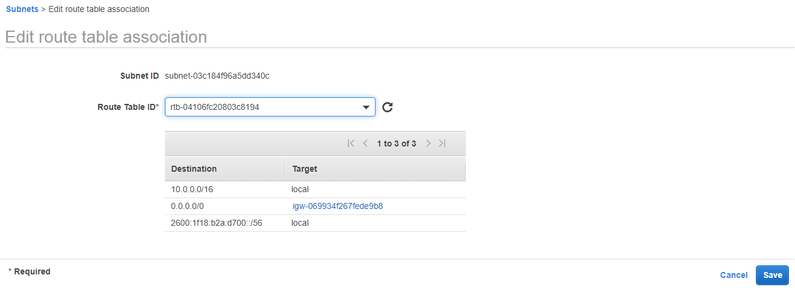

1. Create another subnet

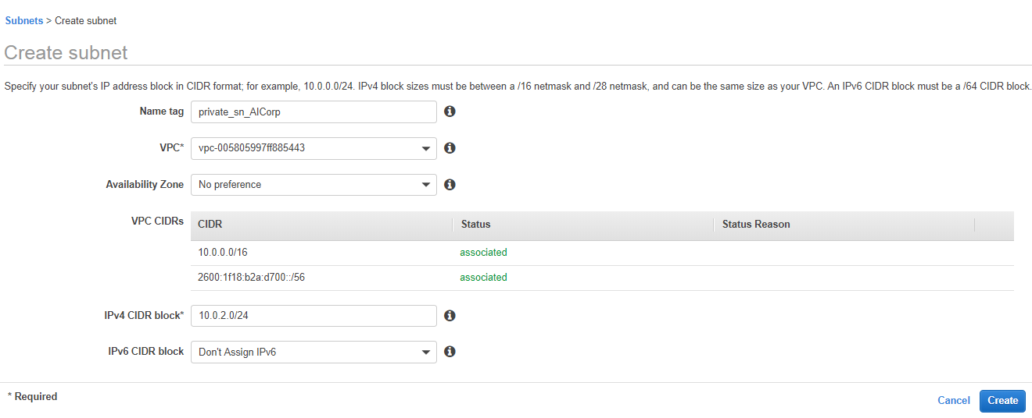

1. Create another route table

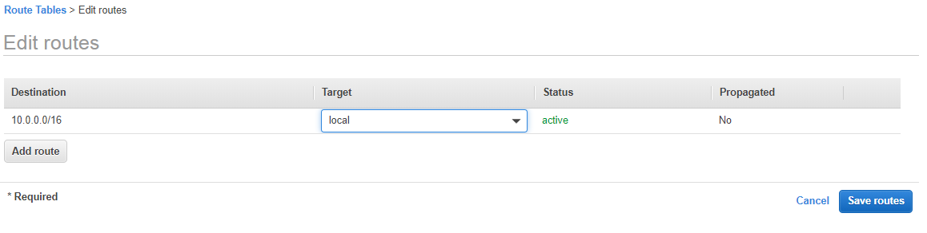

1. Edit route table association for subnet

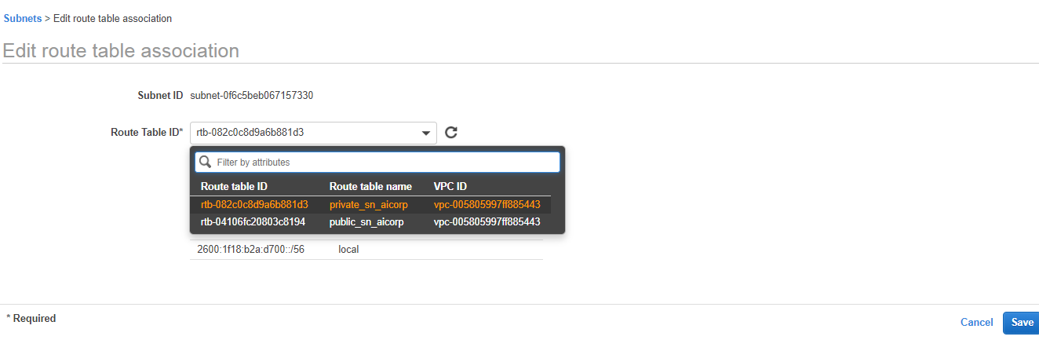

1. Create a new instance and associate it with private subnet

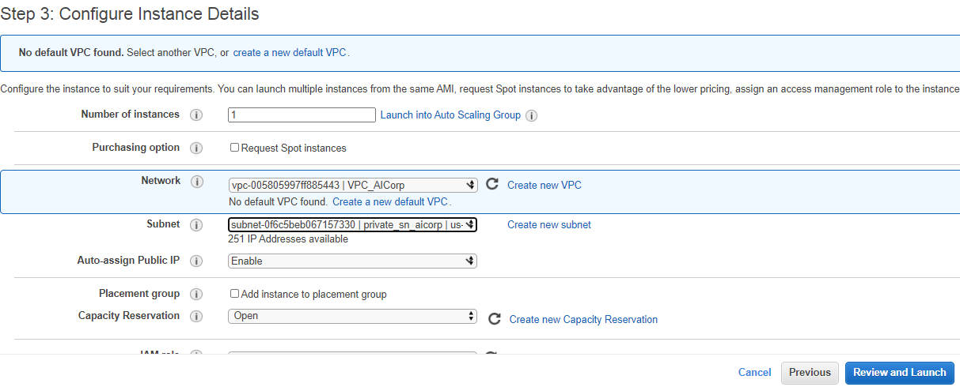

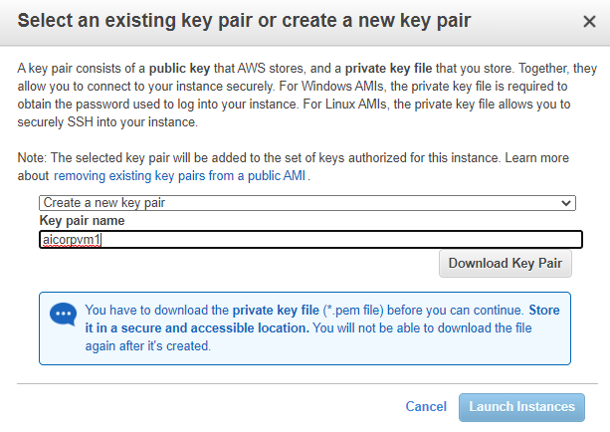

1. Create a new instance and associate it with public subnet
2. Create a NAT instance, in the public subnet

AWS checks if the request source and response destination are same while accessing internet, since we are using NAT instance to allo private VM to access internet remove this restriction

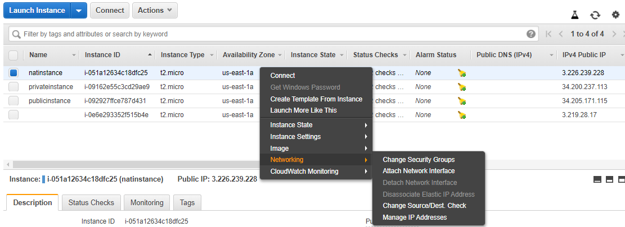

15) Set NAT instance to connect to internet getaway

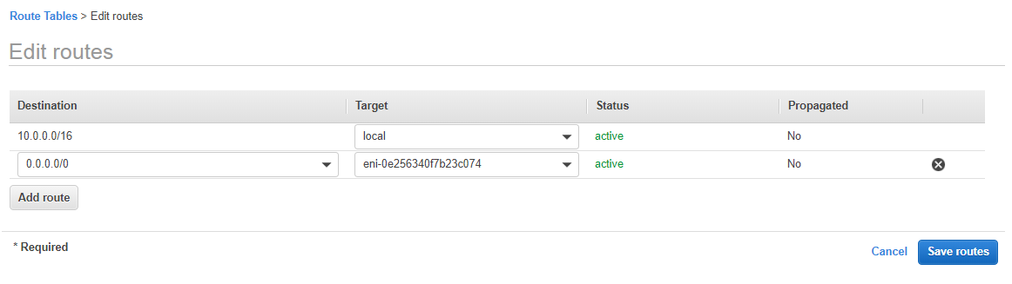

1. Edit the route table of private VM to hit NAT instance

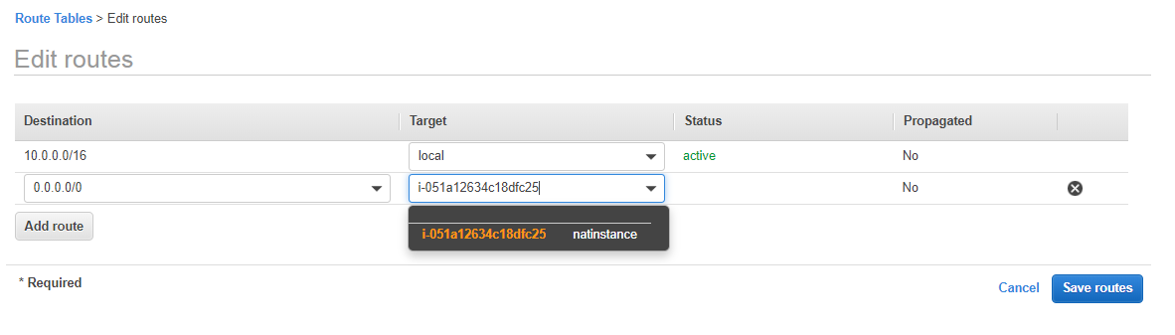

1. SSH into Public VM using Putty
2. SSH into Private VM from Public VM
3. Check internet connectivity from Private VM

Important points

1. Even if a VM has public IP, if its subnet is connected to Internet Gateway, the VM cannot be reached
2. Even a private VM cannot be SSHed into when NAT Gateaway is not setup