* Check boxes are not selectable.- INPRG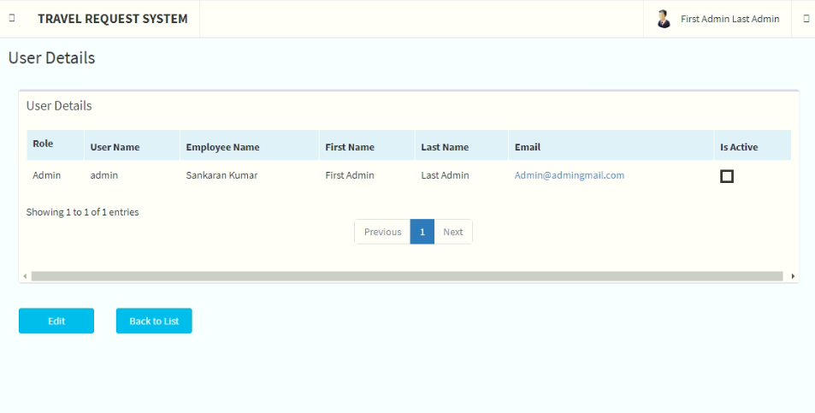
* For some employees Fields not visible in the main dashboard but visible in the details. - Fixed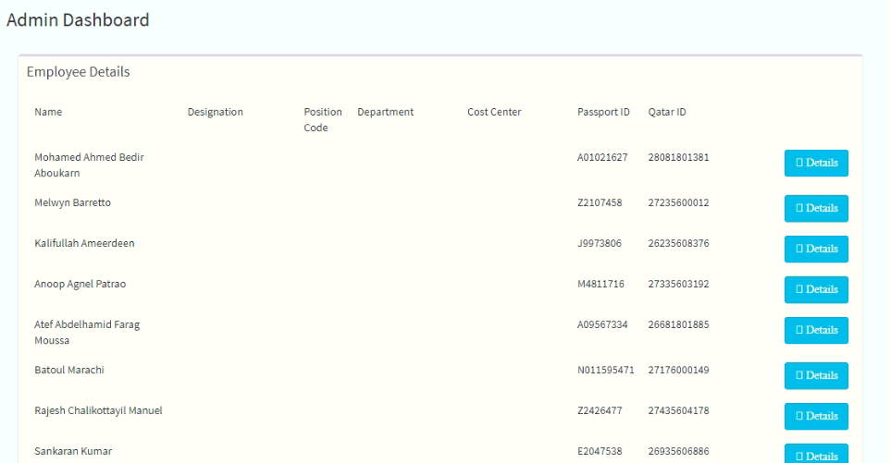
* Displayed values are not as same as that in the details section - values are contradicting . - Fixed 

Once Details button is clicked, 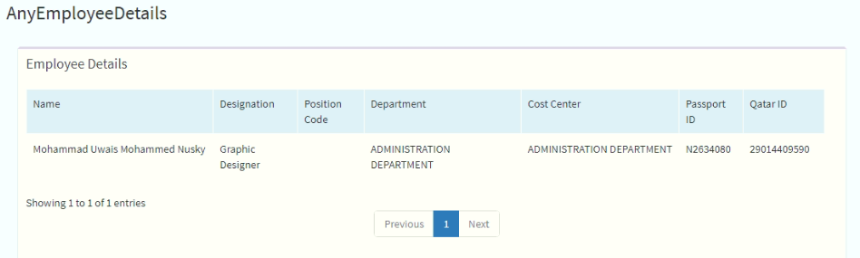

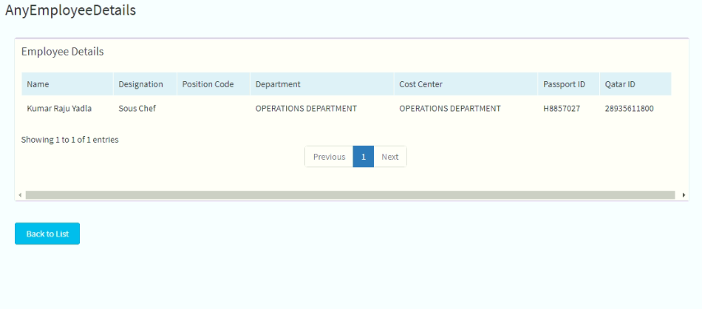

* Dashboard and Manage Employees links taking time to load than other sections – Fixed
* Not able to create new users in Manage Users: - Fixed 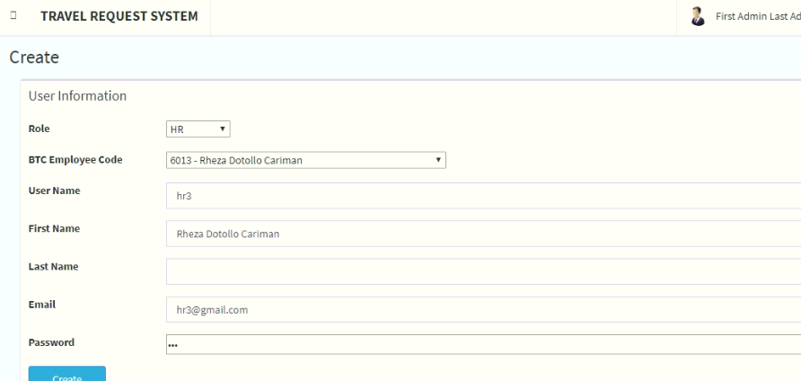

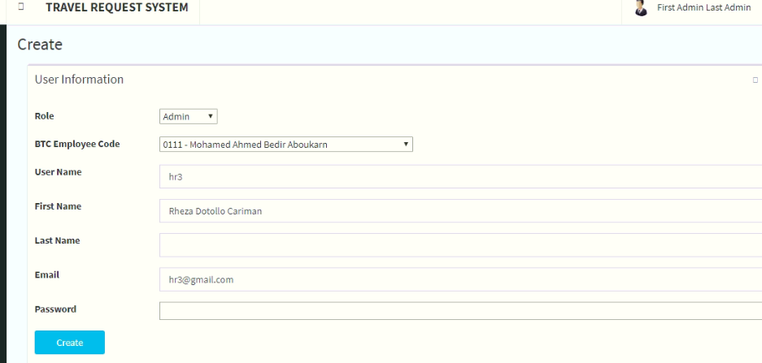

And intermittently not showing the created role in the Manage Users List

**As I retested, it seems repeated or blank Email ID values and Last Name is casuing the issue. Could you please check on this context**

* **Cost Centre** configuration is incorrect – need to query out the right ones - Emailed the Query – Needs Fix

**Employee Dashboard**

* Expenses handled by value wrong when opened in Edit mode. Values showing correct when a new form is created - Fixed

**Create form**

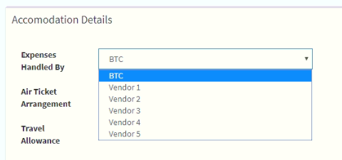

**Form opened in Edit mode (Already saved form)** 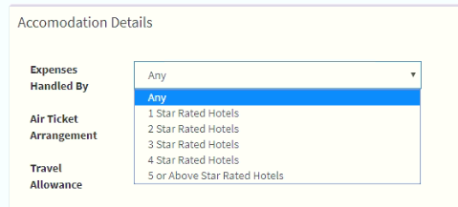

Same happens with Preferred vehicle Types:

**Create form** - FIXED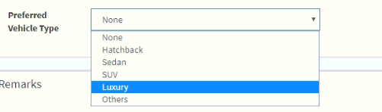

**Form opened in Edit mode (Already saved form)** - FIXED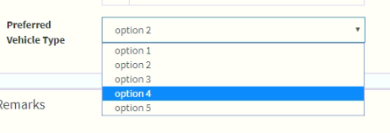

* Values not getting saved when a user saves the created request and opens in Edit mode. Mostly down values – **FIXED** for all except Expenses handled by

 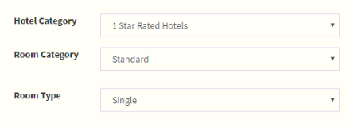  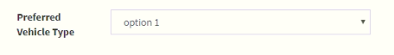

**Cost Centre Manager Dashboard:** – Fixed

Password change is not working fine. Manager is able to login with both old and new password even after changing the password

Here:

Manager1 – Old password

Manager3 – New password.

Both are accepted by the system

**Human Resources Dashboard** - Fixed

Spell error for *Human Resources*

