**1. Can a Python list hold a mixture of integers and strings?**

Yes

**Output:**

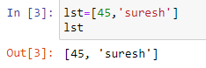

**2. What happens if you attempt to access an element of a list using a negative index?**

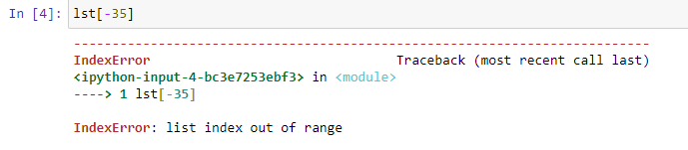

**When there are 35 items in the list, it prints the 35th item from right**



**3. What Python statement produces a list containing the values 45, −3, 16 and 8, in that order?**

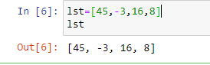

**4. Given the statement**

**lst = [10, -4, 11, 29]**

**(a) What expression represents the very first element of lst?**

0

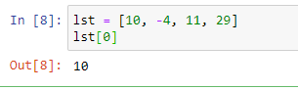

**(b) What expression represents the very last element of lst?**

**3**

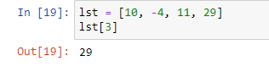

**(c) What is lst[0]?**



**(d) What is lst[3]?**



**(e) What is lst[1]?**

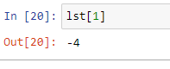

**(f) What is lst[-1]?**



**(g) What is lst[-4]?**



**(h) Is the expression lst[3.0] legal or illegal?**

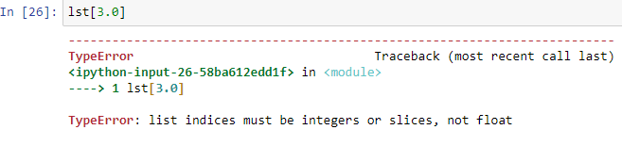

**5. Given the statements**

**lst = [3, 0, 1, 5, 2]**

**x = 2**

**evaluate the following expressions:**

**(a) lst[0]?**

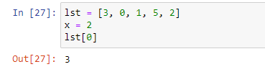

**(b) lst[3]?**



**(c) lst[x]?**

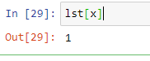

**(d) lst[-x]?**



**(e) lst[x + 1]?**



**(f) lst[x] + 1?**

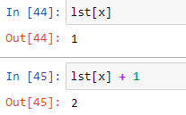

**(g) lst[lst[x]]?**

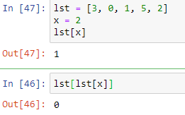

**(h) lst[lst[lst[x]]]?**

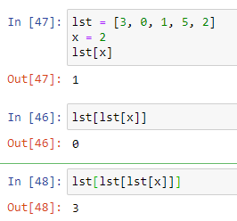

**6. What function returns the number of elements in a list?**

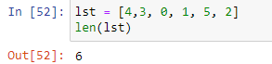

**7. What expression represents the empty list?**

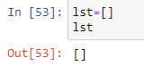

**8. Given the list**

**lst = [20, 1, -34, 40, -8, 60, 1, 3]**

**evaluate the following expressions:**

**(a) lst**

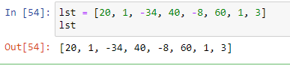

**(b) lst[0:3]**



**(c) lst[4:8]**



**(d) lst[4:33]**

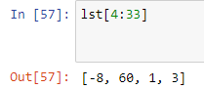

**(e) lst[-5:-3]**

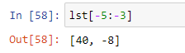

**(f) lst[-22:3]**



**(g) lst[4:]**



**(h) lst[:]**

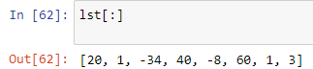

**(i) lst[:4]**



**(j) lst[1:5]**

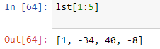

**(k) -34 in lst**



**(l) -34 not in lst**



**(m) len(lst)**



**9. An assignment statement containing the expression a[m:n] on the left side and a list on the right side can modify list a. Complete the following table by supplying the m and n values in the slice assignment statement needed to produce the indicated list from the given original list.**

