1

**Waterfall Model**

This is the most basic [software development life cycle](https://www.edureka.co/blog/software-testing-life-cycle/) process which is followed broadly in the industry. In this model, the developers follow a sequence of processes downwards towards the ultimate goal. It is like a waterfall where there are various phases involved.

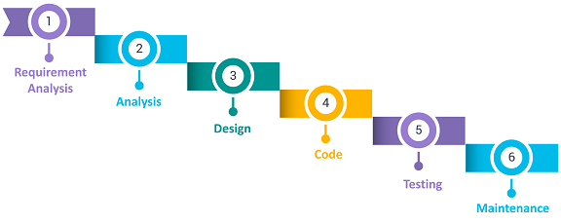

**Advantages**

* It is easy to implement and maintain.
* The initial phase of rigorous scrutiny of requirements and systems helps in saving time later in the developmental phase.
* The requirement of resources is minimal and testing is done after each phase has been completed.

**Disadvantages**

* It is not possible to alter or update requirements.
* Once you move into the next phase you cannot make changes.
* You cannot start the next phase until the previous phase is completed.

### ****V Model****

The V Model is considered superior to the waterfall model. In this model, the development and test execution activities are carried out side by side in the downhill and uphill shape. Also, testing starts at the unit level and spreads towards the integration of the entire system.

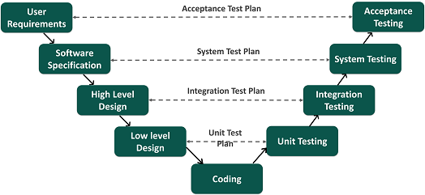

**Advantages**

* It is easy to use since testing activities like planning and test designing are done before coding.
* This model enhances the chances of success and saves time.
* Defects are mostly found at an early stage and downward flow of defects is generally avoided.

**Disadvantages**

* It is a rigid model.
* The software is developed during the implementation phase so early prototypes of the product are not available.
* If there are changes in the midway, you need to update the test document.

### ****Agile Model****

In the Agile model, requirements and solutions evolve through collaboration between various cross-functional teams. It is also known as an iterative and incremental model. The agile software testing model focus on process adaptability and customer satisfaction by rapid delivery of working software product and by breaking the product into small incremental builds.

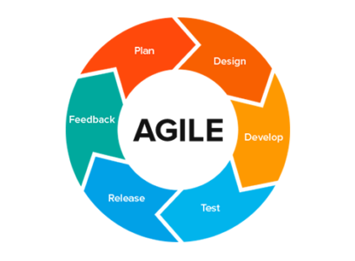

**Advantages**

* It ensures customer satisfaction with rapid and continuous development of deliverables.
* The continuous interaction between the customers, developers, and testers makes it a flexible model.
* You can develop the working software quickly and adapt to changing requirements regularly.

**Disadvantages**

* It is difficult to assess the effort required at the beginning of the cycle for large and complex software development cases.
* Due to continuous interaction with the customer, the project can go off track if the customer is not clear about the goals.

### ****Spiral Model****

This software testing model is similar to the [Agile model](https://www.edureka.co/blog/what-is-agile-testing/), but with more emphasis on risk analysis. The different phases of the spiral model include planning, risk analysis, engineering, and evaluation. In this case, you need to gather the requirements and perform the risk assessment at the base level and every upper spiral builds on it.

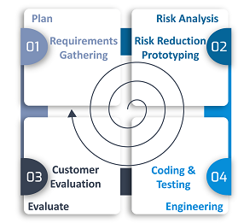

**Advantages**

* It is suitable for complex and large systems.
* You can add functionalities depending on the changed circumstances.
* Software is produced early in the cycle.

**Disadvantages**

* It is a costly model which requires highly specialized expertise in risk analysis
* It does not work well on simpler projects.

### ****Iterative Model****

The Iterative model does not need a full list of requirements before beginning the project. The development process starts with the requirements of the functional part, which can be expanded later. The process is repetitive and allows new versions of the product for every cycle. Every iteration includes the development of a separate component of the system which is added to the functional developed earlier.

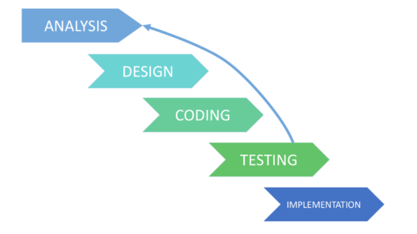

**Advantages**

* It is easier to control the risks as high-risk tasks are completed first.
* The progress is easily measurable.
* Problems and risks defined within one iteration can be prevented in the next sprints.

**Disadvantages**

* Iterative model requires more resources than the waterfall model.
* The process is difficult to manage.
* The risks may not be completely determined even at the final stage of the project.

2

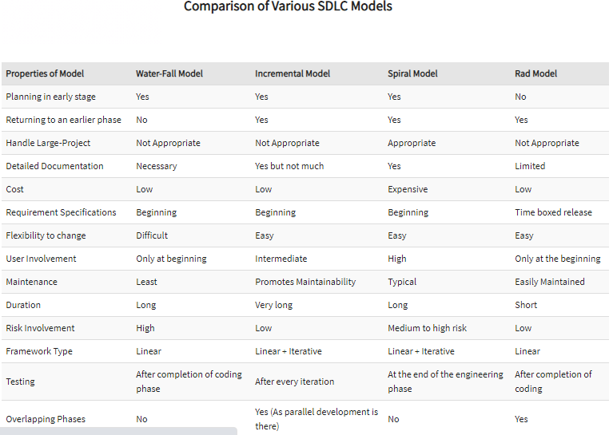

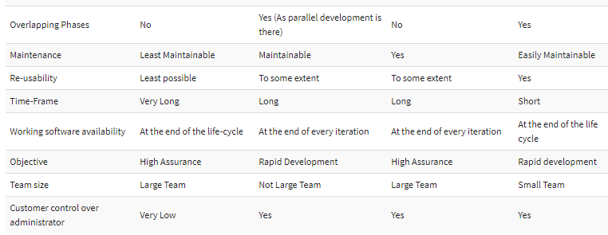

3

## Requirement Engineering Process

It is a four step process, which includes –

* Feasibility Study
* Requirement Gathering
* Software Requirement Specification
* Software Requirement Validation

Let us see the process briefly -

### Feasibility study

When the client approaches the organization for getting the desired product developed, it comes up with rough idea about what all functions the software must perform and which all features are expected from the software.

Referencing to this information, the analysts does a detailed study about whether the desired system and its functionality are feasible to develop.

This feasibility study is focused towards goal of the organization. This study analyzes whether the software product can be practically materialized in terms of implementation, contribution of project to organization, cost constraints and as per values and objectives of the organization. It explores technical aspects of the project and product such as usability, maintainability, productivity and integration ability.

The output of this phase should be a feasibility study report that should contain adequate comments and recommendations for management about whether or not the project should be undertaken.

### Requirement Gathering

If the feasibility report is positive towards undertaking the project, next phase starts with gathering requirements from the user. Analysts and engineers communicate with the client and end-users to know their ideas on what the software should provide and which features they want the software to include.

### Software Requirement Specification

SRS is a document created by system analyst after the requirements are collected from various stakeholders.

SRS defines how the intended software will interact with hardware, external interfaces, speed of operation, response time of system, portability of software across various platforms, maintainability, speed of recovery after crashing, Security, Quality, Limitations etc.

The requirements received from client are written in natural language. It is the responsibility of system analyst to document the requirements in technical language so that they can be comprehended and useful by the software development team.

SRS should come up with following features:

* User Requirements are expressed in natural language.
* Technical requirements are expressed in structured language, which is used inside the organization.
* Design description should be written in Pseudo code.
* Format of Forms and GUI screen prints.
* Conditional and mathematical notations for DFDs etc.

### Software Requirement Validation

After requirement specifications are developed, the requirements mentioned in this document are validated. User might ask for illegal, impractical solution or experts may interpret the requirements incorrectly. This results in huge increase in cost if not nipped in the bud. Requirements can be checked against following conditions -

* If they can be practically implemented
* If they are valid and as per functionality and domain of software
* If there are any ambiguities
* If they are complete
* If they can be demonstrated

## Requirement Elicitation Process

Requirement elicitation process can be depicted using the folloiwng diagram:

Requirement elicitation process

* **Requirements gathering -**The developers discuss with the client and end users and know their expectations from the software.
* **Organizing Requirements -**The developers prioritize and arrange the requirements in order of importance, urgency and convenience.
* **Negotiation & discussion -**If requirements are ambiguous or there are some conflicts in requirements of various stakeholders, if they are, it is then negotiated and discussed with stakeholders. Requirements may then be prioritized and reasonably compromised.

The requirements come from various stakeholders. To remove the ambiguity and conflicts, they are discussed for clarity and correctness. Unrealistic requirements are compromised reasonably.

* **Documentation -**All formal & informal, functional and non-functional requirements are documented and made available for next phase processing.

## Requirement Elicitation Techniques

Requirements Elicitation is the process to find out the requirements for an intended software system by communicating with client, end users, system users and others who have a stake in the software system development.

There are various ways to discover requirements

### Interviews

Interviews are strong medium to collect requirements. Organization may conduct several types of interviews such as:

* Structured (closed) interviews, where every single information to gather is decided in advance, they follow pattern and matter of discussion firmly.
* Non-structured (open) interviews, where information to gather is not decided in advance, more flexible and less biased.
* Oral interviews
* Written interviews
* One-to-one interviews which are held between two persons across the table.
* Group interviews which are held between groups of participants. They help to uncover any missing requirement as numerous people are involved.

### Surveys

Organization may conduct surveys among various stakeholders by querying about their expectation and requirements from the upcoming system.

### Questionnaires

A document with pre-defined set of objective questions and respective options is handed over to all stakeholders to answer, which are collected and compiled.

A shortcoming of this technique is, if an option for some issue is not mentioned in the questionnaire, the issue might be left unattended.

### Task analysis

Team of engineers and developers may analyze the operation for which the new system is required. If the client already has some software to perform certain operation, it is studied and requirements of proposed system are collected.

### Domain Analysis

Every software falls into some domain category. The expert people in the domain can be a great help to analyze general and specific requirements.

### Brainstorming

An informal debate is held among various stakeholders and all their inputs are recorded for further requirements analysis.

### Prototyping

Prototyping is building user interface without adding detail functionality for user to interpret the features of intended software product. It helps giving better idea of requirements. If there is no software installed at client’s end for developer’s reference and the client is not aware of its own requirements, the developer creates a prototype based on initially mentioned requirements. The prototype is shown to the client and the feedback is noted. The client feedback serves as an input for requirement gathering.

### Observation

Team of experts visit the client’s organization or workplace. They observe the actual working of the existing installed systems. They observe the workflow at client’s end and how execution problems are dealt. The team itself draws some conclusions which aid to form requirements expected from the software.

## Software Requirements Characteristics

Gathering software requirements is the foundation of the entire software development project. Hence they must be clear, correct and well-defined.

A complete Software Requirement Specifications must be:

* Clear
* Correct
* Consistent
* Coherent
* Comprehensible
* Modifiable
* Verifiable
* Prioritized
* Unambiguous
* Traceable
* Credible source

## Software Requirements

We should try to understand what sort of requirements may arise in the requirement elicitation phase and what kinds of requirements are expected from the software system.

Broadly software requirements should be categorized in two categories:

### Functional Requirements

Requirements, which are related to functional aspect of software fall into this category.

They define functions and functionality within and from the software system.

#### **Examples -**

* Search option given to user to search from various invoices.
* User should be able to mail any report to management.
* Users can be divided into groups and groups can be given separate rights.
* Should comply business rules and administrative functions.
* Software is developed keeping downward compatibility intact.

### Non-Functional Requirements

Requirements, which are not related to functional aspect of software, fall into this category. They are implicit or expected characteristics of software, which users make assumption of.

Non-functional requirements include -

* Security
* Logging
* Storage
* Configuration
* Performance
* Cost
* Interoperability
* Flexibility
* Disaster recovery
* Accessibility

Requirements are categorized logically as

* **Must Have** : Software cannot be said operational without them.
* **Should have** : Enhancing the functionality of software.
* **Could have** : Software can still properly function with these requirements.
* **Wish list** : These requirements do not map to any objectives of software.

While developing software, ‘Must have’ must be implemented, ‘Should have’ is a matter of debate with stakeholders and negation, whereas ‘could have’ and ‘wish list’ can be kept for software updates.

## User Interface requirements

UI is an important part of any software or hardware or hybrid system. A software is widely accepted if it is -

* easy to operate
* quick in response
* effectively handling operational errors
* providing simple yet consistent user interface

User acceptance majorly depends upon how user can use the software. UI is the only way for users to perceive the system. A well performing software system must also be equipped with attractive, clear, consistent and responsive user interface. Otherwise the functionalities of software system can not be used in convenient way. A system is said be good if it provides means to use it efficiently. User interface requirements are briefly mentioned below -

* Content presentation
* Easy Navigation
* Simple interface
* Responsive
* Consistent UI elements
* Feedback mechanism
* Default settings
* Purposeful layout
* Strategical use of color and texture.
* Provide help information
* User centric approach
* Group based view settings.

## Software System Analyst

System analyst in an IT organization is a person, who analyzes the requirement of proposed system and ensures that requirements are conceived and documented properly & correctly. Role of an analyst starts during Software Analysis Phase of SDLC. It is the responsibility of analyst to make sure that the developed software meets the requirements of the client.

System Analysts have the following responsibilities:

* Analyzing and understanding requirements of intended software
* Understanding how the project will contribute in the organization objectives
* Identify sources of requirement
* Validation of requirement
* Develop and implement requirement management plan
* Documentation of business, technical, process and product requirements
* Coordination with clients to prioritize requirements and remove and ambiguity
* Finalizing acceptance criteria with client and other stakeholders

4

Software Quality Management ensures that the required level of quality is achieved by submitting improvements to the product development process. SQA aims to develop a culture within the team and it is seen as everyone's responsibility.

Software Quality management should be independent of project management to ensure independence of cost and schedule adherences. It directly affects the process quality and indirectly affects the product quality.

## Activities of Software Quality Management:

* **Quality Assurance -**QA aims at developing Organizational procedures and standards for quality at Organizational level.
* **Quality Planning -**Select applicable procedures and standards for a particular project and modify as required to develop a quality plan.
* **Quality Control -**Ensure that best practices and standards are followed by the software development team to produce quality products.