

**Department of Master of Computer Science**

**Experiment No. 5**

**Submitted By: Submitted To:**

Yerraballi Suresh Kumar Reddy Prof. Kuldeep V

19MCAR0080

Semester: 3rd MCA

**Q1 Print hello world using WPF**

<Grid>

<Label Content="WPF First Program" HorizontalAlignment="Left

" Margin="331,91,0,0" VerticalAlignment="Top"/>

<Button Content="Print Hello" HorizontalAlignment="Left" Margin="351,178,0,0" VerticalAlignment="Top" Width="75" Click="Button_Click"/>

</Grid>

private void Button_Click(object sender, RoutedEventArgs e)

{

System.Windows.MessageBox.Show("Hello World");

}

**Output:**

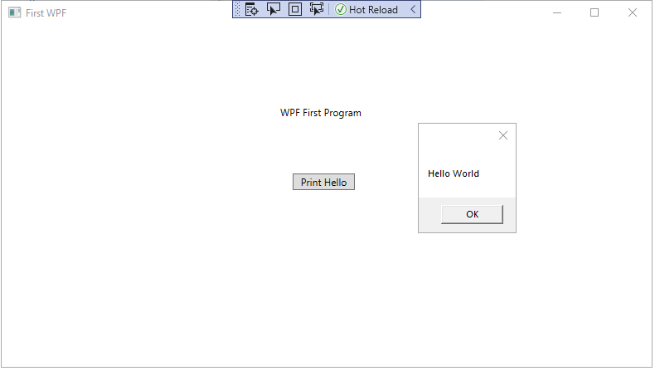

**Q2 Print the text which is on textbox**

<Grid>

<Button Content="Submit" HorizontalAlignment="Left" Margin="394,184,0,0" VerticalAlignment="Top" Width="75" Click="Button_Click"/>

<Label Content="Last Name" HorizontalAlignment="Left" Margin="283,129,0,0" VerticalAlignment="Top"/>

<TextBox x:Name="firstname" HorizontalAlignment="Left" Height="23" Margin="356,90,0,0" TextWrapping="Wrap" Text="" VerticalAlignment="Top" Width="156" TextChanged="TextBox_TextChanged"/>

<TextBox x:Name="lastname" HorizontalAlignment="Left" Height="23" Margin="356,133,0,0" TextWrapping="Wrap" Text="" VerticalAlignment="Top" Width="156" TextChanged="TextBox_TextChanged_1"/>

<Label Content="First Name" HorizontalAlignment="Left" Margin="282,85,0,0" VerticalAlignment="Top"/>

<Label Content="Please enter the details" HorizontalAlignment="Left" Margin="344,33,0,0" VerticalAlignment="Top"/>

</Grid>

private void Button_Click(object sender, RoutedEventArgs e)

{

string fName = firstname.Text;

string lName = lastname.Text;

System.Windows.MessageBox.Show("Welcome" + fName+" " + lName);

}

**Output:**

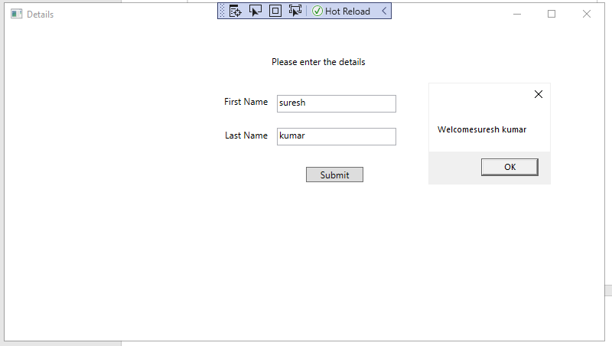

**Q3 addition of two numbers**

private void Button_Click(object sender, RoutedEventArgs e)

{

int firstNumber, secondNumber, sum;

firstNumber = Convert.ToInt32(firstinput.Text);

secondNumber = Convert.ToInt32(secondinput.Text);

sum =firstNumber + secondNumber;

String str = Convert.ToString(sum);

System.Windows.MessageBox.Show(str);

}

