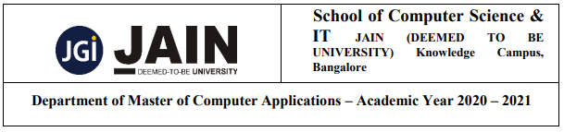

**Department of Master of Computer Science**

**Web Programming**

**Faculty and Student Evaluation System**

**Submitted By: Submitted To:**

Yerraballi Suresh Kumar Reddy Prof. Mehtab M

19MCAR0080

Semester: 3rd MCA

**Introduction:**

Faculty and Student evaluation system provides easy method to store the evaluation from the user and stores it in database and it shows the results based on needed in different formats and also it can export in pdf format.

**Modules:**

1. **Admin**
2. **Faculty**
3. **Student**

**DFD**

**Flow Chart**