

**Department of Master of Computer Science**

**Web Programming**

**Self-Attendance System**

Activity-2

**Submitted By: Submitted To:**

Yerraballi Suresh Kumar Reddy Prof. Mehtab

19MCAR0080

Semester: 3rd MCA

**Introduction:**

This system makes it ease for the faculty to take the attendance rather than taking attendance in each and every period and which let at least five to ten minutes of every hour.

**Database:**

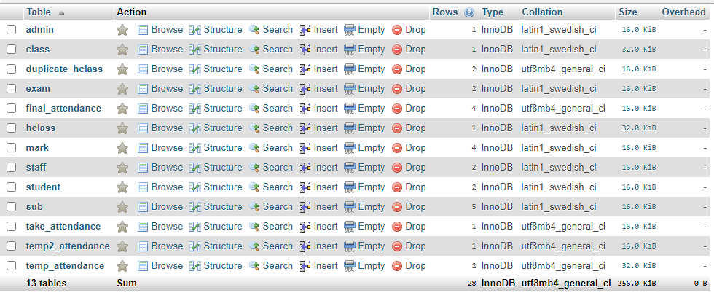

index.php

<?php

include "database.php";

session_start();

?>

<!DOCTYPE html>

<html>

<head>

<title>Admin Login</title>

<link rel="stylesheet" type="text/css" href="css/style.css">

<link rel="shortcut icon" type="image/x-icon" href="logo.jpg" />

</head>

<body class="back">

<?php include"navbar.php";?>

<div class="login">

<h1 class="heading">Admin Login</h1>

<div class="log">

<?php

if(isset($_POST["login"]))

{

$sql="select * from admin where ANAME='{$_POST["aname"]}' and APASS='{$_POST["apass"]}'";

$res=$db->query($sql);

if($res->num_rows>0)

{

$ro=$res->fetch_assoc();

$_SESSION["AID"]=$ro["AID"];

$_SESSION["ANAME"]=$ro["ANAME"];

echo "<script>window.open('admin_home.php','_self');</script>";

}

else

{

echo "<div class='error'>Invalid Username or Password</div>";

}

}

if(isset($_GET["mes"]))

{

echo "<div class='error'>{$_GET["mes"]}</div>";

}

?>

<form method="post" action="<?php echo $_SERVER["PHP_SELF"];?>">

<label>User Name</label><br>

<input type="text" name="aname" required class="input"><br><br>

<label>Password </label><br>

<input type="password" name="apass" required class="input"><br>

<button type="submit" class="btn" name="login">Login Here</button>

<br>

<br>

<!-- <p>Not an Admin? <a href="register_admin.php">Sign up</a></p> -->

</form>

</div>

</div>

<div class="footer">

<?php include("footer.php");?>

</div>

<script src="js/jquery.js"></script>

<script>

$(document).ready(function(){

$(".error").fadeTo(1000, 100).slideUp(1000, function(){

$(".error").slideUp(1000);

});

$(".success").fadeTo(1000, 100).slideUp(1000, function(){

$(".success").slideUp(1000);

});

});

</script>

</body>

</html>

**Output:**

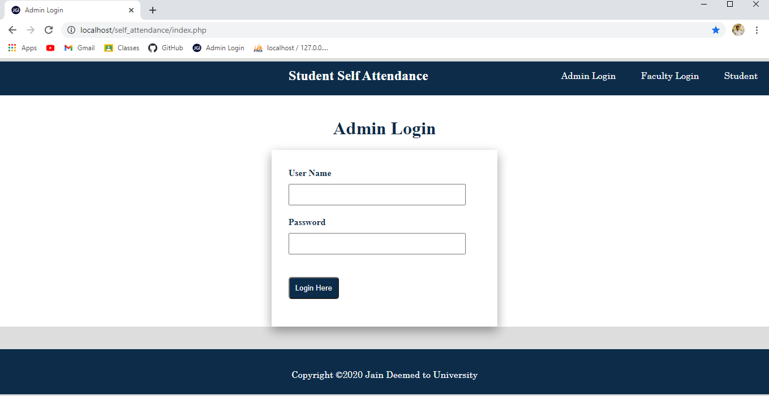

Admin Home

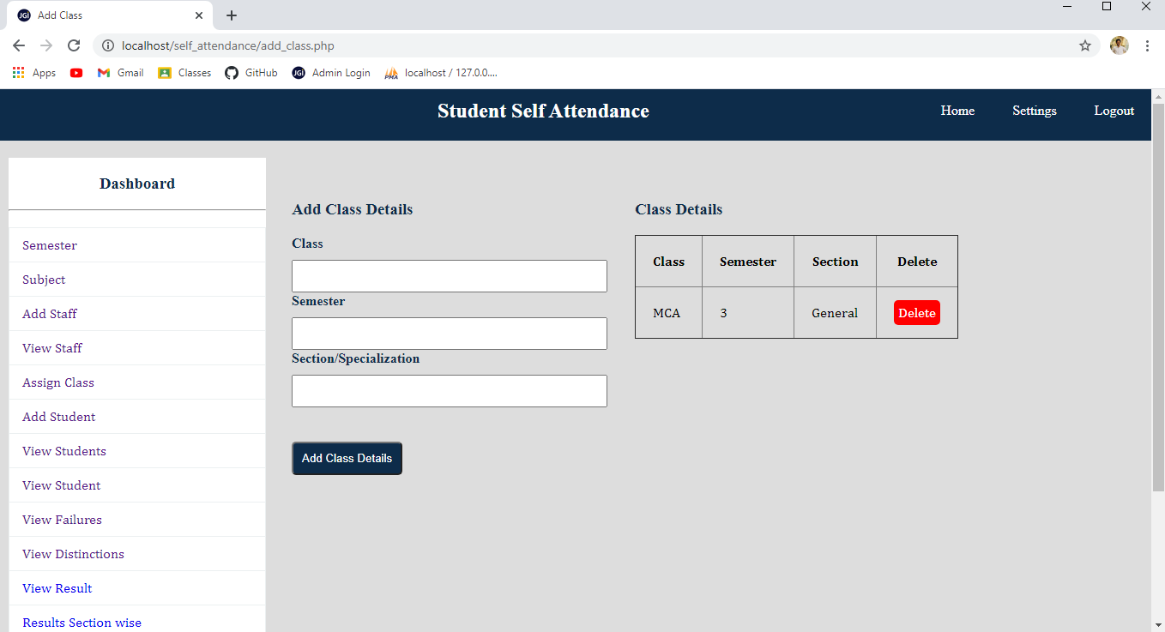

Add subject:

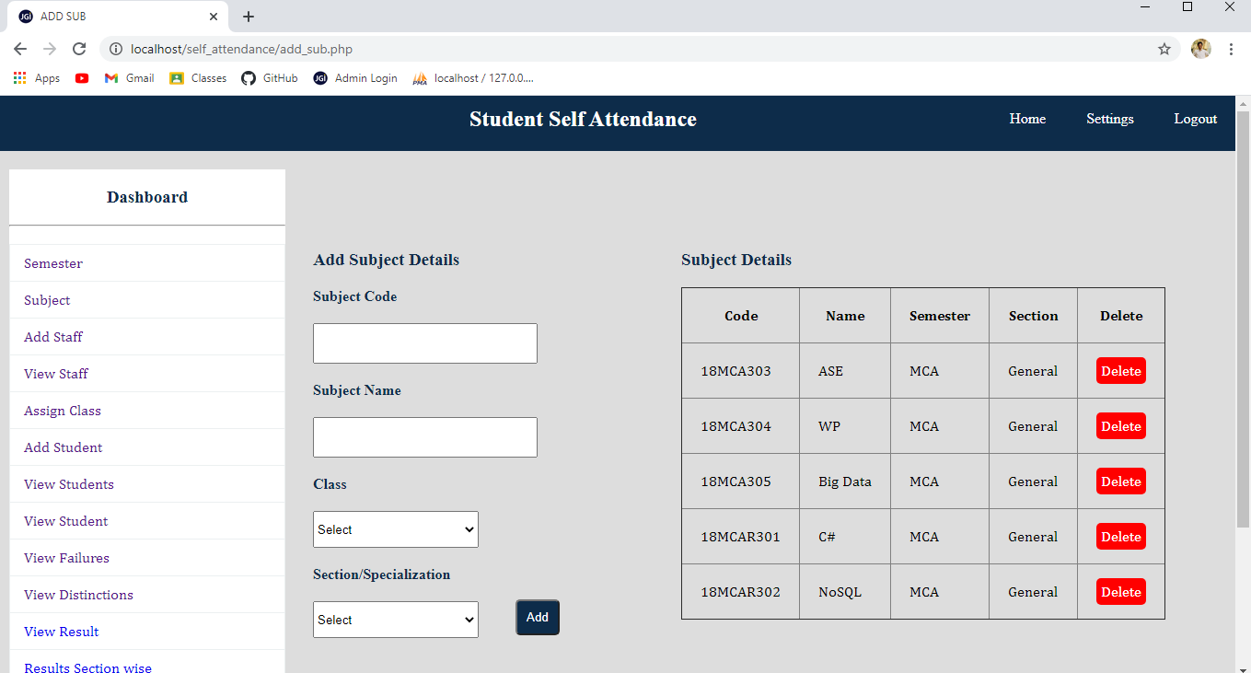

Add staff

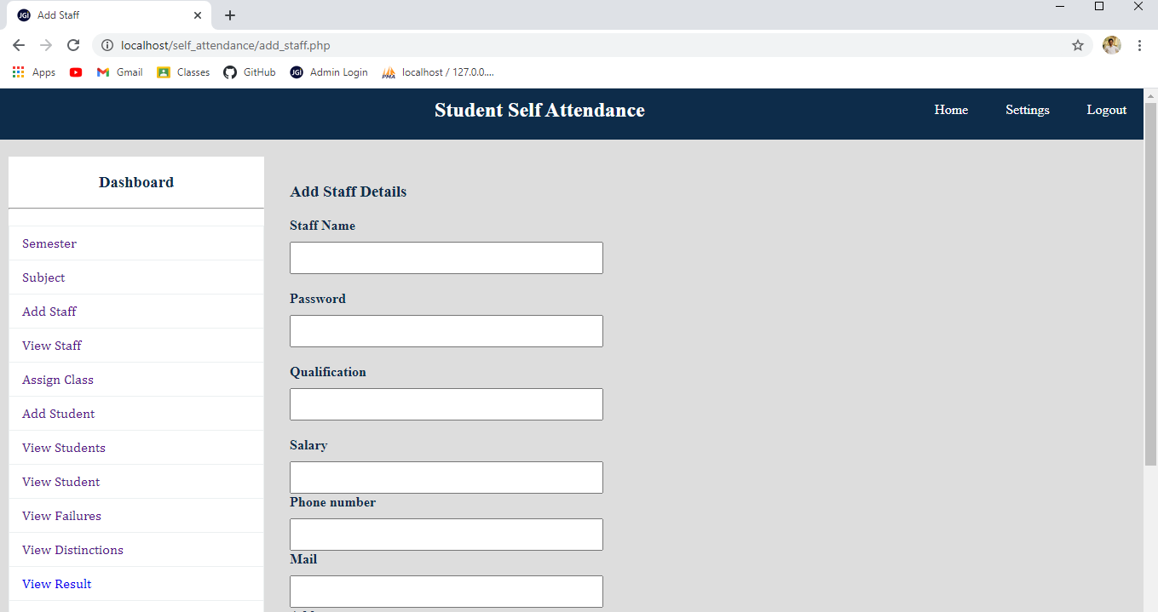



View staff

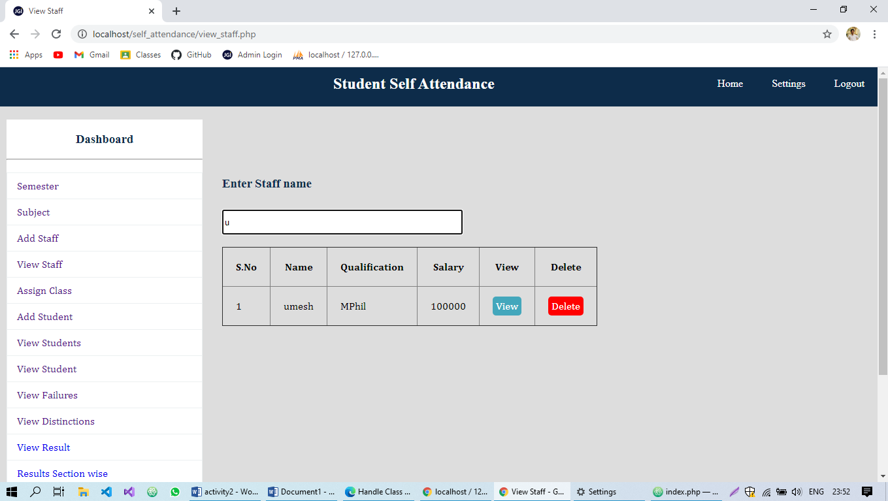

Assign class:

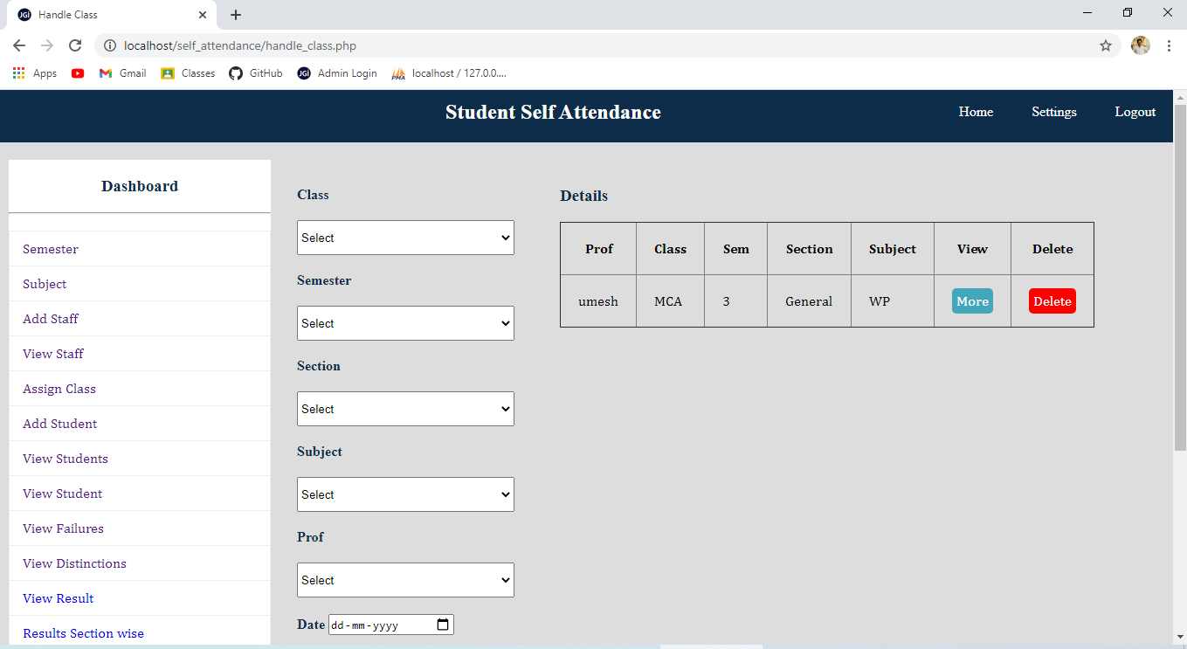

Student

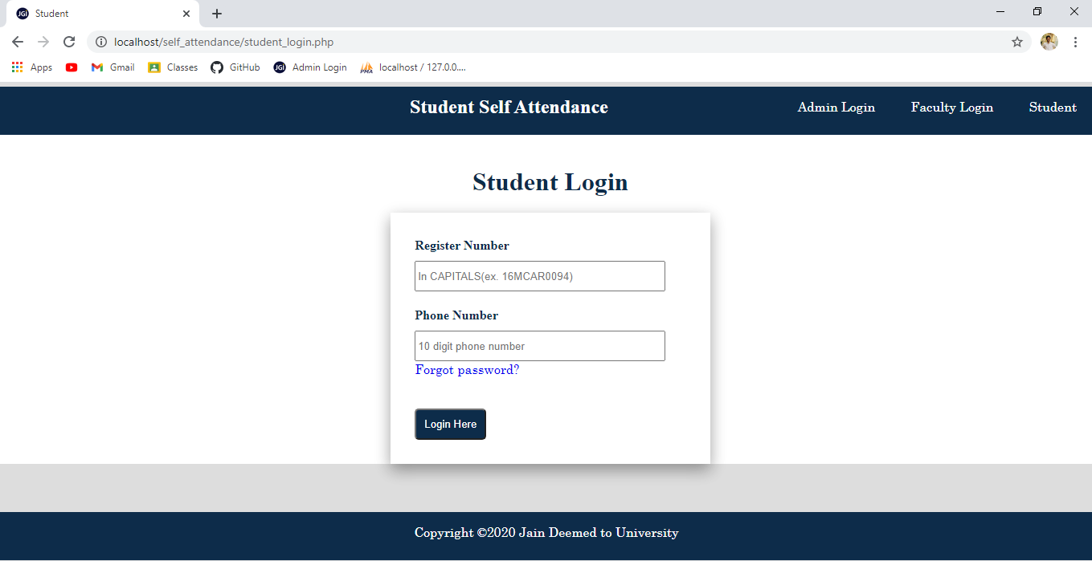

Student home:

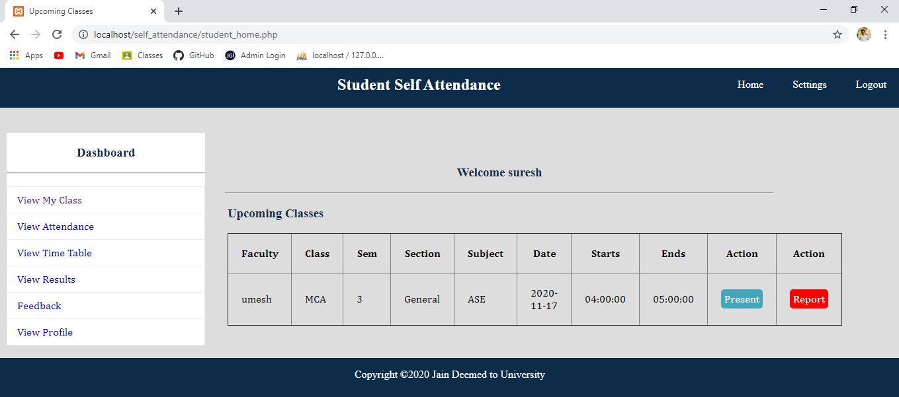

Faculty:

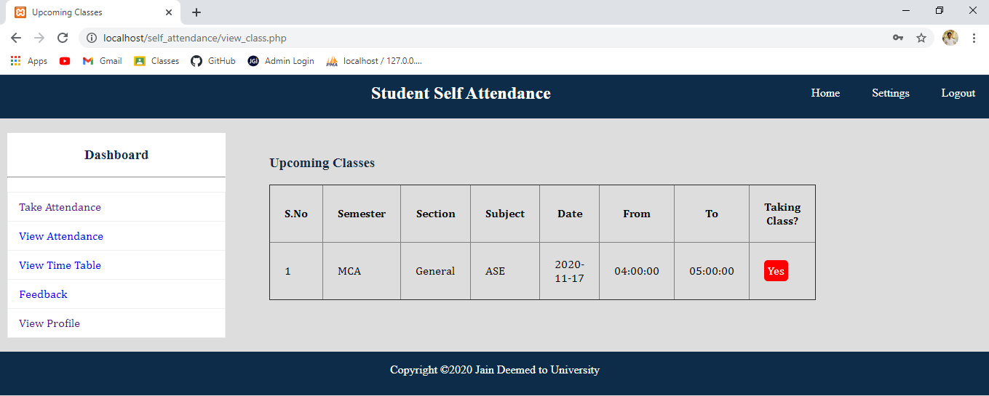

Confirm attendance:

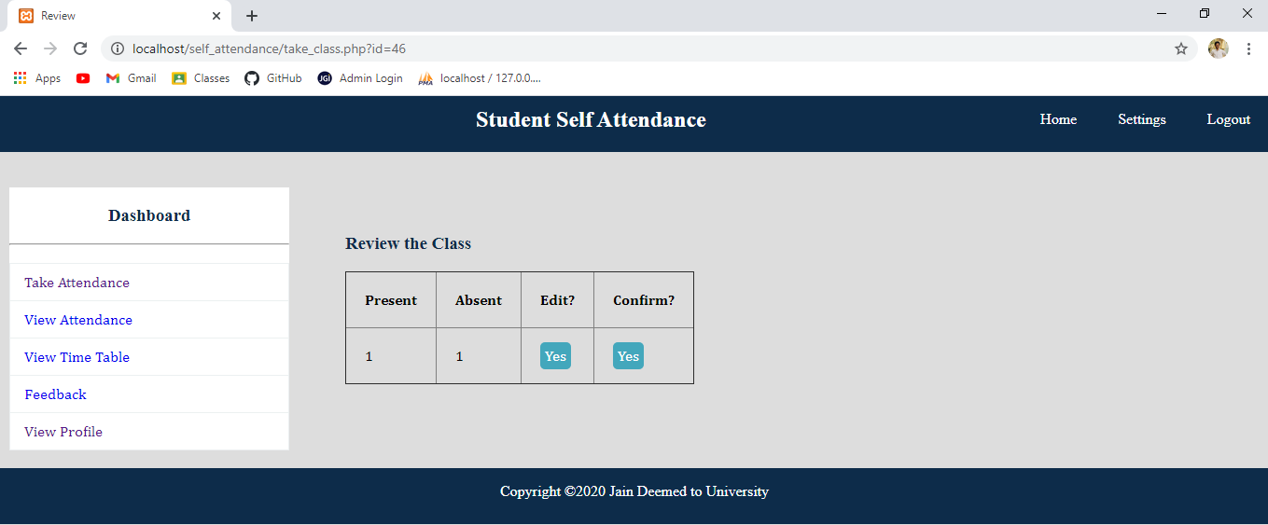

Edit

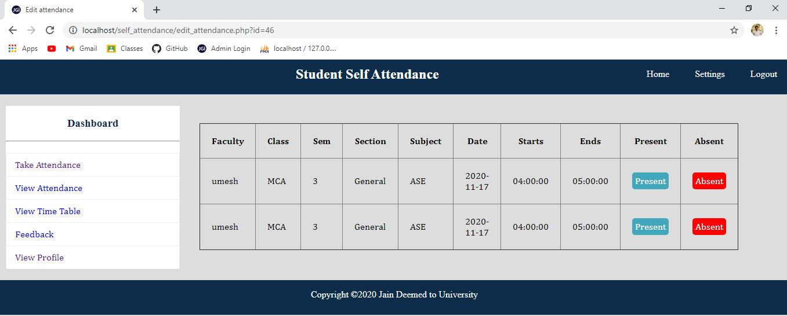

View profile

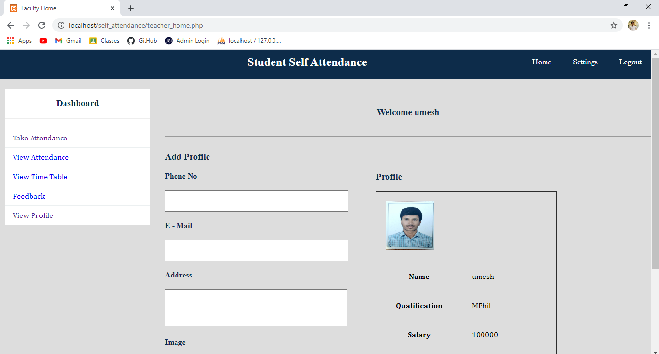

**For source code:**

https://github.com/sureshreddy56/self_attendance