Lab 1. Write a JavaScript program to display the current day and time in the following format.

Source Code:-

<!DOCTYPE html>

<html>

<head>

<title>

JS-LAB-3

</title>

</head>

<body>

<script type="text/javascript">

var myDate = new Date();

var myDay = myDate.getDay();

var weekday = ['Sunday', 'Monday', 'Tuesday',

'Wednesday', 'Thursday', 'Friday', 'Saturday'

];

document.write("Today is : " + weekday[myDay]);

document.write("<br/>");

var hours = myDate.getHours();

var ampm = hours >= 12 ? 'PM' : 'AM';

hours = hours % 12;

hours = hours ? hours : 12;

var minutes = myDate.getMinutes();

minutes = minutes < 10 ? '0' + minutes : minutes;

var myTime = hours + " " + ampm + " : " + minutes +

" : " + myDate.getMilliseconds();

document.write("\tCurrent time is : " + myTime);

</script>

</body>

</html>

Output:-

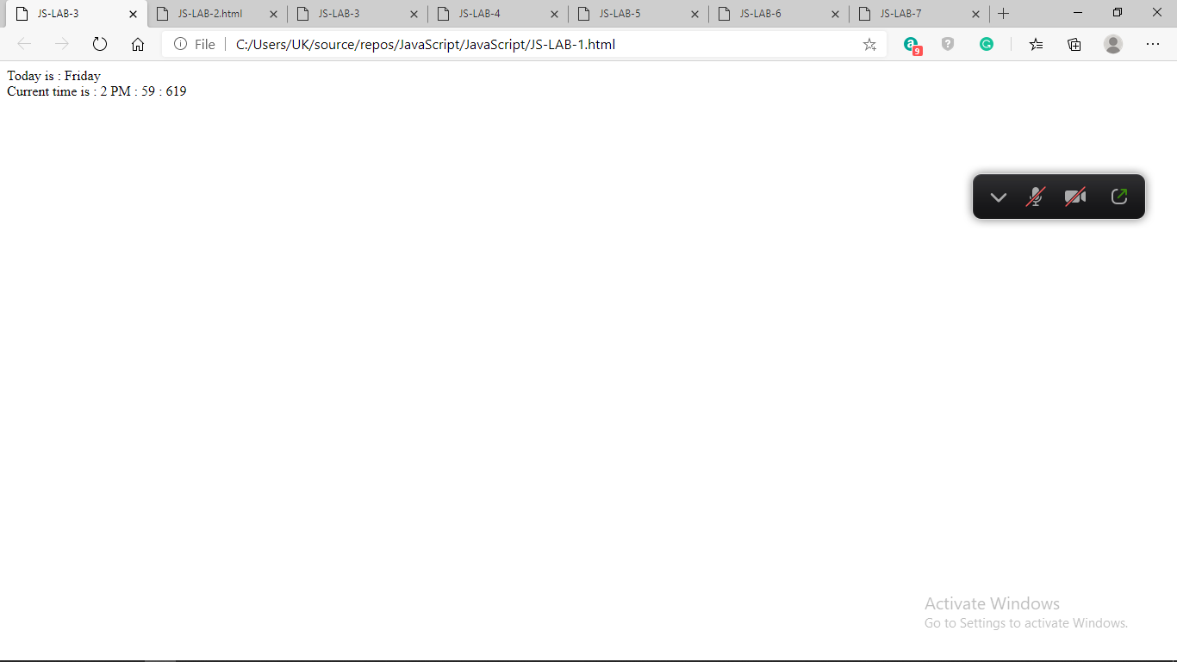

Lab 2. Write a JavaScript program to print the contents of the current window.

Source Code:-

<!DOCTYPE html>

<html>

<body>

<h2>The window.print() Method</h2>

<p>Click the button to print the current page.</p>

<button onclick="window.print()">Print this page</button>

</body>

</html>

Output:-

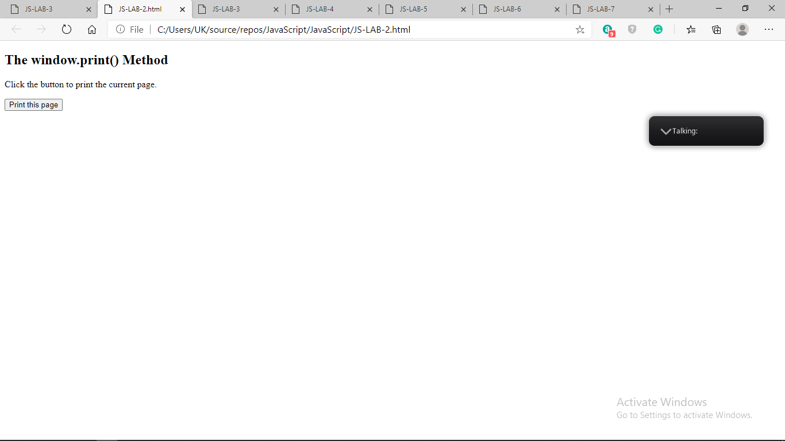

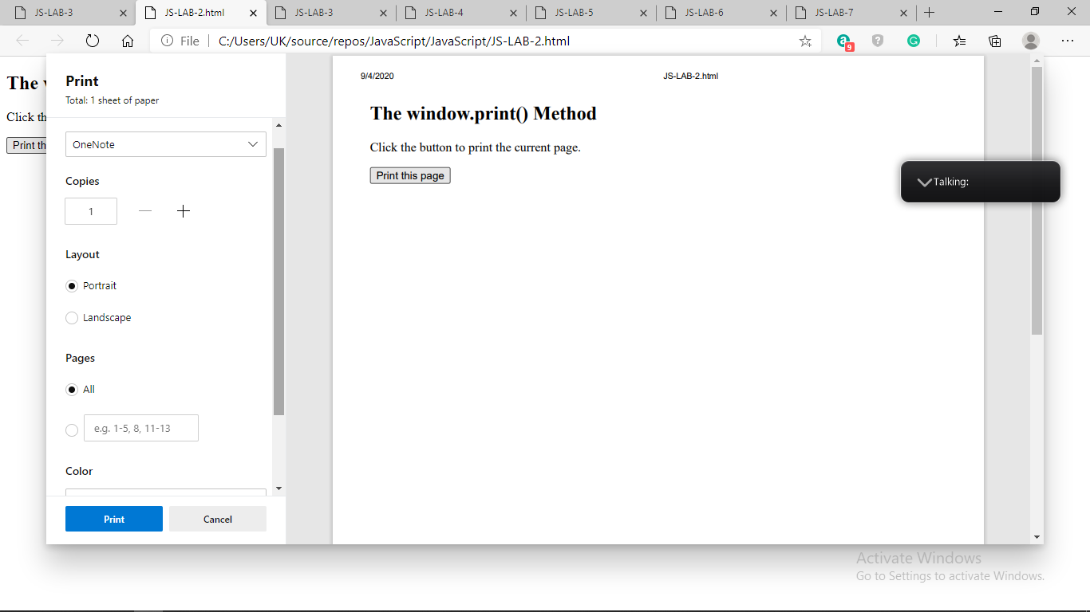

Lab 3. Write a JavaScript program to get the current date.

Source Code:-

<!DOCTYPE html>

<html>

<head>

<title>

JS-LAB-3

</title>

</head>

<body>

<p>

Current Date is:

<span class="output"></span>

</p>

<button onclick="getCurrentDate()">

Get current Date

</button>

<script type="text/javascript">

function getCurrentDate() {

let date = new Date().toDateString();

document.querySelector('.output').textContent

= date;

}

</script>

</body>

</html>

Output:-

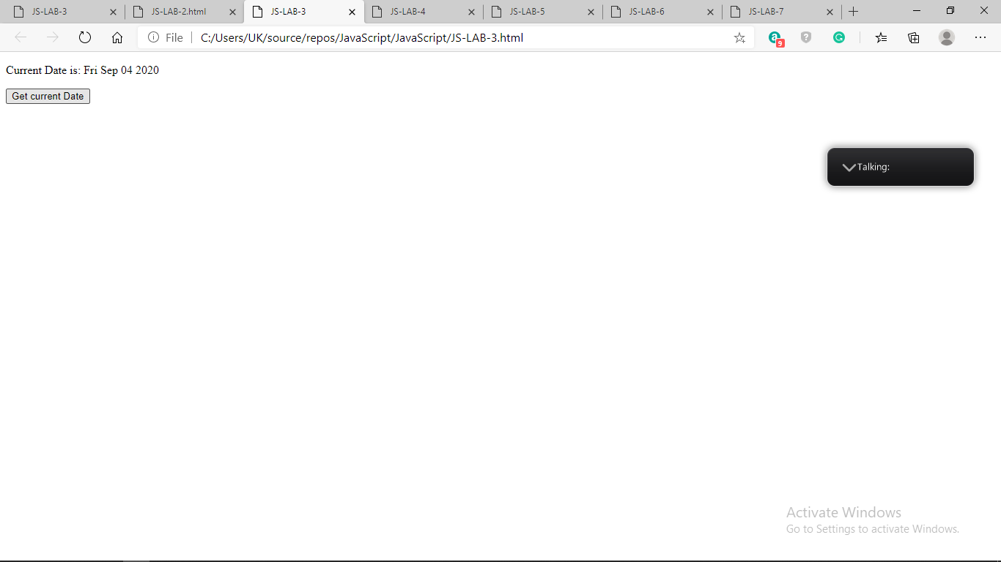

Lab 4. Write a JavaScript program to find the area of a triangle where lengths of the three of its

sides are 5, 6, 7.

Source Code:-

<!DOCTYPE html>

<html>

<head>

<meta charset=utf-8 />

<title>JS-LAB-4</title>

</head>

<body>

<script type="text/javascript">

var side1 = 5;

var side2 = 6;

var side3 = 7;

var s = (side1 + side2 + side3) / 2;

var area = Math.sqrt(s * ((s - side1) * (s - side2) * (s - side3)));

document.write("\tArea of the triangle : " + area);

</script>

</body >

</html >

Output:-

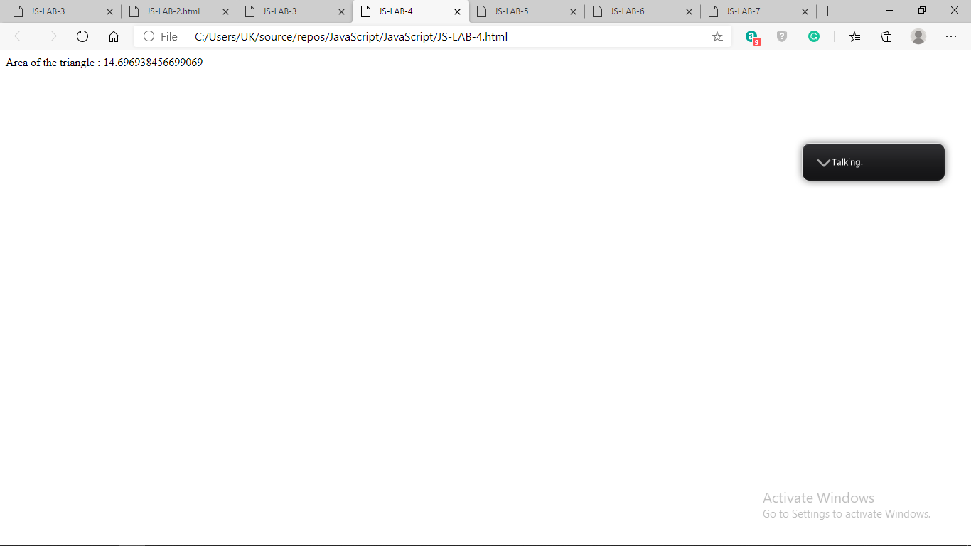

Lab 5. Write a JavaScript program to rotate the string 'w3resource' in right direction by periodically removing one letter from the end of the string and attaching it to the front.

Source Code:-

<!DOCTYPE html>

<html>

<head>

<title>JS-LAB-5</title>

<script type="text/javascript">

function animate_string(id) {

var element = document.getElementById(id);

var textNode = element.childNodes[0]; // assuming no other children

var text = textNode.data;

setInterval(function () {

text = text[text.length - 1] + text.substring(0, text.length - 1);

textNode.data = text;

}, 100);

}

</script>

</head>

<body onload="animate_string('target')"

<pre id="target">w3resource </pre>

</body>

</html>

Output:-

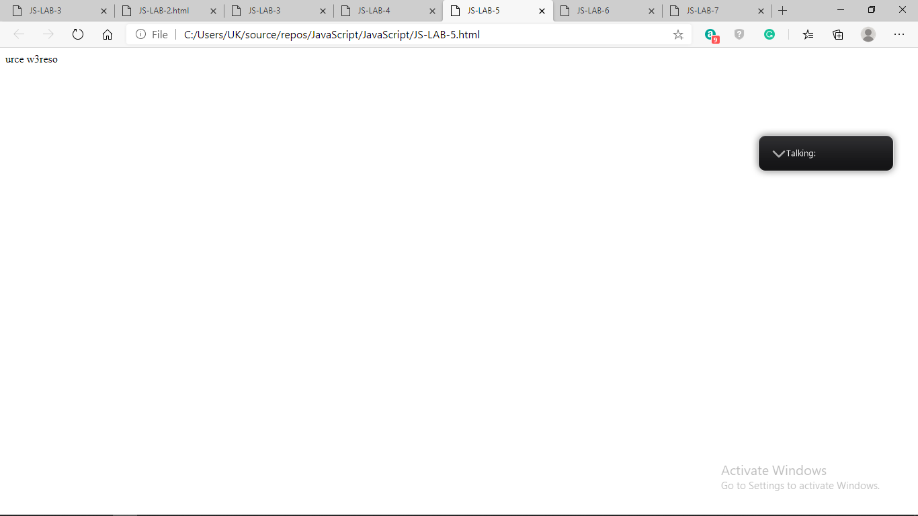

Lab 6. Write a JavaScript program to determine whether a given year is a leap year in the Gregorian calendar.

Source Code:-

<!DOCTYPE html>

<html>

<head>

<title>

JavaScript to check leap year

</title>

</head>

<body>

Input Year: <input type="text" id="year" />

<input type="button" id="button" onClick="isLeapYear()"

value="Check Leap Year">

<p id="GFG"></p>

<script>

function isLeapYear() {

var year = document.getElementById("year").value;

document.getElementById("GFG").innerHTML

= (year % 100 === 0) ? (year % 400 === 0)

: (year % 4 === 0);

}

</script>

</body>

</html>

Output:-

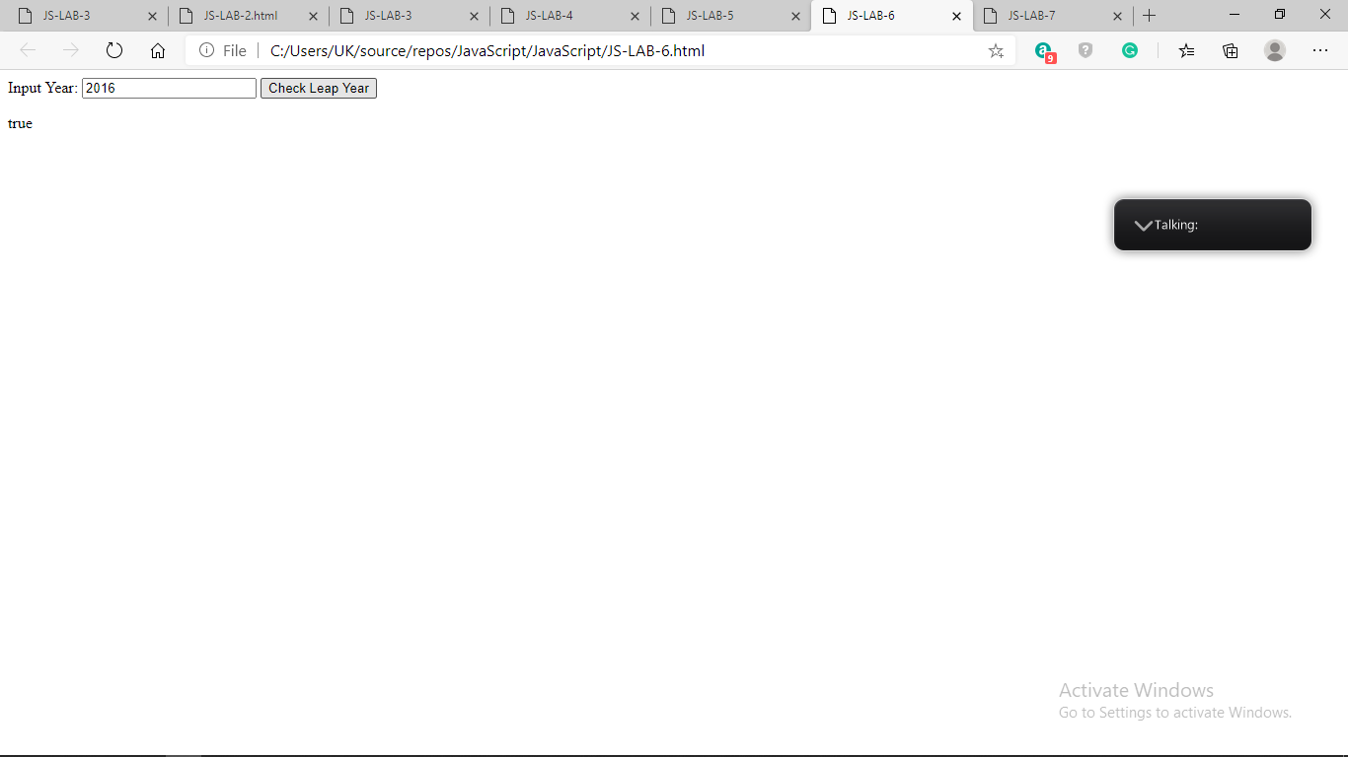

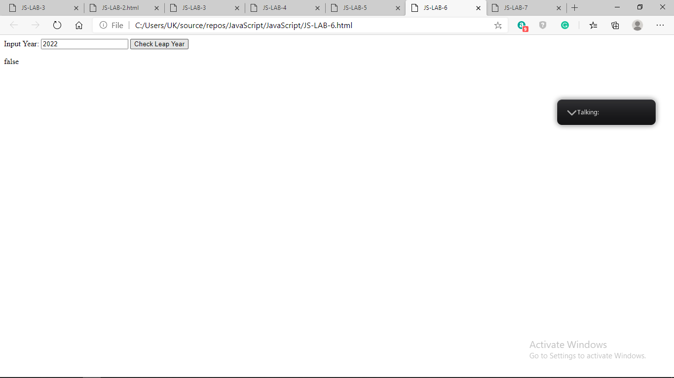

Lab 7. Write a JavaScript program where the program takes a random integer between 1 to 10, the

user is then prompted to input a guess number. If the user input matches with guess number,

the program will display a message "Good Work" otherwise display a message "Not

matched"

Source Code:-

<!DOCTYPE html>

<html>

<head>

<meta charset=utf-8 />

<title>JS-LAB-7</title>

</head>

<body>

<script type="text/javascript">

const num = Math.ceil(Math.random() * 10);

document.write(num);

const gnum = prompt('Guess the number between 1 and 10 inclusive');

if (gnum == num)

document.write("\tGoodWork : ");

else

document.write("\tNot matched " + gnum);

</script>

</body>

</html>

Output:-

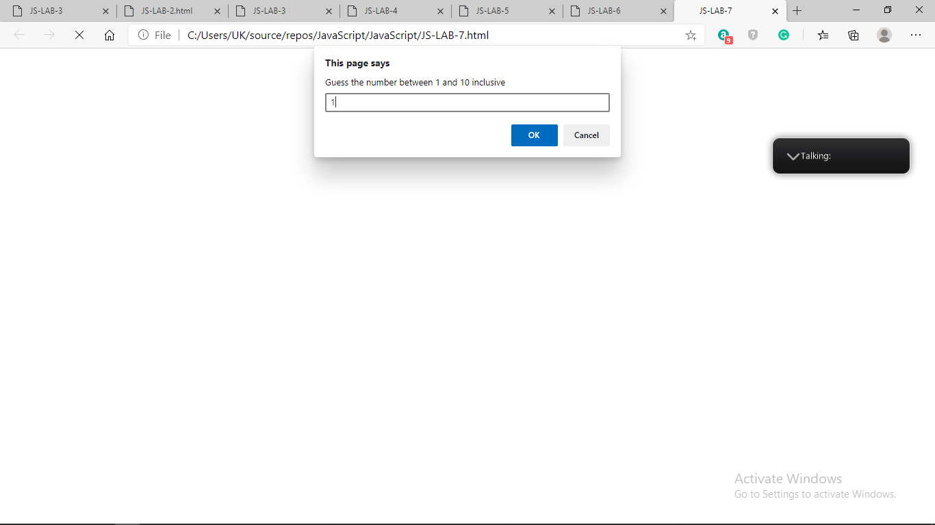

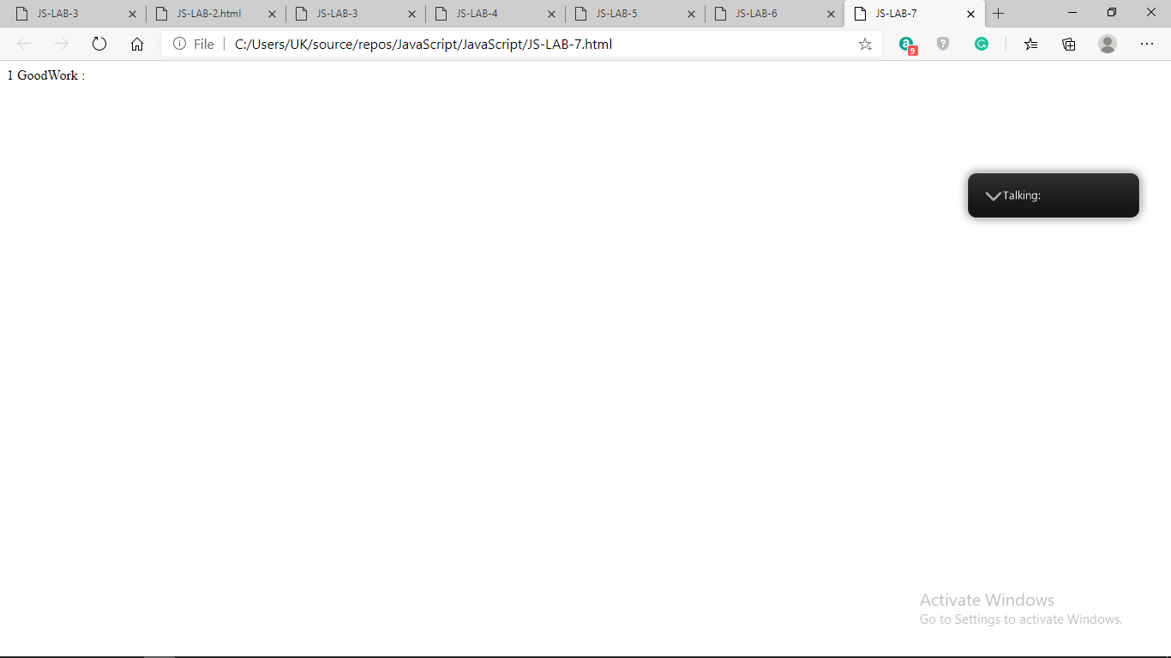

Q 1. Here is a sample html file with a submit button. Now modify the style of the paragraph text

through javascript code.

Source code:-

HTML code-

<html>

<head>

<meta charset=utf-8 />

<title>JS DOM paragraph style</title>

</head>

<body>

<p id ='text'>JavaScript Exercises – MCA III Sem</p>

<div>

<button id="jsstyle"

onclick="js_style()">Style</button>

</div>

</body>

</html>

Js code-

function js_style()

{

text.style.fontSize = "14pt";

text.style.fontFamily = "Comic Sans MS";

text.style.color = "red";

}

Output:-

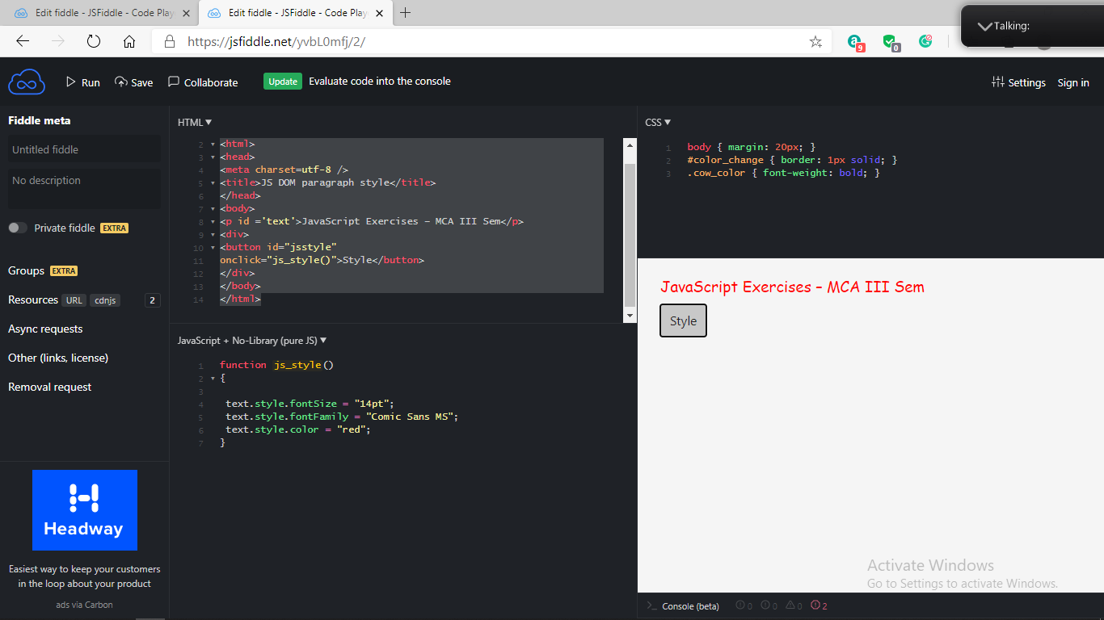

Q 2. Write a JavaScript function to get the values of First and Last name of the following form.

Source code:-

HTML code-

<!DOCTYPE html>

<html><head>

<meta charset=utf-8 />

<title>Return first and last name from a form -MCA III SEM</title>

<style type="text/css">

body {margin: 30px;}

</style>

</head><body>

<form id="form1" onsubmit="getFormvalue()">

First name: <input type="text" name="fname" value="David"><br>

Last name: <input type="text" name="lname" value="Beckham"><br>

<input type="submit" value="Submit">

</form>

</body>

</html>

Js code-

function getFormvalue()

{

var x=document.getElementById("form1");

for (var i=0;i<x.length;i++)

{

if (x.elements[i].value!='Submit')

{

console.log(x.elements[i].value);

}

}

}

Output:-

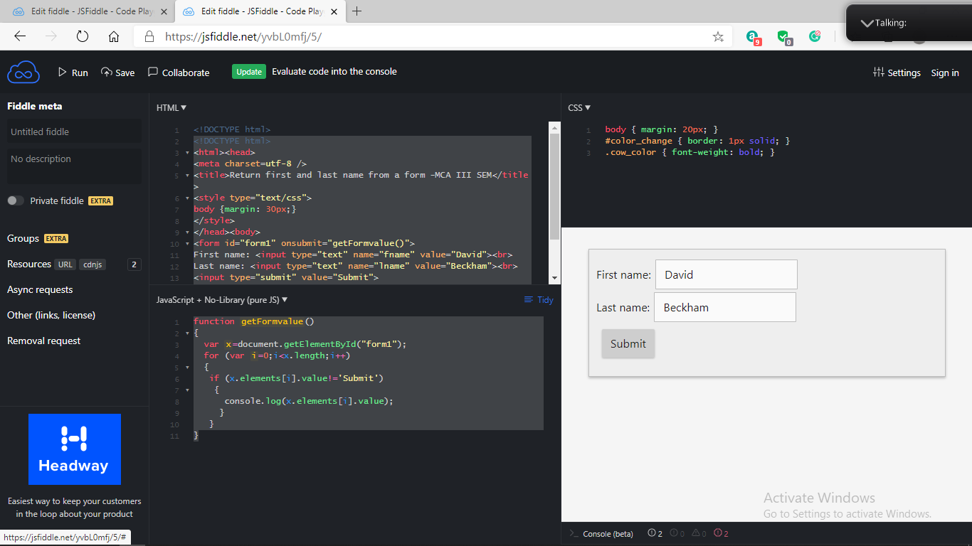

Q 3. Write a JavaScript codeto set the back color of a text.

Source code:-

HTML code-

<!DOCTYPE html>

<html>

<body>

<h1>19MCAR0039</h1>

<button type="button" onclick="myFunction()">Set background color</button>

<script>

function myFunction() {

document.body.style.backgroundColor = "BLUE";

}

</script>

</body>

</html>

Output:-

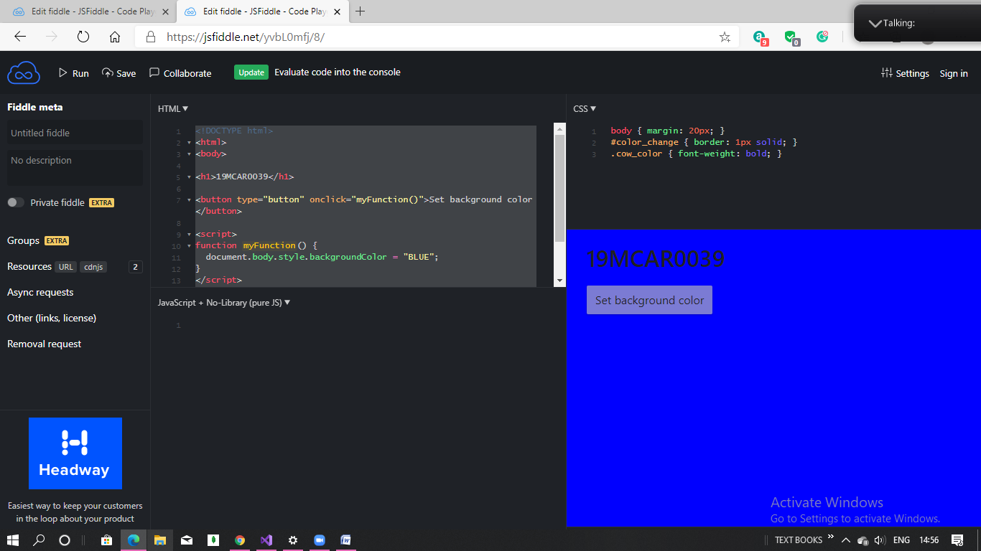

Q 4. Here is a sample html file with a submit button. Write a JavaScript function to get the value of

the href, hreflang, rel, target, and type attributes of the specified link.

Source code:-

HTML code-

<!DOCTYPE html>

<html>

<head>

<meta charset=utf-8 />

<title>Collect the value of href, hreflang, rel, target, and type attributes of a link</title>

</head>

<body>

<p><a id="w3r" type="text/html" hreflang="en-us" rel="nofollow" target="_self" href="https://www.google.com/">Google</a></p>

<button onclick="getAttributes()">Click here to get the attribute's value</button>

</body>

</html>

Js code-

function getAttributes()

{

var u = document.getElementById("w3r").href;

alert('The value of the href attribute of the link is : '+u);

var v = document.getElementById("w3r").hreflang;

alert('The value of the hreflang attribute of the link is : '+v);

var w = document.getElementById("w3r").rel;

alert('The value of the rel attribute of the link is : '+w);

var x = document.getElementById("w3r").target;

alert('The value of the taget attribute of the link is : '+x);

var y = document.getElementById("w3r").type;

alert('The value of the type attribute of the link is : '+y);

}

Output:-

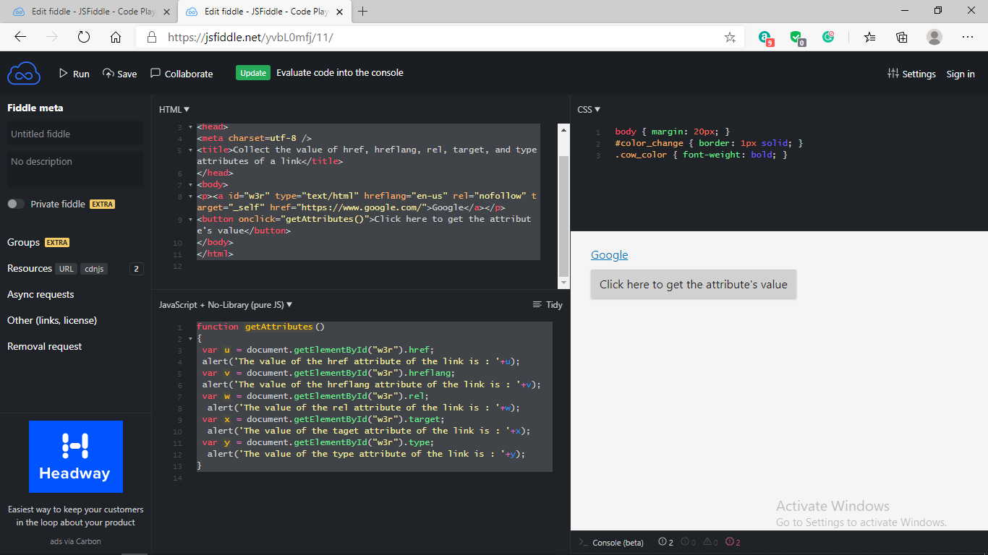

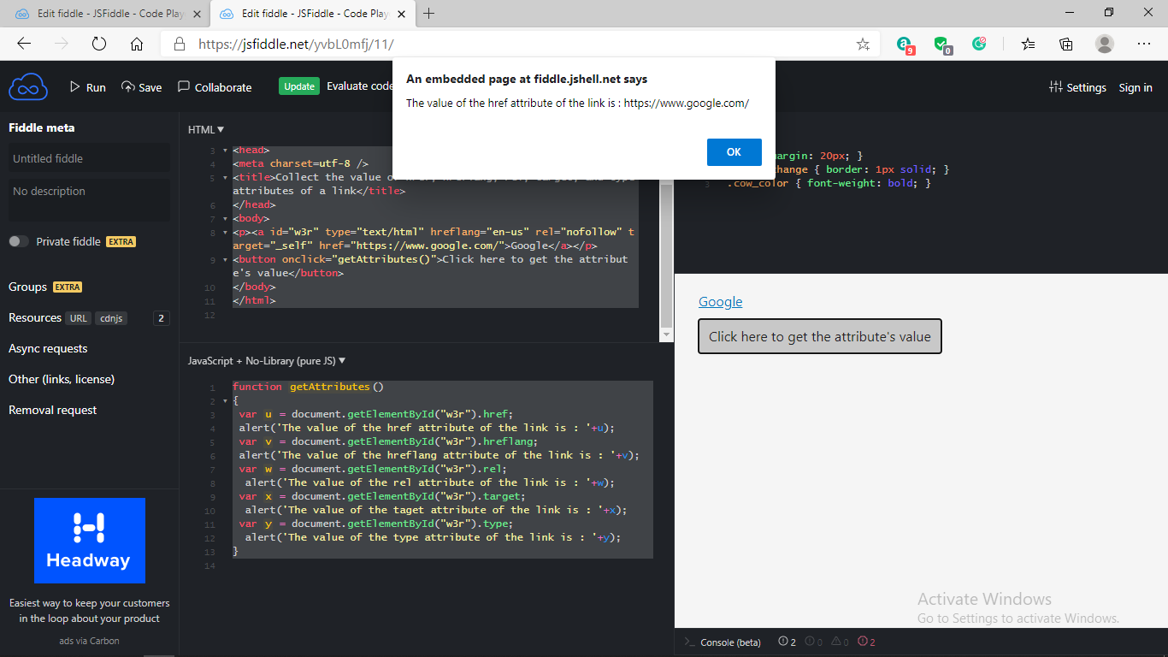

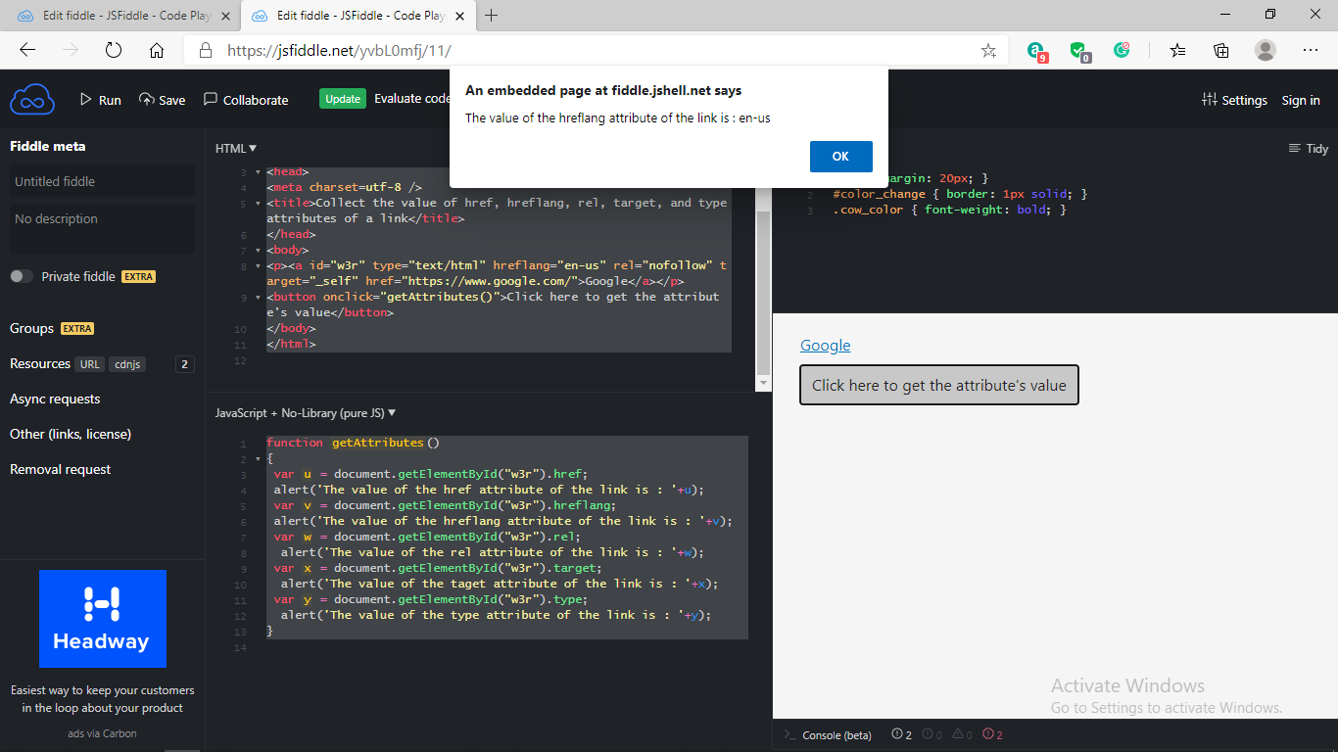

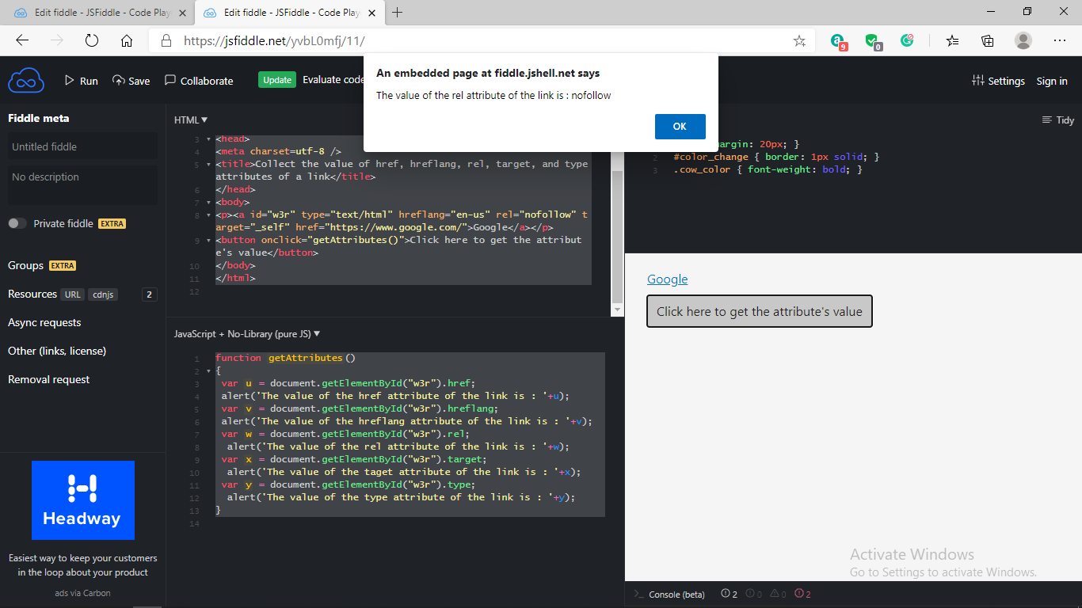

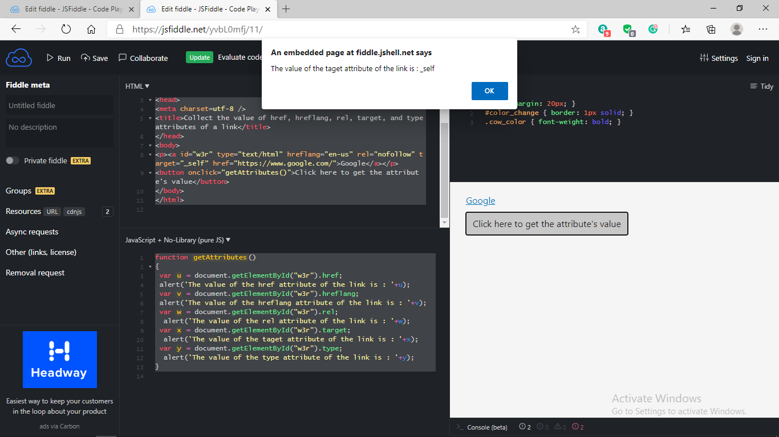

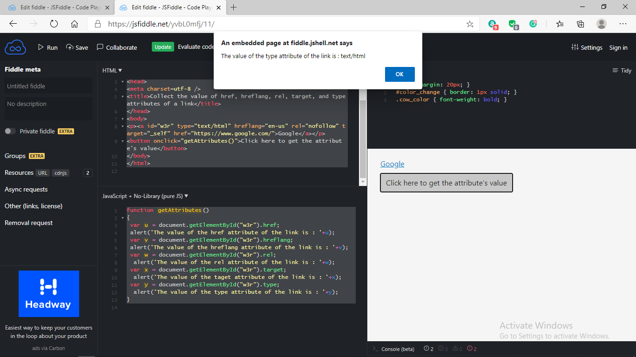

Q 5. Write a JavaScript function to add rows to a table.

Source code:-

HTML code-

<!DOCTYPE html>

<html><head><meta charset=utf-8 />

<title>Insert row in a table - w3resource</title>

</head><body>

<table id="sampleTable" border="1">

<tr><td>Row1 cell1</td>

<td>Row1 cell2</td></tr>

<tr><td>Row2 cell1</td>

<td>Row2 cell2</td></tr>

</table><br>

<input type="button" onclick="insert_Row()" value="Insert row">

</body>

</html>

Js code-

function insert_Row()

{

var x=document.getElementById('sampleTable').insertRow(0);

var y = x.insertCell(0);

var z = x.insertCell(1);

y.innerHTML="New Cell1";

z.innerHTML="New Cell2";

}

Output:-

